MedCommons Central Services Setup Guide 08/15/05

Table of Contents
MedCommons Central Services Setup Guide 08/15/05 1
Install XAMPP 1
Install TortoiseSVN 2
Setup Database 2
Install the MedCommons PHP and Website Collateral 5
Test the Server 6
Edit the Configuration 6
Checking in Changes 8
Moving the SVN Tree to https:/svn.medcommons.net 8
Apache Server Configuration 8
SVN Client Configuration 8
TortoiseSVN 8
Download Trusted CA Certificate 8
Export MedCommons Client Certificate 10
FireFox Browser 10
Internet Explorer Browser 13
Update the Subversion server configuration file 13
TLS Access with Client Certificate authentication. 14
Troubleshooting prompt windows 15
svn client (Linux) 16

This document describes how to install the necessary components on your computer to run MedCommons Central PHP Services.

Install XAMPP
First install XAMPP from http://www.apachefriends.org/en/xampp-windows.html . You need a recent version of XAMPP, this guide was created for the 1.4.15 version which includes PHP5.
Install into the default location which should be c:\apachefriends\xampp. The installer should offer to install XAMPP as a service which I usually do NOT do, but let it start the control panel so that you can start Apache and MySQL manually.
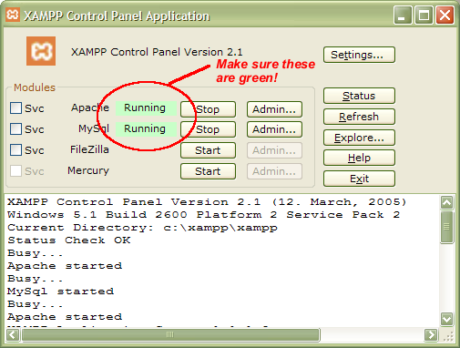
Note: if you have another web server on your computer (eg. IIS) then you may find that Apache fails to start. You may need to edit c:\apachefriends\xampp\apache\conf\httpd.conf and c:\apachefriends\xampp\apache\conf\ssl.conf and change references to port 80 and port 443 to other values (eg. 7080 and 7443).

Install TortoiseSVN
Download and install the latest Tortoise from here:
http://tortoisesvn.tigris.org/download.html
If you already have Tortoise it is worth updating as there have been many fixes/improvements made.

See the Client Configuration section for details on using the secured protocol and server

Setup Database
You can skip this section if you don’t really want to run locally, but are just interested in code-control. Just don’t try to do anything fancy on you local machine.

There are 3 MedCommons databases. As a local user you are probably only interested in ‘MCX’ which houses all the tables for users, documents and gateways. The other databases are “MCBACKGROUND” which controls operational monitoring of all MedCommons hardware and “MCEXTIO” which is used for fax, email, and credit card handling.

There is no reason to create MCBACKGROUND unless you are specifically working on the monitoring software. Likewise for MCEXTIO. {if you want to send faxes,emails, etc from your software make sure your code calls the appropriate web services on secure.xxx.medcommons.net and not on //localhost/

Make a temporary folder on your desktop. Open it and right click and you should have a Tortoise menu option “SVN Checkout …”
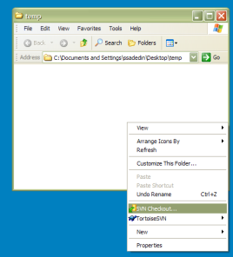
Choose the Checkout option and it will show you a dialog where you should enter the following url:

http://svn.medcommons.net:6666/svn/services/trunk/schema

It should look something like this:

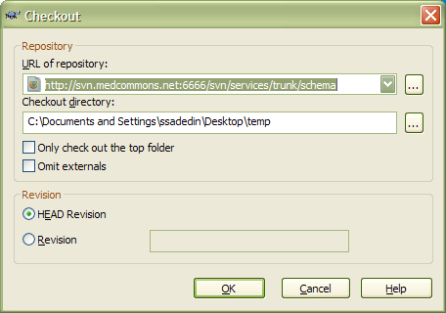

After clicking OK you should get several files in there:

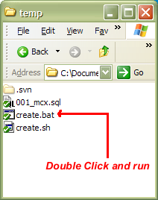

You need to run the file “create.bat”. This will destroy your database (if it existed already) and recreate it.

If all of that worked, you should get a command window that looks like the picture that below:

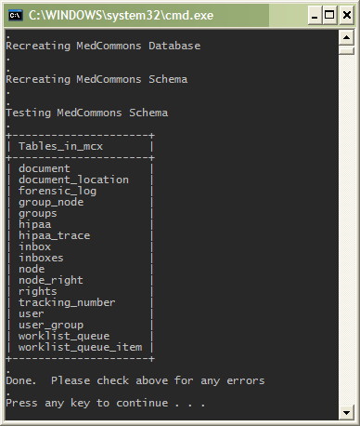

Install the MedCommons PHP and Website Collateral
The MedCommons PHP can be checked out from Subversion directly into your Apache directory. Navigate to the C:\apachefriends\xampp\htdocs folder with Windows Explorer, and right click to choose the SVN Checkout option from Tortoise SVN again: in this example the mctest folder was created under htdocs tol hold the medcommons php and website collateral

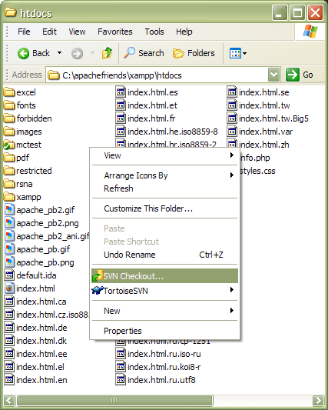

This time, enter the following URL into the Tortoise Checkout box:

http://svn.medcommons.net:6666/svn/services/trunk/php

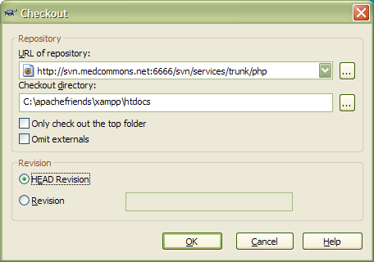
After you click OK, the PHP will be downloaded into Apache install. This includes the complete top level medcommons website, the /ws folder with web service calls, the /ui folder with user interface code in php and html, and several other folders.

Note: if you want you can install into a subdirectory under htdocs instead of directly into htdocs. This is useful especially if you want to run several versions of the code at once. To do that just create the subdirectory and right-click in there to checkout instead. You will need to insert the subdirectory into the paths of any urls that you use to access the services, including in your gateway configuration.

Test the Server
Test the server by calling up http://localhost/xxx/ where xxx is the directory under htdocs where you have placed the PHP and website.

You can further test the installation just by browsing to a URL and checking that valid XML comes back. An example URL that you can use is as follows:

http://localhost/xxx/ws/registerNode.php?type=gw&hostname=https%3A%2F%2Fyowie%3A8443%2Frouter

Edit the Configuration
Your install should work without modification of its configuration, however Email is disabled by default so you may wish to enable it. To do that, you can create files that override the values in your htdocs directory (or wherever you checked out the php files to). These files are:
- dbparams.local.inc.php
- dbparamsmcextio.local.inc.php

Any values you put in these files will override those in the dbparams files from Subversion. You should put any changes you want just for your own installation here. Any changes you want to check in and make available for everybody should go into the original files.

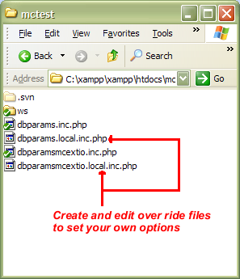

Checking in Changes
When you have made changes and want to commit them to Subversion, do it just by right-clicking in Windows Explorer in your c:\apachefriends\xampp\htdocs directory and choose the “Commit” option. This will bring up a small dialog where you can type a description of the changes and click OK.

If you have added files then you should right click then and select “TortoiseSVN =:> Add” prior to committing your changes so that Tortoise knows to commit them.

Moving the SVN Tree to https://svn.medcommons.net

Apache Server Configuration
Copy the Medcommons Trusted root CA cacert.pem to the $APCHE_HOME/ssl.ca dir (create the dir if need be)

Update the ssl.conf file.

Uncomment and update the following:

SSLCACertificateFile /home/apache3/conf/ssl.ca/cacert.pem
SSLVerifyClient require
SSLVerifyDepth 2

SVN Client Configuration

TortoiseSVN
Here is the overview of configuring TortoiseSVN to connect via TLS and use a client certificate for authentication:
- Download MedCommons Trusted Root CA certificate to client PC
- Export your MedCommons client certificate into the required format for use with TortoiseSVN
- Configure the TortoiseSVN client to use the certificates

Download Trusted CA Certificate
Download MedCommons Trusted Root CA certificate to client PC by opening https://ops.medcommons.net/ca/php-ca/openssl/crypto/cacerts/cacert.pem.
You will see the contents of the certificate:
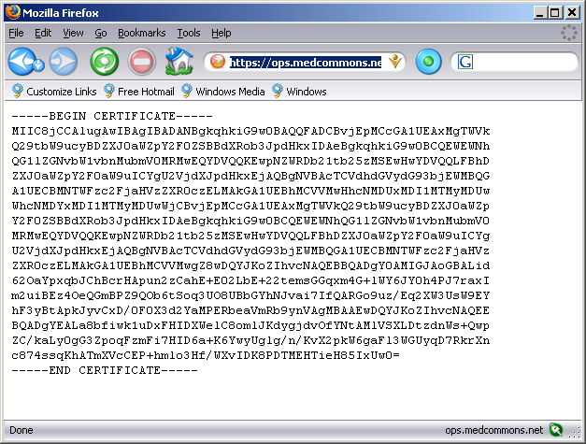

Select File > Save as to save the certificate:
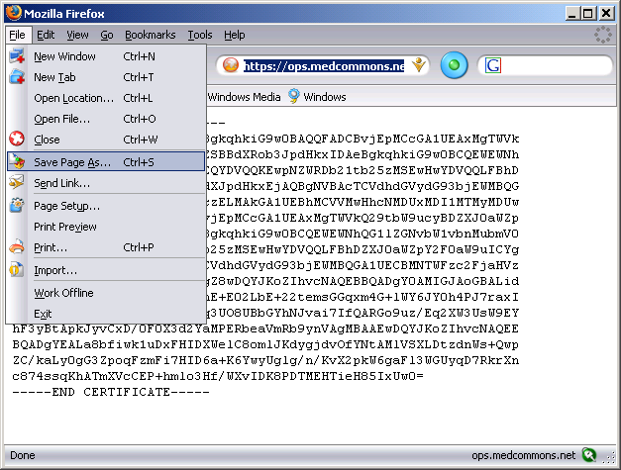

Save the certificate to the Subversion configuration directory:
C:\Documents and Settings\<USER>\Application Data\Subversion\auth\svn.ssl.server, where <USER> is the user you are logged in as. Leave the name at ‘cacert.pem’.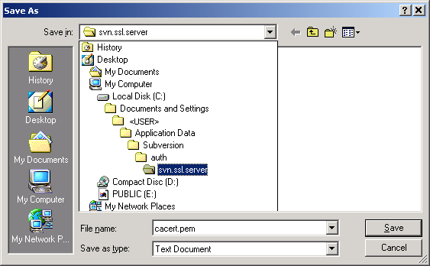

Export MedCommons Client Certificate
Next, we need to export the MedCommons client certificate to the file system to be used by TortoiseSVN. Please see the section appropriate to your browser.

See document MedCommons PKI (non-existent at this date) for details of obtaining a client certificate if you have not done so.

FireFox Browser
Select Tools > Options menu, 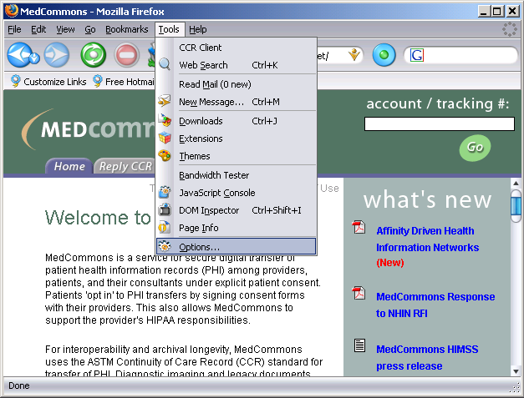

select the Advanced option and then scroll down and click Manage Certificates…:

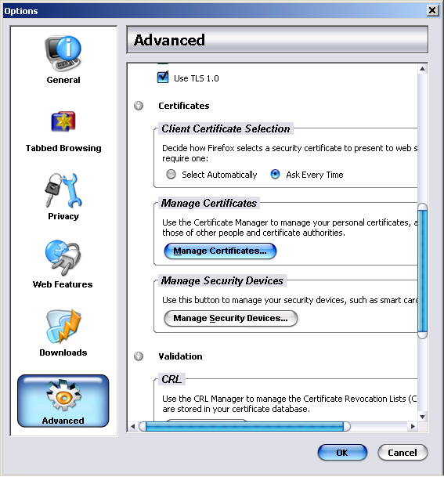

Select your MedCommons certificate and click the Backup button:
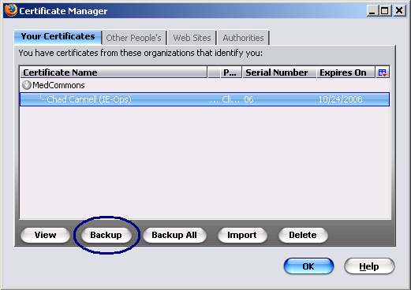

Save the file to C:\Documents and Settings\<USER>\Application Data\Subversion\auth\svn.ssl.server, and name the file <user>_medcom_cert where <USER> is the user you are logged in as. Click Save

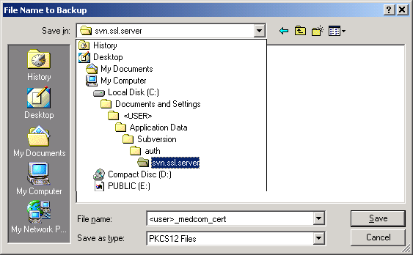

You will be prompted to enter a Certificate backup password. Enter anything you would like and remember it, you will need it in the TortoiseSVN client configuration section.
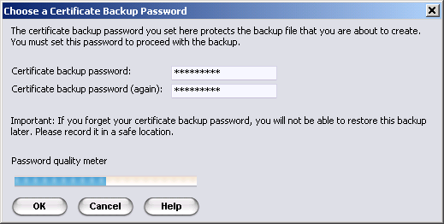

Click OK when you have entered the password. You will see that the certificate has been backed up.

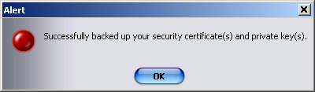

Close out of Firefox windows if you like.

You are now ready to configure the Subversion Client to use the certificates.

Internet Explorer Browser
To be added, much the same as FF.

Update the Subversion server configuration file
Edit the following file: C:\Documents and Settings\<USER>\Application Data\Subversion\servers

Add the following lines, taking care to correct paths, incorrect line breaks and the appropriate <USER>.

Add these lines after the initial comment block, approx line 30 of the servers file:

[groups]
medcom_svn = svn.medcommons.net

[medcom_svn]
ssl-client-cert-file = C:\Documents and Settings\<USER>\Application Data\Subversion\auth\svn.ssl.server\<user>_medcom_cert.p12

ssl-client-cert-password = <enter backup passwd>
#(or leave blank and you will be prompted for the certificate passphrase by TortoiseSVN.)

ssl-authority-files = C:\Documents and Settings\<USER>\Application Data\Subversion\auth\svn.ssl.server\cacert.pem

Save and exit.

TLS Access with Client Certificate authentication.
You can now access the Subversion repository over an encrypted connection and be authenticated with your client certificate.

NOTE: the client certificate serves only to authenticate you at the webserver not at the subversion authentication and authorization level. Your Subversion account still is needed for authorization to access repository nodes.

The access URL is different for the SVN TLS listener.

URL is now https://svn.medcommons.net:6667/svn/services/trunk , note the https protocol and different port number. The URIs are still the same, just the protocol and port are different. Please verify you update the URLs accordingly.

Note: http://svn.medcommons.net:6666 is still up. We will provide both listeners for a brief cutover period.

Open the Repo-Browser:
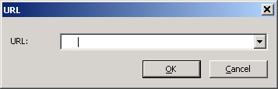

Enter https://svn.medcommons.net:6667/svn/services/trunk as the URL
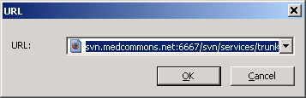

If everything is configured correctly, you will see the repository. Expand a branch to verify.
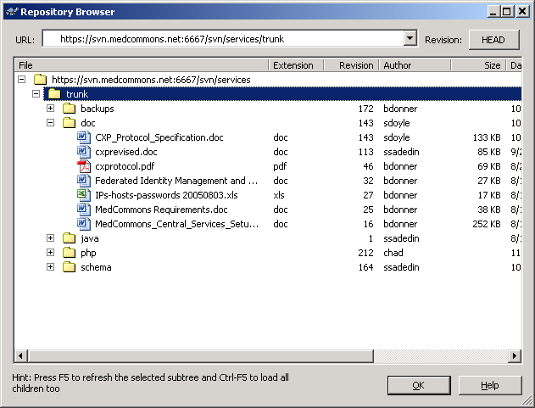

Troubleshooting prompt windows

If you did not enter a passphrase for the p12 file in the servers file, ssl-client-cert-password =, you will be prompted:

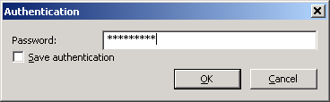

If you did not enter a the cacert.pem in the servers file, ssl-authority-files =, you will be prompted:

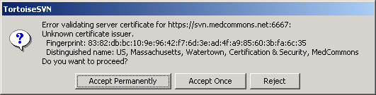

If you did not enter ssl-client-cert-file = in the servers file you will be prompted:
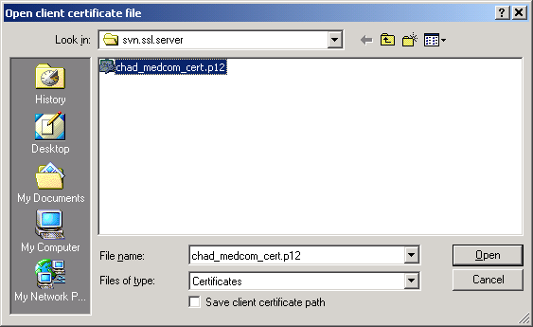

This is a prompt for you Subversion credentials, not client certificate:
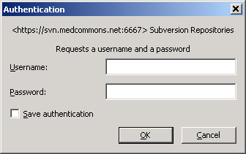

svn client (Linux)

Coming soon

