Quotation Software User Guide
  - Illustrated instructions and complete feature reference
18 September 2026 | English edition
Use this guide to create, check, save, and output quotations, manage reusable records, and prepare goods receipts. Instructions, rules, tables, and troubleshooting are searchable, copyable Word text. Screenshots show where the controls are.

Finding an answer
- Press Ctrl+F to search for a button, problem, or keyword such as mixed tax, markup_override, or goods receipt.
- Use Headings in Word’s Navigation Pane, or follow the linked contents, to jump directly to a section.
- Zoom the Word view to inspect screenshot details. Original image resolution is retained; some figures crop unrelated areas for readability.
- Desktop and browser editions share the editor but use different file buttons. Screenshots show the browser edition; section 2 maps Download to Save and Print to Export PDF.

Asking an AI about this guide
Upload this DOCX to an AI tool that accepts documents. Try: “Using this user guide, explain how to [task]. Give the exact buttons, distinguish desktop and browser behavior, and cite the section number. Clearly identify anything the guide does not explain.”
The screenshots use quotation Q-SLB-INS-20260913-01. It contains incomplete items and illustrates the workflow. Review the quantities, prices, tax rates, and terms of your own quotation before sending it.

Contents
Follow a section link to jump to it, or press Ctrl+F to search the entire guide.
1. What the application does 3
2. Desktop and web differences 3
3. Screen layout and icon guide 3
4. First-time setup and desktop activity history 3
5. Company profiles 3
6. Customer records 3
7. Create, save, open, and back up quotations 3
8. Keyboard shortcuts and undo/redo 3
9. Quotation information 3
10. Sender and customer details 3
11. Line-item pricing basis 3
12. Add and edit line items 3
13. Build a three-level item structure 3
14. Sections, ordering, and the Outline 3
15. Cost-plus and final-price calculations 3
16. Markup inheritance 3
17. Tax setup 3
18. Extra charges 3
19. Currencies and exchange rates 3
20. Goal seek 3
21. Calculation Sheet and Calculation Steps 3
22. Totals and incomplete-item checks 3
23. Preview, templates, logo, and PDF output 3
24. Analysis workspace 3
25. Generate a goods receipt 3
26. Line-item CSV/Excel import and CSV export 3
27. Quotation JSON import and export 3
28. Library backup and transfer 3
29. Recommended end-to-end workflows 3
30. Troubleshooting 3
31. Limits and important behavior 3

1. What the application does
Quotation Software is a local-first quotation editor. It can:
- Create English or Simplified Chinese quotations.
- Store reusable sender-company profiles and customer records.
- Build flat or hierarchical quotations with up to three item levels.
- Price items by cost plus markup or by directly entered final unit price.
- Use one tax rate or multiple tax classes.
- Convert costs from several currencies into the quotation currency.
- Calculate totals, cost, markup, tax, cost/sales percentage, and margin analysis.
- Preview and print a customer-facing quotation using seven document templates.
- Export a complete quotation as JSON, export line items as CSV, and import line items from CSV or Excel.
- Generate a goods receipt from quotation items.
The application is local-first. Keep quotation JSON files and reusable-library backup files outside the app as durable copies. They contain different data and neither can replace the other.

2. Desktop and web differences
The same quotation editor is used in both versions, but file and printing buttons differ.
Task | Desktop app | Web app
Save current quotation | Click Save. The app can write back to the selected file. | Click Download. A JSON file is saved through the browser or browser file picker.
Save with a different name | More actions > Save As | Use Download again. Browser behavior depends on file-system support.
Create PDF | Click Export PDF | Click Print, then choose Save as PDF in the browser print dialog.
Goods receipt output | Export GR PDF in the goods-receipt dialog | Print GR, then use the browser print dialog.
File paths | Full Windows path can be shown. | Usually only the selected or downloaded file name is shown.
Activity history | Available under Settings > General. | Not available.

If a browser blocks a print tab or download, allow pop-ups/downloads for the application site and try again.

3. Screen layout and icon guide

3.1 Main areas
The application has three navigation buttons on the far-left sidebar:
- Editor, with a file-edit icon: create and work with quotations.
- Settings, with a gear icon: app language, backups, desktop activity history, company profiles, and customers.
- User Manual, with a book icon: open or download the searchable Word guide.
Inside Editor, the top command bar contains:
- The quotation number.
- Project name or Untitled quotation.
- Customer name or No customer selected.
- Current file name or Unsaved file.
- Editor and Analysis workspace tabs.
- File, preview, PDF/print, goods-receipt, and menu actions.
The main Editor workspace has:
- The line-item work area in the center/left.
- A resizable support panel on the right.
- A totals bar at the bottom of the item work area.
Drag the narrow divider beside the support panel to make it wider or narrower. Click the chevron at the far right to hide or show the panel. The width and collapsed state are remembered.
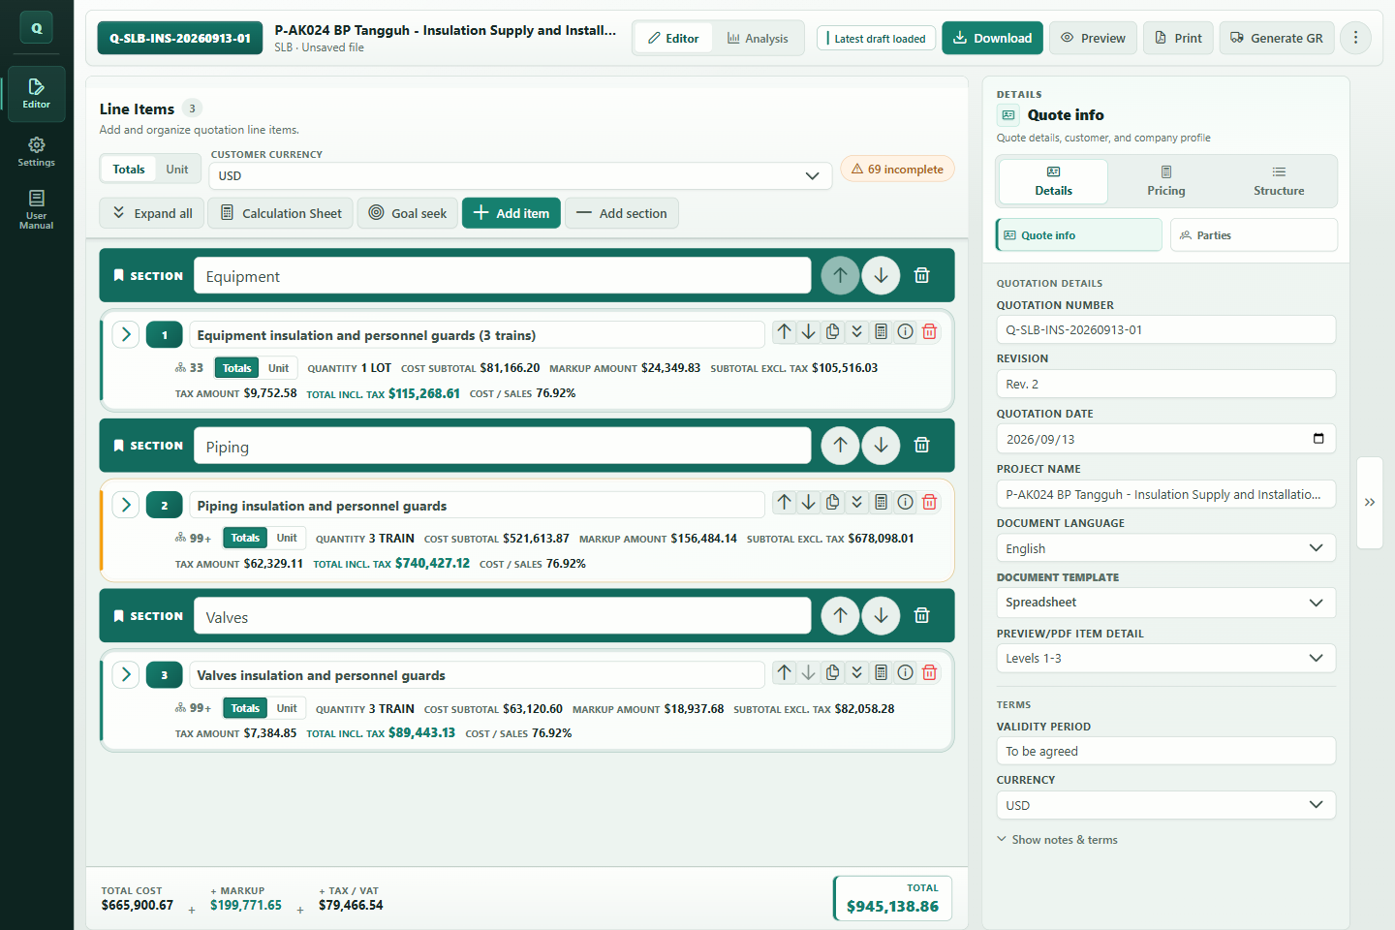
Figure 1 Recognize the main work areas

3.2 Support-panel groups
The support panel has three top-level icon groups:
Group | Icon appearance | Panels inside
Details | ID-card | Quote info, Parties
Pricing | Calculator | Pricing & tax, FX rates
Structure | List | Outline

Click a group, then click the required panel tab inside it.

3.3 Common icon meanings
Buttons usually show a label, tooltip, or accessible name when hovered. The common icons are:
Icon appearance | Meaning
Plus | Add an item, section, tax class, currency, charge, profile, or customer
Downward arrow into a tray | Download/save data
Eye | Open quotation preview
Printer or PDF document | Print or export PDF
Truck | Generate goods receipt
Vertical three dots | Open the More actions menu
Up/down arrows | Move a root row earlier or later
Copy | Duplicate a complete root item and its children
Calculator | Open the Calculation Sheet
Information circle | Show Calculation Steps or explanatory help
Target/bullseye | Open goal seek
Trash can | Delete the row or record
Bookmark | Section header, not a priced item
Chevron | Expand/collapse a group or panel
Drag grip | Drag an Outline row to reorder or reparent it
Check mark | Current default tax class; the check button can make another class the default

4. First-time setup and desktop activity history

4.1 First-time setup
Complete these steps before creating regular quotations.
- Click Settings in the left sidebar.
- Stay on the General tab.
- Under Appearance, choose an App theme.
- Choose English or Simplified Chinese from App language.
- Open Company Profiles and create at least one sender company.
- Open Customers and add regular customers if useful.
- Return to General and click Save backup as to create a quotation-library.json backup after entering reusable records.
Changing App language changes the application interface. It does not automatically change the current quotation document language. Set that separately in Editor > Details > Quote info > Document language.
The available application themes are Ledger Teal, Modern Blue, Warm Sand, and Graphite Night. The selected theme is remembered on the current device. It changes the editor, settings, and Analysis appearance; it does not change the selected quotation document template or the customer-facing PDF.
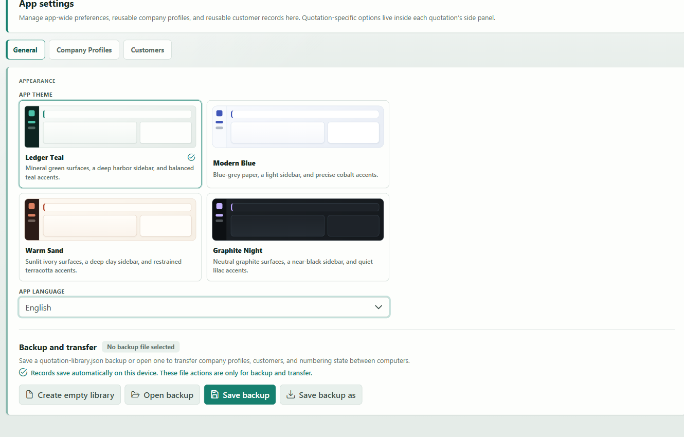
Figure 2 Choose application preferences and back up records

4.2 Desktop activity history
The desktop app keeps a lightweight diary of meaningful actions. To open it:
- Click Settings > General.
- Find Activity History.
- Click Open activity history folder.
The folder is named Quotation Activity History - Safe to Delete. It contains monthly .log files with local timestamps, a quotation or library context, and an English description. Logged actions include committed quotation changes and undo/redo, file imports and exports, company/customer changes, reusable-library operations, and successful desktop goods-receipt PDF exports.
Activity history is separate from quotation undo/redo and from saved files. It cannot restore a quotation. The managed log history is limited to 100 MB; older monthly files are removed as needed. You can delete the folder without affecting quotations, and the app recreates it when a later action is recorded.

5. Company profiles
Company profiles store reusable sender information.

5.1 Create a profile
- Click Settings.
- Click Company Profiles.
- Click New profile (plus icon).
- Enter:
- Company Name: required.
- Contact Number: optional.
- Email: optional, but it must be a valid email address if entered.
- Click Save profile (save icon).
The left Profiles list shows saved records. The most recently updated profiles appear in the reusable library.
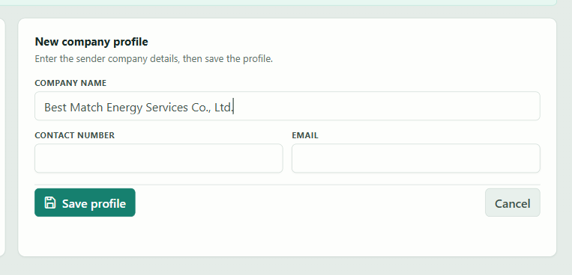
Figure 3 Create a reusable company profile

5.2 Edit a profile
- Click the profile in the Profiles list.
- Change the fields in Edit company profile.
- Click Save profile.
The editor displays the last-updated date for an existing record.

5.3 Cancel or delete
- Click Cancel to discard the current draft changes.
- Click Delete (trash icon), then confirm Delete, to remove an existing profile.
- If you select another record or start a new one while unsaved changes exist, the app asks whether to keep editing or discard the changes.
Deleting or editing a library profile does not rewrite old quotations. A quotation copies the selected profile into a snapshot so historical output remains stable.

6. Customer records
Customer records store reusable recipient information.

6.1 Create a customer
- Click Settings.
- Click Customers.
- Click New customer (plus icon).
- Enter:
- Company.
- Contact Person.
- Contact Details: phone, email, address, or other useful text.
- Enter at least Company or Contact Person. One of these is required.
- Click Save record.
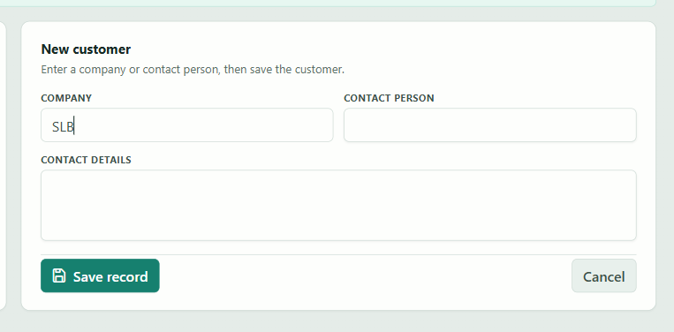
Figure 4 Create a reusable customer

6.2 Edit or delete
- Select a record from the Records list.
- Edit the fields.
- Click Save record.
Click Delete and confirm to remove it. Click Cancel to restore the selected record's saved values. Unsaved-change confirmation works the same way as in Company Profiles.
Applying a customer to a quotation copies its current values into the quotation. Later edits to the reusable customer record do not automatically alter that quotation.

7. Create, save, open, and back up quotations

7.1 Start a new quotation
- Click Editor.
- Click More actions (vertical three-dot icon).
- Click New (file-plus icon).
The app creates a new quotation number, normally in the Q-YYYY-NNN pattern, and starts with one blank item. A new quotation also uses the current app language for its initial document language and can use the available sender profile as its initial sender snapshot.
Save or download the current quotation before clicking New if you need a separate file copy.
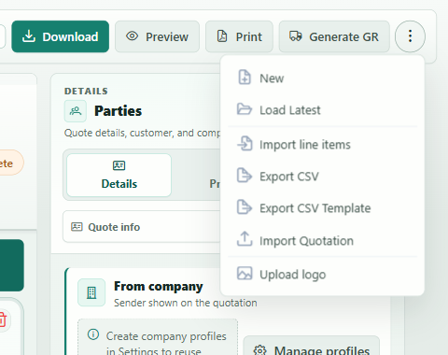
Figure 5 Start a separate quotation

7.2 Save in the desktop app
- Click Save in the command bar or press Ctrl+S.
- Choose a location and JSON file name if the quotation has not been saved before.
- Use More actions > Save As to create another copy with a different name.
Saving also places the quotation in the app's local saved-draft list and updates the reusable quotation-numbering state.
The local draft is stored in the app's local profile on that device. Keep the saved quotation JSON as the durable backup, especially before clearing browser/site data, resetting the app profile, or moving to another computer.

7.3 Download in the web app
- Click Download in the command bar or press Ctrl+S.
- If the browser supports direct file access, select or confirm a JSON file.
- Otherwise, find the downloaded JSON in the browser's Downloads folder.
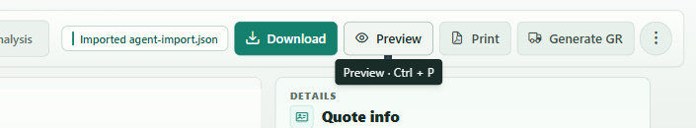
Figure 6 Save a durable quotation copy

7.4 Load the latest locally saved quotation
- Click More actions.
- Click Load Latest (folder-open icon).
This loads the most recently saved local draft. It is not a file browser and it does not mean “open the newest file from a Windows folder.”
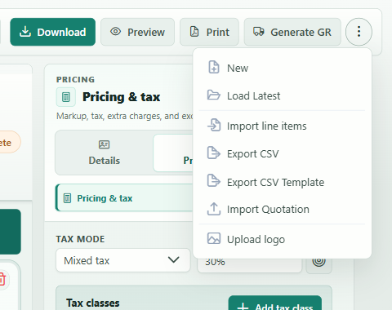
Figure 7 Load the latest local draft

7.5 Open a quotation JSON file
- Click More actions.
- Click Import Quotation (upload icon).
- Select a quotation .json file.
The imported quotation replaces the quotation currently in the editor. Save the current work first if it must be kept.
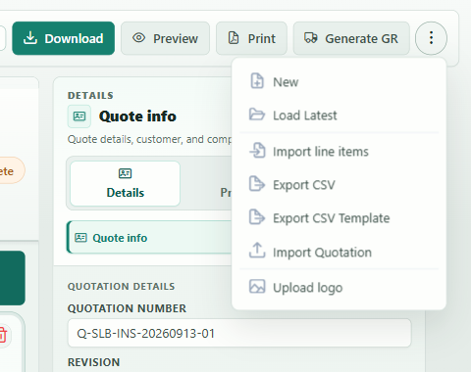
Figure 8 Open a quotation JSON file

7.6 Command-bar actions
Desktop More actions normally contains:
- New.
- Save As.
- Load Latest.
- Import line items.
- Export CSV.
- Export CSV Template.
- Import Quotation.
- Export Quotation.
- Upload logo.
Web More actions normally contains:
- New.
- Load Latest.
- Import line items.
- Export CSV.
- Export CSV Template.
- Import Quotation.
- Upload logo.
The web command bar uses the primary Download button for quotation JSON export, so Export Quotation is not repeated in More actions.

8. Keyboard shortcuts and undo/redo
Windows uses Ctrl; macOS-style browser environments use Command.
Shortcut | Action
Ctrl+S | Save or download the current quotation
Ctrl+P | Open or close the floating quotation preview
Ctrl+B | Hide or show the right support panel
Ctrl+Z | Undo the last quotation change
Ctrl+Y | Redo the last undone quotation change
Ctrl+Shift+Z | Alternative redo shortcut

After undo or redo, a notice describes the changed field or item. The app scrolls to and briefly highlights the affected location when possible.
When the cursor is inside a text box, Ctrl+Z, Ctrl+Y, and Ctrl+Shift+Z are left to the text field for normal typing undo/redo. Click outside the field before using quotation-level undo/redo.
Opening another quotation or resetting the working quotation clears the previous undo/redo history. Undo is not a substitute for saving a file.
On desktop, activity history may record a short description of committed changes, but it is also not a backup and cannot be used as an undo stack.

9. Quotation information
- In Editor, open the right-side Details group.
- Click Quote info.

9.1 Main fields
Field | Use
Quotation number | Customer-visible reference, for example Q-2026-001
Revision | Revision number shown as Rev. N
Quotation date | Date printed on the document
Project name | Project/title shown in the command bar and document
Document language | English or Simplified Chinese output text
Document template | Customer-facing page design
Preview/PDF item detail | Shows level 1 only, levels 1-2, or levels 1-3 in output
Validity period | Customer-visible validity text
Currency | Quotation/sales currency

Changing Preview/PDF item detail only controls customer-facing preview and output. It does not delete hidden children or change their rolled-up totals.
Figure 9 Complete Quote info

9.2 Notes and terms
Turn on Show notes & terms to reveal:
- Notes / Remarks.
- Terms & Conditions.
These fields are printed only when enabled and populated according to the selected template.

10. Sender and customer details
- Open Details.
- Click Parties.

10.1 From company
- Select a saved company profile from the sender selector.
- The Quotation company snapshot shows the sender currently stored in the quotation.
- If no profiles exist, click Manage profiles (gear icon). This opens Settings > Company Profiles.
Selecting a profile copies its company name, contact number, and email into the quotation snapshot.

10.2 To customer
- Select a saved customer when available.
- If no customers exist, click Manage customers.
- You can also type directly into:
- Customer company.
- Contact person.
- Contact details.
Direct edits affect only the current quotation. They do not modify the saved customer record.
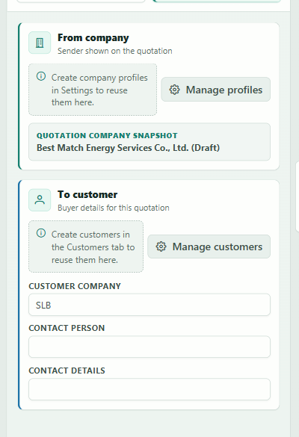
Figure 10 Enter sender and customer details

11. Line-item pricing basis
New leaf items start with Cost + markup. Use the Pricing basis control on an individual leaf row when that item should use Final price instead.
Pricing basis | Enter | Best for
Cost + markup | Cost, currency, and markup | Costing, FX conversion, margin, and analysis
Final price | Known selling price | Items whose selling price is already known

Changing one row's pricing basis does not affect any other item.

12. Add and edit line items

12.1 Add a root item
- Click Add item (plus icon) above the work area.
- Enter the item name and description.
- Enter a positive Qty and a Unit, such as EA, set, hour, or lot.
- Select Pricing basis.
- Complete the price or cost fields.
For a long description, click the expand icon inside the Description field to open Edit item N description. Click Apply (or press Ctrl+Enter) to keep the larger editor's changes; Cancel discards them.
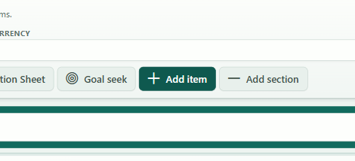
Figure 11 Add a main item

12.2 Root-card controls
The header of a root item can contain:
- Expand/collapse chevron.
- Item number and name.
- Move up and move down.
- Duplicate (copy icon).
- Expand/collapse all levels for grouped items.
- Calculation Sheet (calculator icon).
- Show calculation steps (information-circle icon).
- Delete (trash icon).
Duplicate copies the complete root item, including its descendants, and inserts the copy immediately below the source.
Deleting the last remaining root row creates a new blank item so the editor is never left without an editable item row.

12.3 Totals and unit summary
Use the Totals | Unit switch above Line Items or on any root card. Both controls change the same view for every root card:
- Totals shows quantity, total cost, total markup, subtotal excluding tax, applicable tax, total including tax, and cost/sales percentage.
- Unit shows per-unit cost, markup, selling price, tax, tax-inclusive price, and cost/sales percentage.

12.4 Leaf fields
A detailed cost-plus leaf normally shows:
- Qty and Unit.
- Pricing basis.
- Unit cost.
- Cost FX currency.
- Markup override.
- Tax class when mixed tax is enabled.
- Calculated unit price and amount.
A final-price leaf normally shows the direct Unit price instead of cost and markup inputs.
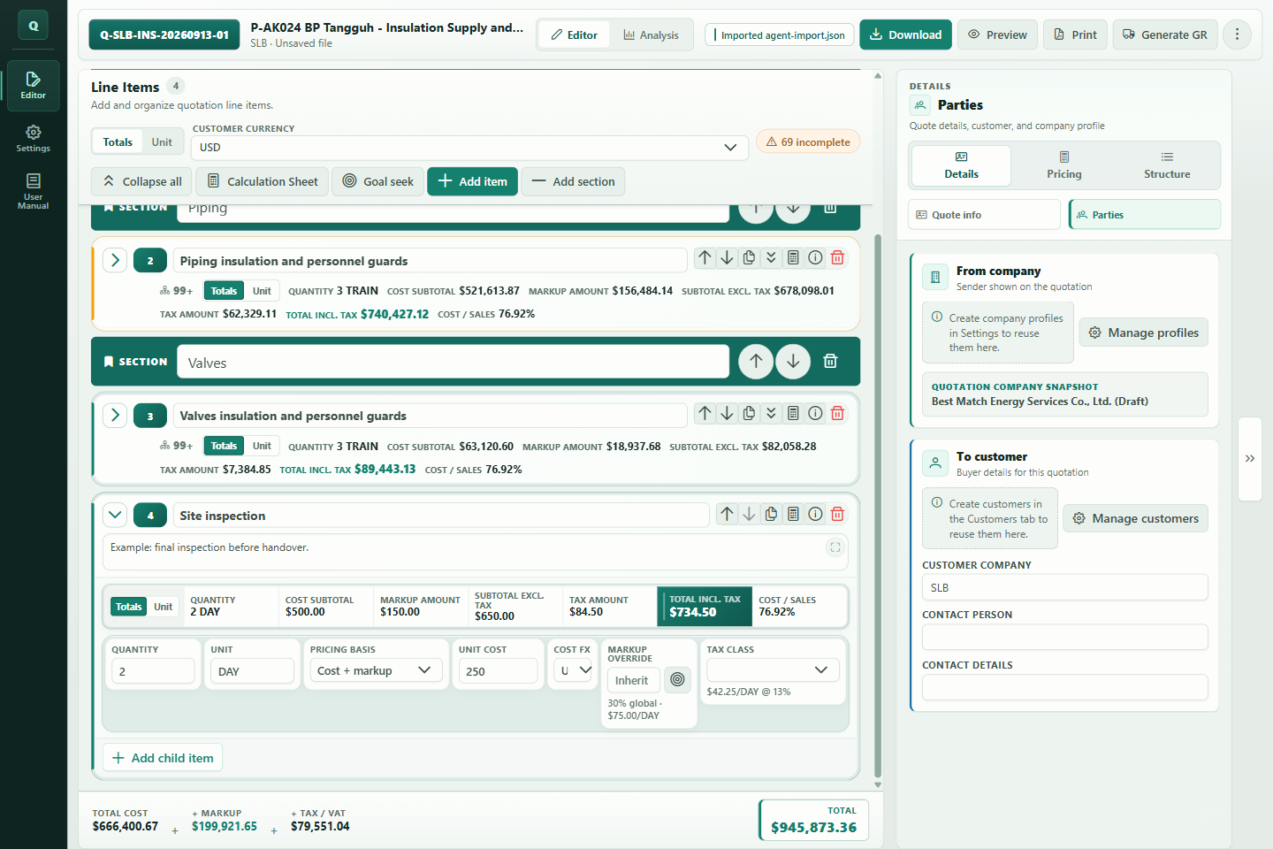
Figure 12 Enter the item and its price inputs

13. Build a three-level item structure
The maximum item depth is three levels:
- Level 1: root/major item, for example 1.
- Level 2: child/sub-item, for example 1.1.
- Level 3: detail item, for example 1.1.1.
For a flat quotation, keep every priced item at level 1 and do not add children. For a hierarchical quotation, add children under a root item. As soon as an item has children it acts as a group/rollup row; the descendant leaves provide the price or cost values.

13.1 Add children
- Find the parent item.
- Click Add child item at the bottom of a root card, or the plus button on a child row.
- Complete the new child fields.
- To create level 3, click Add child on a level-2 row.
Level-3 rows do not show another Add child action because deeper nesting is not allowed.
Figure 13 Add a child item

13.2 Parent and leaf behavior
- An item with children becomes a group/rollup row.
- Leaf rows carry the actual cost-plus or final-price inputs.
- Child/detail values roll up into the parent and then into quotation totals.
- Parent quantity and nested quantities affect the rollup. Use Calculation Steps when you need to verify the exact multiplication path.
- A group displays Default child markup instead of a direct selling-price input.
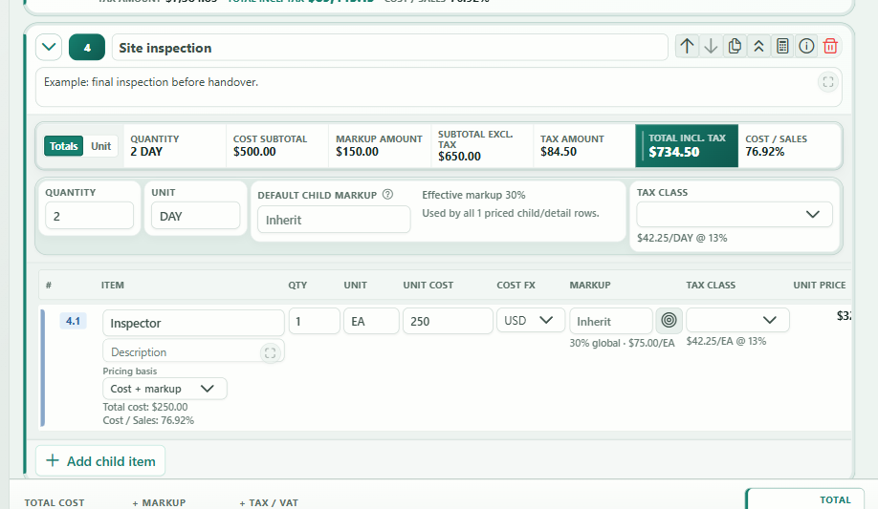
Figure 14 Understand group rollups. Scroll the child table horizontally to see the remaining price and tax columns.

13.3 Child table
Expanded groups display a child table. Depending on tax mode and row type, columns include:
- Item number and description.
- Qty and unit.
- Unit cost and cost currency.
- Markup.
- Unit price.
- Amount.
- Tax fields in mixed-tax mode.
Child rows also have calculation, add-child, and delete controls where applicable.

14. Sections, ordering, and the Outline

14.1 Add a section
- Click Add section above the work area.
- Enter the section title.
A section has a bookmark icon. It is a root-level document heading only; it has no quantity, price, tax, or children.
Use its up/down arrows to move it, or its trash icon to delete it.

14.2 Move root rows
Use the up/down arrows on a root item or section to move it one position. Item numbering updates automatically.

14.3 Use the Outline
- Open the Structure group in the right panel.
- Click Outline.
The Outline provides:
- Search outline: filters by item name, description, number, or section title.
- Expand/collapse controls for groups.
- Collapse all or Expand all.
- A drag grip for reordering.
- Incomplete markers.
- Click-to-jump navigation.
Click an Outline row to scroll to and focus that item in the editor.

14.4 Drag and drop
Drag an Outline item:
- Before or after another root row to reorder it.
- Inside a compatible item to make it a child.
- Out to the root level to remove it from a parent.
The app rejects moves that would:
- Put an item inside itself or its descendant.
- Create more than three item levels.
- Put a section inside an item.

15. Cost-plus and final-price calculations

15.1 Cost + markup
Use Cost + markup when cost and the required markup are known.
For a simple leaf, the application conceptually calculates:
- Convert unit cost into the quotation currency using the selected FX rate.
- Apply the effective markup percentage.
- Multiply by quantity.
- Apply the effective tax rate.
The calculation is rounded using the application's money rules. Use Calculation Steps for the exact displayed values instead of reproducing the calculation in a separate spreadsheet.

15.2 Final price
Use Final price when the selling unit price is already known.
- Select Final price under Pricing basis.
- Enter Unit price.
- Enter quantity and unit.
- Select tax where required.
Switching an existing costed leaf to Final price preserves its stored cost, so analysis can still compare that cost with the entered selling price. A final-price row created without cost is treated as revenue with unknown cost, which lowers cost coverage and makes its margin unavailable.

15.3 Cost/Sales percentage
Cost/Sales means cost divided by sales value. It is not markup percentage.
- Lower Cost/Sales generally means more gross margin.
- If sales value is zero or cost is unknown, the percentage may be shown as unavailable.

16. Markup inheritance
Markup is resolved from the nearest applicable source:
- A leaf's Markup override, if entered.
- The nearest parent group's Default child markup, if applicable.
- The quotation Global markup.
Leave a markup override blank to inherit. Enter 0 to deliberately use zero markup; zero is different from blank.
A group reports whether its default markup is used by all, some, none, or no priced descendants. Manual final-price leaves do not use inherited cost-plus markup.

17. Tax setup
- Open the right-side Pricing group.
- Click Pricing & tax.

17.1 Single tax mode
- Set Tax mode to Single tax.
- Enter Tax / VAT.
The one rate is applied to all priced rows.

17.2 Mixed tax mode
Use mixed mode when different items need different tax rates.
- Set Tax mode to Mixed tax.
- Under Tax classes, click Add tax class.
- Enter a class label and rate.
- Click the check-mark action to make the required class the default.
- Select a Tax class on each applicable item.
The command bar shows a mixed-tax badge while this mode is active.
The last remaining class cannot be deleted. Removing a class that is in use causes rows to fall back according to the current tax configuration, so review item assignments after structural tax changes.
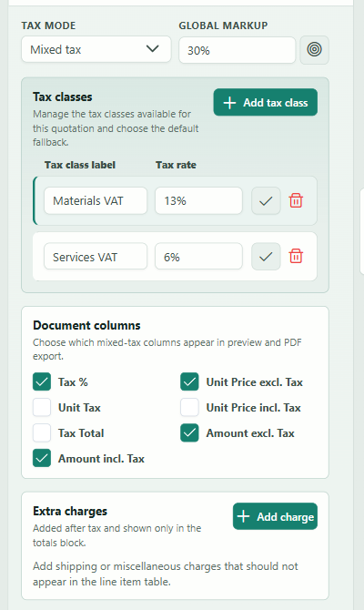
Figure 15 Set markup and tax

17.3 Switch mixed tax back to single
If several effective classes are in use, the app opens a confirmation dialog.
- Choose the tax class/rate to keep.
- Confirm the change.
The selected class is then applied as the single tax rate across the quotation.

17.4 Mixed-tax document columns
Under Document columns, select which columns appear in preview/PDF:
- Tax %.
- Unit Price excl. Tax.
- Unit Tax.
- Unit Price incl. Tax.
- Tax Total.
- Amount excl. Tax.
- Amount incl. Tax.
These checkboxes change customer-facing table columns. They do not change calculation results.

18. Extra charges
Extra charges are fixed amounts added after line tax.
- Open Pricing & tax.
- Under Extra charges, click Add charge.
- Enter a label, such as Shipping, and an amount.
- Use the trash icon to remove a charge.
Extra charges appear in the quote totals and customer-facing output. They do not belong to an item, do not receive item markup, and are not included in line-item analysis as item revenue/cost.

19. Currencies and exchange rates

19.1 Choose quotation currency
Set Currency either:
- At the top of Line Items, or
- In Details > Quote info.
Both controls edit the same quotation currency.

19.2 Edit FX rates
- Open Pricing > FX rates.
- Read each row as: 1 source currency = X quotation currency.
- Enter the required positive rate.
The quotation/base currency is locked at 1.
Example: if the quotation is USD and 1 EUR = 1.10 USD, enter 1.10 on the EUR row.
To update the currencies already in the table from the internet:
- Click Fetch latest rates.
- Wait for the Frankfurter reference-rate date to appear.
- Review every fetched rate before using the quotation.
The fetch action requires an internet connection and at least one non-base currency. If a currency has no online rate, its existing value is kept and the app lists the missing currency. If the request fails, all existing values are kept. These are daily reference rates, not guaranteed transaction rates.
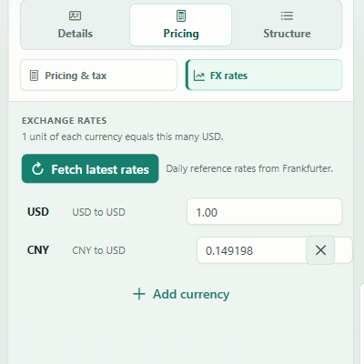
Figure 16 Check exchange rates

19.3 Add or remove a currency
- Click Add currency.
- Choose a currency from Select currency.
- Click Add or click Cancel.
Click Remove beside an unused non-base currency. The app refuses to remove:
- The quotation currency.
- A currency used by a cost row.
- A duplicate or invalid currency addition.
Changing the quotation currency rebases the FX table. Review all displayed rates afterward.
The quotation-currency and item Cost FX lists are searchable. They show the built-in reference currencies and any currency with a stored quotation rate. Selecting a built-in reference currency that is not already in the FX table adds it at its reference rate. An imported currency without a stored or built-in reference rate has no automatic 1:1 fallback; its converted cost is 0 until a valid rate is supplied through quotation JSON or automation.

20. Goal seek
Goal seek calculates the markup required to reach a target selling value.

20.1 Goal seek selected items
- Click Goal seek above the line-item work area, or click the target icon beside an eligible item's markup.
- In Goal Seek Items, select the rows to change.
- Enter a Target unit price for each selected row.
- Review the Preview result.
- Click Apply.
The dialog provides Select all and Unselect all.
Only cost-plus leaf/detail rows with a positive cost are eligible. Group rows, final-price rows, and rows without a usable positive cost are excluded. Applying the result writes item-specific markup overrides.
The row-level target icon opens the same dialog focused on that item.

20.2 Goal seek the quotation total
- Open Pricing & tax.
- Click the target icon beside Global markup.
- In Goal Seek Quotation, choose what to target:
- Subtotal before tax excludes tax and extra charges.
- Total after tax includes tax but excludes extra charges.
- Quotation total includes tax and extra charges.
- Enter the target amount and review the calculated markup.
- Click Apply. If cent rounding prevents an exact match, you can accept the closest value shown.
This changes the global markup and only affects eligible rows that actually use it. Item overrides and manual final prices limit how much of the quotation can be adjusted. Tax classes and extra charges remain unchanged; the selected target determines whether they are included in the amount being solved.
If the target is below the fixed minimum or above the allowed markup range, the dialog shows an error and disables Apply.

21. Calculation Sheet and Calculation Steps

21.1 Full-quotation Calculation Sheet
- Click Calculation Sheet above the line items.
- Review the modal headed Calculation Sheet - Quotation ....
The summary includes:
- Total cost.
- Total markup.
- Total tax.
- Line-items total.
- Extra charges.
- Quote total.
The audit table always shows the item and input columns. Use Totals or Unit amounts to choose which five amount columns are visible:
- Item number and name.
- Qty and unit.
- Cost currency.
- Markup rate/source.
- Cost/Sales percentage.
- Tax rate/class.
- Unit amounts: unit cost, unit markup, unit price, unit tax, and unit total.
- Totals: total cost, total markup, subtotal excluding tax, total tax, and total including tax.
Root/group rows are rollups. Leaf rows show the detailed pricing inputs.
The table is wide; scroll horizontally to see all columns. Click Export CSV inside this dialog to export the audit sheet. The exported audit file includes both the unit and total amount groups, regardless of the current on-screen toggle. This audit CSV is for review and is not the same as the line-item import CSV.

21.2 Per-item Calculation Sheet
Click the calculator icon on a root item to open the same type of sheet scoped to that item and its descendants.

21.3 Calculation Steps
- Click the information-circle icon on a row.
- In Calculation Steps, select any item from the tree on the left.
- Review the pricing method, markup source, tax source, totals, unit flow, and total flow.
Typical displayed values include:
- Converted/base cost.
- Unit markup.
- Unit selling price.
- Unit tax and tax-inclusive unit price.
- Total cost, markup, subtotal, tax, and final total.
- Effective markup and Cost/Sales percentage.
Drag the divider between the item tree and the explanation to resize it. When the divider is focused, Left/Right arrow keys can resize it. Use the dialog's expand/maximize control when more space is needed.

22. Totals and incomplete-item checks

22.1 Bottom totals bar
The totals bar updates immediately as data changes. Depending on tax mode, it shows combinations of:
- Total cost.
- Markup.
- Price before tax.
- Cost/Sales.
- Tax or tax buckets.
- Extra charges.
- Final total.

22.2 Incomplete badge
The N incomplete button appears above the work area when items are missing required values. Click it to jump to the first incomplete item.
An item is incomplete when:
- Its name is blank.
- Quantity is not positive.
- Unit is blank.
- A final-price leaf has no positive manual unit price.
- A cost-plus leaf has no positive unit cost.
Groups need a name, positive quantity, and unit; their leaf descendants carry the price/cost requirement.
Incomplete markers also appear in the Outline. They are editing warnings, not automatic deletion or correction.

23. Preview, templates, logo, and PDF output

23.1 Open preview
Click Preview (eye icon) or press Ctrl+P.
The floating preview is a continuous, responsive document view. It contains:
- Quotation number and revision.
- Project, date, validity, and currency.
- Sender and customer details.
- Logo when uploaded.
- Sections and line items.
- Notes and terms.
- Tax, extra charges, and totals.
The output obeys Document language, Preview/PDF item detail, tax-column choices, and the selected template. The floating preview does not show final page breaks; desktop PDF export and browser printing use the paginated document renderer.
Use Close preview or Ctrl+P to close it.
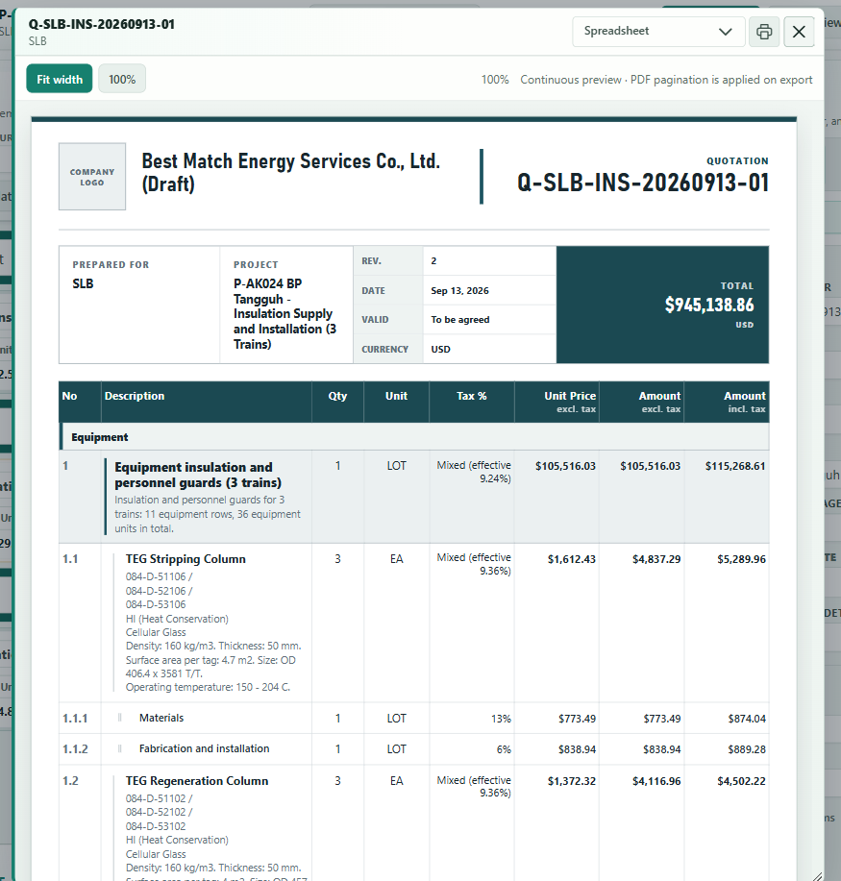
Figure 17 Inspect the customer document

23.2 Templates
The template selector is available in Quote info and in the preview header.
Template | Intended style
Classic | Original, conventional quotation layout
Technical Bid | Bold layout for technical/commercial proposals
Executive Summary | Polished summary-led commercial layout
Luminous | Light premium presentation
Ribbon Ledger | Editorial ledger layout with compact control ribbon
Atelier | Warm editorial layout with a refined project statement
Spreadsheet | Professional accounting-grid layout

Changing the template in preview updates the quotation's selected template.
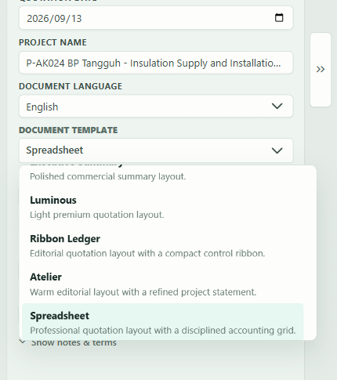
Figure 18 Choose what the customer will see

23.3 Output item detail
Choose one of:
- Level 1 only.
- Levels 1-2.
- Levels 1-3.
Use level 1 for a short customer summary. Use levels 1-3 when every detail line must be visible. Hidden levels remain part of rollup totals.

23.4 Upload a logo
- Click More actions.
- Click Upload logo (image icon).
- Select a PNG, JPEG, GIF, or WebP image no larger than 5 MB.
- Open preview to confirm size and placement.
The app accepts images up to 4096 x 4096 pixels. If a file is within the 5 MB limit but one dimension is larger, the app attempts to resize it proportionally so the longest side is 4096 pixels; the status message reports the old and new dimensions. If resizing fails or the result is invalid, the logo is not applied.
Automatic resizing applies only when you select a file through Upload logo. Automation that supplies a raw logoDataUrl must already use a valid supported image within the 5 MB and 4096 x 4096 limits; invalid data is rejected rather than resized.
The logo is embedded in the quotation JSON. Each document template fits it into its own fixed logo area without stretching it, so there is no separate display-size control. Use a tightly cropped business logo and check every template you plan to send.

23.5 Print or export
Desktop:
- Click Export PDF in the command bar.
- Choose the file location.
Web:
- Click Print in the command bar or the printer icon in the floating preview.
- Wait for the print document/tab to open.
- Choose Save as PDF or a printer in the browser dialog.
Use the browser or system print dialog to confirm page breaks, item detail, tax columns, notes, terms, and totals before sending the document.

24. Analysis workspace
Click Analysis in the command bar. The editor data remains the source; Analysis does not maintain a separate quotation.

24.1 Summary and checks
The top area summarizes values such as:
- Items requiring review.
- Cost visibility/coverage.
- Number of cost currencies.
- Tax mix.
Advisory cards flag:
- Mixed currencies inside an item.
- Mixed tax classes inside an item.
- Zero markup.
- Low markup, using the displayed review threshold.
Use Show more or Show fewer when an advisory affects several items. Click an affected item to return to Editor and focus it.
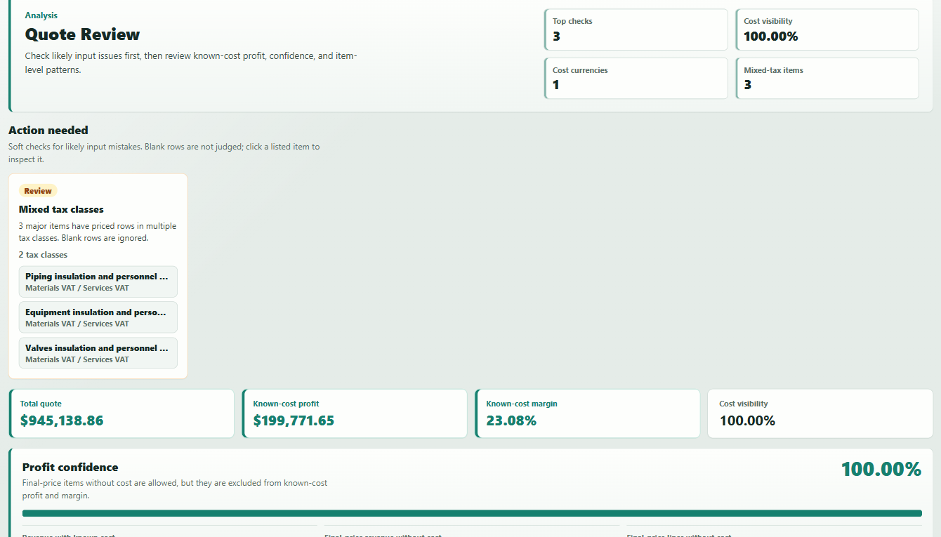
Figure 19 Review warnings and totals

24.2 KPI cards
The KPI area shows:
- Grand total.
- Gross margin amount.
- Gross margin rate.
- Cost coverage rate.
Final-price revenue without known cost lowers cost coverage. Treat profit and margin as incomplete when coverage is below 100%.

24.3 Charts and tables
Depending on quotation data, Analysis shows:
- Currency exposure.
- Effective markup by item.
- Revenue and profit by item.
- Cost distribution.
- Markup bridge/waterfall from cost through markup, tax, extra charges, and final total.
- Margin table.
Clicking an item in a chart's item browser or the margin table returns to the matching editor row.
For larger quotations:
- The first 12 items are shown initially in a chart scope.
- Use Show all items / Show fewer items to change the scope.
- Charts render up to 80 items at once.
- The item browser uses Previous and Next pages for larger sets.
If the quotation has no meaningful priced data, Analysis shows an empty-state message instead of misleading charts.

25. Generate a goods receipt
The goods-receipt tool creates a separate receiving document from quotation items. It does not change quotation quantities or prices.

25.1 Open the dialog
- Make sure the quotation contains usable item rows.
- Click Generate GR (truck icon) in the command bar.
If there are no usable detail items, the command bar shows an error message and the dialog does not open.
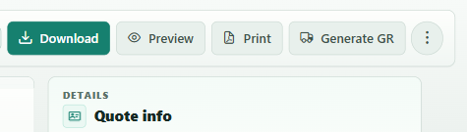
Figure 20 Open the goods receipt tool

25.2 Choose a template
At the top of the dialog, select:
- Standard.
- Compact.
The last selected goods-receipt template is remembered locally.

25.3 Complete receipt details
Enter or review:
- GR No..
- Document date.
- Customer PO / Reference.
- Project name.
- Delivery reference.
- Receiving company.
- Delivery contact.
- Delivery address.
- Contact details.
- Supplier.
- Supplier contact.
- Prepared by.
- General remarks.
The app prefills available project, customer, and supplier snapshot data. A new receipt number normally starts in a GR-YYYYMMDD pattern. It follows the date until you manually edit the receipt number.
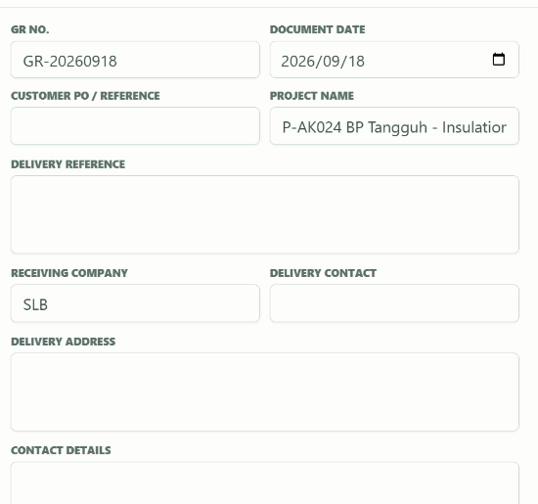
Figure 21 Complete the receipt details. Upper fields are shown; scroll the left panel for the remaining details.

25.4 Select lines
Use Receipt detail to choose the starting selection:
- Summary — main items: include eligible positive-quantity level-1 items.
- Grouped — sub-items: include eligible positive-quantity level-2 items, or a shallower leaf where no level-2 item exists.
- Detailed — individual items: include eligible positive-quantity leaf/detail items.
The field shows Custom selection after you manually change the preset selection. Included only filters the Outline to selected receipt lines, while Exclude all clears the selection.
Use the Outline search to find an item by number or description. Expand groups, select individual leaf checkboxes, or click Use as one line to include a whole group as one receipt line.
Selecting a group and one of its descendants at the same time would duplicate the same branch, so the app keeps selection mutually exclusive along that branch.
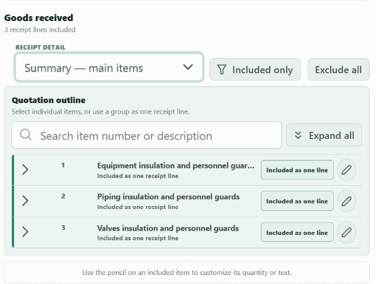
Figure 22 Choose the receipt lines

25.5 Edit received quantities and text
Click the pencil beside an included item to open Customize receipt line. You can edit:
- Received quantity, with the quoted quantity shown for reference.
- Unit.
- Description.
- Remarks.
Edited items show Customized. Click Reset to quotation to restore the quoted quantity, unit, and description and clear the remarks.
Warnings and errors:
- Quantity 0: warning.
- Quantity greater than quoted: warning.
- Negative quantity: error.
- No exportable selected lines: error.
Warnings allow output; errors disable print/export until corrected.
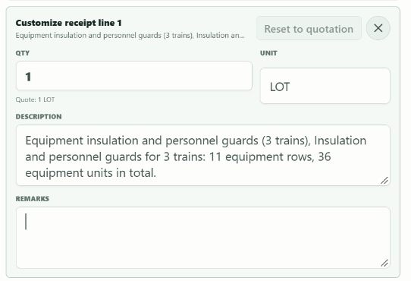
Figure 23 Customize a line and output the receipt

25.6 Preview and output
The right side is a live preview. Drag the divider between editor and preview to resize it; when focused, Left/Right arrow keys adjust it.
The document can include:
- English and Chinese goods-receipt heading.
- Supplier and receiver details.
- Item table and remarks.
- Total quantity when all selected lines use the same unit.
- Prepared/received signature areas.
Desktop: click Export GR PDF.
Web: click Print GR, then choose a printer or Save as PDF.
After a successful native desktop PDF export, the quotation records a goods-receipt history entry, clears its pending receipt draft, and saves the updated quotation to the local draft store. Save the quotation JSON again to include that history in your file backup. Browser print output is not recorded because the browser does not provide a confirmed output file path.
The output file name is based on the GR number. Click Cancel or close the dialog to leave without output.

26. Line-item CSV/Excel import and CSV export
CSV and XLSX imports are for bulk line-item data only. They do not contain the complete quotation setup, parties, branding, document template, extra charges, or reusable library.

26.1 Important: importing replaces the current rows
Choosing a CSV or Excel file only validates it and opens a preview. It does not change or save the quotation. The rows are replaced only after you click Import these items. Line-item import does not merge rows.
- Existing line items are removed.
- Existing section headers are removed. CSV and XLSX imports cannot create section headers.
- Quotation information, parties, branding, tax-class definitions/rates, extra charges, and document template stay in the quotation. If imported leaves use multiple tax classes, the app switches the quotation to Mixed tax mode.
- Tax classes named in the imported file must already exist in the current quotation.
- A cost currency with a built-in reference rate is added to the current FX table during import. An imported currency without a stored or built-in reference rate is not seeded and has a converted cost of 0 until a valid rate is supplied through quotation JSON or automation.
- Any error disables Import these items and leaves the quotation unchanged.
- Warnings do not block confirmation. Read them before confirming because they explain every ignored, defaulted, or non-pricing value.
- Closing the dialog or canceling a pending import leaves the quotation unchanged.
- A confirmed import is one undoable editor action.
Save or download the quotation JSON before importing. Do not rely on CSV as a complete quotation backup.

26.2 Export the current line items
- Click More actions.
- Click Export CSV (file-export icon).
- Save/download the file.
The exported file uses UTF-8 with a BOM for reliable Excel handling. It exports item rows in hierarchy order. Section headers are omitted.

26.3 Download a template
The app provides two different templates:
- Download CSV Template gives you the existing blank CSV with the canonical headers.
- Download Excel Template gives you the canonical bilingual workbook with instructions, examples, formatting, and input checks. The app imports this .xlsx file directly.
To download the CSV template:
- Click More actions.
- Click Export CSV Template.
To use the Excel template:
- Click More actions > Import line items.
- Click Download Excel Template.
- Read Instructions 使用说明 and review Examples 示例.
- Enter your own rows only on Import Data. Do not rename its English headers.
- Save the workbook as .xlsx without renaming Import Data or changing its row-one headers.
- Return to Import line items, click Import Excel, and select the saved workbook.
The Excel workbook is bilingual in one file. Its input sheet keeps exact English headers because XLSX import requires the canonical names and order. Examples 示例 contains a copy-ready 12-row example covering three hierarchy levels, mixed currencies, cost-plus pricing, manual pricing, and markup inheritance. Its short guide is outside the A:J copy range. The workbook has no macros, formulas, or external links.
The downloaded template uses these 10 canonical headers:
item_code,item_name,item_description,qty,qty_unit,manual_unit_price,unit_cost,cost_currency,markup_override,tax_class
For CSV import, columns may be in any order. Header matching trims spaces, ignores case, and treats spaces and hyphens like underscores. For example, Manual Unit Price, manual-unit-price, and manual_unit_price match the same column. Only item_name is a required CSV header; include the other columns needed by your row types.
For XLSX import, the sheet must be named exactly Import Data, and row one must contain all 10 canonical headers in the original order. Extra, missing, renamed, or reordered headers are rejected.
Unknown English or Chinese headers are ignored with a warning. Two headers that normalize to the same recognized name are an error. Do not put a title, comment, or blank row above the header. Header aliases are limited to the current and legacy English names described below.
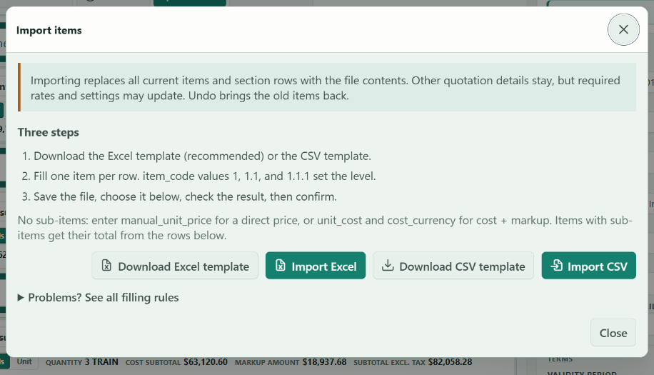
Figure 24 Import many line items

26.4 What must be filled
The importer decides whether a leaf is Final price or Cost + markup from manual_unit_price:
- If manual_unit_price is filled, the leaf uses Final price.
- If manual_unit_price is blank, the leaf uses Cost + markup.
Use this checklist for the current template:
Row type | Required to import | Recommended for a complete quotation | Leave blank unless needed
Any nonblank row | item_name | A valid item_code; qty_unit | item_description, tax_class, markup_override are optional
Parent/group row | item_name | Positive qty and a qty_unit | Price, cost, currency, and legacy pricing-basis values are ignored with warnings; group prices come from children
Cost-plus leaf | qty, unit_cost, cost_currency | Positive qty, positive unit_cost, and a valid unit | manual_unit_price must be blank
Final-price leaf | qty, manual_unit_price | Positive qty, positive manual_unit_price, and a valid unit | unit_cost and cost_currency are optional cost-analysis data

item_code may be blank, but that row is always imported as a new root row with an automatically assigned code and a warning. A child row therefore needs an explicit child code such as 1.1.
Leaf quantities and the required leaf price or cost must be greater than zero. Optional money values may be zero but not negative. Markup must be from 0% through 1000%.

26.5 Detailed column reference
Column | Accepted value | Blank behavior | Important details
item_code | Text in numeric hierarchy form: 1, 1.1, or 1.1.1 | Assigns the next unused root code and reports a warning | Maximum three levels. Each segment must be a positive whole number without leading zeros. Codes must be unique.
item_name | Any text | Error on every nonblank row | Leading and trailing spaces are removed.
item_description | Any text | Empty description | Use CSV quoting if it contains commas, quotes, or line breaks.
qty | Plain number, for example 1, 2.5, or 100 | Group: defaults to 1. Leaf: error | Do not include a unit, thousands separator, or currency symbol. Use a positive number.
qty_unit | Text such as EA, set, hour, day, or lot | Defaults to EA and reports a warning | The importer does not restrict the unit text.
manual_unit_price | Plain selling-price number greater than zero on a final-price leaf | Selects cost-plus pricing when no legacy pricing_basis is present | Any filled numeric value selects final-price pricing. If unit_cost is also filled, the manual price controls sales while the cost supports cost/profit analysis.
unit_cost | Plain cost number | Cost-plus leaf: error. Final-price leaf or group: allowed | For a final-price leaf, also fill cost_currency if the cost should be analyzed in a specific currency. Group cost is not used for group pricing.
cost_currency | Supported three-letter currency code such as USD, EUR, CNY, or JPY | Cost-plus leaf: error. A manual-price analysis cost defaults to the quotation currency with a warning | Matching is case-insensitive and the value is normalized to uppercase. This column does not set the FX rate.
markup_override | Percentage points from 0 to 1000, for example 15 or 15% | Uses parent/global markup inheritance | 15 and 15% both mean 15%. 0.15 means 0.15%, not 15%. A group value is inherited by descendants. A leaf value overrides the group/global value. It is retained but does not change a final-price leaf's selling price.
tax_class | Existing tax-class ID or label | Uses the normal inherited/default tax class | Matching is case-insensitive. It does not create a tax class or import a tax rate. A group value can be inherited by its descendants.

For numbers, use plain decimal text with a period as the decimal separator. Currency symbols, thousands separators, hexadecimal, scientific notation, NaN, and infinity are rejected. For example, use 1200.50, not $1,200.50, 1,200.50, or 1.2e3. A trailing % is accepted only for markup_override.

26.6 Hierarchy, row order, and numbering
- Valid codes include 1, 2, 1.1, 1.2, and 1.1.1.
- Invalid codes include 0, 01, 1.0, -1, .1, A1, and 1.1.1.1.
- Every child must have its parent row. For 1.2.1, rows 1 and 1.2 must exist.
- Parent rows may appear before or after their children in the file. The importer sorts rows numerically by item_code.
- The physical spreadsheet row order is not preserved when it conflicts with item_code.
- Codes describe hierarchy and sort order; they are not permanent item IDs. Gaps are compacted by the editor. For example, imported roots 1 and 5 are displayed and later exported as 1 and 2.
- Duplicate codes are errors.
- A blank item_code cannot describe a child. It creates a new root row.

26.7 Blank, ignored, defaulted, and unsupported data
- Completely blank data rows are ignored.
- Leading and trailing spaces in cells are removed.
- Unknown named columns are ignored and reported as warnings.
- A nonblank cell beyond the header width is an error. Trailing blank cells are allowed.
- Comment rows and subtotal/title rows are not ignored. Any nonblank row must be a valid item row.
- Parent/group price, cost, currency, and legacy pricing-basis values are ignored and reported. Group markup and tax class remain valid inheritance values.
- Section headers are ignored during CSV export and cannot be represented on import.
- Empty and header-only files are rejected; CSV import is not a clearing command.
- Malformed CSV quoting is rejected.
- Line-item import does not import quotation number, dates, customer/sender, notes, terms, logo, document template, tax rates/classes, FX rates, or extra charges.

26.8 Example: multi-level, mixed-currency pricing
This is the copy-ready A:J example from Examples 示例. Its blank tax cells use the quotation's inherited/default tax setup:
item_code,item_name,item_description,qty,qty_unit,manual_unit_price,unit_cost,cost_currency,markup_override,tax_class
1,Pump Skid / 泵组撬装系统,Complete package / 成套系统,1,set,,,,18,
1.1,Mechanical / 机械设备,Pump and motor / 泵及电机,1,set,,,,,
1.1.1,Centrifugal Pump / 离心泵,Process pump / 工艺泵,2,EA,,1200,USD,,
1.1.2,Electric Motor / 电机,High-efficiency motor / 高效电机,2,EA,,6800,CNY,25,
1.2,Controls / 控制系统,Panel and drives / 控制柜及驱动,1,set,,,,12,
1.2.1,PLC Panel / PLC 控制柜,Main control panel / 主控制柜,1,set,,2100,EUR,,
1.2.2,Drive / 变频器,Motor drive / 电机驱动,2,EA,,3600,CNY,,
1.2.3,Control Cable / 控制电缆,Shielded cable / 屏蔽电缆,25,m,,8.5,EUR,0,
1.3,Services / 服务,Site services / 现场服务,1,lot,,,,,
1.3.1,Commissioning / 调试,On-site work / 现场工作,3,day,500,180,USD,,
1.3.2,Training / 培训,Operator training / 操作培训,1,day,800,,,,
2,Export Packing / 出口包装,Seaworthy packing / 适海包装,1,lot,,2800,CNY,,
- Row 1 supplies an 18% markup fallback. Row 1.1.1 inherits it, while row 1.1.2 overrides it with 25%.
- Row 1.2 supplies a nearer 12% fallback for its descendants. Row 1.2.3 explicitly uses 0%.
- Row 1.3.1 uses a manual selling price with USD cost tracking. Row 1.3.2 uses a manual selling price without cost data.
- Row 2 has no row or parent markup, so it uses the quotation's global markup.
- Cost-plus rows demonstrate USD, CNY, and EUR. Review or set those exchange rates after import.
If a tax class is required, enter an existing class ID or label in tax_class, for example Service 6%. The import fails if that class does not already exist in the quotation.

26.9 Import the file and read the report
- Save/download the current quotation JSON first.
- Create any required tax classes and confirm the quotation currency.
- Fill the CSV or Excel template.
- Save CSV as CSV UTF-8, or keep the Excel template as .xlsx.
- Click More actions > Import line items to open the guide.
- Click Import CSV or Import Excel, then select the file.
- Review the recognized and ignored columns, item count, errors, warnings, and defaults.
- If validation succeeds, click Import these items. Selecting the file alone does not replace rows.
- After confirmation, check the incomplete badge, FX rates, tax assignments, Calculation Sheet, and Preview.
The report uses the actual spreadsheet row number: the header is row 1 and the first item is row 2. It shows severity, row, column, and explanation.
Warnings allow confirmation:
- Blank item_code was assigned a root code.
- Blank qty_unit was changed to EA.
- An unknown column or group pricing value was ignored.
- A markup or legacy expected total was retained or ignored without affecting the selling price.
Errors prevent confirmation and replacement:
- Empty/header-only file, malformed quoting, missing item_name, or duplicate recognized headers.
- Invalid or duplicate item code.
- Missing parent or item name.
- Missing required leaf quantity, final unit price, unit cost, or cost currency.
- Invalid, non-positive, negative, or out-of-range numeric value.
- Conflicting manual/legacy price columns or an explicit legacy pricing basis that contradicts the price data.
- Unsupported currency or unknown tax class.

26.10 CSV quoting and Excel
- If a text cell contains a comma, quote, or line break, keep it properly CSV-quoted.
- Inside a quoted cell, write a literal quote as two quotes. Example: "Valve, ""special""".
- Save as CSV UTF-8 to preserve Chinese text.
- Excel may change item codes or numeric formats. Keep item_code as text if Excel tries to reformat it.
- Do not use thousands separators, currency symbols, scientific notation, or spreadsheet formulas in numeric cells. A trailing % is allowed only for markup.
- Do not use the Calculation Sheet's audit CSV as an import file. Its headers do not match the line-item importer.

26.11 Legacy CSV files
Older exported columns are accepted by name and may also be reordered. They include pricing_basis, unit_price, and expected_total.
- pricing_basis uses cost_plus or manual_price.
- unit_price is the old name for the direct/manual unit price. It may coexist with manual_unit_price only when the two values are equal.
- Without pricing_basis, a manual price selects final-price pricing; otherwise the row uses cost-plus pricing.
- With pricing_basis, contradictory price data is an error.
- expected_total is legacy comparison data. A leaf value does not control pricing and is reported when ignored.
For new files, use the current template rather than adding legacy columns.

27. Quotation JSON import and export
Quotation JSON is the complete portable quotation format. It includes:
- Header and parties snapshot.
- Items and hierarchy.
- Pricing and tax configuration.
- Exchange rates.
- Output detail and template.
- Branding/logo.
- Creation and update metadata.
- Any valid pending goods-receipt draft and completed native PDF export history.

Export
- Desktop: click Save, More actions > Save As, or More actions > Export Quotation as appropriate.
- Web: click Download.

Import
- Click More actions > Import Quotation.
- Select the JSON file.
Import replaces the current working quotation. Invalid, malformed, or unsupported JSON is rejected and a status message explains the problem.
Do not manually edit quotation JSON unless you understand the data structure. Use CSV or the Excel template for bulk line-item edits and the UI for the rest.

28. Library backup and transfer
The reusable library contains:
- Company profiles.
- Customers.
- Quotation-numbering state.
It does not contain full quotation files.

28.1 Automatic local storage
Company profiles, customers, and numbering save automatically on the current device. The General-page file actions are for backup and transfer, not a requirement for every edit.
This automatic storage belongs to the current app/browser profile. Clearing its local data can remove the reusable library, so keep a separate quotation-library.json backup. That library backup does not contain quotation drafts or activity-history logs.

28.2 Save a backup
- Click Settings > General.
- Under Backup and transfer, click Save backup as.
- Save quotation-library.json in a backed-up location.
After a backup file has been selected or saved, Save backup writes/downloads the current library using that file context. In browsers without direct file access, it may create another download.

28.3 Open a backup
- Click Open backup.
- Select a valid library JSON file.
- Read the confirmation. It shows the number of company and customer records in the selected file.
- Click Replace only if those records should replace the current local library.
This is replacement, not merge.

28.4 Create an empty library
- Click Create empty library.
- Read the warning.
- Confirm Create.
This clears current company profiles, customers, and numbering state on the device. Back up first if the records may be needed.
Invalid library JSON, invalid profiles/customers, or invalid numbering data is rejected without replacing the current library.

29. Recommended end-to-end workflows

29.1 Create a detailed costed quotation
- Create/select a company profile and customer.
- Click Editor > More actions > New.
- Complete Quote info and Parties.
- Set quotation currency and FX rates.
- Set global markup and tax mode.
- Add items and children; enter positive quantity, unit, cost, and currency.
- Add markup overrides only where needed.
- Click the incomplete badge and correct every marked row.
- Review Calculation Sheet and Analysis.
- Open Preview and verify template, detail level, parties, tax columns, and totals.
- Save/download JSON.
- Export PDF or print to PDF.

29.2 Create a quick final-price quotation
- Start a new quotation.
- Complete quotation and party information.
- Add items and set each leaf row's Pricing basis to Final price.
- Enter item name, positive quantity, unit, and unit price.
- Configure tax and optional extra charges.
- Preview, save/download, and output.
Remember that final-price rows reduce profit-analysis quality because their costs are not known.

29.3 Revise an existing quotation
- Import the saved quotation JSON.
- Increase Revision.
- Update the date, validity, items, prices, and terms.
- Use Calculation Sheet and Preview to compare the result.
- Use Save As or download a new JSON file so the previous revision remains archived.
- Export a new PDF.

29.4 Generate a goods receipt after approval
- Open the approved quotation JSON.
- Click Generate GR.
- Enter PO/reference and delivery details.
- Choose Summary, Grouped, or Detailed under Receipt detail.
- Adjust the Outline with leaf checkboxes or Use as one line for a group.
- Click the pencil beside an included line to edit its quantity, unit, description, or remarks.
- Resolve errors and review warnings.
- Check the live preview.
- Export or print the goods receipt.

30. Troubleshooting

Save/Download produced no file
- Check whether a file chooser opened behind the app.
- Check the browser Downloads list.
- Allow downloads for the site.
- Try Save As on desktop.

Print did not open
- Allow pop-ups for the web app.
- Try again from the floating preview.
- Wait for the print document to finish loading before closing tabs.

PDF shows the wrong item depth
Open Details > Quote info and change Preview/PDF item detail.

Totals look wrong
Check, in this order:
- Item quantity and unit.
- Whether the row is a parent/group or a leaf.
- Pricing basis.
- Cost currency and FX rate.
- Markup override versus inherited/global markup.
- Tax mode and effective tax class.
- Extra charges.
- Calculation Steps for the affected item.
- Full Calculation Sheet totals.

Markup changed but a price did not
The row may use Final price, have its own markup override, or inherit from a nearer parent. Check Calculation Steps for the effective source.

Cannot remove an FX currency
It is the quotation currency or is still used by a cost row. Change the affected rows first.

Goal seek Apply is disabled
- Select at least one eligible row.
- Use cost-plus leaf rows with positive cost.
- Enter a valid positive target.
- For quotation goal seek, use a reachable amount or accept the closest value shown.

CSV or Excel line-item import failed
Reopen Import items from More actions > Import line items, or use the warning/report icon in the command bar to view the last result. Fix every reported error and ensure every child has a parent row. For CSV, include item_name, remove duplicate recognized headers, and save as CSV UTF-8. For Excel, start from a fresh template and keep Import Data plus all 10 headers in their exact order.

A sender/customer update did not appear in an old quotation
This is intentional snapshot behavior. Re-select the updated profile/customer in that quotation or edit the quotation fields directly.

Goods receipt cannot export
Select at least one exportable line and remove negative quantities. Quantities above quoted values are warnings, not blocking errors.

Analysis is blank
Return to Editor; quotation data is not lost. Restart or update the application and try again. In a development build, a blank Analysis screen usually means a chart component failed to load and should be reported as a software issue.

Chinese text is corrupted
Use UTF-8 for CSV and JSON. In Excel, choose CSV UTF-8. Do not save project or data text as GBK/GB2312/CP936.

31. Limits and important behavior
- Item hierarchy is limited to three levels.
- Sections exist only at the root level and have no price.
- Each leaf item chooses its own pricing method: Cost + markup or Final price.
- Deleting the final root row creates a new blank item.
- CSV or Excel line-item import replaces line items; JSON import replaces the whole working quotation.
- Opening a library backup replaces the reusable library; it does not merge.
- Customer and company selections are copied snapshots, not live links.
- Extra charges are added after line tax and do not participate in item markup.
- Goal seek only changes eligible markup values.
- Output detail level hides rows from preview/PDF without deleting them or changing rollups.
- Final-price rows can make margin and cost coverage incomplete.
- Browser print/download behavior depends on browser permissions.
- The floating preview is continuous; print and PDF output is paginated and may break differently.
- Desktop activity history is a temporary diary, not a backup or recovery system.
- Save quotation JSON files separately from the reusable-library backup. They serve different purposes.
Before sending a quotation, always check the customer-facing preview and save the quotation JSON used to create the final PDF.

