LaACES Program
Preliminary Design Review Document
for the
Video, Temperature, Pressure, and Humidity

Experiment
by
Team Philosohook
Prepared by:
Hannah Gardiner Date

Bill Freeman Date

Randy Dupuis Date

Corey Myers Date

Andrea Spring Date
Submitted: 2/4/2011
Reviewed:
Revised:
Approved:
Dr Guzik: Date

Institution Signoff Date

LAACES Signoff Date
TABLE OF CONTENTS
Contents
Experiment i
LIST OF FIGURES iv
LIST OF TABLES v
1.0 Document Purpose 1
1.1 Document Scope 1
1.2 Change Control and Update Procedure 1
2.0 Reference Documents 1
3.0 Goals, Objectives, Requirements 3
3.1 Mission Goal 3
3.2 Objectives 3
3.2.1 Science Objectives 3
3.2.2 Technical Objectives 4
3.3 Science Background and Requirements 4
3.3.1 Science Background 4
3.3.2 Science Requirements 16
3.4 Technical Background and Requirements 17
3.4.1 Technical Background 17
3.4.2 Technical Requirements 19
4.0 Payload Design 20
4.1 Principle of Operation 20
4.2 System Design 21
4.2.1 Functional Groups 21
4.2.2 Group Interfaces 21
4.2.3 Traceability 22
4.3.1 Sensors 24
4.3.2 Sensor Interfacing 25
4.3.3 Control Electronics 27
4.3.4 Power Supply 27
4.3.5 Power Budget 29
4.4 Software Design 32
4.4.1 Data Format & Storage 32
4.4.2 Flight Software 33
4.5 Thermal Design 36
4.6.1 External Structure 37
4.6.2 Internal Structure 38
4.6.3 Weight Budget 38
5.0 Payload Development Plan 39
5.1 Electrical Design Development 39
5.2 Software Design Development 39
5.3 Mechanical Design Development 39
5.4 Mission Development 40
8.0 Project Management 41
8.1 Organization and Responsibilities 41
8.2 Configuration Management Plan 41
8.3 Interface Control 41
9.0 Master Schedule 42
9.1 Work Breakdown Structure (WBS) 42
9.2 Staffing Plan 43
9.3 Timeline and Milestones 44
12.0 Glossary 49

LIST OF FIGURES

3-1: Temperature as a function of Altitude 6
3-2: Lapse rate as a function of altitude 7
3-3: Measured pressure data 8
3-4: Measured humidity data 9
3-5: Measured humidity rate of change 9
3-6: Correlation between temperature error and humidity 10
3-7: Two previous ascent curves 14
3-8: three different camera positions 15
4-1: High level system design 21
4-2: Temperature Sensor Interface 25
4-3: Pressure Sensor Interface 26
4-4: Humidity Temperature Sensor Interface 26
4-5: Control Electronics 27
4-6: Lab Power Distribution 28
4-7: Flight Power Distribution 29
4-8: Energizer AAA battery capacity 30
4-9: Energizer AAA discharge curve 31
4-10: Energizer AA battery capacity 31
4-11: Energizer AA discharge curve 31
4-12: Pre-flight software flowchart 33
4-13: During-flight software flowchart 34
4-14: Post-flight software flowchart 35
4-15: Shows the external structure of the payload 37
9-1: Gantt chart showing the overall project timeline 44
9-2: Gantt chart showing the Payload Development Phase timeline 44
8. Flow chart of payload development 5
6. Flight software flow chart 4
7. Drawing of mechanical details 4
8. Flow chart of payload development 5
6. Flight software flow chart 4
7. Drawing of mechanical details 4
8. Flow chart of payload development 5

LIST OF TABLES

3-1: Properties of layers of the atmosphere 5
3-2: Cloud Name and Description 12
3-3: Cloud Classifications 12
3-4: Typical errors in radius measurement 16
4-1: Traceability matrix 23
4-2: Power budget 29
4-3: Range of values, precision, and bytes 32
4-4: BalloonSat device ranges 36
4-5: Weight budget 38
8-1: Team members, their responsibilities, and email addresses 41
4. Weight budget table 4
4. Weight budget table 4
4. Weight budget table 4
4. Weight budget table 4
4. Weight budget table 4
4. Weight budget table 4

1.0 Document Purpose

This document describes the preliminary design for the Temperature, Pressure, and Humidity experiment by Team Philosohook for the LaACES Program. It fulfills part of the LaACES Project requirements for the Preliminary Design Review (PDR) to be held February 4, 2011.

1.1 Document Scope

This PDR document specifies the scientific purpose and requirements for the Video, Temperature, Pressure, and Humidity experiment and provides a guideline for the development, operation and cost of this payload under the LaACES Project. The document includes details of the payload design, fabrication, integration, testing, flight operation, and data analysis. In addition, project management, timelines, work breakdown, expenditures and risk management are discussed. Finally, the designs and plans presented here are preliminary and will be finalized at the time of the Critical Design Review (CDR).

1.2 Change Control and Update Procedure

Changes to this PDR document shall only be made after approval by designated representatives from Team Philosohook and the LaACES Institution Representative. Document change requests should be sent to Team members and the LaACES Institution Representative and the LaACES Project.

2.0 Reference Documents

[1] "Choosing a Humidity Sensor: A Review of Three Technologies." Sensors Magazine. Web. 23 Nov. 2010. <http://www.sensorsmag.com/sensors/humidity-moisture/choosing-a-humidity-sensor-a-review-three-technologies-840>.

[2] "Cloud Types." Windows to the Universe. Web. 23 Nov. 2010. <http://windows2universe.org/earth/Atmosphere/clouds/cloud_types.html>.

[3] "Earth's Atmosphere." NASA. Web. 23 Nov. 2010. <http://www.nasa.gov/audience/forstudents/9-12/features/912_liftoff_atm.html>.

[4] "Fundamentals of Pressure Sensor Technology." Sensors Magazine. Web. 23 Nov. 2010. <http://www.sensorsmag.com/sensors/pressure/fundamentals-pressure-sensor-technology-846>.

[5] "The Layered Atmosphere." Geography: Physical Geography. Web. 23 Nov. 2010. <http://www.physicalgeography.net/fundamentals/7b.html>.

[6] "Layers of the Earth's Atmosphere: Troposphere, Stratosphere, Mesosphere, Thermosphere, and Exosphere." Windows to the Universe. Web. 23 Nov. 2010. <http://windows2universe.org/earth/Atmosphere/layers.html>.

[7] Stover, Elizabeth. "The History of Weather Balloons." eHow. Web. 23 Nov. 2010. <http://www.ehow.com/about_5050060_history-weather-balloons.html>.

[8] "Types of Temperature Sensors." About Temperature & Moisture Sensors Devices & Uses in Measurement. Web. 23 Nov. 2010. <http://www.temperatures.com/sensors.html>.

[9] "Greenhouse Gases." National Climatic Data Center. Web. 23 Nov. 2010. <http://www.ncdc.noaa.gov/oa/climate/gases.html#watervapor>.

[10] "ESRL Global Monitoring Division - Ozone and Water Vapor Group." NOAA Earth System Research Laboratory. Web. 23 Nov. 2010.<http://www.esrl.noaa.gov/gmd/ozwv/wvap/>.

[11] "ESRL Global Monitoring Division." NOAA Earth System Research Laboratory. Web. 23 Nov. 2010. <http://www.esrl.noaa.gov/gmd/dv/data/index.php?parameter_name=Water+Vapor>.

[13] Oolman, Larry. "Atmospheric Soundings." Wyoming Weather Web. Web. 28 Nov. 2010. <http://weather.uwyo.edu/upperair/sounding.html>.

[14] Gyatt, Graham. "The Standard Atmosphere." Atmosculator. 24 Apr. 2009. Web. 28 Nov. 2010. <http://www.atmosculator.com/The Standard Atmosphere.html>.

[15] "Standard Atmosphere Calculator." DigitalDutch.com. Web. 28 Nov. 2010. <http://www.digitaldutch.com/atmoscalc/>.

[16] Shelquist, Richard. "An Introduction to Air Density and Density Altitude Calculations." Shelquist Engineering. 2 Aug. 2010. Web. 28 Nov. 2010. <http://wahiduddin.net/calc/density_altitude.htm>.

[17] U.S. Standard Atmosphere, 1976, U.S. Government Printing Office, Washington, D.C., 1976.

[18] "Camera Selection Advice Guide." Sensorland. N.p., 2010. Web. 30 Oct 2010. <http://www.sensorland.com/HowPage066.html>.

[19] "Cloud." Atmosphere. Cislunar Aerospace, Inc., 02 Jul 1997. Web. 01 Nov 2010. <http://wings.avkids.com/Book/Atmosphere/instructor/clouds-01.html>.

[20] "Cloud Types." WW2010. Department of Atmospheric Sciences, University of Indiana, 2008. Web. 01 Nov 2010. <http://ww2010.atmos.uiuc.edu/(Gh)/guides/mtr/cld/cldtyp/home.rxml>.

[21] Pidwirny, M. (2006). "Cloud Formation Processes". Fundamentals of Physical Geography, 2nd Edition. 30 Oct 2010. http://www.physicalgeography.net/fundamentals/8e.html

[22] Taylor, Andy Ray. "Project Science." The Global Cooling Project. N.p., 2010. Web. 20 Oct 2010. <http://www.sensorland.com/HowPage066.html>.

[23] Walker, Jearl and David Halliday and Robert Resnick. "Ideal Gases." Fundamentals of Physics. New York: John Wiley & Sons, Inc., 2008. Print.

[24] "Energizer Technical Information." Energizer Technical Information. Web. 02 Feb. 2011. <http://data.energizer.com/SearchResult.aspx>.

[25] Benson, Tom. "Shape Effects on Drag." NASA. 23 Aug. 2010. Web. 07 Feb. 2011. <http://www.grc.nasa.gov/WWW/K-12/airplane/shaped.html>.

[26] Fetkowitz, Paul. "Sounding Balloons." Kaymont Meteorological Balloons. Web. 07 Feb. 2011. <http://www.kaymont.com/pages/sounding-balloons.cfm>.

3.0 Goals, Objectives, Requirements

3.1 Mission Goal

To measure atmospheric conditions in order to study the layers of the atmosphere from liftoff to landing and the surrounding environment of the payload in order to validate atmospheric conditions measured.

3.2 Objectives

The overall objective is to accurately measure and record internal and external temperature and humidity and external pressure on a balloon flight in order to study the atmosphere, and take video of the flight.

3.2.1 Science Objectives

- Determine atmospheric layers flown through during flight
- Characterize atmospheric conditions in layers
- Identify the altitude range of cloud layers in order to estimate peaks in atmospheric turbulence and humidity
- Determine balloon expansion as a function of altitude to approximate relative pressure
- Determine ground and cloud thermal patterns to approximate the effect on the temperature readings

3.2.2 Technical Objectives

- Build a working payload that can withstand conditions of a balloon flight
- Record temperature, pressure, and relative humidity up to 100,000 feet
- Determine at what time and altitude the payload enters and exits clouds
- Determine the radius of the balloon at several times, altitudes, and temperatures
- Determine thermal signature patterns of the underlying environment
- Achieve Pre-PDR, CDR, FRR, and final payload on time as specified by LaACES management

3.3 Science Background and Requirements

3.3.1 Science Background

3.3.1.2 Weather Balloons and the Study of the Temperature, Pressure, and Humidity of the Atmosphere

Weather balloons are large rubber balloons filled with gas that are connected to devices used to collect data from the atmosphere. The mechanics of the weather balloon have not changed much since their creation in France in 1892. These balloons measured pressure, temperature, and humidity. The original balloons had an opening at the bottom. Scientists filled the balloons with gas during the day so that at night the temperature would drop allowing the balloon to deflate and descend, similar to a hot air balloon. However, this method was unreliable as sometimes balloon retrieval would take days since the balloon could land hundreds of miles away.
Today, weather balloons consist of closed rubber or Mylar balloons filled with helium. Balloon descents happen in different ways; from descending slowly to bursting and letting the payload fall to the ground via a parachute. Roughly 900 weather balloons rise into the atmosphere as high as 32.2 kilometers (20 miles) twice a day for up to two hours to collect data and use radio signals to transmit data to the ground [7]. Weather balloons from the National Oceanic and Atmospheric Administration (NOAA) typically measure temperature and pressure on a daily basis in many different locations across the United States. The Earth System Research Laboratory / Global Monitoring Division (ESRL/GMD) used a weather balloon to take humidity measurements in the upper atmosphere in 2009. There have been very few direct measurements of humidity in the atmosphere, but humidity has a great influence on many properties of the Earth.
NOAA, NASA, and the USAF developed the “US Standard Atmosphere” in 1976. Using only the ideal gas law and the hydrostatic equilibrium law, they produced a mathematical model of the atmosphere. This model is “A hypothetical vertical distribution of atmospheric temperature, pressure, and density… representative of year-round mid-latitude conditions” [17]. Using this model, we can predict the range and precision of measurements that we must take in order to characterize properties in the atmosphere.

Layer | Name | Height | Lapse Rate | Base Temp | Pressure
# | Name | km | °C/km | °C | atm
0 | Troposphere | 0 | -6.5 | 15 | 1.0000
1 | Tropopause | 11 | 0 | -56.5 | 0.2234
2 | Stratosphere* | 20 | 1 | -56.5 | 0.0540
3 | Stratosphere* | 32 | 2.8 | -44.5 | 0.0086
Table 3-1: Properties of layers of the atmosphere determined by the "US Standard Atmosphere” produced in 1976
*The stratosphere has two different lapse rates [17]

The model for the standard atmosphere defines layers by the rate of change of temperature with altitude, or lapse rate. Table 1 shows the lapse rate, base temperature, and pressure for each layer. We can determine which layer of the atmosphere we are in by measuring lapse rate and comparing that value to the lapse rate shown in Table 3-1. We can also calculate the precision we need to measure temperature so that we will be able to determine which layer the payload is passing through. For two measurements of temperature at different heights, we can derive the lapse rate:
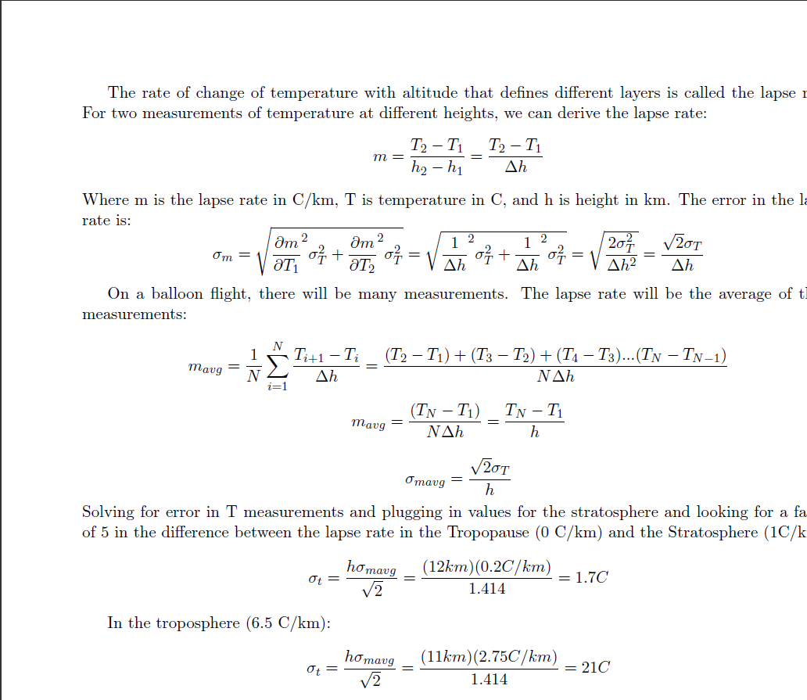

Where m is the lapse rate in C/km, T is temperature in C, h is height in km, and Δh is the height difference between two measurements. Assuming equal errors in both temperature measurements and zero height measurement error, the error in the lapse rate is:
On a balloon flight, there will be measurements at many different altitudes. The above equation assumes that the measurements have equal altitude intervals and each measurement has the same error, the lapse rate will be the average of these measurements:
Where h is the height difference between the two data points. We can solve for the minimum error in temperature readings by plugging in values for the stratosphere and looking for a factor of 5 in the difference between the lapse rate in the Tropopause (0°C/km) and the Stratosphere (1°C/km):
The temperature measurements must have a minimum standard deviation of ± 1.7 °C. From the calculations above, one might assume that we only need to take two measurements of temperature to find the lapse rate within a layer, but we need to take more measurements to determine when one layer ends and another begins. Also, we can look for variations in the lapse rate which might also correspond to humidity variations [16].

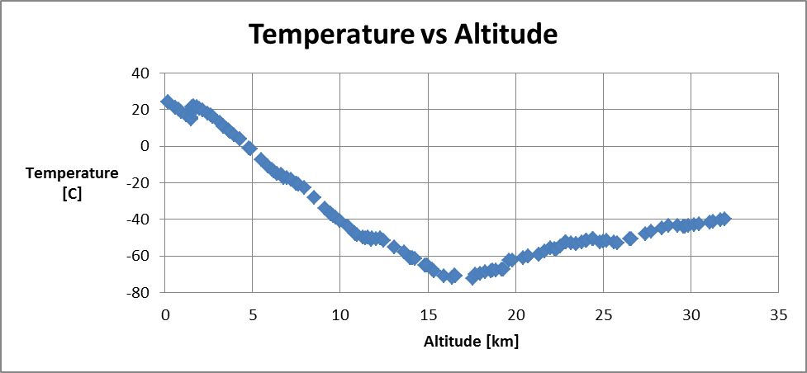
Figure 3-1: Temperature as a function of altitude from NOAA data taken on May 23, 2010 from Fort Worth, Texas [13]

There are several features present in the temperature profile of the NOAA data in figure 3-1. The first section between 0 and 11 km is the Troposphere, where the temperature is linearly decreasing. The second feature between 11 and 20 km is the Tropopause, where the temperature is unchanging. The third layer, between 20 and 32 km is the stratosphere, where the temperature increases linearly. Based on U.S. Standard Atmosphere [17], we expect the absolute maximum temperature range to be between 45 and -86 ºC, but a more reasonable range based on prior data and the summer launch date would be between 30 and -80 °C. The lowest temperature in Figure 3-1 is -72°C.

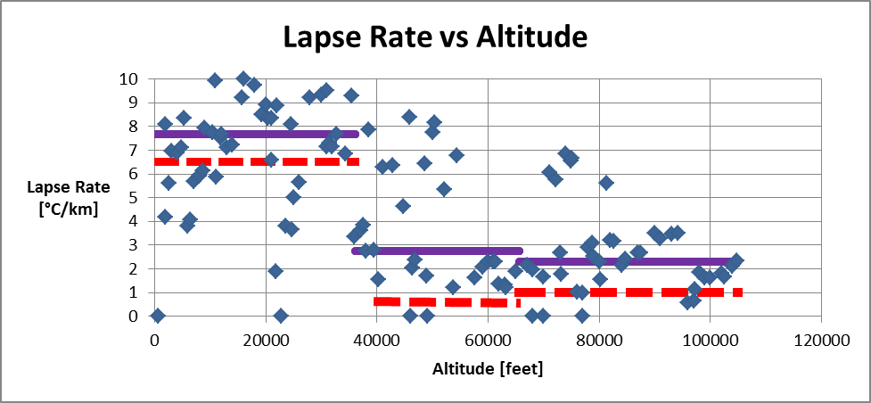
Figure 3-2: Lapse rate as a function of altitude derived from the data in Figure 1 [13]. The expected values based off of the standard atmosphere model [17] are in dashed red lines and the median of the data points shown are the solid purple lines.

We used the temperature measurements in figure 3-1 to calculate the lapse rates in figure 3-2. Some data outliers offset the average lapse rate calculation; we used the median to calculate the solid purple lines in figure 3-2. The NOAA did not publish the errors in the temperature measurements (or altitude measurements), so we could not calculate the error in the lapse rates. Even without knowing the error, the height difference between measurements are small, ~0.25 km, which causes large errors in the lapse rate. The deviations from the expected values could be from humidity in the air. The US Standard Atmosphere assumes that the air has 0% humidity.

Three equations from the US Standard Atmosphere model the pressure as a function of altitude from sea level to the Stratosphere [14]. Because temperature does not change in the Tropopause, the US Standard Atmosphere uses three equations from sea level to Stratosphere.

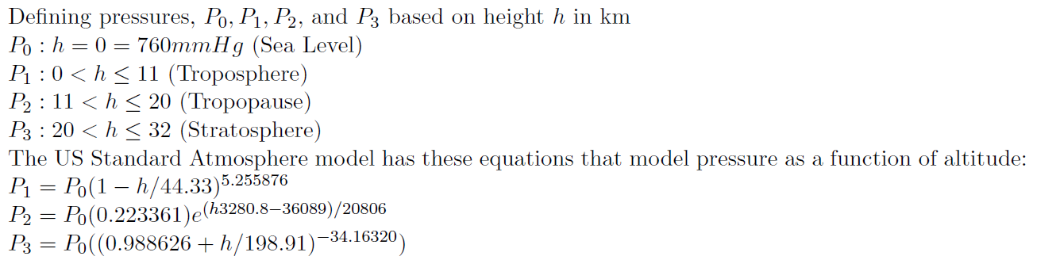

Switching to units of atmospheres (atm) simplifies the above equations by setting P₀ to 1. We can calculate what we expect the pressure to be at any altitude.
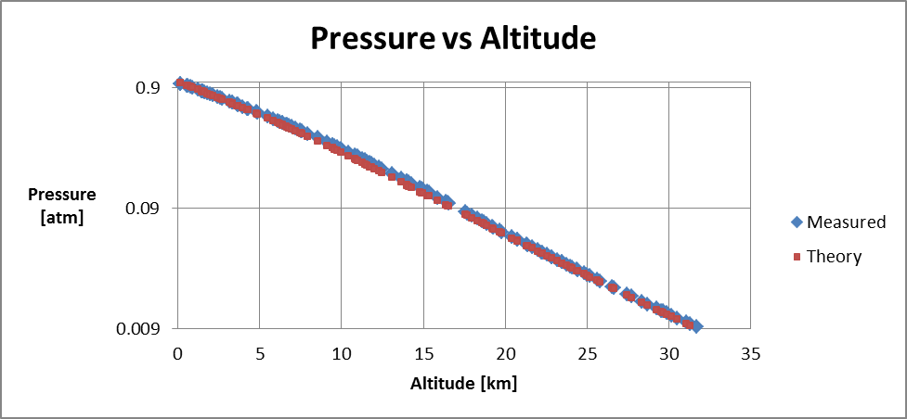
Figure 3-3: Measured pressure data from NOAA data taken May 23, 2010 [13]

In figure 3-3, the NOAA data matches the expected values for pressure with a fair degree of accuracy. The relative error averages 4% but increases in the Troposphere. The pressure ranges from 1 to 0.008 atm. To measure any deviations from the US Standard Atmosphere in the pressure profile, the standard deviation of the pressure must be ±0.002 atm (2 mmHg or 200 Pascals)

In calculating the parameters in the standard atmosphere, the model assumes the air is completely dry, with 0% relative humidity. However, the US Standard Atmosphere uses the density of air which is dependent on humidity [17]. Water vapor weighs less than the average air molecule. When the air is humid, its molecular weight decreases. The US Standard Atmosphere considered molecular weight to be a constant up to 84 km. Since humidity is not constant with altitude, it is important to study and characterize this property [16].
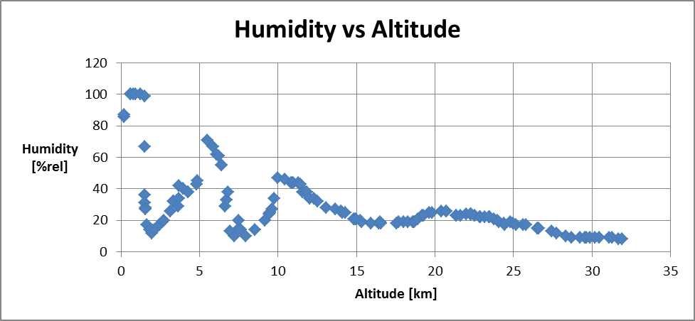
Figure 3-4: Humidity as a function of altitude from NOAA data taken May 23, 2010 [13]

In order to characterize atmospheric humidity, we must take data that shows all of the changes in the profile. The humidity of the atmosphere does not have a standard profile. The NOAA data in figure 3-4 shows the various features of the profile of humidity vs. altitude. The data ranged from 100 to 8 percent relative humidity (%rel) and measured humidity with a standard deviation of ± 0.5 %rel.

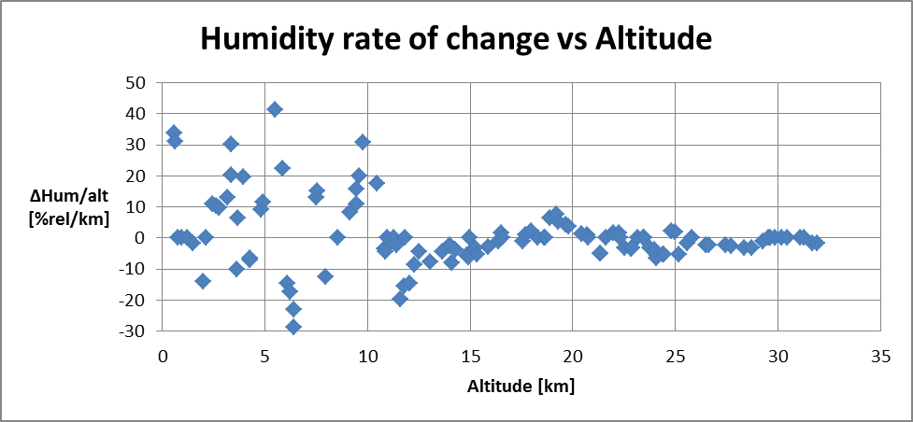
Figure 3-5: Change in humidity as a function of altitude derived from data in figure 4 [13]

As shown in figure 3-5, the humidity changes the most drastically in the first 10 km. The change in humidity per minute peaks at 42 percent per kilometer and suddenly stops changing in the Tropopause. Since we do not understand the causes of the features in the humidity profile, we must take accurate data with a high temporal resolution, especially at the beginning of the flight. From sea level to 11 km, data must be taken at least 30 times per kilometer or 10 times per minute assuming a 1,000 feet per minute ascent rate. Above 11 km, we do not need to take data at such a high frequency, because the rate of change in the humidity decreases. Here, we must acquire data at least 9 times per kilometer or 3 times per minute.

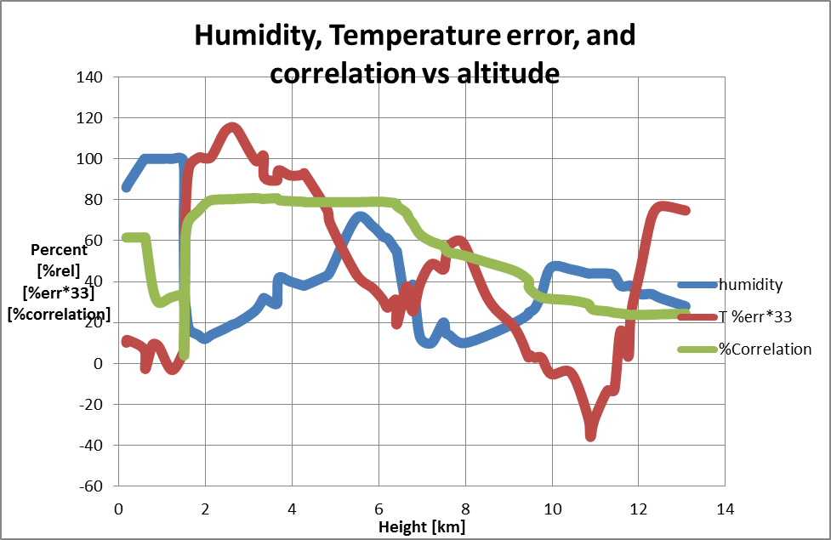
Figure 3-6 Correlation between temperature error and humidity from NOAA data taken May 23, 2010 [13]

The correlation coefficient of two sets of data is indicative of how well one parameter is influenced by the other. The percentage of correlation is found by squaring the correlation coefficient and multiplying by 100. A correlation of 80 percent is very strongly correlated, while 25 percent is a very poor correlation. The temperature error and humidity seem to be very strongly correlated in the troposphere. The temperature data were binned to a 1 °C resolution to show that a relationship existed even if the data was not as high quality as the initial measurements, which were around 0.1 °C error.
From this, we conclude that the temperature resolution should be less than 1 °C to measure and correlation between humidity and temperature.

3.3.1.3 Clouds

The atmosphere of the Earth consists of a large sphere of multiple gasses and water that surrounds and protects the planet from high-energy radiation and the vacuum of space. It consists of four layers (Troposphere, Stratosphere, Mesosphere, and Thermosphere) and four transition layers (Tropopause, Stratopause, Mesopause, Thermopause), determined by a combination of temperature change, chemical composition, and density.
The atmosphere consists of many different gasses as well as water. The most prominent gas, Nitrogen, forms 78% of the atmosphere, followed by Oxygen, which forms 21% of the atmosphere. The final one percent of the atmosphere contains many different gasses including Argon, Ozone and Carbon Dioxide.
The Troposphere starts at the Earth’s surface and extends upward 15 kilometers, making it the lowest layer of the atmosphere. This layer contains most of the gas in the atmosphere making it the densest layer. The temperature starts at an average of 17°C on the surface and decreases to -52°C at the Tropopause [3]. The boundary that separates the Troposphere from the layer above it is called the Tropopause. The height of the Tropopause varies depending on the latitude, season and time of day. Near the equator, the Tropopause is approximately 20 km (12 miles or 65,000 feet) above sea level [6]. The combination of Troposphere and Tropopause is called the lower atmosphere [3].
Unlike the other layers, the Earth’s surface heats the Troposphere. The sun heats up the water and ground and this heat radiates back into the troposphere. Because warm air rises, it passes through the troposphere towards its upper region. This causes the Troposphere to become “stirred up” which creates constant winds that cover the whole globe [6].
Almost all clouds are formed in the Troposphere. Because of the varying density and temperature of the Troposphere, different cloud types are formed at different altitudes. Clouds found near the surface (0 to 2 kilometers) include Cumulus and Cumulonimbus. These clouds are very large and puffy and are the main producers of rain for the Earth due to the higher humidity closer to the Earth. Clouds found higher up (2 to 7 kilometers) include Altostratus and Altocumulus. These clouds normally form in large groups of small clouds, like the Altocumulus, or can form a cover across the whole sky, like the Altostratus. The third and highest (5 to 13 kilometers), cloud forms include Cirrus clouds. These clouds appear as small groups of thin white streamers across the sky, and normally indicate good weather [2].
The Stratosphere, the second layer of the atmosphere, ranges from 15 to 50 Kilometers. Because of higher altitude the Stratosphere contains less humidity and has a lower pressure than the Troposphere. The temperature of the Stratosphere increases from -52° C to -3° C, starting at the Tropopause and ending at the Stratopause, due to the presence of the ozone layer, made from a special form of oxygen called ozone. The ozone layer absorbs the ultraviolet radiation from the sun and causes an increase in temperature. Because of the constant increase in temperature through the whole Stratosphere, there is very little “stirring” which allows for calm or no winds. The Troposphere and Stratosphere make up 99% of all of the gas in the atmosphere.
Clouds are classified according to appearance and altitude. Based on the appearance of the clouds, there are two major types: clouds of vertical development, formed by the condensation of rising air; and clouds that are layered, formed by condensation of air without vertical movement. When clouds are classified by altitude, there are four classes: high, middle, low, and vertical development [19]. The twelve cloud names combine appearance and height. A brief description of the root name will indicate this combination of features [19].
Name | Description
Stratus, strato | Layered or sheet-like
Cumulus, cumulo | Puffy, heaped (vertical)
Nimbus, nimbo | Dark and rainy
Cirrus, cirro | Curly, feather-like
Alto | High (but used to describe a middle cloud)
Fracto | Broken
Table 3-2: Cloud Name and Description
Table 3-2 shows all 12 cloud names. Most rain clouds are in the low cloud range. However, because most of the cloud’s moisture is nearer to the Earth's surface, special mention should be made of those clouds in the vertical development category. Strong storms such as hurricanes and tornados arise from cumulonimbus clouds, which can attain altitudes of 65,000 feet. When the cloud reaches the top of the troposphere it is virtually lopped off by the lid which the stratosphere creates [19].
Classification | Name | Average Composition | Height of Bases
High | Cirrus  Cirrocumulus  Cirrostratus | Frozen water droplets or ice crystals | 20,000 ft.
Middle | Altostratus  Altocumulus | Ice crystals and/or water droplets | 6,500 – 20,000 ft.
Low | Nimbostratus  Stratus  Stratocumulus  Fractostratus  Fractocumulus | Water droplets (ice crystals in winter) | 50 – 6,500 ft.
Vertical Development | Cumulus  Cumulonimbus | Water droplets at lower levels and ice crystals and upper levels | 50 – 6,500 ft.
Table 3-3: Cloud Classifications

Types of Clouds

Cirrus Clouds (thin and wispy): The most common form of high-level clouds are thin and often wispy cirrus clouds. Cirrus clouds are normally composed of ice crystals that originate from the freezing of super-cooled water droplets. They are typically found at altitudes greater than 20,000 feet (6,000 meters). Cirrus generally occur in fair weather and point in the direction of air movement at their altitude. The strong winds at this high altitude blow the cirrus clouds in long streamers across the sky [20].

Altocumulus Clouds (parallel bands or rounded masses): Altocumulus may appear as parallel bands or rounded masses. Typically a portion of an altocumulus cloud is shaded or darkened, a characteristic which makes them distinguishable from the high-level clouds. Altocumulus clouds typically form at altitudes between 6,500 feet and 20,000 feet thus classifying them as middle-altitude clouds. Altocumulus clouds usually form by convection in an unstable layer aloft, which may result from the gradual lifting of air in advance of a cold front. The presence of altocumulus clouds on a warm and humid summer morning is commonly followed by thunderstorms later in the day [20].

Nimbostratus Clouds (dark, low-level clouds with precipitation): Nimbostratus are low-level, dark clouds accompanied by light to moderately falling precipitation. Low clouds are primarily composed of water droplets since their bases generally lie below 6,500 feet (2,000 meters). However, when the inside of these clouds reach a cold enough temperature, these clouds may also contain ice particles and snow [20].

Fair Weather Cumulus Clouds (puffy): Fair weather cumulus have the appearance of floating cotton and have a lifetime of 5-40 minutes. These clouds are typically known for their flat bases and distinct outlines. Fair weather cumulus exhibit only slight vertical growth, with the cloud tops designating the limit of the rising air. Fair weather cumulus normally form at altitudes between 1,500 feet and 10,000 feet. Fair weather cumulus are fueled by buoyant bubbles of air, or thermals, that rise upward from the Earth's surface. As they rise, the water vapor within cools and condenses forming cloud droplets. Evaporation along the cloud edges cools the surrounding air, making it heavier and producing sinking motion (or subsidence) outside the cloud [20].

Contrails (condensation trails): A contrail, better known as a condensation trail, is a cirrus -like trail of condensed water vapor normally resembling the tail of a kite. Contrails are produced at high altitudes above 8,000 meters (26,000 feet) where extremely cold temperatures below -40°C freeze water droplets in a matter of seconds before they can evaporate. Contrails form through the injection of water vapor into the atmosphere by exhaust fumes from a jet engine. If the surrounding air is cold enough, a state of saturation is attained and ice crystals develop, producing a contrail [20].

Cumulonimbus Clouds (reaching high into the atmosphere): Cumulonimbus clouds are much larger and more vertically developed than fair weather cumulus. Fueled by vigorous convective updrafts (sometimes in excess 50 knots), the tops of cumulonimbus clouds can easily reach 39,000 feet (12,000 meters) or higher [20]. Lower levels of cumulonimbus clouds are dominated by water droplets. At higher altitudes, where temperatures inside the clouds are well below 0 degrees Celsius, the cumulonimbus clouds consist of ice crystals. It should be noticed that in the event of a large amount of these clouds being present at the time of liftoff, the balloon launch will most likely be postponed.

Within a cloud, we expect the humidity to be near 100% saturated. The temperature lapse rate should increase, making the measured temperature larger than the expected temperature, because the US Standard Atmosphere does not take the humidity from clouds into account. The pressure might change because humidity makes air less dense.

3.3.1.4 Balloon Expansion

The entire ACES program hinges on the performance of a simple sounding balloon. The hopes and dreams of every ACES participant hinges on the lift from this balloon. Therefore, it is important to characterize the performance of the balloon. The anticipated ascent rate is 1,000 feet per minute and ACES student have used this information to determine parameters such as data acquisition rate.
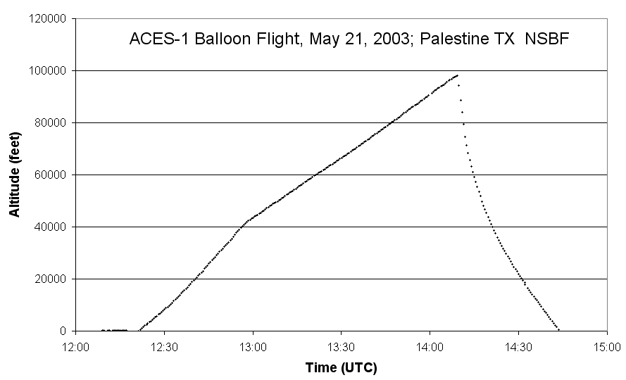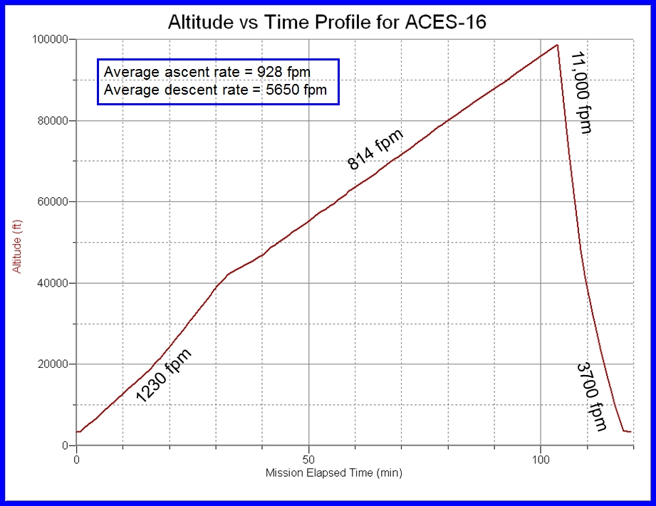
Figure 3-7: Two previous ascent curves from ACES flights

Figure 3-7 shows two previous balloon flights of ACES-1 and ACES-16. The ascent rate is supposed to be a constant, yet both ascent profiles show a change in ascent rate at an altitude 40,000 feet.

According to LaACES Ballooning Unit, Lecture 4, we will use a Kaymont 2000 gm sounding balloon for lift. This balloon has a bursting radius of 10.54 meters at 35.4 km (116,000 ft) and 0.0052 atm (5.3 hPa). The Kaymont 2000 gm is designed to keep a spherical shape while expanding during flight and has a constant ascent rate throughout flight [].

Archimedes’ principle says that buoyant force is the weight of the displaced fluid. In the case of our balloon, the buoyant force is the volume of the balloon multiplied by the density of air. The gravitational constant changes by less than one percent during flight, so we assume it is a constant. When the balloon reaches a constant, all the forces acting on the balloon are equal.

F_{b} = F_{bal} + F_{He} + F_{pay} + F_{drag}

In this equation, F_{b} is the buoyant force (lift from balloon), F_{bal} is the weight of the balloon, F_{He} is the weight of the helium in the balloon, F_{pay} is the weight of the payloads, and F_{drag} is the force of drag on the balloon.

D_{Air}*V*g = m_{bal}*g + m_{He}*g + m_{pay}*g + k*D_{Air}*(π*r²)*S²

In this equation, D_{Air} is the density of air in kg/m³, V is the volume of the balloon in m³, g is gravitational acceleration in m/s², m_{bal} is the mass of the balloon in kg, m_{He} is the mass of helium inside of the balloon in kg. The density of air can be estimated from the US Standard Atmosphere model, radius of the balloon will be measured from the video, volume of the balloon can be calculated from the radius, the mass of the balloon is 2000 grams, the mass of the payloads should be known before launch, g is 9.81m/s², k is a geometrical factor which is between 0.07 and 0.5 for spheres [25], and the speed should be constant and can be calculated from GPS data. The radius, volume, density of air, and the density of helium should be the only factors that change with height. Terms that do not vary with altitude have been grouped into the constant C.

D_{Air}*V*g = C + k*D_{Air}*(π*r²)*S²

(4/3)*π*r³*g*D_{Air}= C + k*D_{Air}*(π*r²)*S²

(4/3)*π*r³*g*D_{Air} - C - k*D_{Air}*(π*r²)*S² = 0

The above equation has one real solution and we aim to test if the above equation holds true throughout flight.

An HD camera has a resolution of 1280x720 pixels. If the fully inflated balloon took up the full width of the image, the angular resolution would give us 1000cm/1280px = 0.8 cm/pixel. At launch, the balloon will be near 200 cm, which will take up 256 pixels. Naively, one might say that we should maximize the apparent size of the balloon in the field by moving the camera as close to the balloon as LaACES management will permit. Although the distance per pixel decreases as one moves the camera closer to the balloon, a closer look at the geometry of the system shows that placing the camera too close to the balloon actually increases the error in the radius measurements.

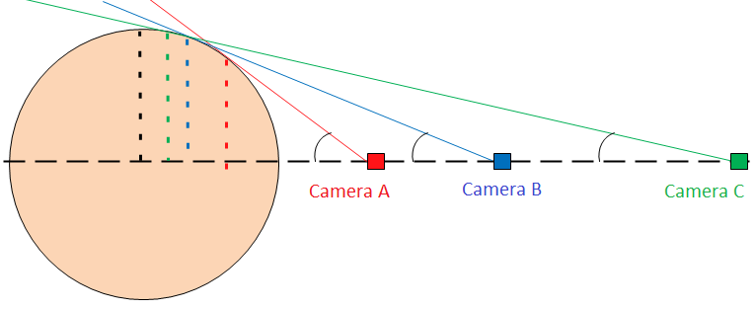
Figure 3-8: three different camera positions for viewing the balloon

The position of the camera is critical. The camera must be far enough away to accurately measure the size of the balloon, but if the camera is too close, the apparent size of the balloon is not correct. Figure 3-8 shows this graphically. Camera A is too close to the balloon because the apparent radius (dashed red line) is much smaller than the actual radius (dashed black line). As cameras B and C show, the further away the camera, the closer the measured radius will be to the actual radius of the balloon. There is a trigonometric relationship between camera distance and apparent radius.

r = R * cos(θ)

r = R*cos(arctan(R/(L+R)))

θ = arctan(R/(L+R)) ≈ arctan(r/(L+r))

R_{meas}= r/cos(arctan(r/(L+r)))

R is the actual radius of the balloon, θ is the viewing angle (black arc in figure 3-8), r is the apparent radius measured by the camera (dashed lines in figure 3-8), L is the distance from the edge of the balloon to the camera, and R_{meas} is the final radius after taking into account the geometry of the balloon. The difference between measured radius and actual radius can be calculated using:

R_{meas} - R = r/cos(arctan(r/(L+r))) - R

R (m) | L(m) | r(m) | Rmeas (m) | delta R (cm)
1 | 4 | 0.980581 | 0.999405 | 0.0595347
2 | 4 | 1.897367 | 1.993148 | 0.68518917
3 | 4 | 2.757435 | 2.978174 | 2.182649507
4 | 4 | 3.577709 | 3.956422 | 4.35775999
5 | 4 | 4.370786 | 4.930739 | 6.926057375
1 | 8 | 0.993884 | 0.999934 | 0.006616778
2 | 8 | 1.961161 | 1.998809 | 0.119069399
3 | 8 | 2.894291 | 2.994691 | 0.530920306
4 | 8 | 3.794733 | 3.986296 | 1.370378341
5 | 8 | 4.666728 | 4.973375 | 2.662450515
Table 3-4: Typical errors in radius measurement based on geometry

Table 3-4 shows what the errors would be with a distance to the payload of 4 or 8 meters and the radius of the balloon varying from 1 to 5. The best resolution we could hope to get would be about 1 cm/pixel, as discussed previously. If the balloon is far enough away from the payload, the limiting factor will be the resolution of the camera, not the geometry.
The payload directly above the Philosohook payload will be obstructing part of the view. The angle blocked by a 17 cm square payload would be given by the following formula:

θ_{b} = arctan(8.5/L_{p})

θ_{b} is the angle blocked in one dimension and L_{p} is the distance to the next payload in cm. A distance of 50 cm will block 10 degrees, 75 cm will block 6 degrees, and 100 cm will block 5 degrees. Optimal placement of the payload will need to be coordinated with the LaACES management and will be discussed in future documents.

3.3.2 Science Requirements

- We shall measure temperature, pressure, and humidity of the atmosphere every six seconds and record a timestamp for each of these measurements
- We shall calculate altitude using a timestamp from each data point and GPS data from the flight
- We shall identify layers of atmosphere using temperature lapse rate measurements
- We shall compare measured pressure with expected pressure of the US Standard Atmosphere
- We shall characterize features in the humidity profile
- We shall identify cloud types and coverage
- We shall measure balloon expansion because of atmospheric pressure and temperature changes
- We shall measure radius of the balloon as a function of altitude and compare our measurements to the theoretical relationship discussed in the science background
- We shall determine any effects of passing through a cloud on temperature, pressure, and humidity readings
- We shall calculate altitude during the video using timestamps of the video recorder

3.4 Technical Background and Requirements

3.4.1 Technical Background

To study the atmospheric layers the payload needs to be able to measure the various atmospheric conditions. Each characteristic: temperature, pressure, and humidity, requires a specific sensor to make each measurement. The sensors used in the payload will be chosen based on several factors like accuracy of measurements, expected range during flight, cost, and how they function.

Temperature sensors fall into two categories, contact sensors and non-contact sensors. Contact sensors measure work by measuring their own temperature compared to the surrounding temperature when the sensor and target have no flow of heat between the sensor and target. Non-contact sensors measure the thermal radiant power of the infrared or optical radiation that they receive from a target’s surface. There are different types of contact sensors, thermocouples, resistant temperature detectors (RTDs), and thermistors. Thermocouples are based on the Seebeck effect, which is the conversion of temperature differences into voltages. Thermocouples do not need batteries and can measure a wide range of temperatures. RTDs work based on the principle of the positive temperature coefficient of electrical resistance of metals, or in other words the hotter they are the higher the resistance. RTDs are the most accurate temperature sensors and they are easy to recalibrate, but they have a smaller range than thermocouples, are more expensive, and are not very sturdy in environments with a lot of vibration. Thermistors work the same way as RTDs but are made of different materials. RTDs are usually made of pure metals and thermistors are made out a ceramic or polymer. Thermistors have a smaller range than RTDs but are extremely accurate. Non-contact sensors can only detect the temperature of a solid object or liquid, not a gas. These sensors would not be useful in studying the atmosphere [8].

Pressure can be sensed by using different mechanical elements that are designed to deflect when pressure is applied to the system. The deflection can be measured and transduced to obtain an electrical output. There are several types of pressure sensors: potentiometric sensors, inductive sensors, capacitive sensors, piezoelectric sensors, and strain gauge sensors. Potentiometric pressure sensors use a Bourdon tube, capsule, or bellows to sense the pressure. The pressure then drives the wiper arm on a resistive element changing the resistance. These sensors are low cost, but to increase reliability the wiper arm must bear on the mechanical element with some force which may cause repeatability errors. Inductive sensors measure movement of a diaphragm by changes in inductance. Capacitive sensors use a variable capacitor to measure the pressure. One plate of the capacitor is a diaphragm and the other plate of the capacitor is stationary. When pressure is applied the diaphragm deflects which changes the distance between the two plates causing the capacitance to change. Piezoelectric elements consist of metalized quarts or ceramic material. These elements convert stress into an electric potential. These sensors only provide output when the input is changing so they can only be used to measure varying pressures. Strain gauge sensors use a metal diaphragm with strain gauges attached to it. One type of these sensors is piezoresistive integrated semiconductors. These sensors incorporate four piezoresistors arranged in a Wheatstone Bridge. When stress is applied the resistance changes and the pressure can be calculated by the difference in the output voltages of the bridge [4].

There are three types of humidity sensing technologies: capacitive, resistive, and thermal conductive. Capacitor sensors consist of a substrate, usually glass, ceramic, or silicon. A thin film of metal oxide or polymer is placed in between two conductive electrodes on the substrate. To protect the circuitry surface from contamination and exposure to condensation, the sensing surface is coated with a porous metal electrode such that as the relative humidity changes, the capacitor’s capacitance changes linearly. These sensors can function in high temperature and can fully recover from condensation. Resistive humidity sensors measure the change in the impedance of a hygroscopic medium. Hygroscopy is the ability of a substance to attract water molecules from the surrounding environment. The change in impedance is usually related to the relative humidity in an inverse and exponential relationship. These sensors typically have operating temperatures ranging from -40 to 100 °C. Thermal Conductive humidity sensors measure the absolute humidity by using the difference of the thermal conductivity of dry air and of air containing water vapor. These circuits operate in temperatures up to 300 °C but the temperature affects the output voltage of these sensors [1].

The payload will use a digital camera with a real time clock to take video during flight. A camera with a CMOS sensor will be used because they are more versatile, have a lower price and consume less power than the alternative CCD sensors. A CMOS image detector is an array of photo-detectors that detect and amplify light. The output from the image detector can be used to create still images or video of the detected light. A typical CMOS sensor can operate between −55 °C and 125 °C [18].

High Definition (HD) video comes in two different resolutions, 720p at 1280x720 pixels and 1080p at 1920x1080 pixels. The 720p resolution uses 2-3 MB/s and the 1080p resolution uses 5-6 MB/s. the data rate varies because video cameras use a compression algorithm that changes storage based on what one is recording.

The video output will be focused upwards so that we can see when our payload moves into and out of clouds. The duration of the time spent in a cloud will be taken down and since there is a target ascent rate of 1000 ft/min a rough estimate of cloud height can be determined by the video. This along with altitude readings will help us determine cloud type.

The color video will also be used to related balloon expansion. Knowing the distance to the balloon, the size of the balloon will be determined by counting the number of pixels contained in the balloon’s diameter. Calibration data will provide a conversion from pixels into meters. We will use screenshots from the video at several heights and create a graph of radius vs. height. While the balloon is passing through a cloud, the balloon will most likely become obscured. Since we do not need the balloon’s radius at every frame, the clouds will not interfere with our data.

3.4.2 Technical Requirements

- The payload’s cost shall not exceed $500
- The payload’s mass shall not be greater than 800g
- The payload shall be able to be attached to the weather balloon using strings 17 cm apart
- The payload shall have a temperature sensor that to measure temperatures between 30 and -70 °C on the outer side of the payload with a standard deviation of ± 0.6 ºC
- The payload shall have a temperature sensor that to measure temperatures between 30 and -70 °C on the inside of the payload with a standard deviation of ± 0.6 ºC
- The payload shall have a pressure sensor to measure pressures between 1 and 0.008 atm with a standard deviation of ± 0.004 atm
- The payload shall have a humidity sensor to measure humidity between 100 and 0 %rel with a standard deviation of ± 0.5 %rel
- The sensors on the payload shall take readings once every 6 seconds
- The payload shall have a power supply to power the BalloonSat from liftoff to landing
- A conditioning circuit shall be used to condition the signals received from the sensors into signals that are readable by the Analog to Digital Convertor
- The payload shall survive the liftoff, turbulence of flight, and landing
- We shall work with LaACES management and place our payload in an optimal position to view the balloon

4.0 Payload Design

The payload and its components must be able to withstand flight up to an altitude of 100,000 feet, including the ability to withstand and function at temperatures between -70 and 30 °C and pressures between 0.008 and 1 atm. The electronic components of the payload will reside inside of a box made out of polystyrene foam which is then wrapped in aluminized Mylar to protect the components from extreme temperature. All of the components and the foam box will weigh less than 800 grams.

4.1 Principle of Operation

The payload will measure internal and external temperature, pressure, and humidity as well as provide video of the flight. All of these sensors will be connected to the BalloonSat with wires for both the external temperature and humidity sensors to reach to the outside of the payload. The camera and internal temperature and pressure sensors will reside on the inside of the payload.

4.2 System Design
Power Transfer
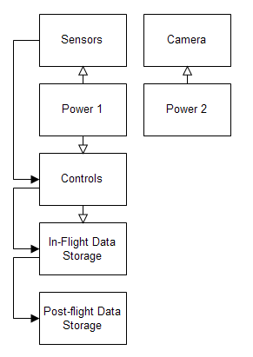
Data Transfer
Figure 4-1: High level system design

4.2.1 Functional Groups

Our system contains several different major components. One of the main components is the control system. The control system serves as an attachment unit, where the rest of the devices will be connected on. It controls, reads, and stores the data from the sensors. In order to send commands to all the sensors all programs must be written into the BalloonSat containing Basic Stamp. All data will be recorded to the EEPROM. Detector system will contain all of our sensors. The power sources will power the control system, sensors, and camera. The in-flight data system will store the data during the flight. The post-flight data system will be used to store and analyze the data after the flight.

4.2.2 Group Interfaces

Every feature of the payload interfaces with one another. The connections between systems depend on which systems are communicating. The control system receives a 12V input from power source 1, in addition it also receives data from the sensor system. The control system also sends data and a 5V output voltage to the In-Flight Data Storage System. Power source 2 also sends 4.5V for the Camera.

We have decided to use 2 different power sources. This is because other than the camera, all other components need low currents. If we attached the camera and all other components to one power supply, the camera will drain the power supply much faster. Therefore, we use two different power supplies to take care of this problem.

4.2.3 Traceability

Mission Goal:
To measure atmospheric conditions in order to study the layers of the atmosphere from liftoff to landing and study the surrounding environment of the payload in order to validate atmospheric conditions measured.
Objective | Requirement | Design Element
Determine atmospheric layers flown through during flight | -We shall identify layers of atmosphere using temperature lapse rate measurements  -We shall calculate altitude using a timestamp from each data point | Time Stamp on the EEPROM
Characterize atmospheric conditions in layers | -We shall take measure temperature, pressure, and humidity of the atmosphere every six seconds  -We shall verify theoretical relationship of pressure and altitude  - We shall characterize features in the humidity profile | Temperature, pressure, humidity sensors, and EEPROM
Identify the altitude range of cloud layers in order to estimate peaks in atmospheric turbulence and humidity | - We shall identify cloud types and statistics. | Video Camera
Determine balloon expansion as a function of altitude to approximate relative pressure | - We shall measure balloon expansion because of atmospheric pressure and temperature changes | Camera
Determine ground and cloud thermal patterns to approximate the effect on the temperature readings | -Determine any effect passing through a cloud might have had on temperature and humidity readings | Temperature and humidity sensor and EEPROM
Objective | Requirement | Design Element
Build a working payload that can withstand conditions of a balloon flight | -The payload’s cost shall not exceed $500  -The payload’s mass shall not be greater than 800g  -The payload shall be able to be attached to the weather balloon using strings 17 cm apart  - The payload shall have a power supply to power the BaloonSat from liftoff to landing  - Operational Amplifiers shall be used to condition the signals received from the sensors into signals that are readable by the Analog to Digital Convertor  - The payload shall survive the liftoff, turbulence of flight, and landing  -We shall inspect the balloon for defects and thin spots | All team members
Record temperature, pressure, and relative humidity up to 100,000 feet | -The payload shall have a temperature sensor that to measure temperatures between 30 and -70 °C on the outer side of the payload with a standard deviation of ± 0.6 ºC  - The payload shall have a pressure sensor to measure pressures between 1 and 0.008 atm with a standard deviation of ± 0.002 atm  - The payload shall have a humidity sensor to measure humidity between 100 and 0 %rel with a standard deviation of ± 0.5 %rel  - The sensors on the payload shall take readings once every 6 seconds | Temperature, humidity, and pressure sensors and the EEPROM
Determine at what time and altitude the payload enters and exits clouds | -The payload shall place a timestamp on the data collected during flight | Real time clock, EEPROM, camera, and humidity sensor
Determine the radius of the balloon at several times, altitudes, and temperatures | - Must relate balloon expansion to relative pressure | Camera
Determine thermal signature patterns of the underlying environment | -Must determine effects of ground and cloud heat reflection on the temperature readings of the payload. | Temperature sensor and EEPROM

Table 4-1: Traceability matrix
4.3 Electrical Design

4.3.1 Sensors

The payload will require four sensors, one to measure external temperature, one to measure internal temperature, one to measure pressure, and one to measure humidity. The sensors will be judged based on cost, sensing range, accuracy, mass, and how they are integrated. We need to have sensors that fit our requirements and because we have a set budget they must not be costly. The payload must be 17 cm across and be less than 800 g so the sensors chosen need to be small enough to fit inside the payload and add as little mass as possible. How the sensor is integrated is important because if the sensor requires extra circuitry to function properly, that circuitry must be within the requirements. The best possible sensors will be chosen based on how well they meet the requirements mentioned above.

The BalloonSat has a temperature sensor which will be used to measure the internal temperature of the payload. The external temperature sensor must be able to measure temperatures from -70 °C to 30 °C, accurate to 1.7 °C. Thermocouples and Resistive Temperature Detectors (RTDs) are extremely more accurate than other temperature sensors but are also much more expensive (RTD’s can cost around $1700 and thermocouples can cost around $75). Thermistors sense temperatures from -80°C to 150°C, and cost around $8.00 for a thermistor that can sense in that range. Diodes can measure temperature by using the turn on voltage of the diode. The turn on voltage of a diode is linearly affected by the diode’s temperature coefficient as long as the temperature remains in the diodes operating range. Diode’s operating range is from -60°C to 200°C and each diode only cost about $0.02. We currently plan on using either a diode or a thermistor as a temperature sensor because they meet our requirements.

Only one pressure sensor is needed, because the internal pressure and external pressures are equal. Potentiometric sensors have repeatability errors. Piezoelectric sensors are a good choice because of their low cost, small size, linearity, sensitivity, stability, and repeatability. Because the piezoelectric sensors have a high impedance, a device with higher impedance is required to measure the voltage stored on the sensor. The voltage stored by the sensor could be another potential problem due to the voltage being drained before the measurement can be taken. These sensors are more suited for taking measurements that change rapidly which will not be practical for taking pressure measurements during flight. We plan to use a piezoresistive pressure sensor because they have many of the same characteristics of a piezoelectric sensor, but have a better low frequency response. This means that they can take measurements that are not rapidly changing.

The humidity sensor for the payload must be able to take measurements from inside and outside the payload every six seconds, function in the extreme environment, and sense the relative humidity from 0% to 100% within a standard deviation of ± 0.5%. Thermal conductive humidity sensors are not viable choices for the payload because they measure absolute humidity and the output voltage of the sensor is affected by temperature. Resistive humidity sensors can measure the relative humidity and output an impedance. The impedance is related to the relative humidity in an inverse exponential relationship but by using AC signal conditioning the signal can be made linear. Capacitive humidity sensors measure the relative humidity and output a capacitance. The capacitance and relative humidity are related linearly. Many of these sensors have built-in conditioning that converts the capacitive output into a linear voltage output, which can then be conditioned into a 0V-3V signal to be read by the ADC. These sensors also contain protection from contamination due to condensation. We plan to use capacitive humidity sensors for the payload, because the output is linear causing less signal conditioning to be required. In addition, they can function in the environment expected during flight.

For video during flight, we plan on using a CMOS image detector because it is inexpensive and has a low power consumption. CCD sensors are more expensive and consume more power than a CMOS image detector. A CMOS detector is an array of photo-detectors that detect and amplify light and the output of the sensor can be used to create video of the detected light.

4.3.2 Sensor Interfacing

The temperature sensor interface can be seen below in Figure 4-2. The ADC can only read voltages from 0V to 3V but the thermistor outputs resistance. A constant current source is needed to transform the output resistance into a voltage. Then the output voltage can be amplified to fit the range of the ADC. The sensor interface of a diode temperature sensor is similar to that of a thermistor. A constant current source is needed to power the diode. The voltage of the diode will be conditioned using operational amplifiers and the conditioned signal will then be converted to digital format using an ADC and then the signal will be saved in the EEPROM’s memory. The expected current required of the constant current source should be approximately 1mA.

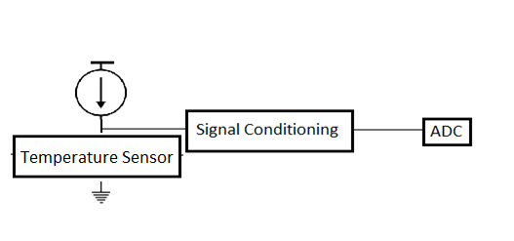
Figure 4-2: Temperature Sensor Interface

The pressure sensor is composed of four piezzoresistors arranged in a whetstone bridge. The interface for the sensor can be seen below in Figure 4-3. The sensor requires a constant current of approximately 2mA and some signal conditioning will be required to convert the difference in the voltage outputs of the bridge into a 0V-3V range for the ADC.
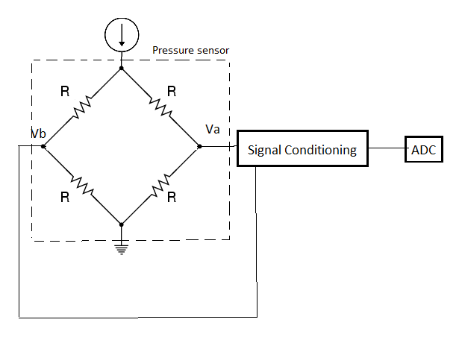
Figure 4-3: Pressure Sensor Interface

Some capacitive humidity sensors have three leads: input voltage, output voltage, and ground. These sensors operate between 4V-6V with a maximum current of approximately 0.5mA. The output voltage will need to be amplified using OpAmps and then the amplified signal will be converted to a digital byte using the ADC. Figure 4-4 shows the circuit interface.
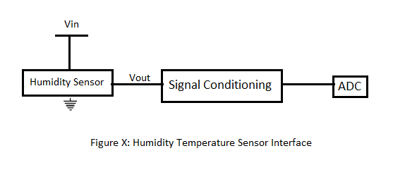
Figure 4-4 Humidity Temperature Sensor Interface

4.3.3 Control Electronics

The BASIC Stamp, located on the BalloonSat, is the main controlling unit of the payload. The BASIC Stamp is a simple programmable microcontroller that communicates with the ADC, RTC, and EEPROM through serial interface. The BASIC Stamp initializes the RTC and takes timestamps during flight. The sensors send a voltage to the signal conditioning circuit, which amplifies the voltage to fit in the range of the ADC. The ADC converts the voltage to a digital byte of data, which is sent to the BASIC Stamp then stored in the memory of EEPROM. The BASIC Stamp can also retrieve the data stored in the EEPROM. Figure 4-5 below shows a high level system drawing of this process.

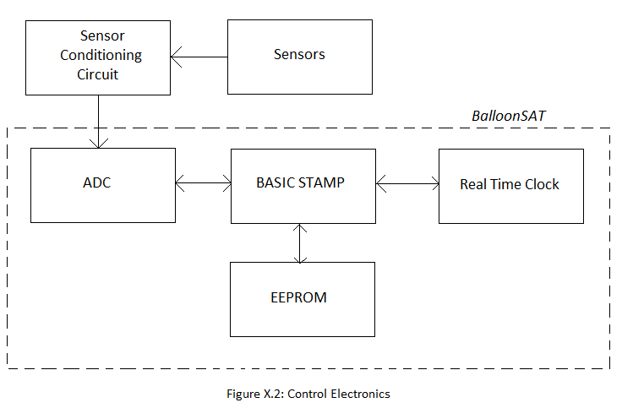
Figure 4-5: Control Electronics

4.3.4 Power Supply

During prototype testing and calibrations a bench power supply will be used to power the BalloonSat, all of the sensors, and the sensor conditioning board. The BalloonSat has a voltage regulator that supplies a safe voltage to all components on the BalloonSat. A bench power supply is ideal for testing because all voltages are readily adjustable and will cost less than using batteries for testing. A high level system drawing of the lab power supply can be seen below in Figure 4-6.

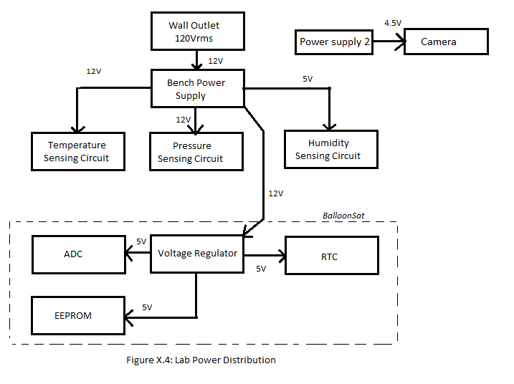
Figure 4-6: Lab Power Distribution

The bench power supply is an impractical power source for flight, because of its large size and vast weight. In addition, it also requires an outside power source. Solar cells are another poor choice because of their high cost and low power output compared to other sources. Batteries are the best possible power source for the payload because they can supply the necessary power and small in weight (about 10 grams each). A system drawing can be seen below in Figure 4-7 of the power distribution.
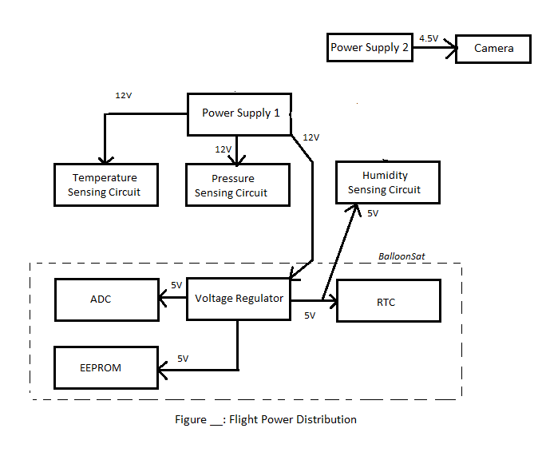
Figure 4-7: Flight Power Distribution

4.3.5 Power Budget

Component | Current  (mA) | Voltage  (V) | Power  (mW) | Flight Time  (hours) | Capacity  (mA-hours)
Temperature Sensor | 1 | 12 | 12 | 4 | 4
Pressure Sensor | 2 | 12 | 24 | 4 | 8
Internal  Humidity Sensor | .5 | 5 | 2.5 | 4 | 2
External Humidity Sensor | .5 | 5 | 2.5 | 4 | 2
Camera | 250 | 4.5 | 1125 | 4 | 1000
BalloonSat | 52 | 12 | 624 | 4 | 208
Total | 306 | 12 | 1790 | 4 | 1224
Table 4-2: Power budget

Since the camera drains the largest amount of current compared to the other components, we will need two different power sources. The first power source will power all of the sensors and the BalloonSat. One AA or AAA battery has 1.5V each so eight batteries will be required to power all of the sensors and the BalloonSat. These components only require 665mW of power so each battery only needs to supply ~80mW of power for four hours, which means a capacity of about 320mWh is required. To power the camera only three batteries will be required and they need to supply a total of 1125mW, which means about 375mW of power supplied by each battery. Since the flight is approximately four hours, the batteries must have a capacity of 1500mWh. For Power Source 1, (BalloonSat and sensors) AA or AAA batteries will work, but since AAA batteries weigh less we will use AAA to supply power to our payload. For Power Source 2, (camera) AAA batteries cannot supply enough power to keep the camera powered during flight so AA batteries shall be used.

For Power Source 1, each battery must supply ~80mW and have a capacity of 320mWh. At a cold temperature (0ºC) and a 100mW constant power discharge, a AAA lithium battery has a capacity of 1600mWh and an alkaline battery only has a capacity of 400mWh. Power source 1 only needs to supply 56mA and at that current drain a AAA lithium battery will stay above 1.4V after twelve hours, while a AAA alkaline battery will drop below 1.4V in about two hours of service. Lithium batteries are better power source for the payload than alkaline for Power Supply 1 because lithium batteries have higher capacities, and they retain their voltage for longer periods of time.

For Power Source 2, each battery must supply ~375mW and have a capacity of 1500mWh. At a cold temperature (0ºC) and a 500mW constant power discharge, a AA lithium battery has a capacity of 3500mWh and an alkaline battery only has a capacity of 400mWh. At 50mA, a AA lithium battery can stay above 1.4V for 45 hours while an alkaline battery drops to 1.3V after only 15 hours. Since the camera will draw five times as much current, a lithium battery can stay above 1.4V for about 9 hours and an alkaline will only stay above 1.4V for 3 hours.

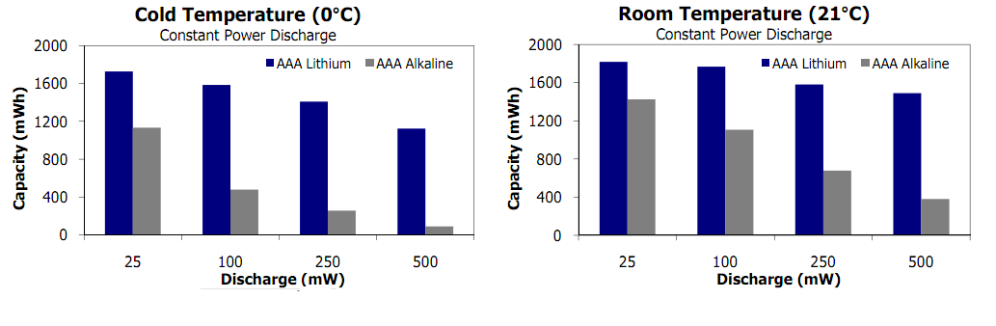
Figure 4-8: Energizer AAA battery capacity at cold and room temperature [24]

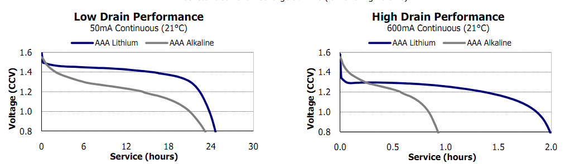Figure 4-9: Energizer AAA Discharge Curve High and Low Drain Performance [24]

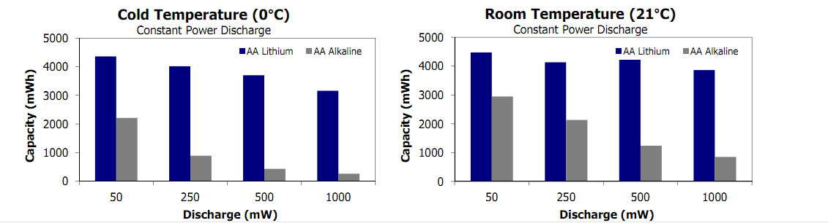

Figure 4-10: Energizer AA battery capacity at cold and room temperature [24]

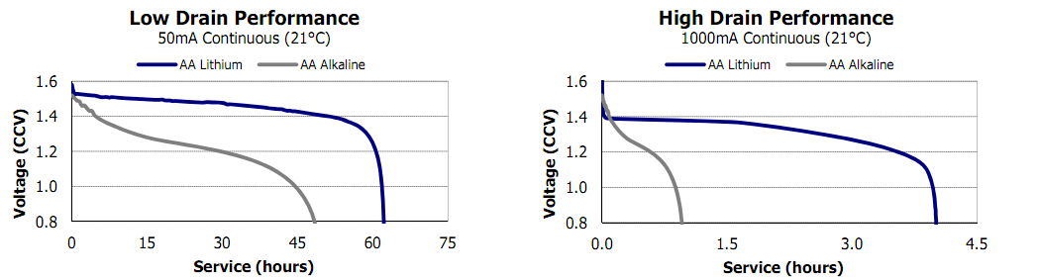
Figure 4-11: Energizer AAA Discharge Curve High and Low Drain Performance [24]

4.4 Software Design

In this section, we will describe software for this project. The software will be run on the BASIC Stamp and will use an EEPROM for data storage. The software must be able to save data and timestamps at the rate specified in the requirements.

4.4.1 Data Format & Storage

There will be two separate data storage devices. The BalloonSat has programmable memory on the EEPROM, and cameras usually have flash data storage built in or an external memory card. Two data storage devices are needed because the camera will record six or seven orders of magnitudes more data than the pressure, humidity, and temperature sensors.

4.4.1.1 BalloonSat Data Storage

Data for the flight will be stored on the EEPROM. On the EEPROM, there are 8191 bytes for data storage. A byte is comprised of 8 bits and can store a number from 0-255. The ADC uses whole numbers only and converts a voltage between 0 and 3 volts to a digital byte of information. Based on the range expected and the precision of measurements, each measurement can be stored into one byte.

Data Type | Minimum | Maximum | Precision | # steps | # bytes | Total Bytes
Pressure | 0.008 | 1 | 0.004 | 248 | 1 | 1
Temperature x2 | -70 | 30 | 0.5 | 200 | 1 | 2
Humidity x2 | 0 | 100 | 1 | 100 | 1 | 2
Timestamp(H,M,S) | 0 | 60 | 1 | 60 | 3 | 3
Table 4-3: Range of values, precision, and bytes for temperature, pressure, and humidity measurements

In Table 4-3 minimum, maximum, and precision of the four data types come from the requirements and the number of steps, number of bits, and number of bytes needed to store each measurement were calculated. One piece of data, including inside and outside sensors requires at least 8 bytes of data. The ascent of the balloon should last 100 minutes or 6000 seconds. In developing the software, we assume that data will be taken during the ascent only and the data will be taken at a constant rate of ten data points per minute (1 data point every 6 seconds). We need to be able to save at least 1000 data points. Since the EEPROM can save 8191 bytes, one data point can only take a maximum of 8 bytes.

In total, the default EEPROM can save 1023 points of data, which will last 102 minutes. This only gives us a 2 minute window to activate our flight code before launch. An expanded EEPROM is extremely cheap and will give us much more time before launch to start our code. The expanded EEPROM has four times the storage of the default EEPROM and can take data at our specified rate for 408 minutes or more than 6 hours.

4.4.1.2 Video Data Storage

The two most common forms of data storage for cameras are Secure Digital (SD) cards or flash memory. SD cards are very common and cost 2 dollars per gigabyte (GB) of storage up to 32 GB. There is a 64 GB card available for 350 dollars. The cost for flash memory cards is almost twice the cost of SD cards for the same memory storage.

A 3 hour movie shot in 720p (1289x720 pixels) will take approximately 25 GB. In 1080p (1920x1080 pixels), a 3 hour video will take about 50 GB.

4.4.2 Flight Software
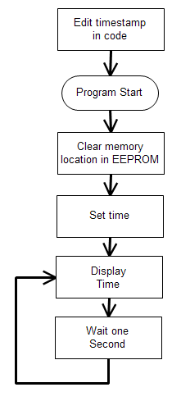
4.4.2.1 Pre Flight
Before the flight, the real time clock (RTC) needs to be set. For ACES activity P6, students used a program to set the RTC. This program was already tested and shown to work as expected. Figure 4-12 is the flowchart* for this program.

This code also resets the “last saved” memory location in the EEPROM. This allows the flight software to begin writing in the first memory location upon startup. This is a risk mitigation step that will be further explained in the during flight section (4.4.2.2).

Also, to test that the RTC is working as expected, we will write a version of this program that only displays the time, but does not set the time.

Figure 4-12: Pre-flight software flowchart

* Flowcharts were made using a trial version of Edraw Max http://www.edrawsoft.com/flow-chart-design.php http://download.cnet.com/EDraw-Flowchart-Software/3000-2191_4-10407719.html
4.4.2.2 During Flight
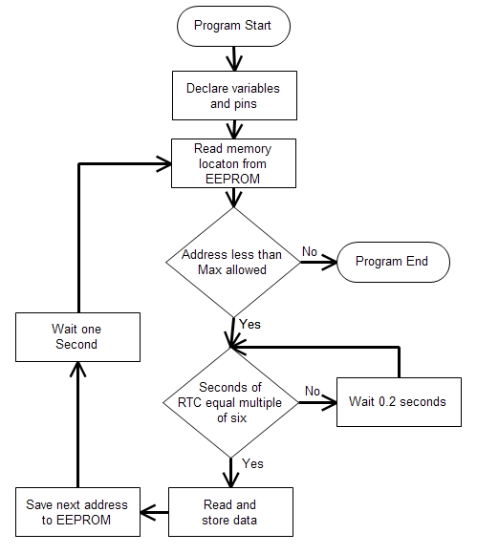
Figure 4-13: During flight software flowchart

Figure 4-13 shows the during flight software. This software must record measurements of the atmosphere once every six seconds. This includes a timestamp of each measurement that records the hour, minute, and second.

The main section of the program is a loop that runs until the EEPROM is filled with data. Within this loop, the program goes into a secondary loop to determine if enough time has passed to take another data point. Since we have determined that we are taking data once every six seconds, the secondary loop checks if the “second” value in the RTC is a multiple of six. If it is, then a data point will be taken. If not, then the secondary loop will wait 0.2 seconds and test the “seconds” variable again. This system is better than using an internal pause in the EEPROM because this way, the variable amount of time that it takes to read and store the data will not affect the data acquisition rate.
One risk during flight is a temporary power outage that resets the BalloonSat. We have added a mitigation step to that saves the address of the last memory location written to the EEPROM. When the BalloonSat starts up, it will read this memory location and begin to write data to that location. Without this step, the BalloonSat will restart and begin to overwrite previous data. This memory location is reset during the pre-flight software so that upon start, the during flight software will work as expected.

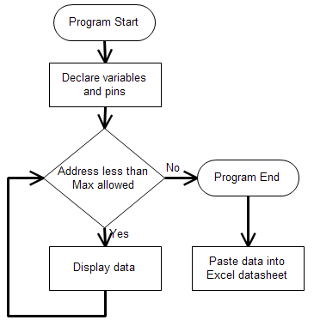
4.4.2.3 Post Flight

Post flight data analysis will be done on Excel, but this program transports the data from the EEPROM to the host computer with Excel. Figure 4-14 shows the post flight software.

The software will display the data delimited by commas. From this display, we can copy and paste the data into Microsoft Excel. Excel has the capabilities to perform the conversion from raw ADC counts to percent relative humidity, temperature, and pressure.

LaACES management will provide a flight profile of altitude vs time. From this profile, we can determine the altitude of each measurement.
Figure 4-14: Post-flight software flowchart

4.5 Thermal Design

The payload will be in flight for approximately four hours reaching an altitude of about 30.5 km. During flight the payload will be subjected to extreme temperature conditions. Based on information gathered in the science background, the payload will have to survive temperatures ranging from approximately -70ºC to 25ºC.

The sensors in the payload need to be able to operate properly in these extreme conditions. The thermal operating ranges for the components is as follows:
ADC, RTC, BASIC Stamp, EEPROM | Pressure Sensor | Humidity Sensor | Temp. Sensor | Camera | Energizer Lithium Batteries  (AA, AAA)
-40°C to 85°C | -20°C to 85°C | -40°C to 85°C | -65°C to 200°C | -20°C to 100°C | -40°C-60°C

Table 4-4: BalloonSat device ranges

The payload box will be constructed from a foam material with a very low thermal conductivity. Therefore the box should properly insulate the inside and maintain any heat produced by the electronics. Further testing needs to be done in order to determine whether this is enough to keep the internal temperature within the operating range. If it is not then an internal heat source will need to be added when the temperature drops below the operational range.
4.6 Mechanical Design

This section describes team Philosohook’s mechanical layout, payload weight, mechanical stresses and design, and materials. The mechanical layout describes the shape and size of the payload in order to insure that the components are safe during flight and landing. Due to constraints of the balloon used to fly the payload, the payload must not weigh more than 800 gr. The payload’s design also takes into account thermal conditions and landing stress. Vacuum, thermal, and shock tests will be performed to verify the safety and structural integrity of the payload. The payload box will be made out of Styrofoam and wrapped in aluminized Mylar.

4.6.1 External Structure

The payload shape will take on the shape of a regular hexagonal cylinder because it is the most efficient balance of volume and structural safety. The payload will have a lid on both ends, one of which will be glued in place and the other will be fastened with duct tape. The purpose of the duct tape is to allow the team to open the payload and retrieve any components after payload testing and during payload recovery after flight. The shell will have two holes 17 cm apart to run through the height of the payload structure to allow for strings that attach to the balloon vehicle. The lid will have two holes, one to allow the temperature and humidity probes to take the outside temperature and humidity and one for the camera to take video. The payload will measure 21 cm in length in order to allow adequate room for the internal structure of the payload.

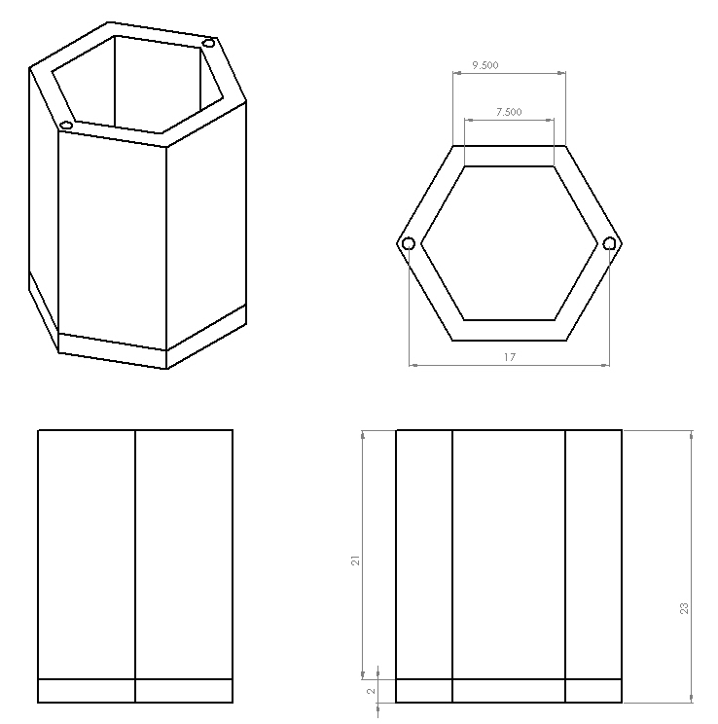
Figure 4-15: Shows the external structure of the payload

4.6.2 Internal Structure

The internal structure of the payload includes the BalloonSat with sensors, the power supply, and signal conditioning board. All of these components will be attached to a piece of balsa wood 7.5 cm wide and 21 cm high so that it will fit securely against one of the inner walls of the box except for one temperature sensor which will extend to the hole cut out in the lid of the box so that external temperature and humidity can be measured. The camera and its power supply will be attached to another wall as to have a good distribution of weight.

4.6.3 Weight Budget

The weight budget for this project is 800 grams. All components will be directly measured for weight or estimated based on prototypes of the individual components. Table 4-5 shows each component, its weight with error, and if the weight was measured directly or estimated.

Component | Weight (g) | Uncertainty (+/-g) | Measured or estimated
BalloonSat | 65.0 | 2 | Measured
Power Supply | 104.3 | 2 | Estimated
Signal Conditioning Board and sensors | 65 | 5 | Estimated
Foam Structure | 150 | 15 | Estimated
Camera | 175 | 5 | Estimated
Total | 559.3 | 16.8
Table 4-5: Weight budget

5.0 Payload Development Plan

For our project to move to the CDR stage we must know all of the specifications for the parts of our project which involves prototyping the circuitry and payload design. Sensors for temperature, pressure, and humidity must be known in order to properly use them for prototyping including how much power is needed, how the signal must be conditioned, and how much memory is needed for this project. Circuitry will be tested on a solderless breadboard before being integrated onto the BalloonSat to ensure that it works correctly. Finally, we will make a prototype of the payload box in order to make sure that it stays within the size constraints of the testing chambers and the balloon vehicle.

5.1 Electrical Design Development

- Research of sensors must be done to find the best choice of sensors for the payload.
- Once sensors are finalized the other circuitry required to interface the sensor to the BalloonSat should be determined based on the requirements.
- Each sensor should be tested and calibrated to determine actual accuracy and measurement capablities.
- Each sensor should be shock tested and cold tested.
- Once the circuit schematics are developed an exact power budget should be determined.

5.2 Software Design Development

- Pre-existing software will be adapted or new software will be written for each program specified
- Programs will be loaded into a test balloonsat board
- Debug program and repeat previous step as necessary
- Build temporary prototype to solder less breadboard
- Compare software output to hardware input to check for consistency

5.3 Mechanical Design Development

In order to get the final mechanical drawings, component layout, and weight table required for the CDR we must build a prototype payload box and submit it to shock, thermal, and vacuum tests. If the payload breaks under the shock test then we must reconsider the shape of the payload for one that can withstand stress better. When going through the thermal test, if any of the electronic components such as the sensors malfunction inside of the box then we will add more insulation or choose sensors that can operate at lower temperatures. Also if any of the components, including the electronic components, sensors, and even the box itself, malfunction or break due to the low pressure, new components will have to be selected and integrated into the payload that work in extremely low pressure environments. When all of these tests have been performed and the payload box and circuitry are satisfactorily changed until they work, the individual parts will be weighed for an accurate weight table.

5.4 Mission Development

To move closer towards a flight-ready payload, several issues need to be investigated. First, the sensors must be calibrated to the proper ranges of values we expect to encounter. Components must also be tested to see if they will function during the balloon flight conditions. This will be achieved during the low-temperature and low-pressure tests. A chart must be developed to progress mission development towards CDR including prototyping, fabricating, calibrating, and testing.

8.0 Project Management

The purpose of this section is to ensure this project meets the experiment’s objectives within the allocated schedule and budget. This includes discussion of project direction, authorization, communication, meeting, reviews, record keeping, and monitoring. In order to ensure proper project direction, the team will refer to its purpose, goals, and objectives contained in sections 1 and 3 earlier in this report. Authority and major decisions are made by the project manager in conjunction with all team members. Any disputes are resolved by a vote with majority rule. In the case of a tie the dispute will be brought to one of the ACES project managers to settle the dispute.

Team Philosohook meets every Tuesday and Thursday from 6:00 pm until 8:00 pm and Wednesdays from 6:00 pm until 7:00 pm. Team members work additionally at their own discretion in order to meet the project timeline. A log book resides in the ACES lab and each member is required to sign in and briefly describe what they did each time they work. Failure by an individual to uphold their part of the project results in disciplinary action as defined by the team contract.

8.1 Organization and Responsibilities

Member | Responsibility | Email
Hannah Gardiner | Project Management | hgardi1@tigers.lsu.edu
Bill Freeman | Software Design | billfreeman44@yahoo.com
Randy Dupuis | Electrical Design | rdupui4@tigers.lsu.edu
Andrea Spring | Mechanical Design | aspri11@tigers.lsu.edu
Corey Myers | Testing and Implementation | cmyer14@tigers.lsu.edu
Table 8-1: Team members, their responsibilities, and email addresses

8.2 Configuration Management Plan

Any major change in mechanical design, electrical design, or software design will be submitted by the team member in charge of the respective section to the rest of the team members. After the pros and cons are weighed the team will put the design change up to a vote decided by majority rule. If the team cannot reach a consensus or the vote ties, then ACES staff will be contacted to help resolve the issue. The Project Manager then records the changes in the log book.

8.3 Interface Control

All team members meet in the ACES lab in Nicholson Hall at LSU. Team members consult each other regarding any effects that their section has on another team member’s section if needed. All major changes will be documented in the log book and discussed at team meetings.

9.0 Master Schedule

This section describes how team Philosohook will organize and manage the effort associated with our payload. Microsoft Project was used to organize our Work Breakdown Structure and Timeline.

9.1 Work Breakdown Structure (WBS)

1.Electronics 12 days
1.1 Electronics Design 6.5 days
1.1.1 Sensor Selection 1.0 days
1.1.2 Parts Selection 1.5 days
1.1.3 Circuit Design 2.0 days
1.1.4 Power budget 1.0 days
1.1.5 Circuit Schematic Drawn 1.0 days
1.2 Electronics Prototyping 6.0 days
1.2.1 Constructing subsystem Prototypes 0.5 days
1.2.1.1 Construct Temperature System Prototype 0.5 days
1.2.1.2 Construct Pressure System Prototype 0.5 days
1.2.1.3 Construct Humididty System Prototype 0.5 days
1.2.2 Test subsystem Prototypes 0.5 days
1.2.2.1 Test Temperature System Prototype 0.5 days
1.2.2.2 Test Pressure System Prototype 0.5 days
1.2.2.3 Test Humididty System Prototype 0.5 days
1.2.3 Develop Sensor Prototype 1.5 days
1.2.3.1 Construct Prototype 1.0 days
1.2.3.2 Test Prototype 0.5 days
1.2.4 Power Supply during flight 1.5 days
1.2.4.1 Finalization of values for Power Supply 1.0 days
1.2.4.2 Interface Power Supply with Prototype 0.5 days
1.2.5 Test Full Prototype 1.0 days
2. Mechanical 16 days
2.1 Design 2.0 days
2.1.1 External Design 1.0 days
2.1.2 Internal Design 1.0 days
2.2 Construction 8.0 days
2.2.1 External Construction 3.0 days
2.2.1.1 Build payload box 2.5 days
2.2.1.2 Cut holes for sensors and camera 0.5 days
2.2.2 Internal Construction 5.0 days
2.2.2.1 Build insert for BalloonSat 2.0 days
2.2.2.2 Install sensors, BalloonSat and camera 3.0 days
2.3 Testing 6.0 days
2.3.1 Sensor and camera testing 2.0 days
2.3.2 Impact testing 1.0 days
2.3.3 Thermal testing 1.0 days
2.3.4 Vacuum testing 1.0 days
3. Software 12 days
3.1 Write Subroutine Flowcharts 3 days
2.1.1 Pre Flight Subroutine Flowcharts. 1 days
2.1.2 During Flight Subroutine Flowcharts 1 days
2.1.3 Post Flight Subroutine Flowcharts 1 days
3.2 Software writing 4.5 days
2.2.1 Pre Flight 1.5 day
2.2.2 During Flight 1.5 day
2.2.3 Post Flight 1.5 day
3.3 Testing 4.5 days
2.3.1Pre Flight 1.5 day
2.3.2 During Flight 1.5 day
*depends on electrical prototype
2.3.3 Post Flight 1.5 day

9.2 Staffing Plan

Primary Roles:
Spokesperson Project Lead – Hannah Gardiner
Mechanical Design Lead – Andrea Spring
Testing and Implementation – Corey Myers
Software – Bill Freeman
Electrical Design Lead – Randy Dupuis
Editing Lead – Hannah Gardiner

Secondary Roles:
Secondary Project Lead – Andrea Spring
Secondary Mechanical Design Lead – Corey Myers
Secondary Testing and Implementation Lead – Hannah Gardiner
Secondary Software – Randy Dupuis
Secondary Electrical Design – Bill Freeman
Secondary Editing – Bill Freeman

9.3 Timeline and Milestones

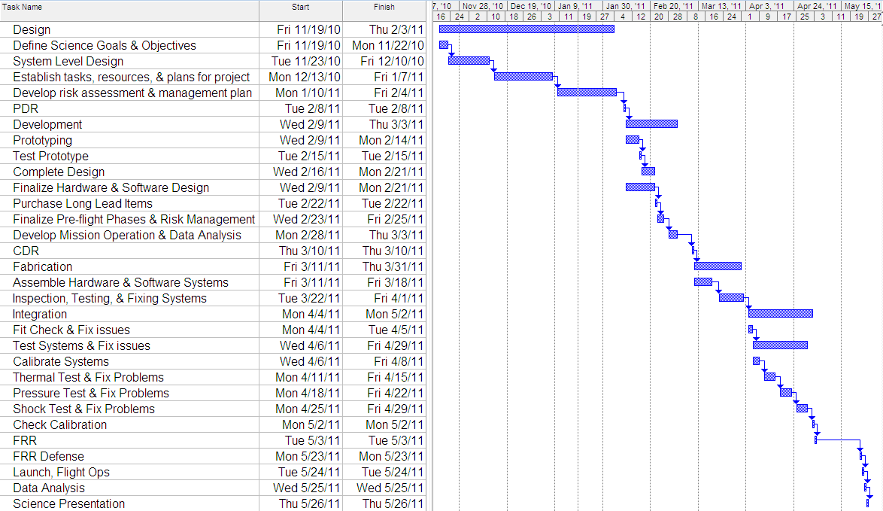
Figure 9-1: Gantt chart showing the overall project timeline

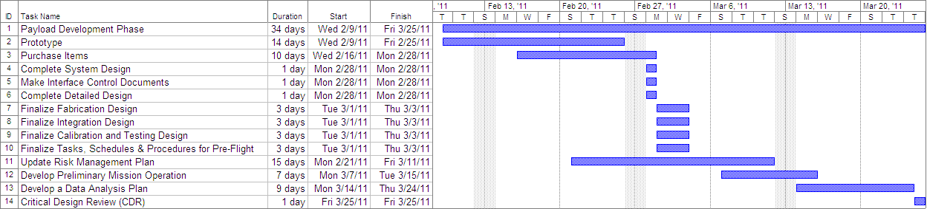
Figure 9-2: Gantt chart showing the Payload Development Phase timeline
11.0 Risk Management and Contingency

Likelihood, impact, and detection difficulty are estimated on a scale of 1 to 5, one being the least likely to happen or the least impact and five being the most likely to happen or the highest impact.
System | Risk | Likelihood | Impact | Detection Difficulty | When
Software | - | - | - | -
 | Loading of the wrong program to the payload | 1 | 5 | 3 | Pre-Flight
 | Forget to load program into payload | 1 | 5 | 1 | Pre-Flight
 | Running out of memory | 4 | 3 | 1 | During flight
 | Temporary power failure | 3 | 4 | 4 | During flight
Mechanical | - | - | - | -
 | Payload box breaks upon landing | 3 | 3 | 2 | Touchdown
 | Lid comes off of box during flight | 1 | 4 | 3 | During flight
 | Lack of insulation | 1 | 5 | 3 | Box production
 | Payload breaks during flight due | 1 | 5 | 5 | During flight
Electrical | - | - | - | -
 | Condensation forming on payload electronics | 4 | 4 | 5 | During flight
 | Components fail during flight | 2 | 4 | 2 | During flight
 | Sensor fail during flight | 2 | 4 | 2 | During flight
 | Short circuit in payload | 2 | 4 | 4 | During flight
 | Bad connection during fabrication | 2 | 4 | 4 | Fabrication
 | Camera failure | 2 | 5 | 3 | During flight
Other | - | - | - | -
 | Going over money budget | 1 | 5 | 3 | Fabrication
 | Going over weight budget | 2 | 5 | 3 | Fabrication
 | Payload enters clouds | 3 | 3 | 2 | During flight
 | Solar flares | 1 | 4 | 5 | During flight
 | Ice forming on payload | 2 | 4 | 5 | During flight
 | Balloon Vehicle is lost | 1 | 5 | 1 | Touchdown

Risk Event | Response | Contingency | Trigger | Who is Responsible
Loading of the wrong program to the payload | Reload | Check program before flight | Lapse in concentration | Bill
Forget to load program into payload | Reload | Check payload before flight | Lapse in concentration | Bill
Running out of memory | Restart program before launch | Use larger EEPROM | Starting flight program too early or late balloon launch | Bill or ACES mangement
Temporary power failure
Payload box breaks upon landing |  | Shock test |  | Corey, Andrea
Lid comes off of box during flight |  | Duct tape to secure the lid
Lack of insulation |  | Thermal Test |  | Corey, Andrea
Payload breaks during flight due |  | Vacuum test |  | Corey, Andrea
Condensation forming on payload electronics |  | Coat parts and secure with foam
Components fail during flight |  | Test all components before flight |  | Corey,
Sensor fail during flight |  | Test all sensors before flight |  | Corey
Short circuit in payload |  | Perform shock test on components |  | Corey
Bad connection during fabrication |  | Follow schematic when building payload |  | Andrea, Randy
Camera failure |  | Check camera functionality and battery pack before flight |  | Corey,
Going over money budget |  | Choose less expensive parts |  | Hannah
Going over weight budget |  | Choose lighter parts |  | Hannah
Payload enters clouds |  | Visual conformation with camera to determine enter and exit time
Solar flares |  | Check solar activity for predicted influence
Ice forming on payload |  | Ample foam to insulate payload |  | Andrea
Balloon Vehicle is lost

12.0 Glossary

%rel Percent relative humidity
AC Alternating Current
ADC Analog to Digital Converter
Atm Atmosphere
CCD Charge Coupled Device
CDR Critical Design Review
CMOS Complementary metal oxide semiconductor
EEPROM Electrically Erasable Programmable Read-Only Memory
ESRL Earth System Research Laboratory
FRR Flight Readiness Review
GMD Global Monitoring Division
HD High Definintion
Hum Humidity
Km Kilometer
LAACES Physics & Aerospace Catalyst Experiences in Research
LSU Louisiana State University
NASA National Aeronautics and Space Administration
NOAA National Oceanic and Atmospheric Administration
PDR Preliminary Design Review
RTD Resistant temperature detectors
TBD To be determined
TBS To be supplied
Temp Temperature
USAF United States Air Force
V Volts
WBS Work breakdown structure

