LaACES Program
Flight Readiness Review Document
for the

PHAT-TACO: Pressure, Humidity, And Temperature Tests And Camera Observations
Experiment
by
Team Philosohook
Prepared by:
Hannah Gardiner Date

Randy Dupuis Date

Bill Freeman Date

Corey Myers Date

Andrea Spring Date
Submitted: 5/21/2011
Reviewed:
Revised:
Approved:
Dr. Guzik: Date

Institution Signoff Date

LAACES Signoff Date

Change Information Page

Title: FRR Document for PHAT-TACO Experiment
Date: 05/21/2011

List of Affected Pages
Page Number | Issue | Date
4 | Rearranged Science background | 3/31/11
4 | Added atmospheric image (3-1) | 3/31/11
8 | Added Radius vs. Altitude image | 3/31/11
18 | Temperature Sensor Interface Circuit Schematic Updated | 4/02/11
19 | Pressure Sensor Interface Circuit Schematic Updated | 4/02/11
19 | Humidity Sensor Interface Circuit Schematic Updated | 4/02/11
21 | Full Circuit Schematic Updated | 4/02/11
43 | Added error calculation to ADC conversions | 4/04/11
29 | Added X,Y, and Z timing calibration flowchart | 4/04/11
41 | Updated Humidity calibration description and add equation to calculate RH | 4/04/11
41 | Added camera timing calibration description to calibration section | 4/04/11
21 | Updated Power Supply section | 4/04/11
16 | Testing procedures updated | 4/04/11
19 | Calibration procedure updated | 4/04/11
61 | Temperature testing procedure updated | 4/13/11
68 | Added instructions on how to use Term232 | 4/30/11
45 | Calibration Results updated | 5/1/11
24 | Updated Pre-Flight software figure | 5/5/11
25 | Updated During-Flight software figure | 5/5/11
71-118 | Added Software code to Appendix | 5/5/11
24 | Removed user input after timestamp on the Pre-Flight Software description | 5/5/11
25 | Fixed logic errors in During-Flight software | 5/5/11
26 | Added LED flashing to During-Flight software | 5/5/11
40 | System testing results updated | 5/5/11
32 | Table 4-5 added | 5/7/11
33-34 | Figures 4-16 and 4-18 updated | 5/7/11

Status of TBDs

TBD  Number | Section | Description | Date  Created | Date Resolved
1 | 4.3.2 | Resistor Value for Pressure Sensor | 3/23/11 | 4/18/11
2 | 4.3.4 | Size of Fuses for Power Supplies | 4/04/11 | 4/18/11

Table of Contents
Change Information Page ii
Status of TBDs iii
Table of Contents iv
List of Figures vi
List of Tables vi
1.0 Document Purpose 1
1.1 Document Scope 1
1.2 Change Control and Update Procedure 1
2.0 Reference Documents 1
3.0 Goals, Objectives, Requirements 3
3.1 Mission Goal 3
3.2 Objectives 3
3.2.1 Science Objectives 3
3.2.2 Technical Objectives 4
3.3 Science Background and Requirements 4
3.3.1 Science Background 4
3.3.1.1 Temperature, Pressure, and Humidity of the Atmosphere 4
3.3.1.2 Clouds 6
3.3.1.3 Balloon Expansion 7
3.3.2 Science Requirements 9
3.4 Technical Background and Requirements 9
3.4.1 Technical Background 9
3.4.1.1 Sensor Background 9
3.4.1.2 Payload Placement 11
3.4.1.3 Precision of measurements 12
3.4.2 Technical Requirements 13
4.0 Payload Design 13
4.1 Principle of Operation 13
4.2 System Design 14
4.2.1 Functional Groups 15
4.2.2 Group Interfaces 15
4.2.3 Traceability 15
4.3 Electrical Design 17
4.3.1 Sensors 17
4.3.2 Sensor Interfacing 17
4.3.3 Control Electronics 20
4.3.4 Power Supply 22
4.3.5 Power Budget 22
4.4 Software Design 24
4.4.1 Data Format & Storage 24
4.4.1.1 BalloonSat Data Storage 24
4.4.1.2 Video Data Storage 25
4.4.2 Flight Software 25
4.4.2.1 Pre-Flight 25
4.4.2.2 During-Flight program and subroutines 26
4.4.2.3 Post-flight program 30
4.4.2.4 Calibration Programs 30
4.5 Thermal Design 31
4.6 Mechanical Design 33
4.6.1 External Structure 33
4.6.2 Internal Structure 35
4.6.3 Mass Budget 36
5.0 Payload Development Plan 37
5.1 Electrical Design Development 37
5.2 Software Design Development 37
5.3 Mechanical Design Development 37
5.4 Mission Development 37
6.0 Payload Construction Plan 38
6.1 Hardware Fabrication and Testing 38
6.2 Integration Plan 38
6.3 Flight Software Implementation and Verification 39
6.4 Flight Certification Testing 39
6.4.1 System Testing Procedures 40
6.4.2 System Testing Results 41
7.0 Mission Operations 47
7.1 Pre-Launch Requirements and Operations 47
7.1.1 Calibrations 48
7.1.1.1 Calibration Procedures 49
7.1.1.2 Calibration Results 50
7.1.2 Pre-Launch Checklist 54
7.2 Flight Requirements, Operations and Recovery 55
7.3 Data Acquisition and Analysis Plan 55
7.3.1 Ground Software 55
7.3.2 Ground Software Implementation and Verification 57
7.3.3 Data Analysis Plan 58
8.0 Project Management 60
8.1 Organization and Responsibilities 60
8.2 Configuration Management Plan 60
8.3 Interface Control 61
9.0 Master Schedule 61
9.1 Work Breakdown Structure (WBS) 61
9.2 Staffing Plan 63
9.3 Timeline and Milestones 63
10.0 Master Budget 63
10.1 Expenditure Plan 64
10.2 Material Acquisition Plan 64
11.0 Risk Management and Contingency 65
12.0 Glossary 68

List of Figures

3-1: Temperature, pressure, and humidity as a function of altitude 4
3-2: Temperature, pressure, and humidity as a function of altitude 5
3-3: Balloon Radius vs. Altitude ...7
3-4: Ascent curves from ACES-16 8
3-5: Three potential camera positions for viewing the balloon 11
4-1: High level system design 14
4-2: Temperature Sensor Interface 18
4-3: Pressure Sensor Interface 19
4-4: Humidity Sensor Interface 19
4-5: Camera Interface 20
4-6: Full Circuit Schematic 21
4-7: Flight Power Distribution 22
4-8: Milliamp-Hours Capacity of AA and AAA batteries 23
4-9: Energizer AAA discharge curve 24
4-10: Energizer AA battery capacity 24
4-11: Pre-flight software flowchart 25
4-12: During-flight software flowchart 26
4-13: Start Camera and Stop Camera subroutine flowcharts 27
4-14: Take data subroutines 29
4-15: Post-flight software flowchart 30
4-16: External structure of the payload 34
4-17: Finished external structure of the payload 34
4-18: Front internal structure view 35
4-19: Internal views of the built payload 36
6-1: Shock test results .41
6-2: Thermal test results .43
6-3: Vacuum test results .45
7-1: Temperature calibration results 50
7-2: Pressure calibration results 52
7-3: Humidity calibration results 53
7-4: Scaled, cropped images used for the tests 54
7-5: Balloon Radius calculator 57
9-1: Gantt chart showing the overall project timeline 63

List of Tables

3-1: Correlation between temperature and humidity 12
4-1: Traceability matrix 15
4-2: Power budget with camera data from Knoxville College 22
4-3: Meaning and cause of each possible camera status byte 28
4-4: BalloonSat device ranges 31
4-5: Thermal Calculations 32
4-6: Mass budget 36
7-1: ADC Counts and the corresponding temperature 51
7-2: ADC Counts and the corresponding pressure 52
7-3: ADC Counts and the corresponding humidity 53
7-4: Pre-launch checklist with expected time needed to fulfill each duty 54
8-1: Team members, their responsibilities, and email addresses 60
10-1: Master Budget 63
10-2: Expenditure Plan 64
10-3: Material Acquisition Plan 64
11-1: Risk Management 65
11-2: Risk Contingency 66

1.0 Document Purpose

This document describes the design for the PHAT-TACO: Pressure, Humidity, and Temperature tests and Camera Observations experiment by Team Philosohook for the LaACES Program. It fulfills part of the LaACES Project requirements for the Flight Readiness Review (FRR) to be held May 23, 2011.

1.1 Document Scope

This FRR document specifies the scientific purpose and requirements for the video, temperature, pressure, and humidity experiment and provides a guideline for the development, operation and cost of this payload under the LaACES Project. The document includes details of the payload design, fabrication, integration, testing, flight operation, and data analysis. In addition, project management, timelines, work breakdown, expenditures and risk management are discussed.

1.2 Change Control and Update Procedure

Changes to this FRR document shall only be made after approval by designated representatives from Team Philosohook and the LaACES Institution Representative. Document change requests should be sent to team members and the LaACES Institution Representative and the LaACES Project.

2.0 Reference Documents

[1] U.S. Standard Atmosphere, 1976, U.S. Government Printing Office, Washington, D.C., 1976.

[2] Oolman, Larry. "Atmospheric Soundings." Wyoming Weather Web. Web. 28 Nov. 2010. <http://weather.uwyo.edu/upperair/sounding.html>.

[3] "Earth's Atmosphere." NASA. Web. 23 Nov. 2010. <http://www.nasa.gov/audience/
forstudents/9-12/features/912_liftoff_atm.html>.

[4] "Layers of the Earth's Atmosphere: Troposphere, Stratosphere, Mesosphere, Thermosphere, and Exosphere." Windows to the Universe. Web. 23 Nov. 2010. <http://windows2universe.org/earth/Atmosphere/layers.html>.

[5] Gyatt, Graham. "The Standard Atmosphere." Atmosculator. 24 Apr. 2009. Web. 28 Nov. 2010. <http://www.atmosculator.com/The Standard Atmosphere.html>.

[6] Shelquist, Richard. "An Introduction to Air Density and Density Altitude Calculations." Shelquist Engineering. 2 Aug. 2010. Web. 28 Nov. 2010. <http://wahiduddin.net/calc/
density_altitude.htm>.

[7] "Cloud Types." Windows to the Universe. Web. 23 Nov. 2010. <http://windows2universe.
org/earth/Atmosphere/clouds/cloud_types.html>.

[8] "Cloud." Atmosphere. Cislunar Aerospace, Inc., 02 Jul 1997. Web. 01 Nov 2010. <http://wings.avkids.com/Book/Atmosphere/instructor/clouds-01.html>.

[9] "Types of Temperature Sensors." About Temperature & Moisture Sensors Devices & Uses in Measurement. Web. 23 Nov. 2010. <http://www.temperatures.com/sensors.html>.

[10] "Fundamentals of Pressure Sensor Technology." Sensors Magazine. Web. 23 Nov. 2010. <http://www.sensorsmag.com/sensors/pressure/fundamentals-pressure-sensor-technology-846>.

[11] "Choosing a Humidity Sensor: A Review of Three Technologies." Sensors Magazine. Web. 23 Nov. 2010. <http://www.sensorsmag.com/sensors/humidity-moisture/choosing-a-humidity-sensor-a-review-three-technologies-840>.

[12] "Camera Selection Advice Guide." Sensorland. N.p., 2010. Web. 30 Oct 2010. <http://www.sensorland.com/HowPage066.html>.

[13] Fetkowitz, Paul. "Sounding Balloons." Kaymont Meteorological Balloons. Web. 07 Feb. 2011. <http://www.kaymont.com/pages/sounding-balloons.cfm>

[14] Fetkowitz, Paul. "Shape and Quality." Kaymont Meteorological Balloons. Web. 14 Mar. 2011. <http://www.kaymont.com/pages/shape.cfm>

[15] Benson, Tom. "Shape Effects on Drag." NASA. 23 Aug. 2010. Web. 07 Feb. 2011. <http://www.grc.nasa.gov/WWW/K-12/airplane/shaped.html>.

[16] Everett, Carter. "Generating Gaussian Random Numbers, Taygeta Scientific Inc." Taygeta Scientific Incorporated. Web. 04 Mar. 2011. <http://www.taygeta.com/random/gaussian.html>.

[17]Sept. 2010. “1230 Ultratable”. Measurement Specialties. Web. Mar 24, 2011. <http://www.meas-spec.com/downloads/1230.pdf>.

[18] Honeywell Internatinal Inco. “HIH-4000 Series Humidity Sensors”. Honeywell Sensing and Control. Web. 01 Mar. 2011. <http://www.sensing.honeywell.com/>

[19] "Zx1 Pocket Video Camera, Digital Video Camera, HD Video Camera - Kodak Online." Digital Cameras, Digital Photo Frames, Video Cameras, Printers & Accessories - Kodak Store. Web. 01 Mar. 2011. <http://store.kodak.com/store/ekconsus/en_US/pd/
Zx1_Pocket_Video_Camera/productID.145117100>.

[20] Bullard, Denae, DeAnna Anderson, Munshi Idris, and Caitlin Johnson. PACER Program Flight Readiness Review Document for the Measuring Temperature, Pressure, and Humidity and Increasing Altitudes Experiment. Tech. Print.

[21] "Energizer Technical Information." Energizer Technical Information. Web. 02 Feb. 2011. <http://data.energizer.com/SearchResult.aspx>.

[22] LaACES Management. “LaACESSteadyState_Flight.” Excel Spreadsheet. Dr. T. G. Guzik.

[23] 2002. “1N457/A”. Fairchild Semiconductor. Web. Mar. 18, 2011. <
http://www.
datasheetcatalog.org/datasheet/fairchild/1N457.pdf>.

[24] “Activity E7c. Sensors and Signal Conditioning.” Fall 2010. LaACEs. LSU. Baton Rouge, La.

[25] Breuer, Hans. "Dia." Home - GNOME Live! 1 Jan. 2011. Web. 24 Mar. 2011. <http://live.
gnome.org/Dia>.

[26] Bolton, David. “The Computation of Equivalent Potential Temperature”. Monthly Weather Review. Vol.108, No. 7 (july) p. 1047.

[27] Aug. 2010. “3299 - 3/8 ” Square Trimpot Trimming Potentiometer”. Bourns Inc. Web. April 4, 2011. <http://www.bourns.com/pdfs/3299.pdf>.

[28] "Atmospheric Gases, Temperature, and Pressure." Wyckoff School District of NJ. Web. 05 Apr. 2011. <http://www.wyckoffschools.org/eisenhower/teachers/chen/atmosphere/
earthatmosphere.htm>.

3.0 Goals, Objectives, Requirements

3.1 Mission Goal

To study the layers of the atmosphere using an instrumented sounding balloon flown in East Texas during May and to analyze the balloon and the environment surrounding the payload in order to study the relationship between the temperature and humidity profiles acquired during flight.

3.2 Objectives

The overall objective is to measure and record humidity, pressure, and internal and external temperature on a sounding balloon flight while taking video of the flight.

3.2.1 Science Objectives

- Determine at what altitude the Tropopause is located
- Characterize temperature, pressure, and humidity in the atmospheric layers
- Determine if the payload passes through clouds
- Determine balloon diameter as a function of altitude

3.2.2 Technical Objectives

- Build a working payload that can withstand conditions of a balloon flight
- Record temperature, pressure, and relative humidity for the duration of flight
- Determine at what altitude the payload enters and exits clouds
- Determine the radius of the balloon at several altitudes
- Document the PHAT-TACO experiment

3.3 Science Background and Requirements

3.3.1 Science Background

3.3.1.1 Temperature, Pressure, and Humidity of the Atmosphere

The atmosphere of the Earth consists of four layers (Troposphere, Stratosphere, Mesosphere, and Thermosphere) and four transition layers (Tropopause, Stratopause, Mesopause, Thermopause), determined by a combination of temperature change, chemical composition, and density. Figure 3-1 shows the layers of the atmosphere.

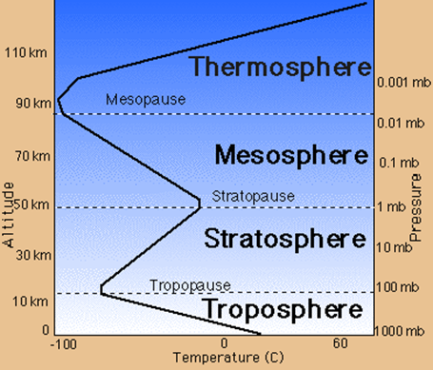
The Troposphere starts at the Earth’s surface and extends upward 15 kilometers, making it the lowest layer of the atmosphere. This layer contains most of the gas in the atmosphere making it the densest layer. The temperature starts at an average of 17 °C on the surface and decreases to -52 °C at the Tropopause, the boundary that separates the Troposphere from the layer above [3]. The height of the Tropopause varies depending on the latitude, season and time of day. The Tropopause is approximately 20 km above sea level near the equator [4]. The combination of Troposphere and Tropopause is called the lower atmosphere [3].

Figure 3-1 Temperature, pressure, and humidity as a function of altitude [28]

The Stratosphere, the second layer of the atmosphere, ranges from 15 to 50 kilometers. Because of higher altitude, the Stratosphere contains less humidity and has a lower pressure than the Troposphere. The temperature of the Stratosphere increases from -52° to -3° C, starting at the Tropopause and ending at the Stratopause, due to the presence of the ozone layer, made from a special form of oxygen called ozone. The ozone layer absorbs the ultraviolet radiation from the sun and causes an increase in temperature [4].

National Oceanic and Atmospheric Administration (NOAA), National Aeronautics and Space Administration (NASA), and the United States Air Force (USAF) developed the “US Standard Atmosphere” in 1976. Using only the ideal gas law and the hydrostatic equilibrium law, they produced a mathematical model of the atmosphere. This model is “a hypothetical vertical distribution of atmospheric temperature, pressure, and density…representative of year-round mid-latitude conditions” [1]. Using this model and prior studies of the atmosphere, we can predict the range and precision of measurements that we must take.

The US Standard Atmosphere predicts that the Tropopause should be between 11 and 20 km, however this is only an approximation and the actual location of the Tropopause changes by season and latitude. More accurately, the US Standard Atmosphere defines layers by the rate of change of temperature with altitude, or lapse rate. The lapse rate is -6.5 °C/km in the Troposphere, 0.0 °C/km in the Tropopause and 1.0 °C/km in the lower Stratosphere. We can determine which layer of the atmosphere we are in by measuring lapse rate and comparing the expected value to the lapse rate value predicted by the US Standard Atmosphere.

Figure 3-2: Temperature (A), pressure (B), and humidity (C) as a function of altitude from NOAA
data taken on May 23, 2010 from Fort Worth, Texas [2]

There are several trends present in the temperature profile of the NOAA data in Figure 3-2A. In the Troposphere, between 0 and 16 km, the temperature decreases linearly. In the Tropopause, between 16 and 18 km, the temperature does not change. Finally, in the Stratosphere, between 18 and 32 km, the temperature increases linearly. Based on U.S. Standard Atmosphere, we expect the absolute maximum temperature range to be between 45 and -86 ºC, but a more reasonable range based on prior data, as shown in Figure 3-2A, and the summer launch date would be between 30 and -70 °C [1, 2].

The US Standard Atmosphere models the pressure as a function of altitude from sea level to the Stratosphere [1, 5]. Because the temperature changes at varying rates throughout the atmosphere, the US Standard Atmosphere uses three equations, one for each layer. In Figure 3-2B, the NOAA data matches the expected values for pressure. The relative error averages 4% but increases in the Troposphere. The pressure ranges from 1 to 0.008 atm. To measure any deviations from the US Standard Atmosphere in the pressure profile, the uncertainty of the pressure must be ±0.004 atm.

When calculating the parameters in the standard atmosphere, the model assumes the air is completely dry, with 0% relative humidity [1]. Water vapor weighs less than the average air molecule. When the air is humid, its molecular weight decreases. The US Standard Atmosphere considered molecular weight to be a constant up to 84 km. Since humidity is not constant with altitude, it is important to study and characterize this property and how it influences the temperature and pressure of the atmosphere [6]. The NOAA data in Figure 3-2C shows the various features of the humidity profile versus altitude. The data ranged from 100 to 8 percent relative humidity (%rel). In order to properly characterize atmospheric humidity, we must take data that shows major changes in the profile.

As shown in Figure 3-2C, humidity changes the most drastically in the first 10 km of the atmosphere. The change in humidity peaks at 42 percent per kilometer. Since we do not understand the causes of the features in the humidity profile, we must take accurate humidity data with a high temporal resolution, especially at the beginning of the flight. From sea level to 11 km, data must be taken at least 30 times per kilometer or 10 times per minute assuming a 1,000 feet per minute ascent rate. Above 11 km, we do not need to take data at such a high frequency, because the rate of change in the humidity decreases. To simplify the software, we will only use one data acquisition rate, which will be one data point every six seconds for all sensors.

3.3.1.2 Clouds

Almost all clouds form in the Troposphere. Different cloud types form at different altitudes because of the varying density and temperature of the Troposphere. Clouds found near the surface (0 to 2 kilometers) include Cumulus and Cumulonimbus and are characterized by higher humidity. Clouds found higher up (2 to 7 kilometers) include Altostratus and Altocumulus. The third and highest (5 to 13 kilometers) cloud forms include Cirrus clouds [7].

There are two major types of clouds. The first type, clouds of vertical development, form because of the condensation of rising air. The second type, layered clouds, form because of the condensation of non-rising air [8].

Due to cloud composition, if our payload passes through a low cloud we expect the humidity to increase drastically but the temperature to remain relatively the same. However, if it passes through a high cloud, we expect the humidity to be mostly unaffected and the temperature to drop because of the surrounding ice crystals.

3.3.1.3 Balloon Expansion

We will use a Kaymont 3000 gm sounding balloon for lift. This balloon has a bursting radius of 13.00 meters at 37.9 km (124,000 ft) and 0.0037 atm [13]. The design of the Kaymont balloons keeps a “spherical shape… [and] consistent ascent rates under all conditions” [14].

When the balloon reaches constant velocity, all the forces acting on the balloon are equal. By setting the buoyant force of the balloon equal to the drag force and the weight, we can derive a relationship between expected radius and altitude (For full derivation, see Appendix A.4).

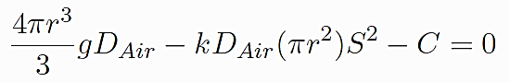

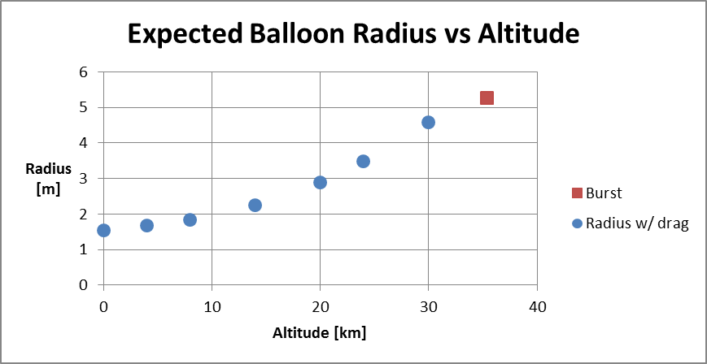
Figure 3-3: Balloon Radius vs Altitude

In this equation, D_{Air} is the density of air in kg/m³; g is gravitational acceleration in m/s²; C is the weight of the balloon, payloads and Helium in Newtons; and S is the speed of the balloon in m/s. The density of air can be estimated from the US Standard Atmosphere model, radius of the balloon will be measured from the video, the weight of the balloon, payloads and Helium should be known before launch, g is 9.81m/s², k is a geometrical factor which is between 0.07 and 0.5 for spheres [15], and the speed can be calculated from GPS data. The radius and density of air should be the only factors that change with height. Figure 3-3 shows the expected radius as a function of altitude using 0.5 for k.

The entire ACES program hinges on the performance and lift of a simple sounding balloon. The hopes and dreams of every ACES participant hinges on the lift from this balloon. Therefore, it is important to characterize the performance of the balloon.
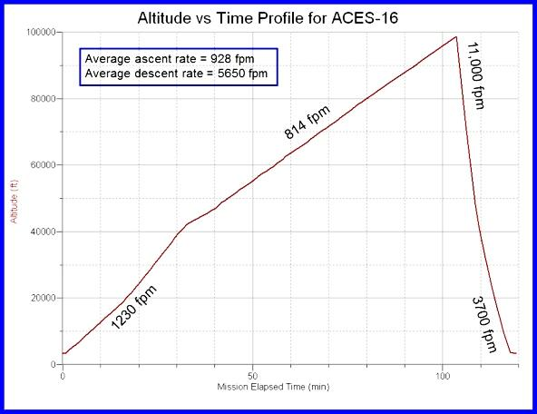
Figure 3-4: Ascent curve from ACES-16

Figure 3-4 shows the ascent curve of ACES-16. The ascent rate is supposed to be a constant, yet the ascent profile shows a change in ascent rate at an altitude of 40,000 feet.

3.3.2 Science Requirements

- We shall measure temperature, pressure, and humidity of the atmosphere every six seconds and record a timestamp for each of these measurements
- We shall calculate altitude using a timestamp from each data point and GPS data from the flight
- We shall identify layers of atmosphere using temperature lapse rate measurements
- We shall compare measured pressure with expected pressure of the US Standard Atmosphere
- We shall characterize features in the humidity profile
- We shall identify if the payload passes through a cloud and when it exits a cloud
- We shall measure radius of the balloon as a function of altitude and compare our measurements to the theoretical relationship discussed in the science background
- We shall determine any effects of passing through a cloud on temperature, pressure, and humidity readings
- We shall calculate altitude during the video

3.4 Technical Background and Requirements

3.4.1 Technical Background

3.4.1.1 Sensor Background

To study the atmospheric layers the payload needs to be able to measure various atmospheric conditions. Each characteristic: temperature, pressure, and humidity, requires a specific sensor, chosen based on measurement accuracy, expected range during flight, and cost.

Temperature sensors fall into two categories: contact sensors and non-contact sensors. Contact sensors work by measuring the difference of temperature between itself and its surroundings. There are different types of contact sensors, thermocouples, resistant temperature detectors (RTDs), and thermistors. Thermocouples work based on the Seebeck effect, the conversion of temperature differences into voltages. Thermocouples do not need batteries and can measure a wide range of temperatures. RTDs work by measuring the resistance increase with temperature. RTDs are the most accurate temperature sensors and they are easy to recalibrate, but they have a smaller range than thermocouples, are more expensive, and are not very sturdy. Thermistors work the same way as RTDs but are made of different materials. RTDs are usually made of pure metals and thermistors are made of a ceramic or polymer. Thermistors have a smaller range than RTDs but are extremely accurate. Non-contact sensors measure the thermal radiant power of the infrared or optical radiation that they receive from a target’s surface. Non-contact sensors cannot detect the temperature of a gas therefore; sensors would not be useful in studying the atmosphere [9].

Pressure sensors function by using different mechanical elements that are designed to deflect when pressure acts on the system. An electrical output is obtained by measuring the deflection and transducing the measurement to an electrical quantity. There are several types of pressure sensors: potentiometric sensors, inductive sensors, capacitive sensors, piezoelectric sensors, and strain gauge sensors. Potentiometric sensors will sense the pressure using a Bourdon tube, capsule, or bellow, and the pressure applied will change the resistance. In short, a potentiometer changes with pressure. These sensors are low cost, but have high repeatability errors. Inductive sensors measure movement of a diaphragm by changes in inductance. Capacitive sensors use a variable capacitor to measure the pressure. One plate of the capacitor is a diaphragm and the other plate of the capacitor is stationary. When pressure is applied, the diaphragm deflects which changes the distance between the two plates causing the capacitance to change. Piezoelectric elements consist of metalized quartz or ceramic material. These elements convert stress into an electric potential. These sensors only provide output when the input is changing so they only measure varying pressures. Strain gauge sensors use a metal diaphragm with strain gauges attached to it. The most common type of these sensors is piezoresistive-integrated semiconductors. These sensors incorporate four piezoresistors arranged in a Wheatstone Bridge. When stress is applied, the resistance changes and the pressure relates to the difference in the output voltages of the bridge. Temperature affects the output of these sensors [10].

There are three types of humidity sensors: capacitive, resistive, and thermal conductive. Capacitive sensors consist of a substrate, usually glass, ceramic, or silicon. These sensors are constructed by placing a thin film of metal oxide or polymer between two conductive electrodes on the substrate and have a capacitive output that changes linearly with the relative humidity. The sensor has a coating to protect the circuitry from humidity and contamination, can function in high temperatures, and can fully recover from condensation. Resistive humidity sensors measure humidity by using the change in impedance across a hygroscopic medium. Hygroscopy is the ability of a substance to attract water molecules from the surrounding environment. The change in impedance relates to the relative humidity in an inverse and exponential relationship. These sensors operate in temperatures ranging from -40 to 100 °C. Thermal conductive humidity sensors measure the absolute humidity by using the difference of the thermal conductivity of dry air and of air containing water vapor. These circuits operate in temperatures up to 300 °C but the temperature affects the output voltage [11].

High Definition (HD) video comes in two different resolutions, 720p at 1280x720 pixels and 1080p at 1920x1080 pixels. The 720p resolution uses 2-3 MB/s and the 1080p resolution uses 5-6 MB/s. The data rate varies because video cameras use a compression algorithm that changes storage based on what is recording.

The video camera will point upwards so that we can see when our payload moves into and out of clouds as well as determine the balloon radius. After we know the distance from the camera to the balloon, we can find the size of the balloon by counting the number of pixels contained in the balloon’s diameter. Calibration data will provide a conversion from pixels to meters. Using screenshots from the video at several heights, we will create a graph of radius vs. height. Clouds will obscure the view of the balloon if the balloon passes through them but we do not need the balloon’s radius at every frame.

3.4.1.2 Payload Placement

If the fully inflated balloon took up the full width of the image (1280 pixels), the angular resolution would give us 1300cm/1280px = 1.02 cm/pixel. At launch, the balloon will be near 200 cm, which will take up about 196 pixels.

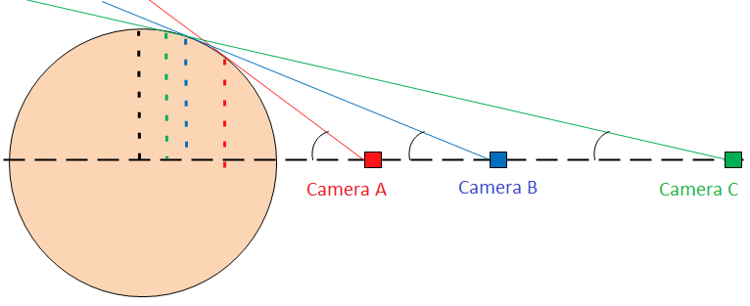
θ
R
r
θ
θ
r
r
Figure 3-5: Three potential camera positions for viewing the balloon

The position of the camera is critical so that we can accurately measure the size of the balloon. If the camera is too close, the apparent size of the balloon is not correct as described graphically in Figure 3-5. Camera A is too close to the balloon because the apparent radius (dashed red line) is much smaller than the actual radius (dashed black line). As cameras B and C show, the farther away the camera, the closer the measured radius will be to the actual radius of the balloon. There is a trigonometric relationship between camera distance and apparent radius.
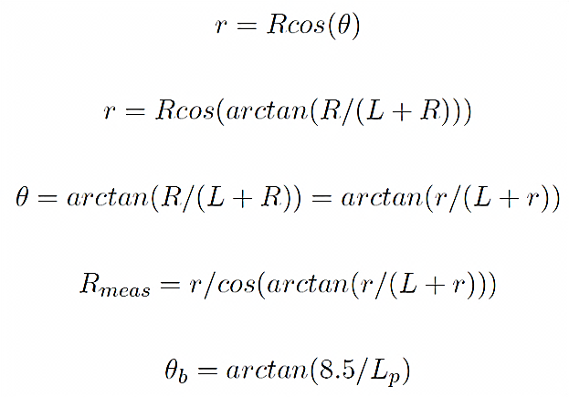
R is the actual radius of the balloon (black dashed line), θ is the viewing angle (black arc), r is the apparent radius measured by the camera (dashed lines), L is the distance from the edge of the balloon to the camera, and R_{meas} is the final radius after taking into account the geometry of the balloon.

The payload directly above the Philosohook payload will be obstructing part of the view. The angle blocked by a 17 cm square payload would be given by the following formula:

θ_{b} = arctan(8.5/L_{p})

θ_{b} is the angle blocked in one dimension and L_{p} is the distance to the next payload in cm. A distance of 50 cm will block 10 degrees, 75 cm will block 6 degrees, and 100 cm will block 5 degrees. Optimal placement will be determined on the day of the launch.

3.4.1.3 Precision of measurements

The correlation coefficient of two sets of data is indicative of how well one parameter influences the other. We find the percentage of correlation by squaring the correlation coefficient and multiplying by 100. A correlation of 80 percent is very strongly correlated, while 25 percent is a very poor correlation. In the NOAA data discussed previously, between 0 and 6 km, the temperature and humidity have a correlation of 80 percent, which is a very strong correlation. The purpose of measuring humidity is to see its effects on other properties. By assuming that our errors will follow a Gaussian distribution, we can add “fake” errors to the data with a set uncertainty [16]. After adding in these errors we measure the correlation again. If there is still a correlation, then our data can have that much uncertainty and still be able to measure this correlation.

 |  | Temperature Uncertainty in C
 |  | 0.1 | 0.3 | 0.6 | 0.9 | 1.2 | 1.5 | 2 | 2.5 | 3 | 4
Humidity  Uncertainty in % rel | 0.5 | 80 | 78 | 76 | 72 | 67 | 62 | 52 | 43 | 35 | 23
 | 1 | 80 | 78 | 76 | 72 | 67 | 62 | 52 | 44 | 35 | 23
 | 2 | 80 | 78 | 76 | 72 | 67 | 62 | 53 | 44 | 36 | 23
 | 3 | 79 | 78 | 75 | 71 | 67 | 62 | 53 | 44 | 36 | 23
 | 4 | 79 | 78 | 74 | 71 | 67 | 61 | 52 | 43 | 36 | 23
 | 5 | 78 | 77 | 74 | 71 | 66 | 61 | 52 | 43 | 35 | 23
 | 6 | 77 | 76 | 73 | 70 | 65 | 60 | 52 | 43 | 35 | 23
 | 7 | 76 | 75 | 72 | 69 | 65 | 60 | 51 | 42 | 35 | 23
 | 8 | 74 | 74 | 71 | 68 | 64 | 59 | 50 | 42 | 34 | 22
 | 9 | 73 | 72 | 70 | 67 | 62 | 58 | 49 | 41 | 34 | 22
Table 3-1: Correlation between temperature error and humidity between 0 and 6 km from NOAA data taken on May 23, 2010 from Fort Worth, Texas [2]

Table 3-1 shows how Gaussian uncertainties influence the correlation between temperature and humidity. The green shading with bold numbers is between 100 and 75 percent correlated, the yellow shading with italicized numbers is between 74 and 60 percent, and the red shading with underlined text and dotted background are below 59 percent correlated. The optimal uncertainties would be ±0.6 °C for temperature and ±5 %rel for humidity.

3.4.2 Technical Requirements

- The payload’s cost shall not exceed $500
- The payload’s mass shall not be greater than 500 g
- The payload shall be able to be attached to the weather balloon using strings 17 cm apart
- The payload shall have a temperature sensor to measure temperatures between 30 and -70 °C on the outer side of the payload with an uncertainty of ± 0.6 ºC
- The payload shall have a temperature sensor to measure temperatures between 30 and -70 °C on the inside of the payload with an uncertainty of ± 0.6 ºC
- The payload shall have a pressure sensor to measure pressures between 1 and 0.008 atm with an uncertainty of ± 0.004 atm
- The payload shall have a humidity sensor to measure humidity between 100 and 0 %rel with an uncertainty of ± 3%rel
- The sensors on the payload shall take readings once every 6 seconds
- The payload shall provide power to the electrical components
- A conditioning circuit shall be used to condition the signals received from the sensors into signals that are readable by the Analog to Digital Convertor (ADC)
- The payload shall survive liftoff, turbulence of flight, and landing
- We shall work with LaACES management and place our payload in an optimal position to view the balloon
- Achieve final payload and science presentation on time as specified by LaACES management

4.0 Payload Design

The payload and its components must be able to withstand flight up to an altitude of 100,000 feet, including the ability to withstand and function at temperatures between -70 and 30 °C and pressures between 0.008 and 1 atm. The electronic components of the payload will reside inside of a box made out of blue insulation foam and wrapped in aluminized Mylar to protect the components from extreme temperatures. All of the components and the foam box will weigh less than 500 grams. The payload will attach to the balloon by two holes drilled into the side 17 cm apart.

4.1 Principle of Operation

The payload will measure internal and external temperature, internal pressure, and external humidity as well as provide video of the flight. All of these sensors connect to their own power source and the BalloonSat for data acquisition with wires for both the external temperature and humidity sensors to reach the outside of the payload. The camera will have its own power source and memory space. The camera and internal temperature and pressure sensors will reside on the inside of the payload.

4.2 System Design
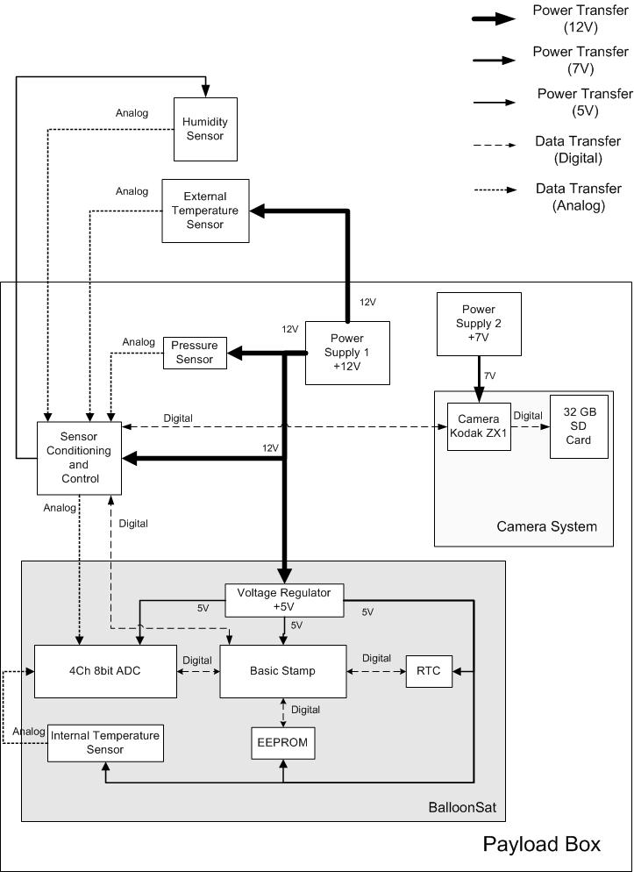

Figure 4-1: High-level system design

4.2.1 Functional Groups

Our system contains several different major components. One of the main components is the control system. The BalloonSat serves as an attachment unit, to which the rest of the devices will connect. It controls, reads, and stores the data from the sensors. In order to send commands to all the sensors, all programs will be written into the Basic Stamp. The EEPROM will record all data, except for video, which has its own internal memory. Detector systems will contain all of our sensors. Power Supply 1 will power the control system and sensors while Power Supply 2 will power the camera. The In-Flight Data Storage system will store the data during the flight. The post-flight data system will store and analyze the data after the flight. Figure 4-1 shows how each of the systems are connected.

4.2.2 Group Interfaces

The connections between the payload systems depend on which systems are communicating. The control system receives a 12 V input from Power Supply 1; in addition, it receives data from the sensor system. The control system also sends data and a 5 V output voltage to the In-Flight Data Storage System. The camera will connect to Power Supply 2, which provides 7 V, because it draws far more current than the rest of the components.

4.2.3 Traceability

Mission Goal:
To study the layers of the atmosphere using an instrumented sounding balloon flown in East Texas during May and to analyze the balloon and the environment surrounding the payload in order to study the relationship between the temperature and humidity profiles acquired during flight.
Objective | Requirement | Design Element
Determine at what altitude the Tropopause is located | - We shall calculate altitude using a timestamp from each data point and GPS data from the flight  - We shall identify layers of atmosphere using temperature lapse rate measurements  - We shall calculate altitude during the video using timestamps of the video recorder | EEPROM, Real time clock,  Temperature sensor
Characterize temperature, pressure, and humidity in layers | - We shall compare measured pressure with expected pressure of the US Standard Atmosphere  -We shall measure temperature, pressure, and humidity of the atmosphere every six seconds and record a timestamp for each of these measurements | Temperature, pressure, and humidity sensor
Use sensor data to determine if the payload passes through clouds | - We shall characterize features in the humidity profile  - We shall identify if the payload passes through a cloud | Camera, temperature and humidity sensors
Determine balloon diameter as a function of altitude | - We shall measure radius of the balloon as a function of altitude and compare our measurements to the theoretical relationship discussed in the science background  - We shall determine any effects of passing through a cloud on temperature, pressure, and humidity readings | Camera
Build a working payload that can withstand conditions of a balloon flight | - The payload’s cost shall not exceed $500  - The payload’s mass shall not be greater than 500g  - The payload shall be able to be attached to the weather balloon using strings 17 cm apart  - The payload shall provide power to the electrical components  - A conditioning circuit shall be used to condition the signals received from the sensors into signals that are readable by the Analog to Digital Convertor  - The payload shall survive the liftoff, turbulence of flight, and landing | All team members
Record temperature, pressure, and relative humidity for the duration of flight | - The payload shall have a temperature sensor to measure temperatures between 30 and -70 °C on the outer side of the payload with an uncertainty of ± 0.6 ºC  - The payload shall have a temperature sensor to measure temperatures between 30 and -70 °C on the inside of the payload with an uncertainty of ± 0.6 ºC  - The payload shall have a pressure sensor to measure pressures between 1 and 0.008 atm with an uncertainty of ± 0.004 atm  - The payload shall have a humidity sensor to measure humidity between 100 and 0 %rel with an uncertainty of ± 5 %rel  - The sensors on the payload shall take readings once every 6 seconds | Temperature, pressure, and humidity sensor
Determine at what altitude the payload enters and exits clouds | - The payload shall have a humidity sensor to measure humidity between 100 and 0 %rel with an uncertainty of ± 5 %rel | Temperature and humidity sensors, Camera, real time clock
Determine the radius of the balloon at several altitudes | - We shall work with LaACES management and place our payload in an optimal position to view the balloon | Camera
Document the PHAT-TACO experiment | -Achieve Science Presentation on time as specified by LaACES management | All team members
Table 4-1: Traceability matrix

4.3 Electrical Design

4.3.1 Sensors

The payload requires four sensors, one to measure external temperature, one to measure internal temperature, one to measure pressure, and one to measure humidity. The basis for choosing sensors includes cost, sensing range, accuracy, mass, and integration. The payload must have a mass less than 500 g, so the sensors chosen need to be small enough to fit inside the payload while adding as little mass as possible.

The BalloonSat has a temperature sensor attached to it, which will measure the internal temperature of the payload. A 1N457 will measure the external temperature of the payload. The 1N457 is a small signal p-n junction diode [23]. A diode can be used to measure temperature by measuring the diode’s forward bias voltage. The forward bias voltage of a diode varies linearly with temperature, due to the diode’s temperature coefficient [24]. This sensor consumes little power and can operate linearly for temperatures from -65 to 200 ºC [23].

The model 1230 series pressure sensors are a set of sensors made by Measurement Specialties. This series can measure different ranges of pressures from 2 to 100 psi. Since the payload only requires a maximum of 1 atm (14.7 psi), a 15 psi absolute pressure sensor from this series will be used. These resistors are composed of piezoresistors arranged in a Wheatstone bridge and the difference in the output voltages from the bridge relates to the pressure. These sensors have circuitry to compensate for the temperature’s effect on the piezoresistors, which ranges from -20 to 85º C. These sensors also contain an internal resistor used to set the gain of the external conditioning circuitry [17].

The HIH-4000 sensor senses Relative Humidity (RH). The RH sensor uses a capacitive sensing element with on-chip integrated signal conditioning to output a voltage that varies linearly with RH. The sensing element's construction provides resistance to most hazardous conditions. The humidity sensor has three leads: input voltage, output voltage, and ground. These sensors operate between 4 and 5.8 V with a maximum current of approximately 0.5 mA. [18]

A Kodak Zx1 pocket video, complimentary metal-oxide-semiconductor (CMOS) camera will record video of the flight with its 4.1 mm lens. The internal memory of the device is 128 MB but has an expansion slot for an SD card. The camera requires 1.5 W of power. This device can take 720p video at 60 fps (frames per second) or 30 fps. This camera is small in size and mass, with a weight of 90 g and dimensions of 2.0 × 4.2 × 0.8 in. [19].

4.3.2 Sensor Interfacing

The external temperature sensor interface seen in Figure 4-2. The 1N457 requires a constant current supply. The LM234 is a three terminal adjustable current source that will supply 1 mA to the sensor; R_{set} determines the amount of current supplied. In order to maximize the precision of our measurements the diode’s signal needs to transform to a 0 to 3 V signal. The sensor’s outputs needs amplification and subtracted from an offset from the amplified signal. An AD820, an operational amplifier (Opamp) will condition the signal.

The output from the AD820 will be converted to a digital format by the ADC channel 1, read out by the BASIC Stamp and saved to the EEPROM. To measure internal temperature the plan is to use the temperature sensor built into the BalloonSat. The internal temperature sensor uses channel 3 of the ADC. Two potentiometers will connect to the circuit, one to adjust the gain and the other to adjust the offset voltage. The potentiometers have a temperature coefficient of ±100 ppm/°C [27]. Using this coefficient and temperature range of 100 °C, the error associated with a 10 kΩ and 1 kΩ potentiometer is 100 Ω and 10 Ω respectively. All circuitry should still perform as expected despite this error [27].

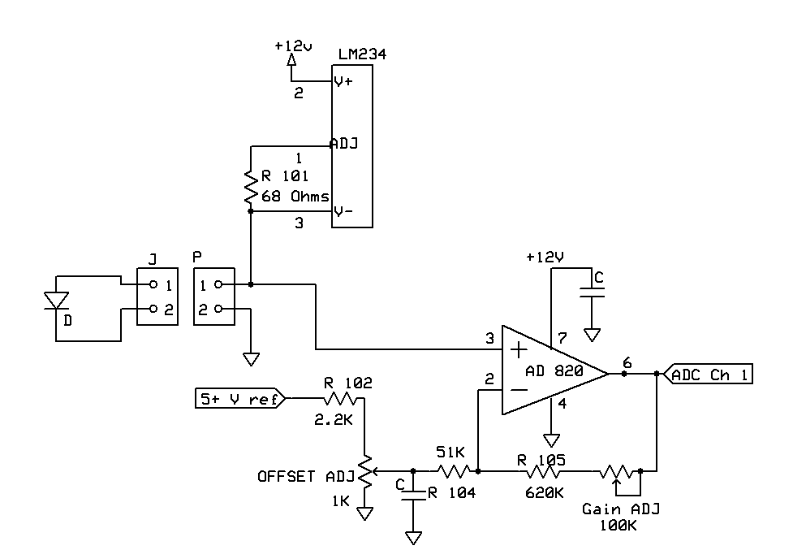Figure 4-2: Temperature Sensor Interface

The interface for the pressure sensor, seen in Figure 4-3, requires a constant current supply. An LM234 will be used to supply the 1.5 mA needed to power the sensor [17]. The sensor outputs two different voltages, and the difference of these voltages relates to the pressure. A differential amplifier will amplify the difference of the sensor’s two output voltages into a 0 to 3 V range readable by the ADC. Precision resistors are required for the 10 kΩ and 100 kΩ resistors because the gain of each of the sensor’s outputs must be equal. The sensor has an internal resistance; a 100K resistor will connect in parallel to help set the gain. For ease of calibration, a 10 kΩ potentiometer will connect to the circuit to make the gain adjustable. The output of this circuit will connect to channel zero of the ADC.
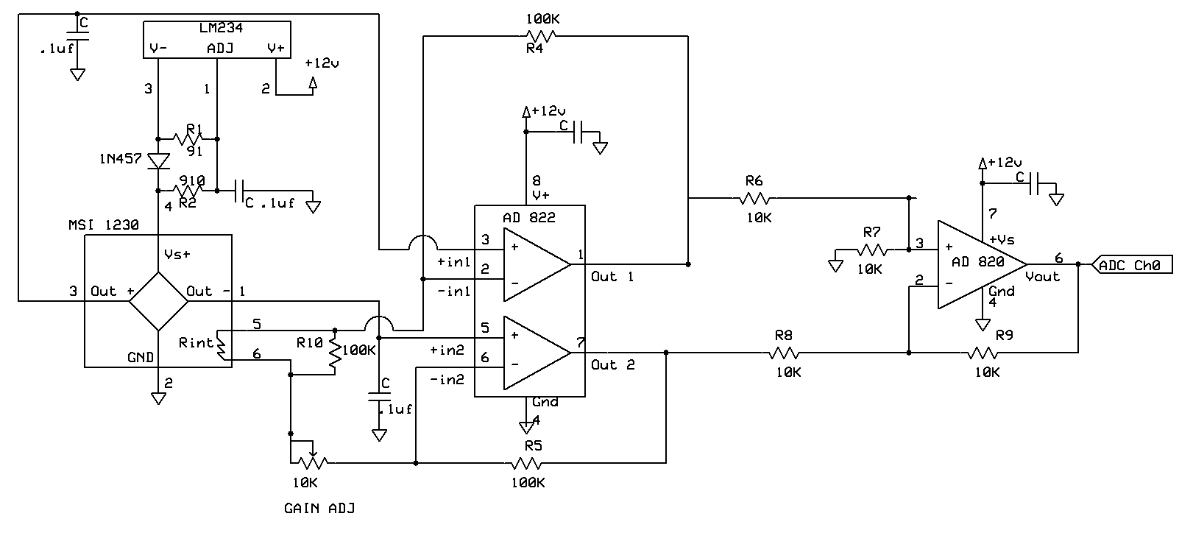
Figure 4-3: Pressure Sensor Interface [24]

Figure 4-4 shows the humidity sensor interface. HIH-4000 sensor will measure humidity and connect to channel two of the ADC. The voltage regulator on the conditioning board will supply power to the sensor. The HIH-4000 outputs a voltage that depends on the voltage used to power the sensor. With 5 V supplied, the output voltage can range from 0.8 to 3.9 V [18]. To condition this signal from 0 to 3 V a gain of 0.9677 will be required and an offset of 0.7740 V to be subtracted from the amplified signal. There must be a minimal load of 80 kΩ from pin 2 to pin 3 [18]. Two 10 kΩ potentiometers will connect to the circuit one to adjust the gain and the other to adjust the offset. The output will connect to an Opamp follower that buffers the signal. This buffering prevents the impedance of the ADC from affecting the measurement.

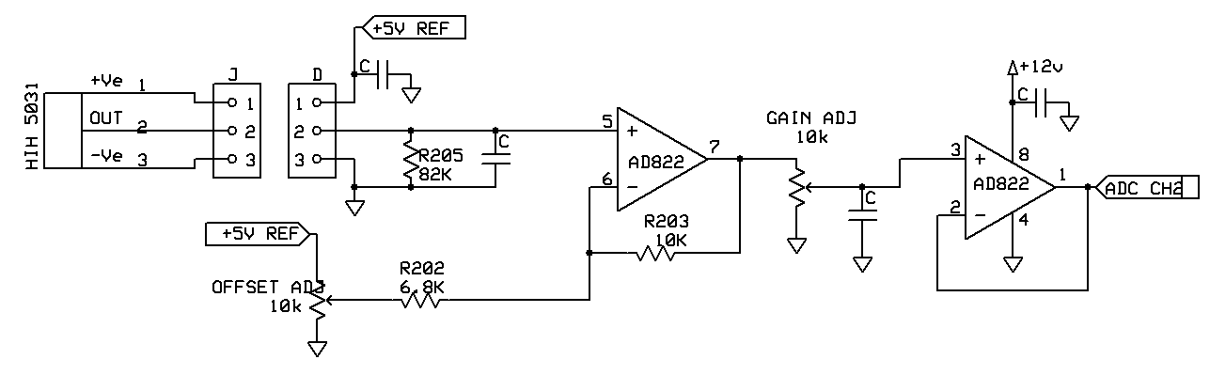
Figure 4-4: Humidity Sensor Interface

Figure 4-5 shows the camera interface. A relay will start and stop the recording of the camera. The BalloonSat will deliver the signal to the relay by using Pin 0. A photoresistor placed next to the “recording” LED on the camera will detect if the camera is recording. When the LED is off the resistance of the photodiode is large, which causes the output at the collector to go to a digital high. When the LED is on the resistance of the photoresistor is low which causes the transistor to switch on making the output at the collector a digital low.

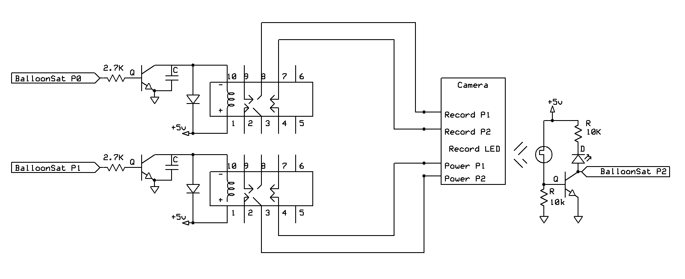
Figure 4-5: Camera Interface

4.3.3 Control Electronics

The BASIC Stamp, located on the BalloonSat, is the main controlling unit of the payload. The BASIC Stamp is a simple programmable microcontroller that communicates with the ADC, RTC, and EEPROM through serial interface. The BASIC Stamp initializes the RTC and takes timestamps during flight. The sensors send a voltage to the signal conditioning circuit, which amplifies the voltage to fit in the range of the ADC. The ADC converts the voltage to a digital byte of data. The data will go to the BASIC Stamp and be stored in the memory of EEPROM. The BASIC Stamp can also retrieve the data stored in the EEPROM. Figure 4-6 shows a full circuit schematic of the payload.

Figure 4-6: Full Circuit Schematic

4.3.4 Power Supply

During prototype testing and calibrations, a bench power supply will power the BalloonSat, all of the sensors, and the conditioning board. The BalloonSat has a voltage regulator that supplies a safe voltage to all components. A bench power supply is ideal for testing because all voltages are readily adjustable. Batteries are the best possible power source for flight because they can supply the necessary power and are small in weight (about 10 g each). A 100mA fuse will connect to Power Supply 1, to prevent excess current from destroying any of the components. Figure 4-7 shows a system drawing of the power distribution.

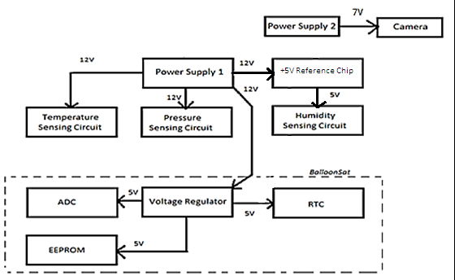
Figure 4-7: Flight Power Distribution

4.3.5 Power Budget

Power Supply 1
Component | Current  (mA) | Voltage  (V) | Power  (mW) | Flight Time  (hours) | Capacity  (mA-hours)
Temperature Interface | 1.2 | 12 | 14.4 | 4 | 4.8
Pressure Interface | 2.1 | 12 | 25.2 | 4 | 8.4
External Humidity Interface | 0.5 | 12 | 6 | 4 | 2
BalloonSat | 52 | 12 | 624 | 4 | 208

Power Supply 2
Component | Current  (mA) | Voltage  (V) | Power  (mW) | Flight Time  (hours) | Capacity  (mA-hours)
Camera | 220 | 7 | 1540 | 4 | 880
Table 4-2: Power budget for power supply 1 and 2 with camera data from Knoxville College [20]

Since the camera drains a large amount of current compared to the other components, two different power supplies are necessary. Power Supply 1 will power all of the sensors, control circuitry, and the BalloonSat. Power Supply 2 will supply power to the camera. Power Supply 1 will consist of eight batteries and Power Supply 2 will consist of four batteries. AA and AAA batteries supply voltages somewhere between 1.3 and 1.8 V each. Power Supply 1 will range from 10.4 to 14.4 V. This range will keep all of the components powered and still be low enough not to damage any component. Power Supply 2 will supply voltages ranging from 5.2 to 7.2 V, so the camera will remain powered during flight. The camera has a safety feature that powers down the camera if over 7 V is applied to the camera. A schottky diode will connect to the camera and Power Supply 2 in order to drop the voltage below the 7V cutoff.

Power Supply 1 will drain 55.8 mA of current and Power Supply 2 will drain 220 mA of current. Using these currents and the chart in Figure 4-8 the capacity of Power Supply 1 and Power Supply 2 will be 1200 mAh. Power Supply 1 will supply 670 mW. By using the graphs in Figure 4-9, a de-rating factor of 0.75 was calculated by taking the ratio of the capacity at a cold temperature and room temperature at 0 ºC. Assuming the same de-rating factor at 0 ºC a total de-rating factor of 0.5625 was calculated at -21 ºC. The inside of the payload will never get lower than -21 ºC (see §4.5) this is an appropriate temperature at which to rate the batteries. Using this de-rating factor the capacity of AAA batteries in Power Supply 1 will be 675 mAh. Power Supply 1 requires 223 mAh so AAA batteries can supply enough power. Power Supply 2 requires 880 mAh and at this de-rating factor AAA batteries cannot supply the power required. Using the AA battery graph in Figure 4-8 the capacity of AA batteries in Power Supply 2 will be 3000 mAh. Power Supply 2 will supply a total of 1540 mW and by using the graphs in Figure 4-10 the de-rating factor 0.5625 at -21 ºC was calculated. Using this factor the capacity becomes 1690 mAh. This capacity is high enough to fit the requirements of Power Supply 2. Using these calculations, Power Supply 1 will consist of eight AAA lithium batteries and Power Supply 2 will consist of four AA lithium batteries.

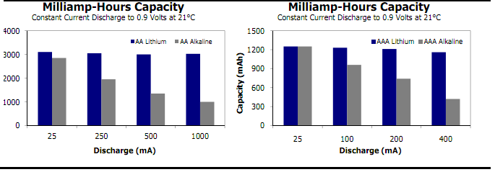
Figure 4-8: Milliamp-Hours Capacity of AA and AAA batteries [21]

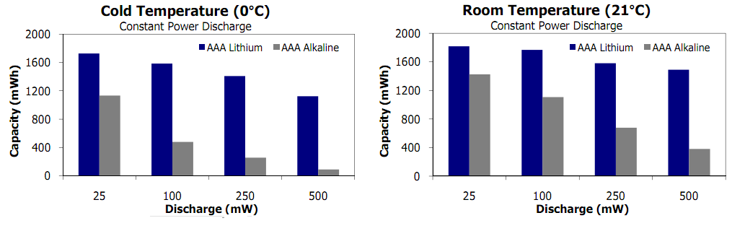
Figure 4-9: Energizer AAA battery capacity at cold and room temperature [21]
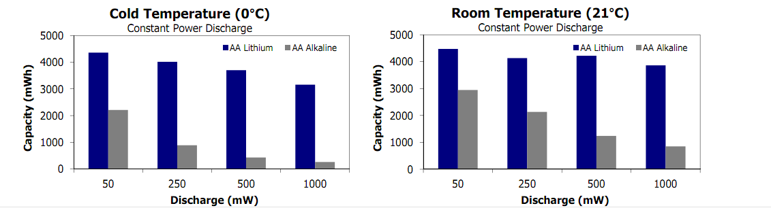
Figure 4-10: Energizer AA battery capacity at cold and room temperature [21]

4.4 Software Design

This section describes the software used for this project. With no software, the PHAT-TACO experiment will fail. Most of the software will run on the BASIC Stamp and will use an EEPROM for data storage. The software must be able to save data and timestamps at the rate specified in the requirements.

4.4.1 Data Format & Storage

There will be two separate data storage devices; The BalloonSat has programmable memory on the EEPROM, and the camera has an external memory card. Two data storage devices are necessary because the camera will record a million times more bytes of data than the pressure, humidity, and temperature sensors.

4.4.1.1 BalloonSat Data Storage

Data from the temperature, pressure, and humidity sensors will be stored on a 32 kilobyte EEPROM. On the EEPROM, there are 32,768 bytes for data storage. In its lifetime, the EEPROM can handle one million read/write cycles and can write one byte of information in 5 ms. A byte is comprised of 8 bits and can store a number from 0 to 255. The ADC uses whole numbers only and converts a voltage between 0 and 3 volts to a digital byte of information. Based on the range expected and the precision of measurements, each measurement can be stored into one byte.

Measurement of the temperature, pressure and humidity will take four bytes because individual sensors use one byte and there are four sensors. We will also use one byte for camera status. One measurement, including sensor data, camera status, and timestamp requires eight bytes of data. The ascent of the balloon should last 100 minutes and the decent will take about 60 additional minutes. The entire duration will be 9,600 seconds and will require ~1600 data points with an acquisition rate of one data point every six seconds. Thus, we will need 12,800 bytes of storage. The EEPROM can take data at our specified rate for 408 minutes, or more than six hours.

4.4.1.2 Video Data Storage

The two most common forms of data storage for cameras are Secure Digital (SD) cards and flash memory. SD cards are very common and cost 2 dollars per gigabyte (GB) of storage up to 32 GB. The cost for flash memory cards is almost twice the cost of SD cards for the same memory storage. A 3 hour movie shot in 720p (1289x720 pixels) will take approximately 25 GB. This will require a 32 GB card, which costs around 64 dollars.

4.4.2 Flight Software

This section has all of the descriptions of the programs and the flowcharts, written in Dia [25]. In the flowcharts, circles indicate the beginning or end of a program or subroutine. A rectangle represents a subroutine call or command. A diamond is a conditional statement, where the program will do one thing if the condition is met, and something else if the condition is not met.
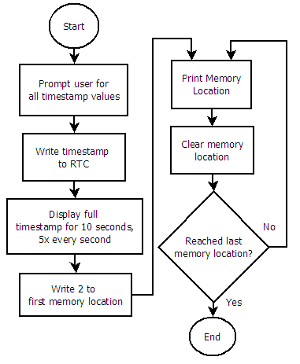
Figure 4-11: Pre-flight software flowchart

4.4.2.1 Pre-Flight

Figure 4-11 shows the Pre-Flight software flowchart. Before the flight, the real time clock (RTC) needs to be set. The command “write timestamp to RTC” is based off ACES activity P6. The user is prompted for the year, month, day, am/pm, hour, minute, and second. After the user enters the “second”, the timestamp is instantly written to the RTC.

After the timestamp is set, the time displays to the screen for 10 seconds, five times per second. This is so that we can check if the timestamp on the RTC matches what we have as the time. If the time is unacceptable, the user must restart the program, but if the time is acceptable, the program continues.

After the software has set the RTC, the number 2 is stored into the first memory location of the EEPROM. We have reserved the first two bytes (byte 0 and byte 1) to store the address variable. The address variable tells the BalloonSat where to begin writing data. This allows the during flight software to begin writing in the correct memory location upon startup. This is a risk mitigation step that will be further explained in the during flight section (see §4.4.2.2). After all of the memory locations are clear, the program clears all of the memory. It takes 25 minutes to clear all of the memory locations. The current memory location displays to the screen so that the user can monitor the progress. The EEPROM can only read/write to any one location one million times. Each time we run the flight code to completion, we will write to this location 4,098 times, which only allows us to test our code 244 times before that address on the EEPROM stops working correctly.

4.4.2.2 During-Flight program and subroutines

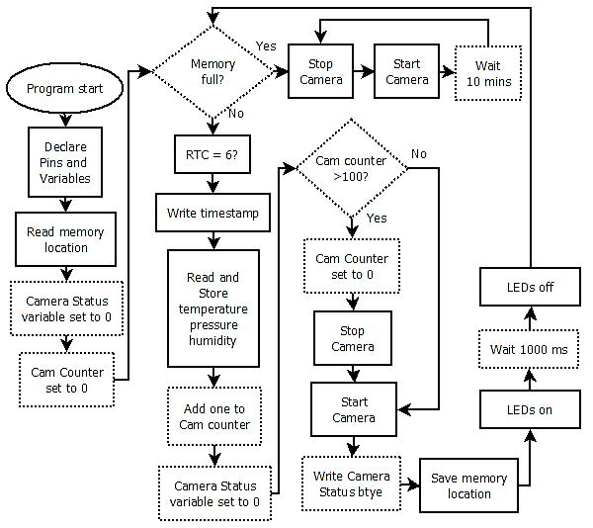
Figure 4-12: During-Flight software flowchart

Figure 4-12 shows the During-Flight software. This software must record measurements of the atmosphere once every six seconds. This includes a timestamp of each measurement, data from each sensor, and the camera status byte. This also must control the video camera.

The main section of the program is a loop that runs until the EEPROM completely fills with data. One risk during flight is a temporary power outage that resets the BalloonSat. We have added a mitigation step that saves the address of the last memory location written to the EEPROM. When the BalloonSat starts up, it will read this memory location and begin to write data to that location. Without this step, the BalloonSat will restart and begin to overwrite previous data. This memory location is reset during the pre-flight software so that upon start, the during-flight software will work as expected.

Since we have determined that we are taking data once every six seconds, the subroutine “RTC = 6?” checks if the “second” value in the RTC is a multiple of six. If it is, then a data point will be taken. If not, then the subroutine will wait 0.2 seconds and test the “seconds” variable again. This system is better than using an internal pause in the EEPROM because this way, the variable amount of time that it takes to read and store the data will not affect the data acquisition rate.
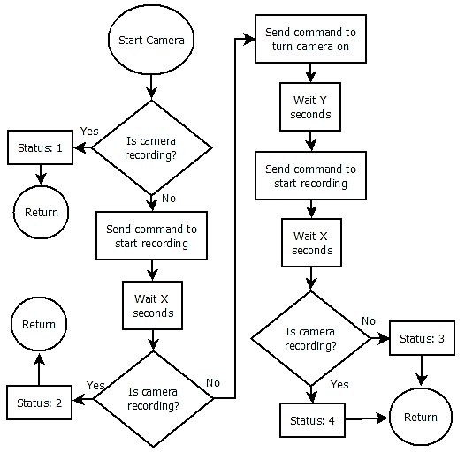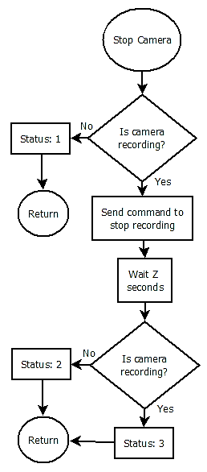
Figure 4-13: Start Camera and Stop Camera subroutines

The BalloonSat is able to control the camera as described in the electrical section (see §4.3.2). The Start Camera and Stop Camera subroutines are how the main program controls the camera. After passing through the Start Camera subroutine, the camera should be recording. After calling the Stop Camera subroutine, the camera will stop recording video. The camera status byte is composed of two nibbles (four bits), one for start camera and one for stop camera.

The Start Camera subroutine in Figure 4-13 accomplishes several tasks. Firstly, this subroutine checks if the camera is recording. If the camera was recording already, the subroutine ends. If the camera is not recording, the subroutine will send the command to activate the record switch. After sending this command, the subroutine waits “X” seconds for the camera to start recording. This is the time it takes from when the record button is pushed until the hardware can detect that the recording LED has turned on. The exact time of “X” will be determined during calibration. Next, the Start Camera subroutine checks if the camera is recording. If the camera is not recording, this probably means the camera is off, so the software sends the command to turn the camera on. “Y” is the time it takes the camera to start up, and will be determined during calibration. After sending the command to turn the camera on, the BalloonSat sends the command to start recording and waits “X” seconds again. After all of this, if the camera is still not recording, all hope is lost and the subroutine returns.

The Stop Camera subroutine uses a similar procedure to stop the video. If the camera is off, then the subroutine returns, because the camera cannot be recording if the camera is off. If the camera is on, then the Stop Camera subroutine tries to stop the recording.

Start Camera and Stop Camera rely on accurate determination if the camera is on or off and if the camera is recording or not. The most time spent in these subroutines during one pass in the main loop of the during flight program will be Z + 2X + Y seconds.

Stop Status | Start Status | Meaning | Cause
0 | 0 | Never entered Start Camera or Stop Camera subroutines | Software Glitch or software just started
0 | 1 | Camera recording normally | NORMAL
0 | 2 | Camera was not recording. Recording restarted | Potential hardware malfunction
0 | 3 | Unable to turn camera on or start recording | Power out or memory full
0 | 4 | Camera was off. Turned camera back on. Recording restarted | Temporary power outage or program start
1 | 0 | Entered Stop Camera, but not Start Camera | Software Glitch
1 | 1 | Conflicting measurements of camera is recording | Hardware Malfunction
1 | 2 | Camera was already stopped, then restarted | camera auto shutdown
1 | 3 | Efforts to start recording on camera are useless | power outage or out of memory
1 | 4 | Camera was stopped. Camera shut off, but power was restored and video was turned on | Temporary power outage
2 | 0 | Entered Stop Camera, but not Start Camera | Software Glitch
2 | 1 | Conflicting measurements of camera is recording | Hardware Malfunction
2 | 2 | Camera video stopped, then restarted | NORMAL
2 | 3 | Stop Camera caused shut down. Successfully restarted power and recording | Temporary power outage
2 | 4 | Stop Camera caused shut down. Unable to turn back on | Batteries out
3 | X | Unable to stop recording | Hardware Malfunction
Table 4-3: Meaning and cause of each possible camera status byte

Table 4-3 shows the meanings behind each potential value for the camera status byte. The entire status byte initializes to zero before the main loop calls either subroutine.

During flight, the only two statuses that we hope to see are [0,1] (where 0 is the stop status and 1 is the start status), meaning that the camera is recording normally and [2,2], meaning that the video was stopped then restarted. Also, on startup, we should see the initialized status [0,0]. The second camera status should have [0,4] because the camera should be off when the software starts.

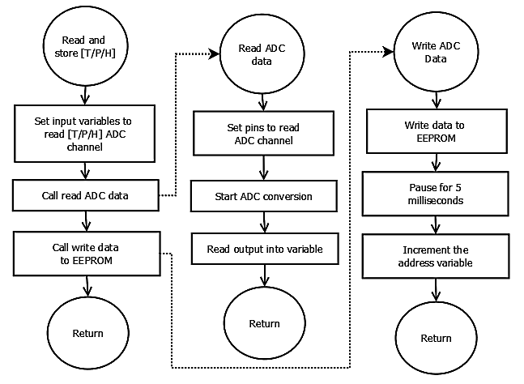
Figure 4-14: Take data subroutines

Figure 4-14 shows the subroutine to take temperature, pressure, or humidity data. The only difference between the subroutines is the pins are set to read different channels of the ADC. The Read ADC data and Write ADC data are very similar to the subroutines given in ACES activity P5 “Interfacing to a serial ADC”. The address variable, which stores the address of the next location to write to the EEPROM, is incremented in the write ADC subroutine. The address variable writes to the first two bytes of the EEPROM for reasons discussed previously.

The program calls the write ADC data subroutine eight times, and it will take approximately 80 milliseconds. The “RTC=6” subroutine could take 200 milliseconds. The Stop and Start Camera subroutines could take almost no time to complete, or they could take up to Z + 2X + Y seconds. There is also a one second pause at the end of the main loop for the during-flight program. As long as the sum of all of these times is less than 5.8 seconds, the program will take data at the required rate of one data point every six seconds.

4.4.2.3 Post-flight program

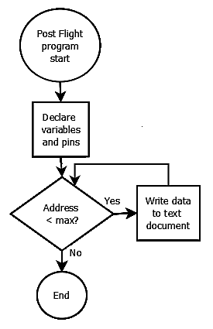
The post-flight software shown in Figure 4-15 will display the data delimited by commas. We will use Term232, a Windows 32 terminal emulator program, to import the output to a plain text file. From this file, we can copy and paste the data into Microsoft Excel. Excel has the capabilities to perform the conversion from raw ADC counts to percent relative humidity, temperature, and pressure based on calibration data. Instructions on how to run Term232 are in Appendix C.1.

LaACES management will provide a flight profile of altitude vs. time. From this profile, we can determine the altitude of each measurement.

Figure 4-15: Post-flight software flowchart

4.4.2.4 Calibration Programs

There are specific camera times that we need to determine during calibrations. To do this, we have written three calibration programs described below and in appendices C.9, C.10, and C.11.

- Program to calibrate X (code in Appendix C.9):
  - Declare Pins/Variables
  - Send command to turn on camera
  - Wait 5 seconds (long enough to ensure that the camera is on)
  - Send command to turn on video
  - Wait X seconds
  - Check if camera is recording or not
  - Debug if camera is recording or not

- Program to calibrate Y(code in Appendix C.10):
  - Declare Pins/Variables
  - Send command to turn on camera
  - Wait Y seconds
  - Send command to turn on video
  - Wait X seconds
  - Check if camera is recording
  - Debug if camera is recording

- Program to calibrate Z(code in Appendix C.11):
  - Declare Pins/Variables
  - Send command to turn on camera
  - Wait Y seconds
  - Send command to turn on video
  - Wait X seconds
  - Wait 1 second
  - Send command to turn off video
  - Wait Z seconds
  - Check if camera is recording
  - Debug if camera is recording

We have also written two programs to help us calibrate data. A program called calibration program v1, in appendix C.7, displays the sensor readout to the debug screen continually. This allows us to make sure both the software and hardware are working properly. Another program, called calibration program v2, in appendix C.8, is the same as flight software, but data points are taken every second instead of once every six seconds. Calibration program v2 also does not have any camera control software. These were only used for calibration, and the thermal, shock, and vacuum tests used the actual flight software.

4.5 Thermal Design

The payload will fly for approximately four hours reaching an altitude of about 30.5 km. During flight, the payload will pass through extreme temperature conditions. Based on information gathered in the science background, the payload will have to survive temperatures ranging from approximately -70 to 30 °C.

The sensors in the payload need to be able to operate properly in these extreme conditions. Based on information gathered from a component's data sheet, its maximum and minimum operational temperatures determined its thermal operating range (Table 4-4).

Device | Upper Temperature (°C) | Lower Temperature (°C)
ADC, RTC, BASIC Stamp, EEPROM | 85 | -40
Pressure Sensor | 85 | -20
Humidity Sensor | 85 | -40
Temperature Sensor | 200 | -65
Camera | 100 | -40
Energizer Lithium Batteries (AA, AAA) | 60 | -40
Table 4-4: BalloonSat component ranges
Thermal tests are necessary in order to assure that our payload remains within operating range for the sensors. Initial thermal calculations used the LaACES Thermal Flight spreadsheet [22].

LaACES Thermal Flight |  |  | Isun | 1377.0 | W/m²
Earth-Space Parameters |  | UNITS | Latitude | 31 | degrees
Stefan-Boltzmann | 5.67E-08 | W/m² K⁴ | T-float | 210 | K
Isun (solar constant) | 1377 | W/m² | Albedo | 0.5
T-space | 4 | K | Day of year | 170 | day
Flight altitude | 30000 | m | Hour of day | 7 | hr
Earth orbit eccentricity | 0.01672 |  | Declination angle | 23.42514 | deg
T-earth | 273 | K | Inclination angle | 65.90066 | deg
R-earth | 6380000 | m | IR Fluxmin | 160 | W/m²
Payload Parameters |  |  | Internal Heat | 2.006 | W
View factor payload-earth | 0.452 |  | Effective Isolar | 1355.08 | W/m²
View factor payload-space | 0.700 |  | Effective Isphere | 336.62 | W/m²
Sphere radius | 0.104 | m | ENERGY BALANCE calculations
bladder thickness | 0.000 | m | Qsun | 16.013 | W
kevlar shell thickness | 0.000 | m | Qalbedo | 6.580 | W
bladder conductivity | 0.026 | W/mK | Qpower | 2.006 | W
kevlar shell conductivity | 0.040 | W/mK | Q-IR | 2.087 | W
Insulation Parameters |  |  | Total input: | 26.687 | W
insulation absorptivity | 0.350 |  | hrad,earth | 1.739 | W/m² K
insulation thickness | 0.015 | m | hrad,space | 0.671 | W/m² K
insulation emissivity | 0.850 |  | constant1 | 0.236 | W/K
insulation conductivity | 0.010 | W/mK | constant2 | 0.091 | W/K
Area Calculations |  |  | constant3 | 0.054 | W/K
Total sphere projected area | 3.40E-02 | m² | Qrad-to-earth | -0.794 | W
Total sphere surface area | 1.36E-01 | m² | Qrad-to-space | 24.239 | W
 |  |  | Qconv-at-float | 3.242 | W
 |  |  | Total output: | 26.687 | W
 |  |  | Ti outer | -3.4 | degC
 |  |  | Ti inner | 16.0 | degC
Table 4-5: Thermal Calculations

The LaACES Thermal Flight spreadsheet calculates the internal temperature at thermal equilibrium. This is the steady-state solution for the thermal properties of our payload. These equations assume that the majority of heat exchanged is in the form of radiation.
Our calculations assume that the time of launch is 7:00 AM in late May. The electronics generate approximately 2 W of heat. The approximate absorptivity and emissivity of the payload is the same as white paint. The foam is 1.5 cm blue insulating foam and the absorptivity and emissivity of white paint are a close approximation of our payload’s absorptivity and emissivity. The calculated radius converted the surface area of the box to an equivalent sphere.
Based on all of these assumptions and simplifications, the equilibrium temperature of the interior of the payload at maximum altitude will be approximately 16.0 °C and at the coldest temperature, approximately 10 km, the inner temperature of the payload should be 15.8 °C. The payload will almost never be in thermal equilibrium with the environment because the payload will always be ascending or descending. The rate at which the payload cools will also be a factor in the temperature of the payload. Additionally, clouds reflect infrared light, so when the payload is above clouds, the temperature will increase.
According to the initial calculations, the interior of our payload should get no colder than 15.8 °C, which is well within the operating range of all the sensors. At this time, there is no need for an additional heating source. These calculations should be justified after thermal testing completion.

4.6 Mechanical Design

This section describes Team Philosohook’s mechanical layout, payload weight, mechanical stresses and design, and materials. The mechanical layout describes the shape and size of the payload in order to ensure that the components are safe during flight and landing. Due to constraints of the balloon used to fly the payload, the payload must not weigh more than 500 g. The payload’s design also takes into account thermal conditions and landing stress. Vacuum, thermal, and shock tests are necessary to verify the safety and structural integrity of the payload.

4.6.1 External Structure

The payload box, constructed of blue insulation foam and wrapped in aluminized mylar, will take on the shape of a regular hexagonal cylinder as shown in Figure 4-16 and Figure 4-17 because it is the most efficient balance of volume and structural integrity. The payload will have a bottom glued in place. The box will also have a lid fastened with duct tape to allow for easy component retrieval after testing and flight. The box will have two holes 17 cm apart to run through the height of the payload structure to allow for strings that attach to the balloon vehicle. The lid will have one hole for the camera to take video. The payload will measure 14 cm in height in order to allow adequate room for the internal structure of the payload. There will also be an external sensor cover to house the humidity sensor in order to protect it from direct sunlight.

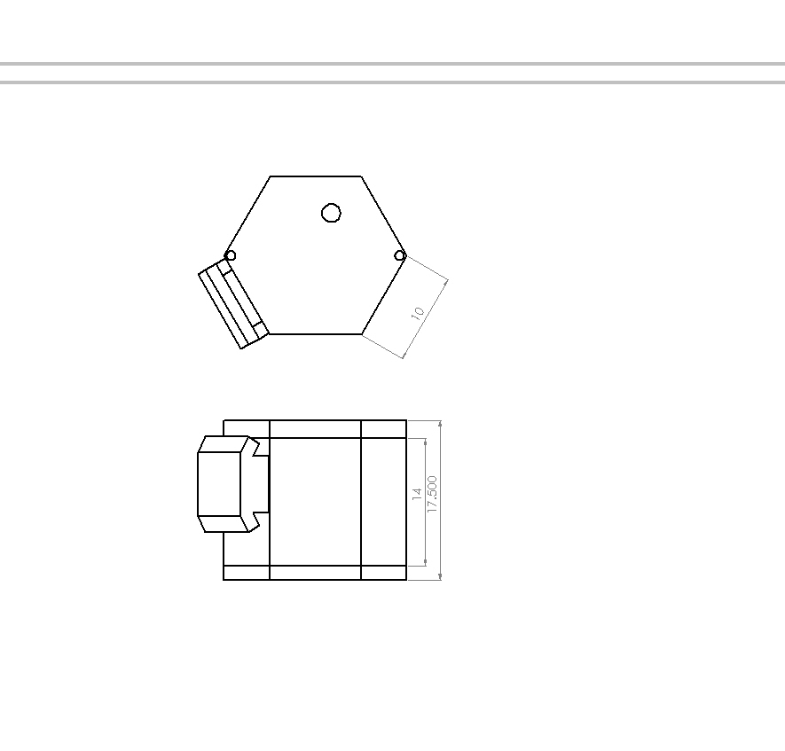
Top
Front
Sensor Cover
Figure 4-16: Shows the external structure of the payload

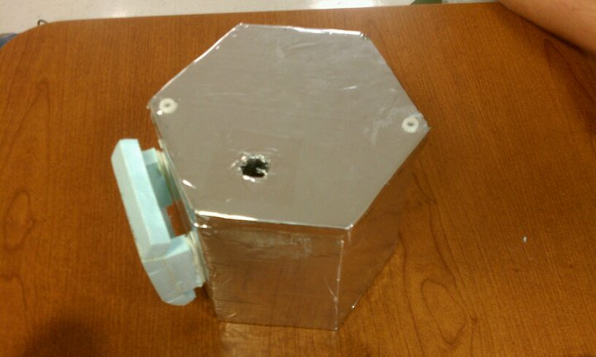
Figure 4-17: Finished external structure of the payload

4.6.2 Internal Structure

The internal structure of the payload includes the BalloonSat with sensors, the power supplies, the signal conditioning board and the camera as shown in Figure 4-18 and Figure 4-19. A foam insert measuring 15.5 cm by 14 cm will secure the BalloonSat with the signal conditioning board and the pressure and internal temperature sensors, battery packs, and camera inside the payload. One side of the insert will contain the BalloonSat, sensors, and signal conditioning board and the other side of the insert will house both battery packs and the camera for the most even weight distribution. A rectangular cut out will secure the BalloonSat and signal conditioning boards and the battery packs fastened with Velcro. The camera will sit on a foam shelf secured by Velcro. There is enough room in between the walls and the insert to allow the battery pack to make a connection to the BalloonSat and signal conditioning board on the other side. The external temperature and humidity sensors will fit under the lid in order to take external readings.

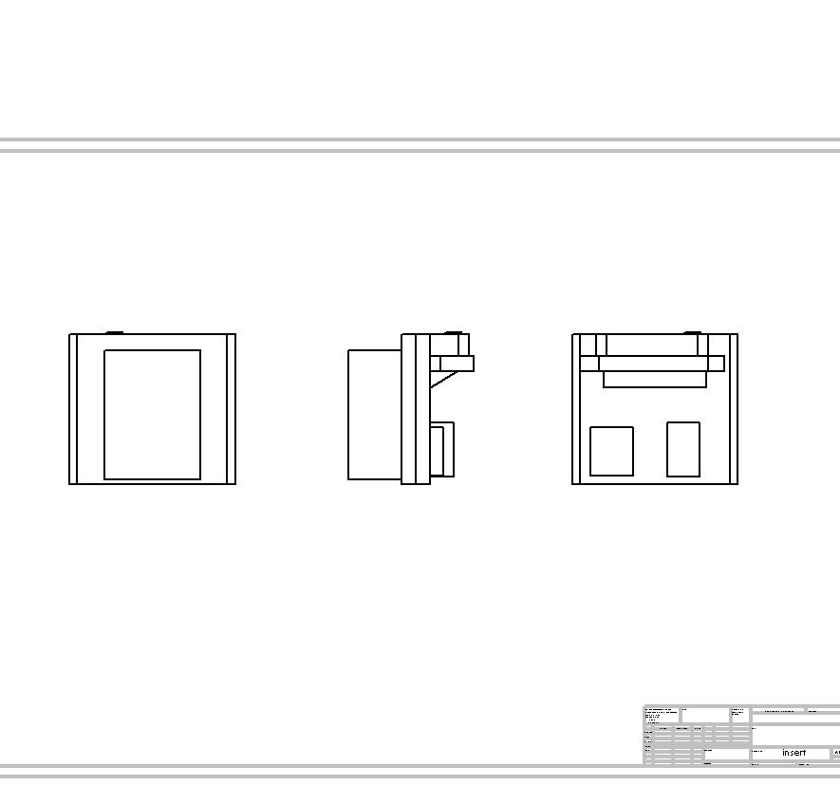
Front
Camera
BalloonSat and Conditioning Boards

Left
Right
Batteries

Figure 4-18: Internal Design (blue shading indicates foam)

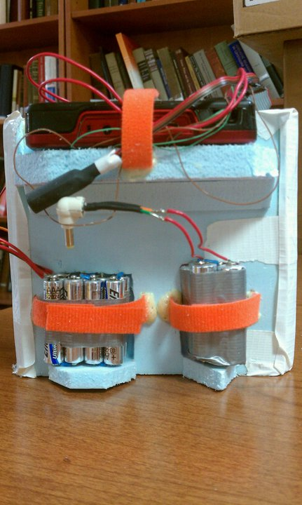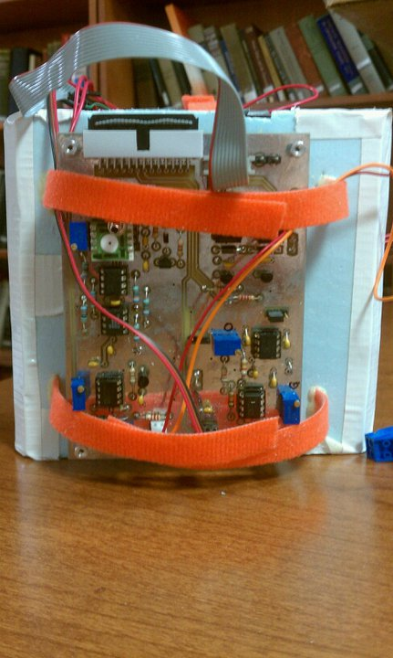
Figure 4-19: Internal views of the built payload

4.6.3 Mass Budget

The mass budget for this project is 500 g. Table 4-6 shows the mass of each component measured or estimated based on individual prototypes with error. The mass of each component was measured directly by using a scale.

Component | Mass (g) | Uncertainty (+/-g)
BalloonSat | 66.3 | .05
Power Supply 1 | 71.8 | .05
Power Supply 2 | 63.7 | .05
Signal Conditioning Board and sensors | 101.5 | .05
Foam Structure | 99.6 | .05
Camera | 97.8 | .05
Total | 500.7 | .12
Table 4-6: Mass budget

5.0 Payload Development Plan

For the approval of our project to fly all of the specifications must be known. This includes prototyping the circuitry and payload design. We purchased sensors for temperature, pressure, and humidity in order to use them for prototyping how much power is needed, how the signal must be conditioned, and how much memory is needed for this project. We will test circuitry on a solderless breadboard before integrating it onto the BalloonSat to ensure proper functionality. Finally, we will make a prototype of the payload box in order to make sure that it stays within the size constraints of the testing chambers and the balloon vehicle.

5.1 Electrical Design Development

- Build prototype on solderless breadboard
- Test and calibrate sensors to determine actual accuracy and measurement capabilities.
- Perform shock and thermal tests on each sensor

5.2 Software Design Development

- Adapt pre-existing or write new software for each program
- Load programs into a test BalloonSat board
- Debug program and repeat previous step as necessary
- Build temporary prototype to solder less breadboard
- Compare software output to hardware input to check for consistency

5.3 Mechanical Design Development

In order to finalize mechanical drawings, component layout, and weight table required for the flight we must build a prototype payload box and submit it to shock, thermal, and vacuum tests. If the payload breaks under the shock test then the shape of the payload will be reconsidered for one that can withstand stress better. When going through the thermal test, if any of the electronic components, such as the sensors, malfunction inside of the box then we will add more insulation or choose sensors that can operate at lower temperatures. Also, if any of the components, including the electronic components, sensors, and even the box itself, malfunction or break due to the low pressure, new components will have to be selected and integrated into the payload that work in extremely low pressure environments. When all of these tests have been performed and the payload box and circuitry prove to function as expected in the established environmental parameters, the individual components will be measured for an accurate final weight.

5.4 Mission Development

To move closer towards a flight-ready payload, several issues have been investigated. First, we calibrated the sensors to the proper ranges of values we expect to encounter. We also tested the components to see if they will function during the balloon flight conditions with thermal and vacuum tests.

6.0 Payload Construction Plan

In order to prepare for launch, the construction plan will initially focus on the external structure of the payload box. Then the focus will move to the individual components. All the sensors will interface to the BalloonSat, which in turn will connect to Power Source 1. A circuit board containing the sensors will interface with the BalloonSat through the ADC channels. Then a wire will connect the BalloonSat to Power Source 1. Once system tests to ensure that all the connections function properly are complete, the circuit board containing the sensors will mount on the BalloonSat. Then the focus will move to the camera. A wire will connect Power Source 2 to the DC power input of the camera.. Then the camera circuit board will interface with the BalloonSat by soldering connections. Next, the components will be in the payload box for final testing. This testing will ensure that the payload can withstand the expected atmospheric conditions and the impact of landing. Then collection and analysis of pre-flight data to help prevent future risk.

6.1 Hardware Fabrication and Testing

First, fabrication of the mechanical system, including the construction of the payload box, will take place. Once construction is complete the box will undergo thermal, shock and vacuum testing. During box testing, work will begin on the electrical and software components of the payload. Each of the temperature, pressure and humidity sensors will be prototyped separately on a solderless breadboard once the sensor becomes available. Then fabrication of circuits shall begin and they will interface to the BalloonSat. The software will be written and tested until it runs and prints data successfully. Then the software will be loaded onto the EEPROM of the BalloonSat and then testing of software and electronics will begin to make sure they work together properly. Finally, the assembled components will the placed in the payload box for final thermal, shock and vacuum testing.

6.2 Integration Plan

Individual tests for each system are necessary and once the systems connect to each another, the joint system needs testing to ensure the new system works properly. Once prototyping is completed and all of the subsystems have been tested and fabricated, the systems must integrate into a working payload. First, the sensors and camera will connect to the sensor conditioning and control system. The sensor conditioning and control system contains the circuitry to condition the output of the sensors into a value readable by the ADC. This system also contains the controls to power the camera and to start and stop the recording of the camera. Then this system will interface to the BalloonSat, which contains the internal temperature sensor, ADC, BASIC Stamp, EEPROM and RTC. Then the power system will attach to the system. Finally, all of the systems will be inside the mechanical system, which will complete the payload integration.

6.3 Flight Software Implementation and Verification

We must test the software on the BalloonSat to ensure that the software meets the PHAT-TACO requirements. The software must take data every six seconds, and must be able to monitor and control the video camera.

The first step in testing the software is to verify that the RTC can accurately keep time for at least 24 hours. In the pre-flight software, when the time is set, the program displays the time. From this, we can check if the time synchronized with a reference time. Before flight, we must synchronize the time with the GPS tracker, but for testing purposes, we can just use any clock with a second hand. To verify that the RTC can maintain the time for at least 24 hours, we can set the time, then wait for 24 hours, then check the time on the RTC. We will check the time by using a version of the pre-flight software that does not write the time or overwrite the data.

Since we have multiple identical BalloonSats, we can use one for software testing, and one for sensor calibration. The software testing ensures that we accurately convert the volts measured by the ADC into counts and saved every six seconds. To do this test, we will setup an input voltage to one of the ADC channels using a potentiometer. We will measure the voltage with a digital multimeter and then we will compare the voltage to the output of the software.

Several tests must be done to determine if the during flight software can control the camera as expected. Additionally, the camera status byte must correspond to what is physically happening to the camera.

Tests that must be done:
- RTC can accurately keep time for 24 hours
- RTC can be set to within one second accuracy
- Check data is saved every six seconds
- Check ADC readout is accurate for each channel
- Software powers on the camera on startup
- Software starts recording video on startup
- If camera power is disconnected, then reconnected, the software must turn the camera back on and start taking video again
- Camera video is restarted once every ten minutes
- Camera status must be accurate for the above camera tests

6.4 Flight Certification Testing

The payload we will build has to survive a series of tests that mimic conditions it will experience during the LaACES balloon flight. During the flight, our payload will experience a temperature range of 30 to -70 °C, a pressure range of 760 to 6 mmHg, and a deceleration from 6 to 0 m/s. To produce these conditions, we will use a shock test, thermal test, and vacuum test. During each test, we will power up the payload to match the conditions of each specific test. If the payload survives each test and collects data without interruption, we can ensure that the payload will survive the balloon flight. Any problems found in testing will be noted and resolved.

To verify proper securing of all subsystems and to ensure that they can undergo the forces involved with a balloon flight, the completed payload will be shock tested. The group will place the two external sensors into the payload to protect them from being crushed. With the lid taped down, team members will drop the payload from a height of 10 feet. This should cause the velocity to increase to around 7 m/s, faster than we except. Afterwards, we will remove the lid to check all components and note any shifting. Better fastening methods will be investigated if shifting of components occurs.

The group will also perform a thermal test for which the payload will be powered on and placed in various temperature environments. Based on the NOAA data, we will place the payload first in the LaACES lab for 10 minutes at approximately 20 °C, a refrigerator for 15 minute at approximately 0 °C, a freezer for 20 minutes at approximately -20 °C, and then a dry ice cooled environment for 20 minutes at approximately -70 °C [2]. Afterwards, the payload shall return to a freezer for 15 minutes, a refrigerator for 15 minutes, and finally the LaACES lab for 10 minutes. (See Appendix B.1 for calculations)

We will perform a vacuum test for which the payload will be powered on and placed into a sealed vacuum chamber. In order to simulate the ascent, the pressure inside the chamber will be decreased by 15 mmHg increments each minute until a vacuum of 80 mmHg. At this point the pressure will be decreased by 3 mmHg increments each minute. Once the chamber reaches a pressure of 6 mmHg, the process will be reversed to stimulate the descent of the payload.

6.4.1 System Testing Procedures

Shock Test Procedures:
- Power up payload
- Run preflight software
- Run during flight software
- Drop from the height of 10 feet onto the floor
- Remove the BalloonSat from box
- Run post-flight software
- Analyze and verify data

Thermal Test Procedures:
- Power up payload
- Run preflight software
- Run during flight software
- Place the camera, battery pack and the BalloonSat in the payload box
- Let the BalloonSat collect data at the LaACES lab for 10 minutes
- Place the payload in the refrigerator for 15 minutes
- Move the payload box to the freezer for 20 minutes
- Move the payload box to the dry ice container for 20 minutes
- Move the payload box to the freezer for 15 minutes
- Move the payload box to the refrigerator for 15 minutes
- Move the payload box to room temperature for 10 minutes
- Connect the BalloonSat with the computer using the serial cable
- Run post-flight software
- Analyze and verify data
Vacuum Test Procedures:
- Power up the payload
- Run preflight software
- Run during flight software
- Place the battery pack, the BalloonSat, and the camera in the box
- Place the box in the vacuum chamber
- Make sure the vacuum chamber is sealed tight and the pressure gage is turned on.
- Decrease the pressure by 15mmHg per minute
- At 80mmHg, decrease the pressure by 3mmHg per minute
- Stop the pressure chamber at 6mmHg
- Remove the box from the vacuum chamber
- Run post-flight software
- Analyze and verify data

6.4.2 System Testing Results

Shock Test

Pre-flight and during flight software were loaded onto the payload and then dropped from a height of about 10 feet off Nicholson building at LSU on May 5, 2011, 6:04 p.m. This procedure lasted approximately 30 seconds. We recovered the payload, removed the BalloonSat, downloaded, and analyzed our data using the post-flight software. The payload components were not harmed and no shifting occurred. The data collected was consistent with the expected conditions. Figure 6-1 shows the data collected during the test. The time of -30 on the graphs refers to the 6:04 p.m. time stamp.
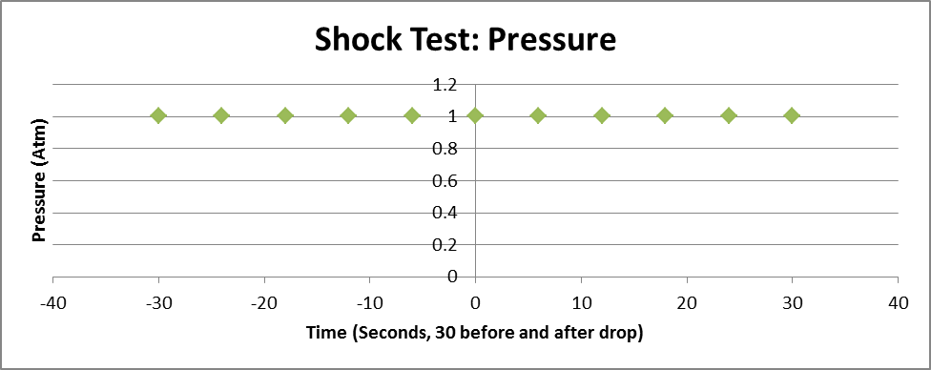

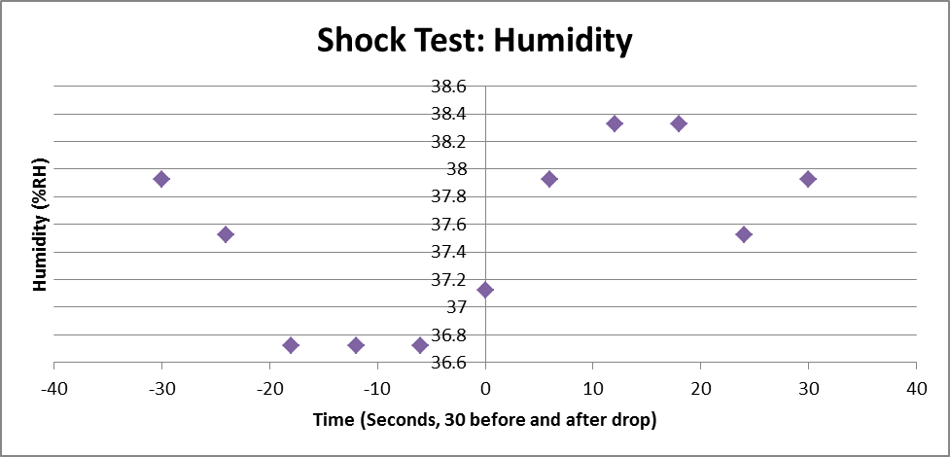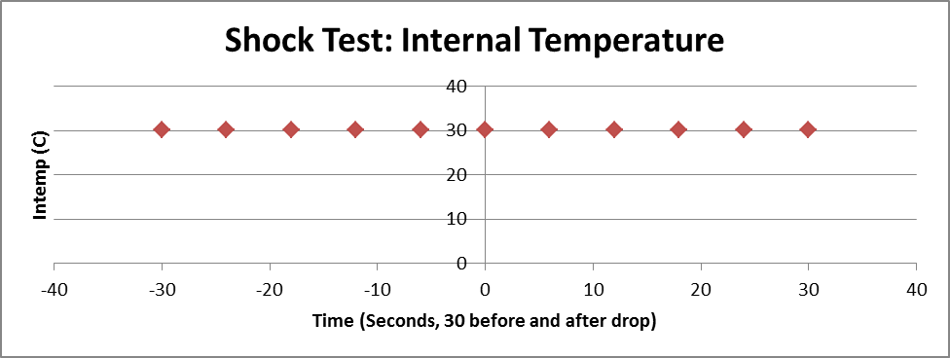
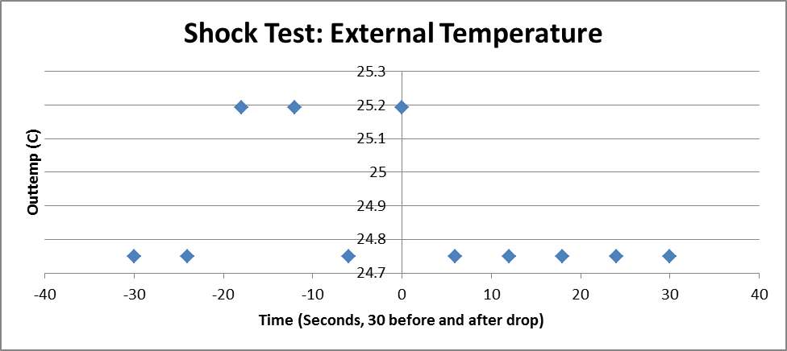
Figure 6-1: Shock test results

Thermal Test

Pre-flight and during flight software was loaded onto the payload and then placed in varying temperature conditions for 1 hours and 50 minutes as described in §6.4.1 on May 3, 2011 at 8:09 p.m. After the test was completed, the BalloonSat was taken out of the payload and we downloaded and analyzed the data using the post-flight software. All systems performed as expected. However, the humidity tends to change as the temperature changes. No definitive profile can be conjectured about humidity as a function of temperature solely from these graphs because the different environments that the payload was subjected to (the refrigerator, freezer, etc.) are different environments with factors that could affect humidity such as open containers of water. Figure 6-2 shows the data we collected. The time of 0 on the graphs refers to the 8:09 p.m. time stamp.

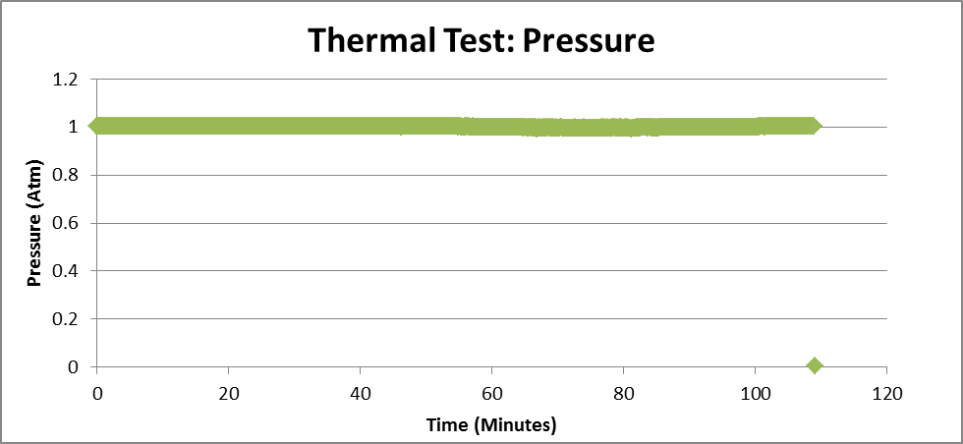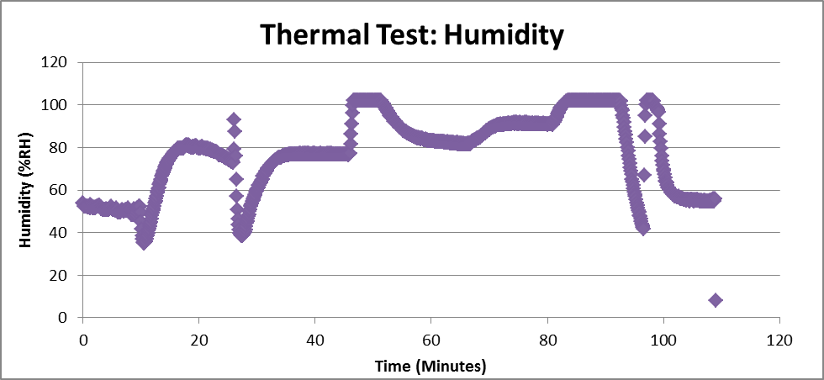
Insert into Dry Ice
Insert into Freezer
Room Temperature
Room Temperature
Insert into refrigerator
Insert into Freezer
Insert into refrigerator
Figure 6-2: Thermal Test Results

Vacuum Test

Pre-flight and during flight software was loaded onto the payload and then placed in the vacuum chamber for 1 hour and 40 minutes on May 4, 2011 at 6:04 p.m. The payload spent a certain amount of time at certain time intervals as described in §6.4.1. Once the test completed, we removed the payload from the chamber and then the BalloonSat from the payload, then we downloaded and analyzed our data using our post-flight software. All systems performed as expected. However, there is a correlation between humidity and pressure. Humidity decreases as pressure decreases. This is because humidity is based off the water in the air, if there is no to little air, then there is no to little humidity. Figure 6-3 shows the data we collected.
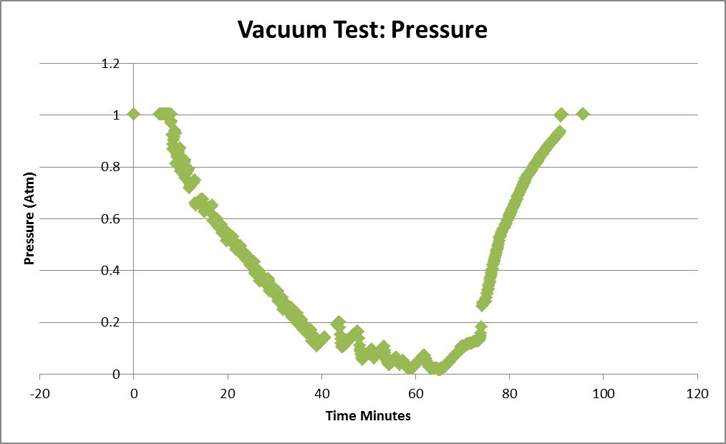
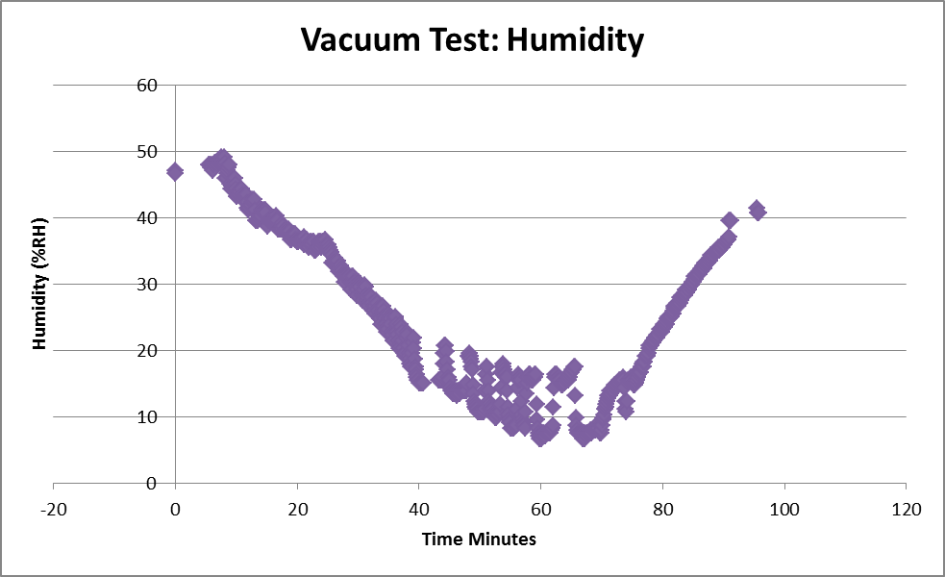
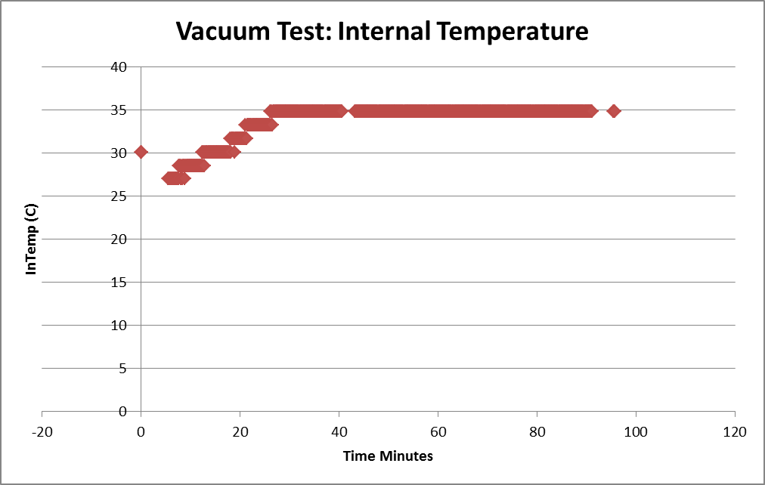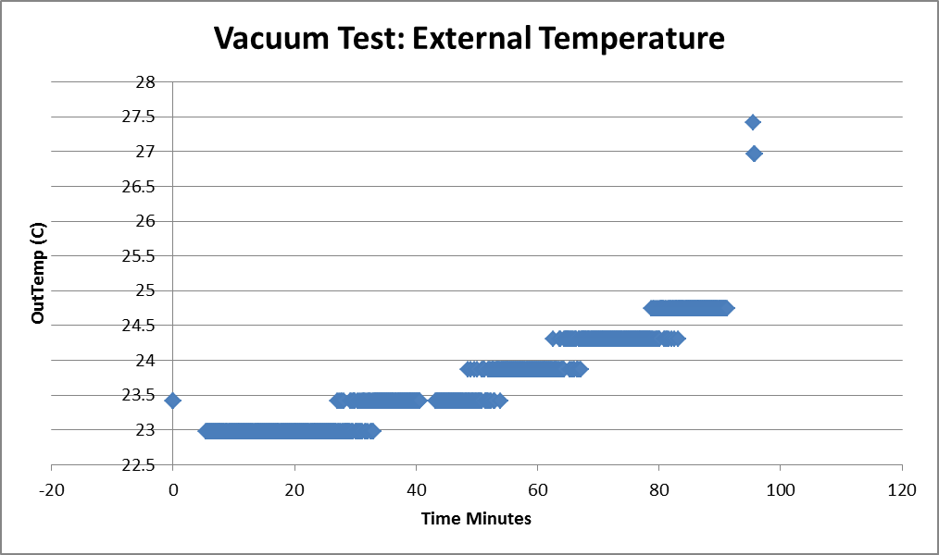
Figure 6-3: Vacuum test results

Software Tests

During each of the tests, the software worked as expected. The RTC was able to maintain the time without power from the BalloonSat for 24 hours with only a two second deviation from the actual time. The during-flight software met all requirements including:
- Taking data once every 6 seconds
- Controlling the camera
- Restarting the video once every 10 minutes
- Not overwriting data if the power is temporarily disconnected
- The Start Camera subroutine does not take up so much time that the data misses one of the six second intervals
These results are from a test where we intentionally disconnected the power, then reconnected the power. The software continued writing data normally. The during-flight software now flashes the LEDs to indicate BalloonSat power and conditioning power. Two LEDs will flash if only the BalloonSat is powered, and all four will flash if the conditioning board and the BalloonSat are powered.

7.0 Mission Operations

We must take appropriate steps to ensure that we can successfully fly the PHAT-TACO experiment on May 24th, 2011 in Palestine, Texas. This includes several procedures, such as extensive testing and calibrating, which we have already done to mitigate any risk that makes our payload unflyable. Additionally, we will instigate measures to assure that the payload can safely fly and recover our payload.

7.1 Pre-Launch Requirements and Operations

Before launch, we will put several procedures in place to ensure payload flyability. We will calibrate each of the sensors to give us equations for the respective temperature, pressure, or humidity based on ADC counts. Furthermore, we will test the camera to make sure it can survive and take video of the entire flight under cool temperatures and low pressures. Software must be written and tested to assure it properly stores data from the sensors onto the EEPROM and that the camera properly saves video to its internal SD card. Tests must also be done to ensure that our selected batteries will survive the duration and extreme conditions of the flight so that all components are powered for the full flight time. Before launch, we will load the software to the EEPROM and the two power sources will each receive a set of new batteries. In addition, on the day of launch, we will measure weight of the balloon and the distance from the payload to the balloon. Additionally, a checklist ensuring all pre-flight procedures are done will be checked to ensure the payload’s readiness.

7.1.1 Calibrations

To calibrate each sensor, we will perform tests to determine the outputs of the sensors. We will take measurements across each sensor using a voltmeter while exposed to a set battery voltage and environmental conditions. The group will use these to determine the conditioning circuits we will need to create, in order to use the ADC’s 0 to 3 V range. Once the conditioning circuits are constructed, we shall perform second calibrations to compare the conditioned outputs to the actual values they represent.

For the temperature sensor, we will use a PASCO SF-9616 multimeter to measure the temperature in various environments. First both our sensor and the SF-9616 will measure the LaACES lab temperature. First, we will allow both our sensor and the HOBO to measure room temperature. Next, we will place both the payload and SF-9616 in a refrigerator. Both shall then be placed in the freezer. During each environment, we will record the SF-9616 value and corresponding ADC value. After data collection is complete, we will input the data into an Excel spreadsheet and calculate the correlation between the ADC values and the collected information.

A similar process will be utilized for the calibration of the humidity sensor. To calibrate the humidity sensor, a Hobo humidity sensor will be used to accurately measure the humidity in a saturated environment, a NaCl humidity reduced environment, and outside environment. At the same time these measurements are taken, the payload humidity sensor will take measurements. Once again, we will take the recorded value from the sensor and calculate a line of best fit between the Hobo’s detected humidity and the ADC values recorded from the humidity sensor.

To calibrate the pressure sensor, we will use the vacuum chamber in the LaACES lab. After activating our payload, the pressure sensor will measure ground-level pressure. Team members will adjust the variable resistor on the payload to set ground-level pressure near the top of the 3V range in order have more accurate readings at lower pressures. Next, the group will place the payload in the vacuum chamber and the chamber activated. At various intervals, teammates will stop the vacuum chamber and allowed the pressure sensor to take several measurements at that pressure as well as record the pressure indicated by the vacuum chamber pressure gauge. Team members will use these data points to create a line of best fit for the pressure sensor’s output voltage versus absolute pressure.

Finally, we will calibrate the camera. First, one team member will start the camera to make sure it is operating properly. Next, another teammate holding a ruler will stand at a distance away from the camera until the ruler is fully visible in the camera screen. The first team member will take video for about to collect data and tell of when the ruler is fully in the screen both vertical and horizontally. After data collection is complete, both team members will use the pixels of the camera images to determine the angular resolution of the pixels.

The BalloonSat will control the video camera, but the camera takes a significant amount of time to execute commands sent by the BalloonSat. Because of this delay, the software must have set timing delays to control the camera properly. We must determine time “X” which is the time between when the BalloonSat sends the command to start recording and when the LED light is detected by the BalloonSat. In addition, we must determine time “Y” which is the time between the command to turn on the camera and the camera having the ability to receive the command to start recording. Finally, the “Z” time is the time between when the BalloonSat sends the command to stop recording and the BalloonSat detects the recording LED is off. After the during flight software is completed, this program can be simplified to determine the x, y, and z times. Flowcharts for these programs are in §4.4.2.2.

7.1.1.1 Calibration Procedures

Calibration of temperature sensor
- Both payload and PASCO SF-9616 with temperature sensor will be placed in room temperature environment, a refrigerator, a freezer and brought back to room temperature for 10-15 minutes each.
- Graph collected ADC voltage data versus PASCO SF-9616 measured temperatures, using data points once each sensor reached equilibrium in an environment.
- Calculate line of best fit
Calibration of pressure sensor
- Allow the payload pressure sensor to measure the pressure of the lab
- Place payload in vacuum chamber
- Run vacuum and read pressure of the chamber, stopping at certain points for 2-3 min each
- Record values of payload at each pressure
- Graph collected ADC voltage data versus actual measured pressures
- Calculate line of best fit
Calibration of humidity sensor
- Allow both Hobo humidity sensor and payload humidity sensor to collect humidity data from the saturated environment
- Allow both Hobo humidity sensor and payload humidity sensor to collect humidity data from NaCl environment
- Allow both Hobo humidity sensor and payload humidity sensor to collect humidity data from outside environment
- Graph collected ADC voltage data versus Hobo measured humilities
- Calculate line of best fit
Calibration of camera
- Start camera to see if operating properly
- Teammate holding ruler will stand at a distance away from the camera until ruler is fully visible in screen.
- Teammate will measure distance from camera to ruler for vertical and horizontal test
- Team members to find amount of information contained in each pixel will examine camera video.
Camera timing calibration:
To determine time X:
- Connect camera to BalloonSat
- Connect BalloonSat to PC
- Run X calibration software
- Adjust value of X until debug says that the camera is recording
To determine time Y:
- Connect camera to BalloonSat
- Connect BalloonSat to PC
- Run Y calibration software
- Adjust Y until debug says that camera IS recording
To determine time Z:
- Connect camera to BalloonSat
- Connect BalloonSat to PC
- Run Z calibration software
- Adjust Z until debug says that camera is not recording

7.1.1.2 Calibration Results

Temperature Sensor Calibration

The temperature sensor was tested by putting it into cold environments such as the refrigerator and dry ice. We used the digital meter ranging from -70 to 200°C. Using graphical analysis of our data, we obtained the equation of temperature versus ADC count:

For external temperature sensor: Temperature(C°) = -.4439(ADC Count) + 28.3
Error: ((.013151*ADC Count)^2+(.917709)^2)^.5 C°

For internal temperature sensor: Temperature(C°) = 1.5648(ADC Count) - 364.2
Error: 2.07 C° (error variation because of ADC Counts is very small)

The ADC counts correspond linearly to the temperature. For the external temperature sensor, a high ADC count indicates a lower temperature. For the internal temperature sensor, a high ADC count indicates a higher temperature. Figure 7-1 graphically represents our temperature calibration data. Table 7-1 shows a few sample ADC counts for a given temperature.

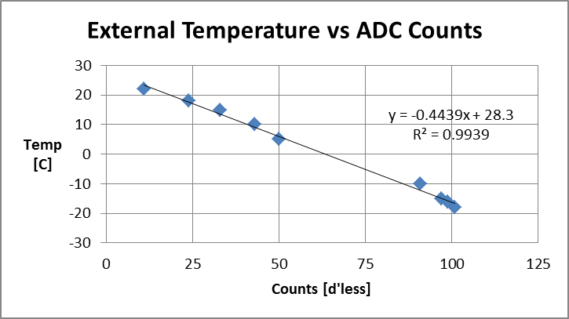
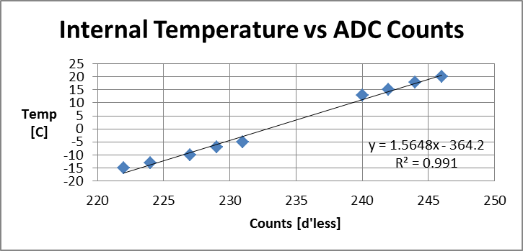
Figure 7-1: Temperature calibration results

ADC counts | Temperature(External C°)
11 | 22
43 | 10
50 | 5
97 | -15
101 | -18
ADC counts | Temperature (Internal C°)
246 | 20
242 | 15
231 | -5
227 | -10
222 | -15
Table 7-1: ADC counts and the corresponding temperature

Pressure Sensor Calibration

The pressure sensor was placed in the pressure vacuum chamber to collect pressure data in millimeters of mercury against the corresponding ADC count. Graphical analysis software obtained the following pressure equation as a function of ADC counts of based off these results:

Pressure(Atm)=.0039464(ADC counts)-.002953703
Error=((1.98378e-5*ADC counts)^2+(.002055339)^2)^.5 Atm

The equation for pressure is linear and a higher pressure corresponds to a higher ADC count, similarly a lower pressure corresponds to a lower ADC count. Figure 7-2 shows a graph of our pressure data versus ADC counts. Table 7-2 lists a few of the pressure data points and its ADC count.

Figure 7-2: Pressure calibration results

ADC counts | Corresponding Pressure (mmHg)
209 | .816
135 | .526
101 | .395
67 | .263
32 | .125
6 | .020
Table 7-2: ADC counts and the corresponding pressure

Humidity Sensor Calibration

We placed the humidity sensor in a saturated container at room temperature. Using a HOBO, we correlated the ADC count with the calculated humidity. Graphical analysis software obtained the following humidity equation as a function of ADC counts:

RH(%)= 0.4003(ADC count) – .1047
Error: ((0.01453*ADC count)^2+(2.706038)^2)^.5%

The humidity equation is linear and a higher ADC count corresponds to a higher percent humidity, whereas a lower ADC count represents a lower percent humidity. Figure 7-3 shows a graph of our humidity data versus ADC counts. Table 7-3 lists a few of the humidity data points and their associated ADC counts.

Figure 7-3: Graph of humidity versus ADC counts

ADC counts | Corresponding Humidity
113 | 50
162 | 60
187 | 75
225 | 90
249 | 100
Table 7-3: ADC counts and the corresponding humidity

Camera Calibration

After performing the measurements described in the camera calibration section, we have determined that by holding a 39.5 inch ruler 103.5 inches away, a vertical angle of 21.4° in given. Holding a 39.5 inch ruler 61 inches away, a horizontal angle of 35.7° is given. The angular resolution of the camera:

1 pixels = 0.03125 degrees = pi/5760 radians

From this, we will be able to convert the measured radius in pixels to an angle in radians. Knowing the distance of the payload to the base of the balloon, we can convert the angle to a balloon radius measurement.

We ran all three camera calibration programs and determined the following times:

X = 900 ms
Y = 2000 ms
Z = 550 ms

Using these delay times, the software can control the camera as expected. In addition, the times are not so long that the data acquisition rate is affected.

Software Verification

Post-flight software is necessary to convert measurements of the edge of the balloon from the video, into a radius with units of pixels. The program uses a “brute force” method of finding the radius by minimizing the standard deviation of the radius inputs from the user. To test this program, we created images of circles with known centers and radii. The first test circle is drawn in MS Paint with the center at (578, 294) and a radius of 100 pixels (left image in Figure 7-4). To measure the circle, we put the four corners of the circle as inputs to the radius-calculating program. The program found the center to be (579, 295), a radius of 99.5, and a standard deviation of 0.50. For the second test, we used five points on one quarter of the circle. The program found the center to be (577, 293), a radius of 97.6, and a standard deviation of 0.21. As a final circular input test, we made an circle with a radius of 350 pixels (center image in Figure 7-4). Using only one quarter of the circle, the program calculated the radius to be 350.2 pixels.

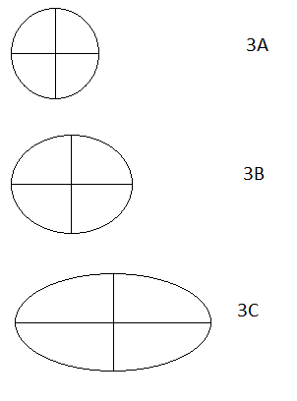
Figure 7-4: Scaled, cropped images used for the tests

This program also calculates the radius if the input is not perfectly circular. To test this, we created three ellipses (right image in Figure 7-4). The semi-major axis of the circles are 50, 62.5, and 100. The semi-minor axes of these ellipses are all 50. The Radius-Calculating program found the radius of these ellipses to be 46, 56, and 77 respectively. Each of these radii are between the values of the semi-major and semi-minor axes. The standard deviations of the ellipses are 0.75, 5.6, and 22.5. The standard deviation increases as the input deviates from a circle. In the case of the balloon, this would indicate how non-spherical the balloon is which could impact the lift force and our calculations of the volume of the balloon.

7.1.2 Pre-Launch Checklist

Event | Time needed | T- minus to launch
Verify that all components are ready for flight and operational. | 10 minutes | 2 days
Run pre-flight software | 25 minutes | 12 hours
Load during flight software | 1 minute | 11.5 hours
Put in the appropriate fresh batteries for each of the power sources and make sure each power source is connected to its appropriate components. | 2 minutes | 1 hour
Place components in payload and tape the lid shut and check to make sure camera is facing up and through the hole in the lid. | 1 minute | 1 hour
Attach the payload to the launch vehicle and check to make sure it is secure. | 10 minutes | 45 minutes
Take picture from a distance in order to calculate distance from payload to balloon. | 2 minute | 5 minutes
Total Time | 51 minutes
Table 7-4: Pre-launch checklist with expected time needed to fulfill each duty.

7.2 Flight Requirements, Operations and Recovery

Our flight vehicle will be filled with helium such that our ascent rate should be 1000 feet per minute. Our expected flight duration is three hours and we expect the flight to start in the early morning. The camera will have enough power and memory to record video of the entire flight. Additionally the EEPROM will have sufficient power and memory for each of our sensors to record data for the entire flight. The camera will need to be facing the balloon for the duration of the flight in order to allow us to calculate its radius. We will also need the altitude of the balloon at all times in order to compare our temperature, pressure, and humidity readings to altitude. We will need the position of the balloon in order to track it so that we can retrieve the payload after landing. The payload vehicle will have two additional payloads to send GPS coordinates of the balloon to LaACES management and a sounding beacon loud enough to hear within several hundreds of feet in case the payload lands in a densely forested area or other area that is hard to navigate through or see. Additionally, these extra payloads are yellow in color and the parachute is multicolored so that they are easier to spot from far away.

7.3 Data Acquisition and Analysis Plan

May 23rd will be the FRR defense, May 24th will be launch and flight operations, the 25th will be a day of data analysis, and on the 26th we will present our science results. Therefore, there is only one day to analyze our data and make a science presentation. In order to fully analyze our data, we will design and test post-flight software. In addition, after the balloon launch, we will follow a detailed post-flight data analysis plan. We will not have any spare time to fix any software during the launch trip, so we must ensure that all post-flight software works appropriately. We will already have a science presentation prepared, and we will add in data from the flight the day before the presentation.

7.3.1 Ground Software

Once we remove the BalloonSat from the payload box, we will need to download the data to a computer and save the data into a text document. We will use Term232, a Windows terminal emulator, to save the output of the BalloonSat to a text document. During software testing, we will develop a step-by-step procedure to properly run Term232. From this text document, we will be able to copy and paste the data into our post-flight Excel sheet.

The temperature, pressure, and humidity sensors all have linear outputs. During calibration, we will determine equations that convert ADC counts to temperature, pressure, and humidity. We will set these calibration data into the post-flight Excel sheet. We will use Excel to convert raw ADC counts into temperature, pressure, and humidity measurements. We will also measure errors on the calibrations, which will enable us to calculate the uncertainties in temperature, pressure, and humidity.
(1)
(2)
(3)
(4)

(5)
(6)

(7)

(8)
$$Temperature=m_{t}(ADC)+b_{t}$$
$$Pressure=m_{p}\left(ADC\right)+b_{p}$$
$$Humidity=m_{h}(ADC)+b_{h}$$
$$Error= {\sqrt{{(σ_{m}ADC)}^{2}+σ_{ADC}m^{2} {+ (σ_{b})}^{2}} }^{}$$

$${θr}_{pix}=r$$
$$θσ_{pix}=σ_{r}$$

$$Radius (R)=\frac{r}{cos(arctan(\frac{r}{L+r})}=r\sqrt{\frac{r^{2}}{{(L+r)}^{2}}+1}$$

$$R=σ_{r}\frac{L^{3}+{3rL}^{2}+5r^{2}L++2r^{3}}{{(L+r)}^{3}\sqrt{\frac{r^{2}}{{(L+r)}^{2}}+1}}$$

The temperature, pressure, and humidity sensors are all linear. In Equations 1-4 above, m is the slope of the fit, b is the y-intercept of the fit, and ADC is the ADC counts of each sensor. The subscript indicates pressure temperature or humidity in Equations 1-3. In equation 4, the subscript indicates slope, y-intercept, or ADC counts The error of the slope and y-intercept, σ_{m} and σ_{b}, were found using the “linest” function in Excel that calculates the error in any linear fit.

There are several steps in calculating the radius and error of the radius of the balloon. First, a screenshot is taken of the balloon. Next, the x and y coordinates of the edge of the balloon are saved to a text file. After that, the radius calculating program calculates the radius and the standard deviation of the radius in pixels. After that, we use Equation 5 above to calculate the radius in cm, and the The equation for radius of the balloon was derived in §3.4.1.2, and is simplified further here. The radius error equation above assumes that the error is dominated by the measured radius error, r, and no error from the distance from the camera to the balloon, L. We will use the standard deviations of the measurements as the error of the measured radius
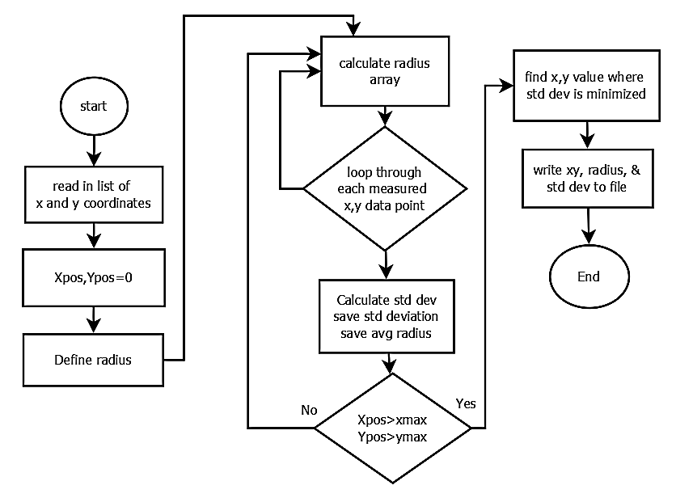
From the altitude measurements, we will calculate the expected temperature, pressure, lapse rate, and density of air. The standard atmosphere depends on sea level measurements of temperature and pressure, which we can calculate from the first measurements, which are near sea level. After calculating the standard atmosphere and uncertainties, we can compare our measured values match with the standard atmosphere. Additionally, we will calculate the correlation between humidity and errors between measured temperature and expected temperature.
Figure 7-5: Balloon Radius calculator

To measure the radius of the balloon, the video will be paused every 2 minutes and a screenshot of the video will be placed into MS Paint. In paint, we will note the x and y coordinate (in pixels) of the edge of the balloon for several locations. A program written in C++ will calculate the radius of the balloon from these x and y measurements. This program works by looping through every possible x,y combination and calculating the radius at each point, then calculating the standard deviation of the radius measurements at each point x,y. A minimum in the standard deviation indicates the radius. In addition, we will watch the video to determine and record when the payload is passing through a cloud.

7.3.2 Ground Software Implementation and Verification

We will use two separate computers for data analysis. One computer, called Post-flight Personal Computer 1 (PFPC1), will analyze and download the video data. The other computer, named Post-flight Personal Computer 2 (PFPC2), will analyze and download the BalloonSat data.

Tests that we must do:
- Verify that camera videos can be downloaded to post-flight PC
- Verify that radius calculating program works
- Learn how to use Term232 and write step-by-step instructions on how to use it
- Verify that post-flight software and Term232 can transfer data from the BalloonSat to Excel for data manipulation
- PFPC-1 must have:
  - SD card reader or USB port
  - At least 32 GB open memory
  - A movie player that can support .MOV video format
  - MS paint
  - MS Excel 2010
  - Dropbox
- PFPC-2 must have:
  - VGA input for BalloonSat
  - At least 32 KB of open memory
  - Term232
  - MS Excel 2010
  - Dropbox

During the software testing, we need to determine that the post-flight software can extract the data from the BalloonSat. Additionally, the radius calculating program must be able to calculate the radius of a circle. These will be tested by making a circle of a known radius in MS paint, measuring the x and y coordinates of the edge, putting these coordinates into the radius calculating program, and see if the output matches the known radius. For the BalloonSat post-flight software, we can run the during flight program, then run the post-flight program and see if the post-flight program successfully outputs the data stored in the EEPROM.

7.3.3 Data Analysis Plan

After the flight, we have very little time to download, convert, and analyze the data. We must be very efficient with our data processing. Team Philosohook will break into two teams, one for video analysis, and the other for BalloonSat data processing.

Post-flight procedure for Team Philosohook:
- Track and locate payload
- Image payload
- Recover payload
- Disconnect power
- Remove camera
- Remove BalloonSat

Next, we will split into two teams; the video processing team will do the following:
- Download Videos to PFPC-1
- Number the videos
- Watch videos in sequence
- For each video
  - Record time (in the video) that the payload passes through a cloud
  - Pause every 2 minutes for radius measurement (also before and after passing through clouds)
    - Pause video
    - Take screenshot of video
    - Paste screenshot into MS Paint
    - Record at least 8 coordinate pairs of the balloon edge
    - Run radius calculating program
    - Record output to Excel sheet
  - Convert time in video to absolute time using data from the BalloonSat (provided by the other team)
  - Convert absolute time into altitude
- Create plot of balloon radius vs. Altitude
- Create plot of when the balloon is passing through a cloud vs. altitude

Simultaneously, the BalloonSat data processing team will do the following:
- Connect BalloonSat to PFPC-2
- Set up Term232
- Run post-flight BalloonSat software
- Save raw output to plain text document
- Paste data into post-flight Excel sheet
- Check video status output byte
- Record times that the video restarts and give to the video analyzing team
- To convert raw data into useful data:
  - Convert ADC counts into T,P,H data using calibration equations
  - Calculate T,P,H errors using calibration errors
  - Calculate lapse rate
  - Determine altitude of the layers of the atmosphere from lapse rate
- To calculate US Standard Atmosphere
  - Input heights of the layers into equations
  - Input sea level temperature and pressure into equations
  - Calculate errors based on equations derived in the appendix

After the flight we will do science. Interesting plots would include:
- Temperature vs. Altitude
- Pressure vs. Altitude
- Humidity vs. Altitude
- Lapse Rate vs. Altitude
  - Layers of the atmosphere vs. Altitude
- Relative error of temperature vs. Altitude
- Relative error of pressure vs. Altitude
- Correlation of temperature error with respect to standard atmosphere and humidity vs. Altitude
- Correlation of pressure error with respect to standard atmosphere and humidity vs. Altitude
- Balloon radius vs. Altitude
- Expected radius vs. Altitude (using actual density of the air and weight of the payloads)
- If the payload is passing through a cloud vs. Altitude
- Temperature, Pressure, and Humidity vs. Altitude before and after passing through cloud
- Internal temperature vs. Altitude

After producing all of these plots, we will analyze them and determine what properties of the atmosphere are affected by passing through clouds. We will also determine if there is any correlation between humidity and temperature or pressure. All of these plots will be made using Excel in a final spreadsheet.

8.0 Project Management

The purpose of this section is to ensure this project meets the experiment’s objectives within the allocated schedule and budget. This includes discussion of project direction, authorization, communication, meeting, reviews, record keeping, and monitoring. In order to ensure proper project direction, the team will refer to its purpose, goals, and objectives contained in Sections 1 and 3 of this report. The project manager, in conjunction with the team members, makes major decision. A majority rule vote resolves any disputes. In the case of a tie the dispute will be brought to one of the ACES project managers to settle the dispute.

Team Philosohook meets every Tuesday and Thursday from 6:00 pm until 8:00 pm and Wednesdays from 6:00 pm until 7:00 pm. Team members work additionally at their own discretion in order to meet the project timeline. A logbook resides in the ACES lab and each member is required to sign in and briefly describe the work that he or she did. Failure by an individual to uphold their part of the project results in disciplinary action as defined by the team contract.

8.1 Organization and Responsibilities

Member | Responsibility | Email
Hannah Gardiner | Project Management | hgardi1@tigers.lsu.edu
Bill Freeman | Software Design | billfreeman44@yahoo.com
Randy Dupuis | Electrical Design | rdupui4@tigers.lsu.edu
Andrea Spring | Mechanical Design | aspri11@tigers.lsu.edu
Corey Myers | Testing and Implementation | cmyer14@tigers.lsu.edu
Table 8-1: Team members, their responsibilities, and email addresses

8.2 Configuration Management Plan

Any major change in mechanical design, electrical design, or software design will be submitted by the team member in charge of the respective section to the rest of the team members. After discussion of the changes, the team will put the design change up to a vote decided by majority rule. If the team cannot reach a consensus or the vote ties, then ACES staff will be contacted to help resolve the issue. The project manager then records the changes in the logbook.

8.3 Interface Control

All team members meet in the ACES lab in Nicholson Hall at LSU. Team members consult each other regarding any effects that their section has on another team member’s section if needed. All major changes will be documented in the logbook and discussed at team meetings.

9.0 Master Schedule

This section describes how Team Philosohook will organize and manage the effort associated with our payload. Microsoft Project was used to organize our Work Breakdown Structure and Timeline.

9.1 Work Breakdown Structure (WBS)

1.Electronics 12 days
1.1 Electronics Design 6.5 days
1.1.1 Sensor Selection 1.0 days
1.1.2 Parts Selection 1.5 days
1.1.3 Circuit Design 2.0 days
1.1.4 Power budget 1.0 days
1.1.5 Circuit Schematic Drawn 1.0 days
1.2 Electronics Prototyping 6.0 days
1.2.1 Constructing subsystem Prototypes 0.5 days
1.2.1.1 Construct Temperature System Prototype 0.5 days
1.2.1.2 Construct Pressure System Prototype 0.5 days
1.2.1.3 Construct Humidity System Prototype 0.5 days
1.2.2 Test subsystem Prototypes 0.5 days
1.2.2.1 Test Temperature System Prototype 0.5 days
1.2.2.2 Test Pressure System Prototype 0.5 days
1.2.2.3 Test Humidity System Prototype 0.5 days
1.2.3 Develop Sensor Prototype 1.5 days
1.2.3.1 Construct Prototype 1.0 days
1.2.3.2 Test Prototype 0.5 days
1.2.4 Power Supply during flight 1.5 days
1.2.4.1 Finalization of values for Power Supply 1.0 days
1.2.4.2 Interface Power Supply with Prototype 0.5 days
1.2.5 Test Full Prototype 1.0 days
2. Mechanical 16 days
2.1 Design 2.0 days
2.1.1 External Design 1.0 days
2.1.2 Internal Design 1.0 days
2.2 Construction 8.0 days
2.2.1 External Construction 3.0 days
2.2.1.1 Build payload box 2.5 days
2.2.1.2 Cut holes for sensors and camera 0.5 days
2.2.2 Internal Construction 5.0 days
2.2.2.1 Build insert for BalloonSat 2.0 days
2.2.2.2 Install sensors, BalloonSat and camera 3.0 days
2.3 Testing 6.0 days
2.3.1 Sensor and camera testing 2.0 days
2.3.2 Impact testing 1.0 days
2.3.3 Thermal testing 1.0 days
2.3.4 Vacuum testing 1.0 days
3. Software 12 days
3.1 Write Subroutine Flowcharts 3 days
2.1.1 Pre-flight Subroutine Flowcharts. 1 days
2.1.2 During Flight Subroutine Flowcharts 1 days
2.1.3 Post-flight Subroutine Flowcharts 1 days
3.2 Software writing 4.5 days
2.2.1 Pre-flight 1.5 day
2.2.2 During Flight 1.5 day
2.2.3 Post-flight 1.5 day
2.2.4 timing programs 0.25 days
3.3 Testing 4.5 days
2.3.1Pre-flight 1.5 day
2.3.2 During Flight 1.5 day
*depends on electrical prototype
2.3.3 Post-flight 1.5 day
4. Calibrations 10.5 days
4.1 Calibration of temperature sensor. 3.0 days
4.1.1 Temperature conditions set up 1.0 day
4.1.2 Temperature information collection 1.0 day
4.1.3 Temperature information calibrated 1.0 day
4.2 Calibration of pressure sensor. 3.0 days
4.2.1 Pressure conditions set up 1.0 day
4.2.2 Pressure information collection 1.0 day
4.2.3 Pressure information calibrated 1.0 day
4.3 Calibration of humidity sensor. 3.0 days
4.3.1 Humidity conditions set up 1.0 day
4.3.2 Humidity information collection 1.0 day
4.3.3 Humidity information calibrated 1.0 day
4.4 Calibration of camera. 1.5 days
4.4.1 Camera conditions set up 0.5 days
4.4.2 Camera information collection 0.5 days
4.4.3 Camera information calibrated 0.5 days

9.2 Staffing Plan

Primary Roles:
Spokesperson Project Lead – Hannah Gardiner
Mechanical Design Lead – Andrea Spring
Testing and Implementation – Corey Myers
Software – Bill Freeman
Electrical Design Lead – Randy Dupuis
Editing Lead – Hannah Gardiner

Secondary Roles:
Secondary Project Lead – Andrea Spring
Secondary Mechanical Design Lead – Corey Myers
Secondary Testing and Implementation Lead – Hannah Gardiner
Secondary Software – Randy Dupuis
Secondary Electrical Design – Bill Freeman
Secondary Editing – Bill Freeman

9.3 Timeline and Milestones

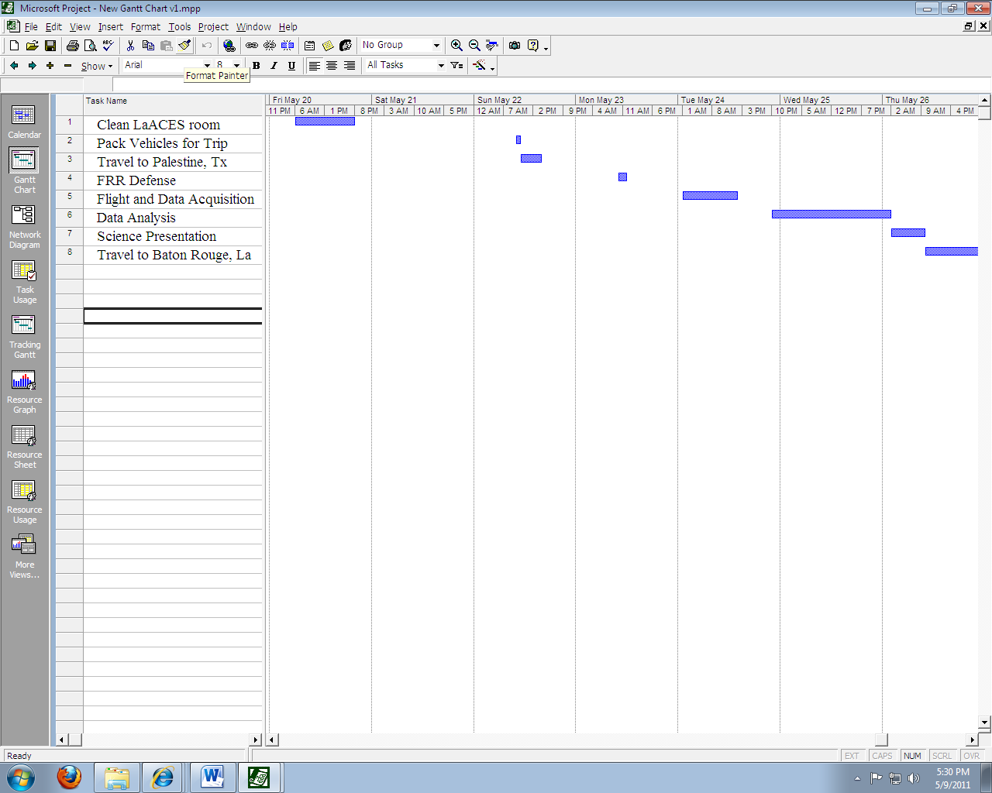
Figure 9-1: Gantt chart showing the overall project timeline

10.0 Master Budget

Item | Source | Manufacturer # | Quantity | Price
Temperature Sensor | DigiKey | 1N457 | 1 | $0.02
Pressure Sensor | TBD | TBD | 1 | $40
Humidity Sensor | DigiKey | HIH-5031 | 1 | $14.11
Risk Contingency | Dr. Guzik | US Mint | 1 | $100
Camera | eBay | Kodak Zx1 | 1 | $40
32 GigaByte SD Card | Amazon | TS32GSDHC10E | 1 | $54
Expanded EEPROM | Paralax | 24AA64 | 1 | $1.50
Batteries (AA) | Thomas Distributing | ENR-L91BP-4 | 4 | $4
Batteries (AAA) | Thomas Distributing | ENR-L92-BP4 | 8 | $8
Additional Camera(s) | eBay | Kodak Zx1 | 1 | $80
Single OpAmp Integrated Circuit | Analog Devices | AD820 | 1 | $2.25
BalloonSat | LaAces Management | bsat12 | 1 | --
 |  |  | TOTAL | $343.88
Table 10-1: Master Budget

Table 10-1 shows our master budget of components, the source at which we will attain them, manufacturer number, quantity, and price. Our total budget thus far is $343.88 that falls within our $500 limit. Our budget also contains a $100 contingency in the event that new parts are needed. Additionally, we have set aside an extra $80 contingency in our budget for extra cameras in case the camera used for testing and calibrations breaks beyond repair. Even with contingency, we still have extra room in our budget.

10.1 Expenditure Plan

Component | Price | Status
Temperature Sensor | $0.02 | Acquired
Pressure Sensor | $40 | Acquired
Humidity Sensor | $14.11 | Acquired
Camera | $40 | Acquired
32 GigaByte SD Card | $64 | Acquired
Expanded EEPROM | $1.50 | Acquired
Batteries (AA) | $4 | Acquired
Batteries (AAA) | $8 | Acquired
Single OpAmp Integrated Circuit | $2.25 | Acquired
BalloonSat | -- | Acquired
Table 10-2: Expenditure Plan shows each component, its price, and status

10.2 Material Acquisition Plan

Many of the materials required for our project are already at our disposal in the LaACES lab. This is very convenient for preliminary testing and calibrations because we save time on waiting on shipping. However, other parts were attained through online vendors such as eBay, Amazon, Paralax, Thomas Distributing, Analog Devises, and DigiKey. Although we already have some of the components, it is important that we document where we can attain the components in case one or more of the components fail and we need to order more.

Material | Quantities | How Acquired | When Needed | When Ordered
BalloonSat | 1 | Supplied by LaACES | Calibration and testing | Already have
Capacitors, wires, resistors, etc. for electronics | 22 | Supplied by LaACES | Calibration and testing | Already have
Styrofoam, Gorilla Glue, & Duct Tape | 50g | Supplied by LaACES | Payload Creation | Already have
1N457 Temperature Sensor | 1 | Supplied by LaACES | Electronics prototyping | Already have
1230 Pressure Sensor | 1 | Supplied by LaACES | Electronics prototyping | Already Have
HIH-5031 Humidity Sensor | 1 | Order Online | Electronics prototyping | Ordered and received
Kodak Zx1 Camera | 1 | Supplied by LaACES | Electronics prototyping | Already have
32 GigaByte SD Card | 1 | Order Online through Amazon | Software Testing | Ordered and received
24AA64 Expanded EEPROM | 1 | Order Online | Electronics Development | Ordered and received
Batteries (AA) | 4 | Order online through Thomas Distributing | Calibrations | Already have
Batteries (AAA) | 8 | Order online through Thomas Distributing | Calibrations | Already have
Table 10-3: Material Acquisition Plan

11.0 Risk Management and Contingency

Likelihood and impact are estimated on a scale of 1 to 5, one being the least likely to happen or the least impact and five being the most likely to happen or the highest impact. Detection difficulty is also estimated on a scale of 1-5, one being the least difficult to detect and five being the most difficult to detect.
System | Risk | Likelihood | Impact | Detection Difficulty | When
Software | - | - | - | -
 | Loading of the wrong program to the payload | 1 | 5 | 2 | Pre-flight
 | Forget to load program into payload | 1 | 5 | 1 | Pre-flight
 | Running out of memory | 4 | 3 | 1 | During flight
 | Temporary power failure | 3 | 4 | 4 | During flight
Mechanical | - | - | - | -
 | Payload box breaks upon landing | 3 | 3 | 2 | Touchdown
 | Lid comes off of box during flight | 1 | 4 | 3 | During flight
 | Lack of insulation | 1 | 5 | 3 | Box production
 | Payload breaks during flight due | 1 | 5 | 5 | During flight
Electrical | - | - | - | -
 | Condensation forming on payload electronics | 4 | 4 | 5 | During flight
 | Components fail during flight | 2 | 4 | 2 | During flight
 | Sensor fail during flight | 2 | 4 | 2 | During flight
 | Short circuit in payload | 2 | 4 | 4 | During flight
 | Bad connection during fabrication | 2 | 4 | 4 | Fabrication
 | Camera failure | 2 | 5 | 3 | During flight
Other | - | - | - | -
 | Going over money budget | 1 | 5 | 3 | Fabrication
 | Going over weight budget | 2 | 5 | 3 | Fabrication
 | Payload enters clouds | 3 | 3 | 2 | During flight
 | Solar flares | 1 | 4 | 5 | During flight
 | Ice forming on payload | 2 | 4 | 5 | During flight
 | Balloon Vehicle is lost | 1 | 5 | 1 | Touchdown
Table 11-1 Risk Management

Risk Event | Response | Contingency | Trigger | Who is Responsible
Loading of the wrong program to the payload | Reload | Check program before flight | Lapse in concentration | Bill
Forget to load program into payload | Reload | Check payload before flight | Lapse in concentration | Bill
Running out of memory | Restart program before launch | Use larger EEPROM | Starting flight program too early or late balloon launch | Bill or ACES management
Temporary power failure | Software Fix | Code in Software | EEPROM times mismatch | Bill
Payload box breaks upon landing |  | Shock test |  | Corey, Andrea
Lid comes off of box during flight |  | Duct tape to secure the lid
Lack of insulation |  | Thermal Test |  | Corey, Andrea
Payload breaks during flight due |  | Vacuum test |  | Corey, Andrea
Condensation forming on payload electronics |  | Coat parts and secure with foam
Components fail during flight |  | Test all components before flight |  | Corey,
Sensor fail during flight |  | Test all sensors before flight |  | Corey
Short circuit in payload |  | Perform shock test on components |  | Corey
Bad connection during fabrication |  | Follow schematic when building payload |  | Andrea, Randy
Camera failure |  | Check camera functionality and battery pack before flight |  | Corey,
Going over money budget |  | Choose less expensive parts |  | Hannah
Going over weight budget |  | Choose lighter parts |  | Hannah
Payload enters clouds |  | Visual conformation with camera to determine enter and exit time
Ice forming on payload |  | Ample foam to insulate payload |  | Andrea
Balloon Vehicle is lost
Table 11-2 Risk Contingency

12.0 Glossary

%rel Percent relative humidity
AC Alternating Current
ADC Analog to Digital Converter
Atm Atmosphere
CCD Charge Coupled Device
CDR Critical Design Review
CMOS Complementary metal oxide semiconductor
EEPROM Electrically Erasable Programmable Read-Only Memory
ESRL Earth System Research Laboratory
FRR Flight Readiness Review
GMD Global Monitoring Division
GPS Global Positionaing Satellite
HD High Definintion
Hum Humidity
km Kilometer
LaACES Louisiana Aerospace Catalyst Experiences for Students
LSU Louisiana State University
NASA National Aeronautics and Space Administration
NOAA National Oceanic and Atmospheric Administration
PDR Preliminary Design Review
RH Relative Humidity
RTD Resistant temperature detectors
TBD To be determined
TBS To be supplied
Temp Temperature
USAF United States Air Force
V Volts
WBS Work breakdown structure

