1、

can not draw a general shape!

\*

\* \*

\*\*\*\*\*

\*\*\*\*\*

\* \*

\*\*\*\*\*

can not draw a general shape!

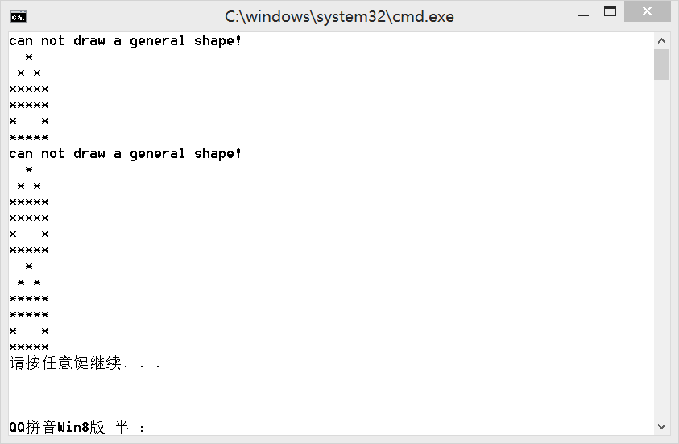 \*

\* \*

\*\*\*\*\*

\*\*\*\*\*

\* \*

\*\*\*\*\*

\*

\* \*

\*\*\*\*\*

\*\*\*\*\*

\* \*

\*\*\*\*\*

The same as I image.

2、

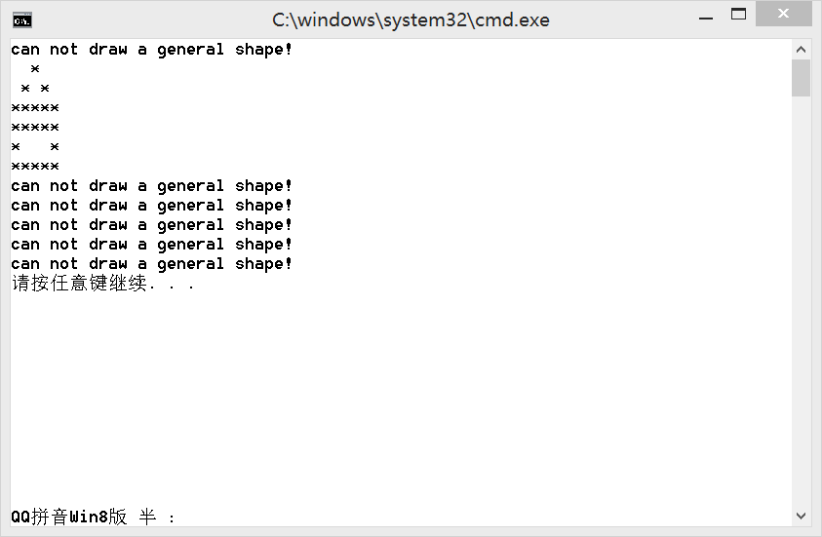

3、

If the function in question is 'virtual' in the base class, the most-derived class's implementation of the function is called according to the actual type of the object referred to, regardless of the declared type of the pointer or reference. If it is not 'virtual', the method is resolved 'early' and the function called is selected according to the declared type of the pointer or reference.

Virtual functions allow a program to call methods that don't necessarily even exist at the moment the code is compiled.

In C++, *virtual methods* are declared by prepending the virtual keyword to the function's declaration in the base class.

This modifier is inherited by all implementations of that method in derived classes, meaning that they can continue to over-ride each other and be late-bound.