武汉大学国际软件学院

实验报告

课程名称 数据库课程设计
专业年级 2014级
姓 名
学 号
协 作 者 无
实验学期 2015-2016 学年 第二 学期
课堂时数 8 课外时数 4
填写时间 2016 年 4 月 10 日

实验概述
【实验项目名称】：Database System Design Lab, Experimental Introduction and Criteria, First experimental
【实验目的】： (1) Learn to install Oracle and PostgreSQL.
(2) Learn to use interactive tool SQL plus of Oracle. Learn to use interactive tools of PostgreSQL, including command line and PgAdmin.
(3) Create all tables in School database, which are introduced in supplementary document, through command line, SQL plus(Oracle) or PgAdmin (PostgreSQL).
(4) Alter table “Teacher”, set field “Teac_sex” to NOT NULL, and change the type of field ” TechPost” to “Varchar(15)”
(5) Add a field “Year” in table “Course”, set type “Varchar(4)”, default value is Null. Add constraint on the field “Year” where the legal values in this field are between 2010 and 2015.
(6) Delete the field “Year” from table “Course”.
(7) Create a domain named “TeacherID”, which consists of number and letter; then apply the domain to field “Teac_id” in Teacher table.
(8) Set a general constraint for fields “Teac_sex” and “Stu_sex” respectively in Teacher and Student tables to make sure that they only hold either “Male” or “Female” values.
(9) Create index on field “Class_id” in table “Class”, and create index on “Stu_id” and “Course_id” in table “6. StudentGrade”.
(10) Use SQL statements to display all tables’ structure.
【实验环境】（使用的软件）：
PostgreSQL9.1
pgAdmin III

【参考资料】：
Internet, Textbook, PPT

实验内容
【实验方案设计】：
(1) Learn to install Oracle and PostgreSQL.
(2) Learn to use interactive tool SQL plus of Oracle. Learn to use interactive tools of PostgreSQL, including command line and PgAdmin.
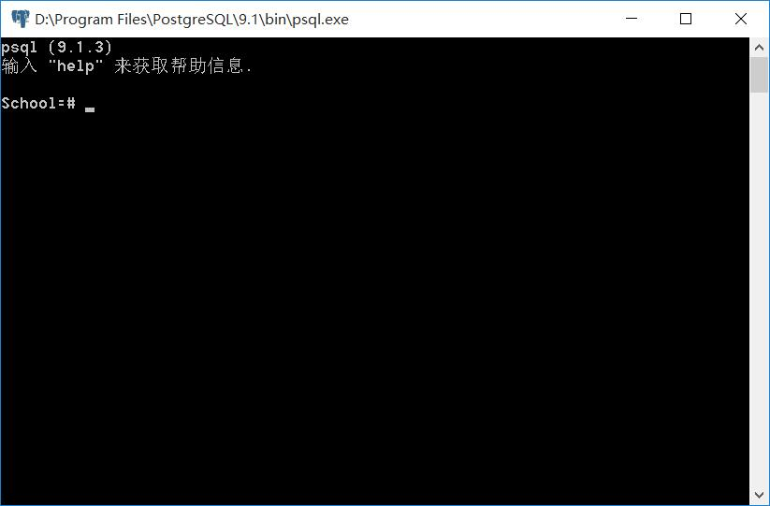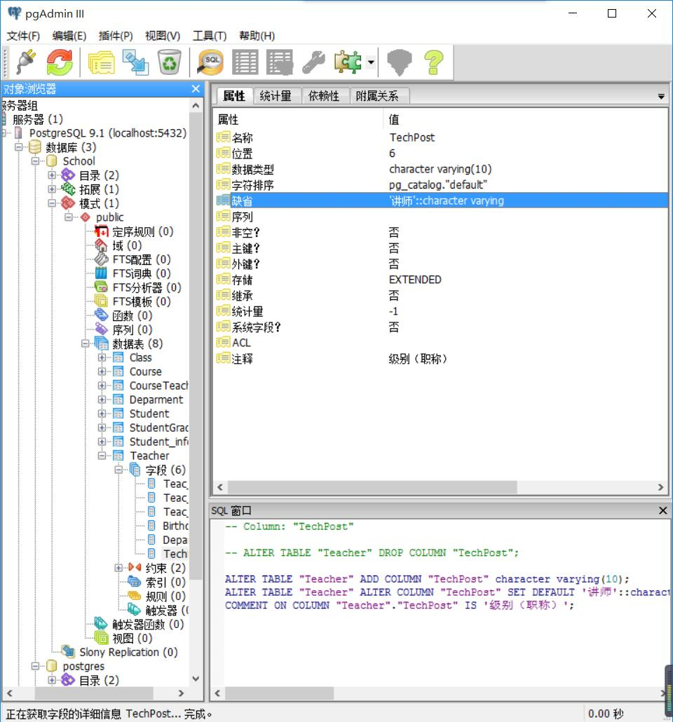
(3) Create all tables in School database, which are introduced in supplementary document, through command line, SQL plus(Oracle) or PgAdmin (PostgreSQL).
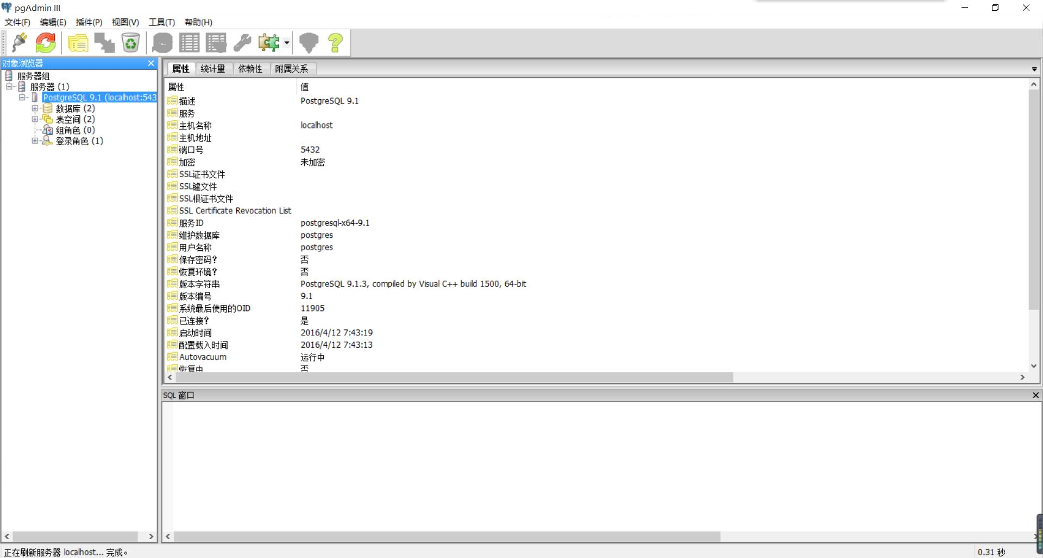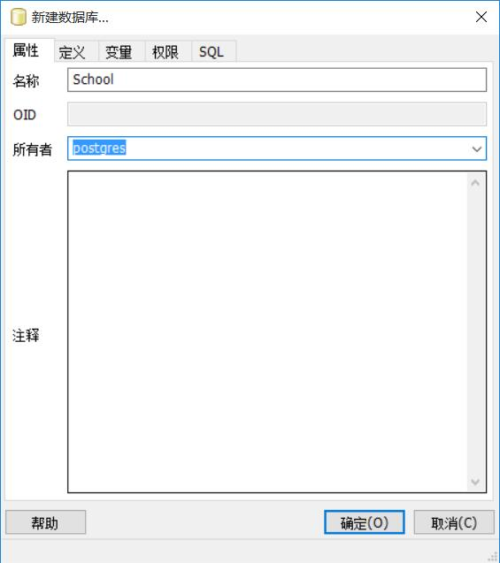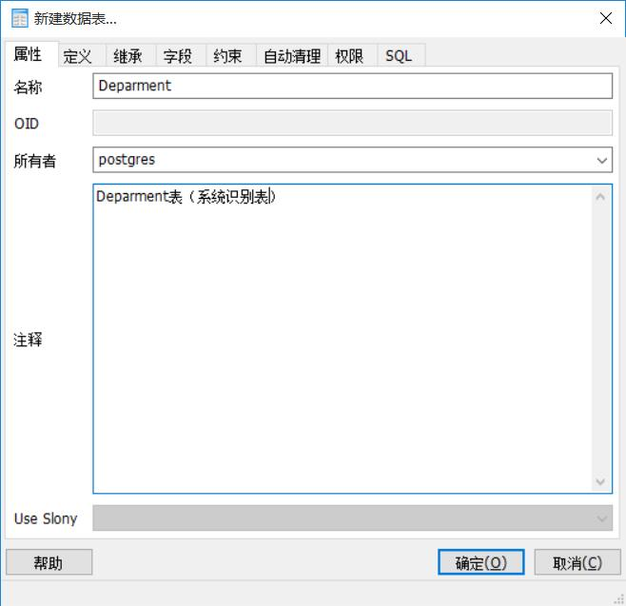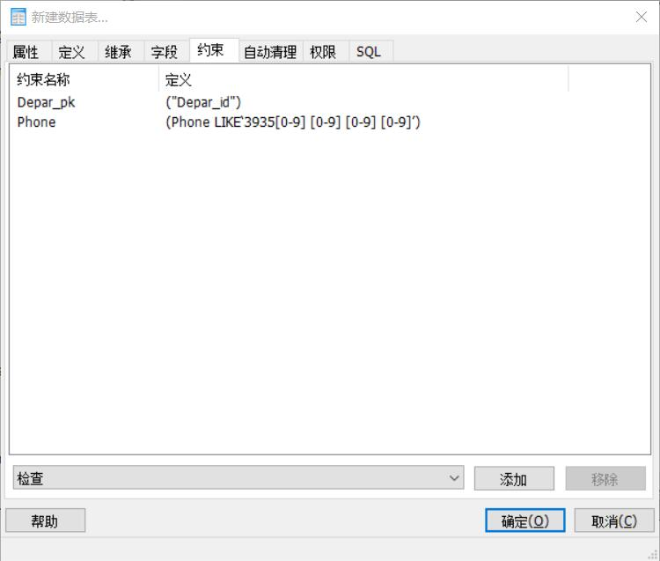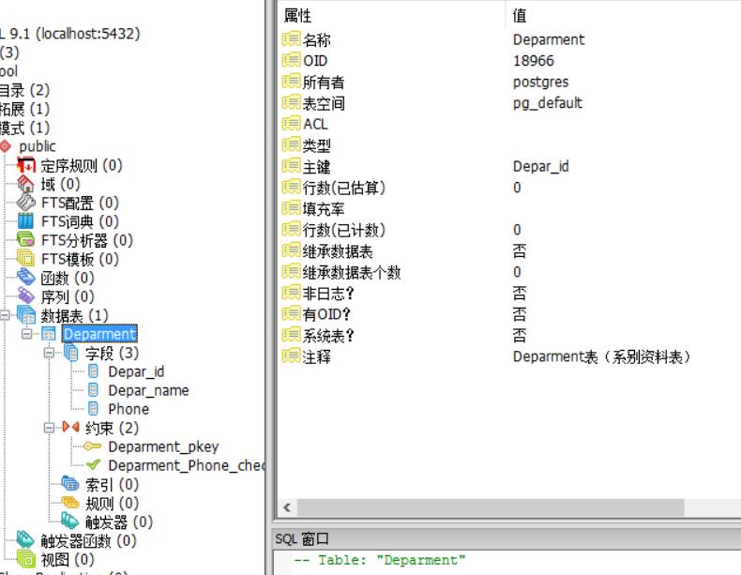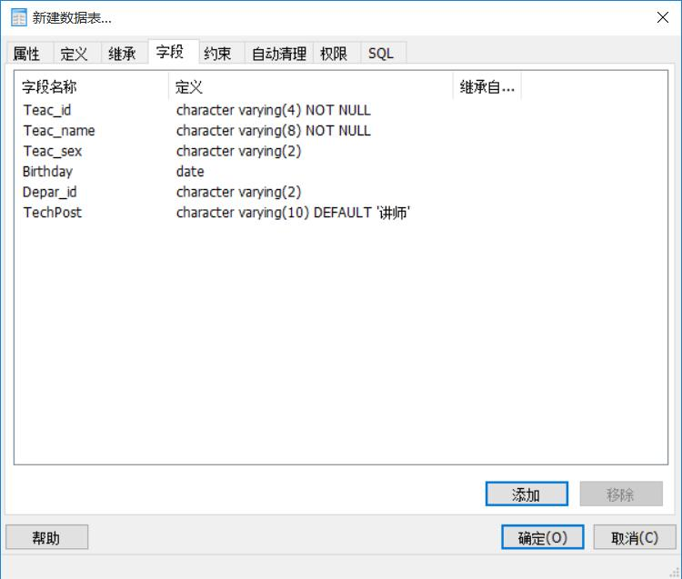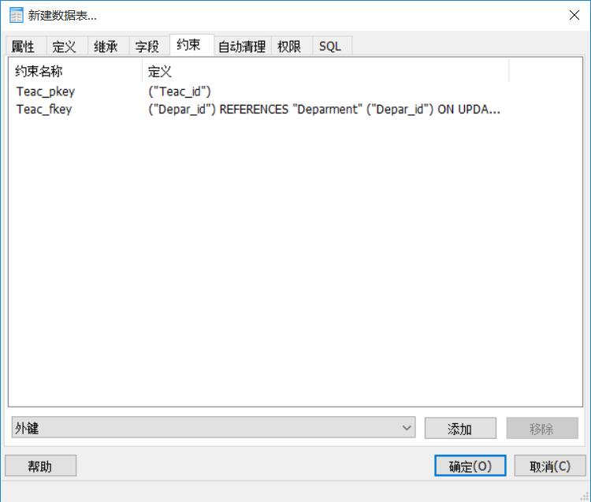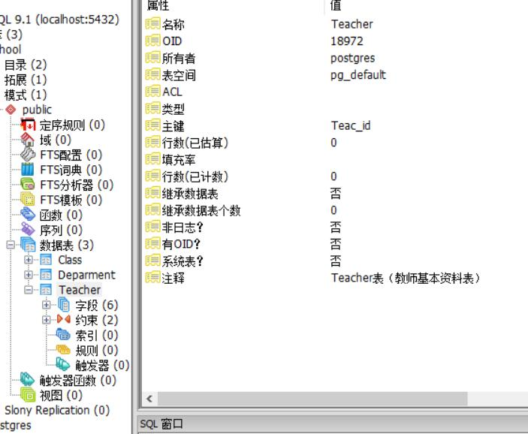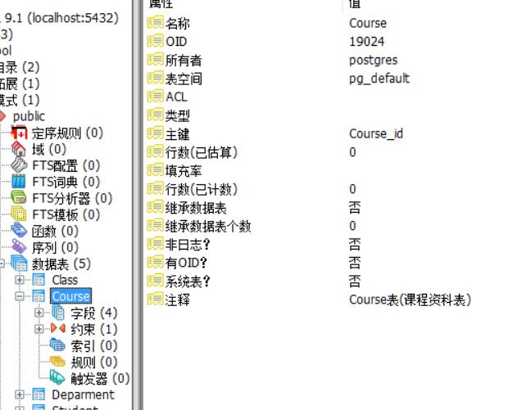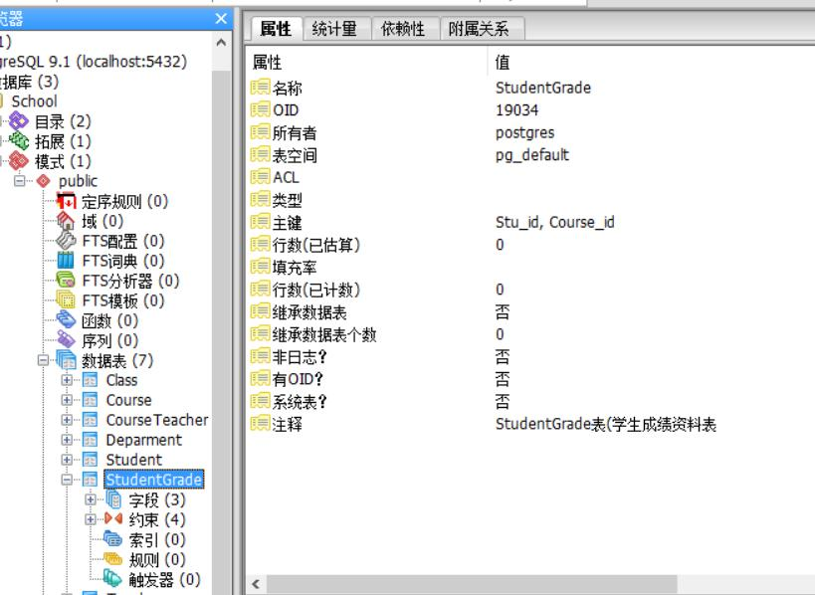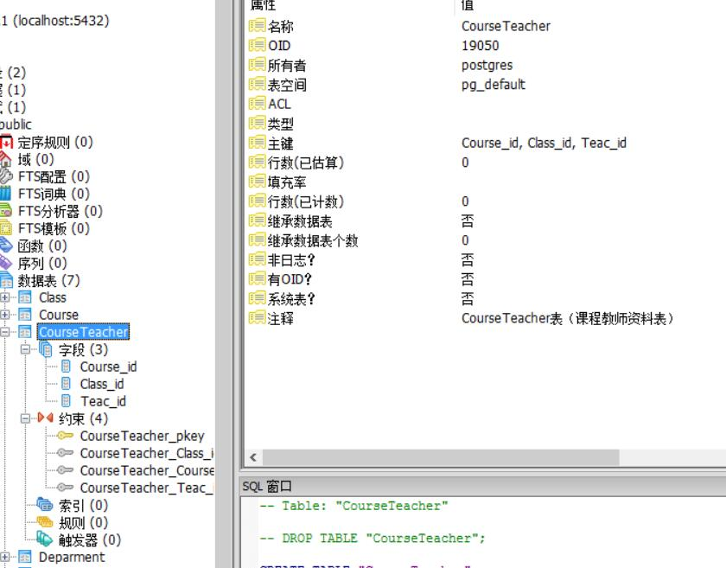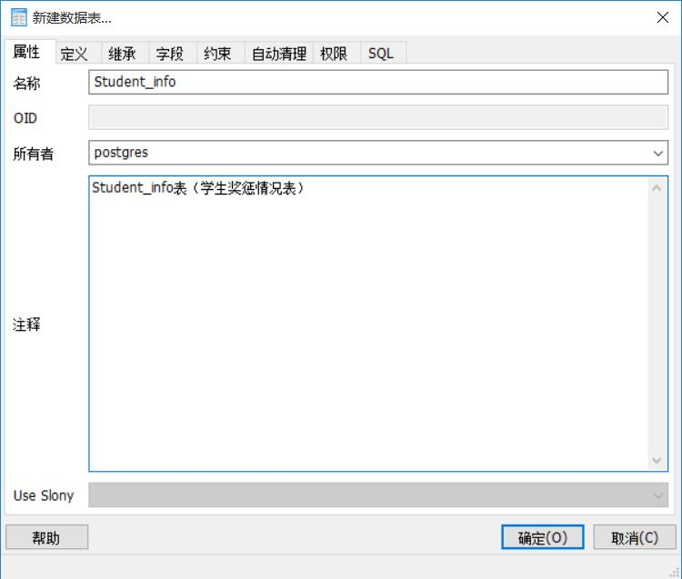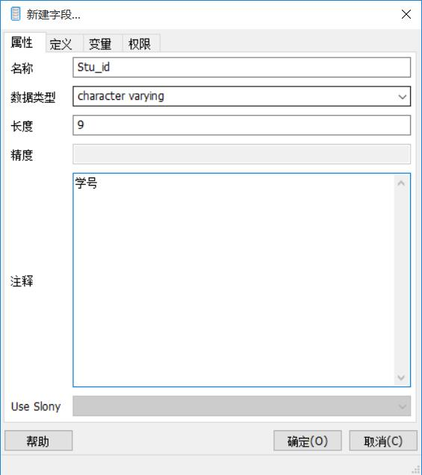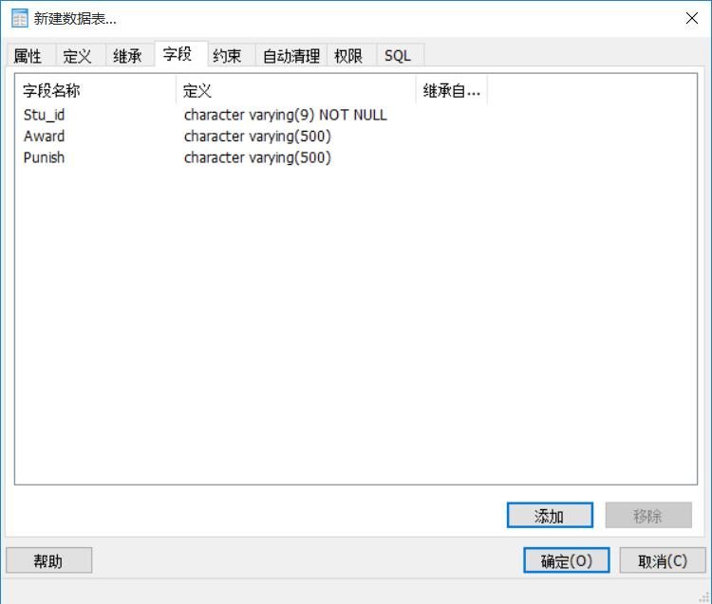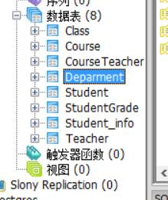
When I set the constraint of the field Phone, there being a problem. I can’t work out with it whether I used dos command or pgAdminIII.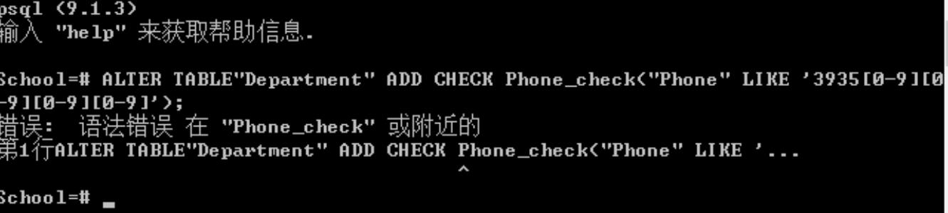 By searching and discussing with classmates, I finally done with it by adding the “” by Phone.
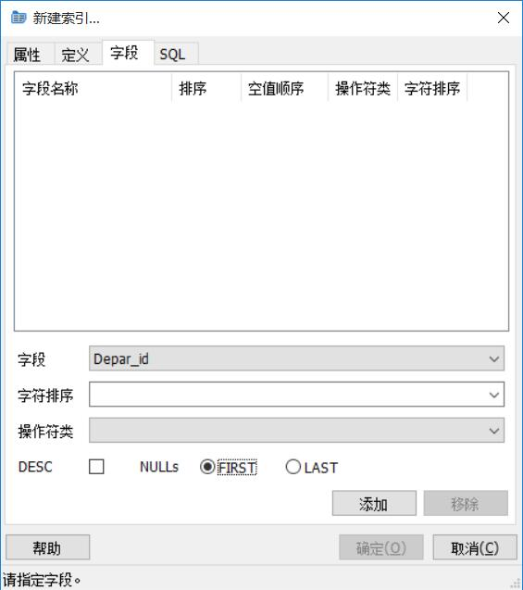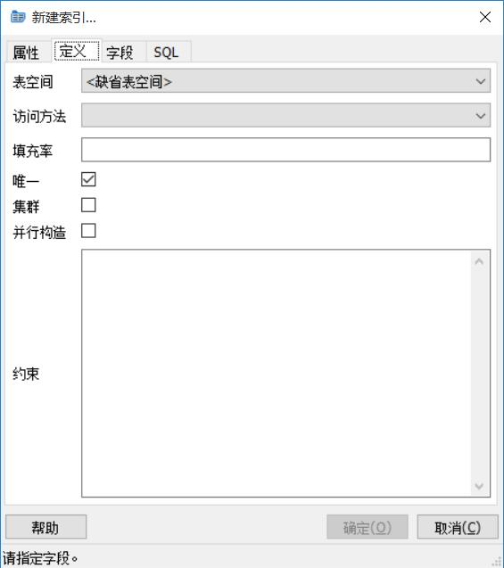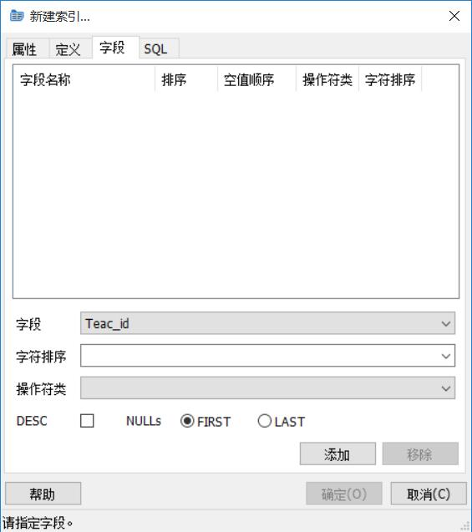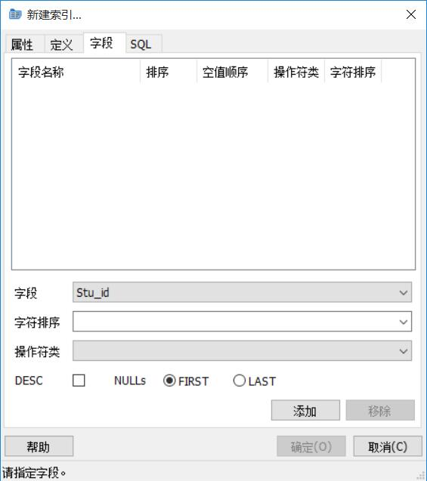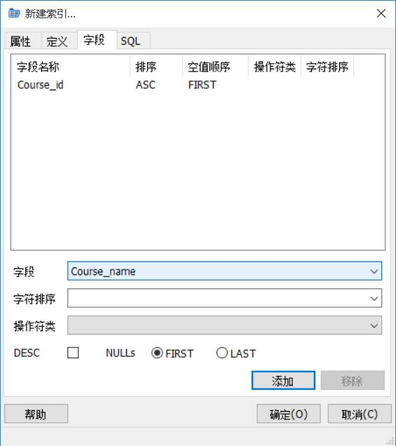
This is from teacher’s file.{ 注意：
l、系别编号为“0l”到“99”。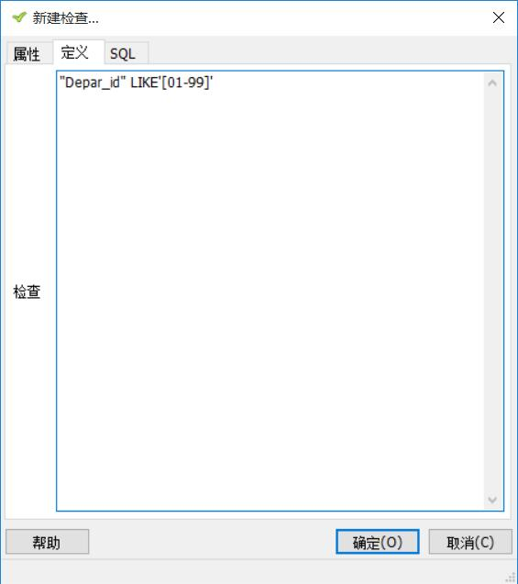
2、教师编号由所属系别编号+序列号组成，序列号为“01”到“99”。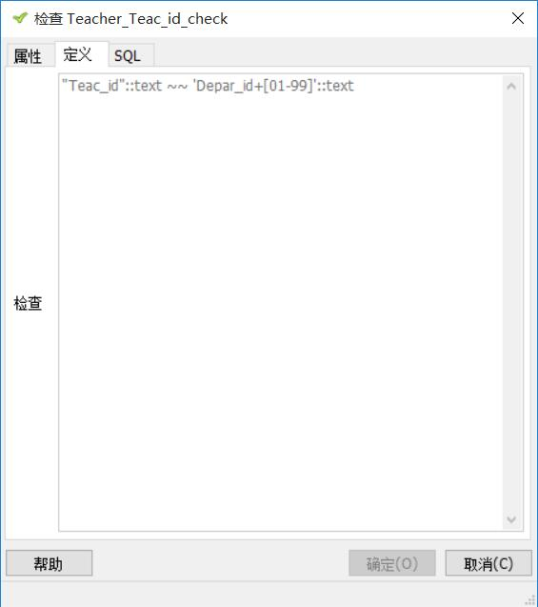
3、班级编号由入学年份的后两位+所属系别编号+序列号组成，序列号为“0l”到“99”。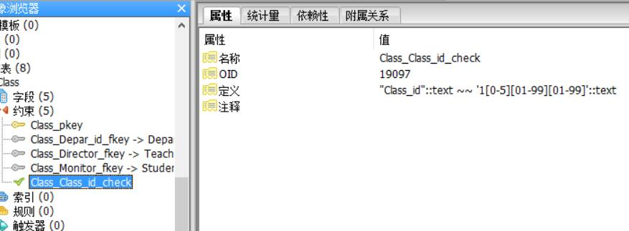
4、课程编号由所属系别编号+序列号组成，序列号，“0l”到“99”。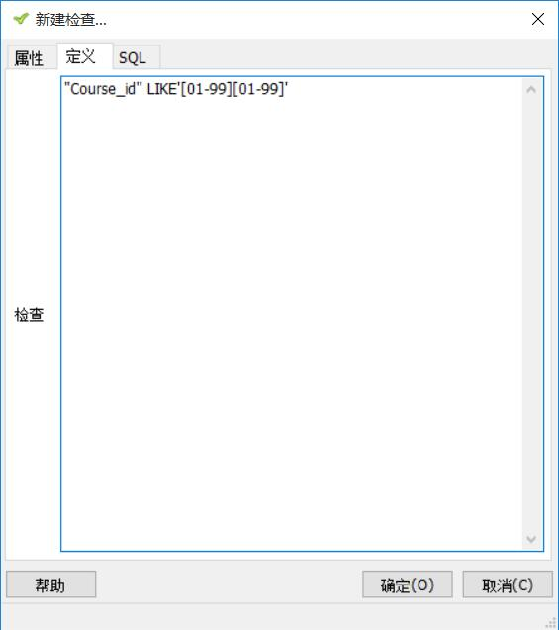
5、学生编号由入学年份的后两位+所属班编号+序列号组成，序列号为“001”到“999”。}
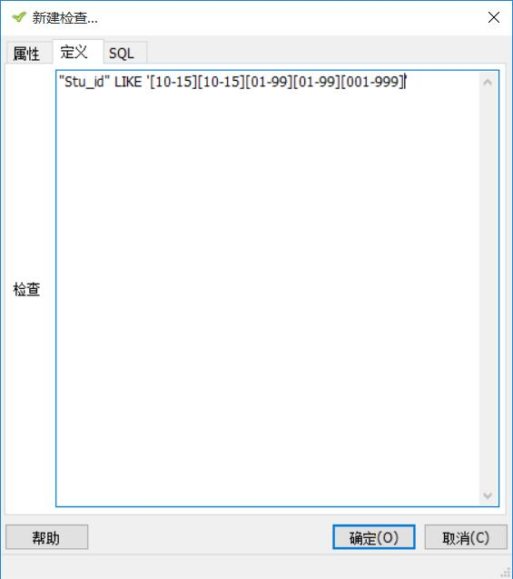
(4) Alter table “Teacher”, set field “Teac_sex” to NOT NULL, and change the type of field ” TechPost” to “Varchar(15)”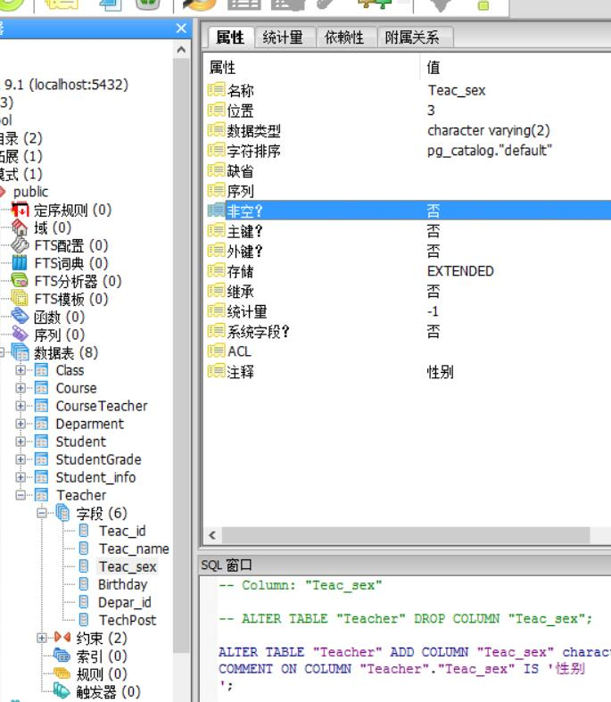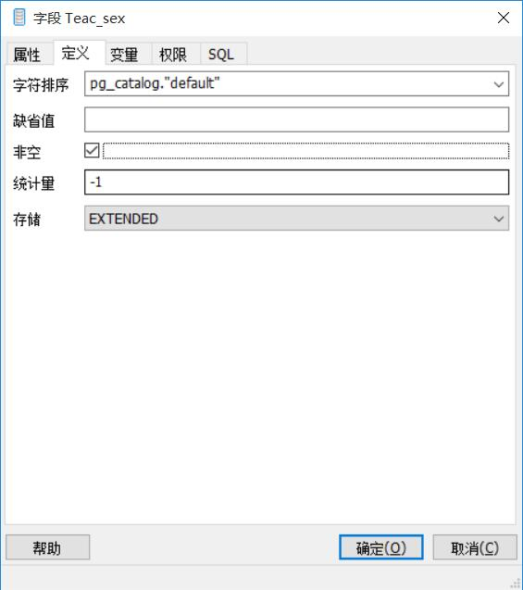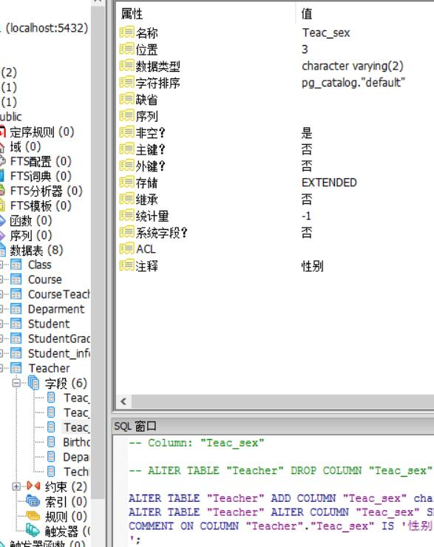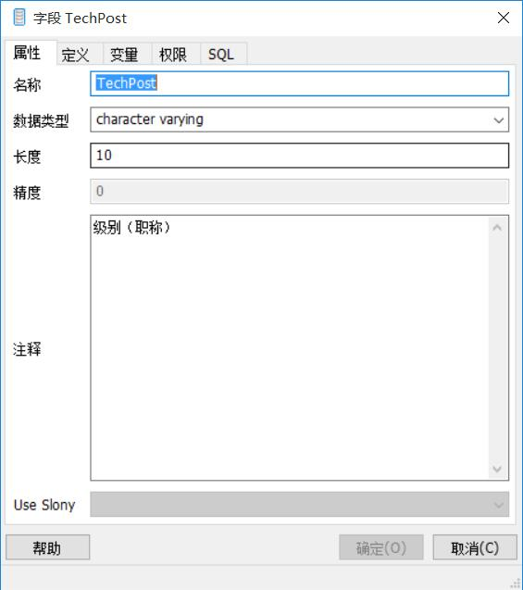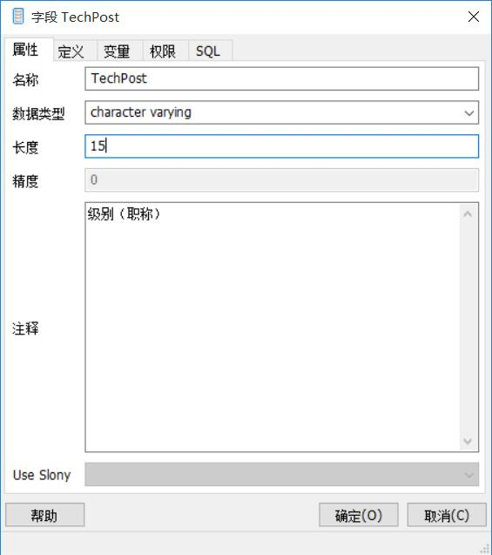
(5) Add a field “Year” in table “Course”, set type “Varchar(4)”, default value is Null. Add constraint on the field “Year” where the legal values in this field are between 2010 and 2015.
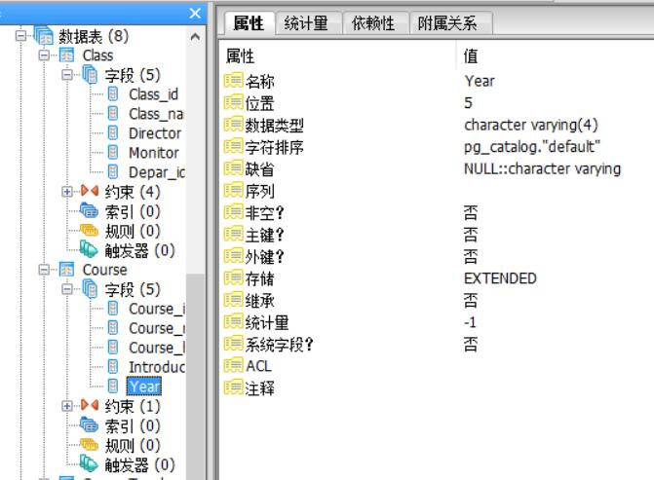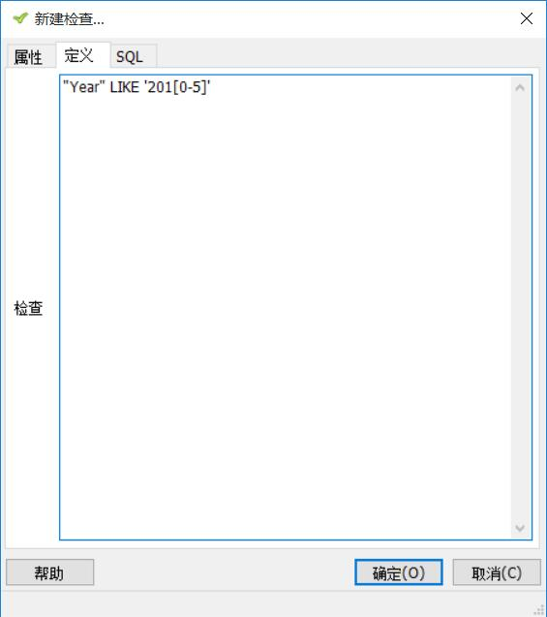
(6) Delete the field “Year” from table “Course”.
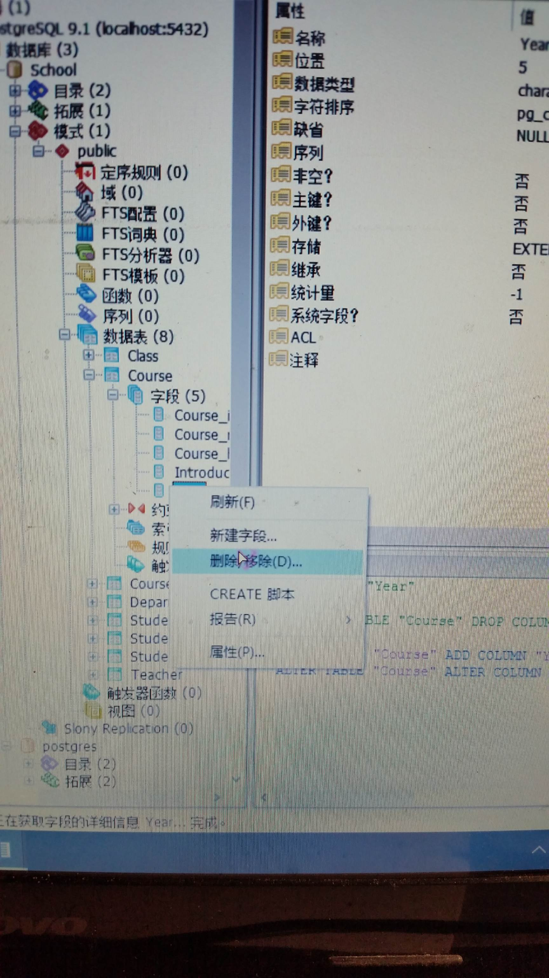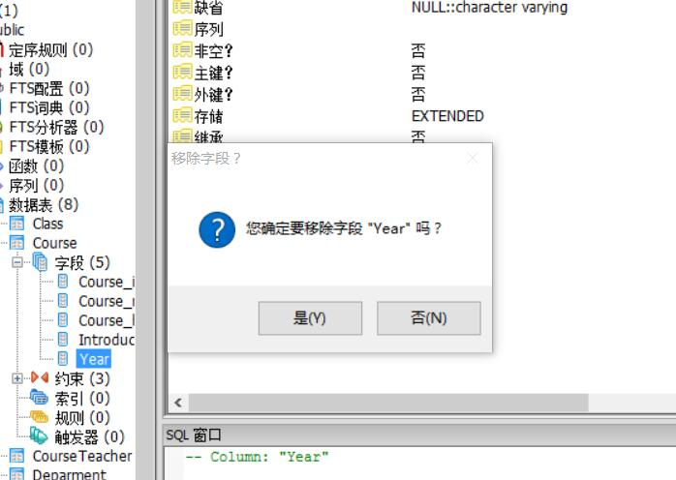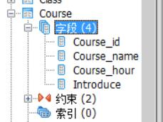
(7) Create a domain named “TeacherID”, which consists of number and letter; then apply the domain to field “Teac_id” in Teacher table.
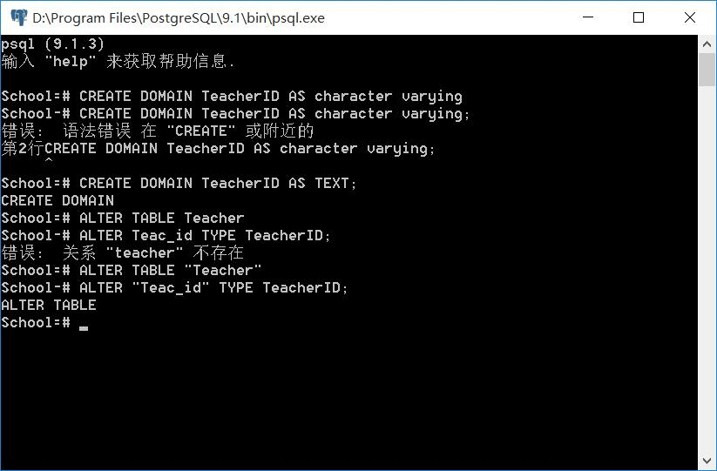
(8) Set a general constraint for fields “Teac_sex” and “Stu_sex” respectively in Teacher and Student tables to make sure that they only hold either “Male” or “Female” values.
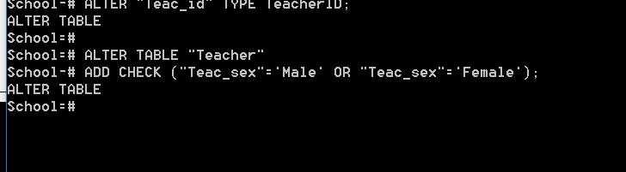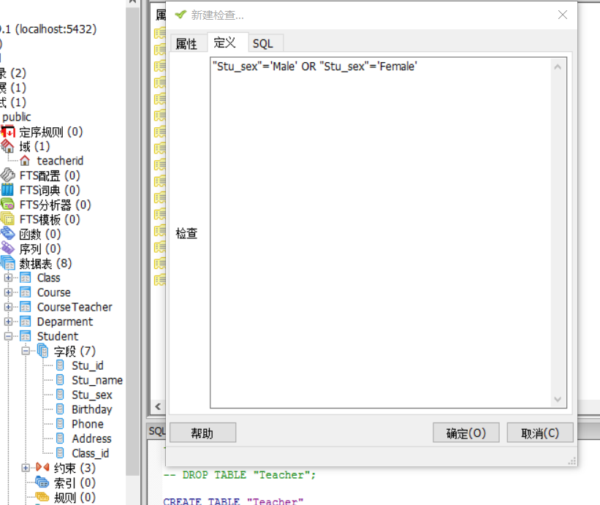
(9) Create index on field “Class_id” in table “Class”, and create index on “Stu_id” and “Course_id” in table “6. StudentGrade”.
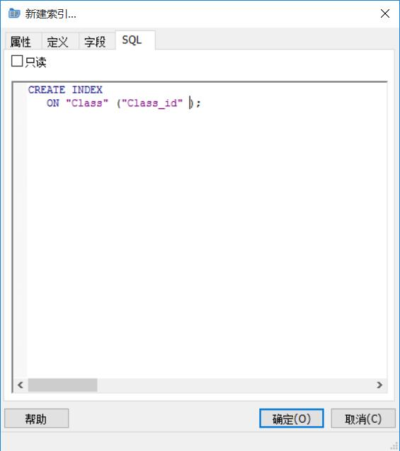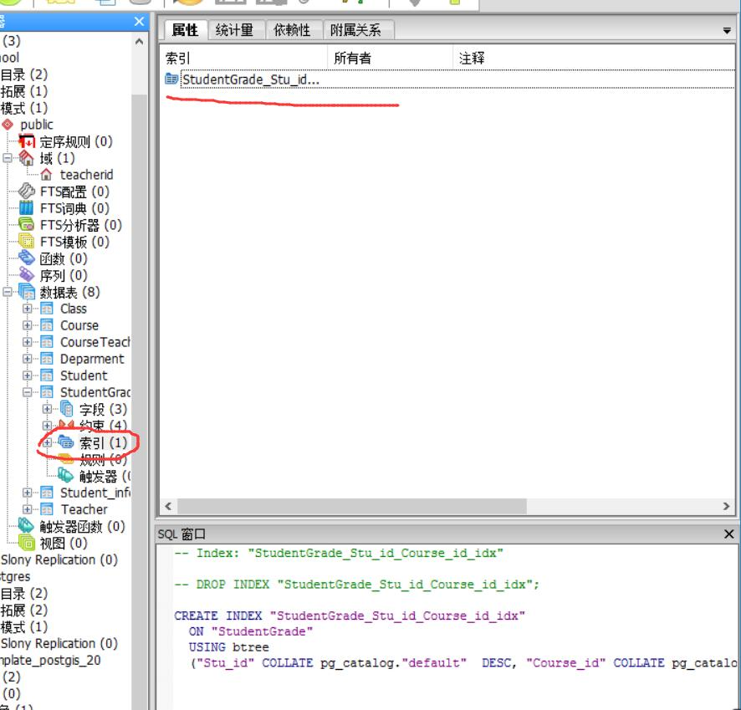
(10) Use SQL statements to display all tables’ structure.
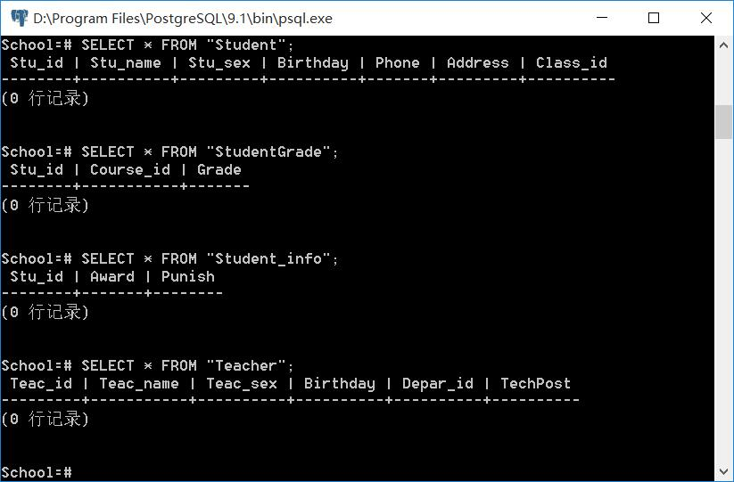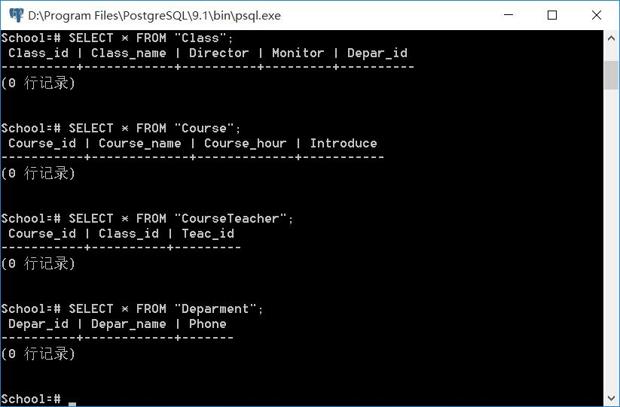

【结论】（结果）：
Good performance！

【小结】：
I learnt a lot.

指导教师评语及成绩
【评语】：

成绩： 指导教师签名：
批阅日期：
附件：
实验报告说明

1．实验项目名称：要用最简练的语言反映实验的内容。要求与实验指导书中相一致。
2．实验目的：目的要明确，要抓住重点，符合实验任务书中的要求。
3．实验环境：实验用的软硬件环境（配置）。
4．实验方案设计（思路、步骤和方法等）：这是实验报告极其重要的内容。包括概要设计、详细设计和核心算法说明及分析，系统开发工具等。应同时提交程序或设计电子版。
对于设计型和综合型实验，在上述内容基础上还应该画出流程图、设计思路和设计方法，再配以相应的文字说明。
对于创新型实验，还应注明其创新点、特色。
5．结论（结果）：即根据实验过程中所见到的现象和测得的数据，做出结论（可以将部分测试结果进行截屏）。
6．小结：对本次实验的心得体会，所遇到的问题及解决方法，其他思考和建议。
7．指导教师评语及成绩：指导教师依据学生的实际报告内容，用简练语言给出本次实验报告的评价和价值。

