武汉大学国际软件学院

实验报告

课程名称 数据库课程设计
专业年级 2014级
姓 名
学 号
协 作 者 无
实验学期 2015-2016 学年 第二 学期
课堂时数 8 课外时数 4
填写时间 2016 年 4 月 13 日

实验概述
【实验项目名称】：Simple Query

【实验目的】：
Learn to use simple query to retrieve some information from database.

【实验环境】（使用的软件）：
pgSQL
pgAdmin III

【参考资料】：
PPT
Website:
http://blog.csdn.net/namelb/article/details/7909910
textbook

实验内容
【实验方案设计】：
- Insert all data into tables you created in Experiment 1.
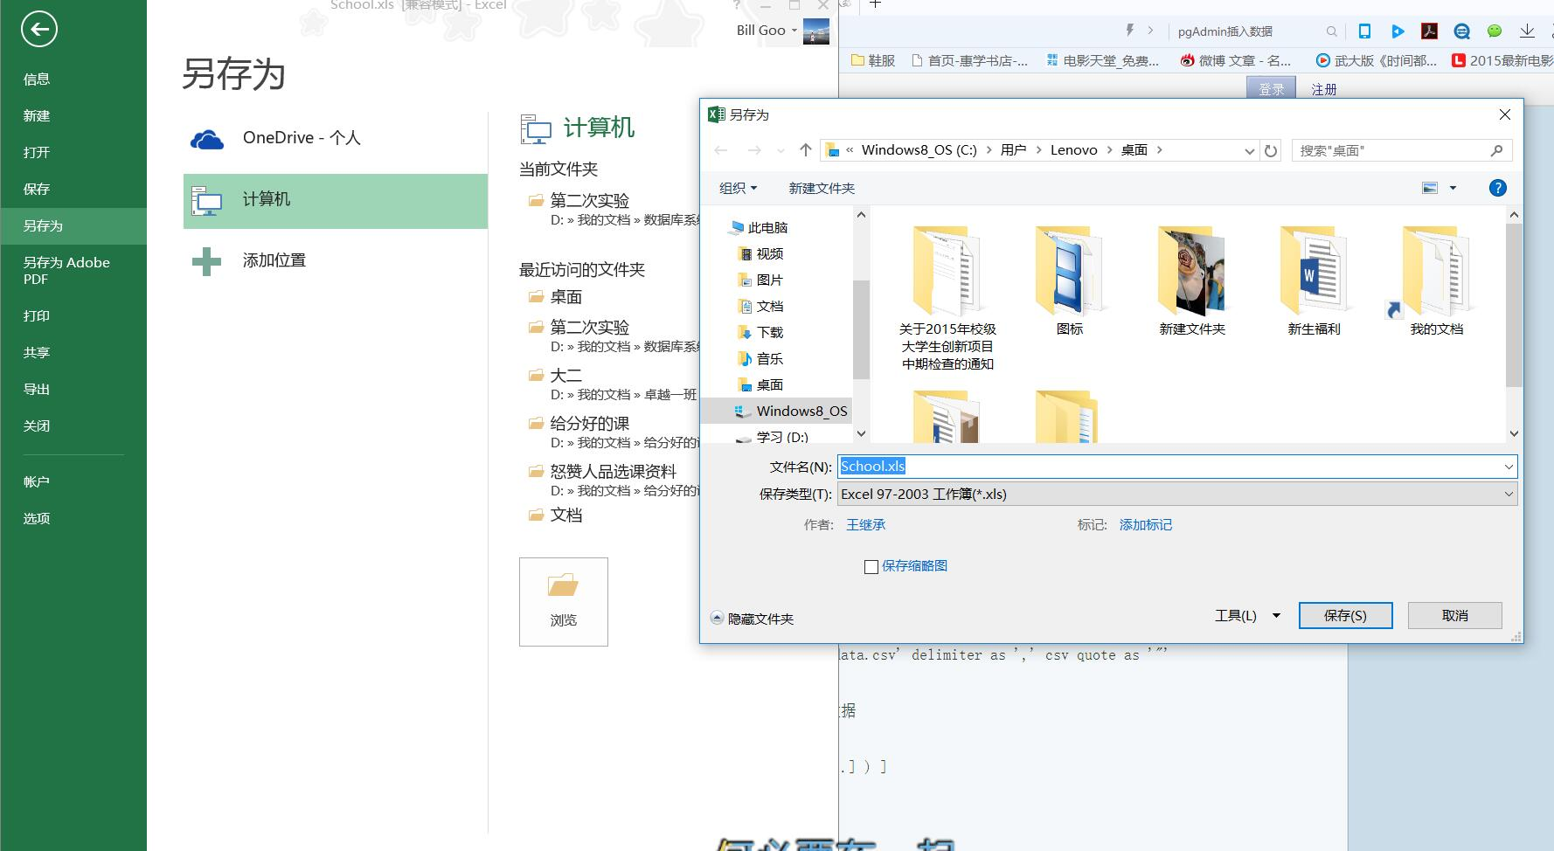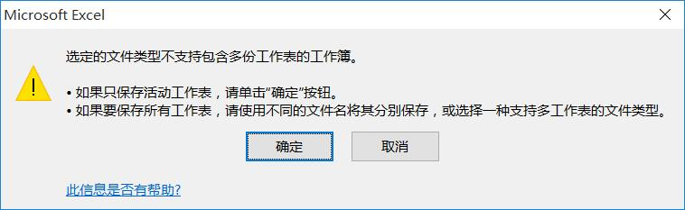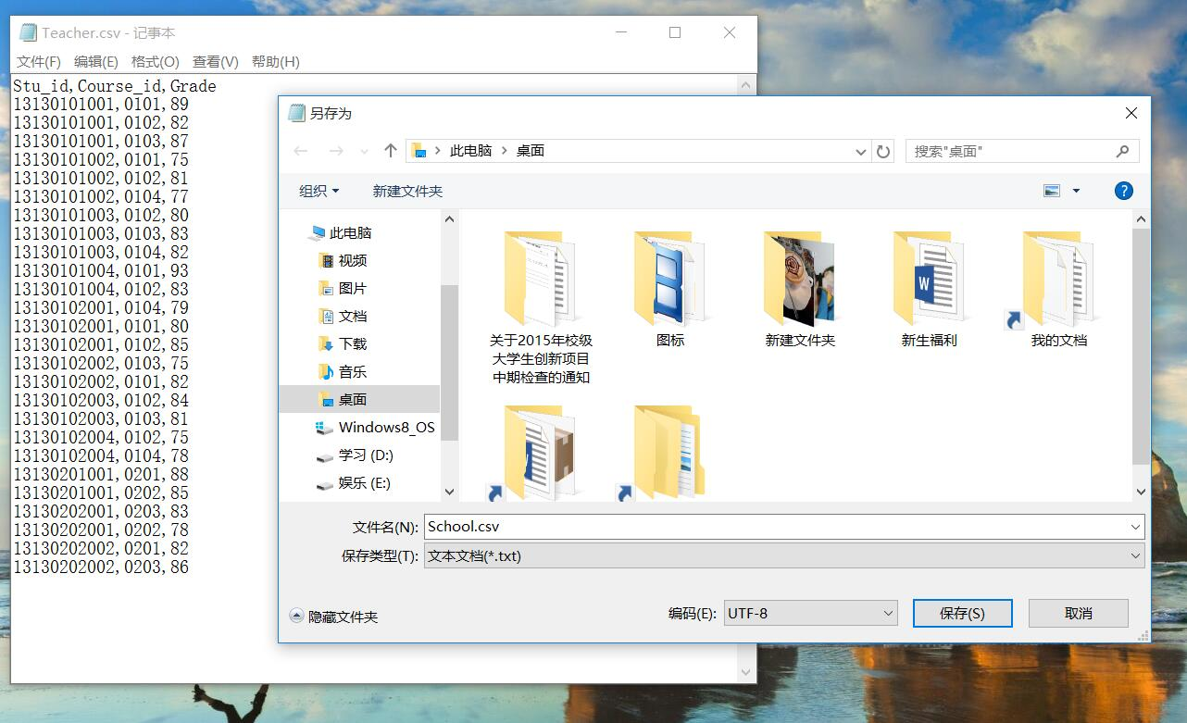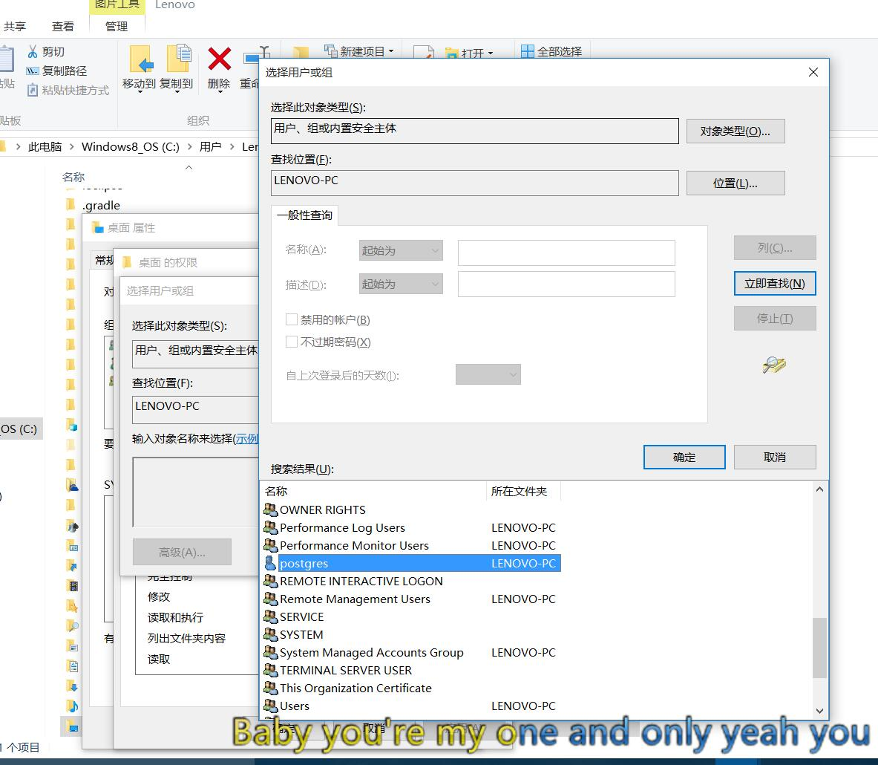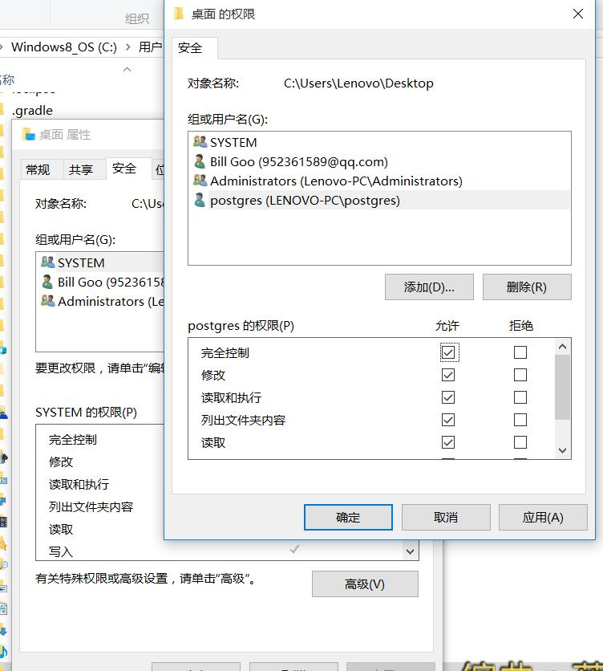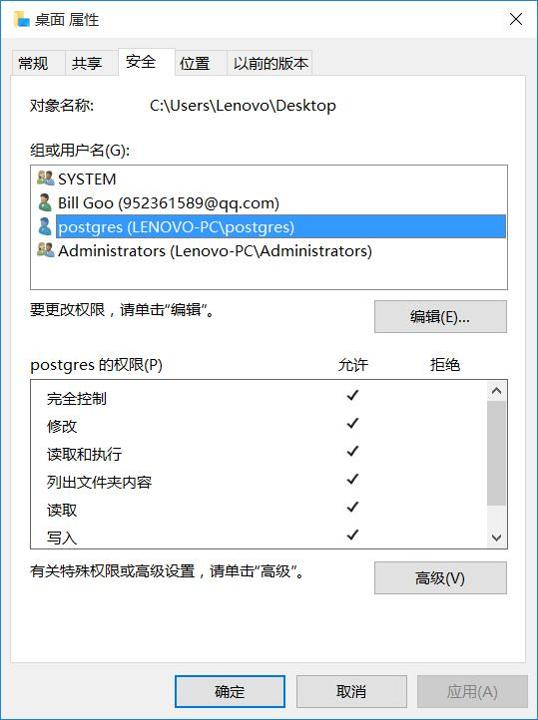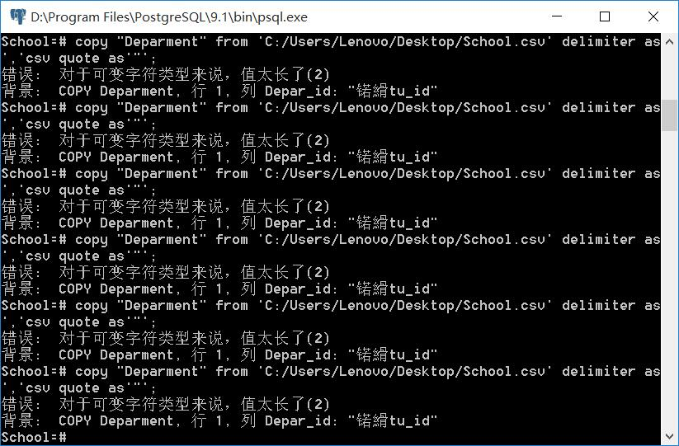
But in vain, so I change a method, a more complex method.
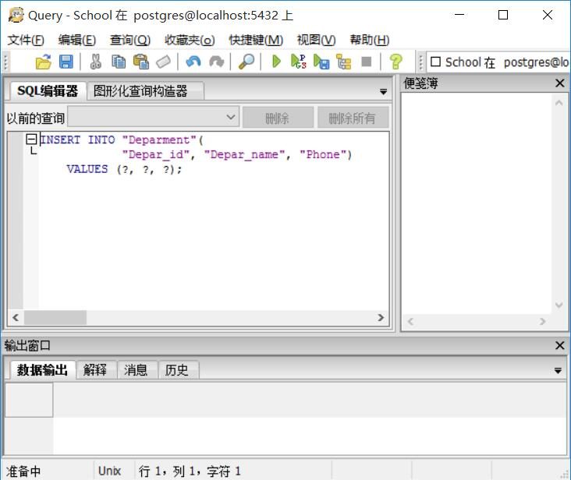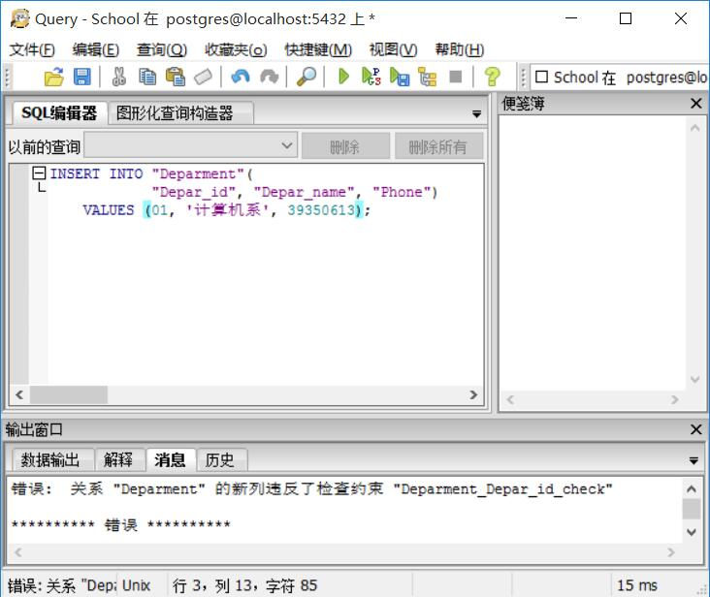
So I delete the constraint.
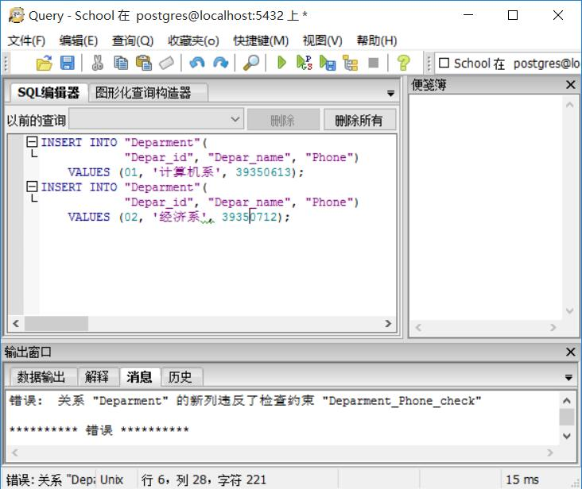
This problem by asking classmates……….WTF!
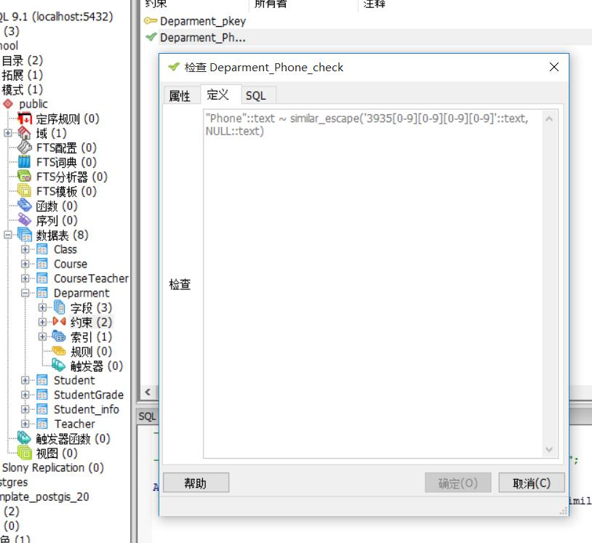
And change the constraint. So succeed.
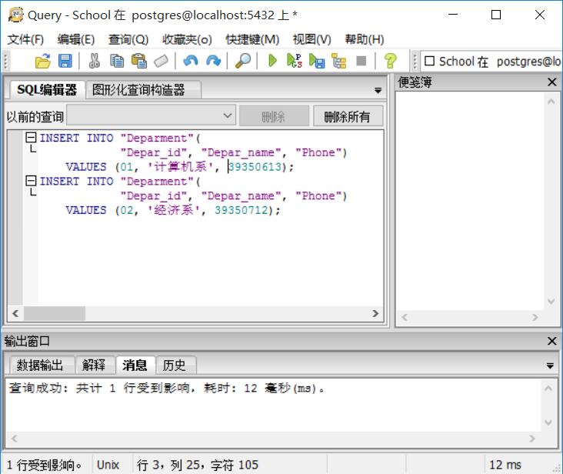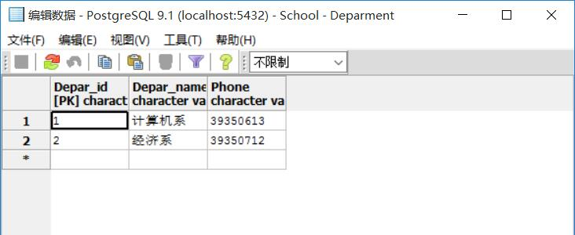
And all to change.
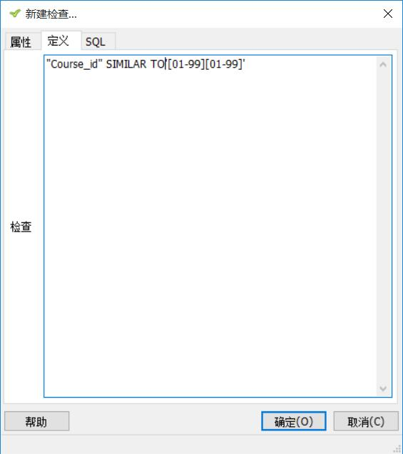
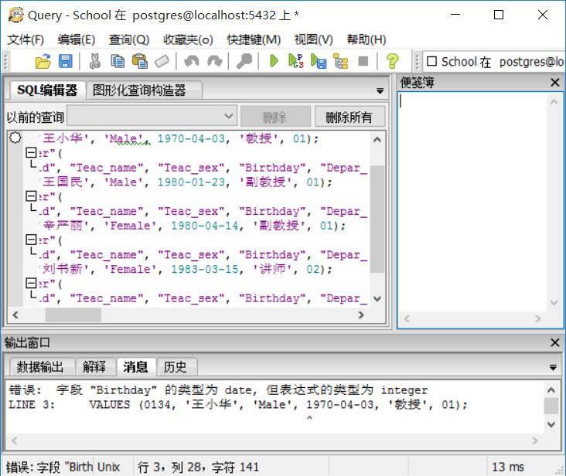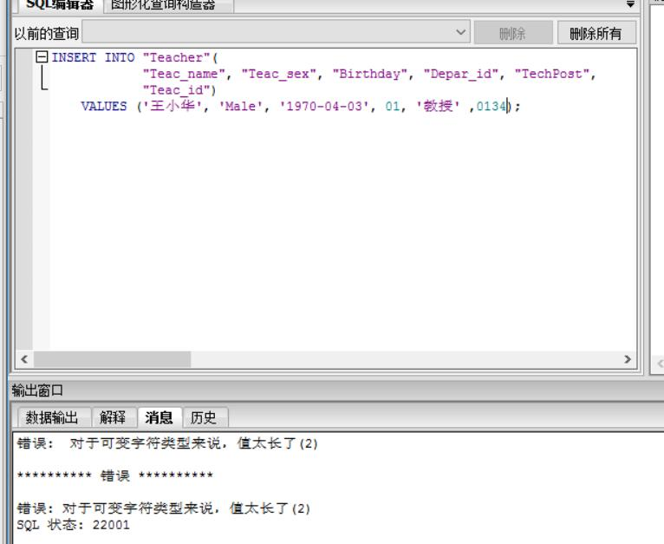
By asking others and changing the field, finally succeed.
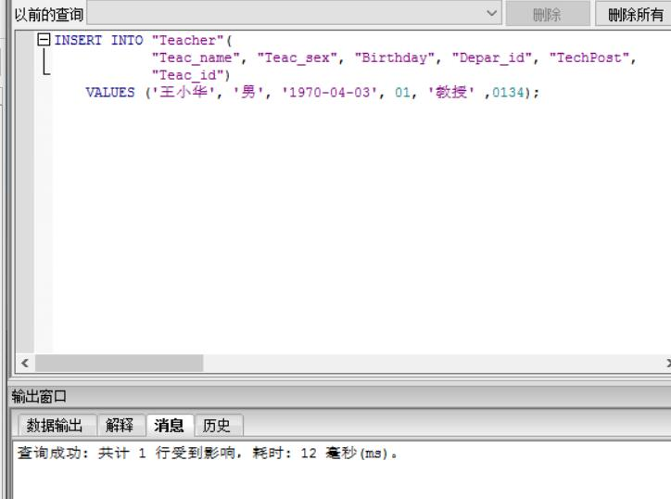
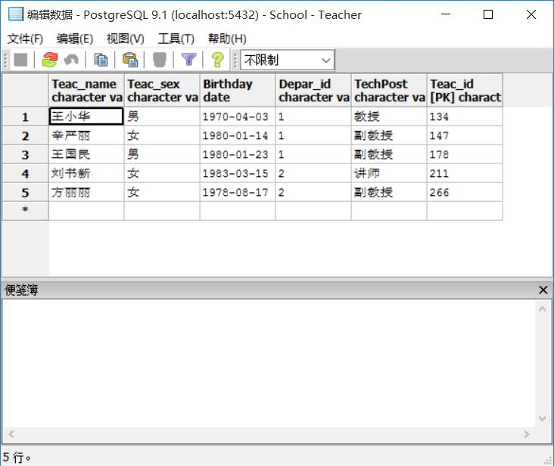
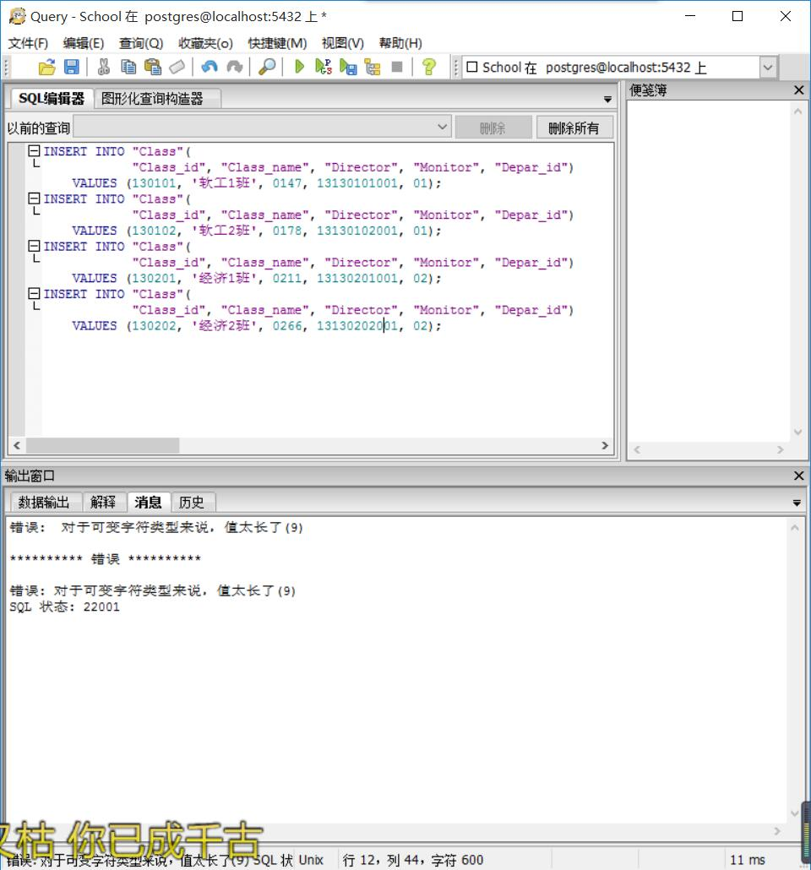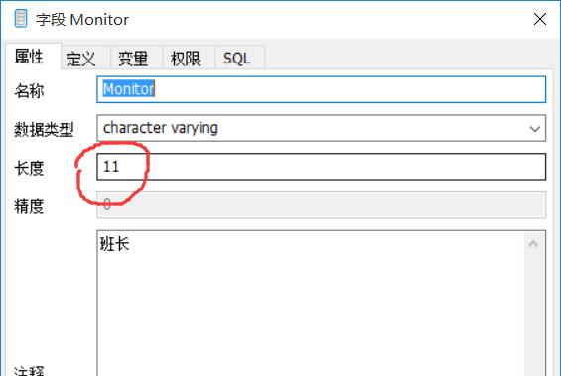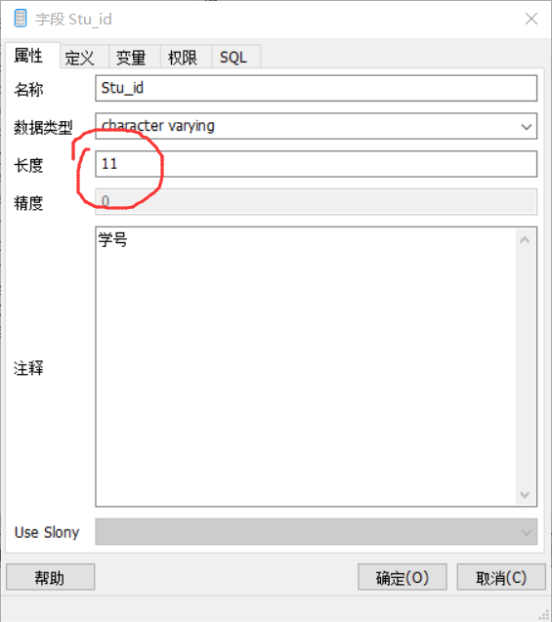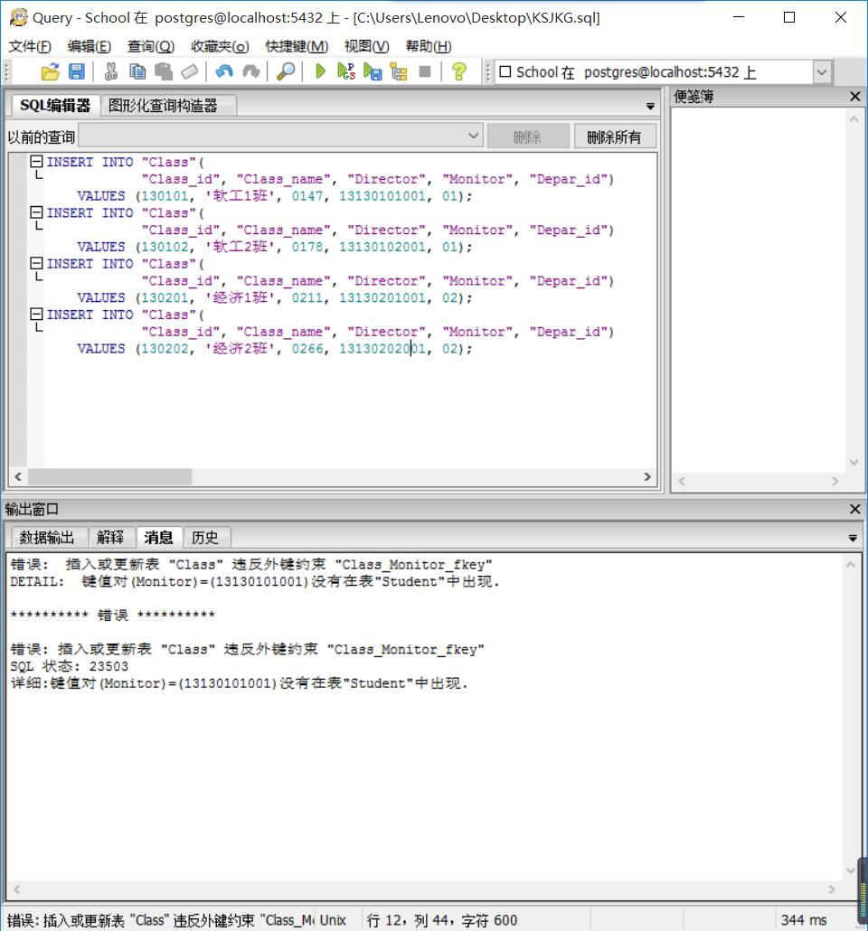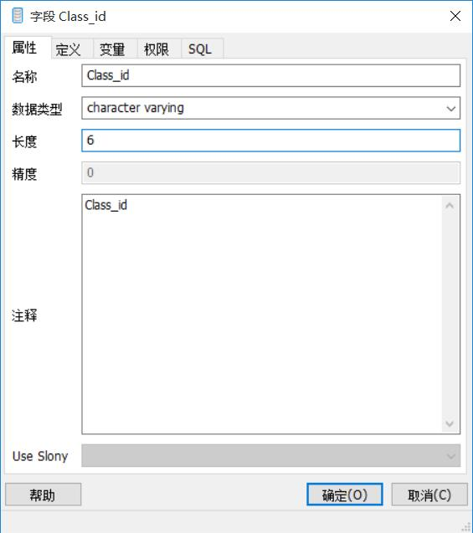
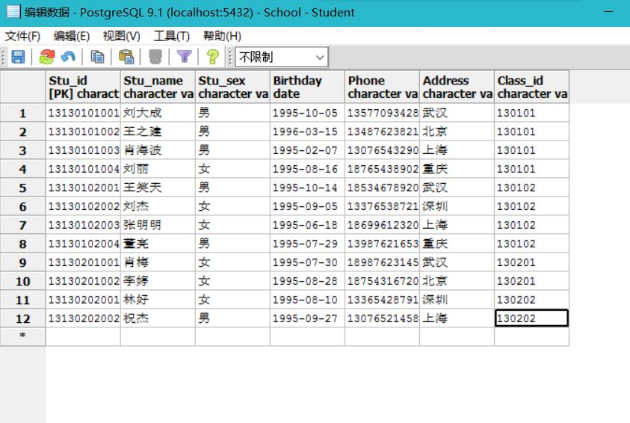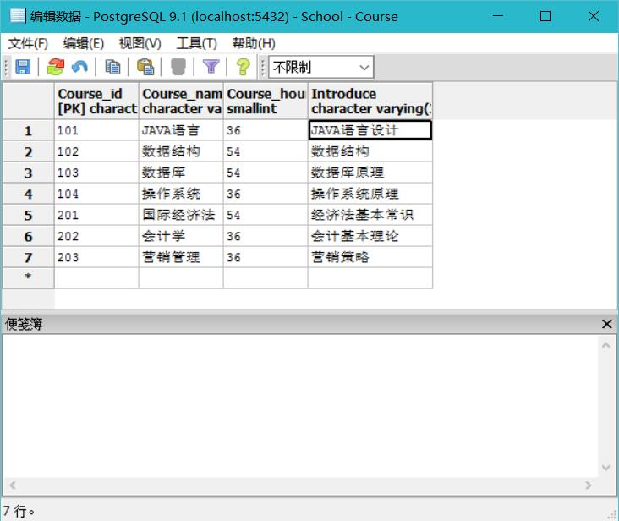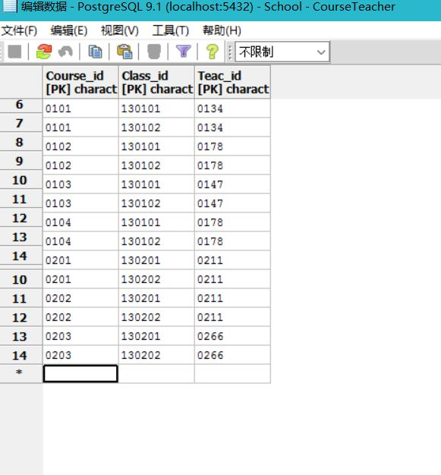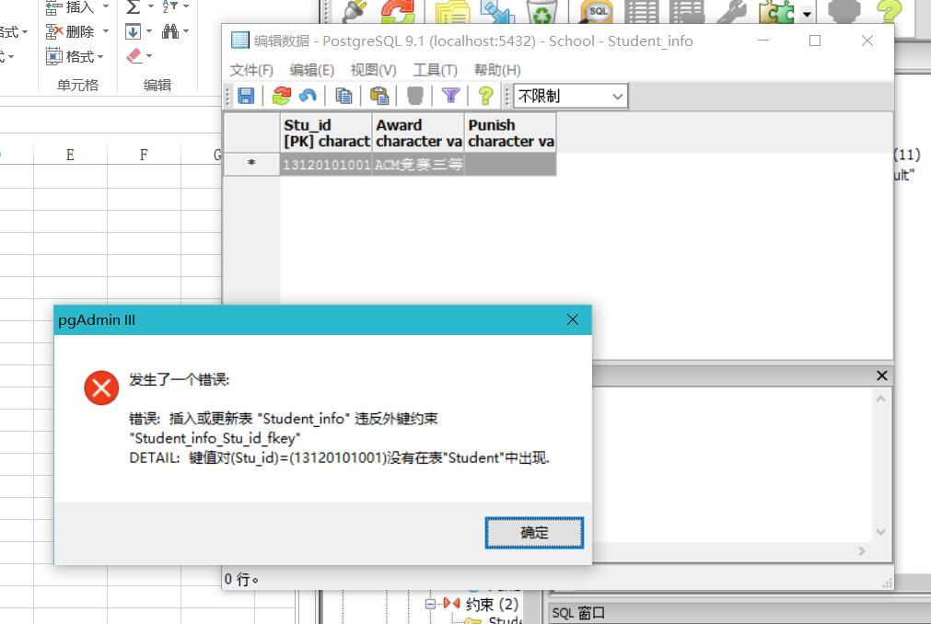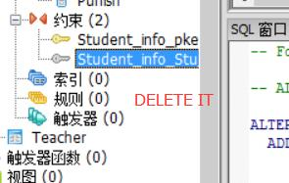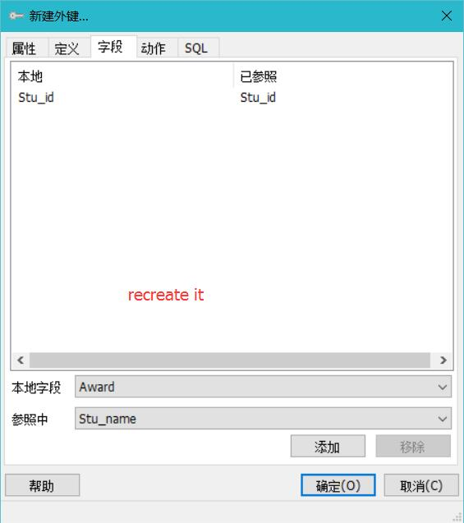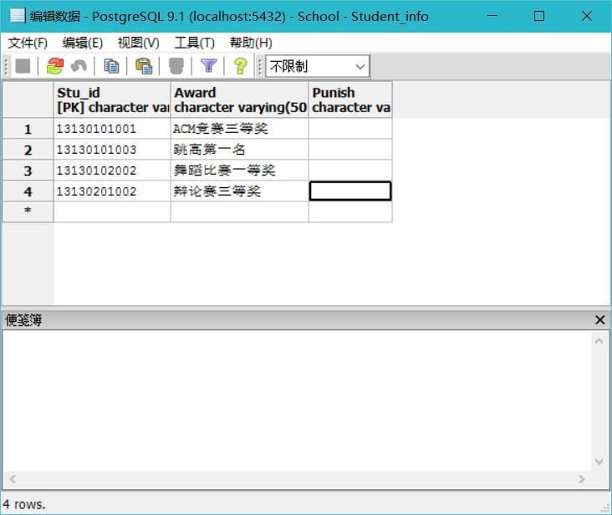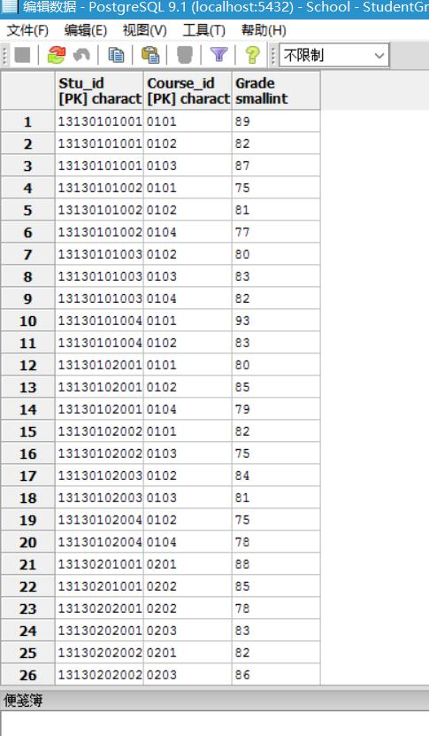
- List the total number of students who enrolled it for every course.
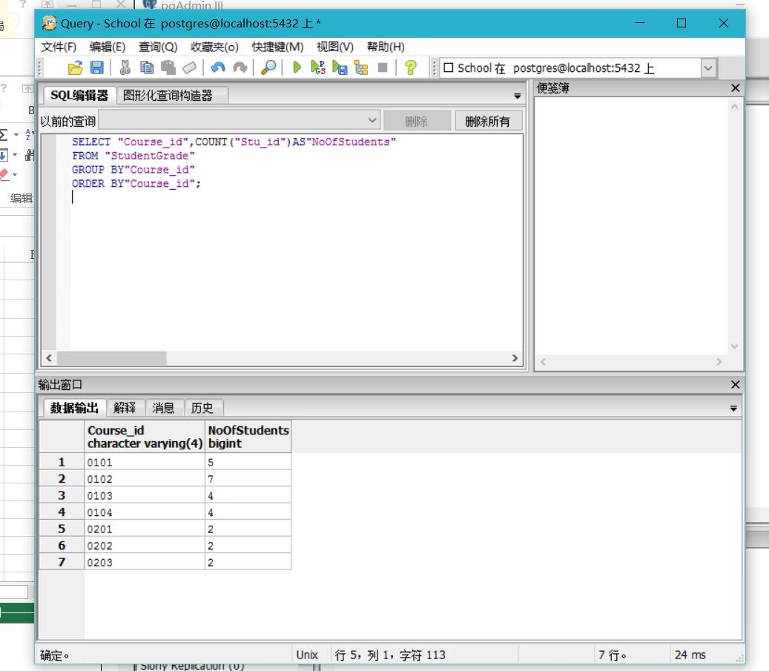
- List details for all classes which belong to “计算机系”
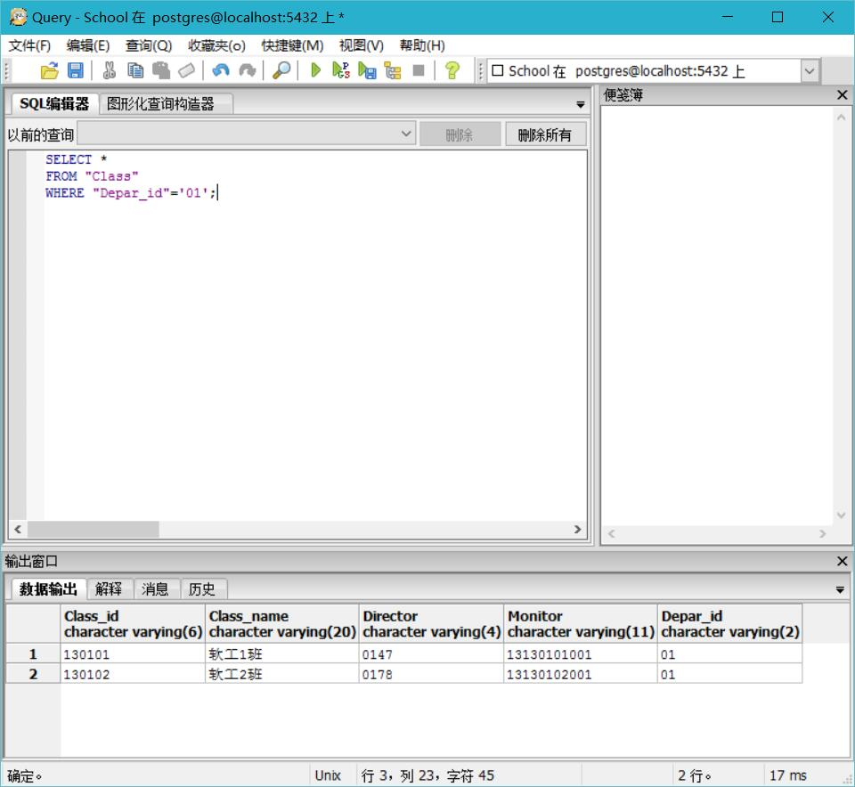
- List Course ids for all Courses taught by teacher whose last name is “王”.
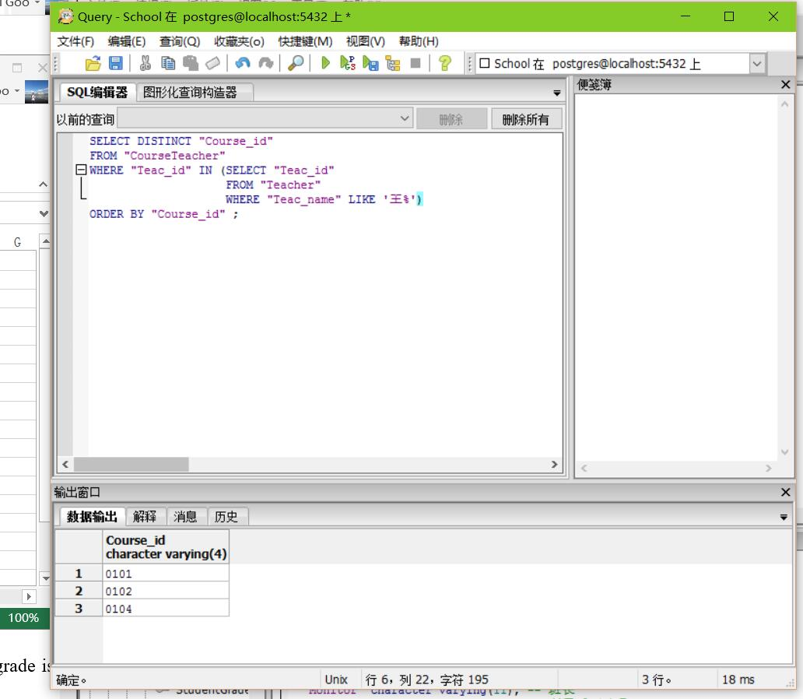
- List name for all courses which is enrolled by students.
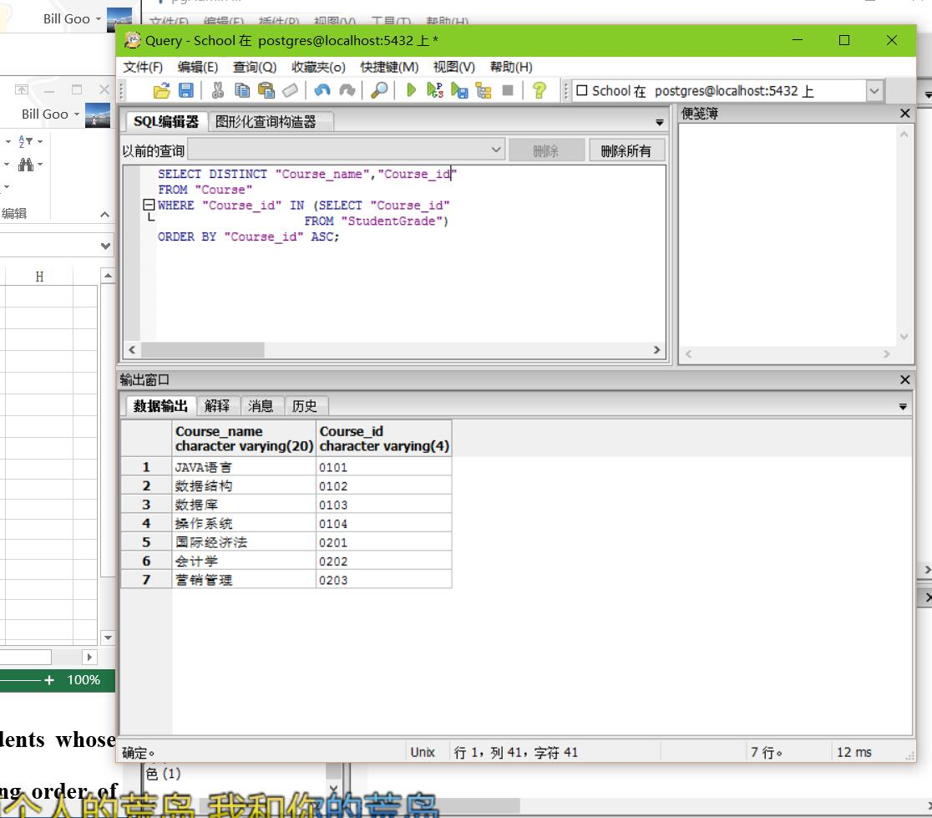
- List names for all students who enrolled the course “0101” and grade is between 80 and 90, arranged in descending order of grade.
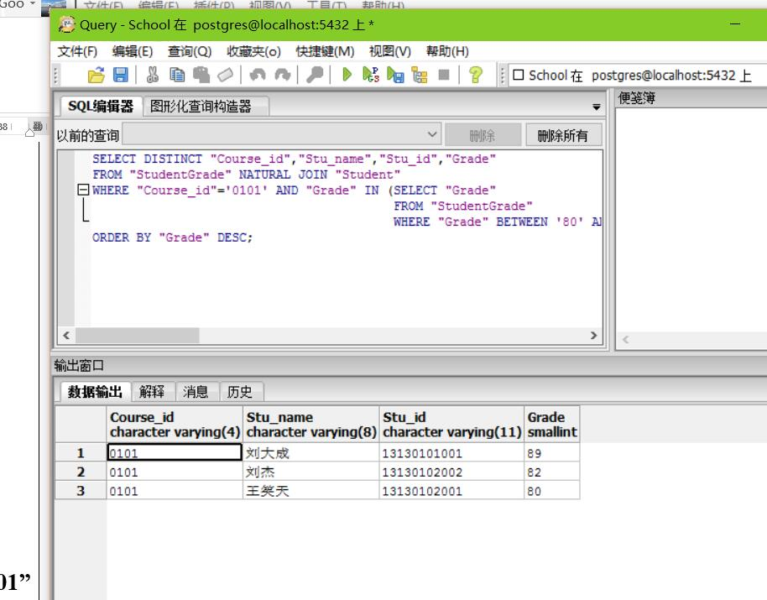
- List student ids and average grades for all students whose average grade is above 80, arranged in ascending order of grade.
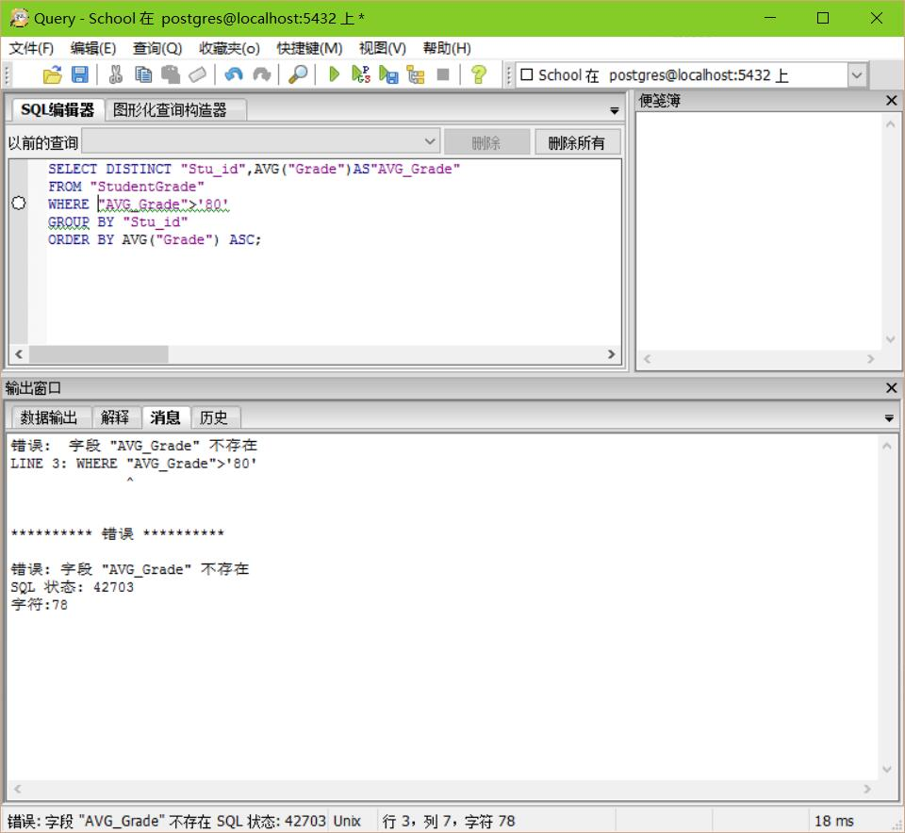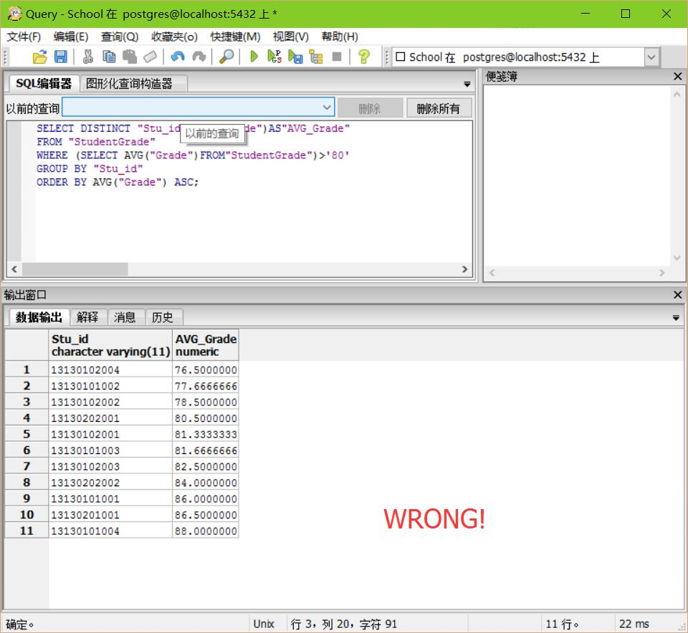
This is wrong because its average grade is not bigger than 80.
So I solve it by changing the code that I use the HAVING clause.
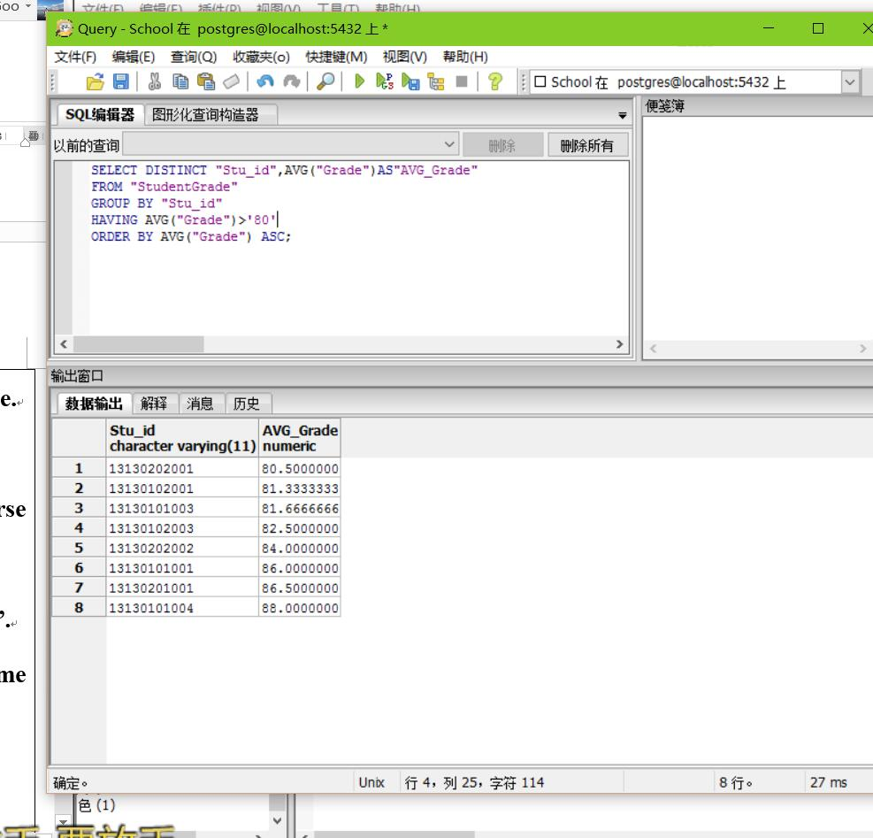
- List names for all students who get higher grade in course “JAVA语言” than “数据结构”
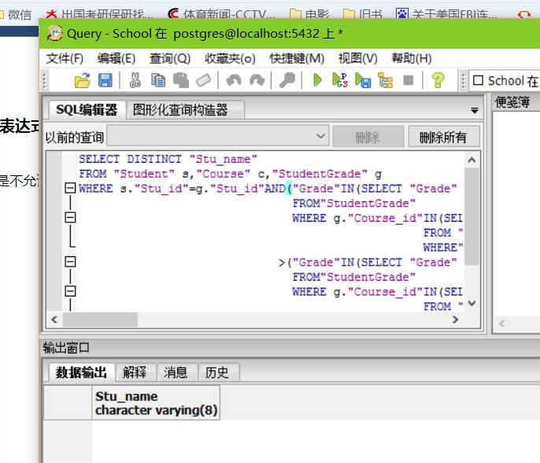
There was something wrong with my code, so I refer to the textbook and find another way to solve it.
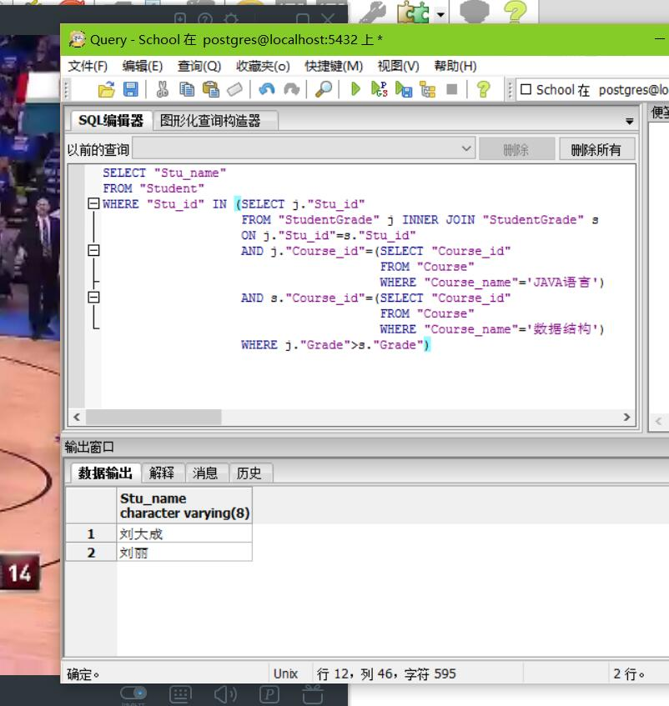
- List students who didn’t enroll courses with name “数据库”.
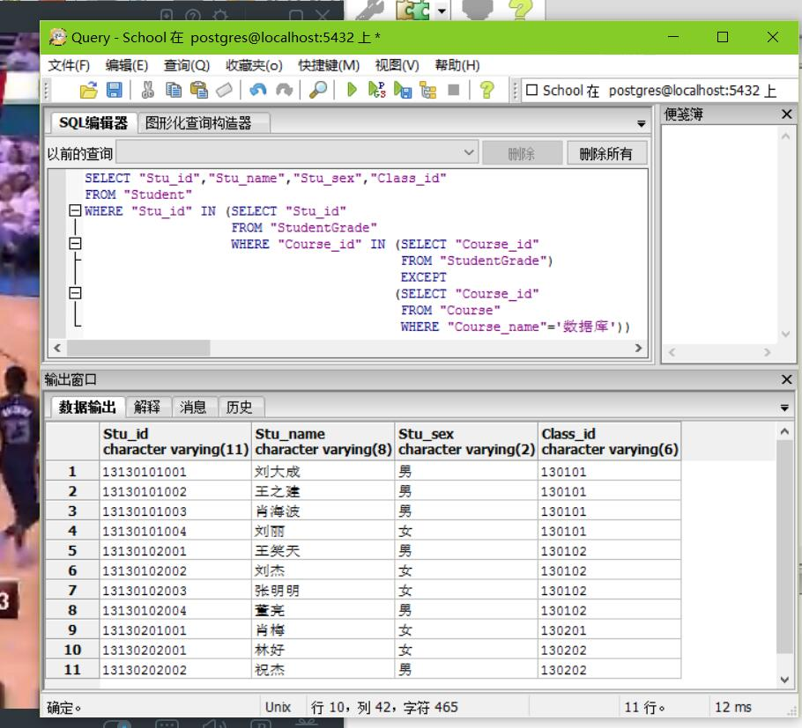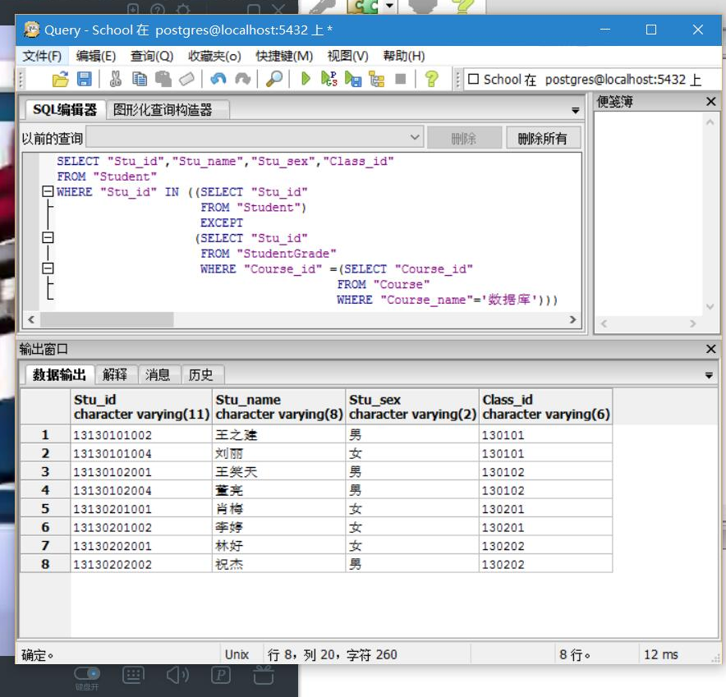
- List maximum, minimum, and average of grade and name for each course enrolled by students.
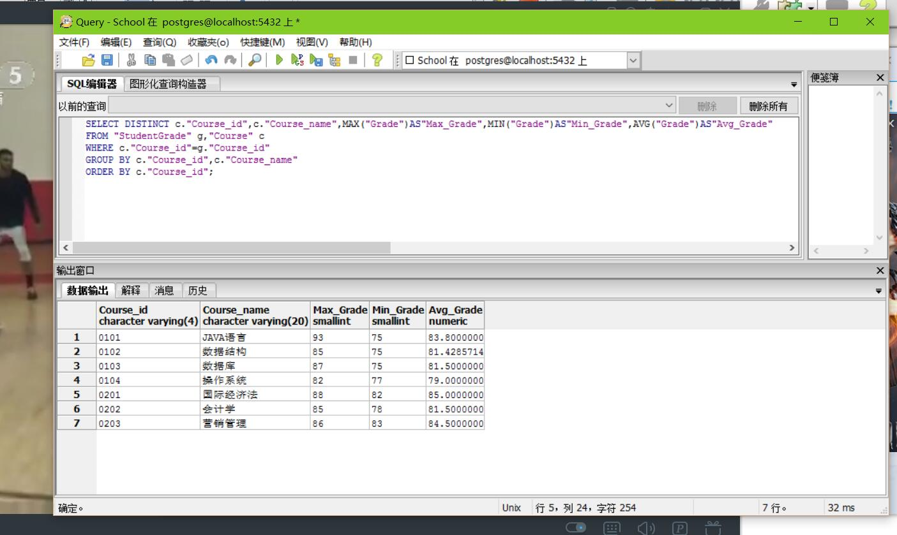

【结论】（结果）：

(1) Use SQL plus, command line or PgAdmin to do some query in School database
(2) Follow the guide of the experimental content to finish all experimental operations.
Finish it.

【小结】：

I learnt a lot.

指导教师评语及成绩
【评语】：

成绩： 指导教师签名：
批阅日期：
附件：
实验报告说明

1．实验项目名称：要用最简练的语言反映实验的内容。要求与实验指导书中相一致。
2．实验目的：目的要明确，要抓住重点，符合实验任务书中的要求。
3．实验环境：实验用的软硬件环境（配置）。
4．实验方案设计（思路、步骤和方法等）：这是实验报告极其重要的内容。包括概要设计、详细设计和核心算法说明及分析，系统开发工具等。应同时提交程序或设计电子版。
对于设计型和综合型实验，在上述内容基础上还应该画出流程图、设计思路和设计方法，再配以相应的文字说明。
对于创新型实验，还应注明其创新点、特色。
5．结论（结果）：即根据实验过程中所见到的现象和测得的数据，做出结论（可以将部分测试结果进行截屏）。
6．小结：对本次实验的心得体会，所遇到的问题及解决方法，其他思考和建议。
7．指导教师评语及成绩：指导教师依据学生的实际报告内容，用简练语言给出本次实验报告的评价和价值。

