武汉大学国际软件学院

实验报告

课程名称 数据库课程设计
专业年级 2014级
姓 名
学 号
协 作 者 无
实验学期 2015-2016 学年 第二 学期
课堂时数 8 课外时数 4
填写时间 2016 年 5 月 3 日

实验概述
【实验项目名称】：Create triggers and Grant privileges

【实验目的】：
Learn to create triggers in database and grant some privileges to some users
【实验环境】（使用的软件）：
pgSQL
pgAdmin III

【参考资料】：
PPT
Textbook
PostgreSQL 9.1.21 Documentation
http://www.php100.com/manual/PostgreSQL8/sql-grant.html and http://www.postgresql.org/docs/9.1/static/sql-revoke.html

实验内容
【实验方案设计】：
(1) Finish all experimental steps and record operation steps and detailed results, screenshots is necessary.
(2) There may be some exceptions during your operation, if you record, instruct them and provide your analysis, you will get additional scores.
(3) You are not allowed to copy others’ work, or you will get no score
- Add a new column “teac_num” in Department table.
AND
- Update teac_num to record the total number of teachers in every department.
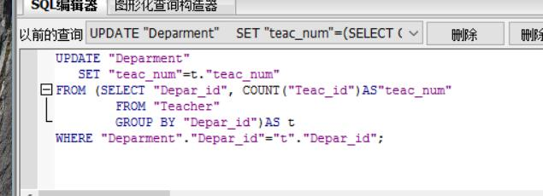
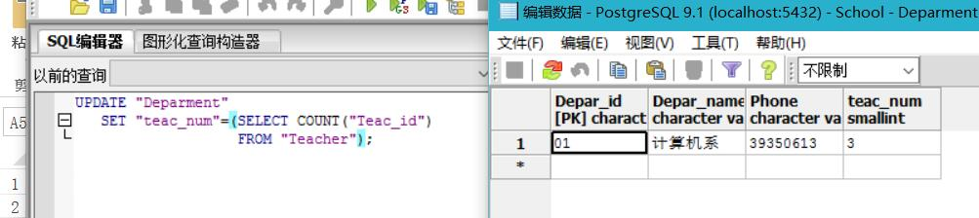
- Create an insert trigger “trigger_in_deparment” to indicate that addition of a new teacher in the table Teacher will change the value of column teac_num in the table department.
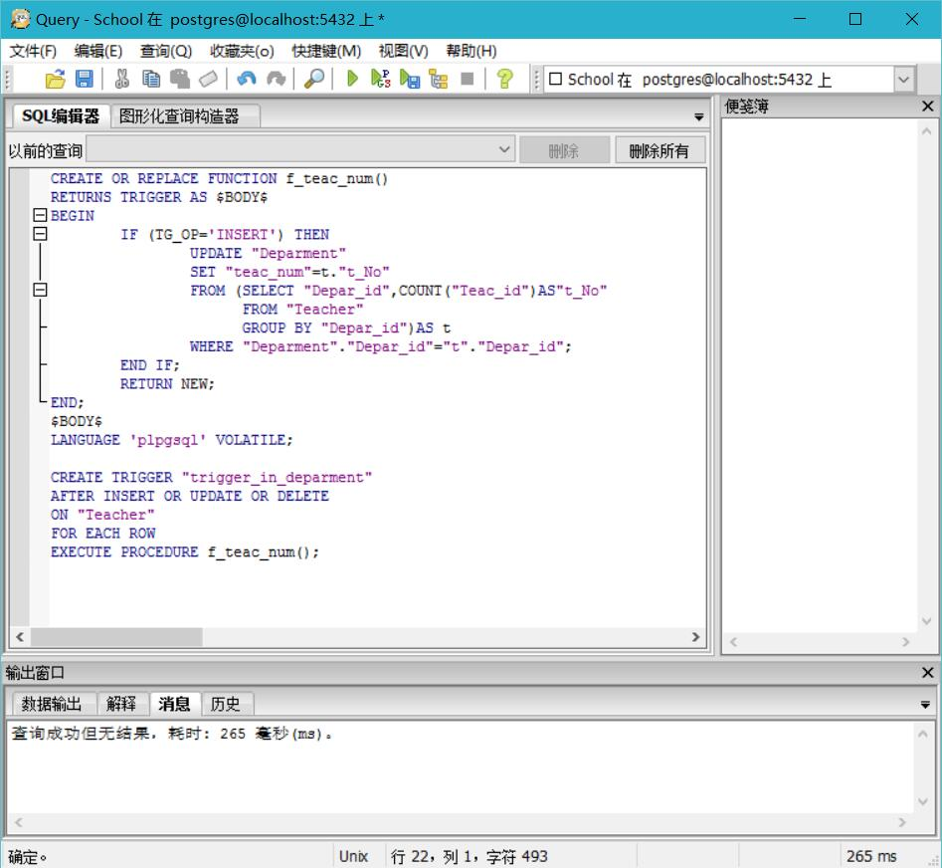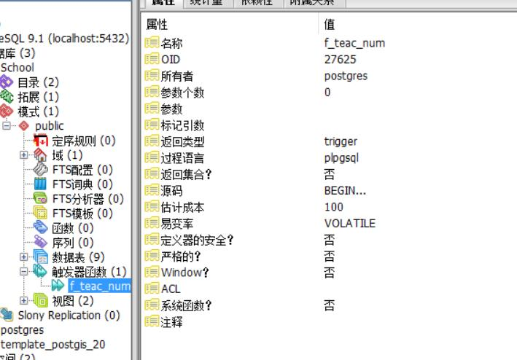
We execute an insertion so we have the change below.
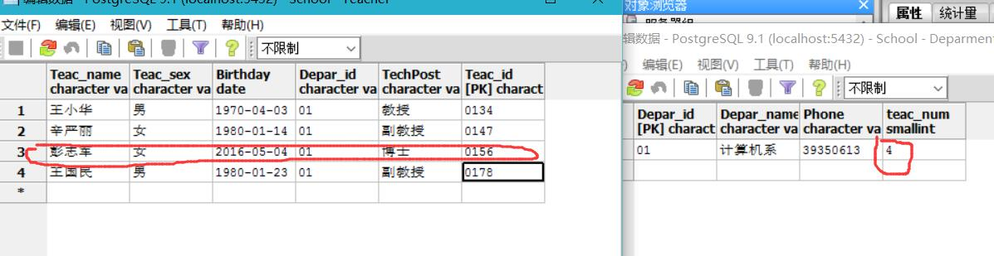

- Create an update trigger “trigger_update_course” to indicate that the course id in table StudentGrand will make the corresponding revision if the course id in the table Course has been modified.
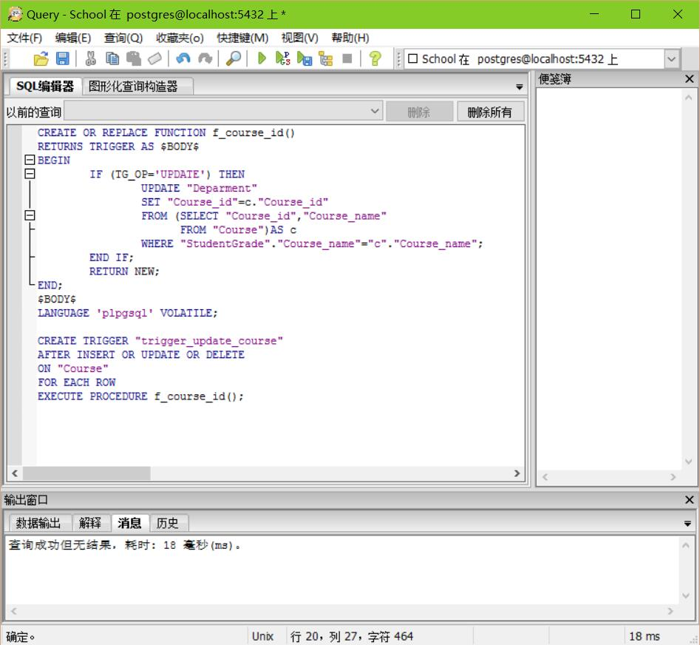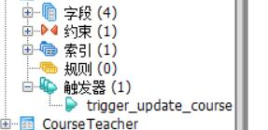
- Drop the trigger “trigger_course”
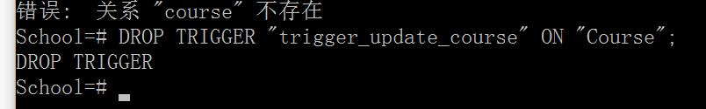
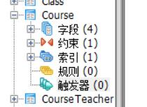
- Create database users U1,U2,U3 to login School database.
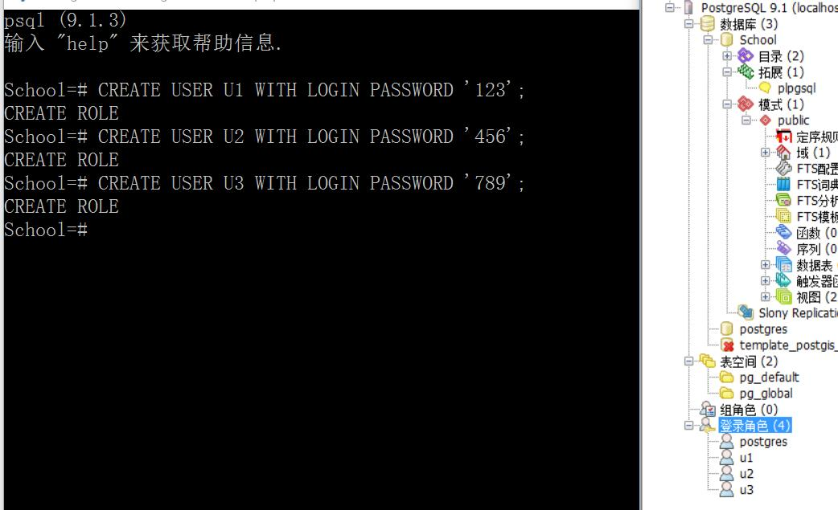
- Give user U1 the privileges SELECT and UPDATE (except for the column student id) on the table Student. Please verify the privileges of user U1.
Firstly, I have some problems like this.
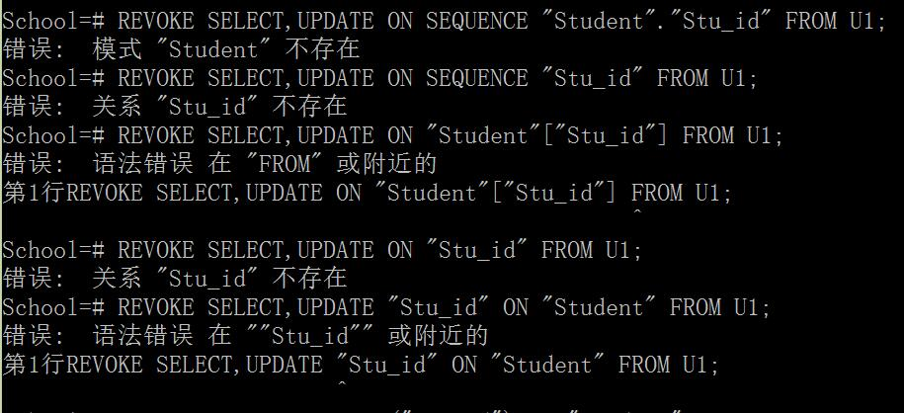
So I refer to the PostgreSQL 9.1.21 Documentation, http://www.php100.com/manual/PostgreSQL8/sql-grant.html and http://www.postgresql.org/docs/9.1/static/sql-revoke.html .
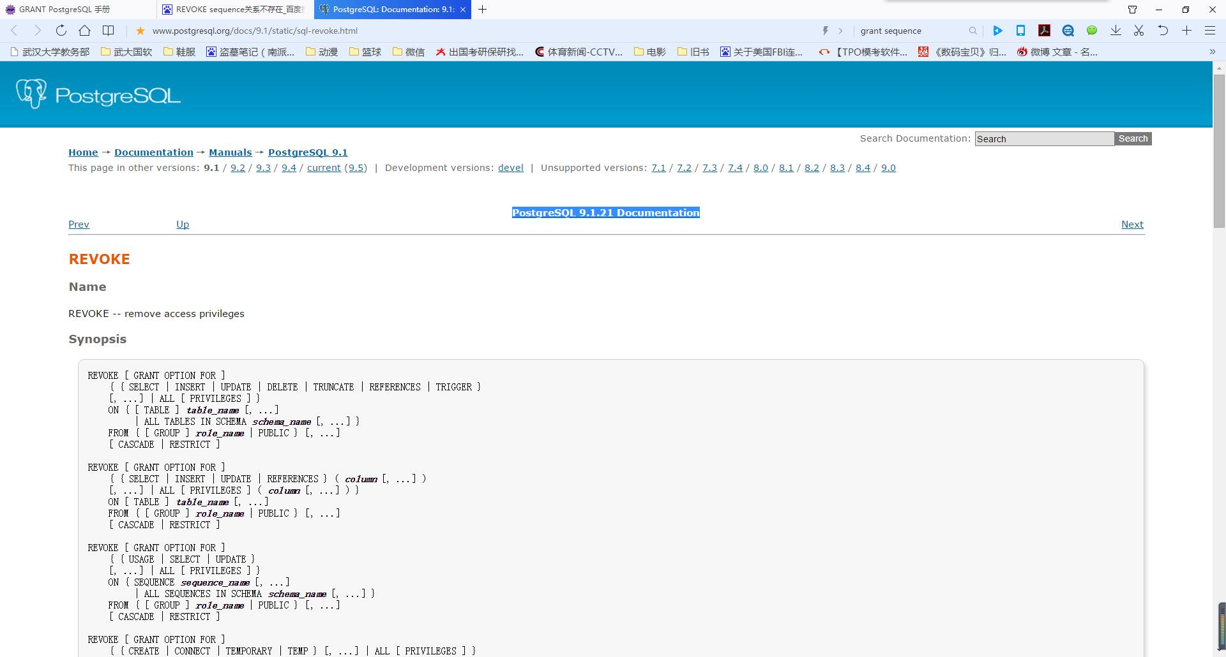
So I solve it. The right answer is in the red circle.
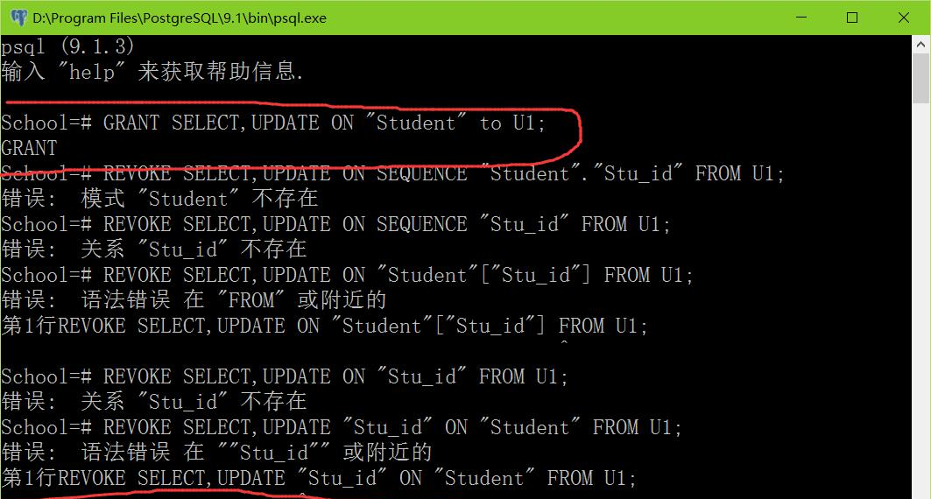
- Set database role A1. Giver role A1 the privileges SELECT and UPDATE on Course
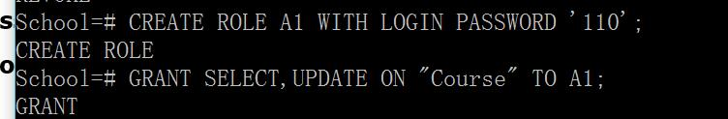
- Grant the role A1 to U2. Please verify the privileges of U2.
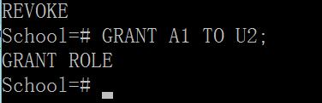
- Modify the privileges of user U1 to allow him to pass the privileges to user U3. Please verify the privileges of U3.
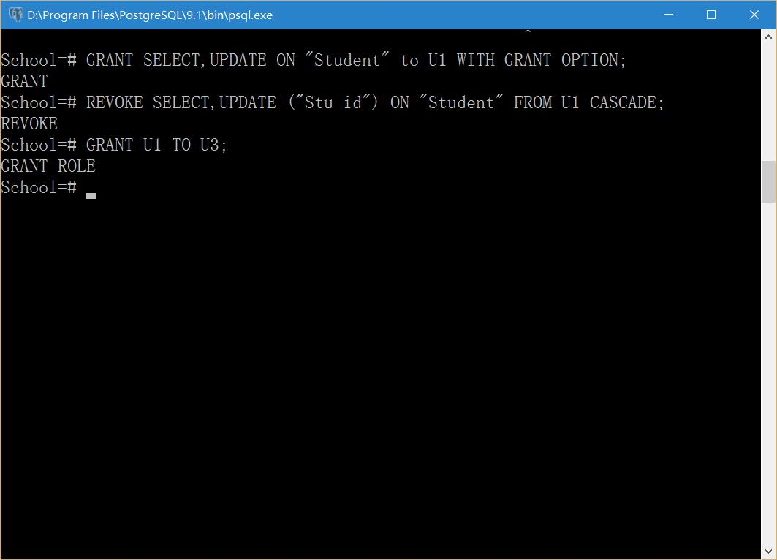
【结论】（结果）：
Finish all experimental steps and record operation steps and detailed results, screenshots is necessary.
There may be some exceptions during your operation, if you record, instruct them and provide your analysis, you will get additional scores.
You are not allowed to copy others’ work, or you will get no score.
(1) Use SQL plus, command line or PgAdmin to create views and do some data manipulation to School database
(2) Follow the guide of the experimental content to finish all experimental operations.
【小结】：
I learnt a lot.

指导教师评语及成绩
【评语】：

成绩： 指导教师签名：
批阅日期：
附件：
实验报告说明

1．实验项目名称：要用最简练的语言反映实验的内容。要求与实验指导书中相一致。
2．实验目的：目的要明确，要抓住重点，符合实验任务书中的要求。
3．实验环境：实验用的软硬件环境（配置）。
4．实验方案设计（思路、步骤和方法等）：这是实验报告极其重要的内容。包括概要设计、详细设计和核心算法说明及分析，系统开发工具等。应同时提交程序或设计电子版。
对于设计型和综合型实验，在上述内容基础上还应该画出流程图、设计思路和设计方法，再配以相应的文字说明。
对于创新型实验，还应注明其创新点、特色。
5．结论（结果）：即根据实验过程中所见到的现象和测得的数据，做出结论（可以将部分测试结果进行截屏）。
6．小结：对本次实验的心得体会，所遇到的问题及解决方法，其他思考和建议。
7．指导教师评语及成绩：指导教师依据学生的实际报告内容，用简练语言给出本次实验报告的评价和价值。

