武汉大学国际软件学院

实验报告

课程名称 数据库课程设计
专业年级 2014级
姓 名
学 号
协 作 者 无
实验学期 2015-2016 学年 第二 学期
课堂时数 8 课外时数 4
填写时间 2016 年 4 月 25 日

实验概述
【实验项目名称】：Create a view and Data manipulation

【实验目的】：
Learn to create views and do some data manipulation to database.
【实验环境】（使用的软件）：
pgSQL
pgAdmin III

【参考资料】：
PPT
textbook

实验内容
【实验方案设计】：
(1) Finish all experimental steps and record operation steps and detailed results, screenshots is necessary.
(2) There may be some exceptions during your operation, if you record, instruct them and provide your analysis, you will get additional scores.
(3) You are not allowed to copy others’ work, or you will get no score.

- Create a view View_CSTeacher, list name, sex and position for each teacher in “计算机系”.
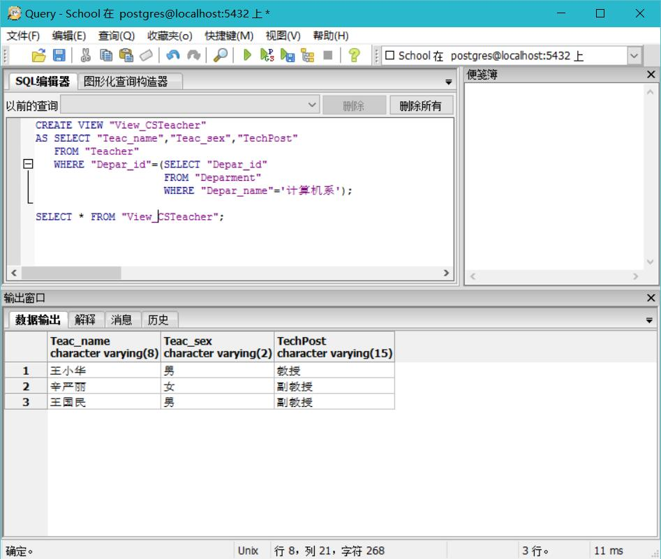
- Create a view View_Class, list class name, department name and total number of students in each class.
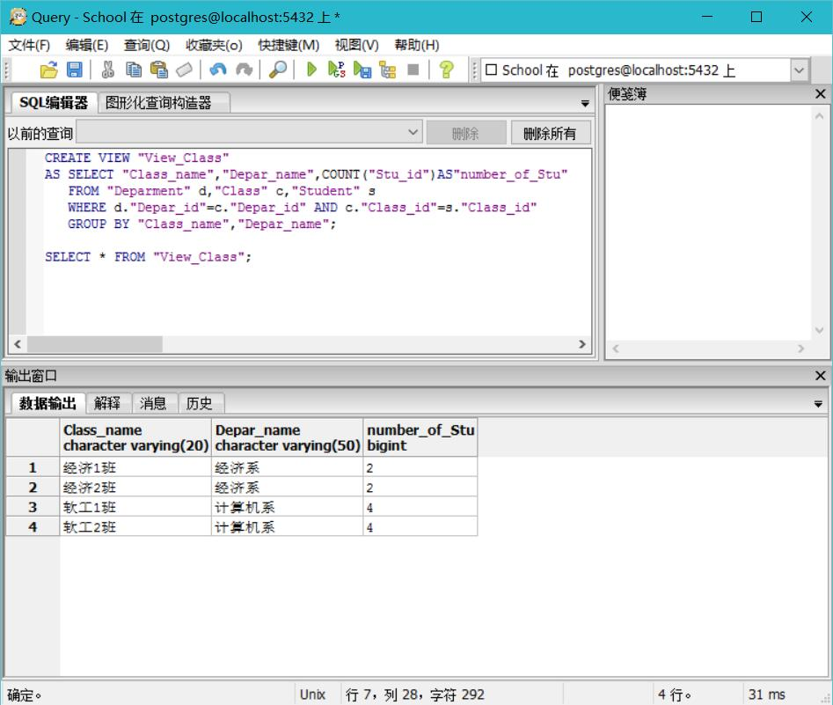
- Create a view View_Student, list student id, total number of courses enrolled by the student, and his/her average grade for each student, and arranged in descending order of average grade.
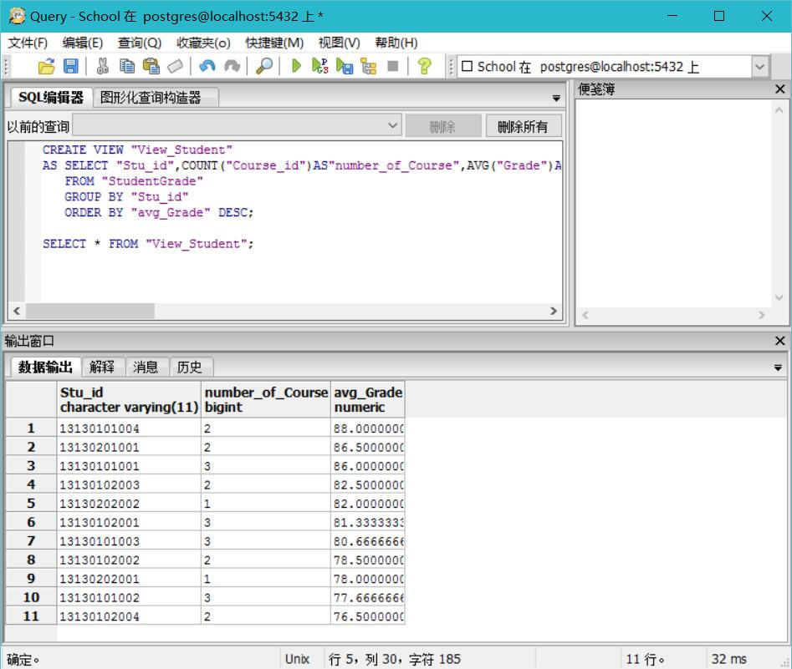
- Query the position for the teacher with id “0134” from the View_CSTeacher, and the result should including all fields in view “View_CSTeacher”.
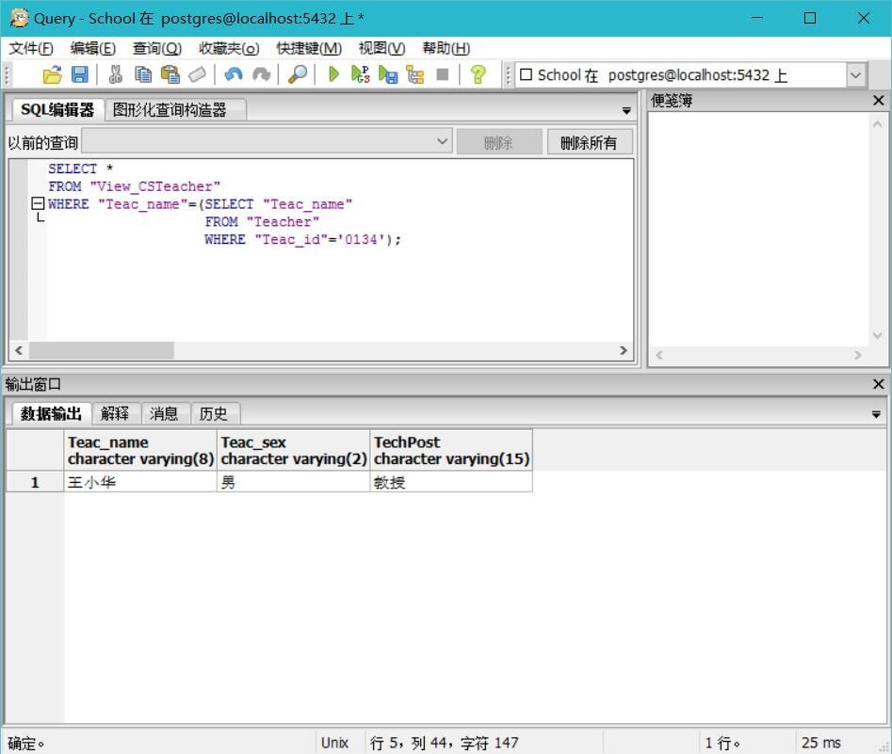
- Update the View_Student to set the average grade for the student “13130101002” to 90, Is the operation successful? Give a reason.
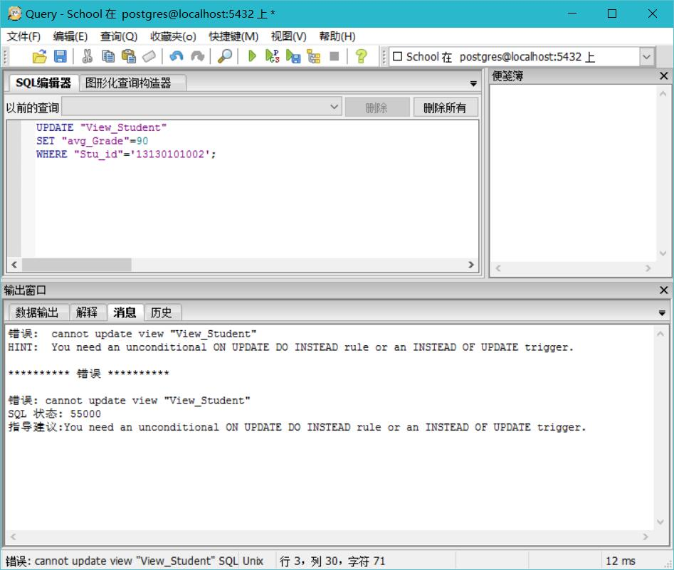
You need an unconditional ON UPDATE DO INSTEAD rule or an INSTEAD OF UPDATE trigger. For that we cannot disobey the constraint of the original table.
- Update view “View_Class” to set department name to “信息系” for the class with class_name “软工1班”. Is the operation successful? Give a reason.
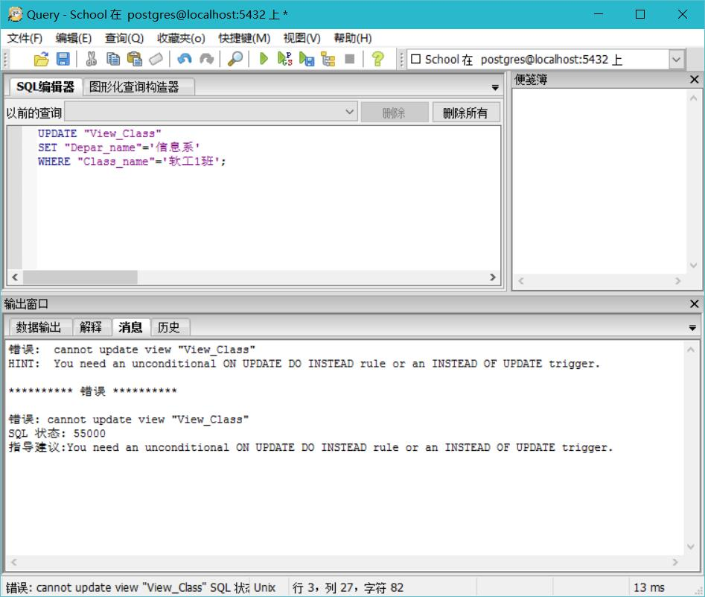
You need an unconditional ON UPDATE DO INSTEAD rule or an INSTEAD OF UPDATE trigger. For that we cannot disobey the constraint of the original table.
The reason is the same to ex5.
- Update view “View_CSTeacher” to set position to “教授” whose teacher name is “王国民”. Is the operation successful? Give a reason.
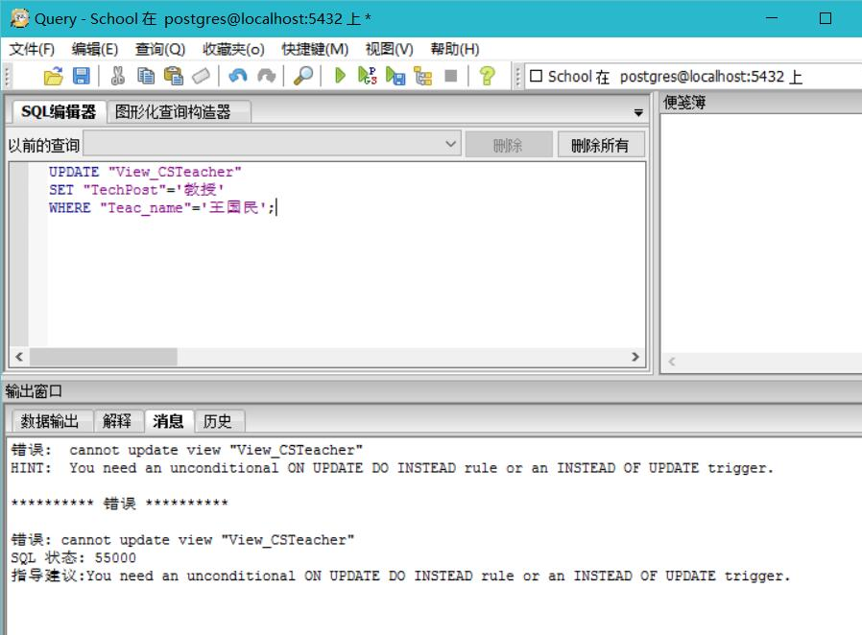
You need an unconditional ON UPDATE DO INSTEAD rule or an INSTEAD OF UPDATE trigger. For that we cannot disobey the constraint of the original table.
The reason is the same to ex5.
- Delete the View_CSTeacher.
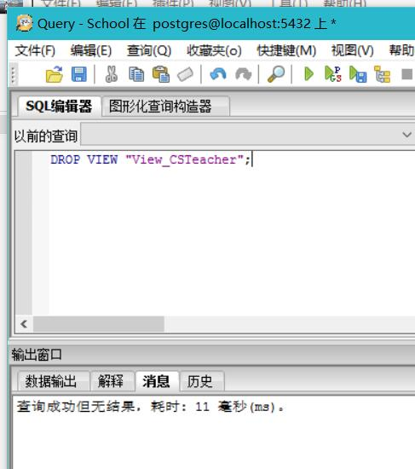
Before delete
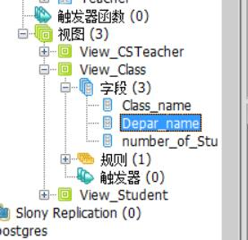
After
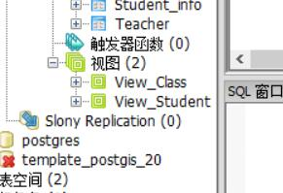
- Can you delete a department with department name “经济系”？If you get failure, give a reason and find a way to delete it.
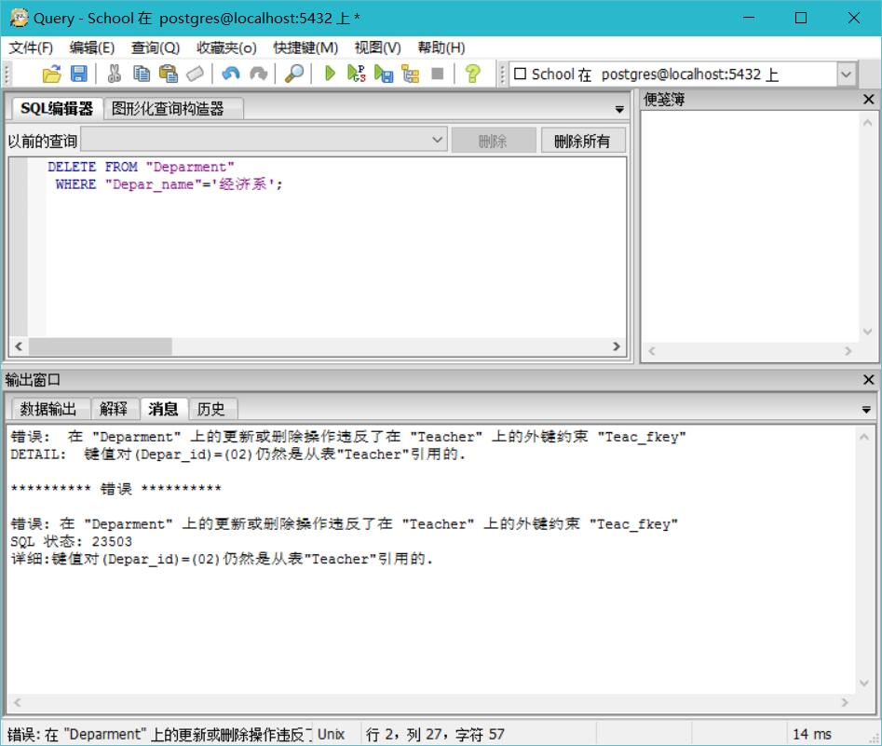
I cannot do it because there are some constraints with it.
So that I find a more safety way to deal with it.
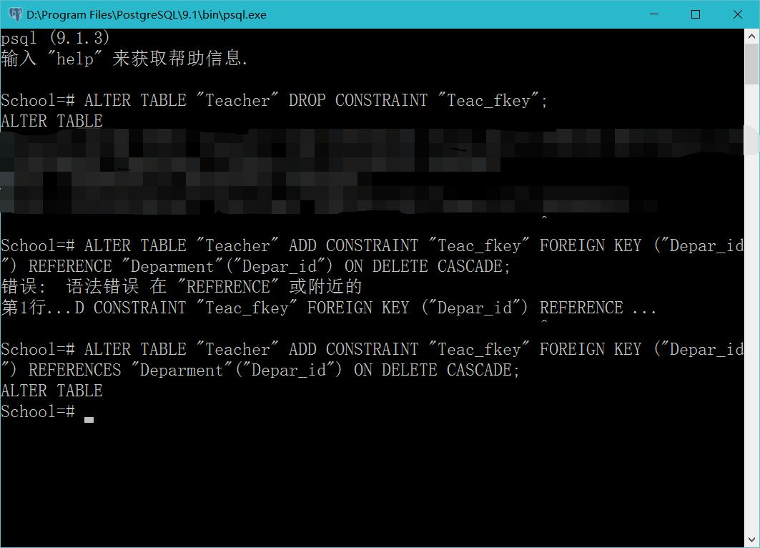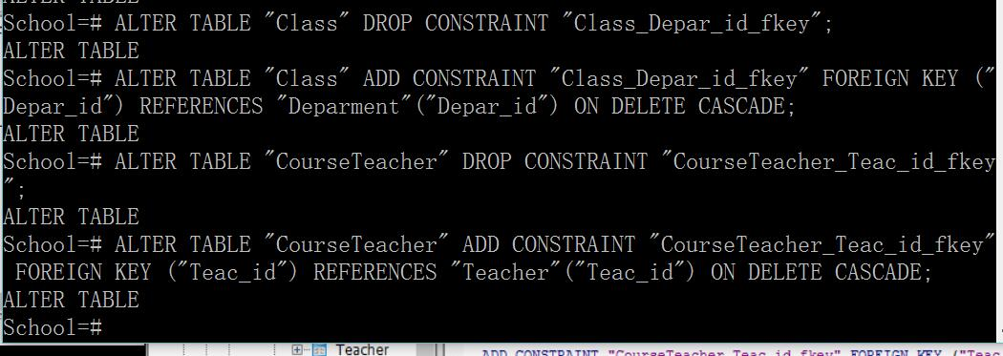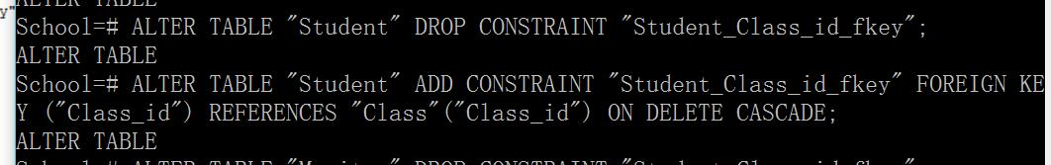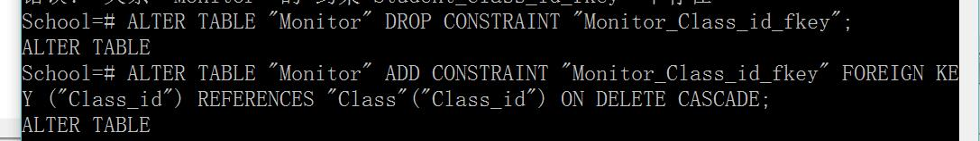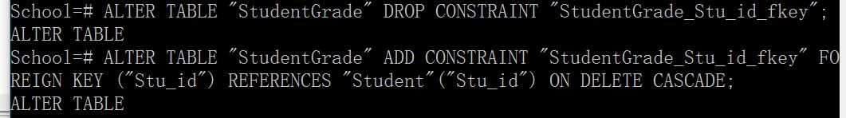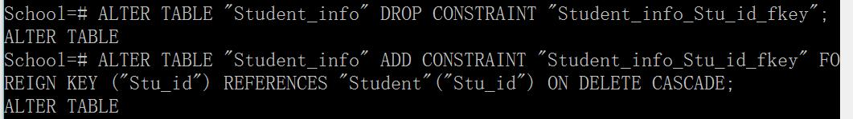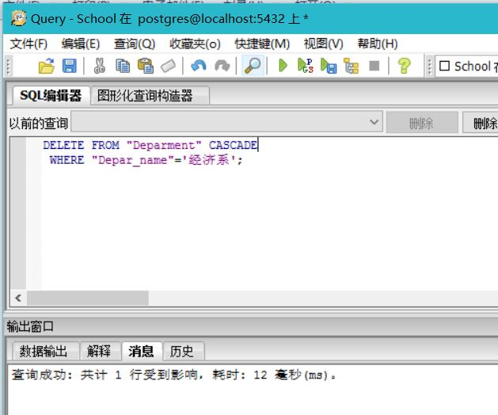
So there is no ‘经济系’.
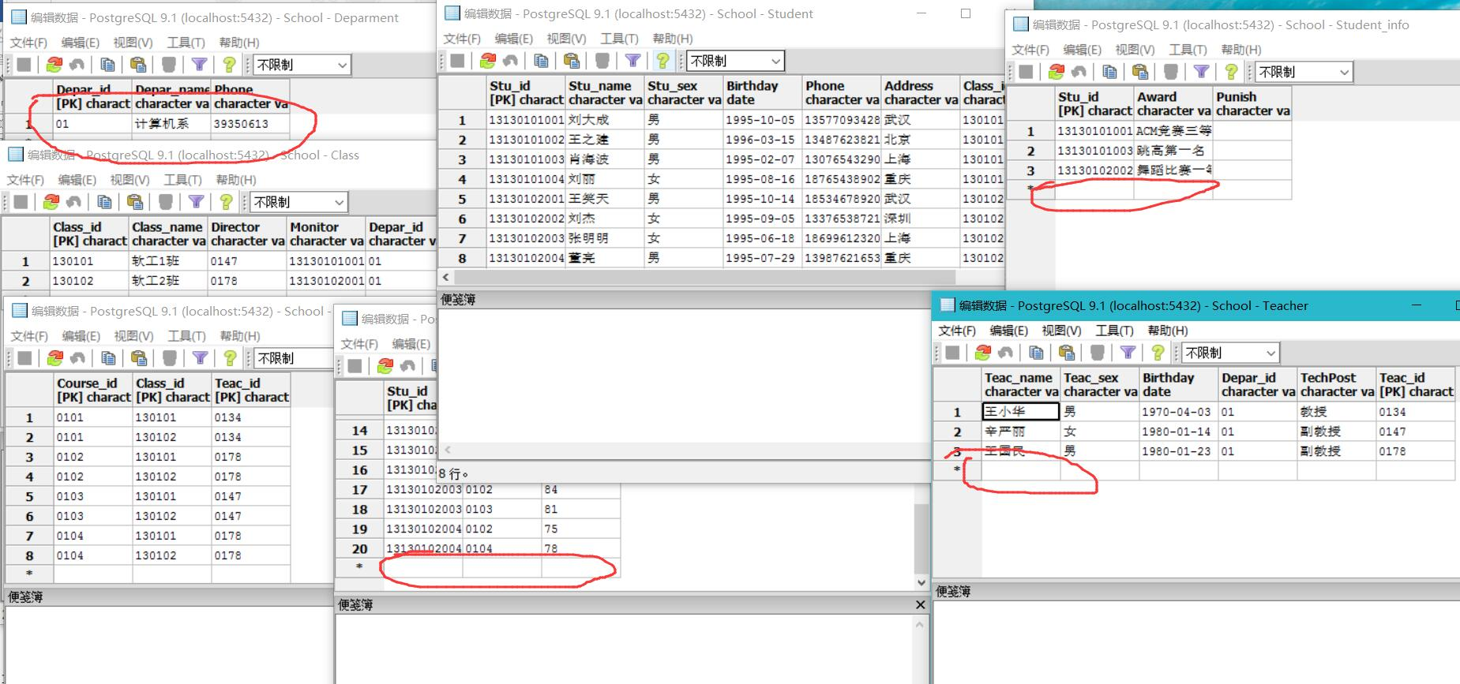
【结论】（结果）：
Finish all experimental steps and record operation steps and detailed results, screenshots is necessary.
There may be some exceptions during your operation, if you record, instruct them and provide your analysis, you will get additional scores.
You are not allowed to copy others’ work, or you will get no score.
(1) Use SQL plus, command line or PgAdmin to create views and do some data manipulation to School database
(2) Follow the guide of the experimental content to finish all experimental operations.
【小结】：
I learnt a lot.

指导教师评语及成绩
【评语】：

成绩： 指导教师签名：
批阅日期：
附件：
实验报告说明

1．实验项目名称：要用最简练的语言反映实验的内容。要求与实验指导书中相一致。
2．实验目的：目的要明确，要抓住重点，符合实验任务书中的要求。
3．实验环境：实验用的软硬件环境（配置）。
4．实验方案设计（思路、步骤和方法等）：这是实验报告极其重要的内容。包括概要设计、详细设计和核心算法说明及分析，系统开发工具等。应同时提交程序或设计电子版。
对于设计型和综合型实验，在上述内容基础上还应该画出流程图、设计思路和设计方法，再配以相应的文字说明。
对于创新型实验，还应注明其创新点、特色。
5．结论（结果）：即根据实验过程中所见到的现象和测得的数据，做出结论（可以将部分测试结果进行截屏）。
6．小结：对本次实验的心得体会，所遇到的问题及解决方法，其他思考和建议。
7．指导教师评语及成绩：指导教师依据学生的实际报告内容，用简练语言给出本次实验报告的评价和价值。

