BILLGRACE CISCO NETWORK

Executive Summary
This report outlines the design and configuration of a scalable, secure, and reliable network for Excel-Tec Inc. The company needed to upgrade its network to accommodate growth at four locations: London, Leeds, Liverpool, and Leicester. The network design incorporates VLANs, dynamic routing (OSPF), DHCP, and access control to enhance efficiency, security and resilience.
London is connected to the internet and includes a DMZ for publicly accessible services, with other sites not allowed to access the internet as per corporate policy. The network design guarantees high availability, efficient traffic control and robust security measures.
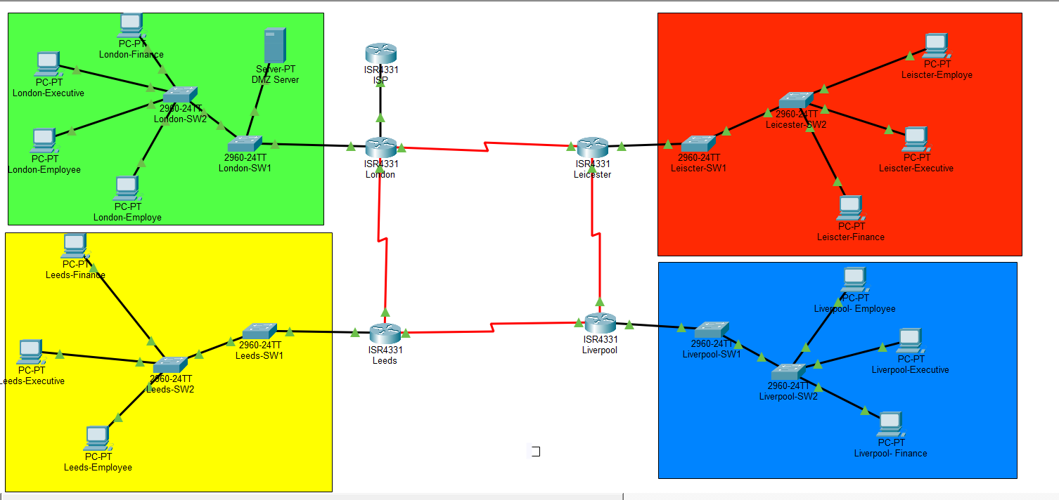

Introduction
Excel-Tec Inc is growing its business and needs a solid network to support the growth in users and services. The current network is not scalable, segmented or secure. The project aims to:
• To create a scalable network with four locations
• To segment the network using VLANs
• To implement dynamic IP addressing with DHCP
• To provide dynamic routing by using OSPF
• To implement security via ACLs and device hardening
• To provide redundancy and reliability

ADDRESSING TABLE
LONDON
Device | Interface | IP Address | Subnet Mask
London | G0/0/0 | 10.0.0.2 | 255.255.255.252
London | G0/0/1.30 | 172.16.16.1 | 255.255.254.0
London | G0/0/1.40 | 172.16.18.1 | 255.255.255.0
London | G0/0/1.50 | 172.16.8.1 | 255.255.248.0
London | S0/2/0 | 172.16.0.1 | 255.255.255.252
London | S0/2/1 | 172.16.0.14 | 255.255.255.252
ISP | G0/0/0 | 10.0.0.1 | 255.255.255.252
Switch1-London | VLAN 40 | 172.16.18.2 | 255.255.255.0
Switch2-London | VLAN 40 | 172.16.18.3 | 255.255.255.0
PC1-London | N/C | DHCP | DHCP
PC2-London | N/C | DHCP | DHCP
PC3-London | N/C | DHCP | DHCP
PC4-London | N/C | DHCP | DHCP

LEEDS
Device | Interface | IP Address | Subnet Mask
Leeds | G0/0/1.30 | 172.16.44.1 | 255.255.255.0
Leeds | G0/0/1.40 | 172.16.45.1 | 255.255.255.128
Leeds | G0/0/1.50 | 172.16.40.1 | 255.255.252.0
Leeds | S0/2/0 | 172.16.0.2 | 255.255.255.252
Leeds | S0/2/1 | 172.16.0.5 | 255.255.255.252
Switch1-Leeds | VLAN 40 | 172.16.45.2 | 255.255.255.128
Switch2-Leeds | VLAN 40 | 172.16.45.3 | 255.255.255.128
PC1-Leeds | N/C | DHCP | DHCP
PC2-Leeds | N/C | DHCP | DHCP
PC3-Leeds | N/C | DHCP | DHCP

LIVERPOOL
Device | Interface | IP Address | Subnet Mask
Liverpool | G0/0/1.30 | 172.16.50.1 | 255.255.255.128
Liverpool | G0/0/1.40 | 172.16.50.129 | 255.255.255.192
Liverpool | G0/0/1.50 | 172.16.48.1 | 255.255.254.0
Liverpool | S0/2/0 | 172.16.0.6 | 255.255.255.252
Liverpool | S0/2/1 | 172.16.0.9 | 255.255.255.252
Switch1-Liverpool | VLAN 40 | 172.16.50.130 | 255.255.255.192
Switch2-Liverpool | VLAN 40 | 172.16.50.131 | 255.255.255.192
PC1-Liverpool | N/C | DHCP | DHCP
PC2-Liverpool | N/C | DHCP | DHCP
PC3-Liverpool | N/C | DHCP | DHCP

LEICESTER
Device | Interface | IP Address | Subnet Mask
Leicester | G0/0/1.30 | 172.16.32.1 | 255.255.254.0
Leicester | G0/0/1.40 | 172.16.34.1 | 255.255.255.0
Leicester | G0/0/1.50 | 172.16.24.1 | 255.255.248.0
Leicester | S0/2/0 | 172.16.0.10 | 255.255.255.252
Leicester | S0/2/1 | 172.16.0.13 | 255.255.255.252
Switch1-Leicester | VLAN 40 | 172.16.34.2 | 255.255.255.0
Switch2-Leicester | VLAN 40 | 172.16.34.3 | 255.255.255.0
PC1-Leicester | N/C | DHCP | DHCP
PC2-Leicester | N/C | DHCP | DHCP
PC3-Leicester | N/C | DHCP | DHCP

WAN LINK SUMMARY
Link | Network | Usable IPs
London – Leeds | 172.16.0.0/30 | 172.16.0.1, 172.16.0.2
Leeds – Liverpool | 172.16.0.4/30 | 172.16.0.5, 172.16.0.6
Liverpool – Leicester | 172.16.0.8/30 | 172.16.0.9, 172.16.0.10
Leicester – London | 172.16.0.12/30 | 172.16.0.13, 172.16.0.14
ISP – London | 10.0.0.0/30 | 10.0.0.1, 10.0.0.2

VLAN SUMMARY
Site | VLAN | Department | Network | Subnet Mask | Gateway
London | 30 | Finance | 172.16.16.0 | 255.255.254.0 | 172.16.16.1
London | 40 | Executive | 172.16.18.0 | 255.255.255.0 | 172.16.18.1
London | 50 | Employees | 172.16.8.0 | 255.255.248.0 | 172.16.8.1
Leeds | 30 | Finance | 172.16.44.0 | 255.255.255.0 | 172.16.44.1
Leeds | 40 | Executive | 172.16.45.0 | 255.255.255.128 | 172.16.45.1
Leeds | 50 | Employees | 172.16.40.0 | 255.255.252.0 | 172.16.40.1
Liverpool | 30 | Finance | 172.16.50.0 | 255.255.255.128 | 172.16.50.1
Liverpool | 40 | Executive | 172.16.50.128 | 255.255.255.192 | 172.16.50.129
Liverpool | 50 | Employees | 172.16.48.0 | 255.255.254.0 | 172.16.48.1
Leicester | 30 | Finance | 172.16.32.0 | 255.255.254.0 | 172.16.32.1
Leicester | 40 | Executive | 172.16.34.0 | 255.255.255.0 | 172.16.34.1
Leicester | 50 | Employees | 172.16.24.0 | 255.255.248.0 | 172.16.24.1

SPLIT HOST SUMMARY
- Finance = 20%
- Executive = 10%
- Employees = 70%

London: 2500 hosts
- Finance: 500
- Executive: 250
- Employees: 1750
Leeds: 1000 hosts
- Finance: 200
- Executive: 100
- Employees: 700
Liverpool: 500 hosts
- Finance: 100
- Executive: 50
- Employees: 350
Leicester: 1600 hosts
- Finance: 320
- Executive: 160
- Employees: 1120

Needed subnet sizes
- 1750 hosts - /21 = 2046 usable
- 1120 hosts - /21 = 2046 usable
- 700 hosts - /22 = 1022 usable
- 500 hosts - /23 = 510 usable
- 350 hosts - /23 = 510 usable
- 320 hosts - /23 = 510 usable
- 250 hosts - /24 = 254 usable
- 200 hosts - /24 = 254 usable
- 160 hosts - /24 = 254 usable
- 100 hosts - /25 = 126 usable
- 50 hosts - /26 = 62 usable
router-to-router links
- /30 subnets

Configuration order
- Configure router basic interfaces
- Configure serial links
- Configure VLANs on switches
- Configure trunk links
- Configure router sub interfaces for inter-VLAN routing
- Configure DHCP
- Configure OSPF
- Configure ACLs
- Configure security

CONFIGURATION
LONDON ROUTER
Basic setup
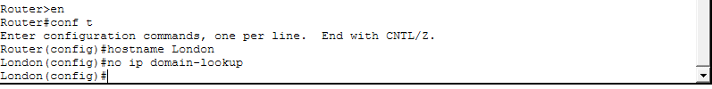

Securing the router
Securing the console port
Securing remote access lines
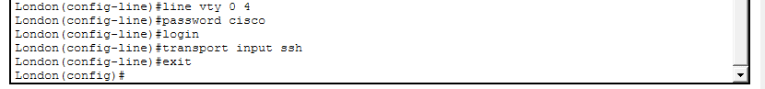
Enabling SSH
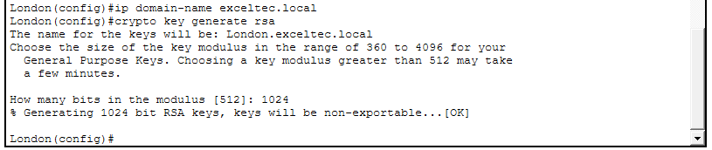

configure ISP-facing interface
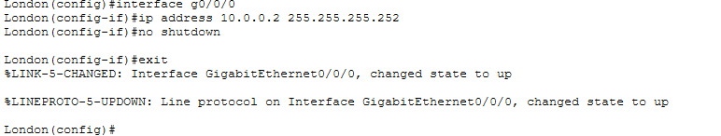
configure main LAN interface
configure sub interfaces for VLANs
VLAN 30 Finance
Vlan 40
Vlan 50\
Configure the DMZ interface
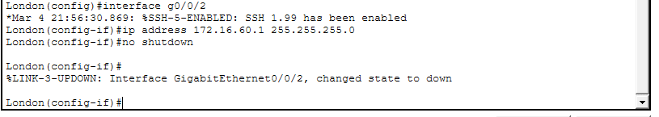

London to leeds
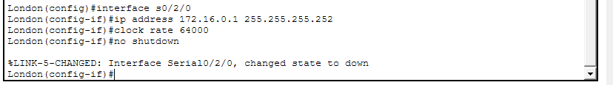
London to Leicester
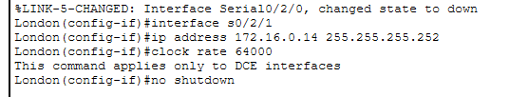
DHCP
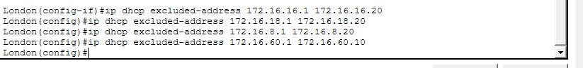
D HCP pool for Executive
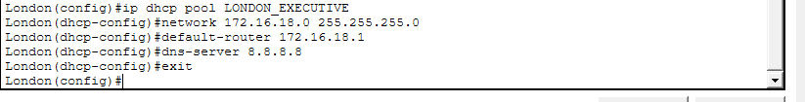
DHCP pool for Employees
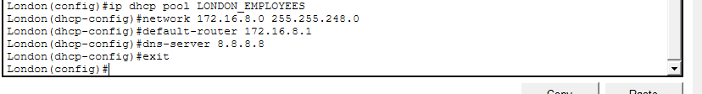
DHCP pool for Finance
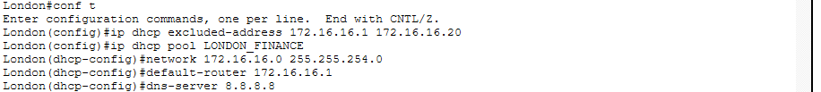
Configure OSPF
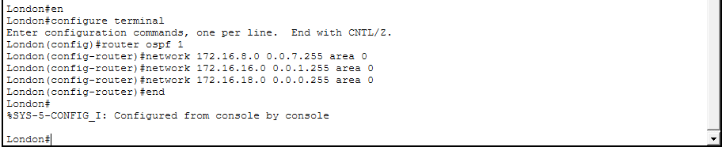
Configure default route
ACL for DMZ

LEEDS
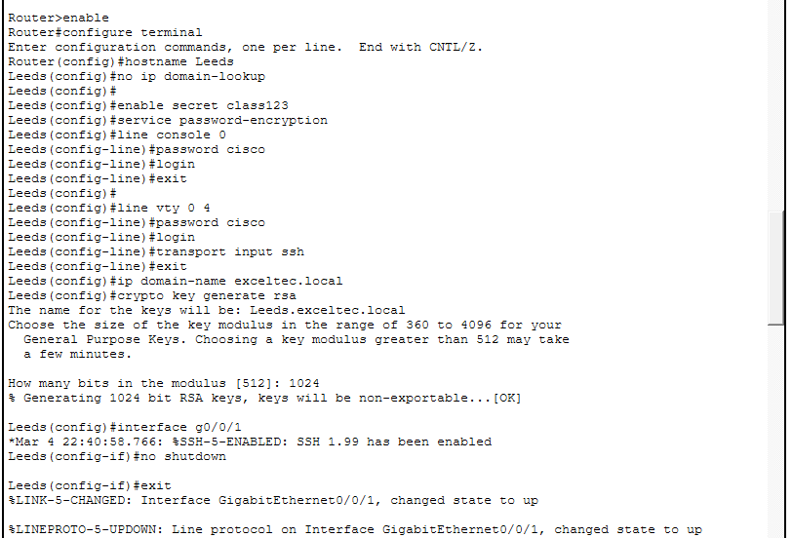
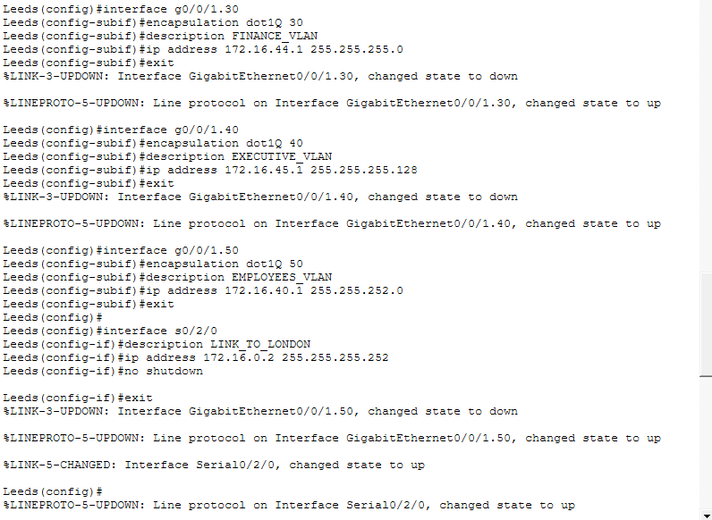
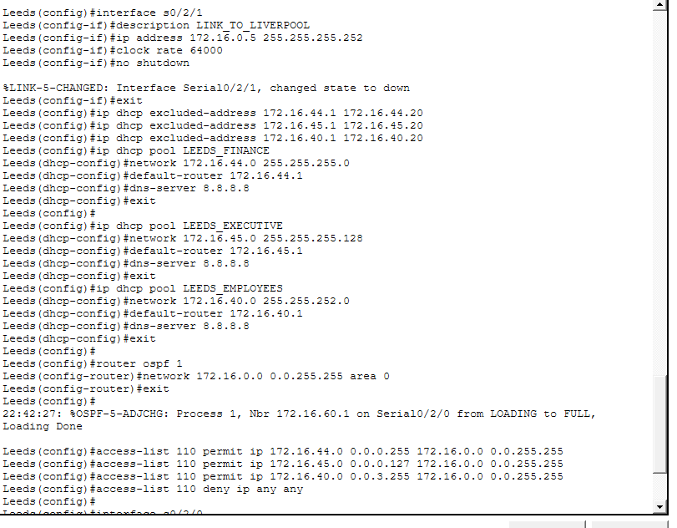
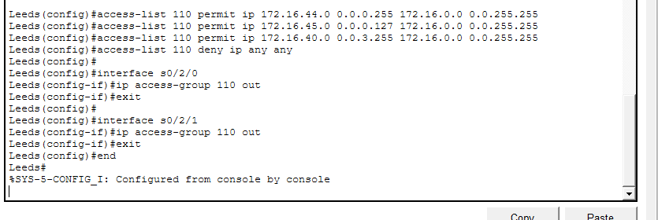
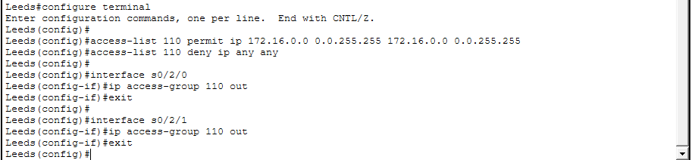
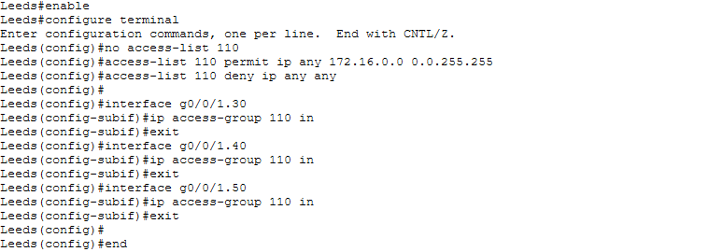
Liverpool
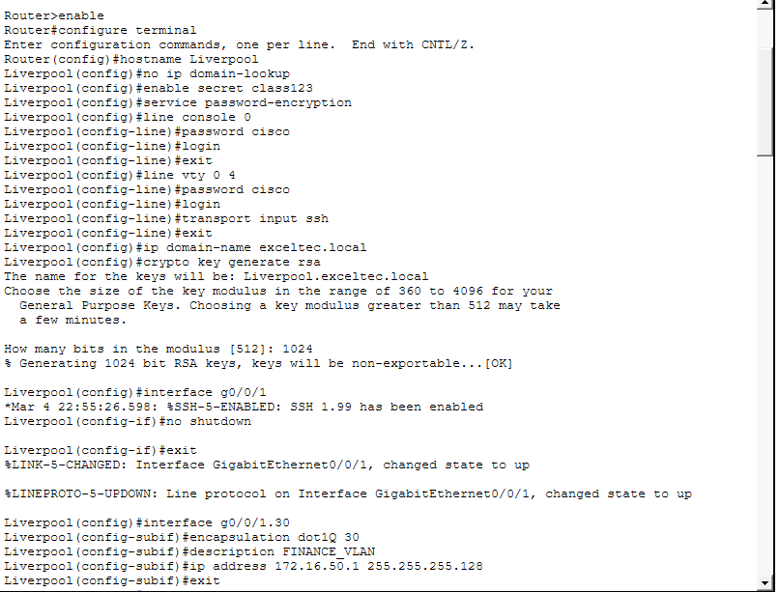
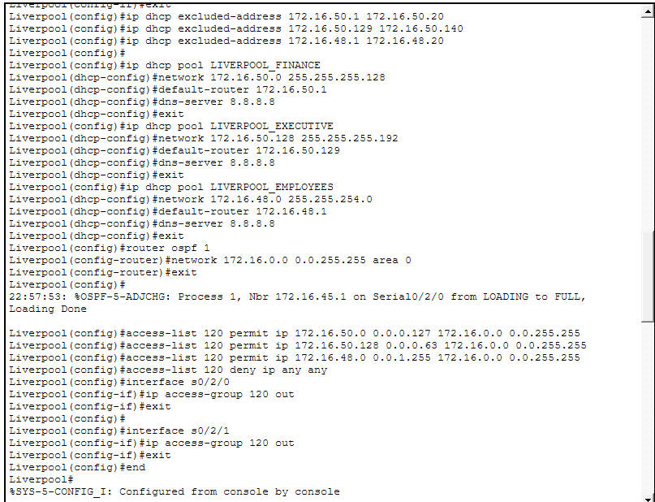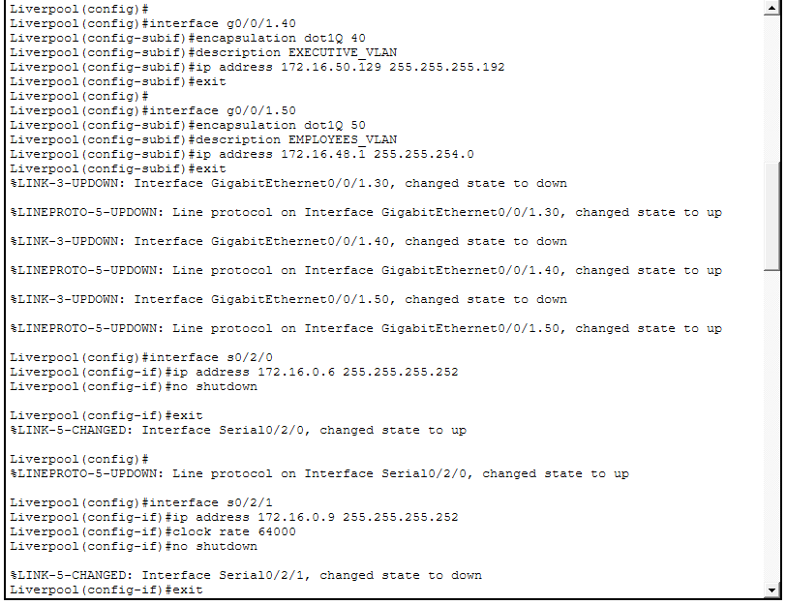
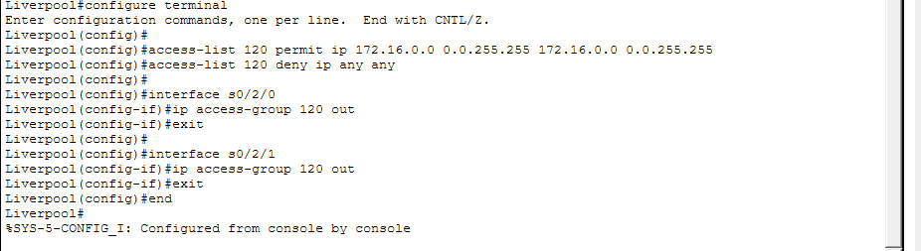
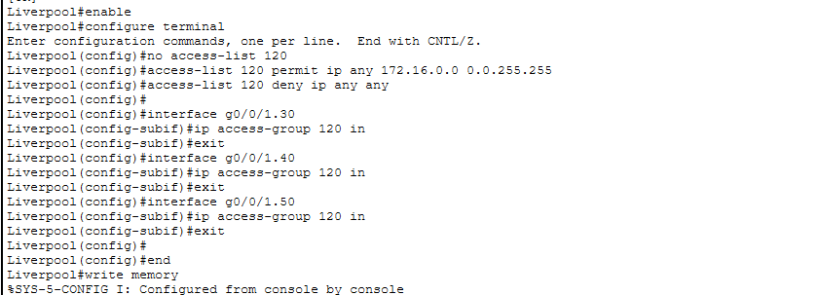
Leiscter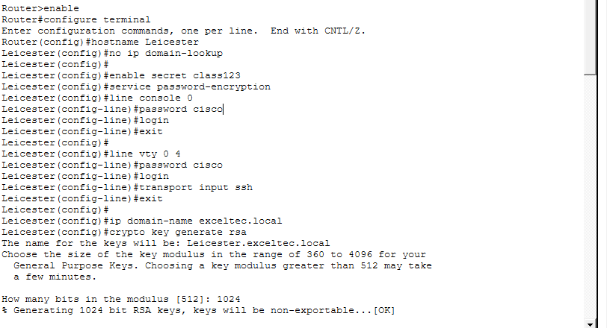
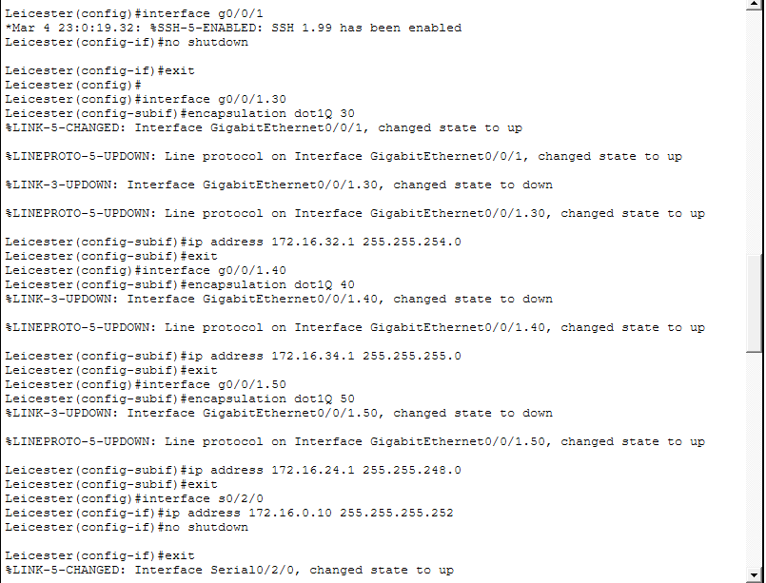
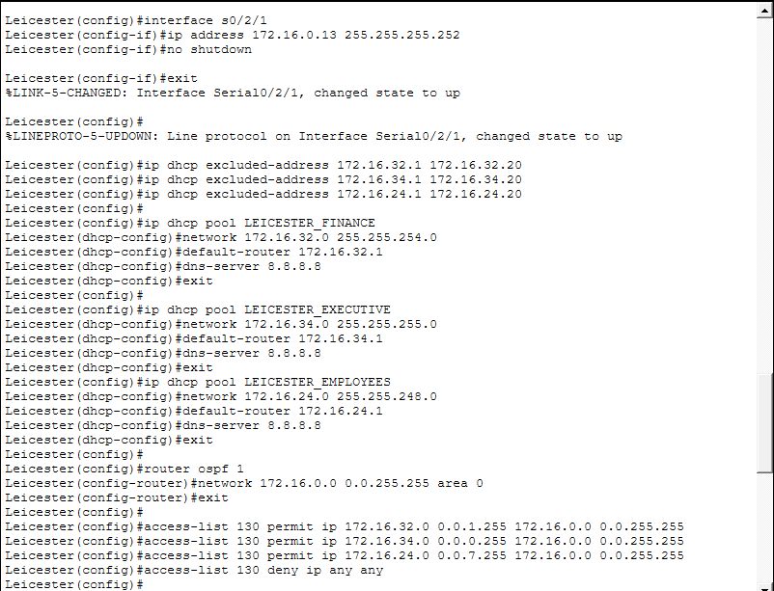
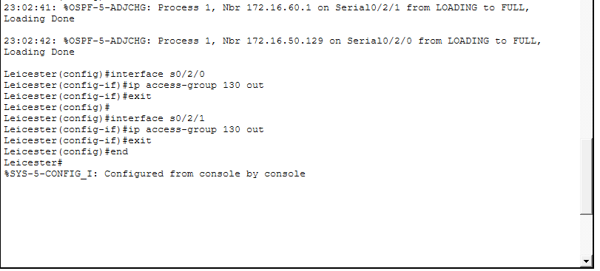
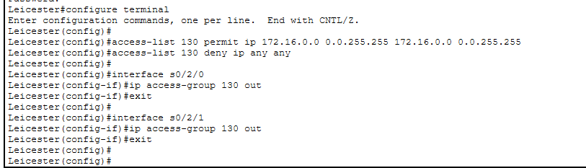
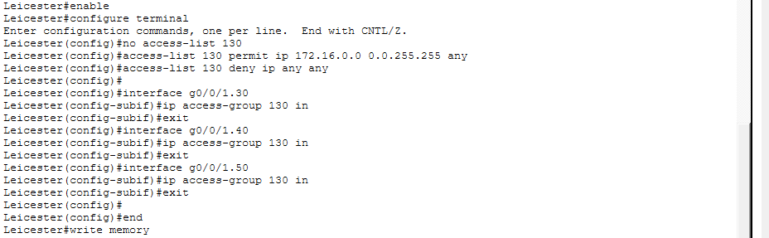
London – Switch Config 1
Basic Access
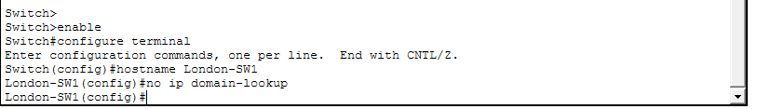
Password Security
Console Access Security
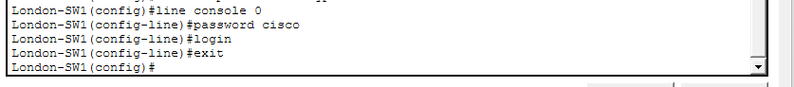
Remote Access Security
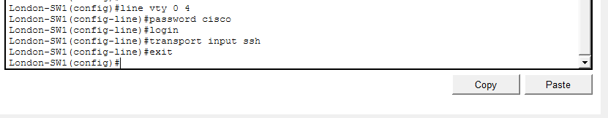
Enable SSH
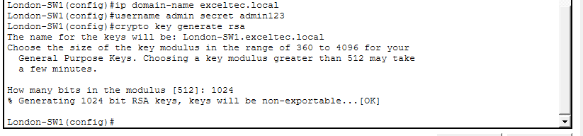
Create Vlan
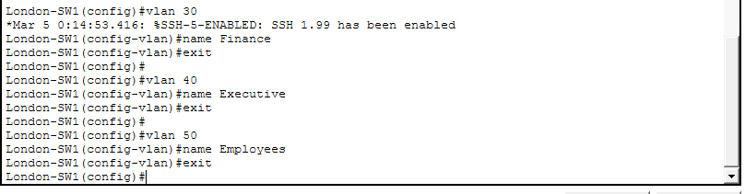
Trunking
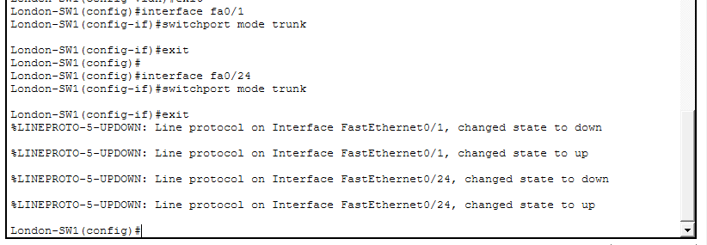
Access ports for PCs
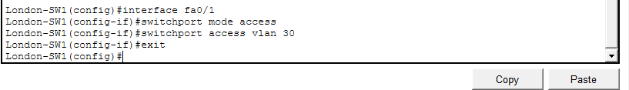
Switch Management IP
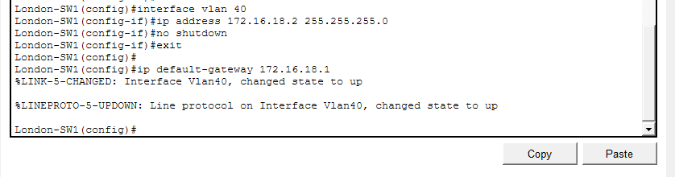
Creating Vlan for DMZ Server, assign ports, allowed vlan 60 for trunk
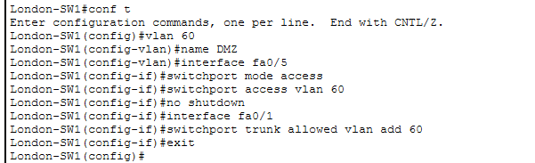

London Switch Config – 2
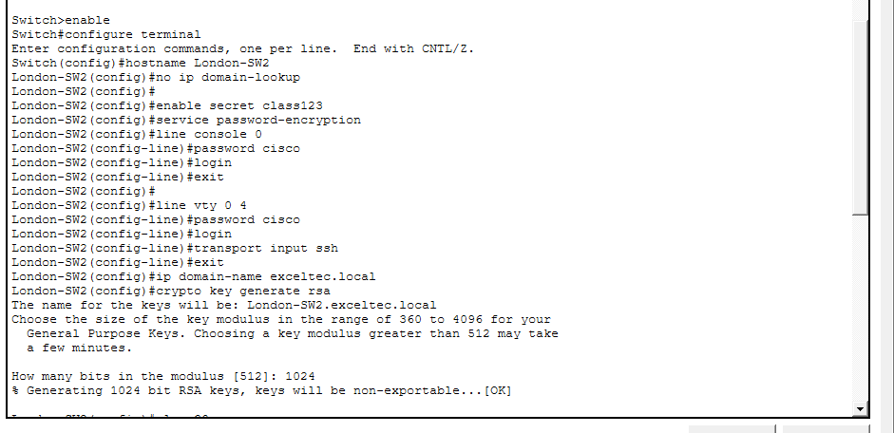
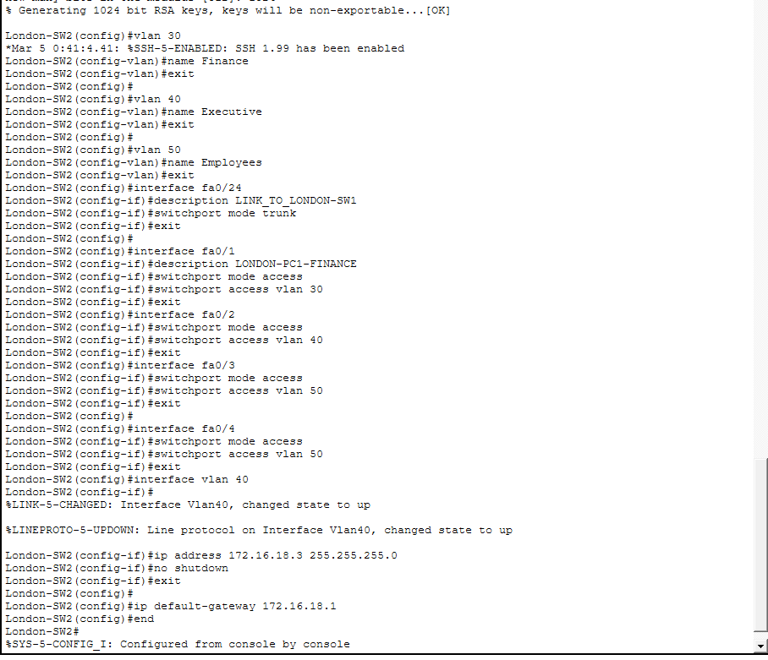
Leeds Swtich Config 1
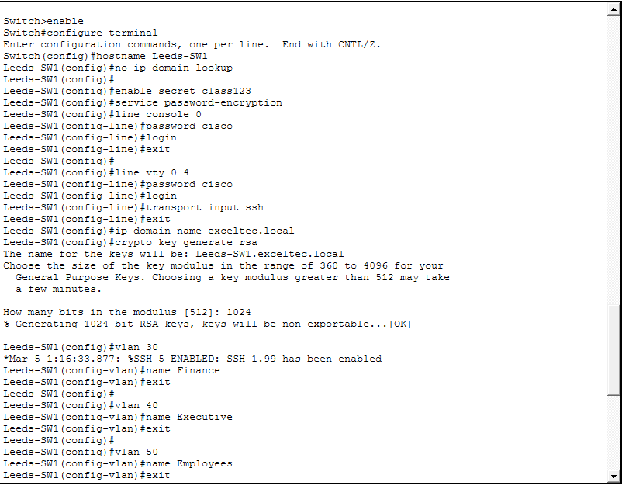
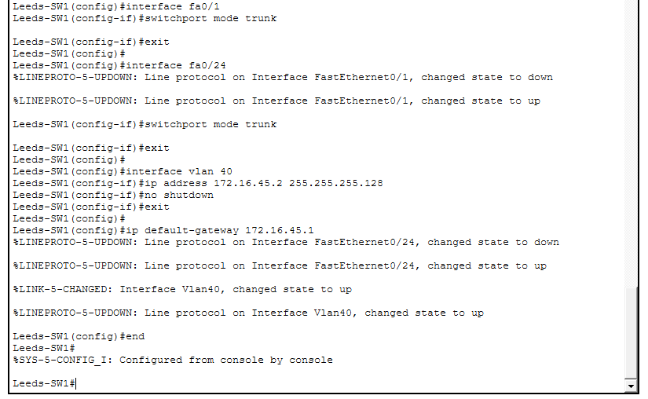
Leeds Swtich Config 2
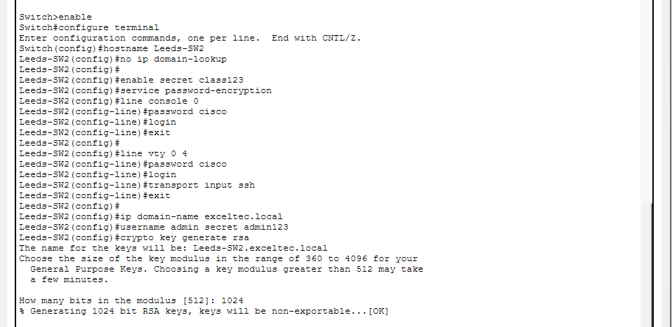
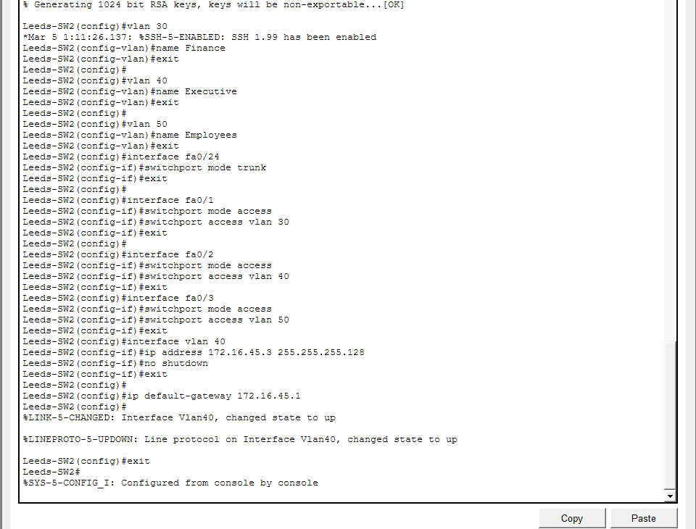
Liverpool Swtich Config – 1
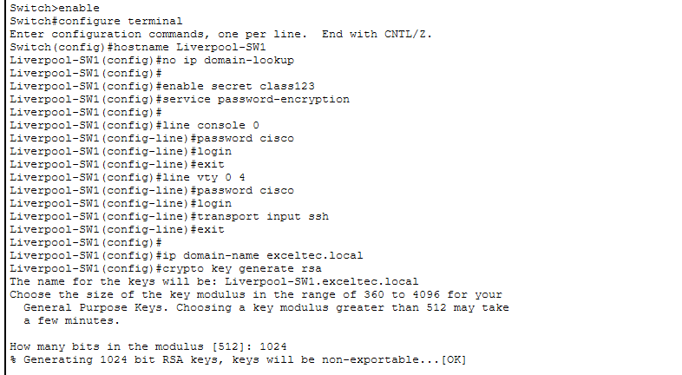
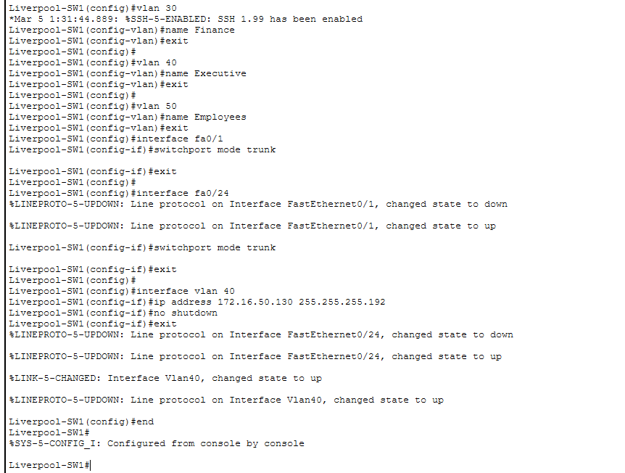
Liverpool Swtich 2 Config
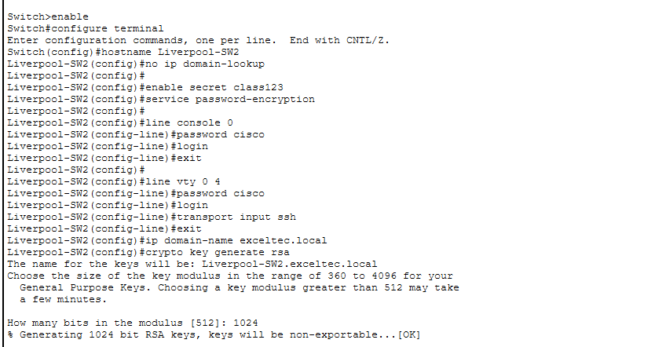
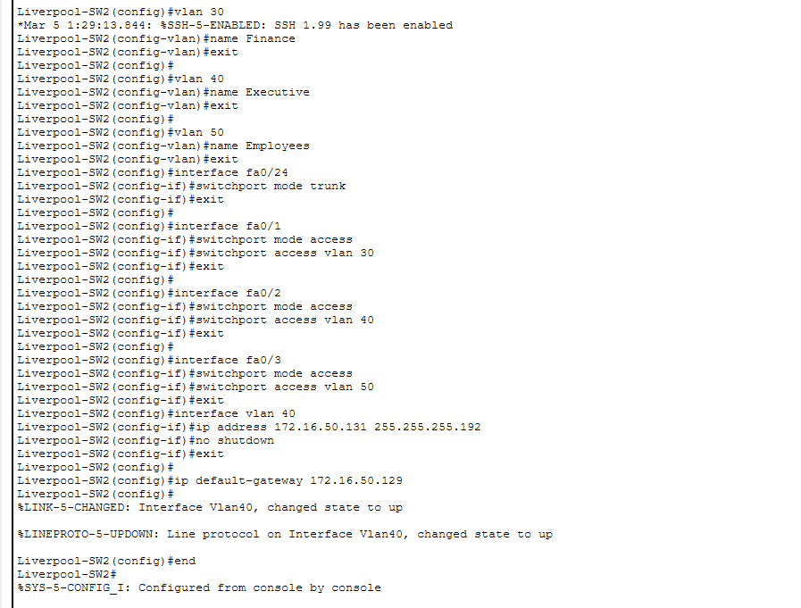
Leicester Switch 1 Config
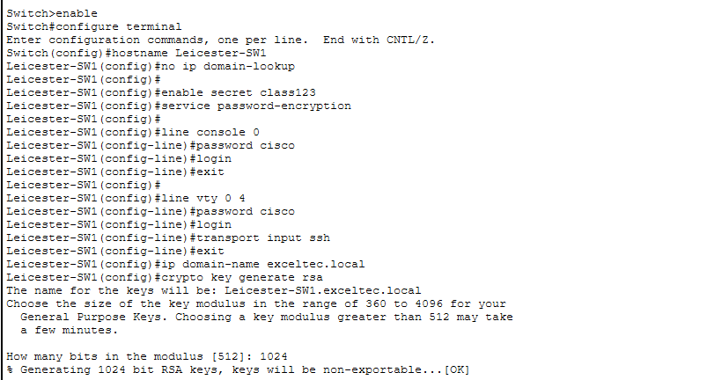
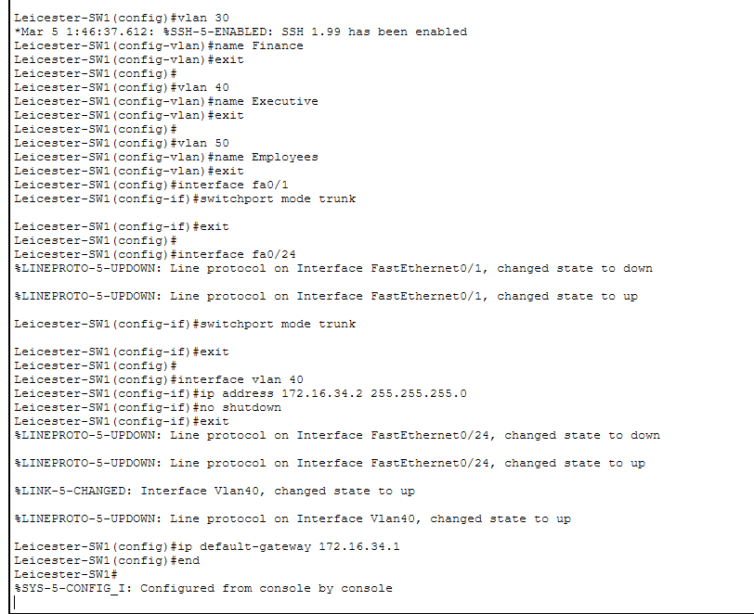
Leicester Swtich2 Config
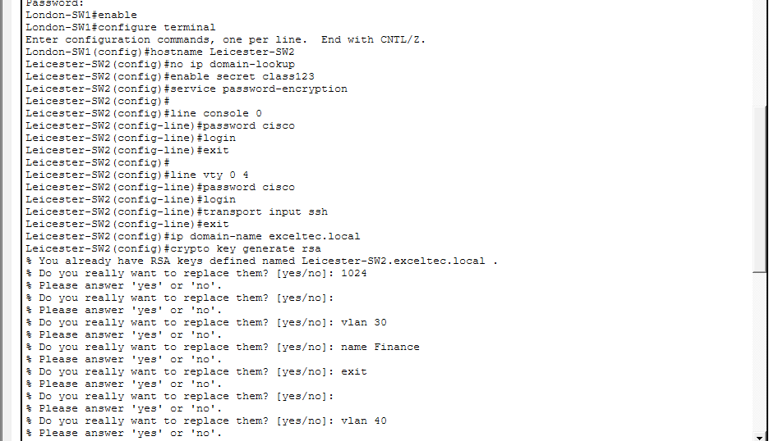
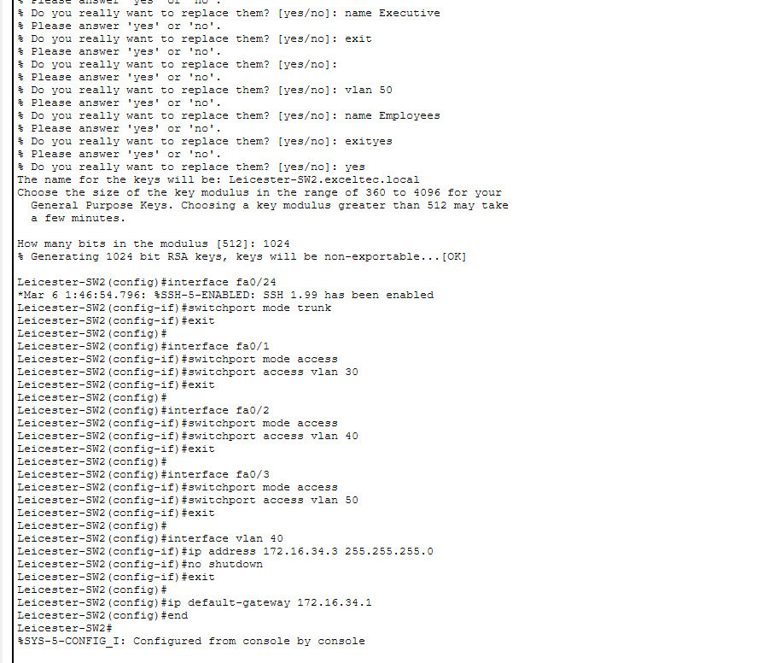

VLAN
A Virtual Local Area Network (VLAN) is a way of segmenting a network within a switch, enabling different networks to co-exist within the same physical network. The primary use of VLANs is to segment various departments of a company to enhance network management and organisation. Using VLANs also minimises broadcast traffic by confining it to a particular part of the network, which leads to better network performance.

TEST Cases
Router Testing
Figure 1: <<Successful ping between London router and other routers>>

Figure 2:<<Successful ping between Leeds router and other routers>>

Figure 3:<<Successful ping between Liverpool router and other router>>

Figure 4:<<Successful ping between Leicester router and other router>>

ARP
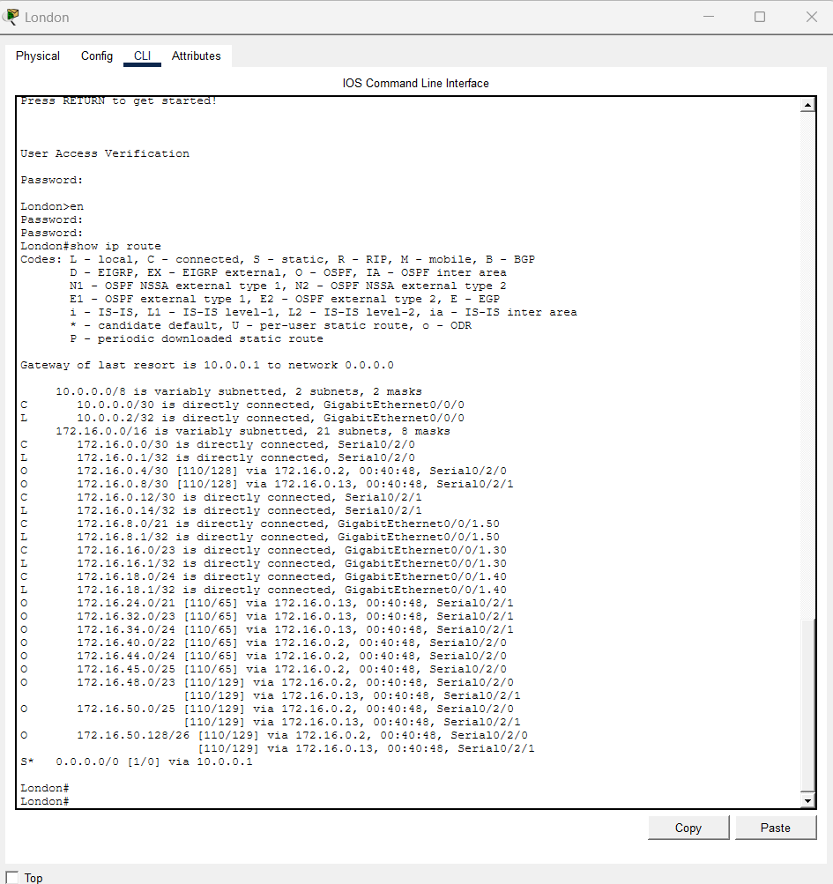
Figure 9<<London ARP tables>>
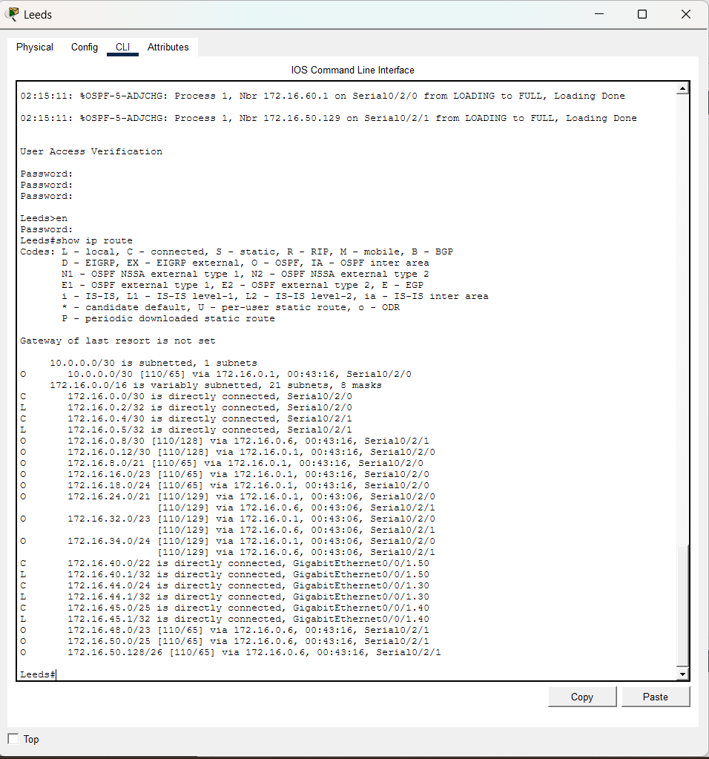
Figure 10<<Leeds ARP tables>>
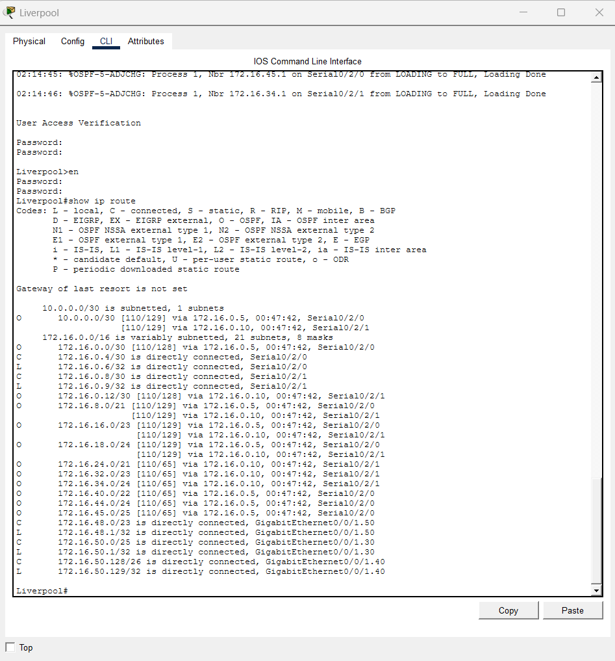
Figure 11<<Liverpool ARP table>>
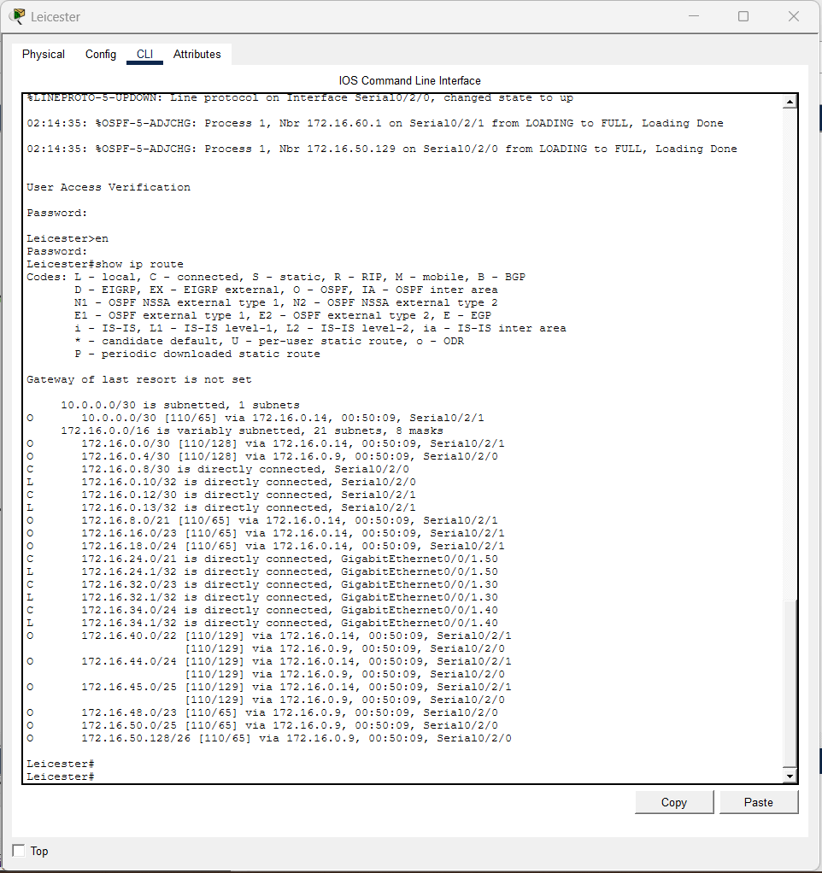
Figure 12<<Liverpool ARP table>>

Sub-interfaces
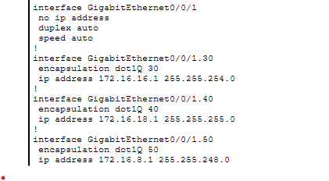
Figure 13<<Sub-interface for London>>
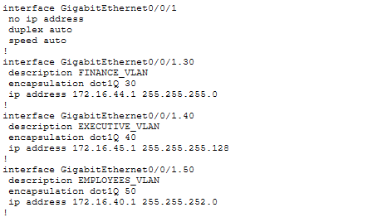
Figure 14<<Sub-interface for Leeds>>
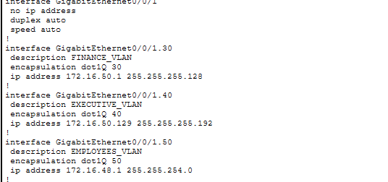
Figure 15<<Sub-interface for Liverpool>>
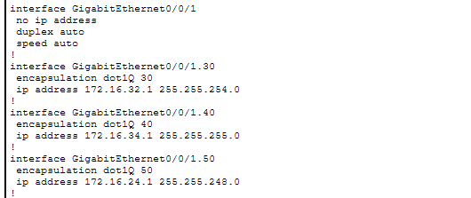
Figure 16<<Sub-interface for Leicester>>

Switched port
An access port is a switch port that is dedicated to a particular VLAN. This is used for end-station connections. Access ports are commonly used to connect desktop computers, printers and other end user devices. Since they are only part of a single VLAN, traffic from the device is confined to the network segment, contributing to appropriate network segmentation and security.
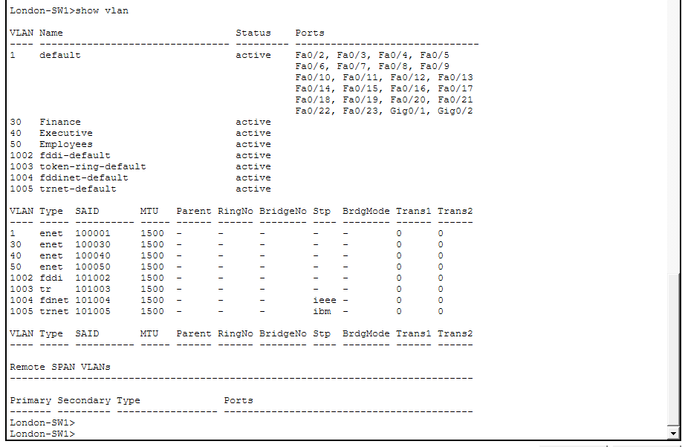
Figure 17<<Switched ports on Switch-1 -London>>
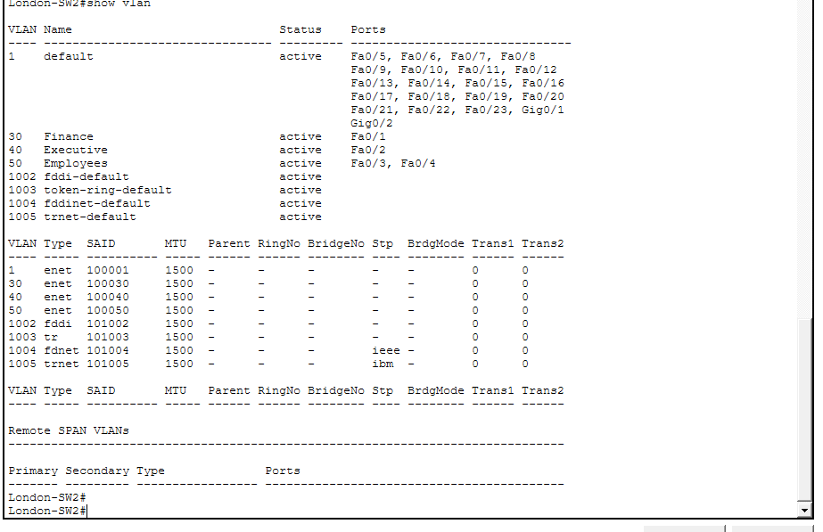
Figure 18<<<<Switched ports on Switch-2 -London>>
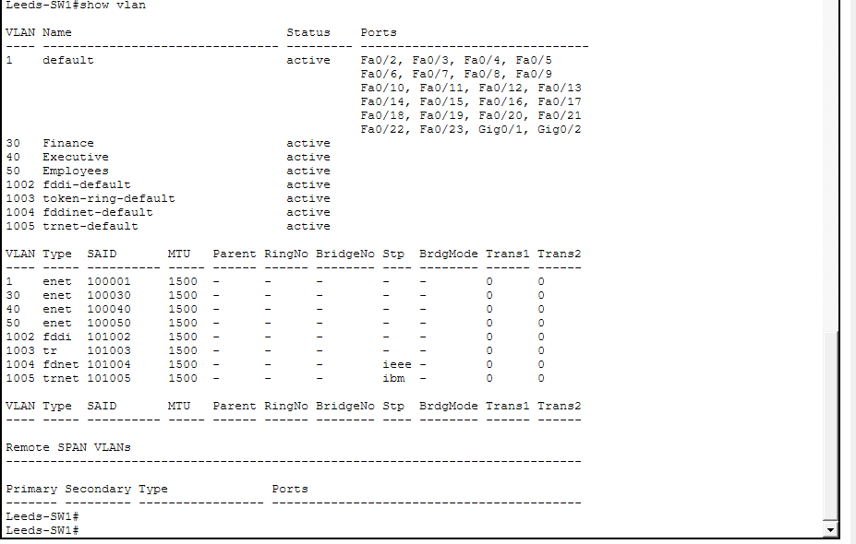
Figure 19<<Switched ports on Switch-1 -Leeds>>
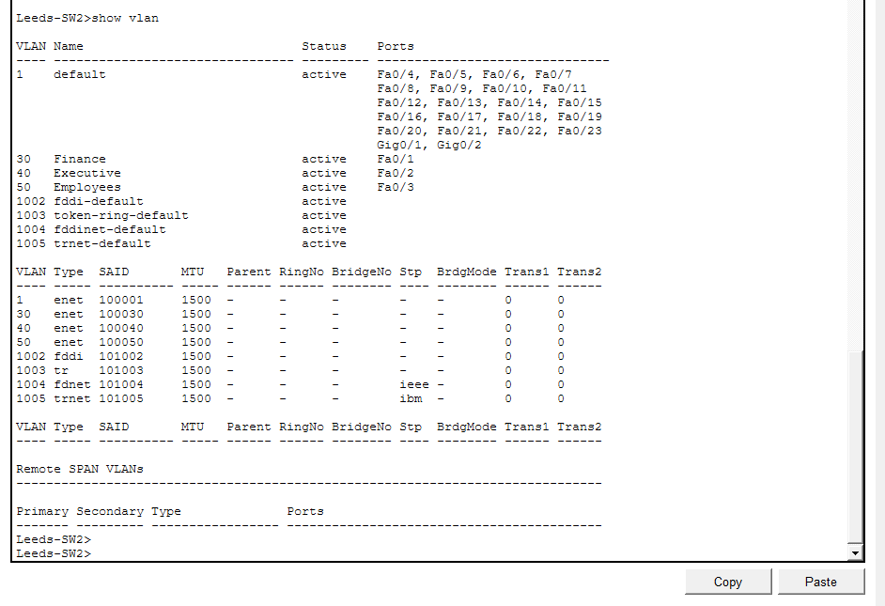
Figure 20<<Switched ports on Switch-2Leeds>>

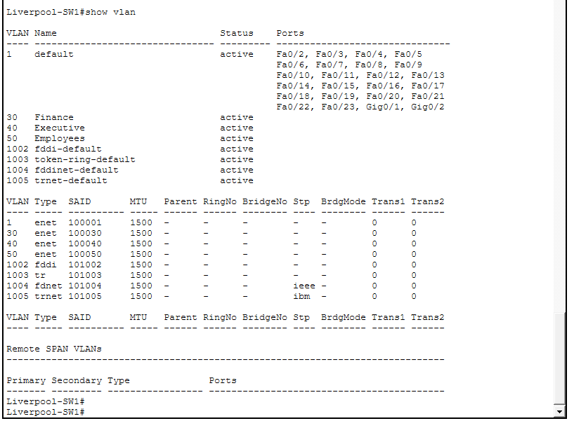
Figure 21<<Switched ports on Switch-1 Liverpool>>
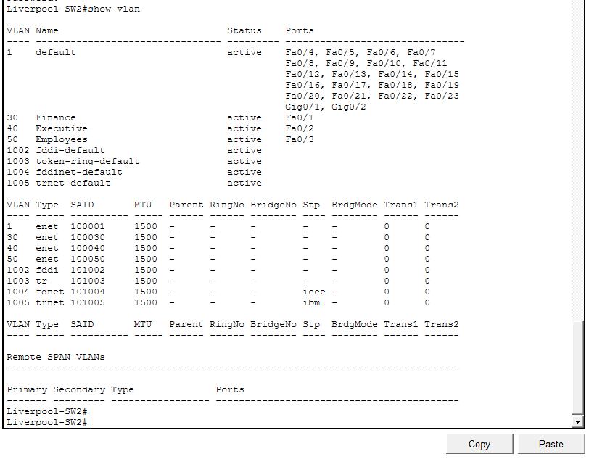
Figure 22<<Switched ports on Switch-2 Liverpool>>
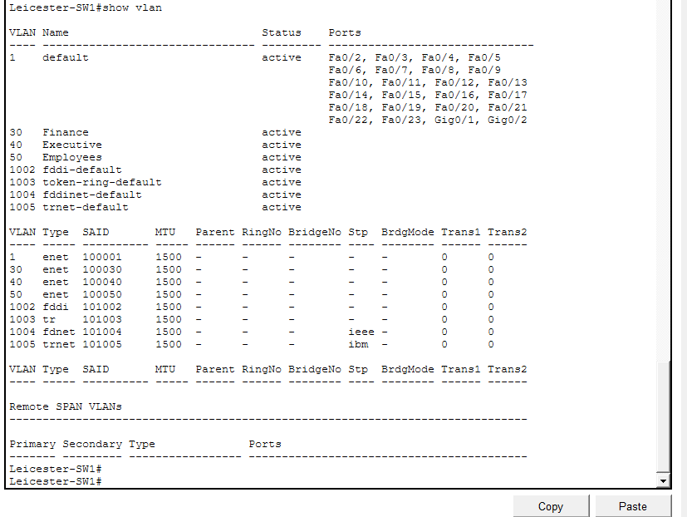
Figure 23<<Switched ports on Switch-1 Leicester>>
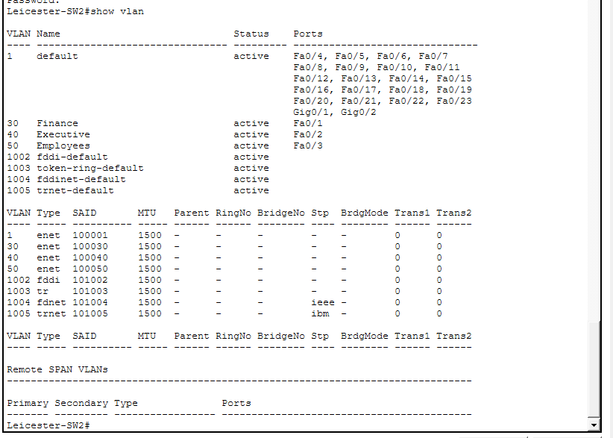
Figure 24<<Switched ports on Switch-2 Leicester>>

Trunking :
A trunk port is a switch port that can carry traffic for multiple VLANs at the same time. It is mainly used to connect networking devices such as switches or routers, allowing VLAN information to be shared across the network.
Trunk ports use VLAN tagging to identify which traffic belongs to which VLAN, ensuring that data is correctly delivered to the appropriate network segment. This makes them essential for communication between different parts of a VLAN-based network.

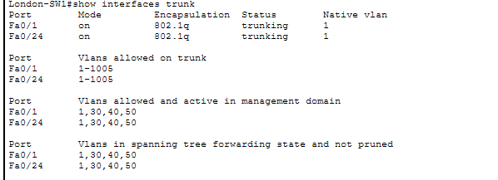
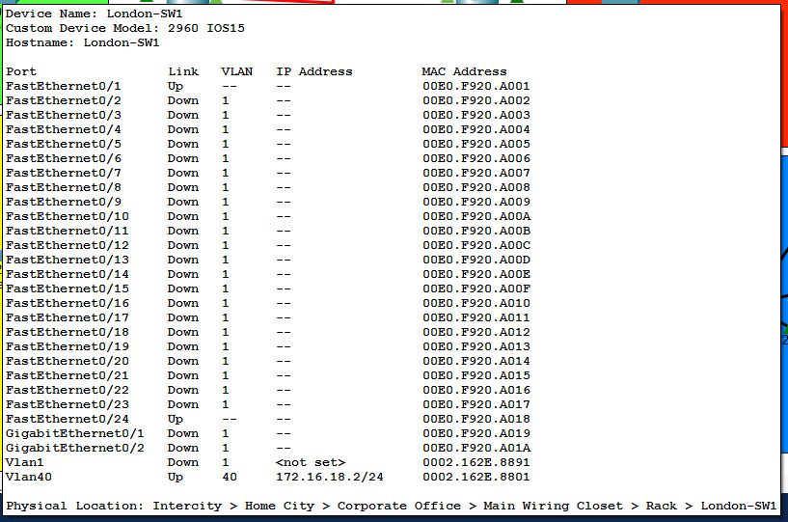
Figure 25<<Trunking on Switch-1 London>>

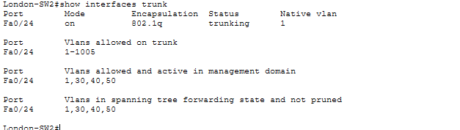

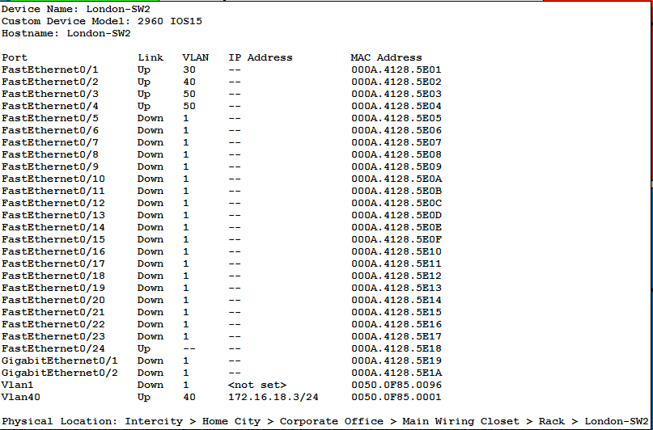
Figure 26<<Trunking on Switch-2 London>>
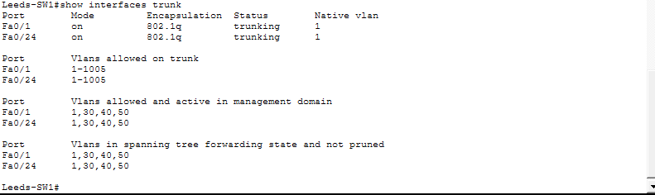

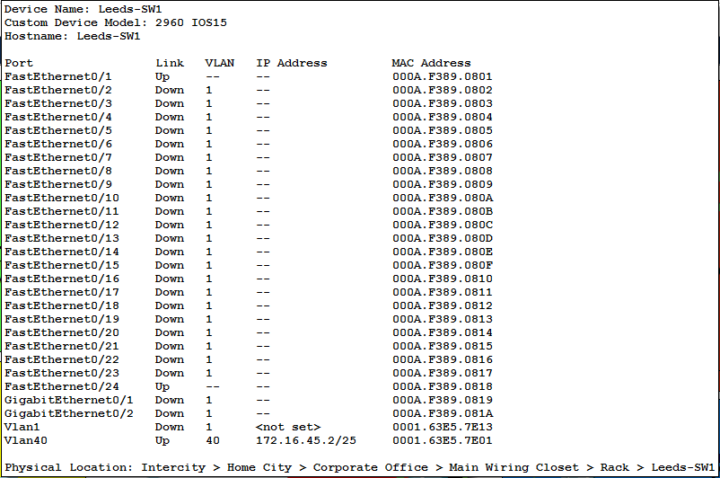
Figure 27<<Trunking on Switch-1 Leeds>>
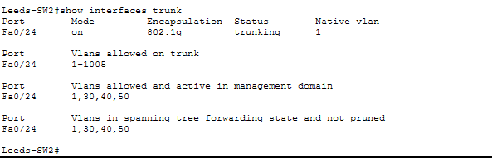
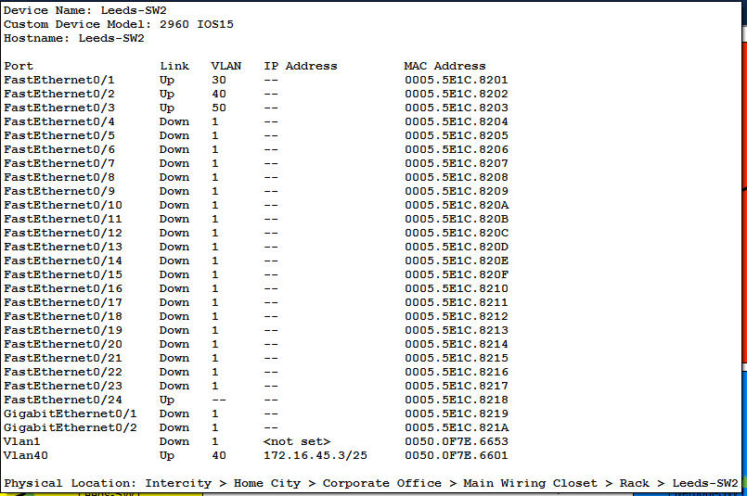
Figure 28<<Trunking on Switch-2 Leeds>>
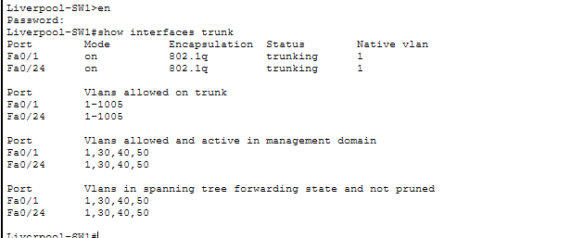
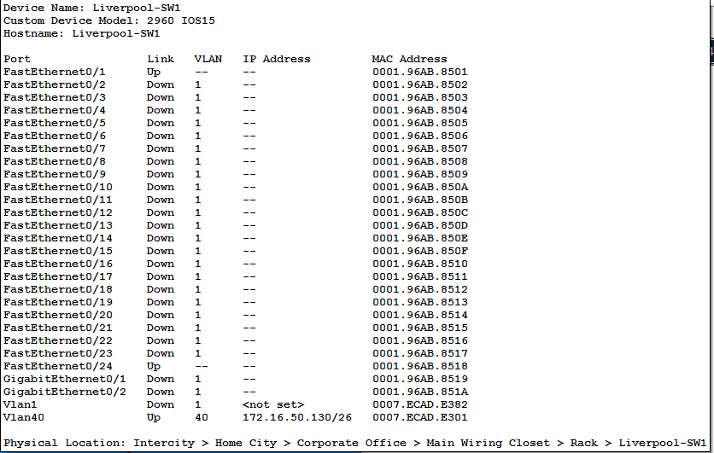
Figure 29<<Trunking on Switch-1 Liverpool>>
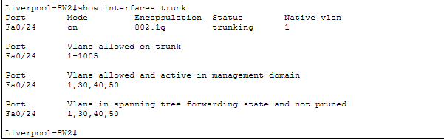
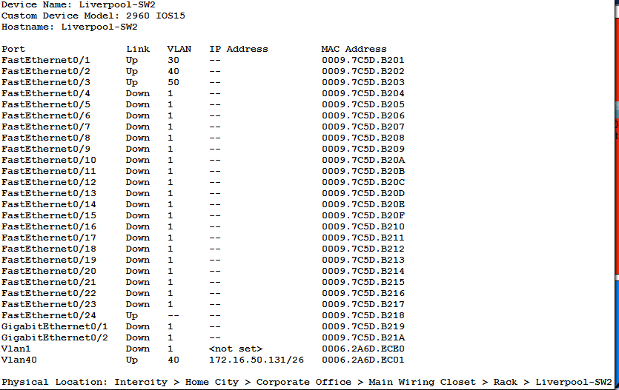
Figure 30<<Trunking on Switch-2 Liverpool>>

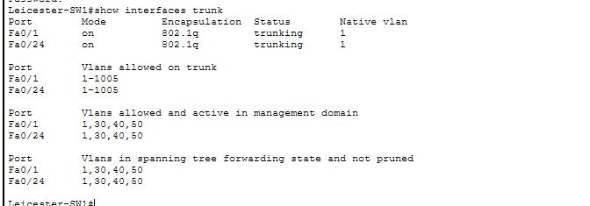
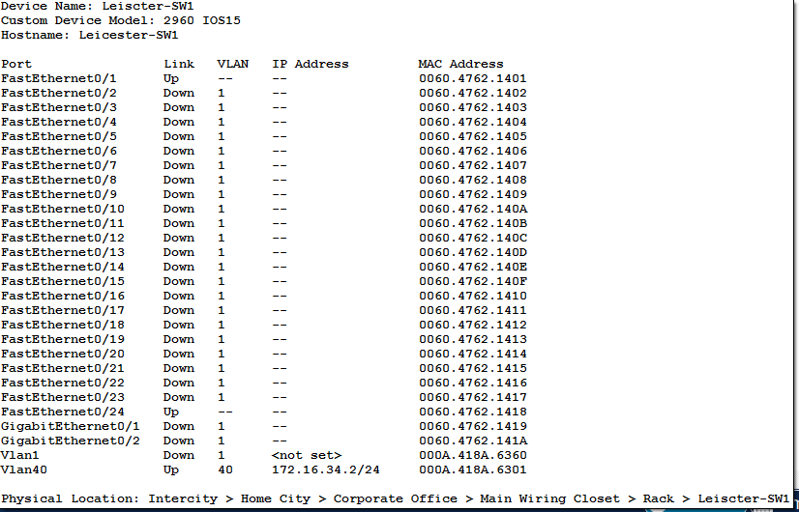
Figure 31<<Trunking on Switch-1 Leicester>>
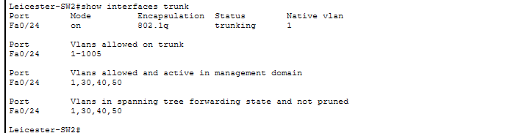
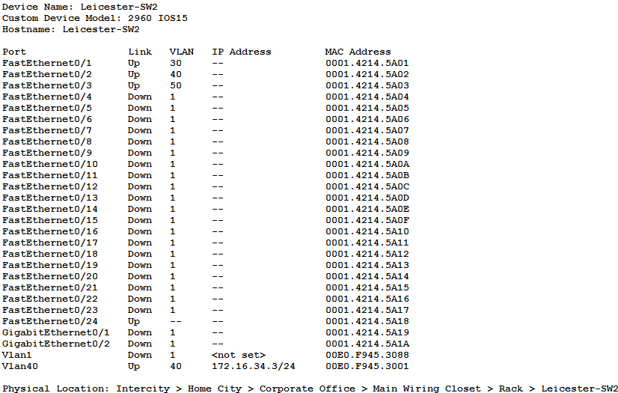
Figure 32<<Trunking on Switch-2 Leicester>>

DHCP Testing
DHCP (Dynamic Host Configuration Protocol) is a network service that automatically assigns IP addresses to devices when they connect to a network.
Its main advantages include reducing the need for manual configuration, which makes network setup easier and more efficient. It also helps avoid IP address conflicts by ensuring that each device is given a unique address. Overall, DHCP saves time and simplifies network management, especially in large environments.

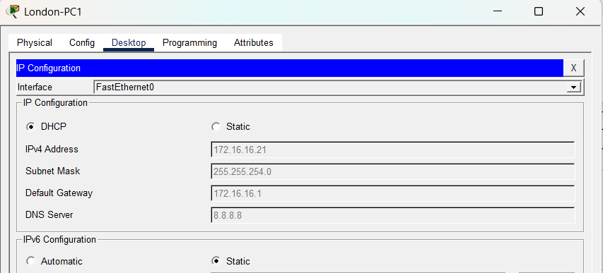
Figure 33<<DHCP IP addresses on London PC - 1>>

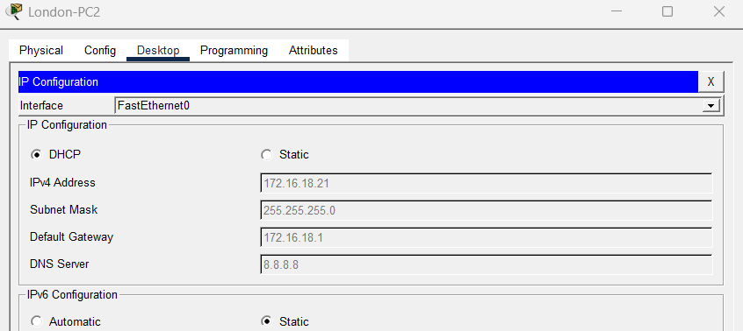
Figure 34<<DHCP IP addresses on London PC - 2>>
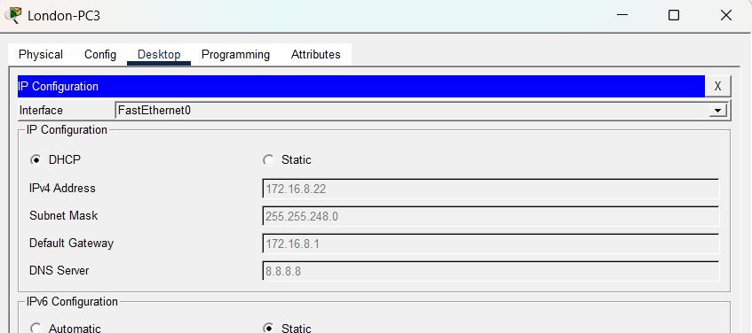
Figure 35<<DHCP IP addresses on London PC - 3>>
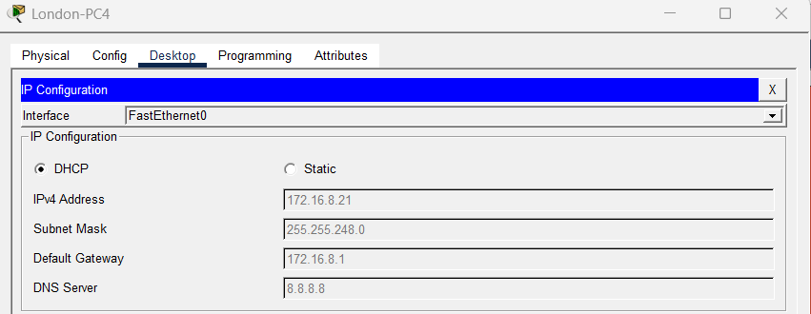
Figure 36<<DHCP IP addresses on London PC - 4>>
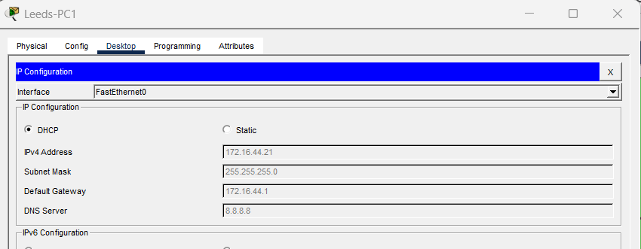
Figure 37<<DHCP IP addresses on Leeds PC - 1>>
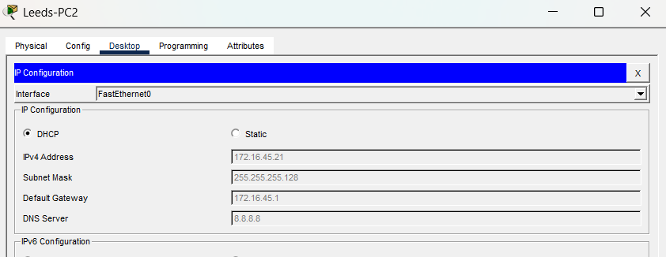
Figure 38<<DHCP IP addresses on Leeds PC - 2>>
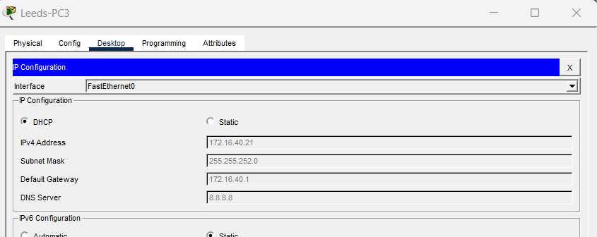
Figure 39<<DHCP IP addresses on Leeds PC - 3>>
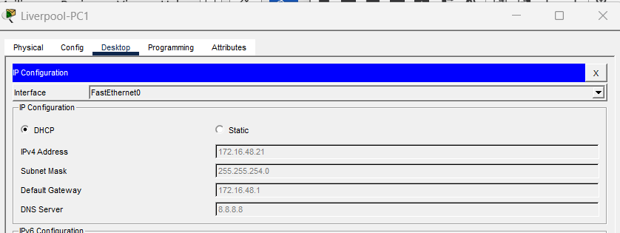
Figure 40<<DHCP IP addresses on Liverpool PC - 1>>
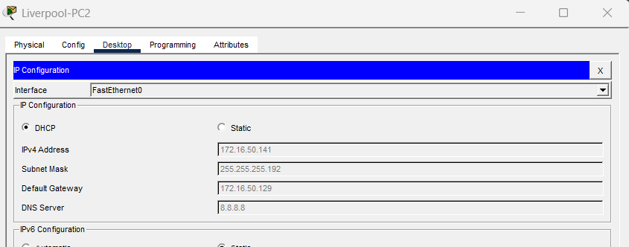
Figure 41<<DHCP IP addresses on Liverpool PC - 2>>
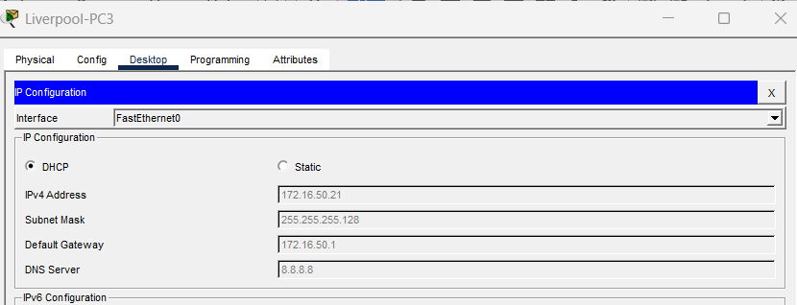
Figure 42<<DHCP IP addresses on Liverpool PC - 3>>

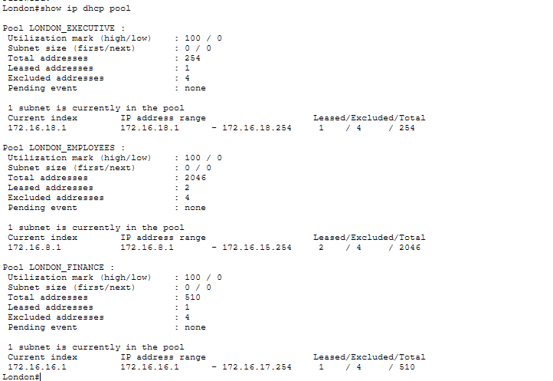
Figure 43<<London router dhcp pool testing>>
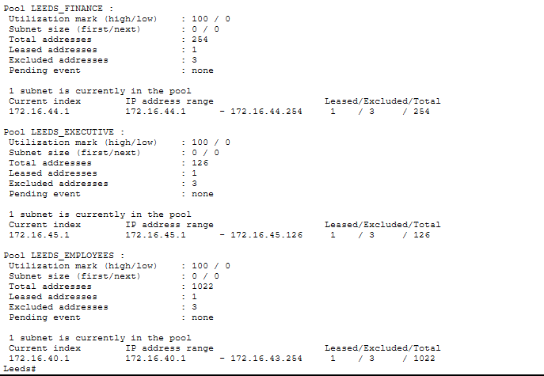
Figure 44<<Leeds router dhcp pool testing>>
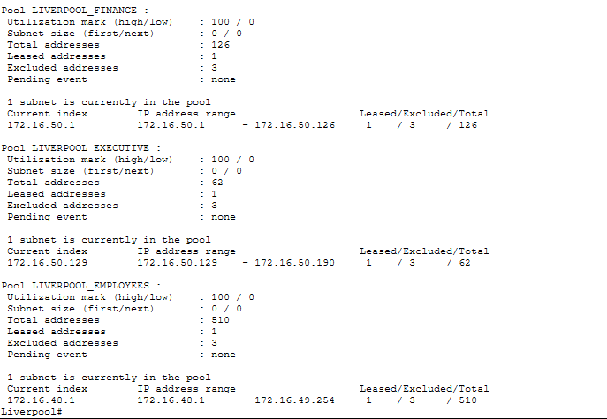
Figure 45<<Liverpool router dhcp pool testing>>
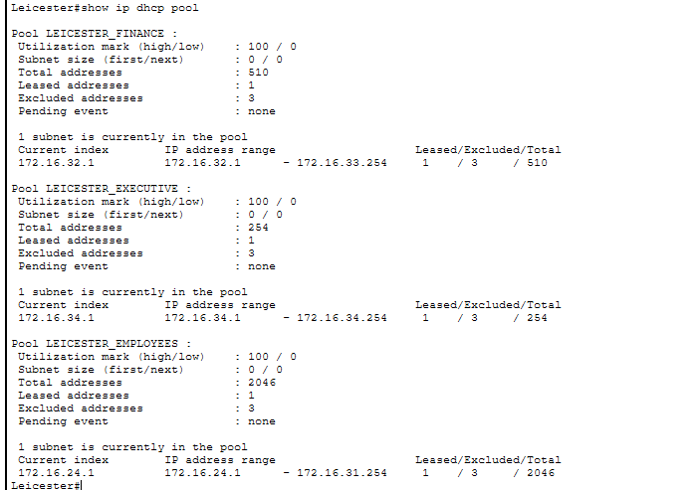
Figure 46<<Leicester router dhcp pool testing>>

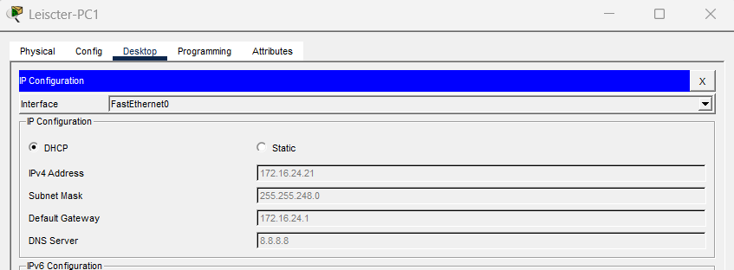
Figure 47<<DHCP IP addresses on Leicester PC - 1>>
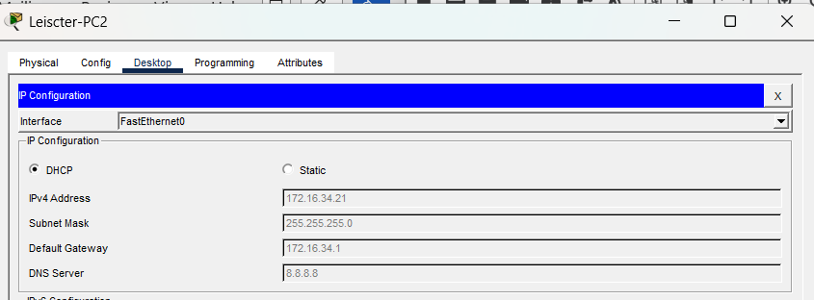
Figure 48<<DHCP IP addresses on Leicester PC - 2>>
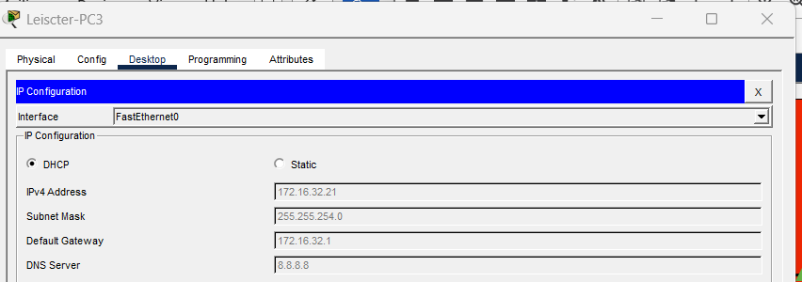
Figure 49<<DHCP IP addresses on Leicester PC - 3>>

Router interface brief status
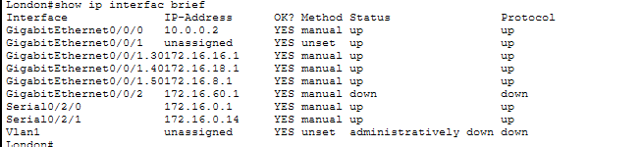
Figure 50<<London router interface brief status>>
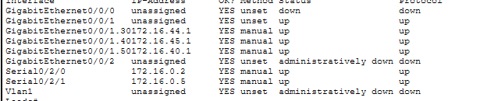
Figure 51<<Leeds router interface brief status>>
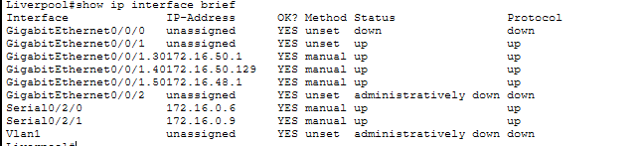
Figure 52<<Liverpool router interface breif status>>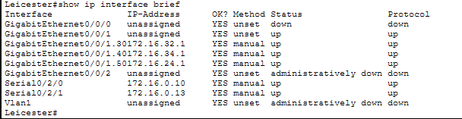
Figure 53<<Leicester router interface status>>

OSPF Testing
OSPF (Open Shortest Path First) is a dynamic routing protocol used to exchange routing information between routers automatically.
It allows routers to determine the best path for data to travel across a network by calculating the shortest and most efficient routes. OSPF is widely used in enterprise networks because it adapts quickly to network changes, improves routing efficiency, and supports large and complex network structures.

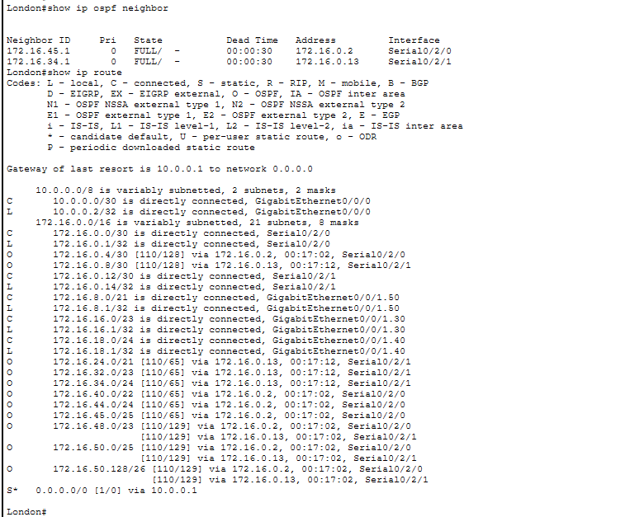
Figure 54<<London router>>
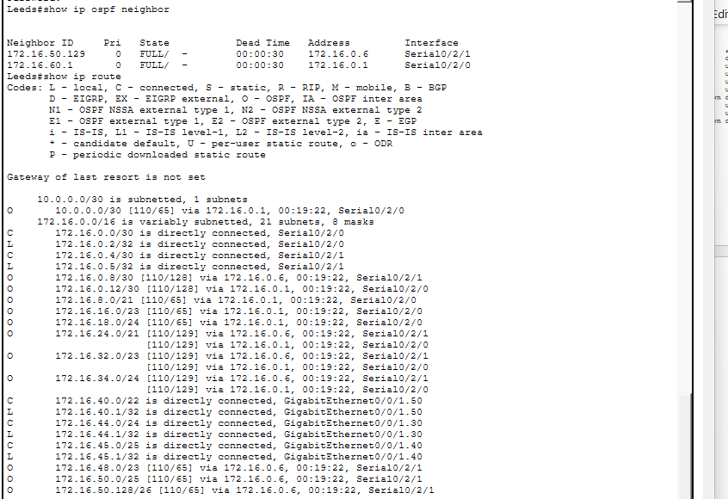
Figure 55<<Leeds router>>
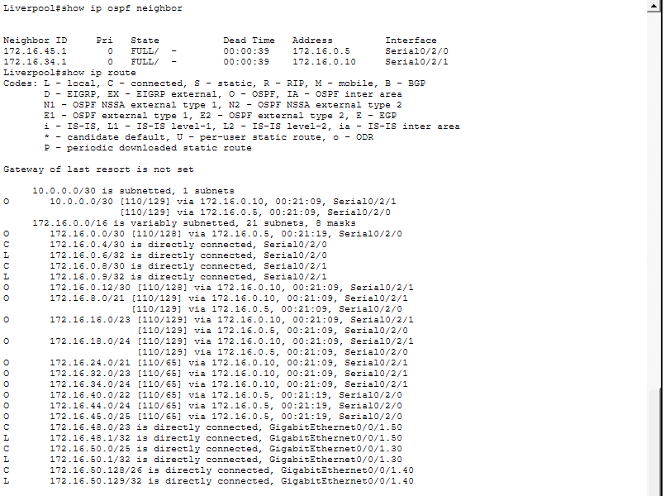
Figure 56<<Liverpool router>>
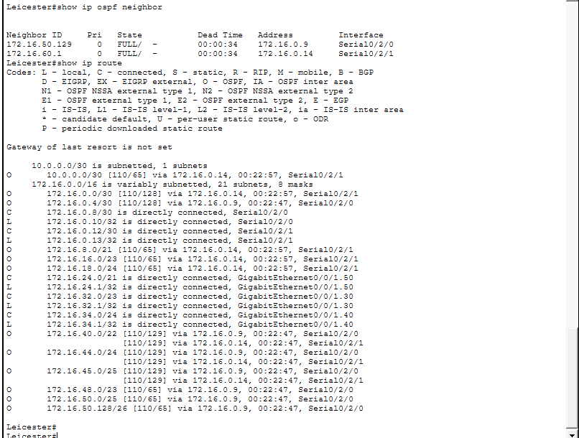
Figure 57<<Leicester router>>

ACL(Access Control List)
An Access Control List (ACL) is a set of rules used to permit or deny network traffic based on defined conditions.
ACLs are used to protect sensitive departments by controlling which devices or users can access specific parts of the network. They also help enforce security policies by ensuring that only authorised traffic is allowed, reducing the risk of unauthorised access.

Gateway testing

Inter-VLAN Routing Testing
Inter-VLAN Routing
Inter-VLAN communication allows devices in different VLANs to communicate with each other through a router.
In this project, the router-on-a-stick method is used. This involves configuring a single physical router interface with multiple subinterfaces, each assigned to a different VLAN. Each subinterface is given an IP address, allowing the router to route traffic between VLANs while keeping them logically separated.

-Finance and Executive Department can Ping to Every department
-Employee Department can only ping to Employee Department
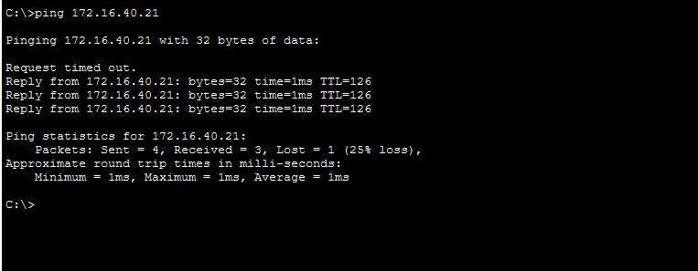
Figure 58<<London Employee to Leeds Employee>>
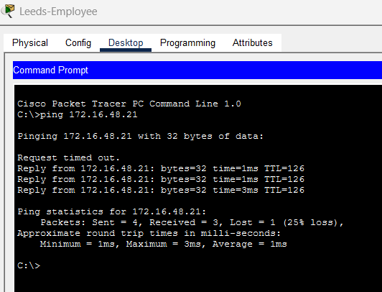
Figure 59<<Leeds Employee to Liverpool Employee>>
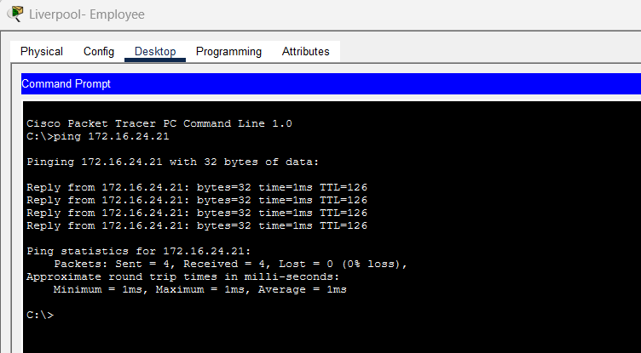
Figure 60<<Liverpool Employee to Leicester Employee>>
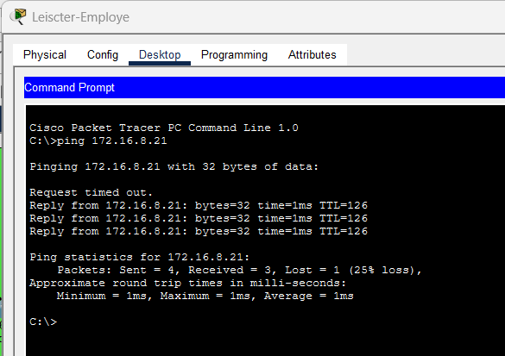
Figure 61<<Leicester Employee to London Employee>>

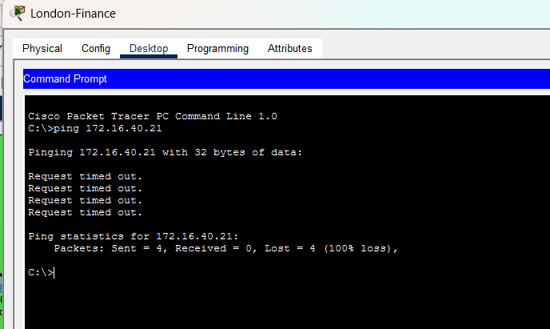
Figure 62<<Failed London Employee to London Finanace>>
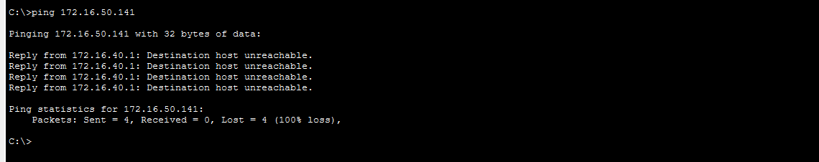
Figure 63<<Failed Leeds Employee to Liverpool Executive>>
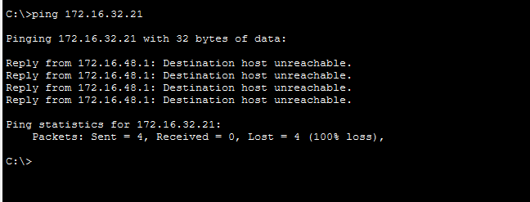
Figure 64<<Failed Liverpool Employee to Leicester Finance>>

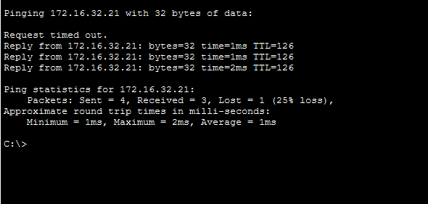
Figure 65<<London Finance to Leicester Finance>>
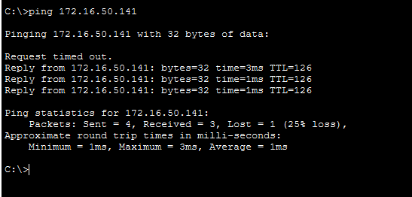
Figure 66<<Leeds Executive to Liverpool Executive>>

Figure 67<<London PC>>
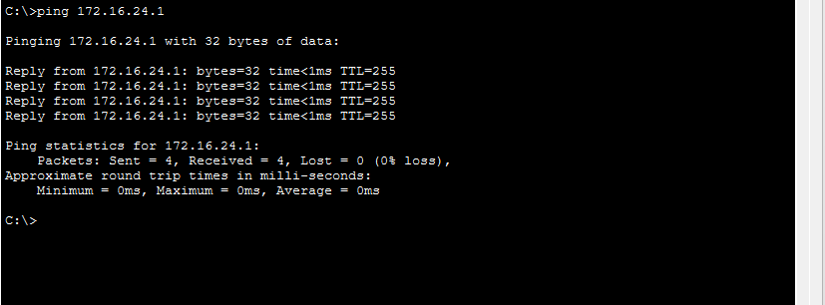
Figure 68<<Leicester Pc>>

ISP testing
-ISP should only provide internet access to London
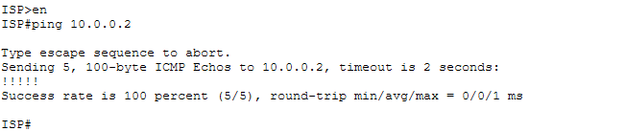
Figure 69<<Successful ISP to London>>
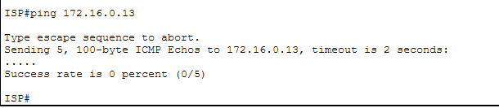
Figure 70<<Failed ISP to Leicester>>
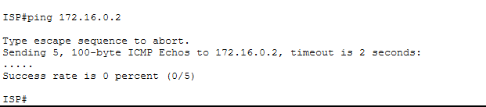
Figure 71<<Failed ISP to Leeds>>
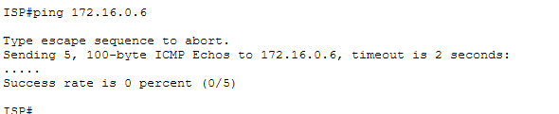
Figure 72<<Failed ISP to Liverpool>>

DMZ Testing
A DMZ (Demilitarised Zone) is a separate network used to host public-facing services, such as servers that need to be accessible from the internet.
In this design, the server is placed in VLAN 60, which isolates it from the internal network. This separation helps protect sensitive internal systems by preventing direct access from external users. Overall, the use of a DMZ improves security by adding an extra layer of protection between the internal network and potential external threats.

-DMZ shouldn’t have access to any devices
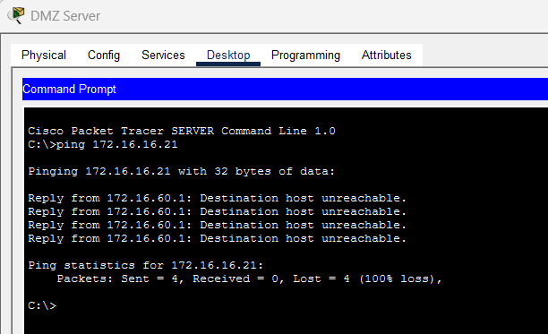
Figure 73<<Failed DMZ to London PC>>
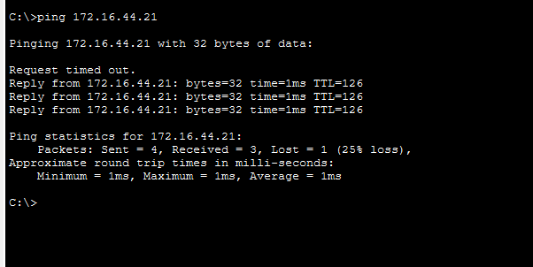
Figure 74<< Failed DMZ to LEEDS PC>>
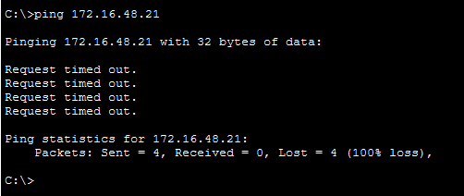
Figure 75<< Failed DMZ to Liverpool PC>>

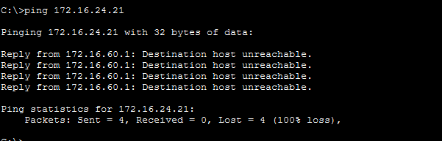
Figure 76<< Failed DMZ to Leicester PC>>

Conclusion
This assignment showcases the design and implementation of a secure, efficient and scalable enterprise network with multiple branches. Through the integration of various networking technologies such as VLANs, inter-VLAN routing, dynamic routing (OSPF), dynamic host configuration protocol (DHCP), ACLs and a DMZ, the network can achieve the required functionality and security. The different departments are logically segmented using VLANs, which minimises broadcast traffic and enhances network management. Inter-VLAN routing is used to enable communication between the departments, enabling data traffic to reach its destination while maintaining security. OSPF is used to ensure efficient and automatic route exchange between all locations, enhancing network performance and flexibility. Furthermore, DHCP streamlines network address allocation by automatically configure network settings. Network security is a key consideration. Access Control Lists (ACLs) are implemented to control employee access to critical departments, allowing only legitimate traffic. Additionally, a demilitarised zone (DMZ) is used to separate the server from the network to further secure it from external attacks. Additionally, internet connectivity is managed through the London location, enabling effective monitoring, control and management of traffic. While simple ACLs are stateless and may restrict certain types of two-way communication, such as ICMP replies, overall this design effectively implements security policies and allows for required communication. Overall, this project serves as a real-world example of enterprise network design, and illustrates the integration of various technologies to achieve a secure and efficient network. The proposed design provides optimal performance, enhanced security and scalability, making it ideal for future expansion and development.

REFERENCE
Cisco Systems (no date) Cisco IOS IP Configuration Guide. Available at: https://www.cisco.com (Accessed: 27 April 2026).
Cisco Systems (no date) Configuring VLANs. Available at: https://www.cisco.com/c/en/us/support/docs/lan-switching/vlan (Accessed: 27 April 2026).
Cisco Systems (no date) Open Shortest Path First (OSPF) Configuration Guide. Available at: https://www.cisco.com/c/en/us/support/docs/ip/open-shortest-path-first-ospf (Accessed: 27 April 2026).
Cisco Systems (no date) Access Control Lists (ACL) Overview. Available at: https://www.cisco.com/c/en/us/support/docs/security/access-control-lists (Accessed: 27 April 2026).
Cisco Systems (no date) Dynamic Host Configuration Protocol (DHCP) Configuration Guide. Available at: https://www.cisco.com/c/en/us/support/docs/ip/dynamic-host-configuration-protocol-dhcp (Accessed: 27 April 2026).
Cisco Networking Academy (no date) Introduction to Networks. Cisco Press.
Cisco Networking Academy (no date) Switching, Routing, and Wireless Essentials. Cisco Press.
Cisco Networking Academy (no date) Enterprise Networking, Security, and Automation. Cisco Press.
Forouzan, B.A. (2017) Data Communications and Networking. 5th edn. New York: McGraw-Hill.
Tanenbaum, A.S. and Wetherall, D.J. (2011) Computer Networks. 5th edn. Pearson.
IETF (1998) RFC 2328: OSPF Version 2. Available at: https://datatracker.ietf.org/doc/html/rfc2328 (Accessed: 27 April 2026).
IETF (1997) RFC 2131: Dynamic Host Configuration Protocol (DHCP). Available at: https://datatracker.ietf.org/doc/html/rfc2131 (Accessed: 27 April 2026).

