: BILLGRACE JAVA PROJECT
- Introduction
1.1 Project Requirements
1.1.1 Functional Requirements
1.1.2 Non-Functional Requirements
1.1.3 Assumptions and Risks
1.2 Usability
1.3 Wireframe Overview
1.3.1 Login / Connection Page
1.3.2 Dashboard / Home Screen
1.3.3 Schema Explorer
1.3.4 Documentation Editor
1.3.5 Collaboration & Export Page
1.4 System Flowcharts
1.4.1 System Overview
1.4.2 Database Connection Flow
1.4.3 Schema Explorer Flow
1.4.4 Documentation Flow
1.4.5 Export & Collaboration Flow
1.5 Use Case Diagram
1.6 Pseudocode
1.6.1 Database Connection Process
1.6.2 Dashboard Overview Process
1.6.3 Schema Explorer Process
1.6.4 Documentation Generation Process
1.6.5 Documentation Editing and Review Process
1.6.6 Export and Collaboration Process
1.6.7 Notifications and Schema Monitoring Process
1.6.8 Global Search and Quick Actions Process
1.7 System Class Diagram
1.8 Navigation Map
1.9 High-Fidelity Prototype Screens
1.9.1 Database Connection Screen
1.9.2 Dashboard Screen
1.9.3 Scheme Explorer Screen
1.9.4 Documentation Editor Screen
1.9.5 Collaboration and Review Screen
2.0 Evaluation
2.1 Conclusion
2.2 References

1.0 Introduction
In software development, databases form the backbone of every application. They store and organize data that supports daily operations, reporting, and decision-making. However, as databases grow and change over time, their documentation often becomes outdated, incomplete, or entirely missing. This creates confusion among developers, data analysts, and database administrators (DBAs), making it difficult to understand relationships, maintain systems, or troubleshoot issues effectively.
The SQL Documentation Assistant (SQL-DA) is designed to solve this challenge by automating the process of creating and maintaining database documentation. The tool connects directly to SQL databases, extracts metadata such as tables, columns, constraints, relationships, and stored procedures, and then automatically generates accurate and up-to-date documentation. This removes the need for manual documentation, reduces human error, and ensures that information remains synchronized with the actual database structure.
Beyond automation, SQL-DA focuses on collaboration and usability. Users can annotate, comment, and approve documentation changes, allowing teams to share knowledge and maintain consistency across projects. Integration with version control systems like Git ensures that documentation evolves alongside schema updates, providing a full history of changes and supporting better governance and traceability.
The system also includes advanced search and navigation features, helping users quickly locate specific database objects or definitions. Optional AI assistance can generate natural-language summaries of stored procedures or suggest documentation improvements, making complex database logic easier to understand.
Overall, the SQL Documentation Assistant aims to simplify database management by combining automation, collaboration, and intelligence in one tool. It ensures that organizations maintain reliable, easily accessible, and continually updated database documentation—reducing effort, improving accuracy, and enhancing teamwork across all roles involved in database development and maintenance.
1.1 Project Requirements
The SQL Documentation Assistant (SQL-DA) is designed to automate, streamline, and centralize the process of generating and maintaining documentation for relational databases. In many software environments, database documentation is created manually, which makes it difficult to keep updated as the schema evolves. This often leads to inconsistencies, errors, and communication gaps between developers, database administrators (DBAs), and analysts. The SQL Documentation Assistant addresses these challenges by automatically extracting metadata from SQL databases and converting it into structured, readable, and collaborative documentation.
The project requirements define the key functionalities, performance expectations, and environmental constraints necessary for successful implementation. They act as a foundation for system design, development, and evaluation.
1.1.1 Functional Requirements.
The functional requirements define the essential actions and capabilities that the SQL Documentation Assistant (SQL-DA) must perform to achieve its objectives. These requirements describe how the system will interact with users, databases, and other tools to provide accurate, real-time, and collaborative documentation. Each requirement ensures that the system remains useful, efficient, and adaptable across different organizational environments.
1. Database Connectivity
The system must allow users to securely connect to multiple SQL databases such as MySQL, PostgreSQL, Oracle, and Microsoft SQL Server.
- Users should be able to input connection details including hostname, port number, database name, username, and password.
- The system must validate these credentials before granting access.
- Only read-only connections should be established to ensure that no unintended modifications occur in the connected databases.
This functionality ensures that SQL-DA can integrate with existing systems without risking data integrity.

2. Metadata Extraction
Once connected, the system must automatically extract structural metadata from the target database.
- This includes information such as tables, columns, data types, constraints (primary and foreign keys), relationships, indexes, and stored procedures.
- The extraction process should be adaptable to different SQL dialects and DBMS structures.
- It must store the extracted metadata in an internal data model for further processing.
This enables the tool to understand the schema and serve as the foundation for documentation generation.

3. Automated Documentation Generation
The system must generate comprehensive and human-readable documentation directly from the extracted metadata.
- Each database object (e.g., table, view, stored procedure) should have a dedicated documentation page containing its attributes, relationships, and dependencies.
- The documentation should include diagrams or visual representations (e.g., Entity Relationship Diagrams) for better clarity.
- The generated documentation should be organized hierarchically (Database → Schema → Table → Column).
This feature automates what is traditionally a time-consuming manual process, ensuring accuracy and consistency.

4. Manual Editing and Annotation
While most documentation is generated automatically, users must have the option to add or modify information manually.
- Users can annotate tables, describe the purpose of columns, and add business definitions.
- Comments and notes should be stored persistently and appear alongside the automatically generated content.
- A change history should track edits for transparency and accountability.
This function allows customization while maintaining system-generated accuracy.

5. Collaboration and Version Control
The system should support multi-user collaboration, allowing teams to work together on maintaining and reviewing documentation.
- Multiple users should be able to comment, suggest edits, and approve or reject changes.
- The system must integrate with version control platforms (e.g., Git) to track changes and maintain documentation history.
- Every modification should be timestamped and linked to the responsible user for traceability.
This requirement ensures teamwork and transparency, making documentation maintenance a shared responsibility.

6. Search and Navigation
The system must include a powerful search engine to help users find specific database objects or terms.
- Users should be able to search by table name, column name, procedure name, or keyword.
- Advanced filtering should allow searches by data type, schema, or relationship.
- A navigation panel should provide structured access to database components, ensuring intuitive exploration.
This feature improves user efficiency and accessibility, particularly in large databases.

7. Export and Reporting
The system must provide the ability to export documentation in various formats such as PDF, HTML, or Markdown, ensuring easy sharing and offline access.
- Exported documents must retain the same structure and formatting as the interactive version.
- Users should be able to include or exclude sections (e.g., tables only, views only) when exporting.
- The system may also support automated report scheduling for periodic exports.
This requirement enables portability and simplifies distribution within teams or organizations.

8. AI-Assisted Summarization and Insights
To enhance understanding, the system may include AI-driven natural language generation to summarize complex SQL logic.
- AI can interpret stored procedures or triggers and describe their purpose in simple language.
- It may also suggest improvements for documentation clarity or completeness.
- AI-generated content must always be editable and reviewed by users before approval.
This feature enhances accessibility for users with limited SQL expertise.

9. Change Detection and Notifications
The system must monitor connected databases for schema changes and notify users when updates occur.
- It should identify added, removed, or altered tables and columns.
- Notifications can be displayed through dashboards or sent via email.
- Users should be prompted to regenerate or update affected documentation.
This ensures that documentation remains continuously synchronized with live databases.

10. User Roles and Access Control
To maintain data integrity and prevent unauthorized edits, the system must include role-based access control.
- Roles such as Administrator, Editor, and Viewer should define different privilege levels.
- Only administrators can manage users and connections.
- Editors can modify documentation, while viewers can only access read-only versions.
This function ensures proper governance, accountability, and security within multi-user environments.

11. Backup and Recovery
The system must maintain regular backups of generated documentation and user-added annotations.
- Backups should include metadata, comments, and version history.
- In case of data loss or corruption, users should be able to restore the latest saved state without re-extraction from the database.
This requirement guarantees data safety and reliability during system operation.

12. Integration with External Tools
The system should support integration with commonly used development and collaboration tools such as SQL Server Management Studio (SSMS), Visual Studio Code, or Jira.
- These integrations allow developers to view or update documentation directly from their working environment.
- APIs or plugins can be developed to facilitate interoperability.
This increases usability and encourages adoption across different teams and workflows.
1.1.2 Non-Functional Requirements
The non-functional requirements specify how the SQL Documentation Assistant (SQL-DA) should perform and the quality standards it must meet.
While functional requirements describe the system’s behavior and features, non-functional requirements define the overall attributes that ensure the system is efficient, reliable, secure, and user-friendly. These requirements are essential for maintaining long-term stability, scalability, and usability of the system.

1. Performance
The system must deliver high performance to maintain user productivity and minimize waiting times.
- Documentation generation for small to medium-sized databases (up to 500 tables) should complete within 10 seconds.
- Search operations should return results in less than 2 seconds under normal conditions.
- The system should handle concurrent user sessions efficiently without degradation in response time.
Consistent performance will ensure the tool remains practical for both individual users and collaborative environments.

2. Usability
SQL-DA must provide a user-centered interface that is intuitive and simple to navigate.
- The layout, color scheme, and iconography should follow consistent design standards.
- Tooltips, error messages, and confirmation prompts must be clear and informative.
- Users with minimal database knowledge should still be able to connect, generate, and explore documentation with minimal training.
A focus on usability ensures that the system is accessible to developers, DBAs, and non-technical stakeholders alike.

3. Reliability
Reliability ensures that the system consistently performs its intended functions without failures or data loss.
- All documentation generated must accurately reflect the latest database schema.
- The system should perform automatic backups of metadata, annotations, and user edits at regular intervals.
- In case of errors (e.g., failed connections or export failures), the system must recover gracefully and preserve user data.
This requirement guarantees stable performance and user trust during day-to-day operations.

4. Security
Because the system connects directly to live databases, security is a critical concern.
- All communication between SQL-DA and the database should be encrypted using SSL/TLS protocols.
- User credentials and configuration data must be stored securely using encryption or tokenization methods.
- The system must enforce role-based access control, restricting permissions for viewing, editing, or approving documentation.
- Audit logs must record user activities for accountability and compliance.
Implementing strong security measures protects sensitive data and maintains organizational integrity.

5. Scalability
The architecture of SQL-DA should support scaling as the number of users or databases increases.
- It should efficiently handle multiple database connections simultaneously.
- The design should allow future extensions to additional database engines, such as NoSQL or cloud-native services.
- Performance should remain stable as data volume and user load grow.
Scalability ensures that the tool remains viable for both small teams and enterprise-level deployments.

6. Maintainability
SQL-DA must be designed with modularity and maintainability in mind.
- Each component (e.g., extraction module, UI, AI summarization) should be independent to allow isolated updates.
- Source code should be well-documented and adhere to standard naming conventions.
- Configuration and deployment procedures must be simple and clearly explained.
This facilitates future maintenance, bug fixes, and feature enhancements with minimal system disruption.

7. Compatibility
The system should maintain broad compatibility with common platforms and database technologies.
- SQL-DA must operate on Windows, macOS, and Linux environments.
- It should integrate with major relational database systems such as MySQL, PostgreSQL, SQL Server, Oracle, and Azure SQL through standard drivers or connectors.
- It should also integrate with development tools such as SQL Server Management Studio (SSMS), Visual Studio Code, and cloud environments where applicable.
Compatibility broadens adoption and allows seamless integration into existing workflows.

8. Availability
SQL-DA should remain available and responsive whenever users require access.
- The system should achieve 99% uptime during normal operating periods.
- Built-in recovery procedures must restore services quickly after failures or downtime.
- The system should support multiple users accessing the platform simultaneously without interruptions.
High availability guarantees continuous access and dependable performance in production environments.

9. Accuracy
Accuracy ensures that the documentation reflects the true structure and logic of the connected databases.
- The metadata extraction process must capture all database elements precisely without omissions.
- Relationships and constraints must be documented correctly.
- Any AI-generated summaries or insights must be verified and editable by users to maintain correctness.
Accurate documentation is critical for analysis, debugging, and long-term data governance.

10. Portability
SQL-DA should be easily deployable across different environments.
- The application should support installation both as a web-based platform and as a stand-alone desktop client.
- It should not depend on a single programming language or server technology.
- Data and settings should be exportable, allowing users to migrate the system to other environments if needed.
Portability ensures that organizations can adapt the tool to different infrastructures without compatibility issues.
1.1.3 Assumptions and Risks
The design and operation of the SQL Documentation Assistant (SQL-DA) are based on several key assumptions. It is assumed that all target databases are accessible through secure network connections and that users have valid read-only credentials to retrieve metadata without altering live data. The databases are expected to follow standard relational structures and be compatible with common database drivers such as those for Microsoft SQL Server, Azure SQL, MySQL, and PostgreSQL. The system also assumes a stable network environment, adequate hardware resources, and that users possess basic SQL knowledge. Additionally, it is presumed that organizations implementing SQL-DA will use a version control system, such as Git, to support documentation versioning and collaboration.
However, several risks may affect the project’s performance and reliability. Potential risks include database connection failures due to network issues or incorrect credentials, as well as security threats such as unauthorized access or data leakage. Schema parsing errors may occur if databases use non-standard structures, while AI-generated summaries could produce inaccurate information. Performance degradation is also possible when processing large databases, and concurrent user edits could lead to version conflicts. Other risks include data loss, integration failures with third-party tools, and low user adoption due to unfamiliarity. These risks can be mitigated through robust error handling, encryption, validation, automatic backups, version control, and user training.
In summary, identifying these assumptions and risks ensures that appropriate mitigation strategies are established, allowing SQL-DA to operate securely, efficiently, and reliably within diverse database environments.
1.2 Usability
The SQL Documentation Assistant (SQL-DA) is designed with a strong emphasis on usability to ensure that users can interact with the system efficiently, regardless of their technical background. Since the tool will be used by developers, database administrators, and analysts, it must provide a simple, intuitive, and responsive interface that facilitates quick access to essential features such as database connection, documentation generation, and collaboration.
The system interface will follow a user-centered design approach, focusing on clarity, consistency, and minimal complexity. Upon logging in, users will be greeted by a dashboard displaying recent activities, connected databases, and quick actions for generating or updating documentation. Clear navigation menus and icons will guide users through different sections such as database overview, schema explorer, and documentation editor. Tooltips and visual cues will assist users in understanding the purpose of various buttons and controls without requiring extensive training.
Usability is further enhanced through collaborative features that allow multiple users to comment, edit, and review documentation simultaneously. Each change is tracked with timestamps and user identifiers, ensuring transparency and accountability. The inclusion of role-based access control ensures that users can only perform actions permitted by their designated roles, thereby preventing accidental modifications.
Accessibility is another key aspect of usability. The interface will be designed to accommodate users with different preferences and needs, including options for dark and light modes, adjustable text sizes, and responsive layouts for different screen resolutions. Real-time feedback messages, such as “connection successful,” “documentation updated,” or “export completed,” will help users stay informed about system operations and reduce confusion.
To ensure a seamless workflow, SQL-DA will integrate with common database tools like SQL Server Management Studio (SSMS) and Visual Studio Code, enabling users to access or update documentation directly from their development environments. The system will also provide export options in formats such as PDF, HTML, and Markdown, allowing users to easily share or archive generated documentation.
Overall, the usability of SQL-DA focuses on creating an efficient, consistent, and user-friendly experience. By minimizing complexity, providing clear visual structure, and supporting collaboration, the system ensures that users can manage and maintain database documentation with minimal effort and maximum productivity.

1.3 Wireframe Overview
1.3.1 Login / Connection Page
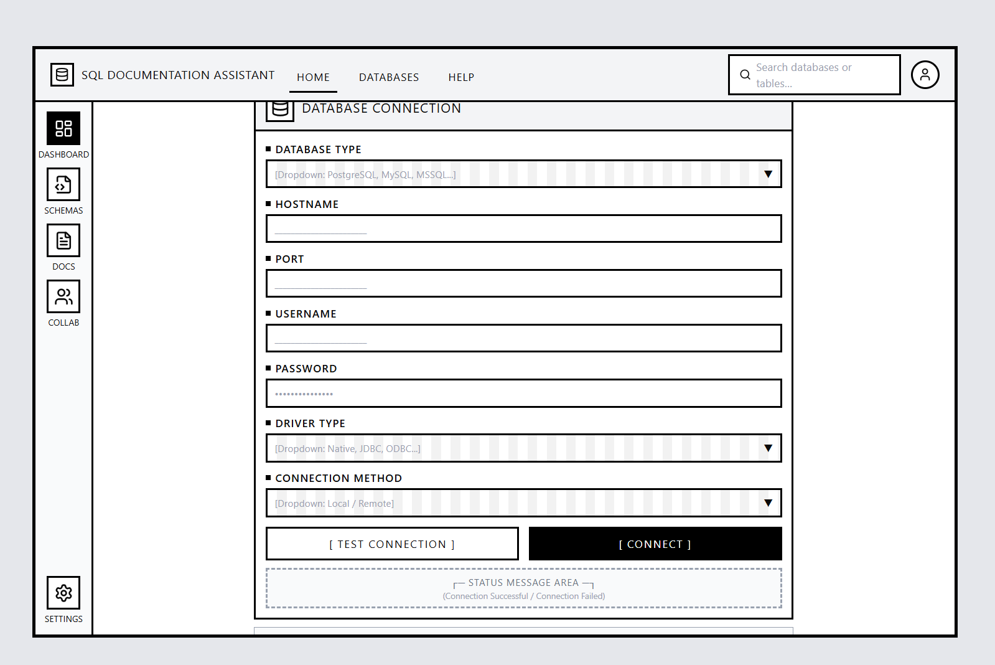

The Login or Database Connection page is the first interface users see upon launching the SQL Documentation Assistant (SQL-DA). It allows users to securely connect to their SQL databases by entering essential connection details such as the database type (MySQL, SQL Server, PostgreSQL, etc.), hostname, port number, username, and password. The page also includes dropdown menus to select the database driver and connection method (local or remote).
A “Connect” button initiates the connection, and a “Test Connection” feature enables users to verify the details before establishing a session. Connection status messages appear below the form, informing users whether the connection was successful or failed. This page ensures a smooth and secure start to the workflow, guiding users with clear labels and error feedback
1.3.2 Dashboard / Home Screen
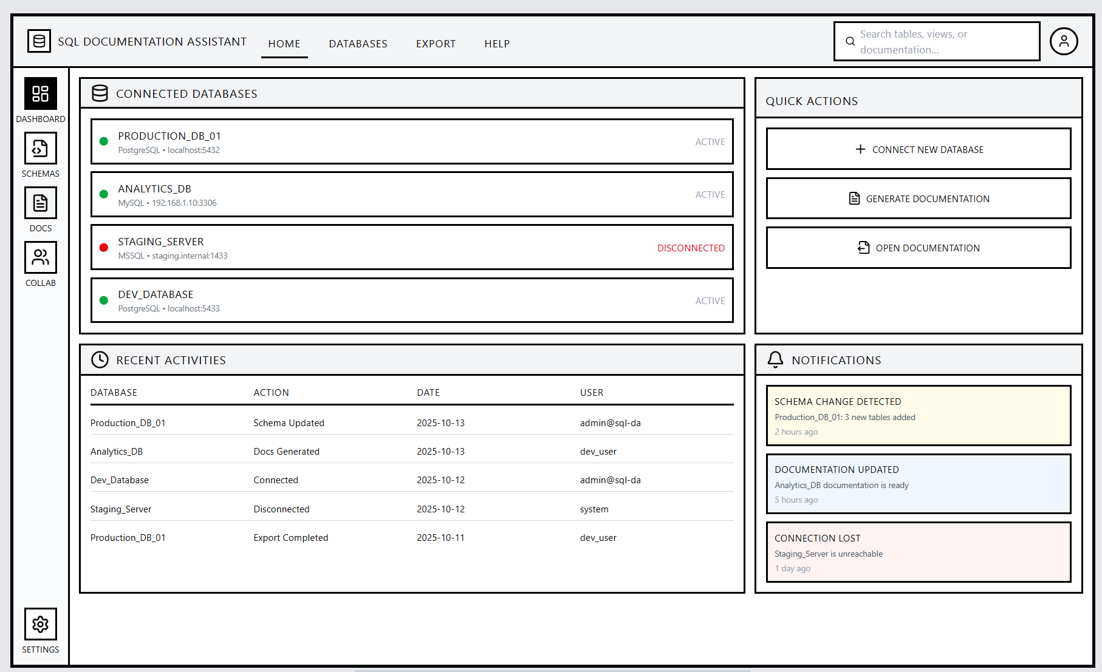
The Dashboard acts as the main hub, summarizing connected databases, recent activities, and quick actions. A consistent top bar and sidebar navigation enable smooth transitions between modules like Schemas and Documentation. Key panels display active connections, activity logs, and shortcuts for connecting new databases or generating documentation, while a notifications section highlights important system updates.
1.3.3 Schema Explorer Screen
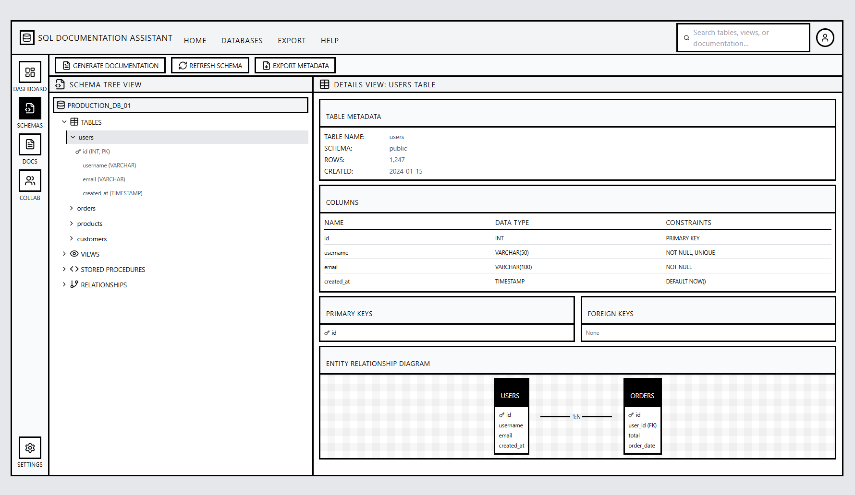
The Schema Explorer is a core feature of the SQL Documentation Assistant (SQL-DA), allowing users to easily view and navigate the structure of their connected databases. After a successful connection, it displays a hierarchical tree view of database objects such as tables, views, stored procedures, and relationships.
The layout keeps the familiar top navigation bar and left sidebar for consistency. The main content area is split into two panels — the left panel shows a collapsible list of database elements, and the right panel displays detailed information about the selected item, including columns, data types, primary and foreign keys, and relationships.
A small toolbar provides quick actions like Generate Documentation, Refresh Schema, and Export Metadata. This interface gives users a clear, organized view of their database without needing to write SQL queries, making schema exploration simple and efficient.
1.3.4 Documentation Editor Screen
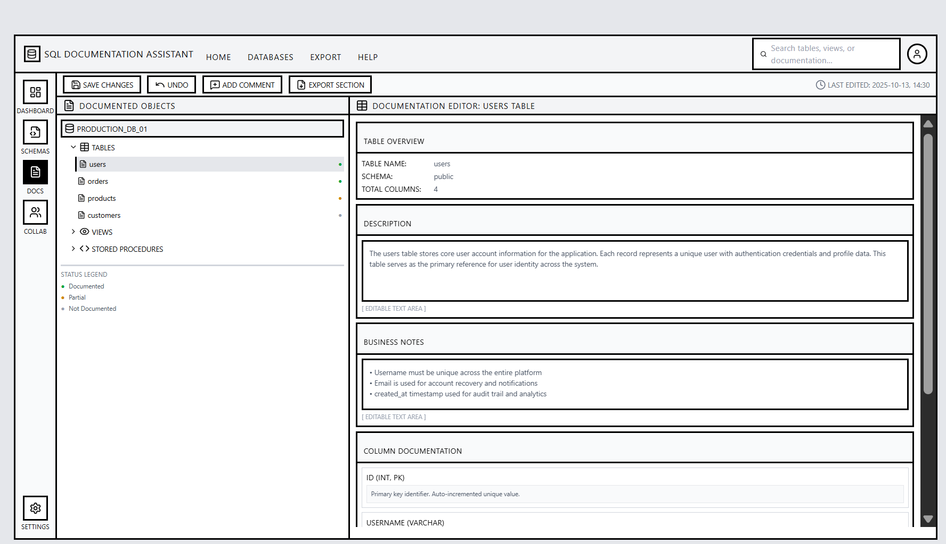
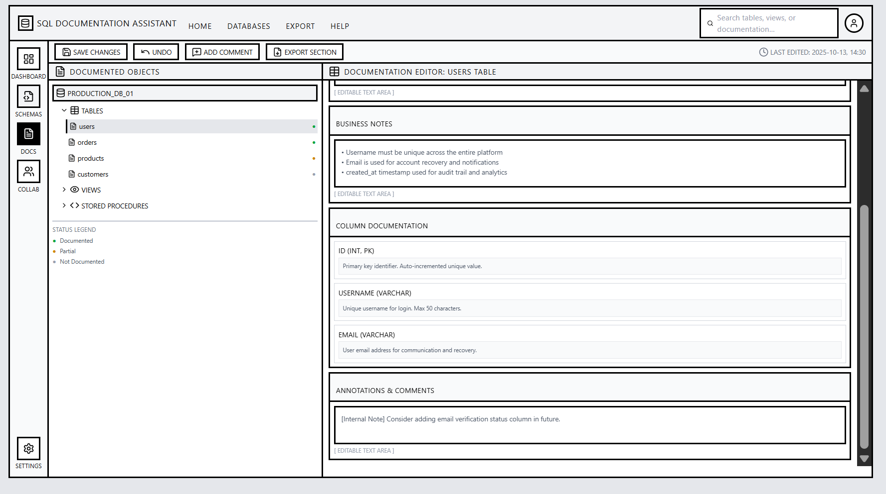

The Documentation Editor screen allows users to view, edit, and manage the generated database documentation. After metadata extraction, the documentation for each table, column, and relationship is displayed in an organized, readable format.
The interface maintains the same layout structure, with the top navigation bar and sidebar for consistency. The main area is divided into two sections — on the left, a navigation panel lists all documented database objects, and on the right, the selected item’s documentation appears in detail. Users can add or edit descriptions, business notes, and annotations directly from this panel.
A toolbar above the editor provides quick actions such as Save Changes, Undo, Add Comment, and Export Section. A version history feature allows users to review or revert previous edits, supporting collaboration and accountability.
Overall, the Documentation Editor is designed for simplicity and clarity, giving teams a centralized space to create, refine, and maintain up-to-date database documentation.
1.3.5 Export & Collaboration Page
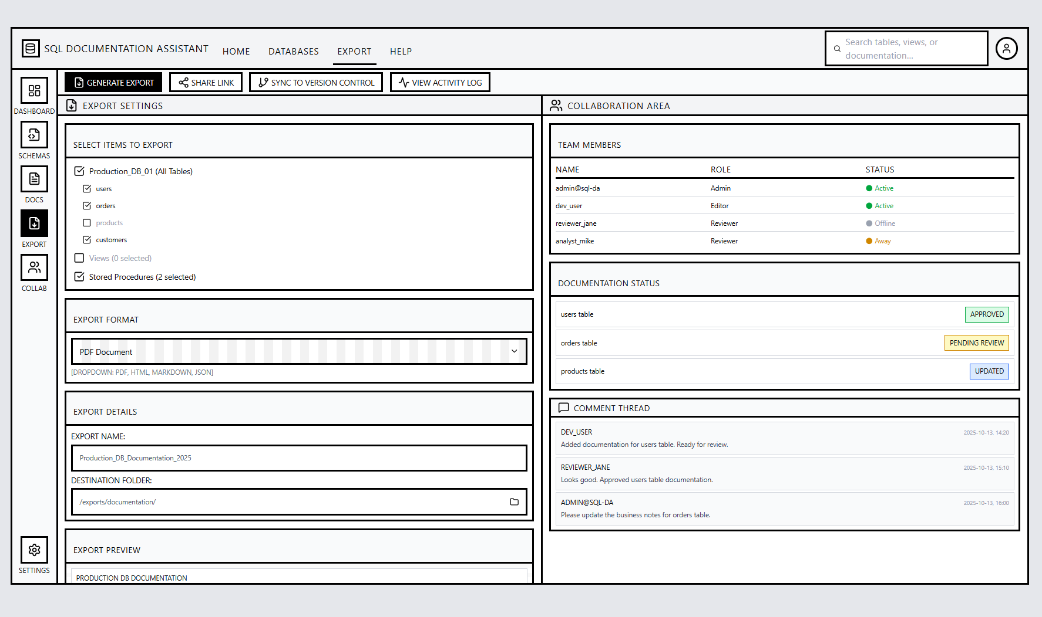
The Export & Collaboration Page provides tools for generating, sharing, and managing database documentation across teams. Unlike the Documentation Editor, which focuses on creating content, this page is dedicated to distribution and teamwork.
The interface keeps the top navigation bar and sidebar but introduces a two-column layout. The left section focuses on export settings, where users can select databases or modules to export and choose output formats such as PDF, HTML, or Markdown. The right section functions as a Collaboration Panel, displaying team members, their roles, and pending review tasks.
A toolbar along the top offers quick actions like Generate Export, Share Link, and Sync to Version Control. Notifications appear for approvals or feedback. This screen emphasizes coordination and smooth documentation delivery, ensuring that all collaborators have access to the most recent and approved database documentation.
1.4 System Flowcharts
1.4.1 System Overview Flowchart
The Figure 1.4.1: SQL Documentation Assistant – System Overview Flowchart illustrates the complete workflow of the SQL Documentation Assistant (SQL-DA). It visually represents the key processes of the system, beginning with user authentication and database connection, followed by metadata extraction, schema exploration, documentation generation, and collaboration.
The diagram demonstrates how user actions and system operations interact to automate the creation and management of SQL documentation efficiently. This overview serves as the foundation for understanding the detailed processes shown in the subsequent flowcharts.

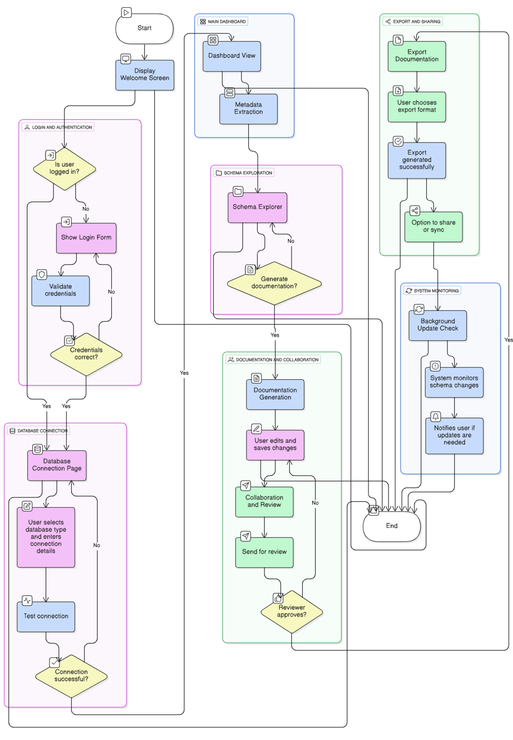
Figure 1.4.1: SQL Documentation Assistant – System Overview Flowchart
1.4.2 Database Connection Process Flowchart
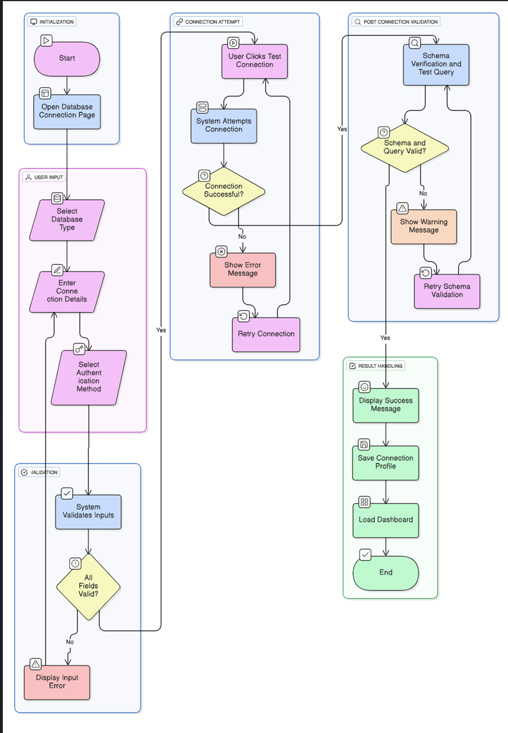
Description:
The database connection process in the SQL Documentation Assistant (SQL-DA) allows users to securely link the application to different SQL database systems. The flowchart above represents the logical sequence of actions from launching the connection module to establishing a verified database link.
Users begin by opening the connection interface, selecting their database type (such as MySQL, SQL Server, or PostgreSQL), and entering credentials including host, port, username, and password. The system validates the provided inputs and performs a test connection using the appropriate database driver.
If the connection is successful, the system saves the connection profile and transitions the user to the main dashboard. In the event of invalid credentials or network issues, an error message is displayed, allowing users to retry or modify connection parameters. This process ensures secure, efficient, and reliable database connectivity within the application.
1.4.3 Schema Explorer Flowchart
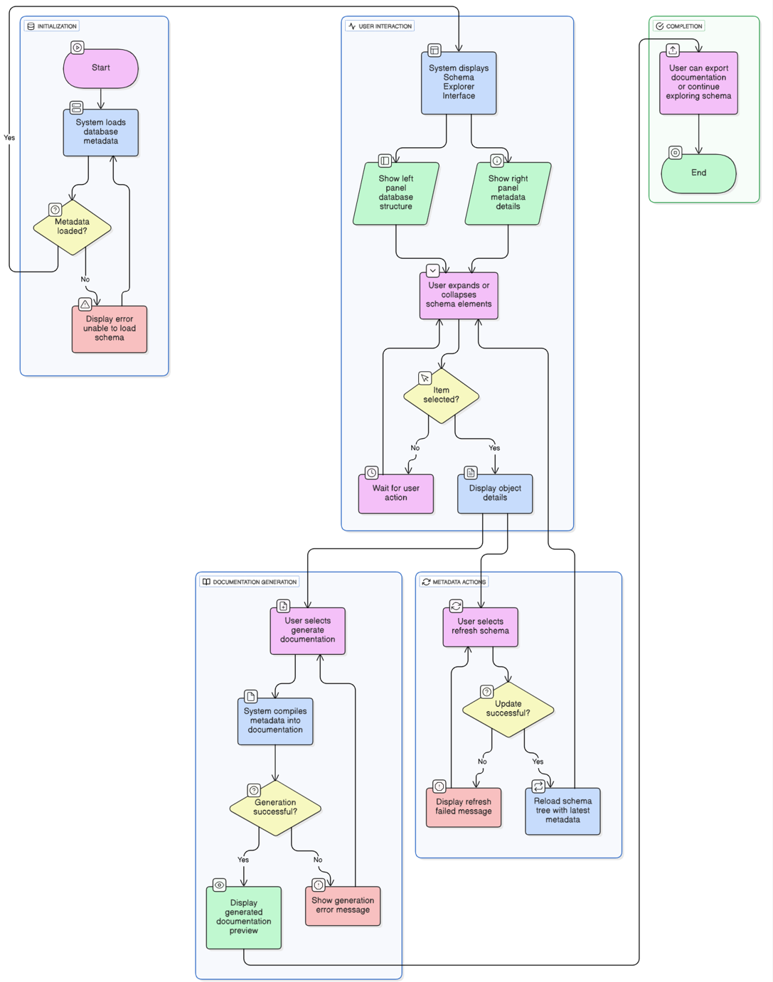

Figure 1.4.3: Schema Explorer Flowchart – SQL Documentation Assistant (SQL-DA)
Description:
The Schema Explorer Flowchart illustrates the process users follow after successfully connecting to a database within the SQL Documentation Assistant (SQL-DA). Once a connection is established, the system automatically retrieves and loads metadata, including tables, views, stored procedures, and relationships. If the metadata fails to load, the system attempts up to three retries before displaying an error message and allowing the user to return to the dashboard.
After a successful load, the Schema Explorer interface displays a structured, collapsible tree view of the database schema on the left and detailed metadata for the selected object on the right. Users can browse, expand, or refresh schema elements and initiate documentation generation directly from the interface.
The process also reflects basic role distinctions — Database Administrators can refresh and generate documentation, while Technical Writers or Viewers can only explore and view metadata. This ensures clarity, access control, and smooth exploration within the SQL-DA environment.
1.4.4 Documentation Generation Flowchart
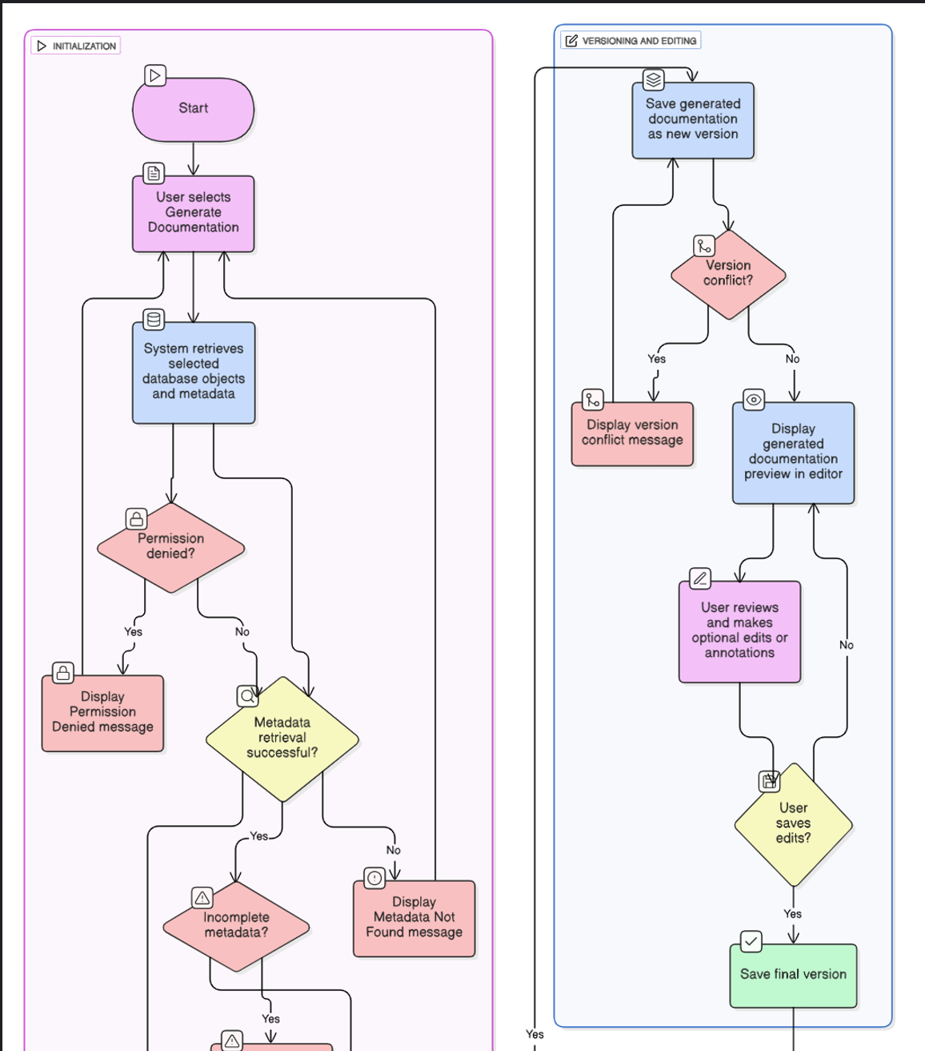
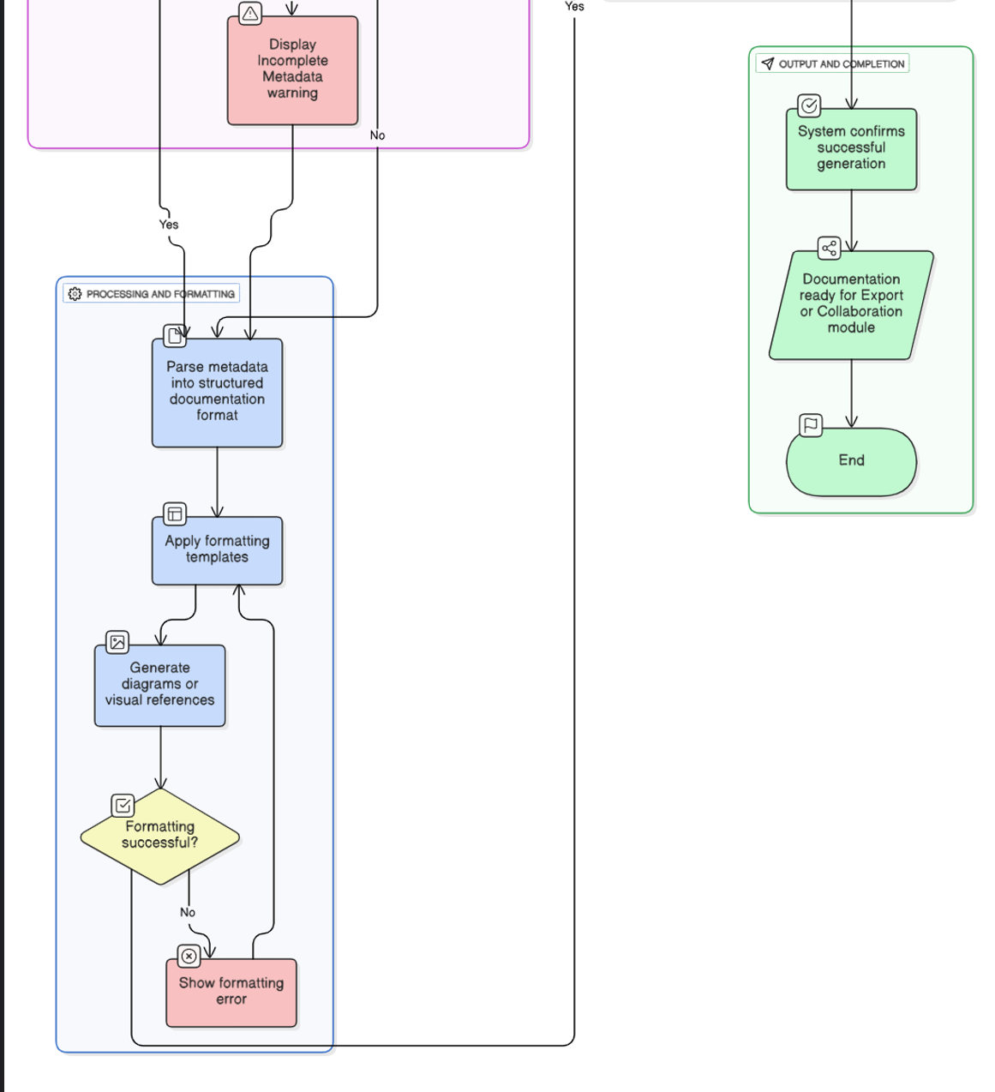
Figure 1.4.4: Documentation Generation Flowchart – SQL Documentation Assistant (SQL-DA)
Description:
The Documentation Generation Flowchart illustrates how SQL Documentation Assistant (SQL-DA) converts extracted database metadata into structured, readable documentation. The process begins when the user selects the “Generate Documentation” option in the Schema Explorer. The system retrieves the chosen database objects and validates the availability of metadata before proceeding.
Once the metadata is successfully retrieved, the system parses and formats it into a predefined documentation structure. This includes tables, field descriptions, data types, and relationships, with optional ER diagrams for visual representation. Any formatting or processing errors prompt retry options, ensuring accuracy and consistency.
After successful generation, the documentation is versioned automatically and presented in the built-in editor, allowing users to review and refine content. The finalized version becomes available for export or collaboration. This process ensures that documentation is accurate, well-structured, and ready for distribution or review within the SQL-DA environment.
1.4.5 Export & Collaboration Flowchart
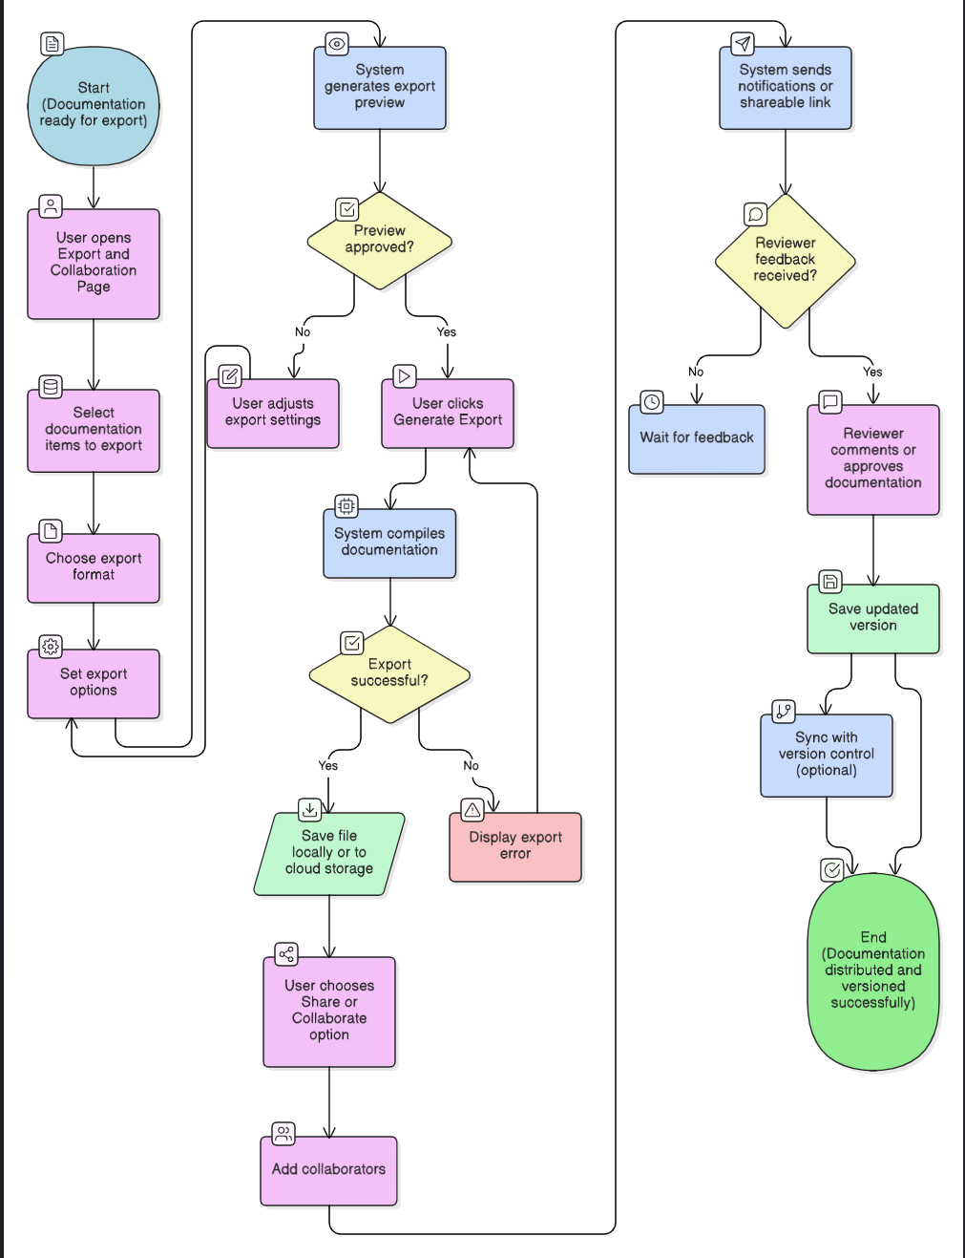
Figure 1.4.5: Export & Collaboration Flowchart – SQL Documentation Assistant (SQL-DA)
Description:
The Export & Collaboration Flowchart illustrates the final phase of the SQL Documentation Assistant (SQL-DA) workflow, where users share and distribute generated documentation. The process begins when a user accesses the Export & Collaboration page to select specific documentation items and preferred output formats, such as PDF, HTML, or Markdown. Users can adjust configuration settings, including file naming, header preferences, and the inclusion of selected database objects.
Once settings are confirmed, the system generates a preview before final export. If the export fails due to permission or configuration errors, retry options are available. After a successful export, users can initiate collaboration by sharing the file with team members or reviewers. The collaboration module allows adding comments, approving content, and maintaining version history. Each revision is automatically versioned and can be synchronized with external version control systems.
This structured process ensures that SQL-DA supports efficient documentation sharing, review, and team coordination, maintaining accuracy and traceability throughout the export lifecycle.
1.5 Use Case Diagram
The Use Case Diagram provides a high-level visualization of how different user roles interact with the SQL Documentation Assistant (SQL-DA). It outlines the major features and user goals defined in the previous sections, including database connectivity, schema management, AI-assisted documentation, collaboration, and export processes.
This diagram also distinguishes the responsibilities of each actor — Database Administrators handle connection and schema operations, Technical Writers focus on documentation generation and editing, Reviewers manage feedback and approval, and Viewers access documentation in read-only mode. It further shows SQL-DA’s integration with external systems such as Database Engines, AI Services, Version Control Systems, and Notification Platforms, ensuring seamless automation and teamwork.

1.5 Use Case Diagram
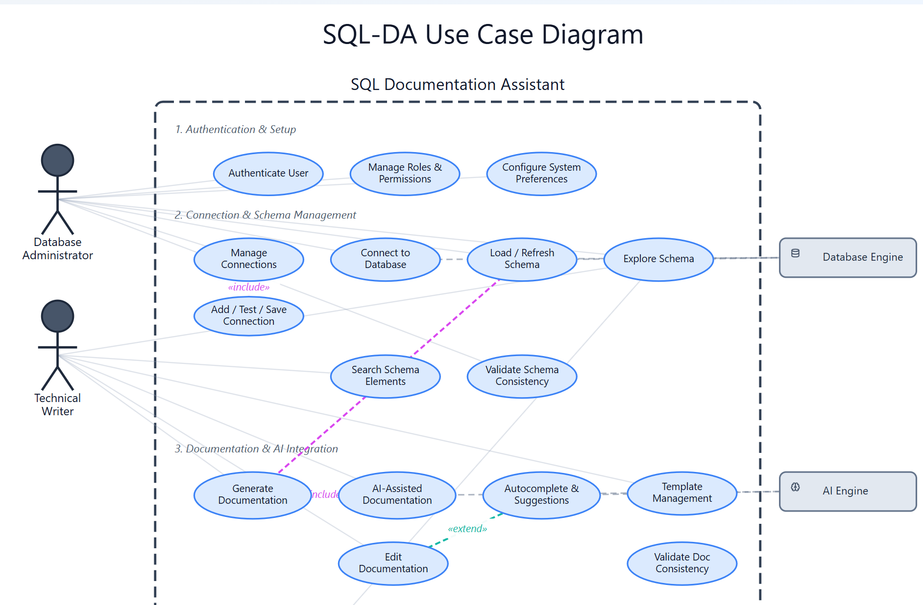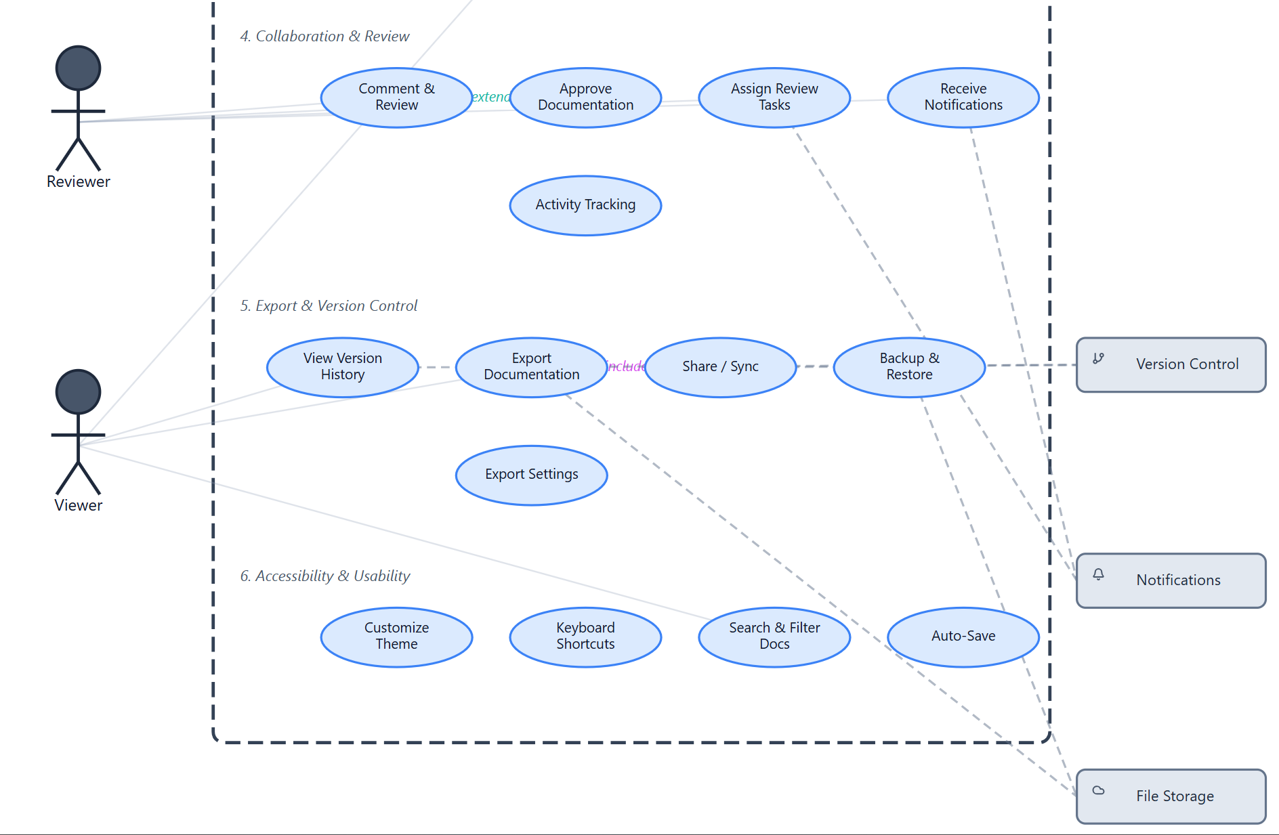
Brief Use Case List
- Manage Connections (Actor: DBA) – Add, test, and save database connection profiles securely.
- Connect to Database (Actor: DBA) – Establish a verified connection to a selected database.
- Load/Refresh Schema (Actor: DBA) – Retrieve current metadata for documentation, including tables, views, and relationships.
- Explore Schema (Actors: DBA, Writer, Viewer) – Visually browse and inspect schema elements.
- Search Schema Elements (All Roles) – Quickly locate database objects or documentation sections.
- Generate Documentation (Actors: DBA, Writer) – Create structured documentation from schema metadata.
- AI-Assisted Documentation (Actors: Writer, Reviewer) – Automatically generate content and descriptions using AI.
- Autocomplete & Smart Suggestions (Actor: Writer) – Get real-time AI suggestions for consistent documentation formatting.
- Edit Documentation (Actor: Writer) – Modify content, add notes, and update metadata.
- Comment & Review (Actors: Writer, Reviewer) – Collaborate on content through inline comments.
- Approve Documentation (Actor: Reviewer) – Provide final sign-off for documentation publication.\
- Export Documentation (Actors: DBA, Writer, Viewer) – Export to multiple formats (PDF, HTML, Markdown, JSON).
- Share/Sync (Actors: DBA, Writer) – Sync documentation to Git or Azure DevOps repositories.
- View Version History (All Roles) – Review and compare past document versions.
- Receive Notifications (All Roles) – Get alerts for schema updates, review tasks, and export completion.
- Manage User Roles & Permissions (Actor: DBA) – Control user privileges within the system.
- Template Management (Actor: Writer) – Save and reuse custom documentation templates.

1.6 Pseudocode
This section presents simplified pseudocode describing the logical flow of the main functions within the SQL Documentation Assistant (SQL-DA).
Each pseudocode outlines the sequence of user and system activities based on the wireframes, flowcharts, and use case diagrams developed earlier.
The purpose is to explain the logical process clearly, without focusing on programming syntax or code structure.

1.6.1 Database Connection Process
Objective:
To establish a secure connection between the user and a selected database.
Pseudocode:
START
Display the Database Connection screen.
User selects database type (MySQL, MSSQL, PostgreSQL, etc.).
User enters hostname, port, username, password, and driver details.

IF user clicks "Test Connection" THEN
System attempts to connect to the database.
IF connection is successful THEN
Display message "Connection Successful".
ELSE
Display message "Connection Failed. Please check details."
ENDIF
ENDIF

IF user clicks "Connect" THEN
System validates all required inputs.
IF inputs are valid THEN
Establish connection with the database.
Display message "Connection Established Successfully".
Redirect user to the Dashboard.
ELSE
Display message "Missing or Invalid Details".
ENDIF
ENDIF
END

1.6.2 Dashboard Overview Process
Objective:
To display an overview of the connected databases, recent activities, and quick actions.
Pseudocode:
START
Load the Dashboard after successful login or database connection.
Display connected databases and their current status.
Display recent activities and system notifications.

Provide Quick Action buttons:
- Connect New Database
- Generate Documentation
- Open Documentation

IF user selects a quick action THEN
Redirect to the corresponding module.
ENDIF
END

1.6.3 Schema Explorer Process
Objective:
To allow users to browse and understand the database structure.
Pseudocode:
START
Load the Schema Explorer screen.
System retrieves and displays the database schema in a tree structure.

User can expand or collapse items such as tables, views, or procedures.

IF user selects an item THEN
Display details including columns, data types, keys, and relationships.
ENDIF

IF user clicks "Refresh Schema" THEN
System reloads the latest schema information.
Update the display with new schema details.
ENDIF
END

1.6.4 Documentation Generation Process
Objective:
To automatically generate structured documentation based on the database schema.
Pseudocode:
START
User selects "Generate Documentation".
System retrieves the schema metadata.

System generates documentation sections for:
- Tables
- Views
- Relationships
- Stored Procedures
- Triggers and Indexes (if selected)

IF AI assistance is enabled THEN
System automatically adds field descriptions and summaries.
ENDIF

Display the generated documentation preview to the user.
END

1.6.5 Documentation Editing and Review Process
Objective:
To enable users and reviewers to edit, comment, and approve documentation.
Pseudocode:
START
Display generated documentation in an editable interface.
User adds notes, edits content, or includes comments.

IF user clicks "Save Changes" THEN
System saves updates and creates a new version.
ENDIF

IF user clicks "Send for Review" THEN
Notify assigned reviewers with a document link.
Update status to "Pending Review".
ENDIF

Reviewer opens document and reviews content.
IF reviewer approves THEN
Update status to "Approved".
Lock current version.
ELSE
Reviewer adds comments and requests changes.
ENDIF
END

1.6.6 Export and Collaboration Process
Objective:
To allow users to export documentation in multiple formats and collaborate with others.
Pseudocode:
START
User opens the Export and Collaboration page.
User selects desired export format (PDF, HTML, Markdown, or JSON).
User customizes export settings (headers, sections, file name).

System generates export file and shows a preview.

IF user clicks "Share Link" THEN
System generates a shareable link.
Notify collaborators with the access link.
ENDIF

IF user clicks "Sync to Version Control" THEN
System uploads the documentation to the selected repository.
Display message "Sync Completed Successfully".
ENDIF
END

1.6.7 Notifications and Schema Monitoring Process
Objective:
To notify users about schema updates, completed exports, and review statuses.
Pseudocode:
START
Background process runs at scheduled intervals.

IF database schema changes are detected THEN
Create an alert and notify relevant users.
ENDIF

IF a document review or export is completed THEN
Send notification to all involved users.
ENDIF
END

1.6.8 Global Search and Quick Actions Process
Objective:
To provide users with quick access to key features and information.
Pseudocode:
START
User enters keyword in the global search bar.
System searches across:
- Database schema elements
- Documentation titles and sections

Display matching results.

IF user selects a result THEN
Redirect user to the relevant page or section.
ENDIF

Quick Action buttons provide instant navigation to:
- Connect Database
- Generate Documentation
- Open Documentation
END
1.7 System Class Diagram
The System Class Diagram provides a structural overview of the core components in SQLDA and how they interact. It represents the major classes involved in database connection, schema extraction, documentation management, collaboration, and AI-driven suggestions.
The diagram defines the main system entities such as Connection Manager, Schema Service, Documentation Service, Export Service, and AI Assistant, along with data models like Db Config, Table, Column, Document, and User.
Crow’s-feet notation is used to illustrate key relationships, showing how database tables contain columns, relationships exist between tables, and documents are versioned and linked to table/column notes.
This structure ensures separation of responsibilities and supports scalability. Each component focuses on a specific function:
- Connection Layer manages database credentials and connection profiles.
- Schema Layer fetches and stores database structure metadata.
- Documentation Layer enables documentation creation, editing, and approval workflows.
- Collaboration Layer manages users and version control.
- Export & AI Layer handles exporting documentation and generating intelligent suggestions.
Overall, the class diagram demonstrates a modular, extensible system architecture that supports SQLDA’s core goals: accurate database insight, structured documentation, collaboration, and automation.
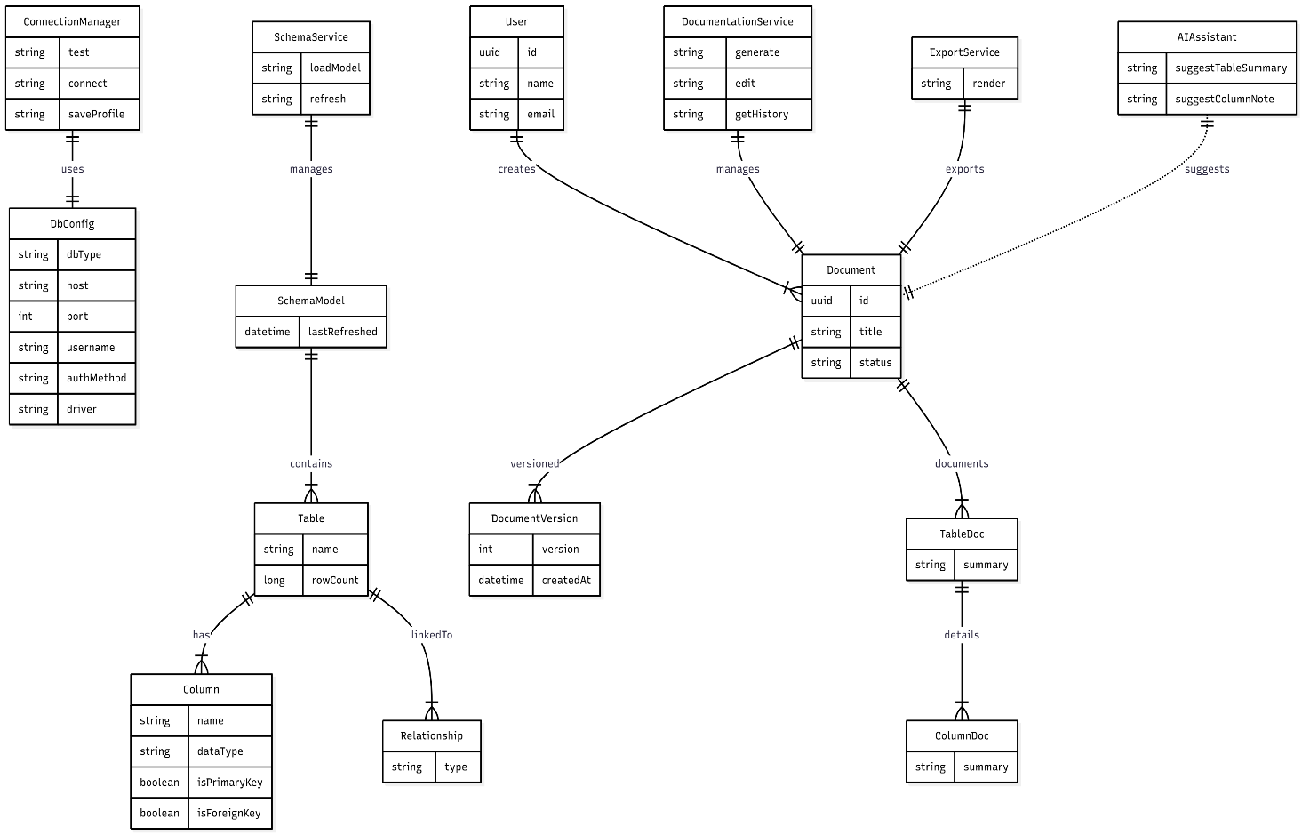

1.8 Navigation Map
The navigation map illustrates the overall structure and primary movement paths within the SQL Documentation Assistant (SQLDA). After successfully connecting to a database, users land on the Dashboard, which serves as the central access point to all major system modules, including the Schema Explorer, Documentation workspace, Collaboration and Review hub, Export Center, and Settings.
Navigation follows a modular and role-based design, ensuring users can quickly access tools relevant to their responsibilities. Database administrators primarily use the connection and export interfaces, technical writers focus on documenting schemas and editing descriptive fields, and reviewers use the collaboration area to approve changes before publication. A guest or read-only user may only view output or approved documentation.
The navigation map highlights the core workflow of the application — exploring database schema, generating and refining documentation with AI assistance, requesting review and approval, and finally exporting documentation once approved. While the platform supports backward navigation and error recovery, the map intentionally focuses on the primary flow to maintain clarity and readability. Conditional transitions are also shown, such as documentation moving to the collaboration module only after a review request, and export functionality becoming available once approval is granted.
This structure ensures that SQLDA is intuitive to use, supports logical task progression, and maintains a consistent experience across user roles.

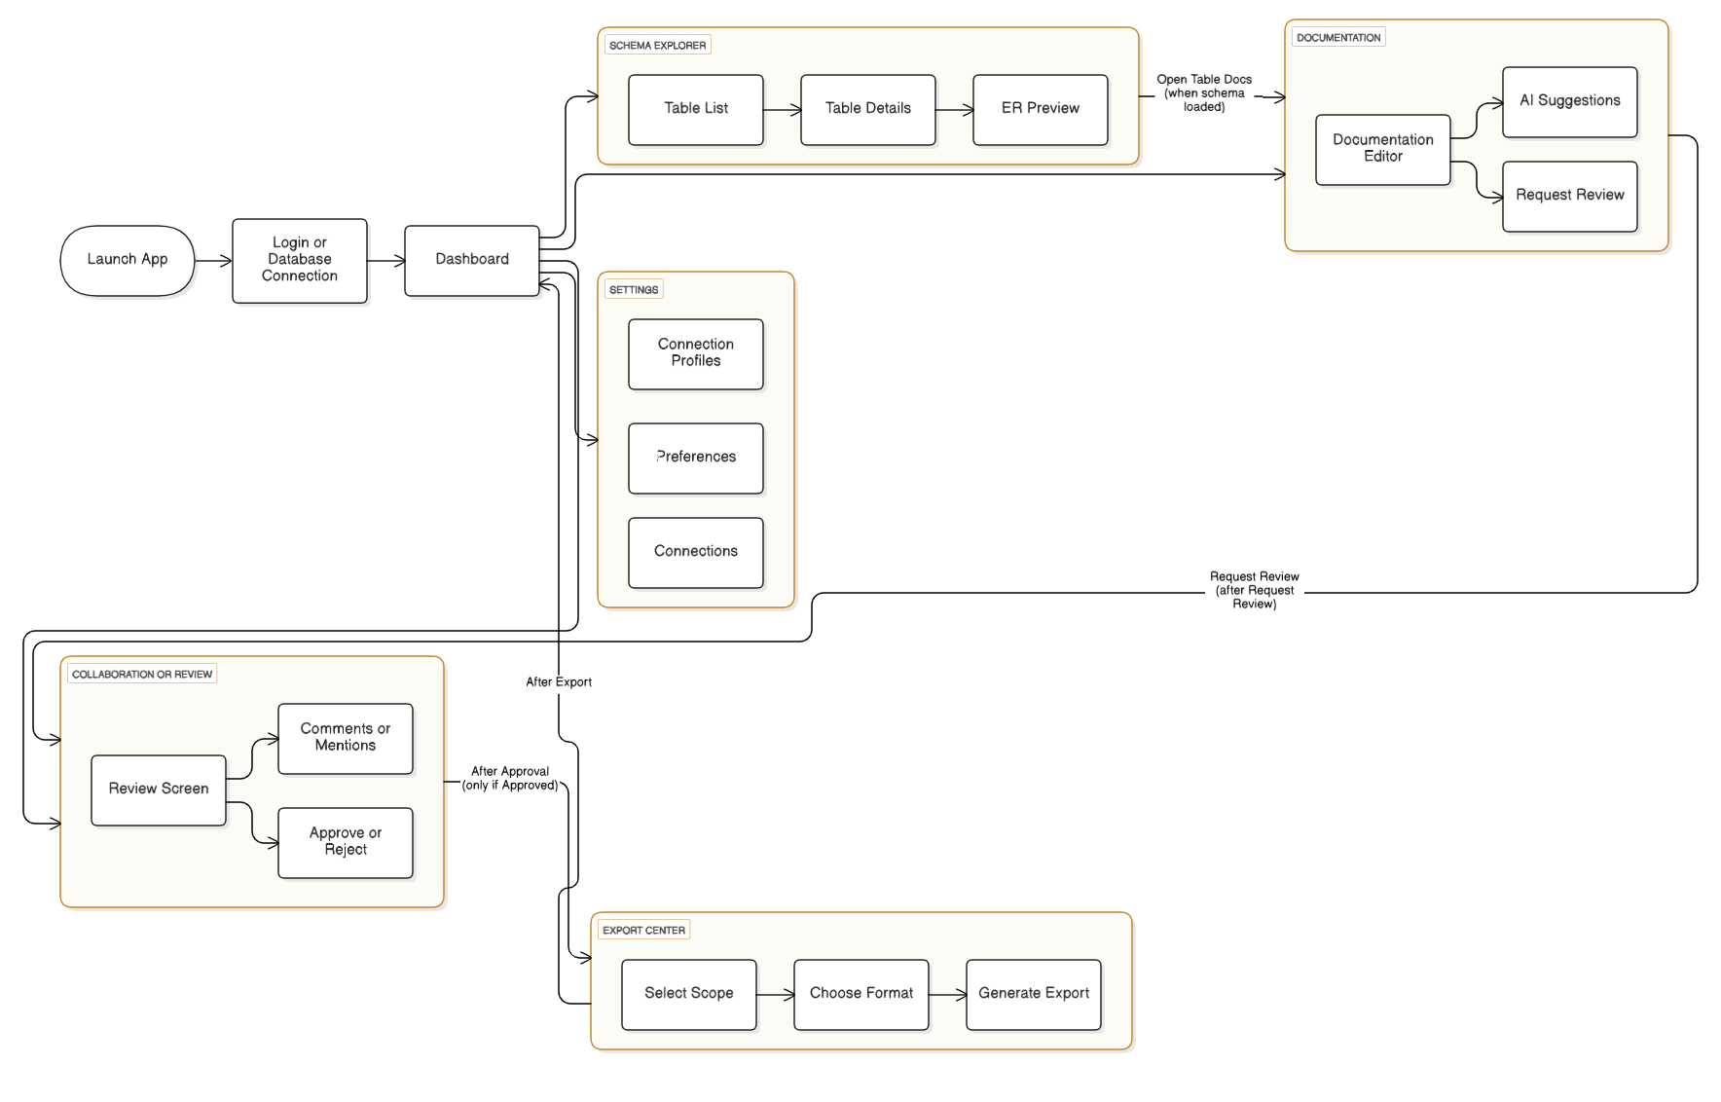

1.9 High-Fidelity Prototype Screens
This section shows how the SQL Documentation Assistant (SQLDA) would look in its final form. The prototype turns the earlier wireframes and ideas into real interface designs. The goal is to make the system easy to use, modern, and professional while keeping all main features visible and simple to access.

1.9.1 Database Connection Screen
The Database Connection Screen is the first step of using SQLDA. It lets users connect to their database by entering connection details such as the database type, hostname, port number, username, and authentication method.
The design uses a clean dark theme with well-organized sections and clear labels. Main actions like Connect, Test Connection, and Save Profile are easy to find.
A small database visualization on the right adds a modern touch to the interface while keeping it simple and functional.
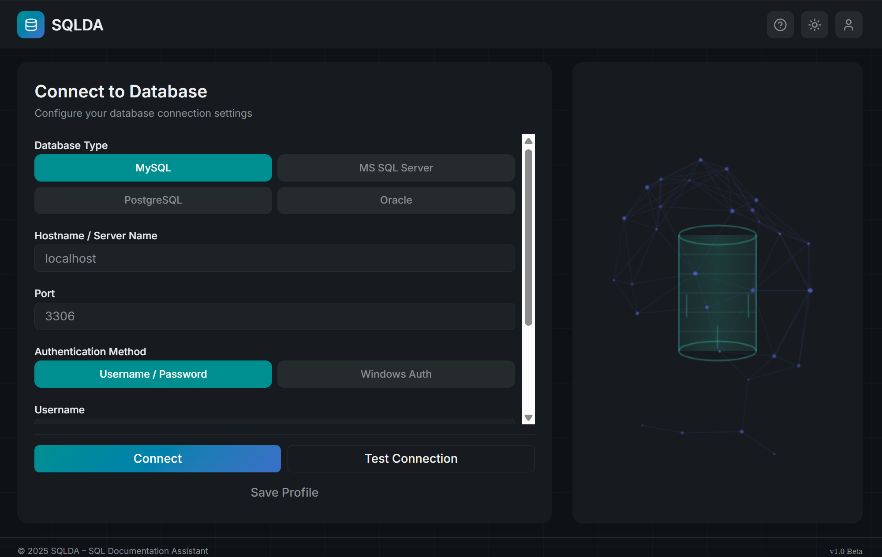
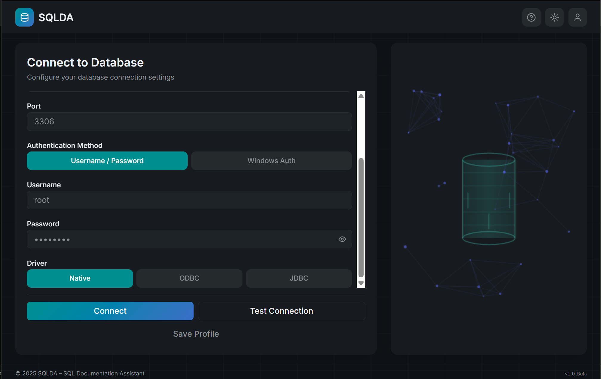
1.9.2 Dashboard Screen
The Dashboard is the main page of SQLDA where users can see an overview of their work and access important tools. It shows all connected databases, recent documentation activities, and quick actions such as opening the Schema Explorer or generating documentation. The layout is clean and well-organized, helping users find what they need easily.
A sidebar on the left allows quick navigation between modules like Dashboard, Schemas, Documentation, Collaboration, and Settings. The top bar includes a global search bar, profile icon, and notification options.
The design focuses on a modern and professional look, ensuring that users can manage and monitor their databases efficiently.
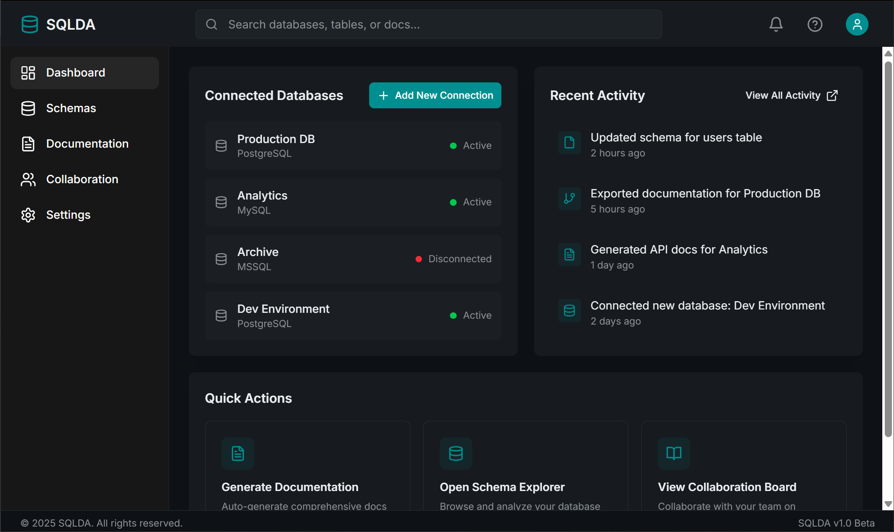
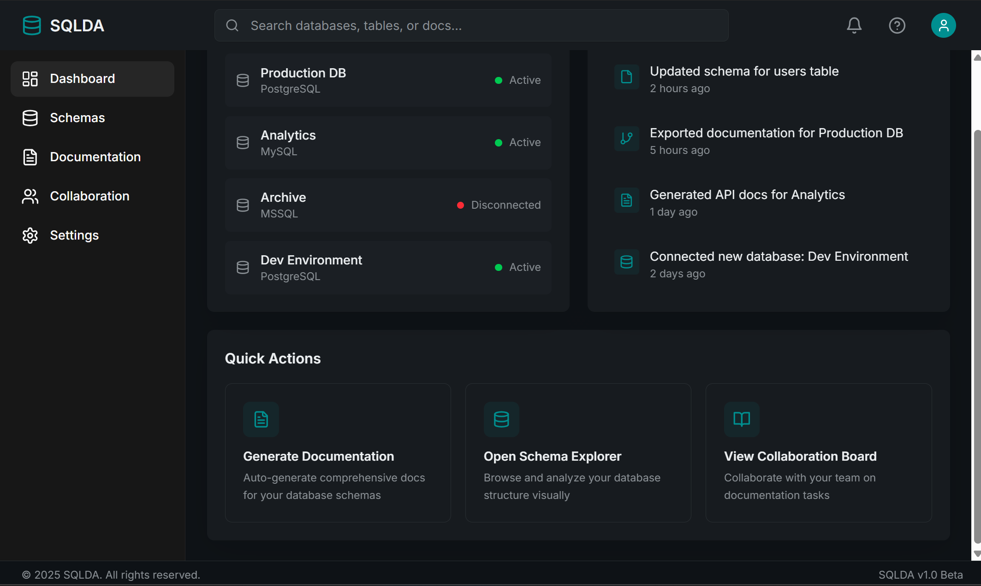

1.9.3 Schema Explorer Screen
The Schema Explorer Screen allows users to browse and understand the structure of the connected database.
It displays database objects such as tables, views, stored procedures, functions, and triggers in a well-organized side panel.
When a table (e.g., Customers) is selected, the system shows key information including row count, creation date, last modified date, and relationship insights. The ER Diagram Preview visually represents table relationships, helping users quickly understand data connections and dependencies.
This interface is designed for clarity and efficiency, supporting smooth navigation and fast access to metadata.
Modern visual elements and a dark UI theme ensure a clean and professional look aligned with SQLDA’s overall identity.

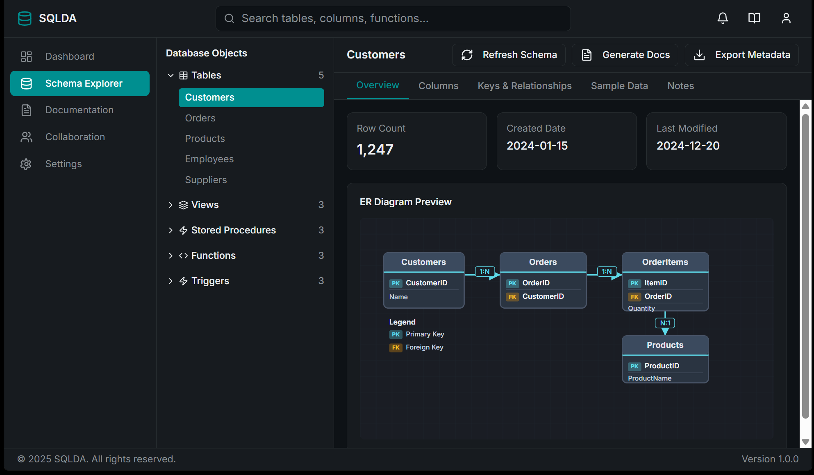
1.9.4 Documentation Editor Screen
The Documentation Editor Screen enables users to create and maintain clear, structured descriptions for database tables and columns. This interface is designed to improve database understanding and knowledge sharing across technical and non-technical team members.
The left panel lists all database objects, allowing users to select a table (e.g., Customers) for documentation. The main work area displays editable fields for table and column descriptions, along with metadata such as key indicators, data types, and table statistics. Users can update information directly in the interface, helping ensure accuracy and completeness.
An integrated AI assistant provides suggestions for documentation, streamlining the process and supporting users who may not fully understand the database structure. The screen also includes collaboration features such as comments, assigned reviewers, and documentation status indicators (e.g., Draft, In Review, Approved), ensuring controlled and transparent updates.
Overall, the Documentation Editor is a key feature in SQLDA, supporting consistent, detailed, and high-quality database documentation by combining user input, AI-generated suggestions, and team review workflows.

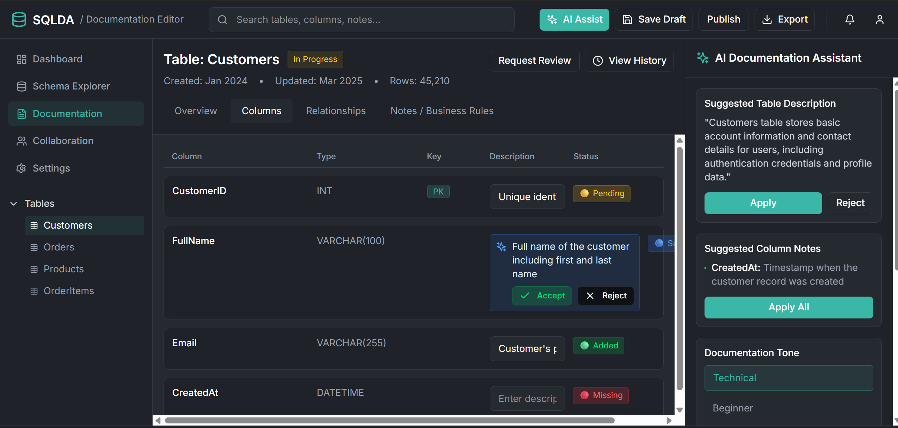
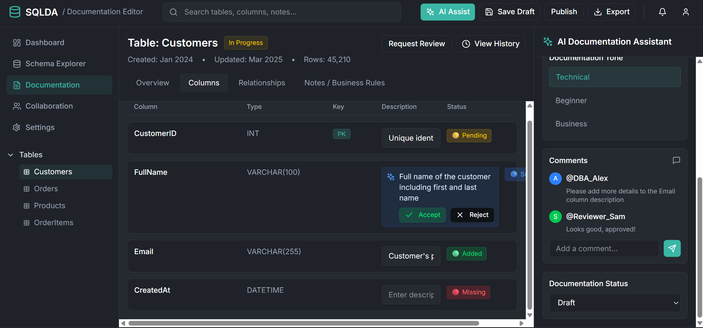

1.9.5 Collaboration & Review Screen
The Collaboration & Review Screen supports teamwork and quality control within SQLDA by allowing multiple users to review, comment on, and approve documentation. This screen ensures that database knowledge is accurate, peer-checked, and aligned with organisational standards before publication.
The left navigation menu remains consistent with other screens, allowing users to switch between modules easily. The main content area displays documentation review features, including a comment thread where users can leave feedback, tag team members, and attach notes for clarification. Status indicators such as Draft, In Review, and Approved provide visibility into the documentation lifecycle, ensuring that all changes undergo a structured approval process.
A right-side activity panel shows an audit-style timeline of updates, such as documentation edits, reviews requested, comments added, and approvals completed. This creates transparency and accountability throughout the documentation process. Users can also compare previous and current versions of documentation and request reviewer approval directly from this screen.
Overall, the Collaboration & Review Screen strengthens teamwork and governance by combining comments, version history, and workflow approval mechanisms within one interface.
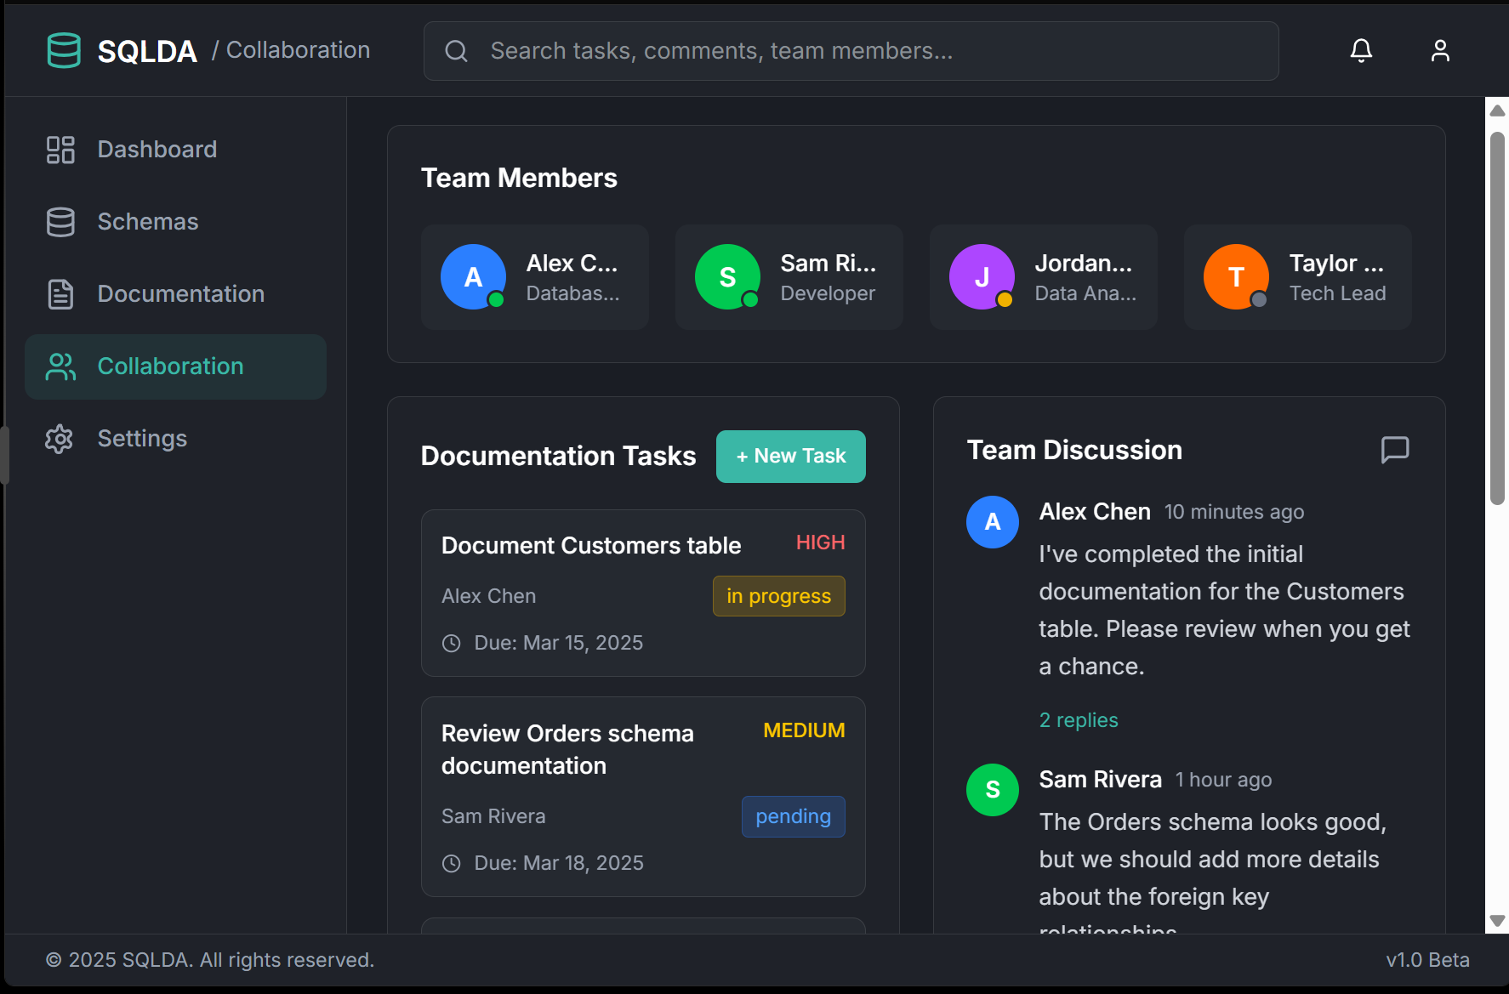
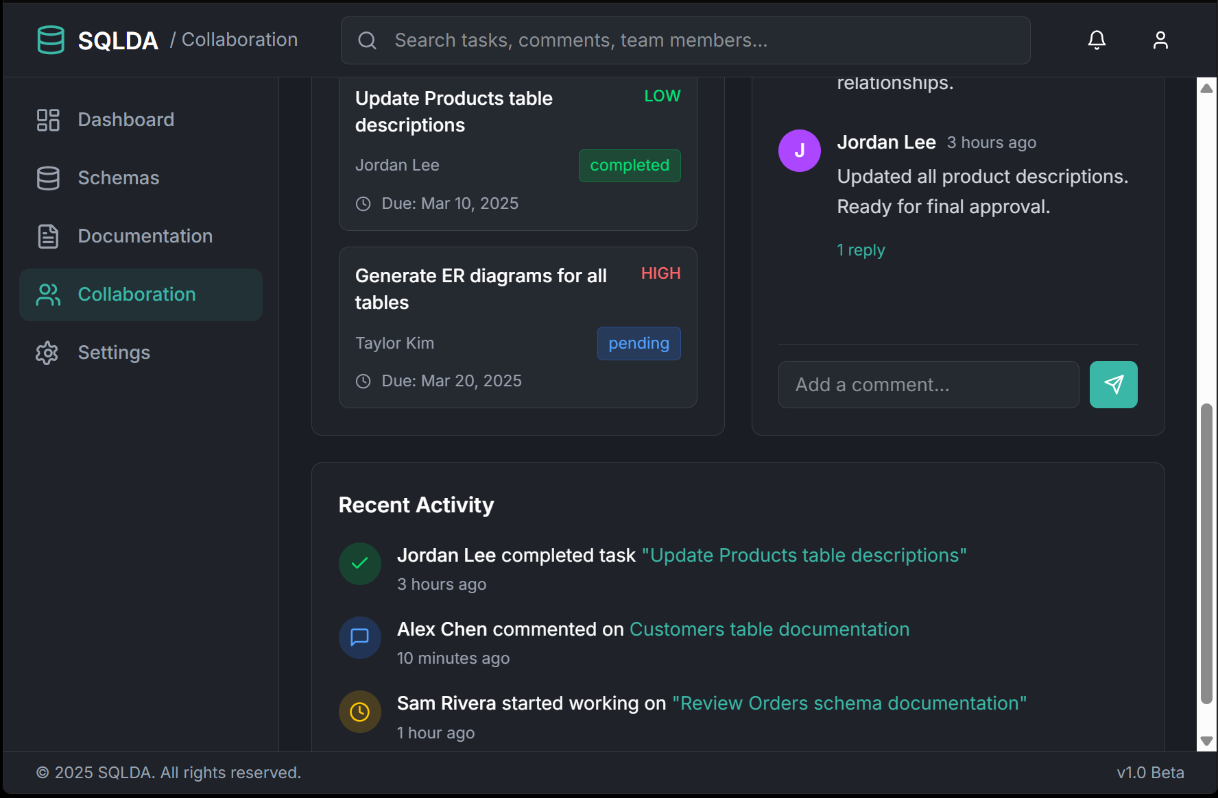

2.0 Evaluation
The SQL Documentation Assistant (SQLDA) was designed with usability, efficiency, and scalability as core priorities. Throughout the development process, each design component — from wireframes to the high-fidelity prototype — was evaluated against the original requirements to ensure the concept provides genuine value to end-users.
First, usability was assessed by analyzing interface clarity, navigation flow, and cognitive load. The system uses a clean dashboard, persistent sidebar navigation, and logical grouping of features, enabling database administrators, technical writers, and reviewers to locate functions quickly without unnecessary complexity. The step-by-step workflow for schema exploration, documentation editing, review, and export encourages intuitive task progression and reduces learning time for new users.
The prototype also demonstrates task efficiency improvements over manual documentation workflows. Features such as automatic schema extraction, ER diagram previews, AI-assisted text generation, and structured approval flows reduce the effort required to produce and maintain accurate database documentation. Navigation paths confirm that users can move between related tasks in one or two steps, supporting fast, uninterrupted workflows.
From a scalability and maintainability perspective, the modular architecture supports integration with additional database engines and documentation standards in future development. Components such as schema processing, AI suggestions, collaboration, and export logic are designed to remain independent, allowing iterative upgrades without system disruption.
Although the design meets the brief requirements, user testing would further validate performance and usability in practice. Future evaluation activities may include interactive usability tests, feedback collection from DBAs and technical writers, and iterative refinement based on behaviour analysis and user preference patterns.
Overall, SQLDA demonstrates strong alignment with its objectives, offering a structured, intuitive, and modern solution for improving SQL documentation workflows.

2.1 Conclusion
The SQL Documentation Assistant (SQLDA) addresses the widely recognised challenges of documenting and maintaining SQL databases. Traditional manual approaches are time-consuming, inconsistent, and prone to misinformation. SQLDA offers a streamlined alternative by combining automated schema extraction, intelligent content assistance, collaboration features, and export tools into a unified interface.
The completed design successfully achieves project goals by providing a role-based workflow, simple navigation structure, consistent UI patterns, and modular architecture. Key features — including schema browsing, documentation editing with AI support, review management, and export options — position SQLDA as a practical and modern tool for development and data teams.
While this phase focused on conceptualisation and prototyping, the system provides a strong foundation for future implementation. Potential enhancements include real-time collaborative editing, native Git integration, custom database drivers, and machine-learning-based term recognition to generate advanced technical descriptions.
In summary, SQLDA represents a scalable and forward-thinking solution to SQL documentation challenges. With continued development, testing, and refinement, it has the potential to evolve into a useful professional tool for database administrators, engineers, and technical writers.
2.2 References
Ambler, S.W., 2003. Agile database techniques: Effective strategies for the agile software developer. Indianapolis: Wiley Publishing.
Oracle, 2024. Database concepts documentation. [online] Available at: https://docs.oracle.com [Accessed 24 October 2025].
Microsoft, 2024. SQL Server documentation. [online] Available at: https://learn.microsoft.com/sql [Accessed 26 October 2025].

