1. What is the alternative name of logistic regression? What is used for?

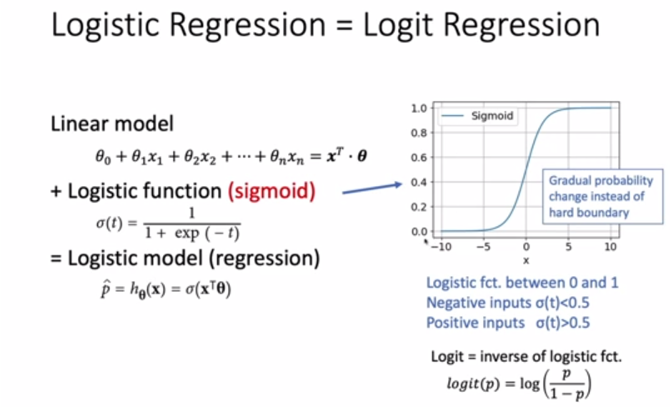

1. What is the sigmoid function? Why is it designed like this? What is the Logit function?

The same screenshot as Q1. Smooth function ---> differentiable

1. How do we train a logistic model? What is the loss function? Why is it designed to minimize the negative log of p?

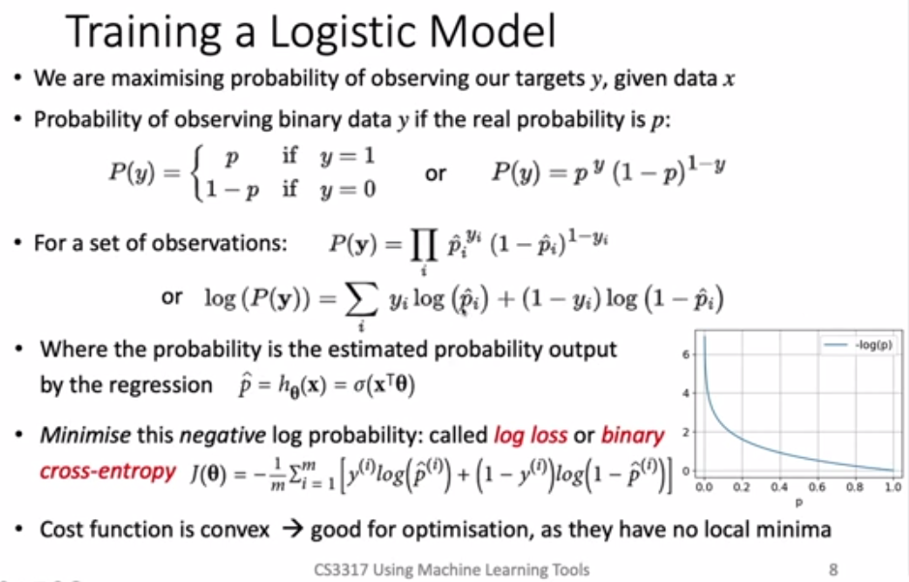

1. What are decision boundaries?

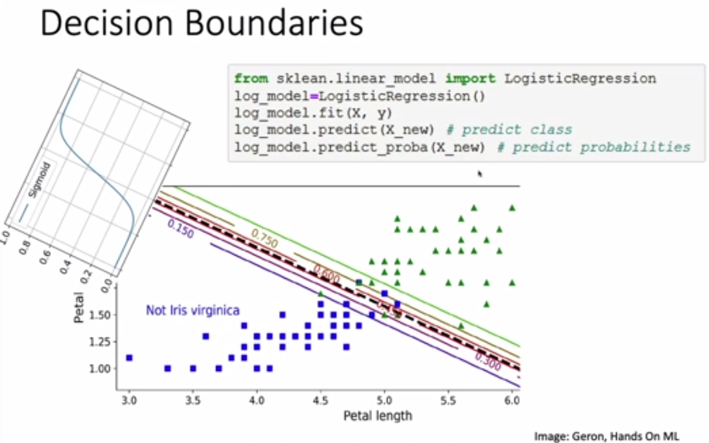

1. How do we extend the idea of Logistic regression to multi-classes? What are the differences between binary and multi-class classification?

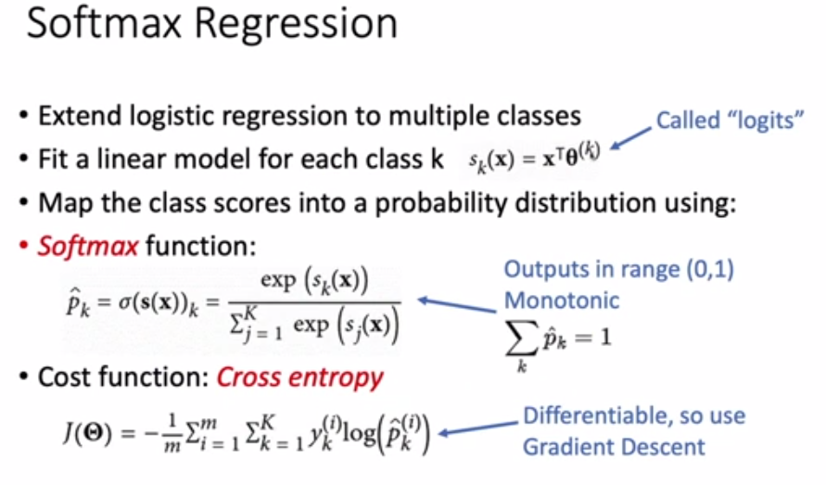

1. Please explain the process in the below images.

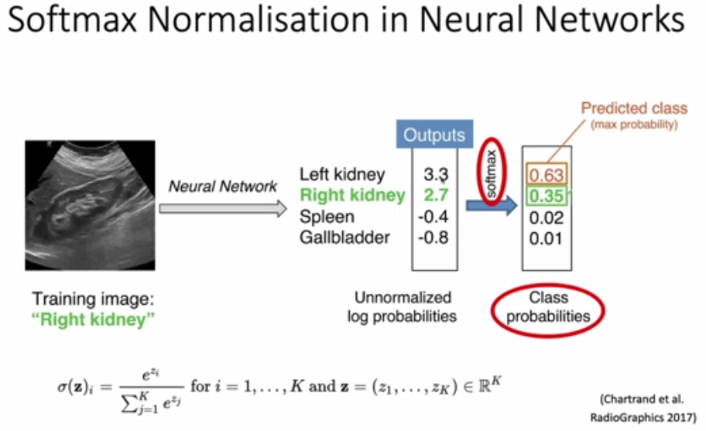

1. What is the key idea of SVM?

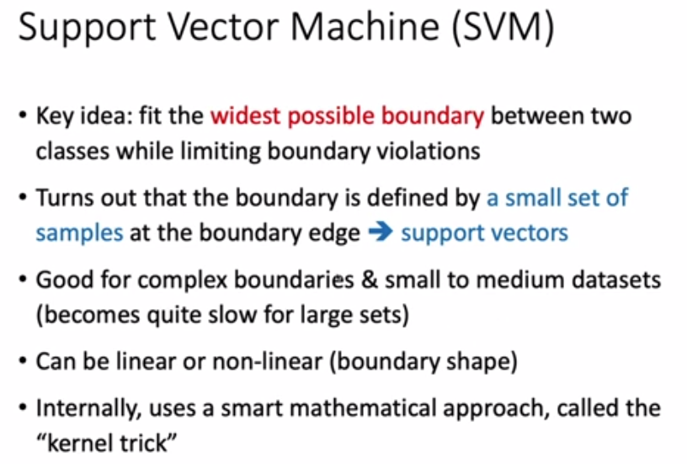

* How does logistic regression work? What is logit regression? (slide 3-4)

* What happens when we are training a logistic model? (slide 8)

* How to use logistic regression in sklearn? How to predict the classes and the probabilities in sklearn? (slide 9)

* How to extend logistic regression to multiple classes? (slide 10)

* How does SVM work? SVM is good for what types of boundaries and datasets? (slide 13)

* What is the difference between the hard margin and the soft margin of Linear SVM? (slide 14-15)

* What is the Hinge loss function? (slide 16)

* How to handle non-linear boundaries in SVM? (slide 17)

* What are SVM hyperparameters? (slide 18)

* What is a kernel trick? (slide 19)