1. What is the difference between traditional machine learning and deep learning (slide 5)?
3. What is a neuron? What are components in a neuron? (slide 6)
5. How perceptron is resembled through neuron? (slide 7)
7. What are input layers, hidden layers, output layer, and fully-connected layers of a neural network? (slide 8)
9. What are weights and bias? (slide 10)
11. How many parameters are there in the following neural network (slide 10)?

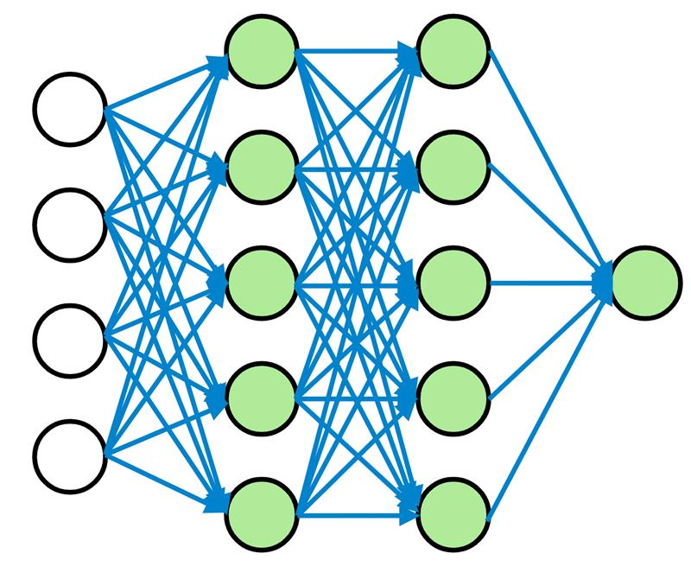

1. What is the importance of nonlinearity? (slide 11)
3. What are the popular activation functions and draw their shapes? What activations functions are suitable for regression and classification? (slide 12, 16, 17)
5. What is a loss function? What loss functions are suitable for regression and classification? (slide 13, 16, 17)
7. What is a optimization method, backpropagation, local minima and global minima? (slide 14)
9. What are batches, batch size and epochs? (slide 15)