1. What is the problem in reshaping input values as 1D vectors? What is convolution? (slide 6)

1. How each layer is represented when we have images in CNN? (slide 7)
2. What is a convolution layer? (slide 8)
3. What is the output of the following convolution layer? What happens to the output in CNN (slide 10-20) 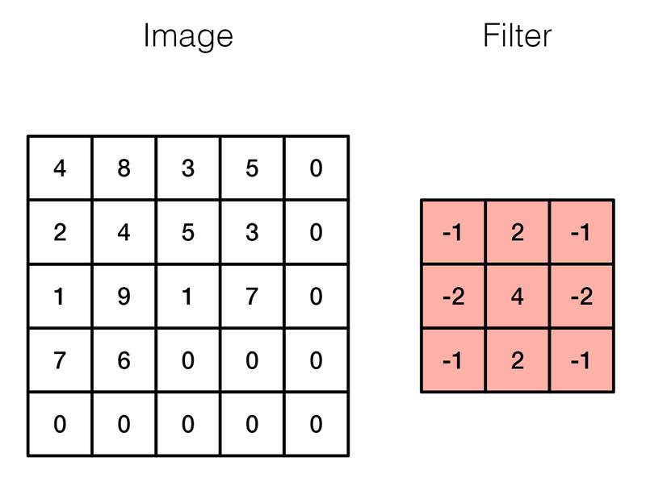
4. What are kernels? How many kernels are there in a CNN? What does it do? (slide 22)
5. What happens to the kernels as we move along the hidden layers in CNN? Illustrate your answer? (slide 25)

What is max pooling layer? What is a stride? What are the other options, in addition to max pooling layer? What is the output of the following with (slide 26)

* + 2x2 filer and stride 1 (max pooling layer)
  + 2x2 filter and stride 2 (average pooling layer)

1. Draw an architecture of CNN with input, hidden and output layers (slide 28)
2. What is the most common filter size used in CNN? How many parameters are associated with it? What happens to the number of parameters if we have 3 colour channels? (slide 29)
3. How many parameters are there in this CNN architecture? (slide 32)

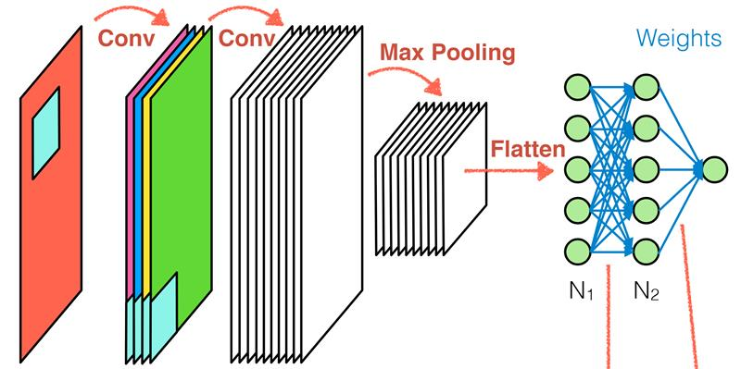

1. Think about real-world problems where you could apply CNN? Discuss with your peers and tutors.
2. What are the reasons for overfitting and underfitting? (slide 36)
3. What factors are dependent on the results of training (optimisation)? What is it called when we combine different trained models? (slide 37)