**Paradigm Pet Professionals: Information Architecture**

**1. Necessary Website Functionality and Microinteractions**  
The Paradigm Pet Professionals website must provide core functionality that ensures a seamless user experience and meets stakeholder goals. The website must be fully responsive, allowing it to function optimally on both desktop and handheld devices. It must be built to meet accessibility standards, which includes alt-text for images, keyboard navigability, readable fonts, and strong contrast between text and background.

A central element of functionality should be a comprehensive contact and consultation form. This form must collect the user's name, phone number, email address, and time zone, along with the pet's name, type, and age.

To improve usability and retention, the site should implement microinteractions throughout, such as hover states that highlight navigation links, focused text fields, and breadcrumb trails. Search functionality should also be implemented to help users locate pet care topics quickly. All of these interactions contribute to a more intuitive, informative, and engaging website experience that aligns with the needs of users and stakeholders.

**2. Content Plan for a New Page Based on the Bird Owners Persona**  
One new page will be created to address the needs of bird owners, a new user persona outlined in the design specifications. Bird owners are interested in understanding the relational and emotional well-being of their birds and are most likely to access the website from a desktop device.

The page, titled “Bird Care & Emotional Health,” will begin with an introduction explaining the emotional sensitivity and diversity of bird breeds. This introduction will lead into a clearly organized section outlining signs of bird depression, such as reduced appetite, irritability, and changes in vocal tone.

The next section will offer actionable tips for prevention and care, such as providing daily stimulation, social interaction, and properly arranged living environments.

A call to action will invite users to consult with a Pexpert to discuss their bird’s needs in more detail. The page will conclude with links to reputable bird care and rescue resources. This page aligns with the bird owner persona by offering desktop-friendly, detailed, and emotionally resonant content that validates their concerns and encourages interaction.

**3. Existing Content to Be Removed or Redeveloped**  
One area of existing content that should be redeveloped is the list of pet adoption resources currently absent from the home page.

This lack of information fails to support the company’s goal of providing an easy-to-navigate, accessible, and engaging website. It also misses an opportunity to guide users toward scheduling a consultation or exploring further resources tailored to their needs.

To align this section with stakeholder and audience goals, it should be redeveloped into an interactive “Pet Adoption Information” module. This module would allow users to browse a curated list of links for additional information about the adoption process. There is a consultation form for users to fill out if they require more information.

The website navigation will also be redesigned for functionality, as trying to navigate to the home page from the FAQ page doesn’t function properly. This clearly fails user and stakeholder needs, as a broken website link could easily lead a user to leave the site, hurting stakeholders’ need for retention.

Additionally, the existing style site-wide is outdated and in need of a visual refresh to bring it up to modern standards. Each page will be redesigned to follow a new style that is more visually appealing and that better serves the user experience. This will contribute to the users’ needs by making the site easier to look at and navigate, which also contributes to the stakeholders’ needs of keeping users interested in using the site.

**4. Visual Sitemap**  
The structure of the Paradigm Pet Professionals website includes a homepage, individual pages for each of the pet categories (cats, dogs, and birds), and a FAQ page.

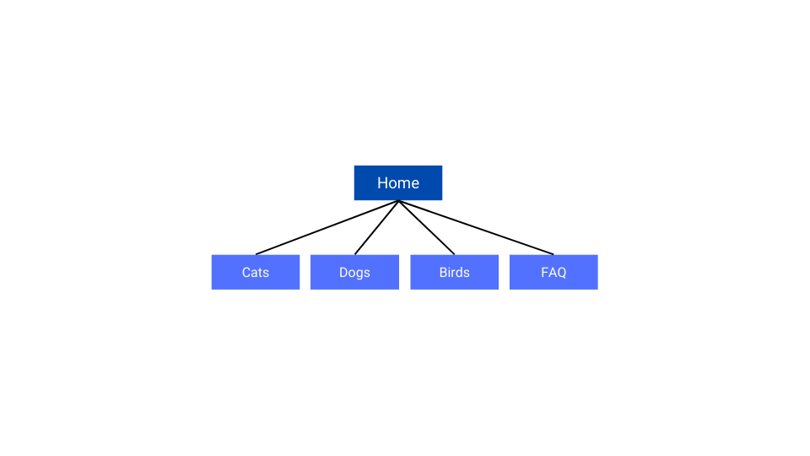

**5. How the Information Architecture Meets Audience and Stakeholder Needs**  
The proposed information architecture is designed to address both audience and stakeholder needs in a structured and user-friendly manner. By organizing content around pet type, users are able to immediately find information relevant to them. The clear structure improves content discoverability, which helps retain first-time visitors and reduces bounce rates.

Stakeholders benefit from the emphasis on the consultation call-to-action, which is integrated throughout the site, including on individual pet pages and the homepage. By ensuring that each page is optimized for specific user personas and their concerns, the site fosters trust and engagement.

Additionally, the architecture supports long-term goals such as increased traffic through search engine optimization. The inclusion of keyword-focused content and detailed resources contributes to higher visibility in search engine rankings.

**6. Primary and Secondary Navigational Elements**  
The primary navigation will consist of a persistent top menu with links to the Home page, the three different pet types supported by the site, and an FAQ page.

Secondary navigation will be included under the main navigation bar that shows the site path from the home page to the current page.

The primary navigation supports audience needs by offering a straightforward way to reach the most relevant pages based on their pet interests. For stakeholders, it ensures that users are regularly guided toward booking consultations, fulfilling one of the primary business objectives.

The secondary navigation (breadcrumb trails) offers users clarity on where they are currently located in the site as well as the ability to backtrack if they choose. For stakeholders, it supports user retention and engagement by minimizing confusion and keeping visitors oriented, which encourages deeper exploration and interaction with the site.