**Dropoff User Manual**

**Installation**

Currently the installation is done using the .apk , in the future it will be available on the google play store.

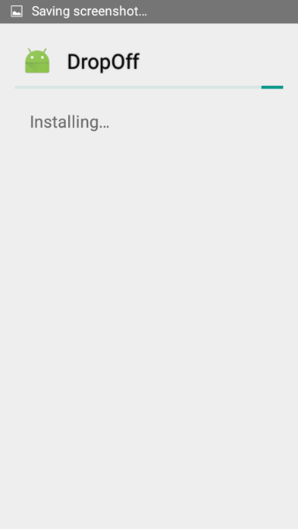**Step1: Step 2:**   **Step3:**

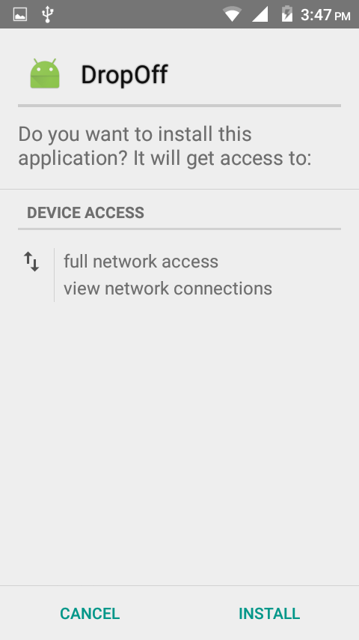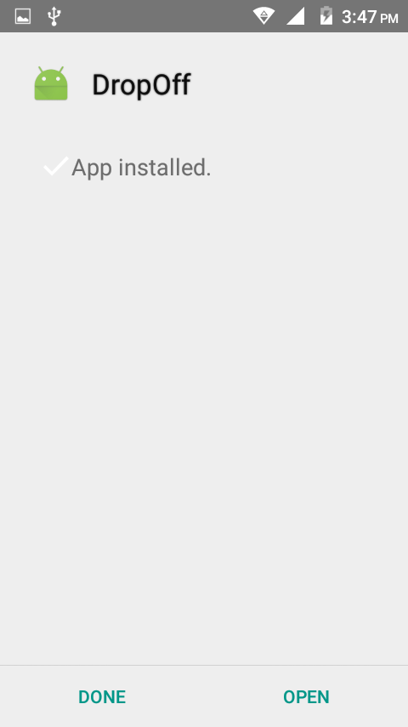

Once the .apk has been clicked on, Step 1 appears telling you the permissions, these permissions are required to communicate with the pi and camera, they are networking permissions only. Step 2 installs the program and step 3 confirms the installation was successful

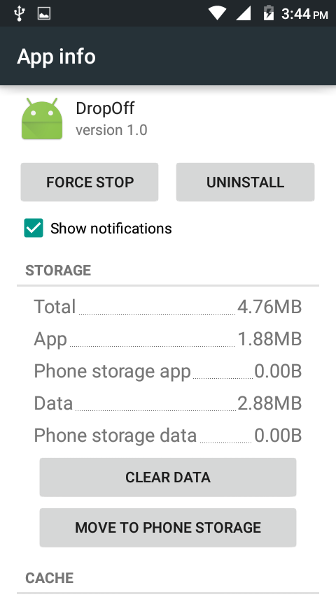

**Application Information**

The app is light weight, it uses less than 10mb of internal storage, this is so that it may run on low cost devices. The current version is 1.0 this is because the application has just entered its beta stages for the demo 2. The version 0.x was used for alpha and 2.x will be used for the actual release

**Application features**

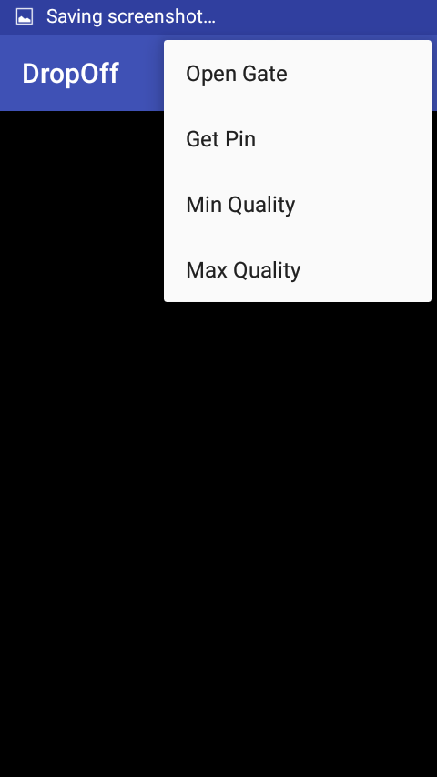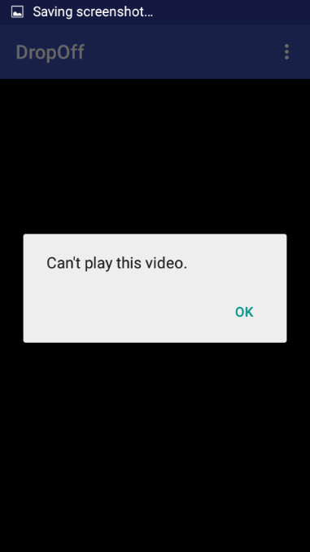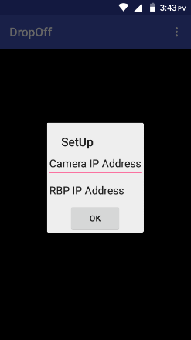**Screenshot1 Screenshot2 Screenshot3**

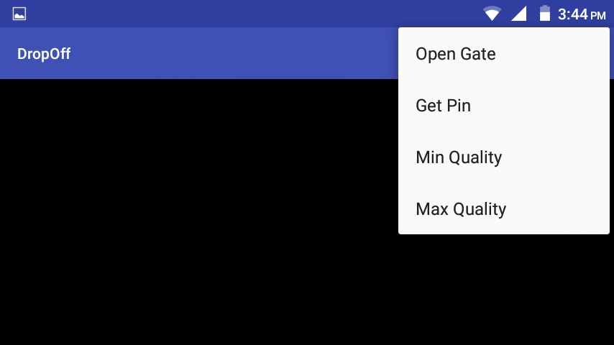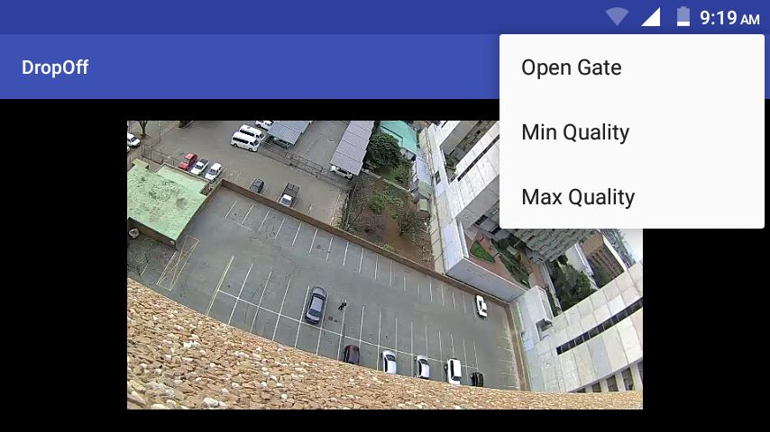**Screenshot4 Screenshot5**

**Screenshot1** Shows the beta version of the application as it is open here you enter the IP address of the pi and the IP camera, this is just for portability until we have an external server set up.

**Screenshot2** Displays the error messages associated with the connection to the camera being unsuccessful

**Screenshot3** Displays the option menu, this is triggered by clicking on the menu button on your device or clicking on the physical menu

**Screenshot4** shows the application with a feed working, this is application version 0.8, added from this point was the functionality as seen in screenshot 1 , the ability to get a pin from the raspberry pi and all errors that caused the app to crash have been resolved

**Screenshot5** displays the application menu in landscape form