**CS5543 Real-Time Big Data Analytics**

MapReduce & Spark Programing

Quiz 3

9/6/2016

Class ID:

Name: Bill Capps

**MapReduce Programming – Calculate everyone's common friends for Facebook**

Facebook has a list of friends (note that friends are a bi-directional thing on Facebook. If I'm your friend, you're mine). They also have lots of disk space and they serve hundreds of millions of requests everyday. They've decided to pre-compute calculations when they can to reduce the processing time of requests. One common processing request is the "You and Joe have 230 friends in common" feature. When you visit someone's profile, you see a list of friends that you have in common. We're going to use MapReduce so that we can calculate everyone's common friends once a day and store those results. Later on it's just a quick lookup. We've got lots of disk, it's cheap.

1. Draw a MapReduce diagram similar to the word count diagram below.
2. Sketch a MapReduce algorithm for the common Facebook friends (referring to the word count code below).
3. Sketch Spark Scala implementation (referring to the word count code below).

**Example**

Assume the friends are stored as Person->[List of Friends], our friends list is then:

A -> B C D

B -> A C D E

C -> A B D E

D -> A B C E

E -> B C D

The result after reduction is:

(A B) -> (C D)

(A C) -> (B D)

(A D) -> (B C)

(B C) -> (A D E)

(B D) -> (A C E)

(B E) -> (C D)

(C D) -> (A B E)

(C E) -> (B D)

(D E) -> (B C)

Now when D visits B's profile, we can quickly look up (B D) and see that they have three friends in common, (A C E).

**WORD COUNT EXAMPLE**

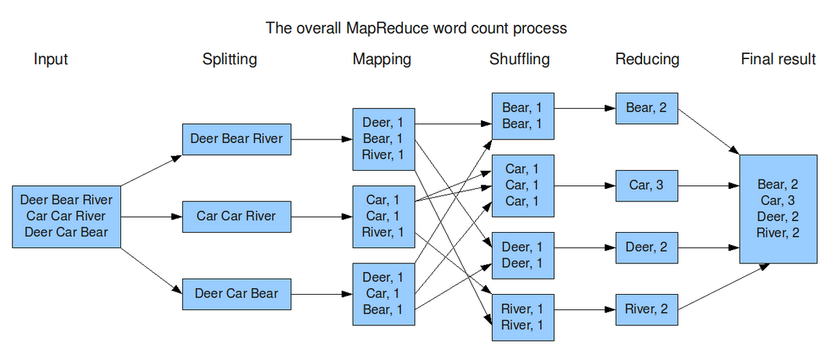

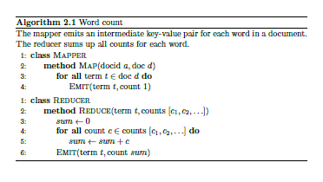

**MapReduce Scala Code for WordCount**

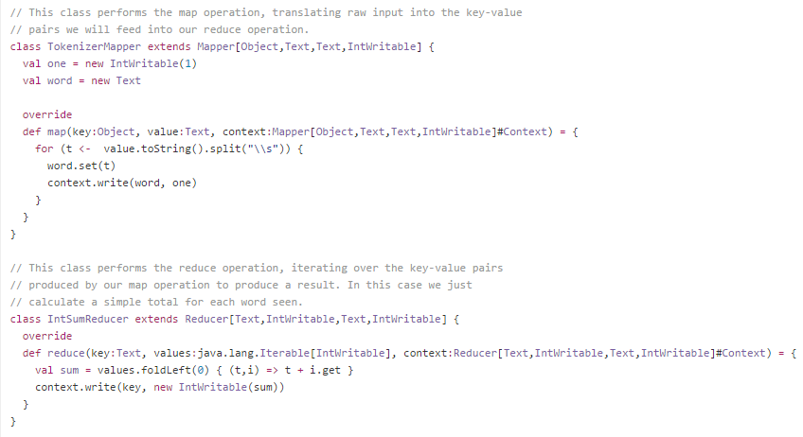

**Spark Scala Code for WordCount**

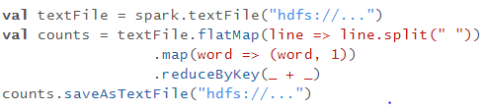

|  |  |
| --- | --- |
| **flatMap(func)** | Similar to map, but each input item can be mapped to 0 or more output items (so func should return a Seq rather than a single item). |
| **reduceByKey**(*func*, [*numTasks*]) | When called on a dataset of (K, V) pairs, returns a dataset of (K, V) pairs where the values for each key are aggregated using the given reduce function *func*, which must be of type (V,V) => V. Like in groupByKey, the number of reduce tasks is configurable through an optional second argument. |