Introduction to BIRT XML Data Source
Keywords
Actuate, BIRT，XML, Data Source
Version Control
Version | Date | Description of Changes
Draft 1 | Jun 10 2008 | First draft

Please visit BIRT EXCHANGE website to acquire the latest version of this document:
http://www.birt-exchange.com
Index
1. Introduction 2
2. BIRT XML Data Source: Advantages and Limitations 3
3. Mapping XML to Relation Table 4
3.1 Row Mapping 5
3.1.1 Definition 5
3.1.2 Limitations of Row Mapping 6
3.2 Column Mapping 7
3.2.1 Definition 7
3.2.2 Column Mapping Working Folw 8
3.2.3 Limitation of Colum Mapping 9
3.3 List of BIRT supported XPATH Expression 10
4. Define XML Data Source Using BIRT Report Designer 10
4.1 Create XML Data Source 10
4.2 Create XML Data Set 12
4.3 Preference Setting for XML Data Source 17
5. XML Data Source Examples 18
5.1 Title/Author/Category Table 18
5.2 Author/Title Table for Chinese Authors 19
5.3 Title/First Author/Second Author Table 20
5.4 Title/Published Date Table 20
5.5 Geography Table 21
6. Use XML Data Source at API Level 22
7. References 22

Introduction
XML is a data exchange and storage format prevailed in industry. Large amount of data is stored and distributed using XML format in real life every day.

The XML Data Source support provided by BIRT is simple but powerful. It is very easy to use XML document as source of data in BIRT report.

This article serves as an introduction to BIRT XML Data Source support. It covers the basic concepts, such as Row-Mapping, Column-Mapping, etc., of BIRT XML Data Source, and provides the DEMO for the usage of XML Data Source in BIRT 2.3.0.

BIRT XML Data Source: Advantages and Limitations
- Advantages
  - Simple
It is very simple to define BIRT XML Data Source. Sever mouse clicks are enough to mapping your tree-like XML document to a relation table (The latter is the familiar by most of RDBMS users).

BIRT also provides XPATH-like BIRT XML mapping expressions, which can help advanced users to make complex row/column mappings. As the syntax of such expressions are mimics for that of XPATH, a person with awareness of XML standard can very easily to learn to use BIRT XML mapping expressions.

  - Powerful
BIRT XML driver is powerful in terms of its ability to convert various XML document to a simple and straightforward relation table. All kinds of XML elements, as well attributes, can be mapped to data values in targeting relation table.

- Limitations
  - Less efficient than that of Database queries
BIRT XML Data Source cannot produce even similar performance compare to popular RDBMS such as Oracle and Sql Server. So at any moment user should prefer RDBMS data source to XML data source, providing that performance is critical.

  - No Semantic Analysis to Ordinary XML elements
BIRT XML Data Source includes no semantic analysis for popular XML elements, say, SOAP header in WSDL documents. However, this limitation is not that harmful by general for the XML ←→ Relation Table mapping in BIRT is very powerful.

Mapping XML to Relation Table
It is generally acknowledged that the XML document has strong hierarchy. Each XML document consists of a group of elements as well as attributes, and those elements can nest to each other; Every XML document includes a “root” element, serving as the container of all other elements, etc. This structure is greatly different from that of relation table in RDBMS.

The following is an example XML document:
<?xml version="1.0"?>
<library>

<book category="COOKING">
<title lang="en">Everyday Italian</title>
<author name="Giada De Laurentiis" country="it"/>
<year>2005</year>
</book>

<book category="CHILDREN">
<title lang="en">Harry Potter</title>
<author name="J K. Rowling" country="uk" />
<year>2005</year>
</book>

<book category="WEB">
<title lang="en">XQuery Kick Start</title>
<author name="James McGovern" country="us" />
<author name="Per Bothner" country="us" />
</book>

<book category="WEB">
<title lang="en">Learning XML</title>
<author name="Erik T. Ray" country="us" />
<year>2003</year>
</book>

<audio format="CD" category="MUSIC">
<title lang="en">Feels Like Home</title>
<artist name="Norah Jones" country="us" />
<year>2005</year>
</audio>

<photo format="VCD" category="PICTURE">
<title lang="cn">Adventure to Tibet</title>
<photographer name="Zhang San" country="cn" />
<year>2002</year>
</photo>

</library>
Table 3-1：XML Document Example
The XML document showed in Table 3-1 can be mapped to numerous relation tables. I hereafter give two of them:

Category | Title
COOKING | Everyday Italian
CHILDREN | Harry Potter
WEB | XQuery Kick Start
WEB | Learning XML
Table 3-2：Category, Title Table

Author | Title
Giada De Laurentiis | Everyday Italian
J K. Rowling | Harry Potter
James McGovern | XQuery Kick Start
Per Bothner | XQuery Kick Start
Erik T. Ray | Learning XML
Table 3-3: Author, Title Table
As we can find from the above examples, the relation tables that generated from an XML document can consists of different number of rows, columns and different data value. Then by what means BIRT XML data source convert an XML document to a relation table? To describe this, we must introduce two most import concepts of XML data source: Row Mapping and Column Mapping.

Row Mapping

Definition
Let us image how an XML document is read by program. Take Table 3-1：XML as an example: When being read, the first element being visited would be root element “library”, and then the first “book”, first “title”, first “author”, first “year”, and then second “book”…That is to say, when we are processing XML document, we always make sequential access. It is not possible for us to by pass first “book” and read “title” directly.

The above process is similar to the way BIRT creating relation table out of XML document. BIRT makes a sequential outputting of a relation table. It will first output the first row, and then second, third, fourth row… until the last row is processed. Take Table 3-2：Category, Title as an example: BIRT always generates row <”COOKING”,” Everyday Italian”> firstly, and then row <”CHILDREN”,” Harry Potter”>, etc.

Based on above, it is natural for us to introduce the idea of Row Mapping:
Row Mapping defines a group of elements, which have same characteristic, in XML document. The start of each element (in that group) leads to the creation of a new row in target relation table. The generation of that new row will be finished when the end of each element (in that group) is accessed.
Take Table 3-2 as an example. Its row mapping is “all the book titles”(/Library/book/title)，please note that I have put the corresponding XPATH expression in the bracket. That is, when BIRT is processing XML document, every time /Library/book/title element is meet, BIRT will generate a new row. In Table 3-1，there are four occurrences of such element, that is why Table 3-2 includes 4 rows. On the other hand, Table 3-3 has row mapping “All the authors”(/Library/book/author)。In Table 3-1 we can find five such elements，as a result there is five rows in Table 3-3.

Limitations of Row Mapping
- Only XML elements can be mapped. The XML attributes cannot be used directly in Row Mapping. This not necessary means that XML attributes cannot presents in Row Mapping. Actually, using XML attributes to filter out elements in Row Mapping is only of advanced usage of XML Data Source. We will give introduction to this in Section 5.
- BIRT does not fully support using a group of element with different characteristics as Row Mapping. Say, BIRT does not support Row Mapping such as “All authors and all artists” (/Library/book/author|/Library/audio/artist). The relation table such as Table 3-4 may need this kind of mapping.

Author (Artist) | Title
Giada De Laurentiis | Everyday Italian
J K. Rowling | Harry Potter
James McGovern | XQuery Kick Start
Per Bothner | XQuery Kick Start
Erik T. Ray | Learning XML
Norah Jones | Feels Like Home
Table 3-4：Author(Artist), Title Table
Please note that BIRT can also work around the problem by providing support to XPATH wildcard “*”. This will be introduced later.

Column Mapping

Definition
In last section we have learnt that how to define a row out of an XML document using BIRT. In this section we will go ahead with the definition of column values for each row. In BIRT we call that “Column Mapping”.
Column Mapping defines a group of elements/attributes that are of same characteristics. The values of those elements/attributes serve as column values of each row. If for certain row there are multiple qualified column mapping value found, BIRT will by default fetch the first matched one.
Based on the definition of Column Mapping we conclude that：
- The target for Column Mapping could be either element or attribute. Each Column Mapping can only target for either element or attribute, but not both.
- Every column in relation table has one and only one Column Mapping corresponding with.
- For a column value in a row, according to the Column Mapping there might be multiple qualified values corresponding with. BIRT will how every use the first matched one as the column value of such row.

The Column Mapping is also represented by XPATH-like expression in BIRT. The XPATH script for Column Mapping is a “relative” path, of an element or attribute, to that of Row Mapping. This is the major difference in the XPATH expression between Row Mapping and Column Mapping: the former always use “absolute” XPATH expression.

Take Table 3-2 as example: Its Row Mapping is /library/book/title, which is an absolutely path and can locate all the book title elements in XML document. When BIRT is parsing XML document, every time it meets one of those element it will start a new row.

There are two columns in Table 3-2, “Category” and “Title” representatively。The XPATH for “Category” is: ../@category。Combine it with Row Mapping we get following expression：/library/book/title/../@category, which equals to: /library/book/@category. That is to say, for column “Category”, it is Column Mapping to <@category> attribute of all <book> elements.

As for “Title”, the Column Mapping expression of it is “empty”. Combine an “empty” expression with Row Mapping we get: /library/book/title. That is, “Title” column is corresponds with all the sub-element <title> of all <book> element.

Column Mapping Working Folw
I would like to dig into more details of BIRT Column Mapping using table hereafter. In Table 3-5，we try to acquire all the book title and author name. If there are multiple authors for a book we only need the name of first author.

Title | Author
Everyday Italian | Giada De Laurentiis
Harry Potter | J K. Rowling
XQuery Kick Start | James McGovern
Learning XML | Erik T. Ray
Table 3-5：Title, Author Table
The Row/Column Mapping Table 3-5 corresponds with is listed in Table 3-6:
Row Mapping |  | /library/book/title
Column No. | Column Name | Column Mapping
1 | Title
2 | Author | ../author/@name
Table 3-6
When BIRT is parsing XML document, it will first access element /library/book/title, which leads to the creation of first row. The very element matches “Title” Column Mapping as well, so its value, “Everyday Italian” is assigned as the column “Title” value of first row.

The, BIRT will access author name “Giada De Laurentiis”, which is qualified for “Author”Column Mapping. By this step, we generate following rows
Title | Author
Everyday Italian | Giada De Laurentiis
After that, BIRT will meet second book title and create second row. And then meet book title value “Harry Potter” and author name attribute “J K.Rowling”, both qualified for Column Mapping. So far we have two rows:
Title | Author
Everyday Italian | Giada De Laurentiis
Harry Potter | J K. Rowling

Immediately BIRT will encounter the third book title element, “XQuery Kick Started”and two author name attributes,“James McGovern”and“Per Bothner”. Because BIRT access the former first, it will automatically use the first attribute value as Column Mapping value. We will in turn get the third row:

Title | Author
Everyday Italian | Giada De Laurentiis
Harry Potter | J K. Rowling
XQuery Kick Start | James McGovern

Repeat above steps again, finally we can get Table 3-5。

Limitation of Colum Mapping
- Similar to that of Row Mapping, in the current BIRT XML data source, multiple elements/attributes serve as Column Mapping of a single column is not supported.

List of BIRT supported XPATH Expression
As we have mentioned, BIRT supports XPATH-like syntax for its Row/Column Mapping expression. The following elements of XPATH have been supported by BIRT:
Expression | Desc
/elementName | Select all the “elementName”elements, starting the search starting from root element.
//elementName | Select all the “elementName”elements, the search starting from any element.
.. | Return to parent node
@attributeName | Select an Attribute
* | Element wildcard, select all the matched elements nodes. Please note every “*”only correspond to one element nade. That is, /* can locate /a or /b, but not /a/b.
[n], n is a 1-based positive integer | Select the n^{th} element from parent node
[@a=“bc”] | Select elements according to the attributes value. Please note that BIRT only support operator “=”.
Table 3-7：List of XPATH-like Expression Supported

Define XML Data Source Using BIRT Report Designer
In this section we introduce the creation of BIRT XML Data Source in BIRT Designer.

Create XML Data Source
First, we need to create an XML Data Source
- Similar to the creation of all other data sources, we need to right click “Data Source” in BIRT Data Explorer.
- In context menu, we then click “New Data Source”, which will bring us Data Source Creation Wizard. In dialog as showed in Figure 1, select“XML Data Source, and input the Data Source name.
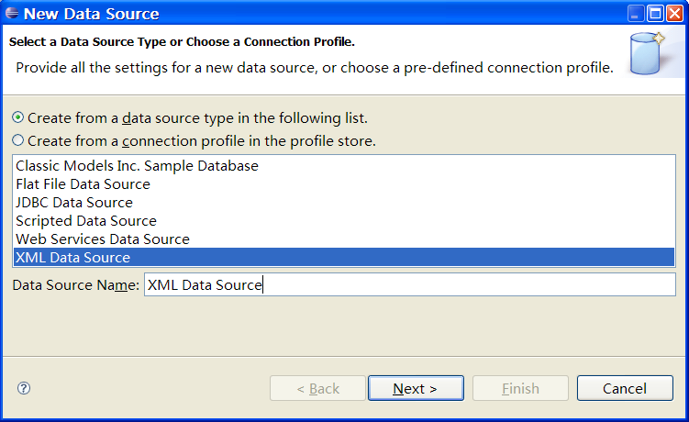
Figure 1
- Click “Next”, we will see Figure 2
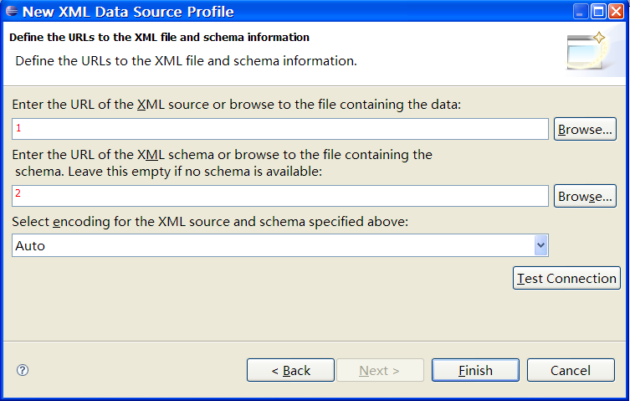
Figure 2

There are two text control and one list control in above dialog. Text 1 accepts the URL of the XML source; Text 2 accepts the .xsd file of target XML document. We can further decide the encoding of XML source by make selection in list control.

Please note that .xsd file is optional. It is only used to enhance the design time performance for XML Data Source. During runtime BIRT will not access .xsd file at all.
- After step 3, we can complete the XML Data Source definition by click “Finish” button. And then we can proceed to the creation of XML Data Set.

Create XML Data Set
- Similar to that of creating all other data sets, we need to right click “Data Set” in BIRT Data Explorer.
- The, in context menu we click “New Data Set” to bring following dialog as showed in Figure 3:
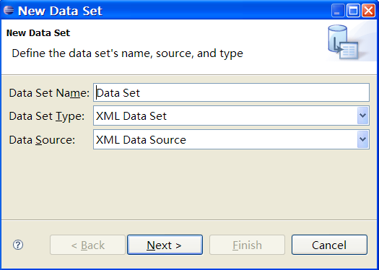
Figure 3
We should input the Data Set name here and select the correct data source to use.
- By clicking “Next” we come to Figure 4:
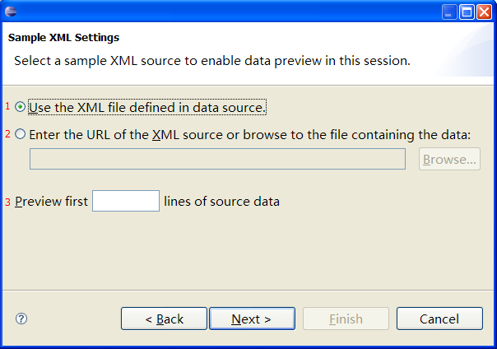
Figure 4
Here we have three places (as marked by 1, 2 and 3) that may accept user inputs. “1” and “2” decide where the source data used in preview window of column mapping page come from. “3”defines the max number of rows that displayable in mapped relation table previewer as showed in Figure 7. By default we will display all rows.
- Then click“Next“，bring the screen as showed below:
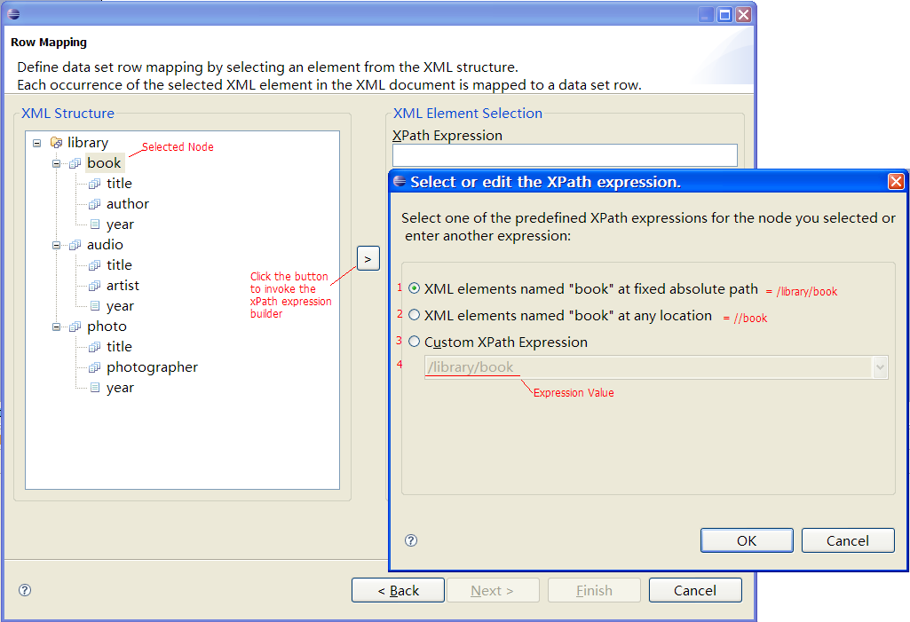
Figure 5
There are three component of a Row Mapping dialog. The XML structure tree to the left (As Row Mapping does not accept attribute, all the attributes are hided in the tree), the expression builder button (“>”) in the middle, and the XPath Expression text control to the right.

We have to ways to create a Row Mapping:
  - We can input the XPATH expression using XPath Expression text control directly.
  - We can also firstly select a node in XML structure tree, and then click “>”to invoke XPATH expression builder to create an expression.

In expression builder, user can either select “1 Absolute Path” or “2 any location” to create XPATH expression. And he/she can also select “3 Custom XPath Expression” to enable “4 text control” to type in expression by his/her own.
- After the definition of Row Mapping, by click “Next” we come to Column Mapping dialog:
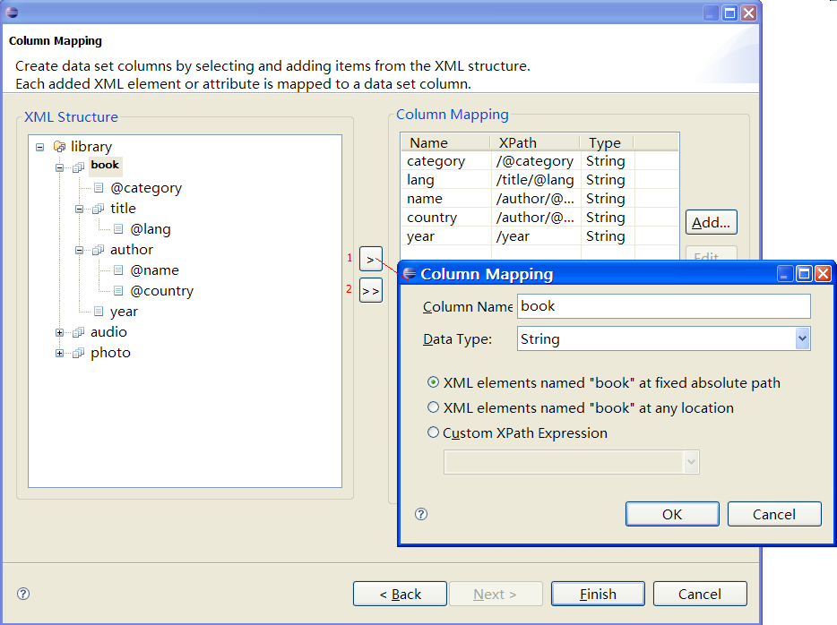
Figure 6
The left part of Column Mapping dialog show the XML structure tree which also honors attributes, this is because Column Mapping accepts attribute values of XML document. There is a table control to the right of the dialog, which shows the “Name”, “XPath Expression” and “Type” of defined Column Mappings.
In the middle there are two buttons. “>”can bring XPATH Expression builder, and “>>”will add all the child nodes of selected node, as well as itself, to right table as Column Mappings. Please note in that circumstance all the XPATH expressions being added would denote to “absolute path”

The button below table control will bring the previewer of targeting relation table, as showed below:
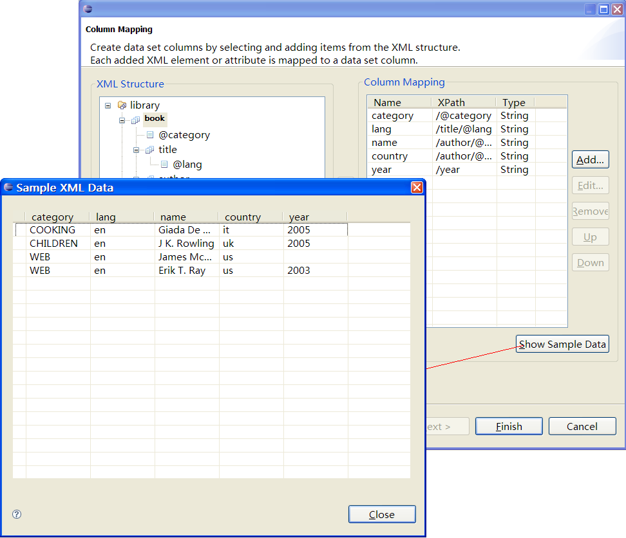
Figure 7
Click “Finish“ after the definition of Column Mapping, we complete the definition of an XML Data Set.

Preference Setting for XML Data Source
In BIRT Report Designer, click “windows”in file menu, and then click “Preferences”, we can bring “Preferences”dialog.

Then click“Data Management”→“Connectivity”→“Open Data Access”→“XML Data Set”, we can set the preference for XML Data Set.
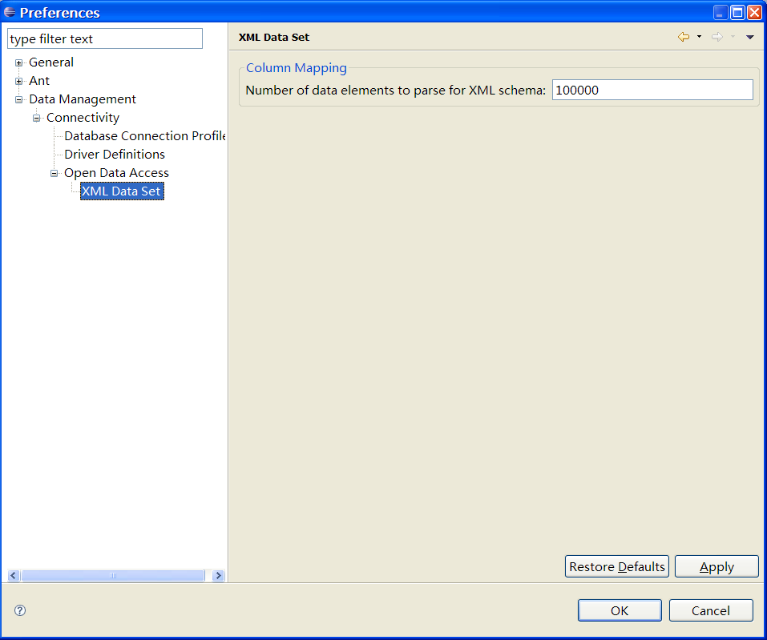
Figure 8
At current stage there is only one setting available: The max number of element to be parsed to acquire XML structure. This option is used by the Data Set that has not provided .xsd file in Figure 2. That is, by analysis the first n elements of source XML document to create XML structure tree as in Figure 5 and Figure 6.

XML Data Source Examples

Title/Author/Category Table
This example address the use of “//”, “*”, “..” and “@” expression. Firstly we use “//” to select all the “title” elements as Row Mapping, and then define three Column Mappings: “title”element itself, attribute” name” and “category”. Please note in column 2, 3, we use “..” to refer to the parent node of Column Mapping “title”. Furthermore, in 2, we use “*”to match all the elements that at the same level of that of “title” element.
Based on Table 3-1，define Row/Column Mappings as in Table 5-8, we can create a relation table as in Table 5-9。
Row Mapping |  | //title
Column No | Column Name | Column Mapping
1 | Title
2 | Name | ../*/@name
3 | Category | ../@category
Table 5-8

Title | Name | Category
Everyday Italian | Giada De Laurentiis | COOKING
Harry Potter | J K. Rowling | CHILDREN
XQuery Kick Start | James McGovern | WEB
Learning XML | Erik T. Ray | WEB
Feels Like Home | Norah Jones | MUSIC
Adventure to Tibet | Zhang San | PICTURE
Table 5-9：Title, Author, Category Table

Author/Title Table for Chinese Authors
In this example, we show the usage of XPATH filter supported by BIRT in Row Mapping definition. Specifically, we select all “title” element the attribute “lang” of which is of value “cn”.
Based on Table 3-1：XML，define Row/Column Mapping as in Table 5-10 we can get Table 5-11。
Row Mapping |  | //title[@lang='cn']
Column No | Column Name | Column Mapping
1 | Title
2 | Name | ../*/@name
Table 5-10
Title | Name
Adventure to Tibet | Zhang San
Table 5-11：Title, Author Table for Chinese Authors

Title/First Author/Second Author Table
This example shows how to select element using index [n] in BIRT XML Column Mapping.
Based on Table 3-1，define Row/Column Mapping as in Table 5-12，we can get Table 5-13：Title, First Author, Second Author Table。
Row Mapping |  | /library/book/title
Column No | Column Name | Column Mapping
1 | Title
2 | Name1 | ../author[1]/@name
3 | Name2 | ../author[2]/@name
Table 5-12

Title | Name1 | Name2
Everyday Italian | Giada De Laurentiis
Harry Potter | J K. Rowling
XQuery Kick Start | James McGovern | Per Bothner
Learning XML | Erik T. Ray
Table 5-13：Title, First Author, Second Author Table

Title/Published Date Table
Based on Table 3-1，define Row/Column Mapping as in Table 5-14, we can have Table 5-15：。
Row Mapping |  | /library/*
Column No | Column Name | Column Mapping
1 | Title | title
2 | Year | year
Table 5-14

Title | Year
Everyday Italian | 2005
Harry Potter | 2005
XQuery Kick Start
Learning XML | 2003
Feels Like Home | 2005
Adventure to Tibet | 2002
Table 5-15：Title and Published Year Table

Geography Table
The following example shows how to use BIRT to deal with XML document with self-nested elements.

The following table is an XML document with “Location” element nested with itself.
<?xml version="1.0" encoding="UTF-8"?>
<Location name = "China">
<Location name = "Hangzhou" />
<Location name = "Shanghai">
<Location name = "Pudong">
<Location name = "Lujiazui"/>
<Location name = "Nanhui"/>
</Location>
</Location>
</Location>
Table 5-16：XML document that contains self-nested elements
Based on Table 5-16，define Row/Column Mapping as in Table 5-17, we can acquire Table 5-18。
Row Mapping |  | //Location
Column No | Column Name | Column Mapping
1 | LocationName | @name
Table 5-17
LocationName
China
Hangzhou
Shanghai
Pudong
Lujiazui
Nanhui
Table 5-18：Geography Table

Use XML Data Source at API Level
In additional to feed XML Data Source with XML document using URL, BIRT also accept InputStream as carrier of XML document by programming. The source InputStream is passed in using application context (AppContext). In execution the InputStream passed in will take priority to that defined in report design. This is an alternative way to dynamically change the XML document of XML Data Source between design time and runtime.

The corresponding AppContext keys are defined as followed:
Key | Desc
org.eclipse.datatools.enablement.oda.xml.Constants.APPCONTEXT_INPUTSTREAM | Key for XML source InputStream. The corresponding value of it in AppContext should be a java.io.InputStream instance.
org.eclipse.datatools.enablement.oda.xml.Constants.APPCONTEXT_CLOSEINPUTSTREAM | Indicates whether the XMLsouce input stream should be closed or not after BIRT finishing processing it. The corresponding value should be a Boolean and is by default set to false.
Table 6-19

References
BIRT Official Site:www.eclipse.org/BIRT
XML Introduction (by W3C)：http://www.w3.org/XML/
XPATH Introduction (by W3C)：http://www.w3.org/TR/xpath

