Download MySQL from http://www.mysql.com/downloads/mysql/:
Choose your platform and download then install. Install with the custom setup option. Choose to install everything except the Developer Components:
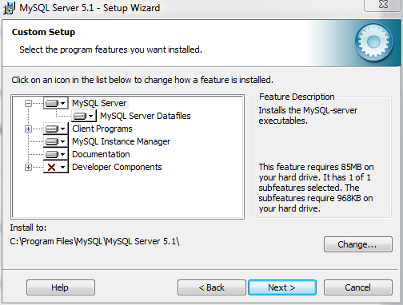

Choose to configure the MySQL server when installation finishes:
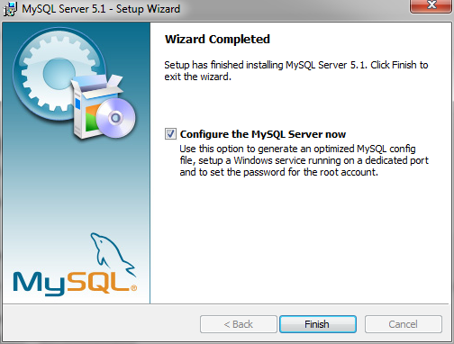

Choose to do a detailed configuration ➔ Developer Machine ➔ Multifunctional Database
For the approximate number of concurrent connections to the server, choose the manual setting and set it to 40 connections for now. We can change this later if it’s too much:
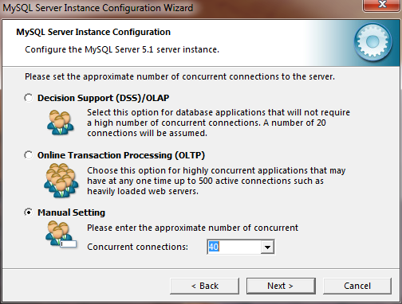
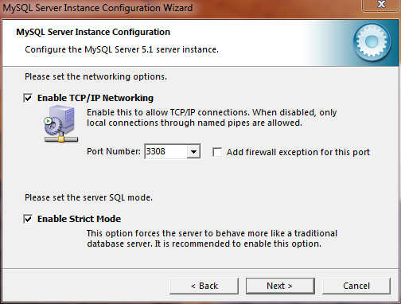
Next choose the standard character set.

Install as a Windows Service and also make sure to check the option for “Include Bin Directory in Windows PATH”:
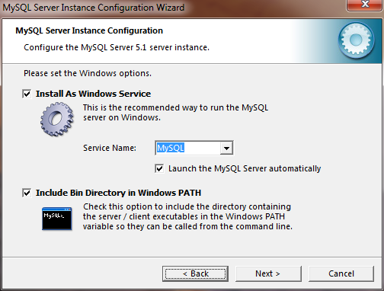

For the security settings, set root password to “rootpass” and check off “enable root access from remote machines”
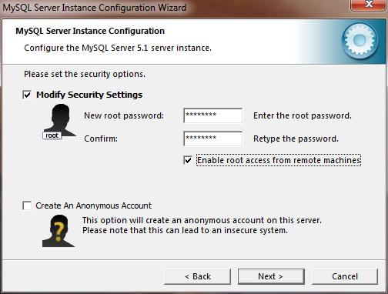

Finally, Execute the configuration.
You can access MySQL two ways: 1- Start up command prompt and type in command “mysql –uroot –prootpass” 2- Launch the “MySQL Command Line Client” from your startup menu.

Launch MySQL and run all the commands in the sql.txt file.

