**Memory Table Tools**

The Memory Table tools create a dictionary to be used to update rows in a table to replace the “Add Join” and “Calculate Field” routines. The Memory Table tools have two options. AttributeUpdate updates only one field in source table, OR the user can choose multiple fields from a “join table” to update by providing a list and using the MultipleAttributeUpdate function. Dictionaries will be created for each “join value” field and they are used to update the update fields.

This tool was created because I was frustrated with the amount of time it takes to make temporary table joins and using the field calculator to update fields. This tool is MUCH faster than using the “add join and calculate” method or the “JoinField” method.

In order to use these functions, the end user must save the MemoryTable.py script into a path that can be accessed by Python (ex: “C:\Python26\ArcGIS10.0\Lib\site-packages”). Once this has been done, the end user can simply import the functions in by using a statement like this:

“from MemoryTable import AttributeUpdate”

Once you have used the above statement in a stand-alone script, you can use the functions.

Written by: Caleb Mackey 11\14\2012

Tool Documentation on next few pages…

AttributeUpdate Function

Tool Summary

This tool can be used to update a single field in the source table using the values from a separate table (join table). A dictionary is created and used with an Update Cursor to accomplish this task.

Usage

* The input features for both the source table and join table must be a Table View, Feature Layer, Feature Class, Shapefile, for Geodatabase Table. Attributes from any table can be added as long as there is a “common field” containing values that can be found in a field in both tables.
* The update field in the source table is populated using values from the dictionary that is created from the join table. Only rows with common values from the join field will be updated.
* This tool can be used as an alternative to joining two tables and performing the field calculator on one field. If you wish to update many fields at once from another table please use the Multiple Attribute Update function in the Memory Table Tools.

Syntax

AttributeUpdate(source_table, in_field, update_field, join_table, join_key, join_value)

|  |  |  |
| --- | --- | --- |
| **Paramater** | **Explanation** | **Data Type** |
| source_table | The table that contains the field to be updated. | Table View, Feature Layer, Feature Class |
| in_field | The “common” field, or field containing unique values that can be used like the “join field” in the “Add Join” tool. This field must have values in common with the “join key” from the “join table” in order to update the desired field. | String |
| update_field | The field that is to updated using values from the “join value” field from the “join table”. | String |
| join_table | This is the table that contains the field with the values that can be used to populate values into the “update field” in the “source table”. | Table View, Feature Layer, Feature Class |
| join_key | This is the “common” field, or field containing unique values that can be used like the “join field” in the “Add Join” tool. This field must have values in common with the “in field” from the “source table” in order to update the desired field. This field will be the key for the dictionary. | String |
| join_value | This field contains the values that can be used to populate values into the “update field” in the “source table”. This field will hold the values for the dictionary. | String |

Code Sample can be found on next page

Code Sample (Stand-Alone Script)

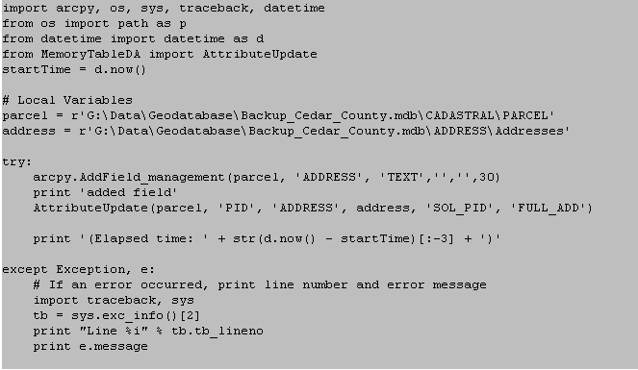

Multiple Attribute Update Function

Tool Summary

This tool can be used to update multiple fields in the source table using the values from fields in a separate table (join table). A dictionary for each join value field is created and used with an Update Cursor to accomplish this task.

Usage

* The input features for both the source table and join table must be a Table View, Feature Layer, Feature Class, Shapefile, for Geodatabase Table. Attributes from any table can be added as long as there is a “common field” containing values that can be found in a field in both tables.
* The update fields in the source table are populated using values from the dictionary that is created from the join table. Only rows with common values from the join field will be updated.
* When creating the input and join value lists of fields, both lists must contain the same number of fields. Also, these fields must be in the same order of that they are to be updated in. For example [ “update_field1”, “ update_field2”] in update fields, and

[“value_field1”, “value_field2”] from the join table.

* This tool can be used as an alternative to joining two tables and performing the field calculator on one field. If you wish to update many fields at once from another table please use the Multiple Attribute Update function in the Memory Table Tools.

Syntax

MultipleAttributeUpdate(source_table, in_field, update_fields, join_table, join_key, join_values)

|  |  |  |
| --- | --- | --- |
| **Paramater** | **Explanation** | **Data Type** |
| source_table | The table that contains the fields to be updated. | Table View, Feature Layer, Feature Class |
| in_field | The “common” field, or field containing unique values that can be used like the “join field” in the “Add Join” tool. This field must have values in common with the “join key” from the “join table” in order to update the desired field. | String |
| update_fields  [‘field_1,…] | A list of fields that are updated using values from the “join values” fields from the “join table”. | String |
| join_table | This is the table that contains the field with the values that can be used to populate values into the “update field” in the “source table”. | Table View, Feature Layer, Feature Class |
| join_key | This is the “common” field, or field containing unique values that can be used like the “join field” in the “Add Join” tool. This field must have values in common with the “in field” from the “source table” in order to update the desired field. This field will be the key for the dictionary. | String |
| join_value  [‘field_1,…] | A list of the fields that contain the values that will be used to populate values into the “update field” in the “source table”. These fields will hold the values for each dictionary. | String |

Code Sample (Stand-Alone Script)

