Classes:
- 0 = Raw image
- 1 = Dendrite
- 2 = Spine core
- 3 = Spine shell
- 4 = Spine neck
- 5 = Soma
- 6 = Axon
We do not care about the axon and soma, so generally just ignore them.
For creating the masks, please note that all segmentations are already separated into channels, and all image stacks are included as well.
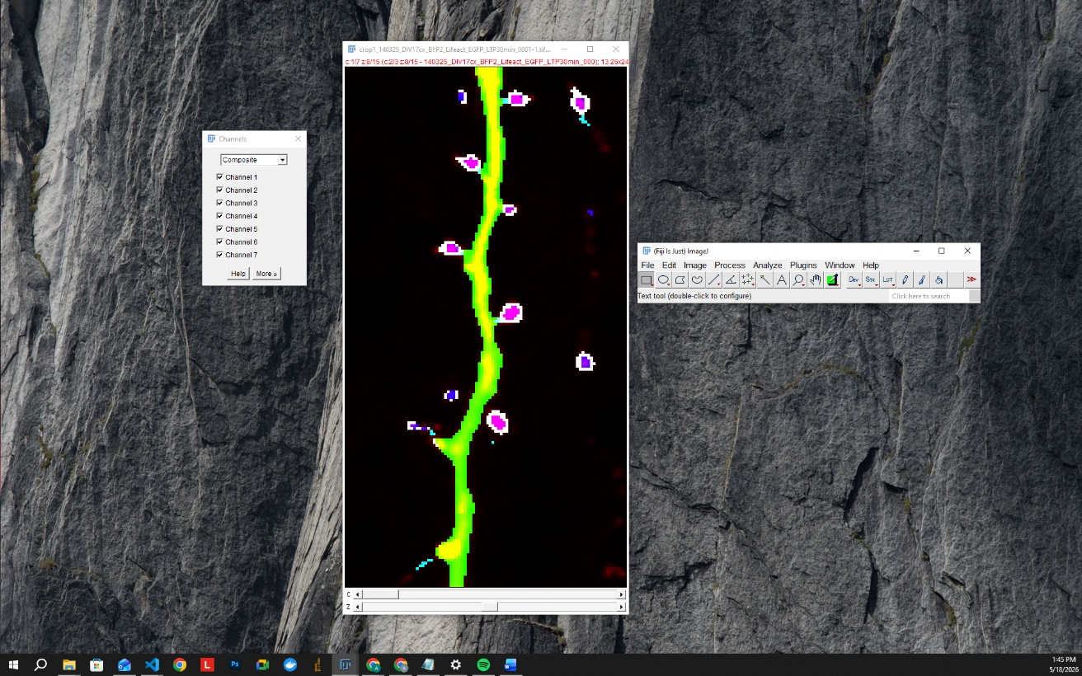
For the main channel (the raw image, Channel 0), please make sure to adjust the intensity properly. The goal is to clearly see all relevant structures without overexposing the image, as overexposure may lead to segmenting structures that are not actually present.
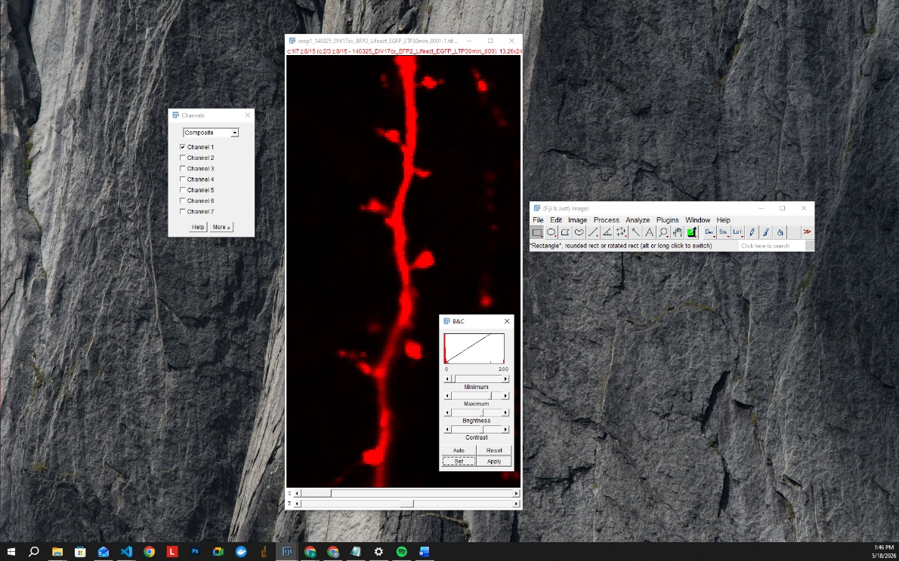
For correcting each segmentation channel, I suggest keeping only the raw image channel and the channel you are currently correcting visible. This makes the correction process much easier and clearer.
Before starting corrections, make sure you are actively selected on the correct channel. For example, if you are correcting spine necks, you must also be working directly on the spine neck channel.

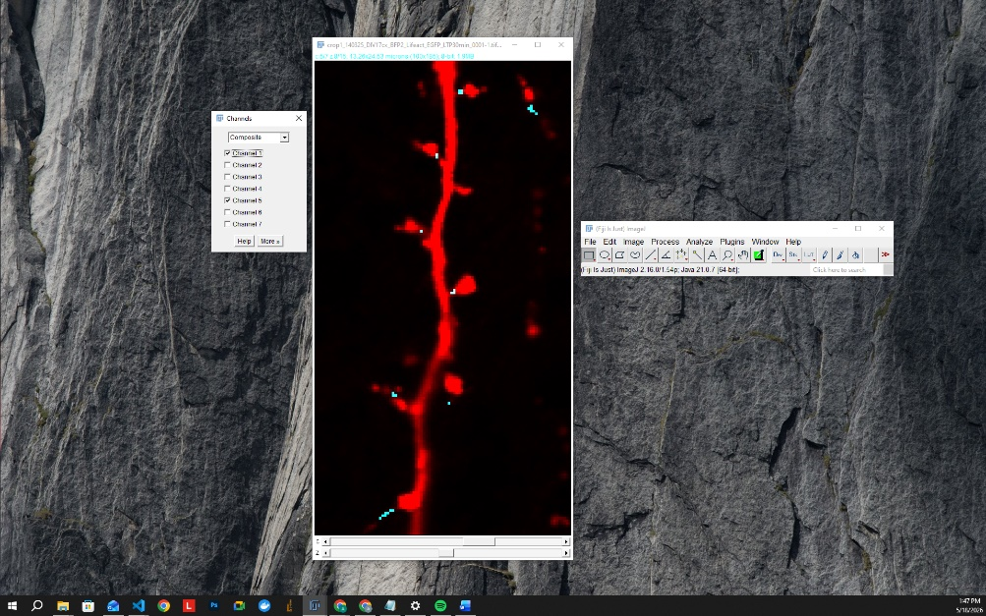
After selecting the correct channel, choose the color picker tool and select the exact same color as the channel you are editing. The brush color and the channel color should always match. Repeat this process whenever you switch to a different channel.

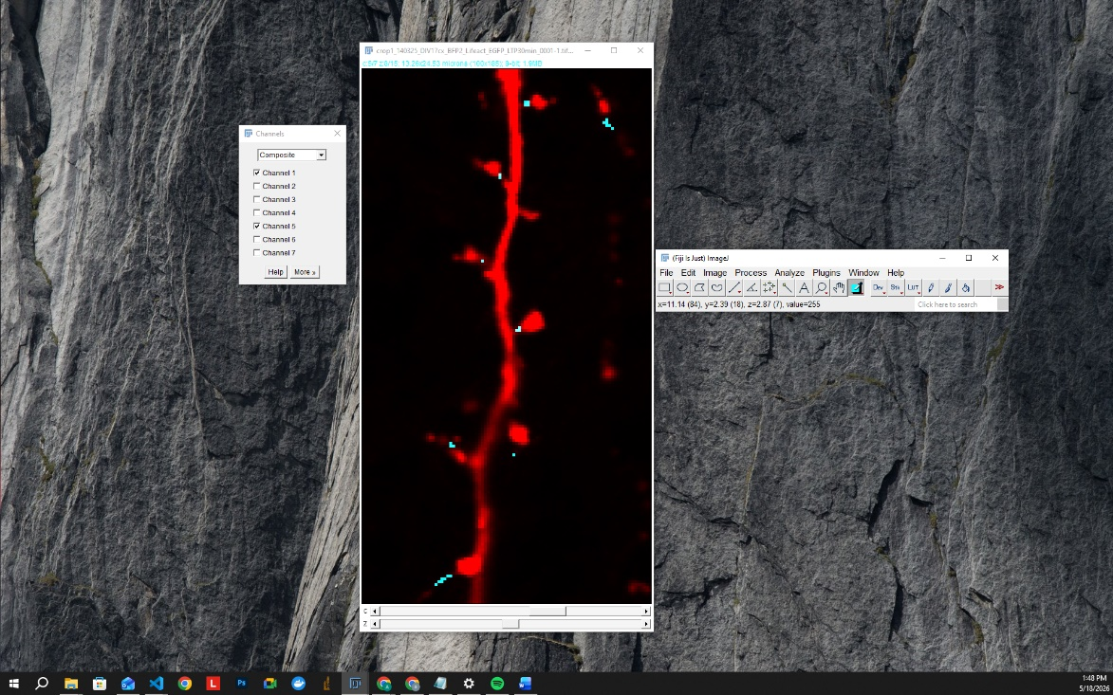

You can then double-click the brush tool to adjust the brush width. I recommend:
- 1–2 pixels for small structures such as necks
- 3–4 pixels for larger structures such as dendrites
In general, choose the brush size that gives you the best balance between accuracy and speed.
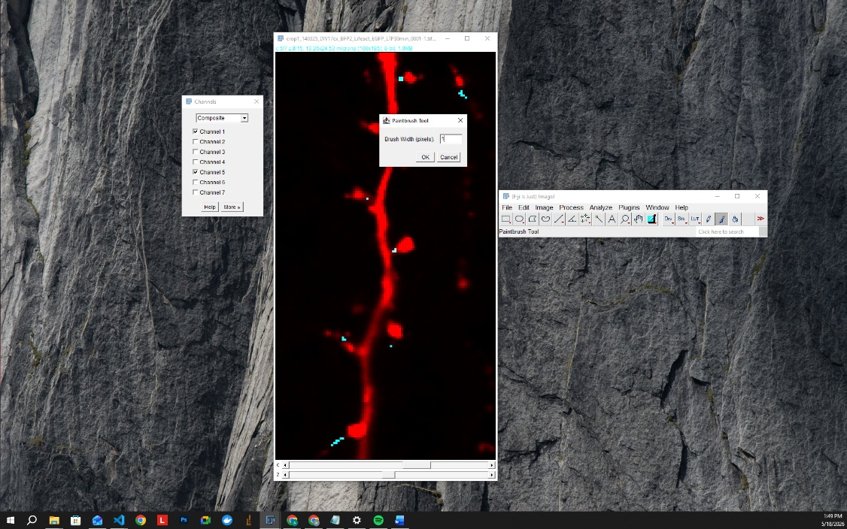
To add segmentation, click and drag on the image to paint.
To remove unwanted segmentation, hold Alt while clicking and dragging on the image.
Please remember to save the image once you are finished.
I also strongly recommend always keeping a backup copy of the original image before starting any work. Fiji does not reliably keep an undo history for these actions, so changes may not be recoverable once applied.

