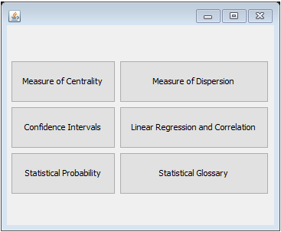

This is a rough GUI design for the main menu of our program giving users an obvious form of navigation through bold menus. Final version will be buttons with images referring to the buttons topic.

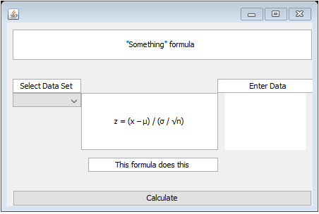

This is a GUI prototype of the calculator portion of the program. This is a rough format that will be duplicated across the program whenever the user enters the calculator for every different equation.

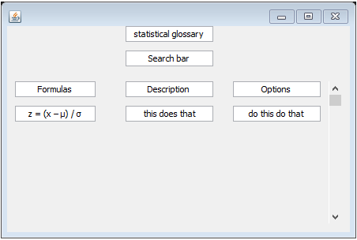

This is a rough GUI prototype of the statistical glossary with a search bar and a scroll bar. The final version will be formatted better to fit all the information with a functioning search bar and scroll bar.

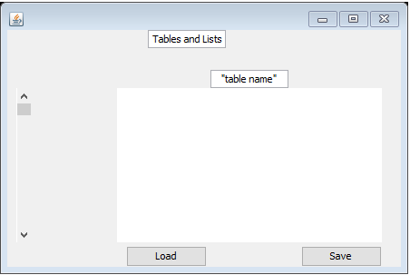

This is a rough GUI prototype of the programs data tables and lists section. Users will be able to access, load, save, and edit their data table here.