**$1.00 USA $2.00 CAN**

**LAKE COUNTY**

**SUNTIMES**

**BEARS HAVE IT IN THEM!**

**BEARS ARE DOING GOOD ENOUGH TO BEAT THE RAVENS,23-20.ON PAGE 2.**

**PAGE 1 SECTION 1**

**BLINDSIDED**

VERY UNEXPECTED

The severe thunderstorm that racked Illinois has caused tornadoes that damaged several areas in Coal City. The National Weather Service in Chicago issued tornado watches for every county.

See **DAMAGE** on **PAGE 3.**

**PAGE 2 SECTION 1**

**NEWS**

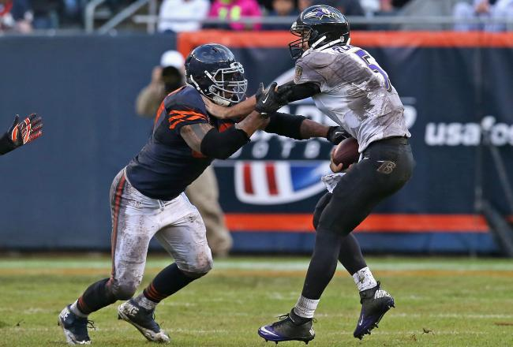

**TOP:#77.VS.#51 IN THE MUD**

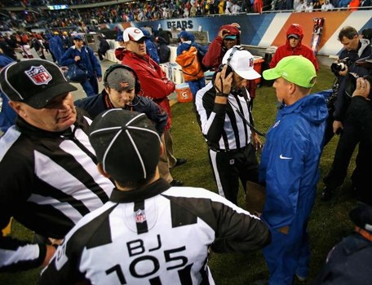

**HOME QUARTER GUEST**

**23 F 20**

**I**

**N**

**A**

**L**