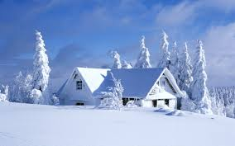

GILLESPIE WEATHER

SERVICE