January 20, 2022

To: FWC Cooperators

From: Bill Pine, University of Florida

After discussions with NFWF in December 2021 and Jim Estes in January 2022 I have been re-examining the “NFWF 1” clutching project from Apalachicola to try and learn how cultch material (lime rock, fossil shell, etc.), cultch density (amount of material per m2), and fishing (open/closed) affect oyster population dynamics on restored reefs in Apalachicola Bay. Improving our understanding of how these factors influence oyster reef restoration is important to inform proposed restoration efforts in Apalachicola in 2022.

Ryan Gandy with FWC provided a file “NFWF_RAW_UF_COPY.xlsx” and I have been working with that file to analyze these data. The file has multiple tabs and I am working with the datasheet tab that has the count data (sheet 3). The data contain -999 values in several categories to indicate missing values so I converted the -999 to NA throughout. Because stations are sampled in different months, I converted the months to seasons following the same pattern I use for Lone Cabbage in Suwannee Sound. April through September is the “summer” period, and October through March is the “winter” period. Because these data are from 2015-2019, the Apalachicola Bay is open to fishing.

Here is a summary table of the data

Table 1: Summary of quadrat data from each year, month, station, and the sum of the number of quadrats in data file NFWF_RAW_UF_copy.xlsx sheet 3

|  |  |  |  |  |
| --- | --- | --- | --- | --- |
| "Period" | "Year" | "Month" | "Station Name" | "Number Quadrats" |
| 2 | 2015 | 10 | "NFWF Bulkhead" | 75 |
| 2 | 2015 | 10 | "NFWF Dry Bar" | 74 |
| 2 | 2015 | 10 | "NFWF Hotel Bar" | 74 |
| 2 | 2016 | 1 | "NFWF Bulkhead" | 75 |
| 2 | 2016 | 2 | "NFWF Dry Bar" | 75 |
| 2 | 2016 | 2 | "NFWF Hotel Bar" | 75 |
| 3 | 2016 | 4 | "NFWF Bulkhead" | 75 |
| 3 | 2016 | 5 | "NFWF Dry Bar" | 75 |
| 3 | 2016 | 5 | "NFWF Hotel Bar" | 75 |
| 3 | 2016 | 7 | "NFWF Bulkhead" | 75 |
| 3 | 2016 | 7 | "NFWF Dry Bar" | 75 |
| 3 | 2016 | 8 | "NFWF Hotel Bar" | 75 |
| 4 | 2016 | 10 | "NFWF Bulkhead" | 75 |
| 4 | 2016 | 10 | "NFWF Dry Bar" | 75 |
| 4 | 2016 | 10 | "NFWF Hotel Bar" | 75 |
| 4 | 2017 | 1 | "NFWF Bulkhead" | 74 |
| 4 | 2017 | 1 | "NFWF Dry Bar" | 75 |
| 4 | 2017 | 1 | "NFWF Hotel Bar" | 74 |
| 4 | 2017 | 2 | "NFWF Bulkhead" | 1 |
| 4 | 2017 | 2 | "NFWF Hotel Bar" | 1 |
| 5 | 2017 | 4 | "NFWF Bulkhead" | 75 |
| 5 | 2017 | 4 | "NFWF Dry Bar" | 75 |
| 5 | 2017 | 4 | "NFWF Hotel Bar" | 75 |
| 5 | 2017 | 7 | "NFWF Bulkhead" | 75 |
| 5 | 2017 | 7 | "NFWF Hotel Bar" | 75 |
| 5 | 2017 | 8 | "NFWF Dry Bar" | 75 |
| 6 | 2017 | 10 | "NFWF Bulkhead" | 75 |
| 6 | 2017 | 10 | "NFWF Hotel Bar" | 75 |
| 6 | 2017 | 11 | "NFWF Dry Bar" | 75 |
| 6 | 2018 | 1 | "NFWF Bulkhead" | 75 |
| 6 | 2018 | 2 | "NFWF Dry Bar" | 75 |
| 6 | 2018 | 2 | "NFWF Hotel Bar" | 75 |
| 7 | 2018 | 4 | "NFWF Dry Bar" | 75 |
| 7 | 2018 | 4 | "NFWF Hotel Bar" | 75 |
| 7 | 2018 | 5 | "NFWF Bulkhead" | 75 |
| 7 | 2018 | 7 | "NFWF Bulkhead" | 75 |
| 7 | 2018 | 7 | "NFWF Hotel Bar" | 75 |
| 7 | 2018 | 8 | "NFWF Dry Bar" | 75 |
| 8 | 2018 | 11 | "NFWF Dry Bar" | 75 |
| 8 | 2018 | 11 | "NFWF Hotel Bar" | 75 |
| 8 | 2018 | 12 | "NFWF Bulkhead" | 75 |
| 8 | 2019 | 1 | "NFWF Bulkhead" | 75 |
| 8 | 2019 | 1 | "NFWF Dry Bar" | 75 |
| 8 | 2019 | 1 | "NFWF Hotel Bar" | 75 |
| 9 | 2019 | 4 | "NFWF Dry Bar" | 75 |
| 9 | 2019 | 4 | "NFWF Hotel Bar" | 75 |
| 9 | 2019 | 5 | "NFWF Bulkhead" | 75 |
| 9 | 2019 | 8 | "NFWF Hotel Bar" | 75 |
| 9 | 2019 | 9 | "NFWF Bulkhead" | 75 |
| 9 | 2019 | 9 | "NFWF Dry Bar" | 75 |

*Summary of live oyster counts*

To assess patterns in live oyster spat counts over time and space, I first plotted counts of live spat for all sites and years vs. cultch density. I used different colors for Station Names

*Figure 1. Fossil shell cultch (x-axis) treatments and live oyster spat (y-axis) at each Station (colored dots) in Apalachicola Bay for all years combined. The gold dot represents the mean live oyster for each cultch density.*

This plot suggests that as the amount of cultch increases, the number of live oysters increases, and this pattern seems to hold for all the Stations. I then checked to see if this pattern has held over the years.

*Figure 2. Fossil shell cultch (x-axis) treatments and live oyster spat (y-axis) at each Station (colored dots) in Apalachicola Bay, with each year plotted as a different panel. The gold dot represents the mean live oyster for each cultch density.*

This graph suggests an increase in the number of live spat at each station in the first year of 2015, but this declined by the end of the study in 2019. I then examined these counts by period and station to see if there are any indications of when the large change occurred.

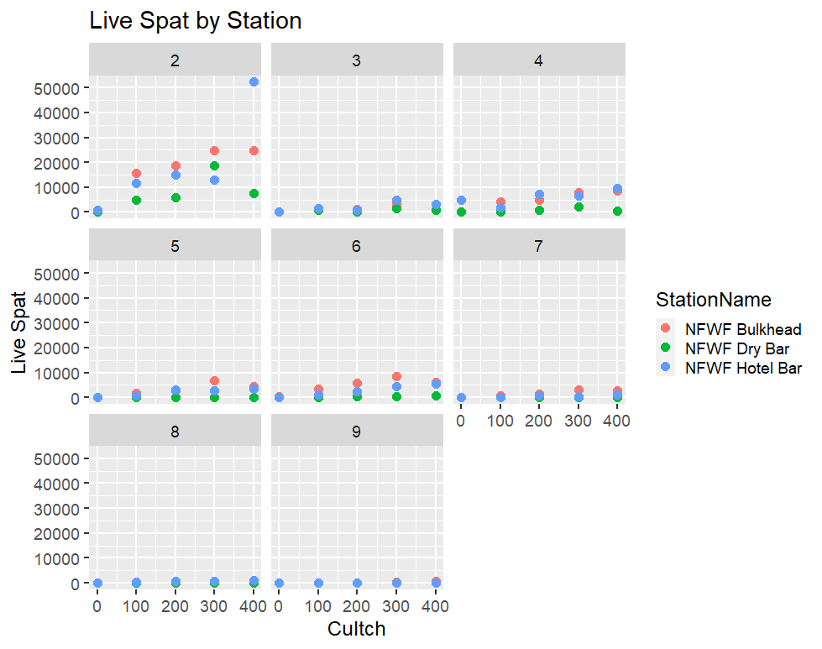

*Figure 3. The number of live oyster spat (y-axis) at different levels of cultch (x-axis) for each station (panels) and then by the station (colored dots).*

Based on Figure 3 it appears that the large decline in live spat occurred between Periods 2 (October 2015 to February 2016) and Period 3 (April 2016 and August 2016) and that these declines occurred at all Stations. Descriptive statistics for Hotel Bar for Periods 2 and 9 below are an example.

Table 2. Summary stats of live spat counts from Hotel Bar in Period 2.

|  |  |
| --- | --- |
| "Mean" | 623.55 |
| "Median" | 173 |
| "SD" | 1118.85 |
| "Var" | 1251830.61 |
| "CV" | 1.79 |
| "SE" | 91.66 |
| "L95SE" | 443.9 |
| "U95SE" | 803.2 |
| "BSMEAN" | 626.06 |
| "L95BS.2.5%" | 452.9 |
| "U95BS.97.5%" | 810.97 |

Table 3. Summary stats of live spat counts from Hotel Bar in Period 9.

|  |  |
| --- | --- |
| "Mean" | 1.41 |
| "Median" | 0 |
| "SD" | 2.62 |
| "Var" | 6.86 |
| "CV" | 1.86 |
| "SE" | 0.21 |
| "L95SE" | 0.99 |
| "U95SE" | 1.83 |
| "BSMEAN" | 1.4 |
| "L95BS.2.5%" | 1 |
| "U95BS.97.5%" | 1.88 |

Table 2 and Table 3 support observations from Figures 2 and 3 of large changes over time (Period) in live oyster spat counts.

*Summary of cultch material density treatments*

FWC personnel and others have described challenges in this restoration project with adding cultch material in a way that allowed the treatment densities to be distinct. Based on emails and discussion it appears that the density of shell material in the field may not have matched the original experimental design. To see if there were differences in the amount of cultch material at the different Stations, I plotted the “total weight” (y-axis) by period (x-axis) for each Station (panel of the graph) to see if the shell material persisted at the site.

*Figure 4. The total weight (y-axis) of material (live and dead cultch, I am assuming) from each quadrat by period for each Station (panel of the graph) and period (x-axis). The red dot is the mean value.*

Figure 4 suggests the amount of material (weight) declined over time. I then looked to see if these declines were similar across Period and Station.

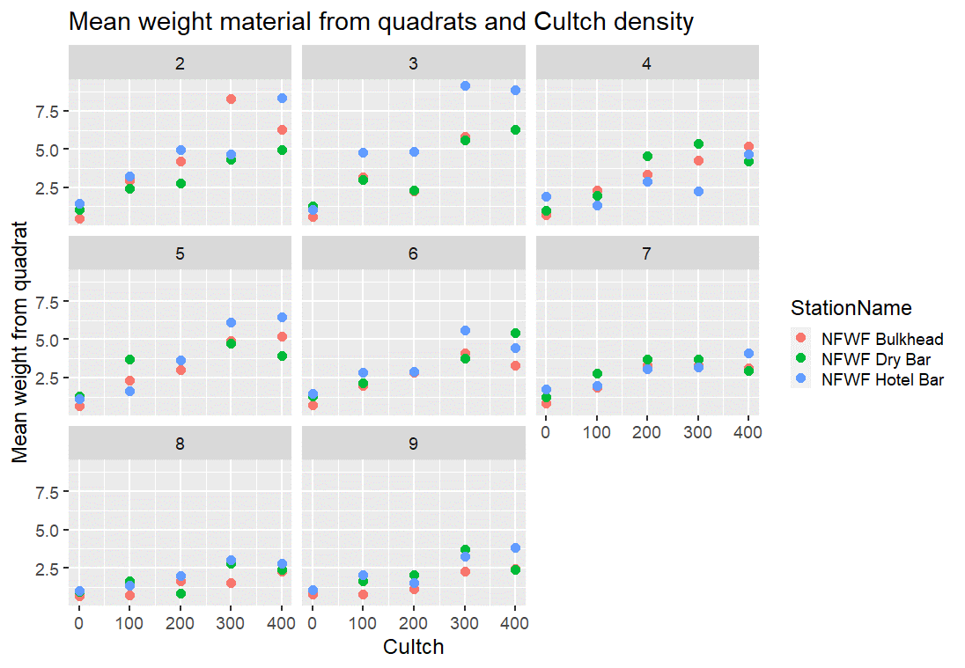

*Figure 5. The mean weight (y-axis) of material taken from quadrats at each Station (color dots) and Period (x-axis; number of quadrats in Table 1).*

The counts of live spat by period and station declined primarily between period 2 (winter 2015/2016) and 3 (spring/summer 2016) but the mean weight of the material does not appear to have declined at the same rapid rate. This change in mean weight over time by station could be analyzed formally, but Figure 5 suggests that cultch material did persist across all periods with higher biomass of cultch material at the higher cultch density locations – but critically oyster spat did not persist on the cultch material in the later periods at cultch densities that did support live oyster spat in period 2. This is a key observation and is supported in Figure 6 below. Here I have plotted the mean cultch weight (x-axis and live oyster spat counts on y-axis (limiting the y axis to 30,000 spat to make the plot more readable, which eliminated one data point), each color represents a different Station, and the plots are individual Periods of time. If you examined the weight values for example between 2.5 and 5.0 in each panel, you see that there were observations of this biomass of cultch (or more) in every period, but the number of live oyster spat produced for this level of cutch material declined. This is interesting because in Period 2 (first period) the cultch biomass of 2.5-5.0 appears to have produced the largest number of live oyster spat per cultch biomass and this return seems to have occurred in every Period. This again suggests if this level of biomass of cultch material persisted, why did the production of live oyster spat decline?

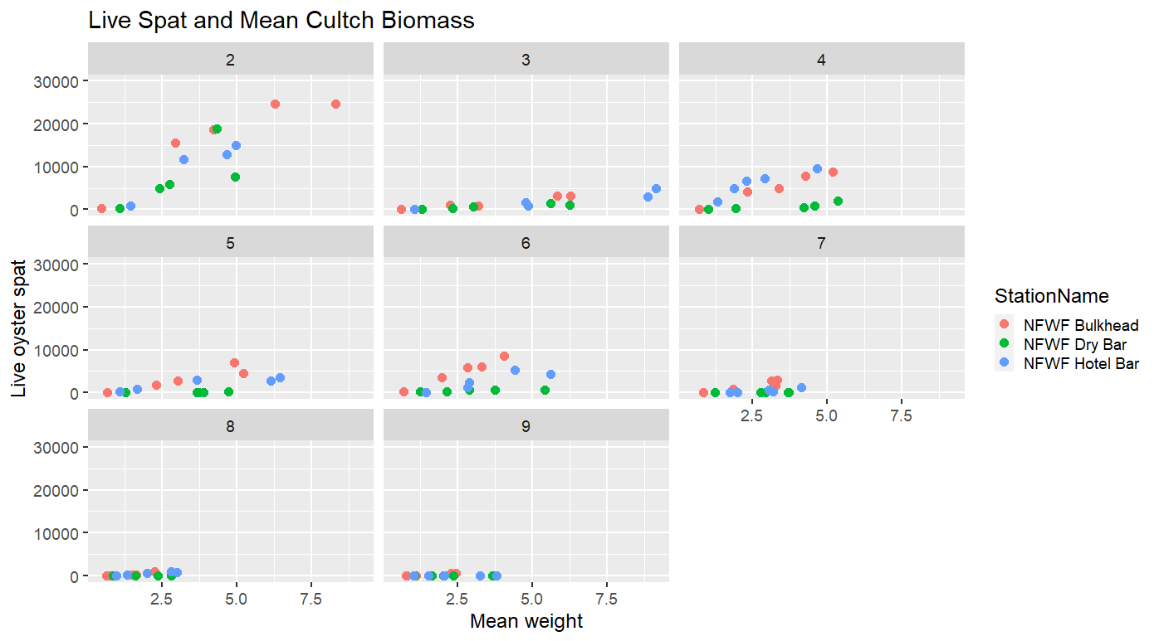

*Figure 6. Mean weight of oyster cultch material (x-axis) and counts of live oyster spat (y-axis; limited to 30,000 reducing one data point) for each Station (colored dots) and Period (panels).*

*Summary of observations from examining graphs of live oyster counts and cultch biomass*

My review of these graphs of data and simple summary statistics suggest that it will be very difficult to assess whether there is a relationship between cultch density and live oyster counts because of the large declines in live oyster counts between the first two sampling periods (periods 2 and 3). It appears the cultch material did perisist in higher biomass at the higher density sites, but this material also declined over time. Most importantly it appears that for a given biomass of cultch material, the production of live oyster spat declined over time, even if the environmental conditions from a river discharge and salinity perspective from one long-term monitoring location appear favorable for survival. This suggests that spat survival, colonization, substrate suitability, or other factors may have changed over just a few months.

*Using GLMs to assess relationships between live oyster counts, cultch density, time, oyster drills, and sampling station*

One of the original motivations of these analyses was to assess whether there are relationships between the number of live oysters and cultch density. These analyses would be useful to inform the amount of cultch material (density) that would support the most number of live oyster spat for planned cultch efforts during 2021. To assess this, I fit nine different GLM models to these data with each model representing different hypotheses of how specific factors including cultch biomass, cultch volume (treatment density), mean counts of oyster drills, year and sampling station all influence the observed counts of live oyster spat. For all analyses, I assumed the data follow a negative binomial distribution because of the dispersion in the count data (variance larger than mean). Models compared were

Table 5. List of competing models fit to the FWC data extracted from R code. Period = period of time, StationName = sampling station, Cultch = density of cultch treatment, Drills = mean number of oyster drills from all quadrats at a location in a given period, Season = winter (odd Periods) or summer (even Periods).

m1 <- glm.nb(LiveSpat ~ Period + offset(log(Num_quads)), data = d5)

m2 <- glm.nb(LiveSpat ~ Period + StationName + offset(log(Num_quads)),

data = d5)

m3 <- glm.nb(LiveSpat ~ Period * StationName + offset(log(Num_quads)),

data = d5)

m4 <- glm.nb(LiveSpat ~ Cultch + offset(log(Num_quads)), data = d5)

m5 <- glm.nb(LiveSpat ~ Cultch + Period + offset(log(Num_quads)), data = d5)

m6 <- glm.nb(LiveSpat ~ Cultch + Period + StationName +

offset(log(Num_quads)), data = d5)

m7 <- glm.nb(LiveSpat ~ Cultch + Period + StationName + season +

offset(log(Num_quads)), data = d5)

m8 <- glm.nb(LiveSpat ~ Drills + offset(log(Num_quads)), data = d5)

m9 <- glm.nb(LiveSpat ~ Cultch + Period + StationName + season + Drills +

offset(log(Num_quads)), data = d5)

and each model includes the number of quadrats as an offset to account for the differences in quadrats collected in each period. I am predicting the count of live spat (not density) while controlling for effort (number of quadrats). I compared how well each model fit the data using AIC and then graphically assessed the performance of the best-fit model by comparing predicted values to observed for Period 9.

*Results of GLM analyses*

The best-fit model from an AIC perspective was m9 (cultch+period+station+season+drills)which was about 118 AIC units lower than model 8 (drills).

AIC table comparing competing models

K AIC Delta_AIC AICWt Cum.Wt LL

cultch+period+station+season+drills 8 1024.84 0.00 1 1 -504.42

drills 3 1142.75 117.92 0 1 -568.38

cultch+period+station+season 7 1855.38 830.54 0 1 -920.69

cultch+period+station 6 1883.05 858.21 0 1 -935.52

period * station 7 1926.83 902.00 0 1 -956.42

period + station 5 1927.52 902.68 0 1 -958.76

cultch + period 4 1934.68 909.85 0 1 -963.34

period 3 1973.16 948.33 0 1 -983.58

cultch 3 2021.93 997.09 0 1 -1007.97

If you examine the results of m9

> summary(m9)

Call:

glm.nb(formula = LiveSpat ~ Cultch + Period + StationName + season +

Drills + offset(log(Num_quads)), data = d5, init.theta = 1.451595305,

link = log)

Deviance Residuals:

Min 1Q Median 3Q Max

-2.7676 -0.9507 -0.1901 0.4075 2.4459

Coefficients:

Estimate Std. Error z value Pr(>|z|)

(Intercept) 6.5325682 0.5894382 11.083 < 2e-16 ***

Cultch 0.0053369 0.0007606 7.017 2.27e-12 ***

Period -0.6578224 0.0797664 -8.247 < 2e-16 ***

StationNameNFWF Dry Bar -2.6292104 0.2680035 -9.810 < 2e-16 ***

StationNameNFWF Hotel Bar -0.8723838 0.2526959 -3.452 0.000556 ***

seasonWinter 0.9307573 0.1973669 4.716 2.41e-06 ***

Drills 0.1221744 0.0951477 1.284 0.199124

---

Signif. codes: 0 ‘***’ 0.001 ‘**’ 0.01 ‘*’ 0.05 ‘.’ 0.1 ‘ ’ 1

(Dispersion parameter for Negative Binomial(1.4516) family taken to be 1)

Null deviance: 356.921 on 74 degrees of freedom

Residual deviance: 83.653 on 68 degrees of freedom

(45 observations deleted due to missingness)

AIC: 1024.8

Number of Fisher Scoring iterations: 1

Theta: 1.452

Std. Err.: 0.222

2 x log-likelihood: -1008.836

>

You see that Drills is not significant. Cultch, Period, Station and Season were all significant factors in the model. Cultch had a positive relationship with the number of live spat and for every unit (cubic yard) increase in Cultch there was a 0.005 increase in the number of live spat. In simpler terms for every 100 cubic yards of fossil shell, there was an increase of about 0.5 live spat. Period of time had a negative relationship with the number of live spat (as observed in plots of raw data). For each period of time, the number of live spat declined on average by about 0.66 live spat per quadrat per time step. When Station is examined these are mean effects which are reported as differences from the baseline factor (ordered alphabetically, so Bulkhead is first). Dry Bar was lower by about 2.15 live oyster spat per cubic yard shell and Hotel Bar by about 0.49 live oyster spat per cubic yard of shell. Higher live oyster spat were observed on average in winter (about 1.07) than in summer.

If you examine the results of a similar model but without the mean number of Drills (m7), the overall results are similar

> summary(m7)

Call:

glm.nb(formula = LiveSpat ~ Cultch + Period + StationName + season +

offset(log(Num_quads)), data = d5, init.theta = 1.17729948,

link = log)

Deviance Residuals:

Min 1Q Median 3Q Max

-2.5887 -1.0438 -0.3363 0.3793 1.7829

Coefficients:

Estimate Std. Error z value Pr(>|z|)

(Intercept) 5.5618182 0.3062631 18.160 < 2e-16 ***

Cultch 0.0060525 0.0005979 10.123 < 2e-16 ***

Period -0.5726926 0.0378345 -15.137 < 2e-16 ***

StationNameNFWF Dry Bar -2.1512225 0.2071858 -10.383 < 2e-16 ***

StationNameNFWF Hotel Bar -0.4924178 0.2064003 -2.386 0.017 *

seasonWinter 1.0676521 0.1729641 6.173 6.71e-10 ***

---

Signif. codes: 0 ‘***’ 0.001 ‘**’ 0.01 ‘*’ 0.05 ‘.’ 0.1 ‘ ’ 1

(Dispersion parameter for Negative Binomial(1.1773) family taken to be 1)

Null deviance: 526.44 on 119 degrees of freedom

Residual deviance: 135.65 on 114 degrees of freedom

AIC: 1855.4

Number of Fisher Scoring iterations: 1

Theta: 1.177

Std. Err.: 0.138

2 x log-likelihood: -1841.375

>

I then used the parameters from m7 to predict the number of live oyster spat in winter and summer for period 9 as an evaluation of model performance (how well does the model fit the data).

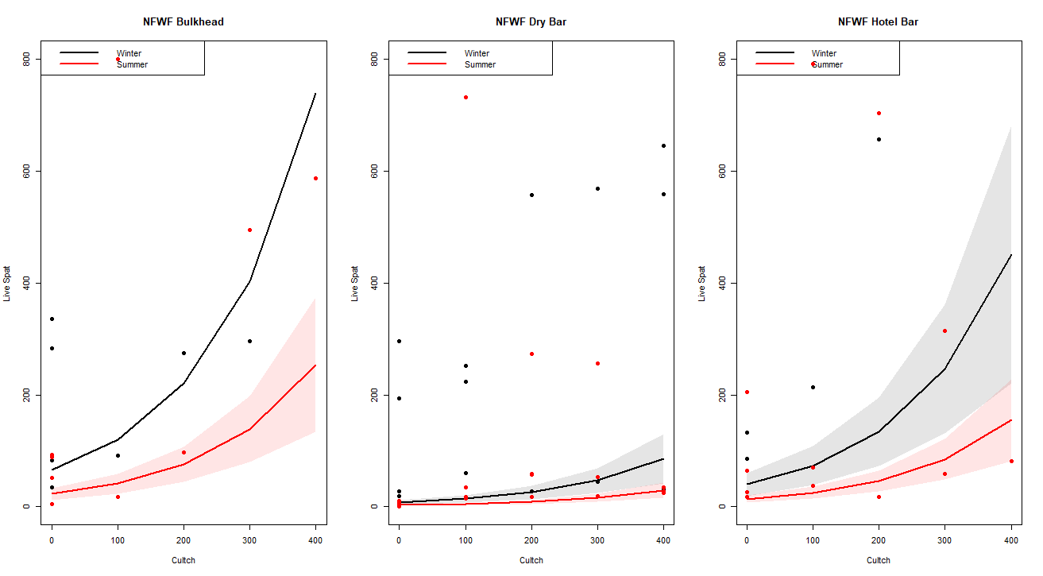

*Figure 7. Predicted live oyster spat (y-axis) at each Station (panels) for winter (black line) and summer (red line) at different cultch densities (x-axis). Black dots are observed data for winter and red dots are observed data for summer. Shaded area is the 95% confidence limits on the predicted values.*

This plot (Figure 7) demonstrates that the model is not very good at predicting the number of live spat. While m9 is the best fitting model from an AIC perspective and models m9 and m7 have similar parameters, neither are very good models. This is likely because the number of live oysters is so low at each location and at each clutching density after period 2.

I then included the mean Total Weight of cultch material across all the quadrats in a sample in similar models as previous, but without Drills. Mean Total Weight was significant, but for every 100 units of total weight there was only an increase of about 0.48 live oyster spat.

> summary(m7.1)

Call:

glm.nb(formula = LiveSpat ~ Cultch + Mean_weight + Period + StationName +

Drills + season + offset(log(Num_quads)), data = d7, init.theta = 1.590246476,

link = log)

Deviance Residuals:

Min 1Q Median 3Q Max

-2.6363 -1.0328 -0.2684 0.5331 2.2784

Coefficients:

Estimate Std. Error z value Pr(>|z|)

(Intercept) 4.865733 0.748303 6.502 7.91e-11 ***

Cultch 0.002342 0.001169 2.004 0.04503 *

Mean_weight 0.487786 0.152627 3.196 0.00139 **

Period -0.498219 0.089748 -5.551 2.84e-08 ***

StationNameNFWF Dry Bar -2.724530 0.256466 -10.623 < 2e-16 ***

StationNameNFWF Hotel Bar -0.966645 0.248117 -3.896 9.78e-05 ***

Drills -0.010857 0.101807 -0.107 0.91507

seasonWinter 1.113825 0.198113 5.622 1.89e-08 ***

---

Signif. codes: 0 ‘***’ 0.001 ‘**’ 0.01 ‘*’ 0.05 ‘.’ 0.1 ‘ ’ 1

(Dispersion parameter for Negative Binomial(1.5902) family taken to be 1)

Null deviance: 390.612 on 74 degrees of freedom

Residual deviance: 82.916 on 67 degrees of freedom

(45 observations deleted due to missingness)

AIC: 1018.8

Number of Fisher Scoring iterations: 1

Theta: 1.590

Std. Err.: 0.246

2 x log-likelihood: -1000.778

>

*Discussion*

The extreme decline in live oyster spat between periods 2 and 3 makes it very difficult to fit simple models to these data to assess the relationships between clutching density and counts of live oyster spat. Reasons for this decline are not known.

Period 2 includes samples from October 2015 and through February 2016. Apalachicola River discharge during Period 2 was lower than the long-term average from the period of record in October but above average for the other months (Figure 8). Period 3 includes April through August 2016 samples and during these months Apalachicola River discharge was between 10-25% below the period of record average for April and May and between 50-75% below the period of record average for June through January 2017 (Figure 8). The relationship between river discharge and oyster populations in Apalachicola Bay is complicated (Fisch and Pine 2016) and an area for additional work. I next extracted salinity data from the NERRS Cat Point monitoring station and examined monthly means (Figure 9) for this same time period and monthly mean salinity values did approach 30 during late fall 2016, but it is unknown if this would have reached lethal levels for oyster spat. Additional water quality data from various sondes and hand-held instruments from a variety of locations in Apalachicola Bay are available and these data could be included as covariates to try and explain observed declines in live oyster spat between Periods 2 and 3. One idea is to calculate rolling averages of 3, 5, 10 day salinity patterns or calculate the percentage of time in the prior period the salinity, DO, or other parameter was below an identified lethal limit.

Reasons for live oyster spat persisting in Periods 3-9 include substrate material failure, water quality conditions, and predators. Figure 6 suggests substrate did persist in all periods but live oyster spat did not colonize this material. Because the material was available, perhaps the material was not suitable? Fossil shell is highly erodible but it is unlikely that shell would have eroded from suitable in Period 2 to unsuitable in Period 3, less than 6 months later. DEP conducted a similar clutching study using limestone as the cultch material and a constant density of 300 yards per acreyp beginning in 2017. Joint analyses (combining DEP and FWC datasets) would allow an assessment of whether the reason the cultch material (limestone vs. fossil shell) produces more live oyster spat. Counts of oyster drills were available beginning in period 5, which is after the large observed decline in live oyster spat making it difficult to draw any inference on the role of drills in influencing the decline in live oyster spat at these stations.

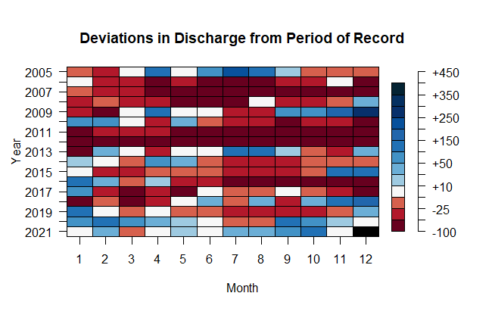

*Figure 8. Heat map of Apalachicola River discharge measured at USGS 02358000 Chattahoochee gage. The colors are percentage deviations from the period of record mean daily discharge. Negative values are months when discharge is below the mean period of record and positive values are months where discharge is above the mean period of record value.*

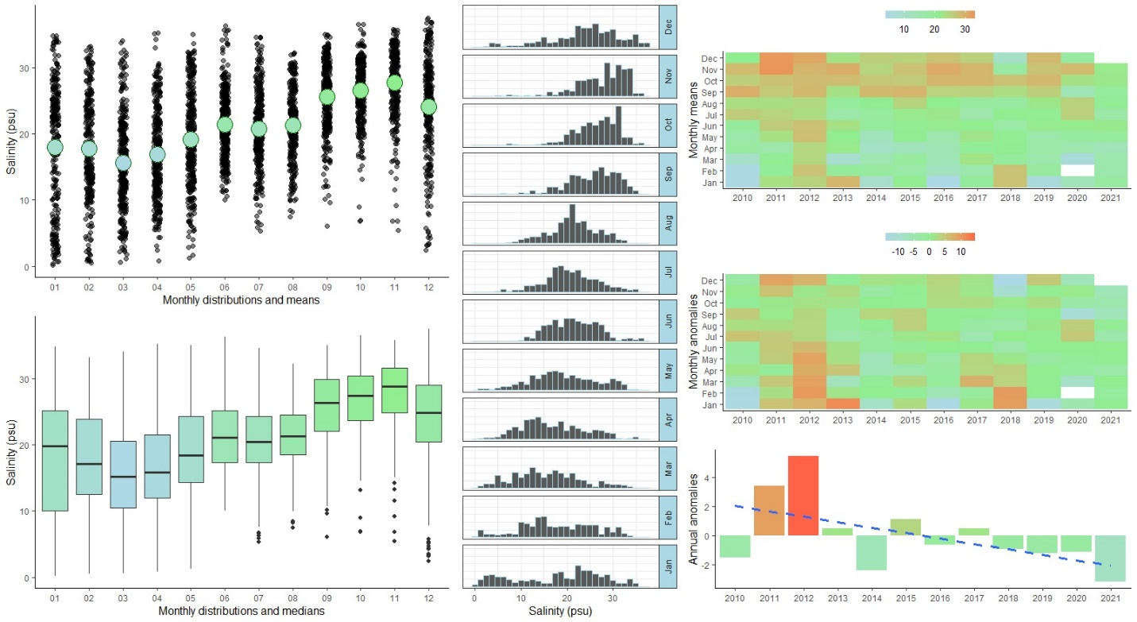

*Figure 9. Monthly and annual estimates of salinity for Cat Point using data from the NERRS Station and plotting functionality from the SWPR R package. Of particular interest are the heat maps on the far right column which show monthly means (top figure, right column), monthly anomalies (middle figure, right column), and annual anomalies (bottom figure, right column) for salinity.*

*Next steps*

(1) Joint analyses with DEP data to test for differences in cultch material.

(2)Assess water quality parameters from NERRS stations and other continuous monitoring locations to assess water quality during Periods 2 and 3.

(3) Clarify learning from this study. It does not appear that the addition of fossil shell as a cultch material promoted colonization and persistence of live oyster spat over time. Does this suggest the system is not substrate limited? Was this not a suitable substrate? Were the cultch sites too distance from extant wild oyster bars to allow for settlement in each year?