Basic summary stats for each reef

| **Reef** | **Count_rocks** | | **Mean_elev** | | **Max_elev** | | **SD_elev** | | **CV_elev** | |
| --- | --- | --- | --- | --- | --- | --- | --- | --- | --- | --- |
|  |  | |  | |  | |  | |  | |
|  |  |  | |  | |  | |  | |  |
| **1** | 10B | 164 | | -1.647945 | | -0.849 | | 0.4158565 | | -25.23485 |
| **2** | 12 | 287 | | -1.712352 | | -1.256 | | 0.4064637 | | -23.73716 |
| **3** | 14 | 158 | | -1.884399 | | -1.416 | | 0.5316076 | | -28.21099 |
| **4** | 17 | 283 | | -1.785216 | | -1.335 | | 0.4881881 | | -27.34617 |

How many rocks were measured on each element again?

| **Element_id_3** | | **num_rocks** | |
| --- | --- | --- | --- |
|  |  | |  |
| **1** | 10B | | 164 |
| **2** | 12 | | 287 |
| **3** | 14 | | 158 |
| **4** | 17 | | 283 |

Are there any over? Yes

| **Element_id_3** | | **count_over** | |
| --- | --- | --- | --- |
|  |  | |  |
| **1** | 10B | | 9 |

9 rocks are over on 10B

So 9 rocks over on 10B our of 164 measured or 5.5%

Are there any under? Yes

| **Element_id_3** | | **count_under** | |
| --- | --- | --- | --- |
|  |  | |  |
| **1** | 10B | | 17 |
| **2** | 12 | | 40 |
| **3** | 14 | | 22 |
| **4** | 17 | | 37 |

As example, 40 are under on reef 12 and 287 rocks were measured. That’s about 14%

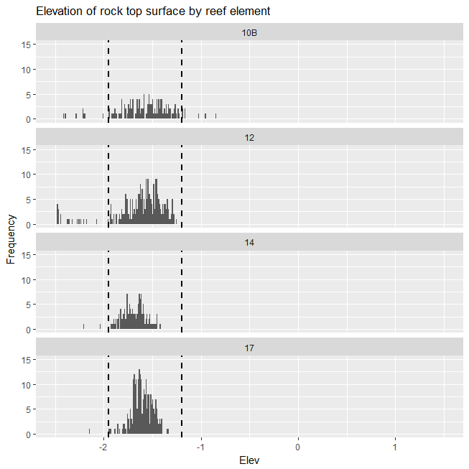

These are the histograms by elevation (x axis) and frequency (y axis). The vertical dashed lines are the specified target ranges for the elevations.

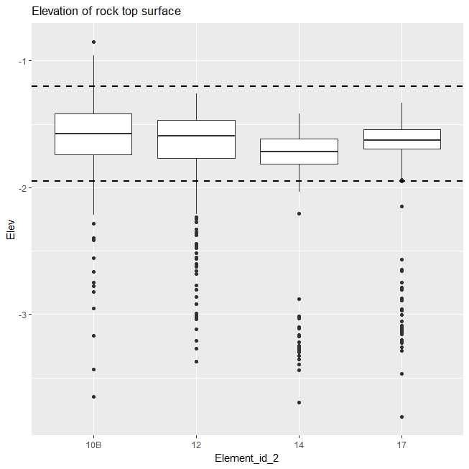

These are the same box plots we’ve been looking at.