Summary stats by reef

| **Reef** | **Count_rocks** | | **Mean_elev** | | **Max_elev** | | **Min_elev** | | **SD_elev** | | **CV_elev** | |
| --- | --- | --- | --- | --- | --- | --- | --- | --- | --- | --- | --- | --- |
|  |  |  | |  | |  | |  | |  | |  |
| **1** | 2 | 80 | | -1.678138 | | -0.82200 | | -2.84400 | | 0.3477776 | | -20.72402 |
| **2** | 3 | 139 | | -1.738367 | | -1.02400 | | -2.84300 | | 0.3549143 | | -20.41653 |
| **3** | 4 | 51 | | -1.710000 | | -1.24000 | | -2.80300 | | 0.3501763 | | -20.47815 |
| **4** | 5 | 52 | | -1.732365 | | -1.19700 | | -2.89600 | | 0.4577192 | | -26.42163 |
| **5** | 6 | 58 | | -1.821741 | | -1.23400 | | -2.94600 | | 0.4263229 | | -23.40194 |
| **6** | 8B | 81 | | -1.824630 | | -1.35900 | | -3.18900 | | 0.3997369 | | -21.90784 |
| **7** | 9A | 53 | | -1.747604 | | -1.28400 | | -3.67900 | | 0.4542060 | | -25.99022 |
| **8** | 9B | 374 | | -1.568152 | | -1.14200 | | -4.14800 | | 0.3085549 | | -19.67633 |
| **9** | 10A | 227 | | -1.572480 | | -1.14800 | | -3.48400 | | 0.3236324 | | -20.58102 |
| **10** | 10B | 164 | | -1.647945 | | -0.84900 | | -3.64800 | | 0.4158565 | | -25.23485 |
| **11** | 11A | 74 | | -1.603932 | | -1.19800 | | -3.46100 | | 0.4255941 | | -26.53442 |
| **12** | 11B | 217 | | -1.618871 | | -1.19800 | | -3.12200 | | 0.3672609 | | -22.68623 |
| **13** | 12 | 287 | | -1.712352 | | -1.25600 | | -3.36900 | | 0.4064637 | | -23.73716 |
| **14** | 13 | 161 | | -1.976866 | | -1.42437 | | -3.36319 | | 0.3453644 | | -17.47030 |
| **15** | 14 | 158 | | -1.884399 | | -1.41600 | | -3.69600 | | 0.5316076 | | -28.21099 |
| **16** | 15 | 229 | | -1.796419 | | -1.33300 | | -3.68800 | | 0.4687917 | | -26.09589 |
| **17** | 16 | 283 | | -1.708565 | | -1.05600 | | -3.61000 | | 0.3607989 | | -21.11707 |
| **18** | 17 | 283 | | -1.785216 | | -1.33500 | | -3.80900 | | 0.4881881 | | -27.34617 |
| **19** | 18 | 180 | | -2.039889 | | -1.30000 | | -3.91500 | | 0.5951644 | | -29.17632 |
| **20** | 19 | 432 | | -1.918174 | | -1.28100 | | -3.96500 | | 0.5088661 | | -26.52868 |
| **21** | 20 | 380 | | -1.998953 | | -1.27100 | | -4.23200 | | 0.6042306 | | -30.22736 |
| **22** | 21 | 250 | | -1.975744 | | -1.27000 | | -3.77000 | | 0.5364273 | | -27.15065 |
| **23** | 22 | 267 | | -1.926569 | | -1.38100 | | -3.63300 | | 0.4733981 | | -24.57208 |

Histogram of elevations

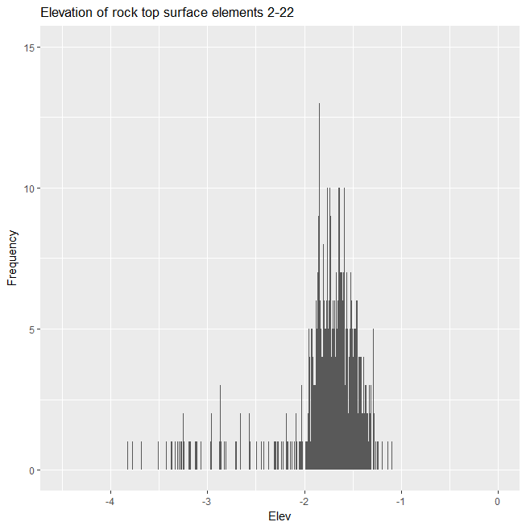

Box plot

