Background

In an effort to provide both training for new team members as well as help everyone think about the challenges that occur when we work to count abundance of anything, we constructed a series of fake rocks of similar size and shape to the rocks used as part of the Lone Cabbage Reef (LCR) restoration project. We then attached known numbers of surrogate oysters to these rocks with the counts based on observed densities from earlier field efforts. We tracked how many oysters were counted by different observers and recorded these counts. The counts were only known to the observer and the person recording the data as to not bias the other observers. We recorded the experience of the observer as someone who had done similar types of counts or not. Rocks were arranged in three ways:

(1) Sentinel rocks were set aside for people to walk around and count all the paper oysters. This would mimic the idea of establishing some number of labeled rocks that would be repeatedly visited over time to track how oyster abundance on that specific rock changes over time.

(2) “Transect close” was a rock arrangement that mimicked the paper rocks being very close and even touching each other. A standard transect (6” wide) was deployed over the rocks and the observers were instructed to count all oysters within the transect “looking straight down” the transect toward the ground.

(3) “Transect spaced” was similar to #2 but the rocks were more spaced out.

Counts were compiled and summaries made to examine variation among observers as well as variation in counts by rock layout and density of oysters on each rock.

Thanks to Nick Fisch for helping compile the graphs. Code and data available on GitHub.

https://github.com/billpine/paper_rock

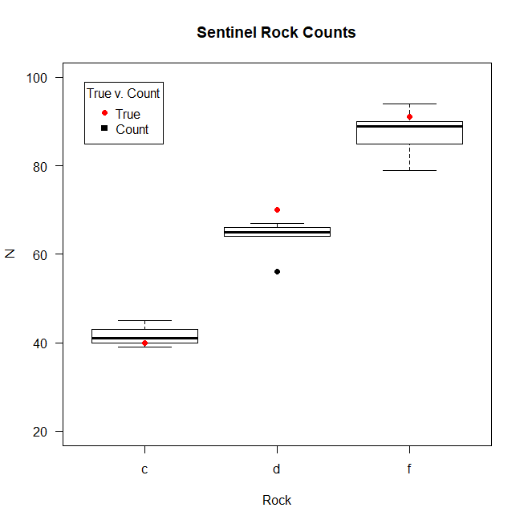

Figure 1. Counts (y-axis) by all observers combined of paper oysters on sentinel rocks (rocks c, d, f). The true number of oysters on each rock are indicated by red dot for each rock.

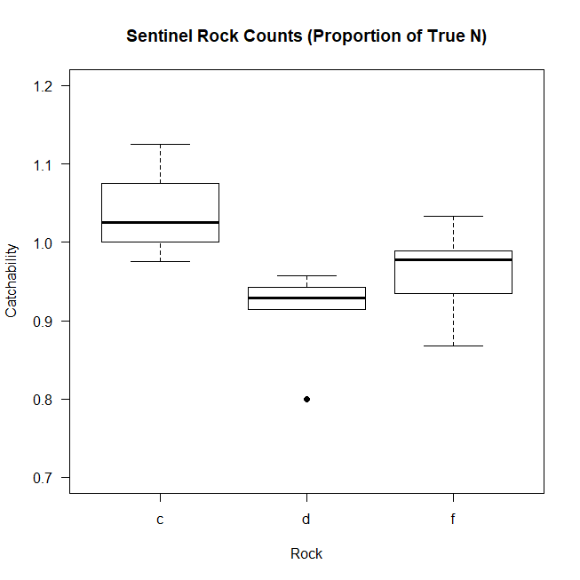

Figure 2. Catchability (proportion of true abundance of oysters on a rock) for sentinel rocks (rocks c, d, and f) by all observers combined.

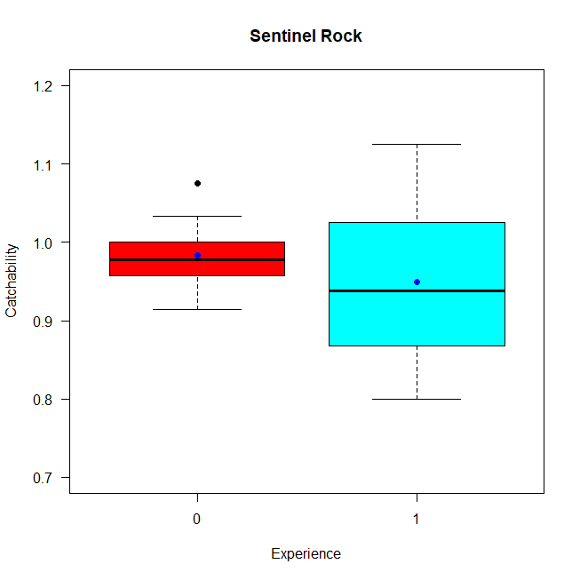

Figure 3. Catchability of paper oysters by observer experience level. Experience = 0 is new team member Experience = 1 is returning team member. The blue dot is the mean count across observers with each experience level.

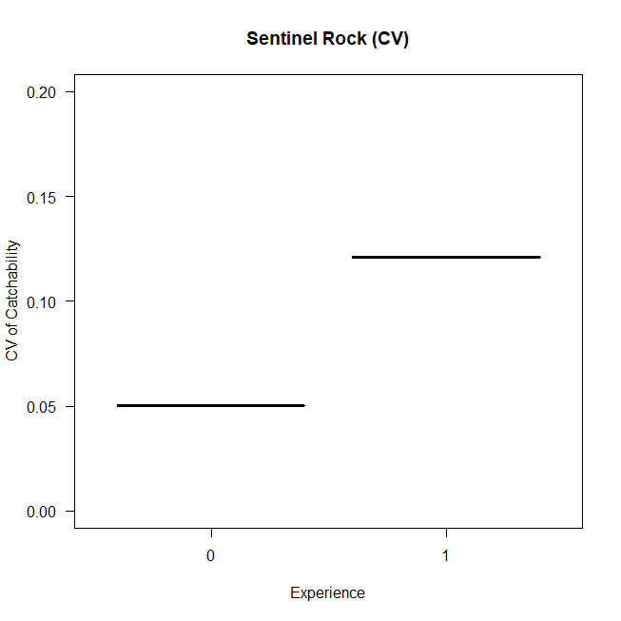

Figure 4. CV of catchability by experience. Experience = 0 is a new team member while Experience = 1 is a returning team member.

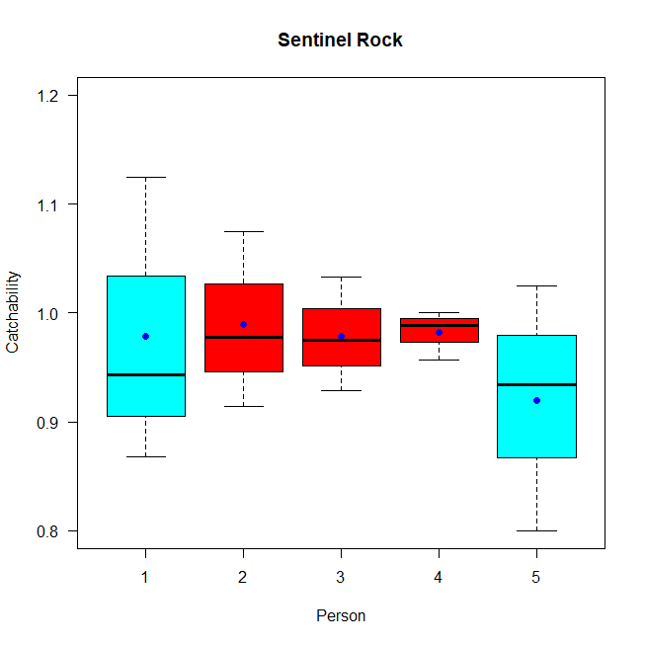

Figure 5. Catchability on the sentinel rocks by observer. The blue boxes are experienced observers and the red boxes are inexperienced observers.

The remaining graphs are from transects.

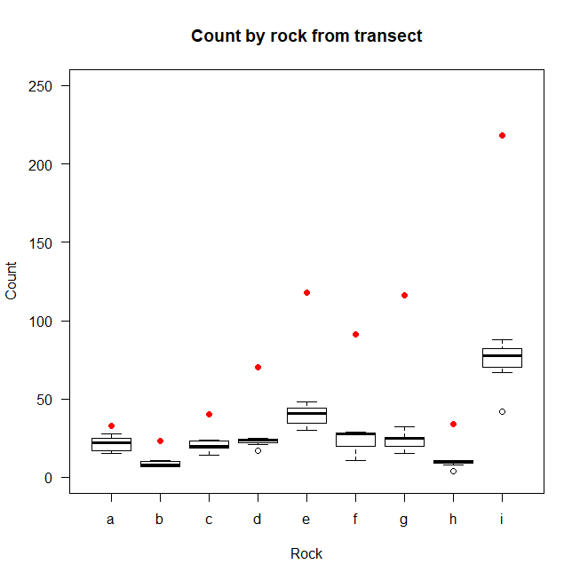

Figure 6. Counts (y axis) of paper rocks (x axis) by all observers (box plots). True paper oyster count on each rock are shown by the red dots.

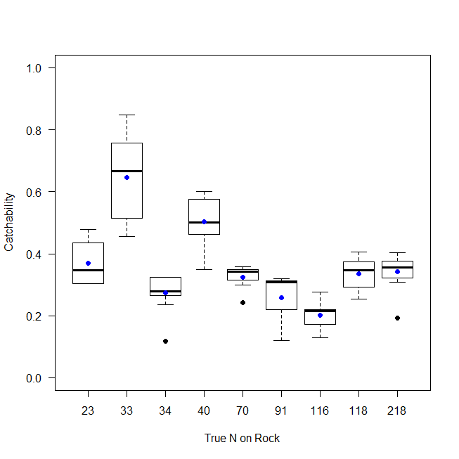

Figure 7. Catchability (y axis) of oysters from transect sample counts. Number of oysters counted was recorded for each paper rock, and the true number of oysters on that rock are known (x axis). The mean of the counts by all observers is shown as a blue dot while the box plots demonstrate the variation in counts by all observers.

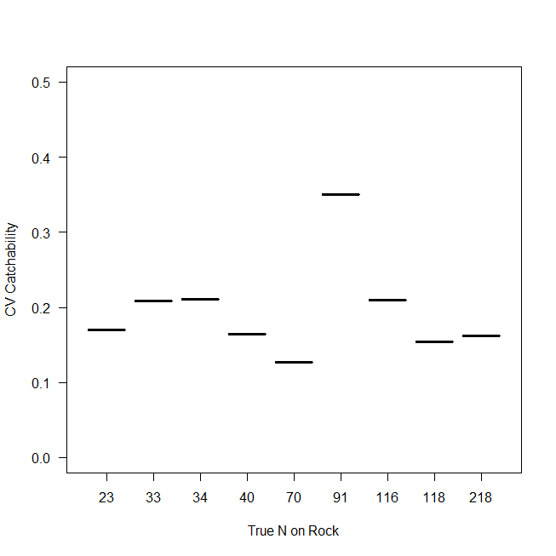

Figure 8. CV in catchability (y axis) of oysters from transect sample counts. Number of oysters counted was recorded for each paper rock, and the true number of oysters on that rock are known (x axis). The mean of the counts by all observers is shown as a blue dot while the box plots demonstrate the variation in counts by all observers.

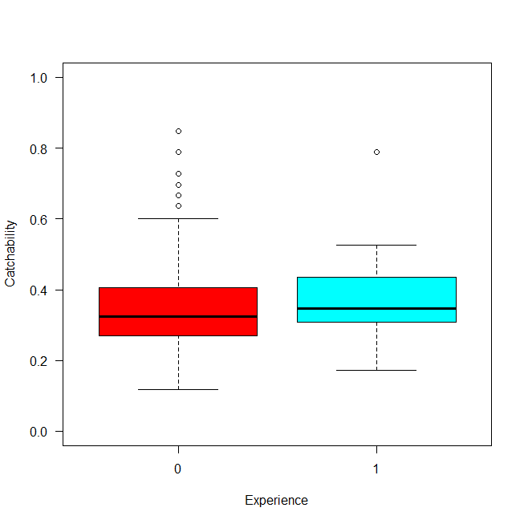

Figure 9. Catchability (y axis) of oysters on rocks as counted via transect by new team members (x axis, Experience = 0) and returning team members (x axis, Experience = 1).

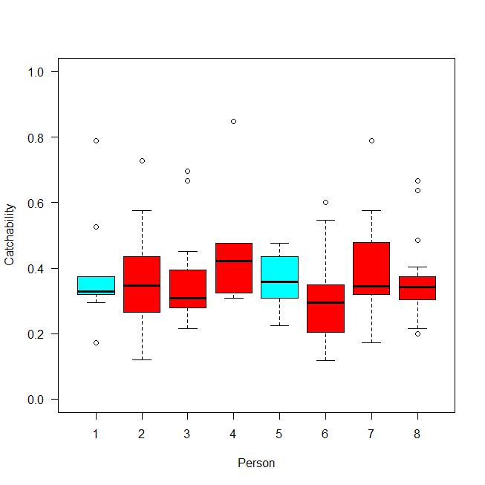

Figure 10. Catchability of paper oysters from transects by observer. The blue boxes are experienced observers and the red boxes are inexperienced observers.

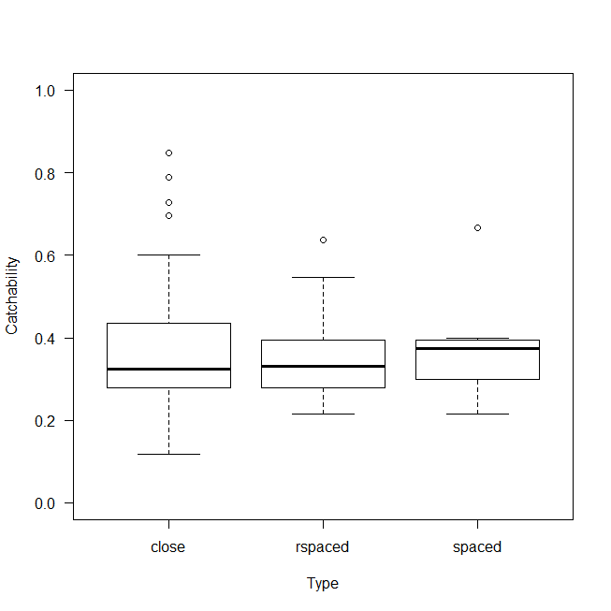

Figure 11. This is the catchability of paper oysters from transect counts (y axis) by rock spacing type. Close was simply the “standard” way the transects counted with the rocks touching. Rspaced is the same rock configuration, but we just reversed the direction the counting occurred on the transect. Spaced is simply removing a couple of the rocks so there is more space between rocks.

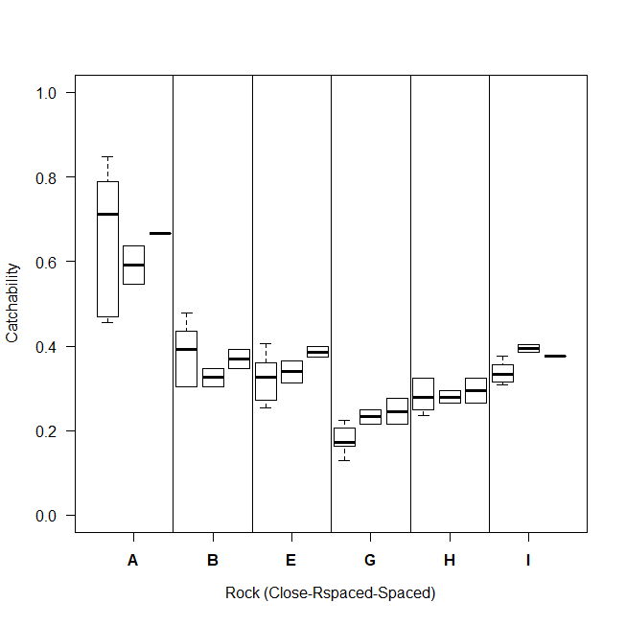

Figure 12. This is the catchability of paper oysters from transect counts (y axis) by rock spacing type. Each individual rock is identified on the x axis by a letter. Close was simply the “standard” way the transects counted with the rocks touching. Rspaced is the same rock configuration, but we just reversed the direction the counting occurred on the transect. Spaced is simply removing a couple of the rocks so there is more space between rocks.