

SCADAsoft

BROWSER
User Manual
SCADAsoft-SUM-07-13_E |  | March 2003
AUTHOR |  | APPROVAL
Jérôme MARTINET |  | Yves LOZINGUEZ

Thales Transportation Systems SA, 66–68 Avenue Pierre Brossolette 92247 Malakoff Cedex France.
Tel: (33) 01 41 48 04 85 • Fax: (33) 01 41 48 16 89

RECORD OF REVISIONS
REVISION | DATE | DETAILS | JUSTIFICATION
A | April 2003 | Initial revision
B | 15/05/01 | Formula Edition | Evolution
C | 13/01/03 | Added Chapter « Context » | Evolution
D | 26/06/03 | Added menu « Preferences » | Evolution
E | June 2007 | - Update to match SCADAsoft document template  - Update (from french document) revisions B, C, D  - New doc number
© Syseca Ltd 2007
© Syseca SA 2007

This manual is protected by international and national copyright laws. All rights reserved.

This manual may not be reproduced or transmitted in whole or in part in any form or by any means, electronic, mechanical, photocopying, recording or otherwise, without the prior written permission of Syseca Ltd and Syseca SA, the copyright holders. Prior written permission must also be obtained before any part of this manual is stored in a retrieval system of any nature.
Information contained in this document is believed to be accurate at the time of publication but no liability whatsoever can be accepted by Syseca Ltd or Syseca SA arising out of any use made of this information.

© Thales Transportation Systems SA

This manual is protected by international and national copyright laws. All rights reserved.

This manual may not be reproduced or transmitted in whole or in part in any form or by any means, electronic, mechanical, photocopying, recording or otherwise, without the prior written permission of Thales Transportation Systems SA, the copyright holders. Prior written permission must also be obtained before any part of this manual is stored in a retrieval system of any nature.
Information contained in this document is believed to be accurate at the time of publication but no liability whatsoever can be accepted by Thales Transportation Systems SA arising out of any use made of this information.

CONTENTS
1. Introduction 1
2. Application start 2
2.1 Windows systems 2
2.2 UNIX systems 2
3. Menus 3
3.1 Menubar 3
3.1.1 “File” menu 3
3.1.2 “Snapshot” menu 4
3.1.3 “Parameters” menu 5
3.2 Toolbar 6
3.2.1 “Connection” icon 6
3.2.2 “Binary” snapshot icon 6
3.2.3 “XML” snapshot icon 6
3.2.4 “Parameters” icon 6
4. Database visualization 7
4.1 Notebook 7
4.1.1 “Classes” notebook page 7
4.1.2 “Instances” notebook page 9
4.2 Array 13
4.2.1 Classes 13
4.2.2 Instances 14
5. Database operations 16
5.1 Classes 16
5.1.1 Add an attribute to a class 16
5.1.2 Create a class 17
5.1.3 Delete an attribute of a class 17
5.1.4 Delete a class 18
5.2 Instances 18
5.2.1 Copy a branch under a point 18
5.2.2 Create an instance 19
5.2.3 Modify the formula of an instance’s attribute 20
5.2.4 Modify the value of an instance’s attribute 21
5.2.5 Delete an instance 23
6. Guide 24
6.1 Display the instances’ aliases 24
6.2 Display the instances’ names 24
6.3 Add an attribute to a class 25
6.4 Search for an instance by alias 25
6.5 Search for an instance by name 26
6.6 Copy a branch under a point 27
6.7 Create a class 28
6.8 Create an instance 29
6.9 Uninhibit the formulas of a branch 30
6.10 Uninhibit the formulas of a class 31
6.11 Uninhibit the formulas of an instance 31
6.12 Uninhibit a formula 31
6.13 Inhibit the formulas of a branch 32
6.14 Inhibit the formulas of a class 32
6.15 Inhibit the formulas of an instance 33
6.16 Inhibit a formula 33
6.17 Modify the formula of an instance’s attribute 33
6.18 Modify the value of an instance’s attribute 34
6.18.1 Scalar 35
6.18.2 Vector 35
6.18.3 Table 35
6.19 Get the properties of the database 36
6.20 Get the properties of a class 37
6.21 Quit the application 38
6.22 Save the database in binary 38
6.23 Save the database in XML 39
6.24 Delete an attribute from a class 39
6.25 Delete a class 39
6.26 Delete an instance 40
7. Glossary 41
8. Index 43

Introduction
The Browser application allows to visualize either a SCADAsoft database or a RTAP® database. The executable file of this application is “scsbrowser.exe” in the Windows operating systems and “scsbrowser” under UNIX systems. It should be remembered that the environment variables SCSPATH and SCSHOME must be defined to make the application work. Moreover, SCSHOME must look like the following directory tree :
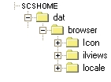

The screen dumps and the windows samples in this document had been realized under Windows NT. Under UNIX systems, it should be possible that they haven’t the same visual aspect, but on the other hand they behave the same way.

Application start

Windows systems
In order to start the application, two ways are possible :
- Double click on the icon of the executable file named “scsbrowser” in the windows explorer,
- Type “scsbrowser” in a command prompt.
Then the following panel appears:
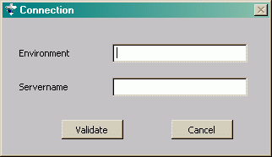
In the first text box, it must be entered the environment the application will be connected to ; in the second text box, the server name to connect to. Then, click on “Validate”.
N.B. : It is also possible to indicate directly in the command prompt, the server name and the environment to connect to. For this, it is necessary to add to the command “scsbrowser” a blank space, the name of the server, a “@” character and the environment name. The correct syntax is as follows :
« scsbrowser server_name@environment_name ».

UNIX systems
In order to start the application, type “scsbrowser” in a shell prompt. Then a panel appears in which you have to enter the environment and the server name to connect to. Then, click on “Validate”.
N.B. : It is also possible to indicate directly in the command prompt, the server name and the environment to connect to. For this, it is necessary to add to the command “scsbrowser” a blank space, the name of the server, a “@” character and the environment name. The correct syntax is as follows :
« scsbrowser server_name@environment_name ».

Menus

Menubar
The menubar is located at the top of the main panel of the application, below the title and looks like :
It includes the menus and the items described hereafter.

“File” menu
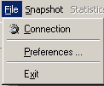
The “File” menu includes 3 items : “Connection”, Preferences and “Exit” described hereafter.

“Connection” item
This menu allows to connect to an environment when the launch had failed. This action is ineffective when the connection is already established on a valid environment.

« Preferences » item
This menu opens the tool preferences panel.
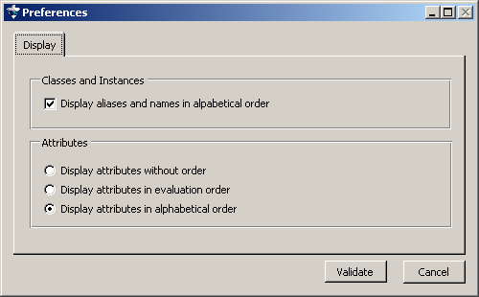

Alphabetic sort of classes or instances names
In « Display » tab, select « Display aliases and names in alphabetical order ». Then click on “Validate”
To go back to default display (order defined in XML files), unselect the option and validate.

“Exit” item
This menu allows to exit the application.

“Snapshot” menu
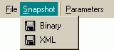
The “Snapshot” menu includes two items : “Binary” and “XML” described hereafter.

“Binary” snapshot item
This menu allows to make a binary snapshot of the database. The generated files are saved in the directory $SCSPATH/Database

“XML” snapshot item
This menu allows to save the database under XML files. The generated files are saved in the directory $SCSPATH/Database/xml
N.B. : this type of snapshot is not authorized in the case of a connection to a RTAP® database.

“Parameters” menu
This menu allows to get the informations of the current database. Then the following panel appears :
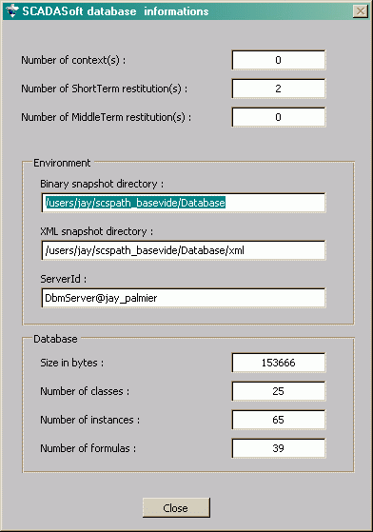
The panel displays the number of contexts, the number of short-term and middle-term restitution, the saving directories (binary and XML), the value of the server Id, the database size, the number of classes, instances and formulas in this database. These data are not modifiable in this panel. The return to the previous panel is possible while clicking on the button in the bottom of the panel.

Toolbar
This toolbar gives direct access to some elements of the menubar and allows a simplified access to the most used functions of the application.

“Connection” icon
Allows the connection to an environment (cf. chapter 3.1.1.1)

“Binary” snapshot icon
Allows the binary snapshot (cf. chapter 3.1.2.1)

“XML” snapshot icon
Allows the XML snapshot (cf. chapter 3.1.2.2)

“Parameters” icon
Allows the access to informations on the database (cf. chapter 3.1.3)

Database visualization
The main panel of the BROWSER application includes two main elements : a notebook and an array of data. The notebook takes place in the left part of the window. It includes two pages (notebook page) entitled “Classes” and “Instances” that are described in details hereafter.

Notebook
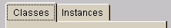

“Classes” notebook page
This notebook page allows to visualize the list of classes and to operate on them.
N.B. : this notebook page is not accessible in the case of a connection to a RTAP® database.

Display
The page displays a list of classes. A left click on the name of one these classes displays automatically the corresponding informations in the array of data in the right part (cf. chapter 4.2.1).

Popup menus

Selected class
After having selected a class in the list and having right clicked, the following popup menu appears :
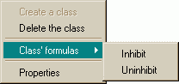
The following operations are available :
- Delete the selected class : the class is definitively deleted as well as all the instances of this class. Be careful, this action is irreversible.
- Inhibit the formulas of the selected class : all the formulas of all instances of the selected class become inhibited.
- Uninhibit the formulas of the class : all the formulas of all the instances of the selected class become uninhibited.
- Get the information on the selected class : choosing “Properties” in the popup menu, the following panel appears after :
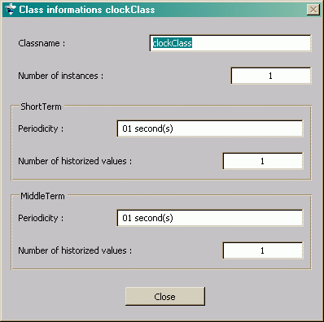
In this panel are listed the name of the class, the number of instances, the periodicity and the number of short-term and middle-term historized values.

No class selected
If none of the classes is selected, then a right click makes appear the following popup menu :
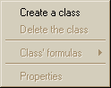
N.B. : if a class is already selected, unselected it by clicking in the free space on the right of the names of the classes.
The only available function of this menu is the creation of class. By clicking on this menu, then the following panel appears:
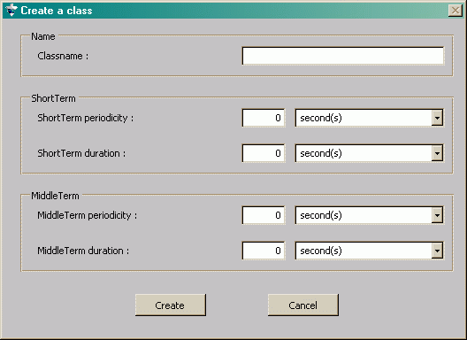
In order to create a class, the name of the class, the periodicities and durations of short-term and middle-term historization must be keyboarded. Then click on the “Create” button to validate these informations et create the new class. By clicking on the “Cancel” button, the panel is closed and no information is taken into account.

“Instances” notebook page
This notebook page allows to visualize the hierarchy of the instances in the loaded database.
N.B. : only this notebook page is accessible in the case of a connection to a RTAP® database.

Display
The display is done as a tree representing the hierarchy of the database like follows :
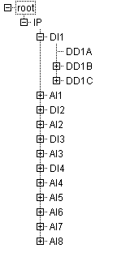
At each node of this tree, there’s an instance. It is represented by its name (or its alias) with, on the left of this, a square in which there’s a sign “+” or “-“, or nothing at all. If, on the left of the instance’s name, there’s :
- A square with a sign “+”, it means that this instance has got one or several children or that this instance has not been explored yet,
- A square with a sign “-“, it means that the hierarchy of the instance had been expanded and that its children are visible,
- No sign, it means that this instance had been expanded and it hasn’t got child.
N.B. : this hierarchy works like the left part of the Windows explorer (with all the directories of the workstation).
A click on the name of an instance displays automatically the corresponding informations in the array of data in the right part (cf. chapter 4.2.2)

Popup menus
After having selected an instance in the hierarchy and right clicked, the following popup menu appears :
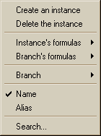
The following operations are available :
- Create an instance : a click on this menu and then the following panel appears:
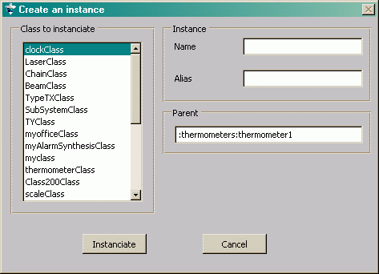
In order to create an instance, the class to instanciate must be choosen in the list of classes in the left part of the panel (in the case of a RTAP® database, no class is available). Then keyboard the name and the alias of the new instance. The alias parameter is optional, if it’s not set, it will be generated automatically. The “Parent” box is not to fill, it remind where will be inserted the new instance. Once these informations set, click on the “Instanciate” button in order to create the new instance. A click on the “Cancel” button makes disappear the panel and go back to the main panel.
- Delete an instance : the selected instance is definitively deleted and then its children. Be careful, this action is irreversible.
- Inhibit the formulas of the instance : all the attributes’ formulas of the selected instance are inhibited.
- Uninhibit the formulas of the instance : all the attributes’ formulas of the selected instance are uninhibited.
- Inhibit the formulas of the branch : all the formulas of the instance and those of its children, the children of its children (etc.), are inhibited.
- Uninhibit the formulas of the branch : all the formulas of the instance and those of its children, the children of its children (etc.), are uninhibited.
- Display the name of the instances : allows to display the name of the instances. If the instances are already displayed by name, the menu is checked off and inaccessible.
- Display the aliases of the instances : allows to display the aliases of the instances. If the instances are already displayed by alias, the menu is checked off and inaccessible.
- Search an instance by its name : allows to search an instance by its name. Be careful, if the instances are displayed by alias, the search will be done by alias (see the next point). A click on this menu makes appear the following panel :
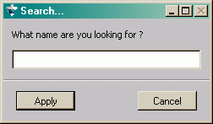
To search the name of an instance, set the name in the box and then click on the “Apply” button. If only one value is found, then it is automatically selected. If several names are found, then the following panel appears :
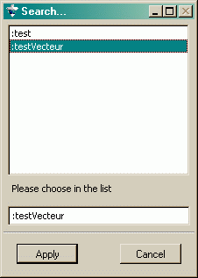
it allows to choose the search name in the list in the top of the panel. By clicking on the “Apply” button, the selected instance is automatically selected in the hierarchy of the instances.
- Search an instance by its alias : allows to search an instance by its alias. Be careful, if the instances are displayed by name, the search will be done by name (see the previous point). A click on this menu makes appear the following panel :
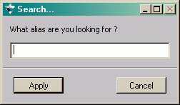
To search the alias of an instance, keyboard the alias in the box and click on the “Apply” button. If the alias is found, the instance is automatically selected in the hierarchy of the instances.

Array

Classes

Display
The array allows to display the informations corresponding to the selected class (cf. chapter 4.1.1). In such a case, are displayed (in the order of the columns) :
- The name of the class’ attributes,
- The type of the class’ attributes (static, volatile, short-term or middle-term),
- The type of the attributes’ value (scalar type, vector or table),
- The default value of each attribute of the class,
- The replicated feature of the class’ attributes. The meaning of the symbol used in this column is the following :
: replicated attribute
: not replicated attribute.

The informations of this array may be consulted but not modified.

Popup menus
Two operations are available in this array :
- Right click in the title of the first column (“Attribute”). Then the following popup menu appears:
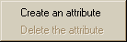
it allows to create an attribute and to add it to the selected class. By clicking on this menu, the following panel appears :
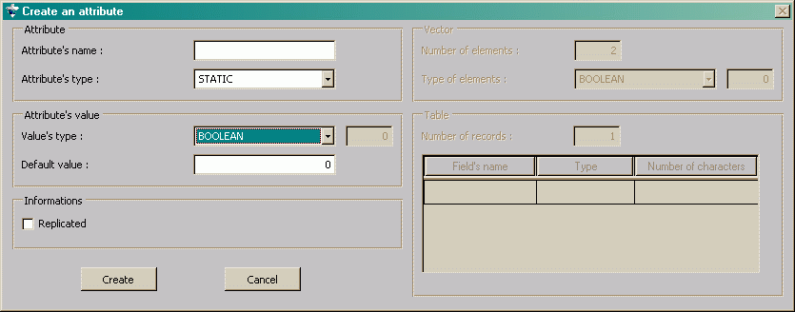
After having keyboarded the name of the attribute, its type, its value type, its default value et the replicated feature, click on the “Create” button to validate these informations and add a new attribute to the selected class.
- Right click in a row of the first column (except the title). Then the following popup menu appears:
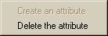
it allows to delete the selected attribute (the row in the array).

Instances

Display
The array allows to display the informations corresponding to the selected instance (cf. chapter 4.1.2). In such a case, are displayed (in the order of the columns) :
- The name of each attribute of the class of the instance,
- The value type of each attribute of the instance (scalar type, vector or table),
- The value of each attribute of the instance,
- The formula associated to each attribute of the instance. It appears over white background when it is uninhibited, over gray background when it is inhibited.
The first and second column of this array are not modifiable. On the other hand, the column “Value” and the column “Formula” are editable. To modify this columns, see chapter 5.2.4 for the values and chapter 5.2.3 for formulas.

Context
The “Context” part allows to display the informations of the selected instance in a specific context. By default, this context is the “real-time” context (e.g. number 0).
To change the display context for the informations of the selected instance, two ways are possible. Either, change the context number and type the “Enter” key, or choose a context in the list (on the right hand of the context).
Once the displayed context modified, the next selected instances will be displayed in this context (until the context will be modified).

Popup menus
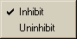
The only popup menu of this array appears after a right click in the column “Formula”. It allows to :
- Inhibit the selected formula (if it is uninhibited),
- Uninhibit the selected formula (if it is inhibited).

Database operations

Classes

Add an attribute to a class
After having selected a class in the list of the notebook page “Classes”, place the pointer on the title row (on the right part of the main panel of the application), in the first column. Right clickand then the following popup menu then appears :
Choose the menu “Create an attribute” and fill the informations in the following panel :
In other words, write the name of the new attribute, choose in the corresponding list the type of the new attribute (use the button on the right of “STATIC” in the example above to scroll the different types), choose the type of the default value (same principle to make scrolling the value’s types), write the default value and check the box in the frame “Informations” if the attribute is replicated. Then click on the “Create” button to validate these informations and create a new attribute.
N.B. : in the case of a value that has a type “CHARN” (resp. “BITFIELD”), precise the number of characters (resp. the size in bytes) in the box on the right of the list of the possible value’s types.
N.B. : it is not possible to add an attribute to a class in the case of a connection to a RTAP® database.

Create a class
In the notebook page named “class”, right click outside the listed classes (in the white space on the right side of the class names, for example). Then the following popup menu appears:
Choose the item “Create a class” and fill the informations in the following panel :
In other words, write the name of the new class, indicate the periodicity and the duration of short term and middle term storing. To choose an other time measure than seconds (default unit, see the illustration above), click on the button on the right of the box to make scrolling the other units. To validate these informations, click on the “Create” button. The created class is then automatically added to the list of the main panel.
N.B. : it is not possible to create a class in the case of a connection to a RTAP® database.

Delete an attribute of a class
In the notebook page named “class”, select the class in which there’s the attribute to delete. The array on the right part is automatically filled with the informations of this class. In this array, select the attribute to delete (in the first column). Right click, then the following popup menu appears:
Choose the item “Delete the attribute”. After a confirmation, the attribute is deleted in the class. Be careful, this action is irreversible.
N.B. : it is not possible to delete an attribute of a class in the case of a connection to a RTAP® database.

Delete a class
In the notebooke page named “class”, select the class to delete. Right click, then the following item appears:
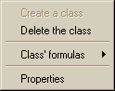
Choose the item “Delete the class”. After a confirmation, the class is deleted. Be careful, this action is irreversible and delete all the existing instances of this class.
N.B. : it is not possible to delete a class in the case of a connection to RTAP® database.

Instances

Copy a branch under a point
In the notebook page named “Instances”, select the instance to copy and right click. Then the following popup menu appears:
Choose the menu “Branch”, then the item “Copy” as follows :
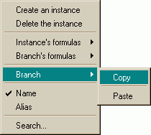
Then select the instance under which will be added the copied branch. Right click and choose the menu “Branch”, then the item “Paste” as follows :
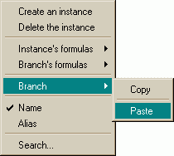
The branch is automatically added under the selected instance.

Create an instance
In the notebook page named “Instances”, select the instance under which will be created the new instance (the instance’s parent). Right click, then the following popup menu appears:
Choose the item “Create an instance” and fill the informations of the following panel :
In other words choose the class from which the instance will be created (in the list on the left side), then write the name and the alias of the instance. The “Parent” box is present here just to remind of the parent of the new instance. To validate these informations, click on the “Instanciate” button. The instance is automatically added under its parent.
N.B. : the “Alias” box is optional. It means that if it’s not filled, an alias will be generated and automatically assigned to the new instance.

Modify the formula of an instance’s attribute
In the notebook page named “Instances”, select the instance in which there’s the formula to modify. The array on the right side is automatically filled with the informations of the selected instance. Double click on the formula to modify (in the “Formula” column). The following panel appears :
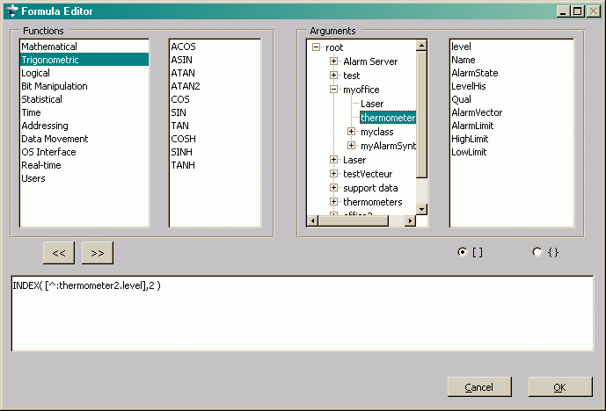
This panel allows to write formulas.
The first list on the left contains the categories of functions. When a category is selected, its functions are displayed in the second list. When double clicking on a function, it is inserted in the box in the bottom with the lowest number of spaces, in order to insert the arguments essential for its working.
In the frame “Argument” (third box in the top), the first tree allows to select the instance in which there’s the attribute to use in the formula. When the instance is selected, all the corresponding attributes are displayed in the list on the right of the panel. When double clicking on an attribute, it is inserted in the box in the bottom. It can be inserted between parenthesis or square brackets depending on whether the symbol [] or {} is selected. It will be preceded by its relative path. The place where will be inserted the attribute will be the first place in the formula if the box in the bottom had not been selected yet. Instead, it will be the last selected place with the cursor.
The buttons and allow to find the previous or next free place in the formula.
It is also possible to modify the formula directly in the box in the bottom of the panel. To confirm the changes, click on the “OK” button; either click on the “Cancel” button.

Modify the value of an instance’s attribute
In the notebook page named “Instances”, select the instance in which the value of the attribute has to be changed. The array on the right side is automatically filled with the informations of the selected instance. In order to change the value of an attribute, just select the box in the column “Value” at the chosen attribute row. Three cases then appear : it is a scalar value, a vector value or a table value. These cases are detailed hereafter.

Scalar
After having selected the value’s box to modify, this box changes as follows :
It is then possible to modify directly the value in the box. In order to validate the modification, the “Enter” key of the keyboard must be pushed down. Be careful, the selection of an other box without having first pushed down the “Enter” key cancels the value’s modification.

Vector
After having selected the value’s box to modify, then a panel appears as follows :
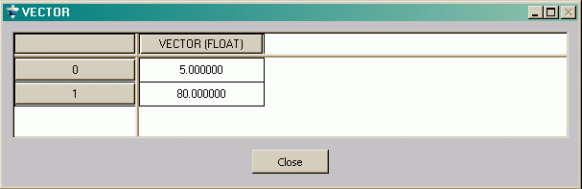
It includes a “Close” button in order to go back to the main panel and an array introducing the value of the selected attribute, in other words a vector. The array has got as much rows as elements in the vector (plus one for the title) and only two columns (one for the numbers of the vector’s elements). The first row and the first column are titles that are not modifiable. In the first column, are shown the number of the vector’s elements. The first row of the second column introduces the type of the vector’s elements (between parenthesis). The modification of a vector’s element is the same as a scalar value (cf. chapter 5.2.4.1).

Table
After having selected the value’s box to modify, then a panel appears as follows :
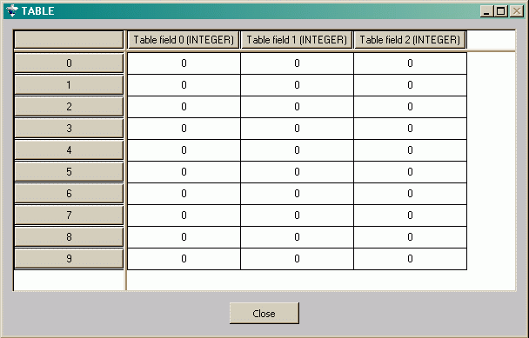
It includes a “Close” button in order to go back to the main panel and an array introducing the value of the selected attribute, in other words a table. The array has got as much rows as records (plus one for the title of the fields) and as much columns as fields (plus one for the numbers of the records). The columns’ titles show the field’s name and its type (between parenthesis). The modification of a record’s field in the table is the same as a scalar value (cf. chapter 5.2.4.1).

Delete an instance
In the notebook page named “Instances”, select the instance to delete and then right click. Then the following popup menu appears:
Choose the “Delete the instance” menu. After a confirmation, the instance is deleted from the hierarchy. Be careful, this action is irreversible and involves the deletion of all instances belonging to the branch which the deleted instance is the root.

Guide

Display the instances’ aliases
In the notebook page named “Instances” (in the left part of the main panel), select an instance (any of them) and right click. Then the following popup menu appears:
Choose the “Alias” menu. The hierarchy of instances is then updated, displaying the instances’ aliases. If the “Alias” menu is toggled and inaccessible, it means that the display is already in “alias” mode.

Display the instances’ names
In the notebook page named “Instances” (in the left part of the main panel), select an instance (any of them) and right click. Then the following popup menu appears:
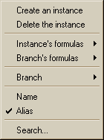
Choose the “Name” menu. The hierarchy of instances is then updated, displaying the instances’ names. If the “Name” menu is toggled and inaccessible, it means that the display is already in “name” mode.

Add an attribute to a class
In the notebook page named “Classes” (in the left part of the main panel), select the class in the list (the one to add the attribute). The array of the main panel is automatically updated with the informations of the selected class. Over the first row of the array (those of the titles) in the first column (named “Attribute”), right click. Then the following popup menu appears:
Choose the “Create an attribute” menu and fill the informations of the following panel :
In other words, write the name of the new attribute, choose in the corresponding list the type of the new attribute (use the button on the right of “STATIC” in the example above to make scrolling the different types), choose the type of the default value (same way to make scrolling the value’s types), write the default value and toggle the box in the “Informations” frame if the attribute is replicated. Then click on the “Create” button to validate these informations and create a new attribute.
N.B. : in the case of a “CHARN” value (resp. “BITFIELD”), specify the number of characters (resp. the size in bytes) in the box on the right of the list of the possible value’s types.
N.B. : it is not possible to add an attribute to a class in the case of a RTAP® database.

Search for an instance by alias
In the notebook page named “Instances” (in the left part of the main panel), select an instance (any of them). Be in “alias” display mode (cf. chapter 6.1). So right click and then the following popup menu appears:
Choosing the “Search…” menu, the following panel appears :
Write the searched alias in the box and click on the “Apply” button. If the alias exists, the corresponding instance is automatically selected in the hierarchy of instances.

Search for an instance by name
In the notebook page named “Instances” (in the left part of the main panel), select an instance (any of them). Be in “name” display mode (cf. chapter 6.2). So right click and then the following popup menu appears:
Choosing the “Search…” menu, the following panel appears :
Write the searched name in the bow and click on the “Apply” button. If the name exists and is the only one, the corresponding instance is automatically selected in the hierarchy of instances. If the name exists but is not the only one (e.g. it exists several instances with the searched name), then the following panel appears:
The list in the top part displays the full path of the instances with the searched name. Selecting the searched instance, then clicking on the “Apply” button, the searched instance is automatically selected in the hierarchy of instances.

Copy a branch under a point
In the notebook page named “Instances” (in the left part of the main panel), select the instance which is the root of the branch to copy. Right click and then a popup menu appears. Choose the “branch” menu and the “Copy” item as follows :
Then select the instance under which this branch will be copied. Right click and then the same popup menu as before appears. Choose the “Branch” menu and the “Paste” item as follows :
The instance is then automatically copied under the selected instance.

Create a class
In the notebook page named “Classes” (in the left part of the main panel), right click outside the listed classes (in the white space on the right side of the class names, for example). Then the following popup menu appears:
Choose the “Create a class” menu and fill the informations of the following panel :
In other words, write the name of the new class, indicate the periodicity and the duration of short term and middle term historization. To choose an other time measure than seconds (default unit, see the illustration above), click on the button on the right of the box to make scrolling the other units. To validate these informations, click on the “Create” button. The created class is then automatically added to the list of the main panel.
N.B. : it is not possible to create a class in the case of a connection to a RTAP® database.

Create an instance
In the notebook page named “Instances”, select the instance under which will be created the new instance (the instance’s parent). Right click, then the following popup menu appears:
Choose the item “Create an instance” and fill the informations of the following panel :
In other words choose the class from which the instance will be created (in the list on the left side), then write the name and the alias of the instance. Le “Parent” box is present here just to remind of the parent of the new instance. To validate these informations, click on the “Instanciate” button. The instance is automatically added under its parent.
N.B. : the “Alias” box is optional. It means that if it’s not filled, an alias will be generated and automatically assigned to the new instance.

Uninhibit the formulas of a branch
In the notebook page named “Instances” (in the left part of the main panel), select the instance which is the root of the branch in which all the formulas will be uninhibited. Right click, then the following popup menu appears:
Choose the “Branch’s formulas” menu, then the “Uninhibit” item. After a confirmation, the operation is executed. Be careful, this operation uninhibits not only the formulas of the selected instance but also the formulas of its children, those of the children of its children, etc.

Uninhibit the formulas of a class
In the notebook page named “Classes” (in the left part of the main panel), select the class in which all the formulas will be uninhibited. Right Click, then the following popup menu appears:
Choose the “Class’ formulas” menu and the “Uninhibit” item. After a confirmation, the formulas of the class are uninhibited. Be careful, this operation uninhibits all the formulas of all instances of this class.
N.B. : it is not possible to uninhibit the formuals of a class in the case of a connection to a RTAP® database.

Uninhibit the formulas of an instance
In the notebook page named “Instances” (in the left part of the main panel), select the instance in which the formulas will be uninhibited. Right click, then the following popup menu appears:
Choose the “Instance’s formulas” menu and the “Uninhibit” item. After a confirmation, the operation is executed. Be careful, this operation uninhibits all the formulas of the instance, in other words each formula associated to the attributes of the selected instance.

Uninhibit a formula
In the notebook page named “Instances” (in the left part of the main panel), select the instance in which there’s the formula to uninhibit. The array (in the right part of the main panel) is automatically updated with the informations of the selected instance. If the formula is already uninhibited, it appears on white background, otherwise on grey background. In this last case, select the box (in the array) of the formula to uninhibit, then right click. Then the following popup menu appears:
Choose the “Uninhibit” menu. The formula then appears on white background : it is uninhibited.

Inhibit the formulas of a branch
In the notebook page named “Instances” (in the left part of the main panel), select the instance which is the root of the branch in which all the formulas will be inhibited. Right click, then the following popup menu appears:
Choose the “Branch’s formulas” menu and the “Inhibit” item. After a confirmation, the operation is executed. Be careful, this operation inhibits not only the formulas of the selected instance, but also the formulas of its children, those of the children of its children, etc.

Inhibit the formulas of a class
In the notebook page named “Classes” (in the left part of the main panel), select the class in which all the formulas will be inhibited. Right click, then the following popup menu appears:
Choose the “Class’ formulas” menu and the “Inhibit” item. After a confirmation, the formulas of the class are inhibited. Be careful, this operation inhibits all the formulas of all instances of this class.
N.B. : it is not possible to inhibit the formulas of a class in the case of a connection to a RTAP® database.

Inhibit the formulas of an instance
In the notebook page named “Instances” (in the left part of the main panel), select the instance in which the formulas will be inhibited. Right click, then the following popup menu appears:
Choose the “Instance’s formulas” menu and the “Inhibit” item. After a confirmation, the operation is executed. Be careful, this operation inhibits all the formulas of the instance, in other words each formula associated to the attributes of the selected instance.

Inhibit a formula
In the notebook page named “Instances” (in the left part of the main panel), select the instance in which there’s the formula to inhibit. The array (in the right part of the main panel) is automatically updated with the informations of the selected instance. If the formula is already inhibited, it appears on grey background, otherwise on white background. In this last case, select the box (in the array) of the formula to inhibit, then right click. Then the following popup menu appears:
Choose the “Inhibit” menu. The formula then appears on grey background : it is inhibited.

Modify the formula of an instance’s attribute
In the notebook page named “Instances”, select the instance in which there’s the formula to modify. The array on the right side is automatically filled with the informations of the selected instance. Double click on the formula to modify (in the “Formula” column). The following panel appears :
This panel allows to write formulas.
The first list on the left contains the categories of functions. When a category is selected, its functions are displayed in the second list. When double clicking on a function, it is inserted in the box in the bottom with the lowest number of spaces, in order to insert the arguments essential for its working.
In the frame “Argument” (third box in the top), the first tree allows to select the instance in which there’s the attribute to use in the formula. When the instance is selected, all the corresponding attributes are displayed in the list on the right of the panel. When double clicking on an attribute, it is inserted in the box in the bottom. It can be inserted between parenthesis or square brackets depending on whether the symbol [] or {} is selected. It will be preceded by its relative path. The place where will be inserted the attribute will be the first place in the formula if the box in the bottom had not been selected yet. Instead, it will be the last selected place with the cursor.
The buttons and allow to find the previous or next free place in the formula.
It is also possible to modify the formula directly in the box in the bottom of the panel. To confirm the changes, click on the “OK” button; either click on the “Cancel” button.

Modify the value of an instance’s attribute
In the notebook page named “Instances”, select the instance in which the value of the attribute must be changed. The array on the right side is automatically updated with the informations of the selected instance. In order to change the value of an attribute, just select the box in the column “Value” at the chosen attribute row. Three cases then appear : it is a scalar value, a vector value or a table value. These cases are detailed hereafter.

Scalar
After having selected the value’s box to modify, this box changes as follows :
It is then possible to modify directly the value in the box. In order to validate the modification, the “Enter” key of the keyboard must be pushed down. Be careful, the selection of an other box without having first pushed down the “Enter” key cancels the value’s modification.

Vector
After having selected the value’s box to modify, then a panel appears as follows:
It includes a “Close” button in order to go back to the main panel and an array introducing the value of the selected attribute, in other words a vector. The array has got as much rows as elements in the vector (plus one for the title) and only two columns (one for the numbers of the vector’s elements). The first row and the first column are titles that are not modifiable. In the first column, are shown the number of the vector’s elements. The first row of the second column introduces the type of the vector’s elements (between parenthesis). The modification of a vector’s element is the same as a scalar value (cf. chapter 6.18.1).

Table
After having selected the value’s box to modify, then a panel appears as follows :
It includes a “Close” button in order to go back to the main panel and an array introducing the value of the selected attribute, in other words a table. The array has got as much rows as records (plus one for the title of the fields) and as much columns as fields (plus one for the numbers of the records). The columns’ titles show the field’s name and its type (between parenthesis). The modification of a record’s field in the table is the same as a scalar value (cf. chapter 6.18.1).

Get the properties of the database
In the main panel of the application, two ways are possible to get the database’s properties :
- Either selecting the “Parameters” menu in the menu bar :
- Or clicking on the parameters icon in the tool bar :
Then a panel of this type appears:
in which are listed the number of contexts, the number of restitutions (short term and middle term), the snapshot directories (binary and XML), the value of the server Id, the database size, the number of classes, instances and formulas in this database. This data are not modifiable in this panel. Clicking on the “Close” button comes back to the previous panel.

Get the properties of a class
In the notebook page named “Classes” (in the left part of the main panel), select the wanted class. Right click, then the following popup menu appears:
Choose the “Properties” menu. Then the following panel appears:
In this panel are listed the name of the class, the number of instances, the periodicity and the number of historized values for short and middle term.
N.B. : it is not possible to get the properties of a class in the case of a connection to a RTAP® database.

Quit the application
In the main panel, choose the “File” menu and the “Exit” item in the menu bar:
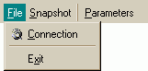

Save the database in binary
In the main panel, two ways are possible to save the database in binary :
- Either select the “Snapshot” menu and the “Binary” item in the menu bar :
- Or click on the “Binary snapshot” icon in the tool bar :
To know where is saved the database, see chapter 6.19.

Save the database in XML
In the main panel, two ways are possible to save the database in XML :
- Either select the “Snapshot” menu and the “XML” item in the menu bar :
- Or click on the “XML snapshot” icon in the tool bar :
To know where is saved the database, see chapter 6.19.
N.B.: this type of snapshot is not authorized in the case of a connection to RTAP® database.

Delete an attribute from a class
In the notebook page named “Classes”, select the class in which there’s the attribute to delete. The array on the right part is automatically updated with the informations of this class. In this array, select the attribut to delete (in the first column). Right click, then the following popup menu appears:
Choose the item “Delete the attribute”. After a confirmation, the attribute is deleted in the class. Be careful, this action is irreversible. Moreover, this operation deletes the attribute of the class but also the corresponding attribute in all the instances of this class.
N.B. : it is not possible to delete an attribute of a class in the case of a connection to a RTAP® database.

Delete a class
In the notebook page named “Classes”, select the class to delete. Right click, then the following item appears:
Choose the item “Delete the class”. After a confirmation, the class is deleted. Be careful, this action is irreversible and deletes all the existing instances of this class.
N.B. : it is not possible to delete a class in the case of a connection to RTAP® database.

Delete an instance
In the notebook page named “Instances”, select the instance to delete and then right click. Then the following popup menu appears:
Choose the “Delete the instance” menu. After a confirmation, the instance is deleted from the hierarchy. Be careful, this action is irreversible and involves the deletion of all instances belonging to the branch which the deleted instance is the root.

Glossary
SCADASoft database
Hierarchy real-time database working with a configurable calculation engine. It organizes the data in classes. A class contains instances having the same features (attributes). Instances are designable through a naming hierarchy.
RTAP® database
Hierarchy real-time database supplied by Hewlett Packard.
Short term / middle term duration for historization
Time during which values are stored in the dedicated area for short (resp. middle) term historization.
Children
Children instances of an instance in the hierarchy. The relation parent instance / child instance is a relation “is composed of”. Two children of a same instance can’t have the same name.
Hierarchy
Naming tree of the instances of the database. This tree is looking as directories of a files system. The instances of a hierarchy are also designated by an alias which is unique in all the database.
Parent
Parent instance of an instance in the hierarchy. An instance has got only one parent.
Contexts
Storage areas who share the same hierarchy. It exists always at least one context named main context. The other contexts allow to store other values of a same attribute. The other contexts are used by the database to historize the short-term values. They can also be used by the user in order to store coherent data set from the past or the future. These contexts are called “user contexts”.
Short term / middle term periodicity
Historization periodicity of an attribute. The attribute value is copied in the expected historization area at the designated frequency (see Short term / middle term duration for historization)
Replication
Copy of all (or a part) of the database on an other server.
Short term / middle term restitution
Reread in memory of the historized data on disk in a context called “restitution context”.

Index

Application
End 38
Exit 3
Start 2
Attributes 13, 15
Create 14, 16, 25
Default value 13
Delete 14, 17, 39
Formula 15
Replication 13
Type 13
Value 15
Value's type 13, 15
Branch
Copy 18, 27
Inhibit the formulas 12, 32
Uninhibit the formulas 12, 30
Classes
Create 9, 17, 28
Delete 7, 18, 39
Display 7, 13
Informations 8, 37
Inhibit the formulas 8, 32
List 7
Middle-term periodicity 8
Notebook page 7
Number of historized values 38
Number of instances 8, 38
Short-term periodicity 8
Snapshot periodicity 38
Uninhibit the formulas 8, 31
Database
Contexts 5, 15
Informations 4, 6, 36
Number of classes 5, 37
Number of contexts 37
Number of formulas 5, 37
Number of instances 5, 37
Number of restitutions 37
Restitution 5
RTAP 1, 4, 7, 9, 11, 16, 17, 18, 25, 29, 31, 32, 38, 39, 40
SCADAsoft 1
Size 5, 37
Snapshot directories 37
Display
Instances' aliases 24
Instances' names 24
Environment
Connection 2, 3, 6
Hierarchy 9
Node 10
Inhibit
Classe's formulas 8, 32
Formula 15
Instance's formula 33
Instance's formulas 11, 33
Instances
Alias 12, 24
Attribute’s value 34
Attribute's value 15, 21
Branch copy 27
Children 10
Copy a branch 18
Create 11, 19, 29
Delete 11, 23, 40
Display 10, 14
Formula 15, 20, 33
Inhibit a formula 15, 33
Inhibit the branch's formulas 12, 32
Inhibit the formulas 11, 33
Name 12, 24
Notebook page 9
Scalar value 22, 35
Search 12, 13, 25, 26
Table 22
Table value 35
Uninhibit a formula 15, 31
Uninhibit the branch's formulas 12, 30
Uninhibit the formulas 12, 31
Value's type 15
Vector 22
Vector value 35
Notebook 7
SCSHOME 1
SCSPATH 1, 4
Search
Instance's alias 13, 25
Instance's name 12, 26
Server
Connection 2
Id 5, 37
Snapshot
Binary 4, 6, 38
Directories 5
XML 4, 6, 39
Uninhibit
Classe's formulas 8
Classes's formulas 31
Formula 15, 31
Instance's formulas 12, 31

