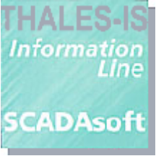

SCADAsoft

Getting Started with ScsVisu
Software User Manual
116500-SUM-01-039_A |  | November 1999
Patrick CHABLE |  | Thomas CHEHIRE

Thales Information Systems Ltd, Southmoor House, Southmoor Road, Wythenshawe, Manchester M23 9SY, UK.
Tel: 0161-946 1001 • Fax: 0161-946 7000 • ukinfo@thales-is.com • www.thales-is.co.uk
Thales Information Systems SA, 66–68 Avenue Pierre Brossolette 92247 Malakoff Cedex France.
Tel: (33) 01 41 48 00 00 • Fax: (33) 01 48 00 10 • info@thales-is.com • www.thales-is.com
RECORD OF REVISIONS

REVISION | DATE | PURPOSE OF THE OPERATION | JUSTIFICATION
A | 12/11/1999 | Initial revision
© Thales Information Systems Ltd 2004
© Thales Information Systems SA 2004

This manual is protected by international and national copyright laws. All rights reserved.
This manual may not be reproduced or transmitted in whole or in part in any form or by any means, electronic, mechanical, photocopying, recording or otherwise, without the prior written permission of Thales Information Systems Ltd and Thales Information Systems SA, the copyright holders. Prior written permission must also be obtained before any part of this manual is stored in a retrieval system of any nature.
Information contained in this document is believed to be accurate at the time of publication but no liability whatsoever can be accepted by Thales Information Systems Ltd or Thales Information Systems SA arising out of any use made of this information.

CONTENTS

1. Introduction 1
2. Thermometers Image Example 3
2.1 Thermometer Rtap Hierarchical Database 3
2.2 Building the Subimage 3
2.2.1 Creating Basic Elements 4
2.2.2 Assembling Elements 8
2.2.3 Connection to the Database 9
2.3 Thermometers image 12
2.3.1 Visual Build 12
2.3.2 Creating a View 13
2.3.3 Connection to the database 14
2.4 Associated Script 16
2.4.1 Script Name & Location 16
2.4.2 Script Structure 17
2.4.3 The image script 17
3. Advanced Functionalities 19
3.1 Adding a behaviour to an object 19
3.1.1 Principle 19
3.1.2 Thermometers 20
3.2 Creating the dialog box 20
Panel Builder 21
3.2.2 Adding behaviour 21
3.2.3 Associated Scripts 22
4. Conclusion 26

FIGURES

Figure 1 - Animator Image 1
Figure 2 - Panel Example 1
Figure 3 - RTAP Database 3
Figure 4- Active Text Editor 4
Figure 5 - Creating Symbol 6
Figure 6- Filling Symbol Class Editor 7
Figure 7- Active Symbol Editor 8
Figure 8 - The image editor 9
Figure 9 Script Editor 12
Figure 10 Thermometers image building 13
Figure 11- View Definition 14
Figure 12- Image Connection 15
Figure 13 Thermometer subimage instance setting 16
Figure 14 - Thermometers Event 20
Figure 15 - Panel Builder 21
Figure 16- Adding button callbacks 22

Introduction
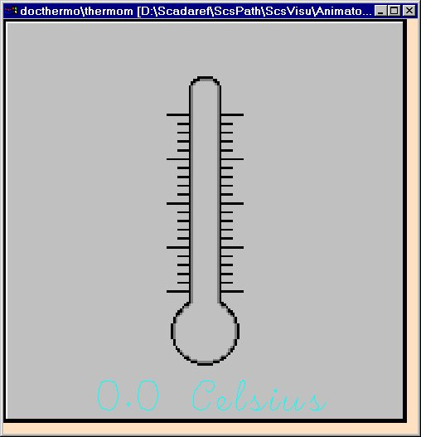
The aim is to build the following image and to use it within a panel:
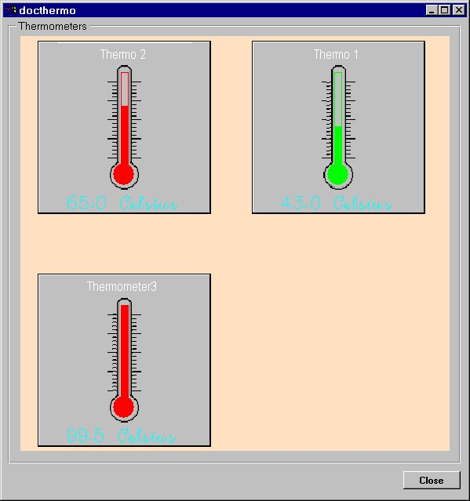
Figure 1 - Animator Image

Figure 2 - Panel Example
This image represents three thermometers each of which is an instance of a thermometer class (subimage)
The subimage provides two information
- The name of the thermometer
- The temperature of the thermometer
This later is shown twice :
- Using a numerical display (Active Number)
- Using a gauge ( Filling Symbol )
The colour and blinking state are computed using the temperature as input.
The symbol is green under 50 degrees and turns red above.
When double-clicked on them, instances of the subimage raise a panel letting the user force the name and temperature of the thermometer.
In this document, you will be shown :
- How to create the different elements of the image,
- How to connect these to the database
- How to animate the objects

Thermometers Image Example

Thermometer Rtap Hierarchical Database

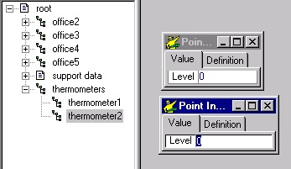
Figure 3 - RTAP Database

We have defined under root point a point named « thermometers », under which are all values used in the image. Under this point we have created two points “thermometer1” and “thermometer2”. These two points will be associated with a subimage instance.
The attribute value of these points is named “Level”. It's the value which is used for the temperature.

Building the Subimage
A subimage is basically an image which may be instanciated many times in a bigger image. Here, we want to build an image containing 3 thermometers. Hence, the first thing to do is to create single thermometer !
The steps are the following :
- Create each element one after another
- Gather them into an image
- Add properties ( Connection, Callbacks ) to the image

Creating Basic Elements
Our thermometer is made of 3 components :
- A string showing the name of the thermometer
- A numeric value showing the temperature of the thermometer
- A graphical representation of the thermometer consisting of
- A gauge
- A reservoir
The corresponding Animator classes are
- An ActiveText object
- An ActiveNumber object
- A Filling Symbol
- An Active Symbol

Thermometer Name : An Active Text
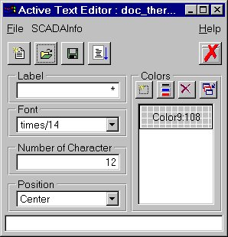
An Active Text is an Animator class whose purpose is to display string of characters under a specific format and shape.
This class can be created using the ScsStudio Active Text Editor Facility.
Figure 4- Active Text Editor
You can chose values at will, those represented here are the ones we have used for our sample.
For more on this functionality, please refer to the "Animator, Getting Started manual"

Thermometer Numeric Value: An Active Number
An Active Number is an Animator class whose purpose is to display a numeric value using a specific format and shape. A specific prefix and postfix can be chosen.
This class can be created using the ScsStudio Active Number editing facility.
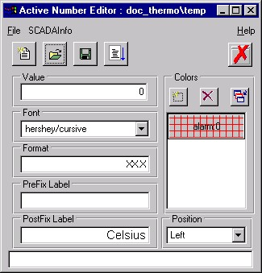
You can chose values at will, those represented here are the ones we have used for our sample.
For more on this functionality, please refer to the "Animator, Getting Started manual"

Thermometer Level : A Filling Symbol Class
A Filling Symbol is an Animator class whose purpose is to display a numeric value in an analogic way, filling a given shape up to a level corresponding to the value to show.
There are 2 steps to create such an object
- Create the symbol to fill
- Define the filling rules for that symbol

Creating the Filling Symbol
First, we have to build the Filling Symbol. The body of the thermometer is a rectangle.
It shall be created with the symbol editor.

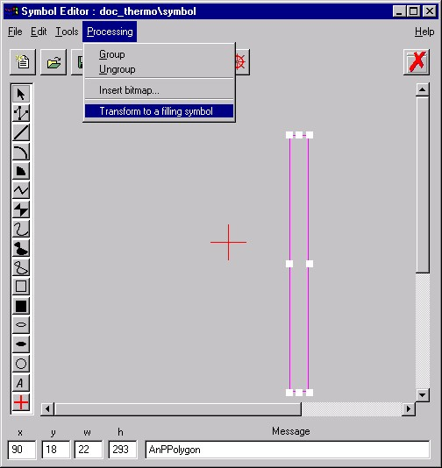
Figure 5 - Creating Symbol
Step | Action | Result | If Fail
1 | Start the symbol Editor from the launcher tool bar | Editor runs
2 | Select the polygon mode and draw a polygon.
3 | Select the polygon object and transform it into a filling symbol (processing menu) | Polygon object is now filled. | Check the object type. It must be made of polypoints.  One object must be in the manager with origin object
4 | Save current symbol |  | Check error dialog box

Creating the Gauge Class
The class definition is responsible for handling the behaviour of the object. It's the class which will perform the matching between the values and the required graphical representation.
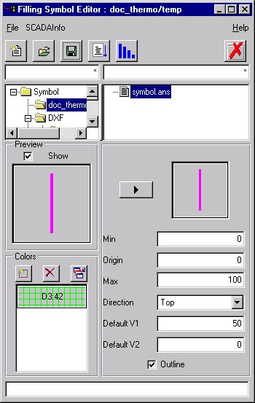
Figure 6- Filling Symbol Class Editor
In our example, we have used the following values :
- Min value is set to 0
- Origin value is set to 0
- Max value is set to 100
- Direction is set to Top
- Default V1 is set to 50
- Default V2 is set to 0
- Add the blinking green colour

The Reservoir: an Active Symbol
The reservoir is a circle whose colour depends on the temperature of the thermometer. It is a simple example of an active symbol, a symbol whose shape or colour may be changed.
Like the body of the thermometer, creating the reservoir is a 2-steps operation :
- Creating the reservoir symbol
- Transform it into an Active Symbol

Creating the Reservoir Symbol
The reservoir is a simple plain circle. Please refer to the thermometer body section on how to create it.

Creating the Reservoir Active Symbol
An Active Symbol a graphical class whose shape and/or colour may be changed at will. Here, the shape stays the same (the reservoir looks always the same), but its colour shall follow the same rules than the body of the thermometer.
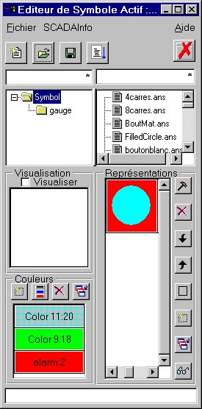
The construction of the class in performed in the ActiveSymbol editor:
Figure 7- Active Symbol Editor

In our example, we have chosen 3 colours :
- A default one
- A "low temperature" one (green)
- A "high temperature" one (red)
Please refer to the Animator "Getting Started Manual" for more on this.

Assembling Elements
This operation is quite simple. The all objective is to import all the elements and put them in one image. This is performed in the image editor.

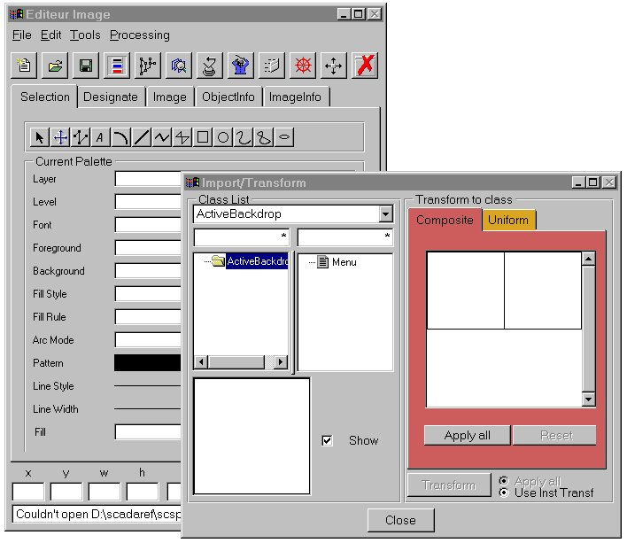
Figure 8 - The image editor

The result should look like this:

Connection to the Database

Principle
The objective here is to have an automatic update of the thermometers according to the values in the database. In order to do that one must establish a connection between objects and their attributes and the database.
A Database address is made of 4 parts:
- Root address of the image,
- Relative address of the object,
- Relative address of the attribute,
- Database attribute to connect to the object.
The reason for this mechanism is that it enables the possibility to relocate objects at runtime by overriding the root address of the image. Thanks to this, a panel or an image may be connected to several subtrees in the database.
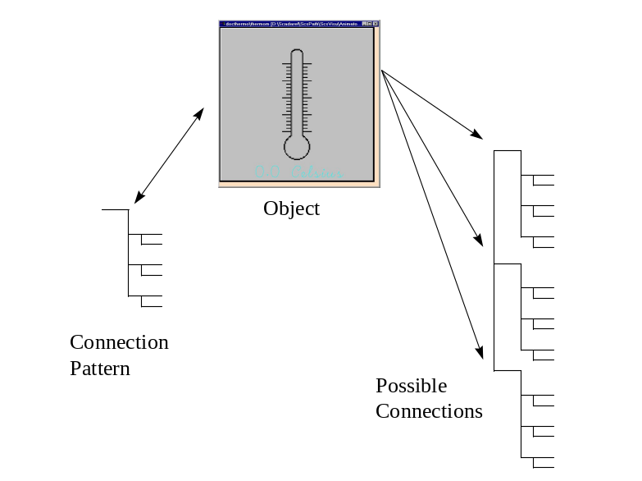The object address is usually used when on intends to instantiate an object several times in an image or panel. This is our case here, since we intend to show 3 thermometers.
The last two bits, aim at giving a little bit more of flexibility, as far as connection is concerned.

Formulae
Sometimes, the value you want to show may not be in the database, but you'd rather deduce it from the value of one or more records. This is what formulae are for.
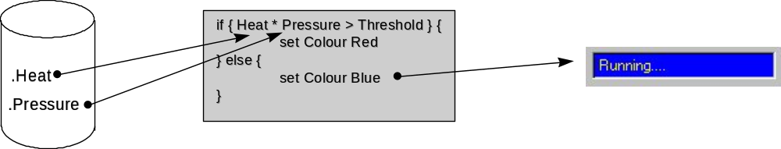

The principle is to have a TCL script (a formula), whose variables are connected to the database. If the database changes, then the value of the variables are changed accordingly and the formula is recomputed.

Formula Editor
The Formula used in our example, changes the value of the color variable when the temperature (level) in the database varies.

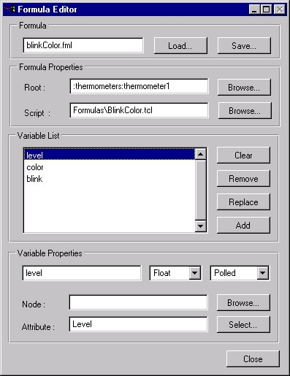
Step | Action | Result | If Fail
1 | Select Formula Editor from Launcher toolbar | Formula editor should appear
2 | Set Formula Properties Root to Rtap path.
3 | Define variable list which will be used with Tcl Script.
4 | Select a type for each defined variable | 3 types appear  - Integer  - Float  - String
5 | Select a mode for each defined variable | 3 modes appear  - Read  - Polled  - Constant

In our example, we have defined 3 variables :
- level : its a floating value and it is associated to Rtap Level attribute point value.
- color : its a constant value and it is computed from Tcl script
- blink : its a constant value and is computed from Tcl script

Script Editor
This panel is designed to let the user edit simple Tcl scripts. It offers Load/Save facility as well as basic syntax checking.
Step | Action | Result | If Fail
1 | Select Script Editor from Launcher toolbar | Script editor should appear
2 | Write a TCL script
3 | Save the file using the “Save” button | The file should now exist on the disk | Check Read/Write rights

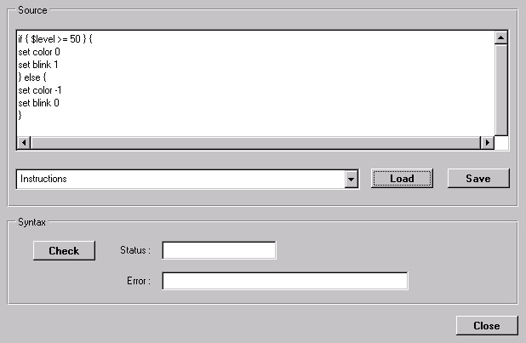
Figure 9 Script Editor
level variable is set by polling.
It used to compute color and blink variable.

Thermometers image
The image we intend to build, is made of 3 thermometers, each connected to different nodes in the database. Like for the subimage, this is a two step operation:
- Visual construction
- Connection of each instance

Visual Build
Open new image and import three subimage instance .

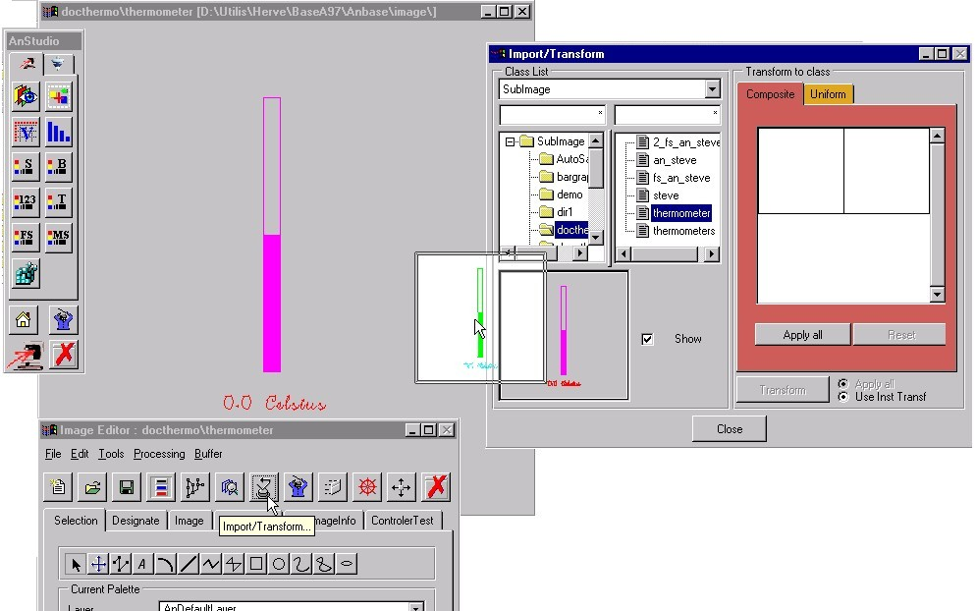
Figure 10 Thermometers image building

Step | Action | Result | If Fail
1 | Select Image Editor from Launcher toolbar | Image editor should appear
2 | Open new image from File menu | A new image should appear
3 | Select Import/Transform from Processing menu | The Import/Transform dialog box should appear
4 | Select SubImage class from class list combo box | The class file list is updated
5 | Select Thermometer SubImage | The preview cell is updated
6 | Select preview cell and drag/drop it into image

Creating a View
Animator supports a multi-view system which lets a user see an image from different perspective. For example, in some cases it might be interesting to see part of an image magnified or with different information. This is what views are for.
In our case, we have to define at least one view so that we content of the image may be mapped on screen. (Actually, this is not totally true since the system may support an automatic view creation mechanism but it does fit in the scope of this document).

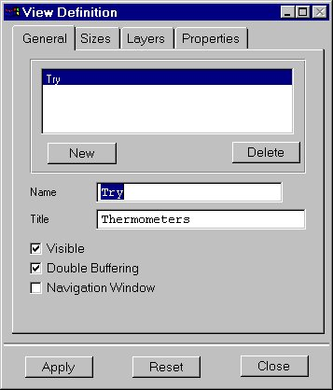
We are therefore going to add a view to the image. This is done in the Tools/View definition panel.
Figure 11- View Definition

Please refer to the Animator reference manual for more on this.

Connection to the database
In the subimage connection section (2.2.3), was described the way the connection path is built. It was emphasized that a connection is build of sub-elemenents, each representing a section of the path. There usually are different levels:
- Image root address
- Object address
- Elements of that object path
The last bit has already been set in the subimage connection section.
We still have to define the first two.

Connecting the image
The image is connected to the "thermometers" branch. This is done by setting the "image path" field, with or without using the browser.

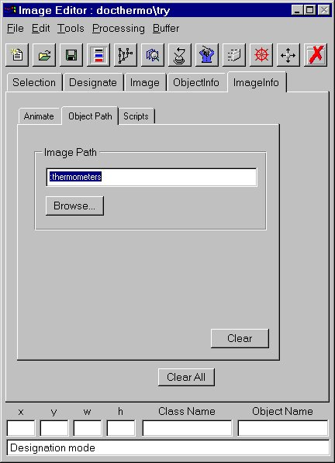
Figure 12- Image Connection
This means that all subsequent addresses will be concatenated to the ":thermometers" node.

Connecting the thermometers
Under the ":thermometers" node, there are 3 nodes called "thermometer1" to "thermometer3". This is this bit of information which has to be added to each of the subimage instances.This notebook page aims at letting the user set the object path (shared by all attributes of the object).
Step | Action | Result | If Fail
1 | Make sure the object path field is clear | The object path editor is clear | Make sure to click on an object not given an object path before
2 | Press the “Browse” button. | The DB browser pops up. | Check connection to the database
3 | Choose the right path for each subimage and press OK | The object path is set to the proper string | Retry
4 | After choosing a path, press the “Set” button, unselect the object and reselect it again | The path is erased but reappears when the object is reselected | Retry
5 | Save image from File menu

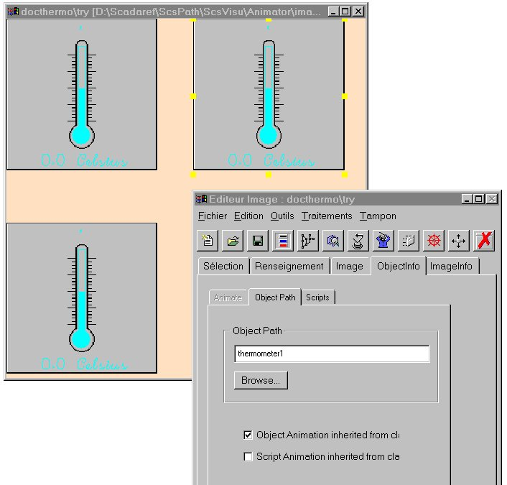
Figure 13 Thermometer subimage instance setting
Altogether, the path for a given attribute will be:
:thermometers (image path)
+ :thermometer1 (object path)
+ .level (attribute path)

Associated Script
So far, all what was done was providing information to the system so that it knows how to connect elements to the database. However, the system only performs what it is asked to do and nothing else. Therefore, it is necessary to provide a set of instructions which will actually "run" the image we have built. This is done in a script.

Script Name & Location
Each image should have an associated script. In order to keep things simple, it should be located in the Script/Animator directory. If a subdirectory structure is used, (i.e. the image is not contained in Animator/image but in Animator/image/XXX/YYY, then the same pattern should be used in the script directory.
Also, the name of the script should the same than the one of the image but for the extension which should be "tcl" instead of "ani". For example, if you call your image "sample.*ani", you should call your script "sample.tcl".

Script Structure
A TCL script is a set of procedures. These procedures may be either called on:
- A system event
- A user generated event.
Events of the first category are predefined. They correspond to different states in the image or panel life cycle. Among them:
- Construction
- Destruction
User generated events, as described in the next chapter, are events corresponding to a specific user action for which the TCL script has a specific handler.
In this section, we shall focus on the system event only.

The image script
The script we need to run for that image is quite simple:
#
# ---- Initialisation
#
proc OnInit {} {
Animator::Show Try
Database::Connect
}

proc OnKill {} {
}

It is made of two procedures (OnInit, OnKill) which correspond to the construction and destruction state of the image.
OnInit should contain all the code to be executed when the image is created. Typically, you may want to show the image and connect it to the database. These are the two actions we perform here.
Please note that we ask the system to "show" the view we have built in section 2.3.2.
"Database::Connect", will connect the image to the database using the default path used during the image construction.
For more on the instruction, please refer to the TCL reference manual.
OnKill corresponds to the code to be run when the panel is destroyed. This may be used to write values to the database or close other panels. We do nothing here.
Once this done, the image is ready to run. Enjoy!

Advanced Functionalities
The objective of this section is to show how to define a user actions, a behaviour for an image. What we want to do here, is to pop a panel corresponding to the thermometer on which the user double clicks and display some values corresponding to that object.
The initial job is performed by double clicking on the object. The basic principle is to associate a procedure on that event. This procedure will then create a panel and run it.
These are all the steps we shall see here.

Adding a behaviour to an object

Principle
Database connection information is stored as an object property. Likewise, the behaviour properties are stored by memorizing the procedure to invoke with the specific object events.
Actually, 3 levels of events are supported
- None
- Generic
- Specific
None indicates that the object has no behaviour. This is the default.
Generic indicates that the object should run a procedure when its main callback is triggered. This really makes sense for gadgets which have a "natural" behaviour. For instance, push buttons are depressed, sliders are moved and so on. End users expect the gadgets to have a standard behaviour, and that's the one which will run the associated script.
Specific is more particularly designed for Animator objects. These objects support a wide range of interactions, such as left, double or right click, with or without key combination. To each of these events, can be associated a specific callback.
In any case, the system may provide an automatic name for the TCL procedure to call. The syntax is:
"On" + Name of the Object + Event (left click, right click, etc.)
It is also possible to force the name of the method to invoke and eventually provide a parameter to that procedure.

Thermometers
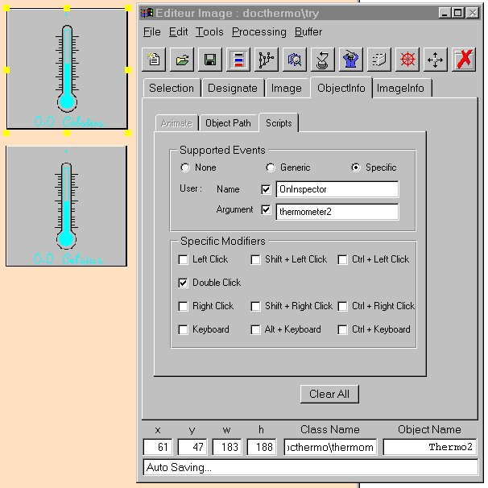
As described above, what we intend to do here is to pop a dialogue when the user double clicks on a thermometer.

Figure 14 - Thermometers Event
In our case, we have decided to execute the procedure "OnInspector" every time the user double clicks on the thermometer. The procedure will be passed the name of the thermometer.

Creating the dialog box
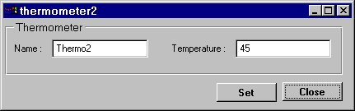
The objective here is to create a new panel letting the user interact with the thermometer. It should look like this:

Once again, we will build this in different steps:
- Visually creating the dialog using the panel builder
- Associating events handlers to some of the gadgets
- Writing the appropriate script.

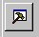Panel Builder
The panel builder is run by clicking on the icon in ScsStudio.
The panel builder is a tool designed to elaborate panels. It provides a comprehensive set of gadgets from the basic push buttons to the advance notebooks.
All is required is to drag the gadgets from the palette to the drawing area. Once done, gadgets may be resized, aligned and so on. Moreover, basic properties may be set by double clicking on the object.
Inside of the editor, it looks like this:
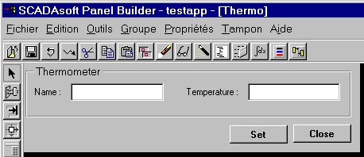
Figure 15 - Panel Builder

Like in the image editor, all elements which are active must have a name. These are these names which will be used to change the values of elements.
The names are for the:
- Name field : NameField
- Temperature field : TempField
- Set button: Set
- Close button : Close

For more on the panel builder, please refer to the panel builder user manual.

Adding behaviour
As the panel may suggest it, the we want to let the user have control over the two buttons Set and Close.
One will let the user write values in the database for the thermometer will was selected, the other will close the panel. Through this example, you should learn some basic interaction with the database as well as you should acquire a better understanding of the dataflow in SCADAsoft.
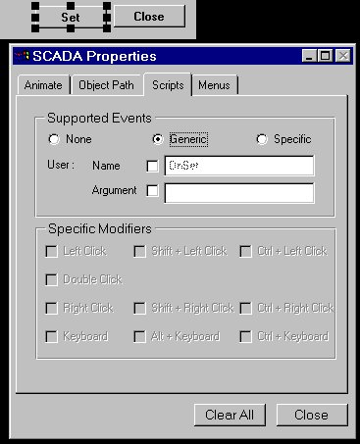
If you refer to section 1.1 in this chapter, you will see that, as far as gadgets are concerned, we recommend that you use the generic property for gadget callbacks.
Figure 16- Adding button callbacks

As you may see in the greyed out section, the implicit name for these procedures will be "OnSet" and if you give a further look "OnClose".

Associated Scripts

Image Script
As we saw in section 3.1.2, the thermometers are sensitive to a double click event. When this occurs, a TCL procedure located in the image script is called and run.
The procedure is:
proc OnInspector { pThermoName } {
Panel::NewPanel Inspector Thermo WS_Standard "" $pThermoName
Panel::SetTitle $pThermoName Inspector
}

There are few things to explain about this procedure:
- Input parameter
- Construction of a new panel
The input parameter is provided by the system. It corresponds to the value defined in the argument field of the dialogue box. Each thermometer will call the same procedure, with a different argument, letting the script knowing which thermometer info it processes.
The second line is in charge of creating a new panel. This is the panel we have created in the former section. It's the Panel::NewPanel instruction which is in charge of it. Actually its default syntax is much simpler than the one used here. At the bare minimum, it could be:
Panel::NewPanel NameOfThePanel NameOfTheFile
Here, the expression used is much longer because we pass the name of the thermometer as a parameter to the panel. The parameters between simply mean that the window should be created with the standard window attributes and no parent.
Please refer the SCADAsoft extension to TCL reference manual for more on this instruction.
The third line is just there to set the title of the window to the proper thermometer name.

Inspector Script
The inspector script is the script associated with the panel we have built. As described before, the script should contain:
- Procedures called by the system (OnInit, OnKill)
- Procedures corresponding to the events to process

System procedures
The procedures are the following:
variable Root

#
# ---- Constructor
#
proc OnInit { pThermometer } {
variable Root
set Root [ concat ":thermometers:" $pThermometer ]

ReadValues $Root
Panel::Show
}

#
# ---- Destructor
#
proc OnKill {} {
}

The OnKill procedure is quite simple…
The OnInit procedure is far more interesting.
First, it has a parameter. In the previous section, it was explained that the name of the thermometer was provided as an argument to the new panel. That's the one we retrieve as a parameter to the OnInit procedure.
The other standard instruction is Panel::Show which maps the panel to the screen.
The rest of the procedure initialize a variable (Root) which the connection address of the panel. We will use this value in the the following ReadValues:
proc ReadValues { pRoot } {
set Name [ Database::ReadValue $pRoot.Name ]
set Temperature [ Database::ReadValue $pRoot.Level ]

ScsSet NameField $Name
ScsSet TempField $Temperature
}

What this procedure does is reading a value from the database (Database::ReadValue). Then this value is stored in a procedure TCL local variable (set Name). The last step is to forward the value to the gadget (remember? They were given names) using the ScsSet instruction.

User Events
There are two user events corresponding to the two buttons in the panel.
The procedures are:
proc OnSet {} {
variable Root

set Name [ ScsGet NameField ]
set Temperature [ ScsGet TempField ]

Database::WriteString $Name $Root.Name
Database::WriteFloat $Temperature $Root.Level
}

proc OnClose {} {
Panel::DeletePanel
}

OnSet job is similar to the ReadValues procedure, expect that is retrieves values of the gadgets and write them to the Database.
OnClose is much simple. All it does is deleting the current panel.
Again, for more on the instruction please refer to the SCADAsoft manual.

Conclusion
You have now built :
- A complete image
- A Panel
This image is made of several instances of a subimage. With the corresponding connection.
You have also seen how to give life to these objects and exchange data with the database. You are now ready to explore the possibilies of SCADAsoft !

