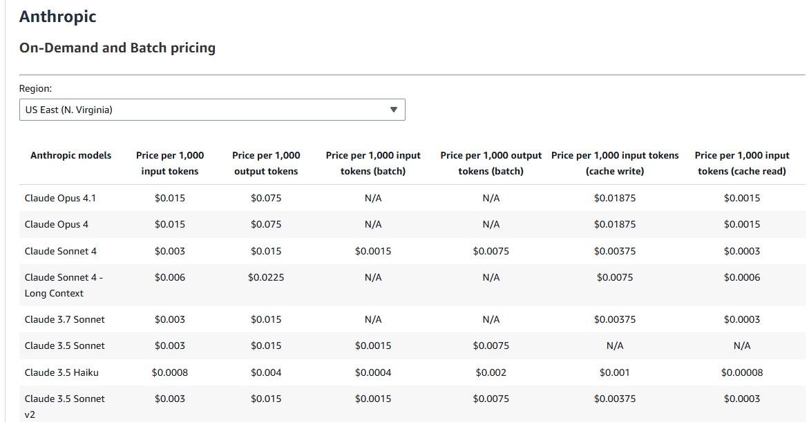

Text & Vision Models - Claude Opus 4.1, Claude Opus 4, Claude 3.7 Sonnet

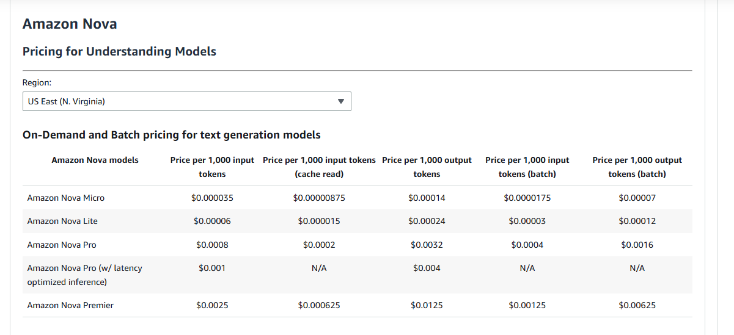
Text & Vision Models – Nova Lite, Nova Pro, Nova Premier

