CV Homework3

姓名:張庭維 學號:R09922170

1. Original image and its histogram

將圖片以矩陣讀取進來，統計每個數值的個數，接著使用matplotlib將長條圖畫出來，圖片如下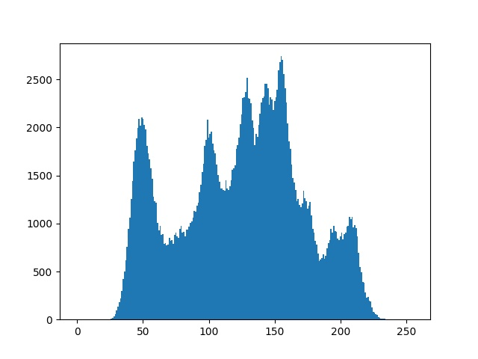

1. Image of intensity divided by 3 and its histogram

將圖片以矩陣讀取進來，將每個pixel的值除以3，再將每個數值的個數畫成長條圖，圖片分別如下

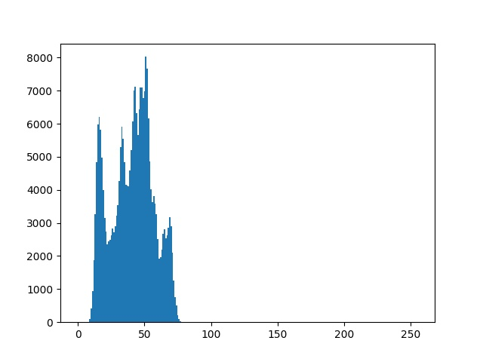

1. Image after applying histogram equalization to (b) and its histogram

將矩陣讀進來，每個pixel除以3，接著以histogram equalization的公式，將0~255的Sk分別算出來，再將圖片中對應到的k分別換成Sk的值，圖片結果分別如下

