|  |
| --- |
| Button |
| <<constructor>>+Button(); |

|  |
| --- |
| Drum |
| <<constructor>>+Drum(); |

|  |
| --- |
| MainWindow |
| -Ui::MainWindow *ui; |
| <<constructor>>+explicit MainWindow(*parent = 0: QWidget);  <<destructor>>+~MainWindow();  +*scene:Scene |

|  |
| --- |
| Scene |
| <<constructor>>+QGraphicsScene();  +init():void  +mousePressEvent(*event: QGraphicsSceneMouseEvent):void  +type1():void  +type2():void  +timer():void  +*start_btn:Button  +*exit_btn:Button  +*drum:Drum  +start_w:int  +start_h:int  +exit_w:int  +exit_h:int  +create():void  +change():void |
|  |
|  |



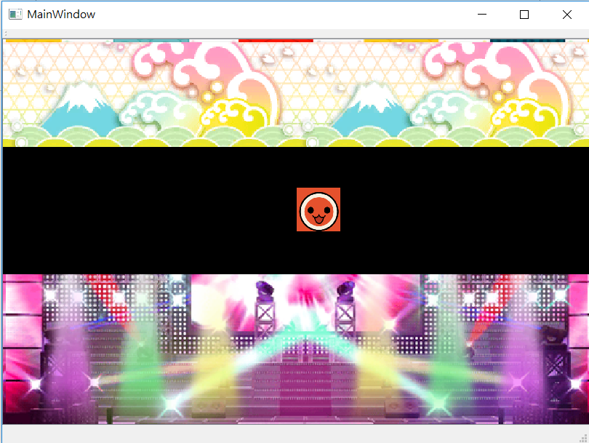

用一個繼承QGraphicsScene的class來構築整個程式,主要的function為內建的void *mousePressEvent*(QGraphicsSceneMouseEvent *event)來偵測滑鼠，在判斷點滑鼠的位置來判斷接下來要執行的動作。