The relationship between Efficiency and Coefficient of Performance

Kenneth D. Moore © July 10th, 2002

1.0 Introduction to the Problem: Considerable confusion appears to exist with respect to the definition of the efficiency (ε) of an energy system or energy process versus the definition of its coefficient of performance (COP). Thus, the purpose of this paper is to show the distinction and the relationship between these two important concepts.

2.0 Assumptions: For the development of this problem the following definitions are needed to clarify the energy flow concepts necessary for a logical understanding of the thermodynamic energy processes involved:
a) An energy process is an entity that accepts input energy, transforms or converts the energy to a different form (producing work), and outputs useful energy.
b) An energy system is a set of two or more energy processes, operating in series and/or parallel, such that the final output is useful energy.
c) An energy system or energy process may be in equilibrium with its environment (i.e. energy input from environment equals energy output to environment) or far from equilibrium with its environment (i.e. energy input from environment differs from energy output to environment). [Note: Hereafter, the word “system” shall be used for “system or process”.]

3.0 Issues Bearing on the Problem: Thermodynamics texts define the efficiency of an energy system many different ways and with many different ground rules for their application. The same can be said for the numerous definitions for COP and the multiplicity of rules that accompany its application. The approach taken was to define energy system efficiency so that it is consistent with the more widely recognized thermodynamics texts {1}{2} with respect to energy flow. Thus, the energy system efficiency (ε) may be defined as the total useful energy output (E_{out})(excluding losses) divided by the total energy input (E_{in}) from all sources:

ε ≡ E_{out (total useful)} / E_{in (total)} [joules/joules] (1)

For an electromagnetic system, it is often convenient to work with the total useful power output (P_{out})(dissipated by the system load) divided by the total power input (P_{in}){3}:

ε ≡ P_{out (total useful)} / P_{in (total)} [watts/watts] (2)

In a perfect energy system without losses, the efficiency would be 1.0, and for an energy system with losses, the efficiency range would be from 0.0 to less than 1.0. Hence, the efficiency of an energy system is bounded as follows:

0.0 ≤ ε ≤ 1.0 or 0% ≤ ε% ≤ 100%

The coefficient of performance (COP) of a system is often defined in the same manner as the efficiency and then special ground rules are developed to apply the COP to a system {4}. If the relationship between efficiency and COP is to be clarified, the definition of COP should be different from that of efficiency. It is submitted that the purpose of having a COP is to provide a relative indicator that shall evaluate the performance of each system in terms of the energy input by the user or operator and the useful energy output generated by the system. This leads to a relationship proposed by Bearden, where the total useful energy output is divided by the total input energy that the operator must supply in order to make the system function properly {5}{6}. Thus,

COP ≡ E_{out (total useful)} / E_{in (operator)} [joules/joules], (3)
and
COP ≡ P_{out (total useful)} / P_{in (operator)} [watts/watts]. (4)

It is noted that for certain systems, the operator input during system operation can be zero, and yet the system continues to produce useful output energy or power dissipation. For example, a windmill, waterwheel or sailboat would be examples of such systems, and it is clear that the environment in which the system is operating supplies the additional input energy. It is also clear that for such systems, the COP is infinite, since the operator’s input is zero. However, the efficiency of these energy systems is bounded between zero and one, which suggests that E_{in (total)} from equation (1) must have an additional component other than E_{in (operator).} Otherwise, the efficiency would also be infinite. Logically, it follows from the empirical evidence (i.e. the windmill, waterwheel and sailboat) that the environment is the additional source of input energy. Therefore,

E_{in (total)} = E_{in (operator)} + E_{in (environment)}, (5)

and the energy efficiency as shown in equation (1) is more precisely defined as:

ε ≡ E_{out (total useful)} / [E_{in (operator)} + E_{in (environment)}] (6)

4.0 Discussion: Equation (6) anticipates the possibility that the operator input energy for a system can be zero, but the efficiency will be less than one due to the inherent losses, such as shaft friction, aerodynamic drag or hydraulic drag, all of which serve to attenuate the useful output. These same or analogous arguments apply to electromagnetic systems, where the environment is the active vacuum or space-time. During the last several years, physicists such as Anastasovski, Bearden, Evans, et al. from the Alpha Foundation’s Institute of Advanced Studies (AIAS) have published new physics based upon non-Abelian O(3) electrodynamics, which is a subset of the Sachs unified field theory derived from the Einstein theory of general relativity {7,8,9}.

To date more than 100 papers have been published by AIAS, which describe a new non-Abelian O(3) electrodynamics that accurately calculates and solves many problems that the current Abelian U(1) electrodynamics does not solve {10,11,12}. Several of these AIAS papers show that the vacuum is not an empty void as it is currently modeled, and it should be modeled as an active and energetic space-time that can be used for energy exchange with a properly designed electromagnetic system {13,14}. Accordingly, the efficiency of an electromagnetic energy system can be more precisely defined from equation (2) as follows:

ε ≡ P_{out (total useful)} / [P_{in (operator)} + P_{in (environment)}] (7)

Then by re-arranging equation (7) and solving for P_{out (total useful)}:

P_{out (total useful)} = ε P_{in (operator)} + ε P_{in (environment)} (8)

Dividing each term by P_{in (operator)}:

P_{out (total useful)} / P_{in (operator)} = ε + ε P_{in (environment)} / P_{in (operator)} (9)

Substituting from equation (4) and re-arranging terms further defines the COP as:

COP ≡ ε [1 + Pin _{(environment)} / P_{in(operator)}] (10)

Equation (10) tells us that the electromagnetic system COP is a function of its efficiency and the ratio of the environmental input power to the operator input power. If the operator input power is zero, the COP becomes infinite, as in the examples described above for a windmill, waterwheel or sailboat. If the environmental input power is zero, the system COP value equals the system efficiency value, as for an under-unity electromagnetic system. Equation (10) also shows that an EM system can be over-unity, where the COP ranges from 1.0 to infinity.

A number of skeptics have argued that COP greater than one is impossible because it is prohibited by the laws of Thermodynamics, and it constitutes “perpetual motion”. These objections are invalid for the following reasons:

1) The thermodynamics law quoted (usually the second law) applies to a “closed system” in equilibrium with its environment, and it does not apply to an “open system” far from thermodynamic equilibrium with its environment. Unfortunately, thermodynamics defines a “closed system” as one that is closed only with respect to mass exchange across the system boundary. Hence, energy exchange across the boundary of an energy system far from equilibrium also is permitted in a thermodynamically “closed system”, so long as mass is not exchanged. Thus, it is evident that the thermodynamic definitions of a closed system and an open system are not mutually exclusive, which is a significant non sequitur. These equilibrium and disequilibrium relationships will be clarified further in the charts and text below.

2) The perpetual motion argument is invalid because it implies the creation of energy within the system, which has not been claimed, and in fact, the origins of the energy inputs have been clearly specified. Furthermore, the thermodynamic definition for a closed system permits energy exchange for a disequilibrium state, which permits a COP greater than one. Rigorously, the discriminator for COP greater than one operation is energy exchange in a disequilibrium state.
In further regard to the perpetual motion issue, Dr. T. E. Bearden (in an e-mail dated 21 June, 2002, subject: Dr. Tom: Canonical momentum) addressed it as follows:

“A strong rebuttal to the charge of "perpetual motion nonsense" (levied by a senior Board Member of the actual corporation owning that set of journals) was what got the second MEG [Motionless Electromagnetic Generator] paper published in Foundations of Physics Letters. We confronted those gentlemen with the proven broken symmetry of the charge and the dipole, each of which has COP = infinity. We also confronted them with the solution to the source charge problem, which does not exist in classical electrodynamics, and then challenged them to either present a solution to it in classical electrodynamics (CED) or accept the fact that CED already accepts total destruction of the conservation of energy law. The award of the Nobel Prize to Lee and Yang for their broken symmetry prediction cinched it. If they then objected to COP>1.0, it meant that they had to exclude from electrodynamics all charges and dipoles. Since all fields and potentials and their energy come from their source charges, this meant they would have to exclude all EM fields and potentials — and thus all EM energy. In short, without COP = infinity of those charges, all electrodynamics models "eat themselves by swallowing their own tail." So the charge either falsifies conservation of energy altogether and destroys all electrodynamics, or it clearly proves that COP>1.0 EM systems are not only possible, but ubiquitous.”

Chart 1 below gives a graphical presentation for solutions to equation (10), using selected ratios of environmental input power (EIP) to operator input power (OIP).

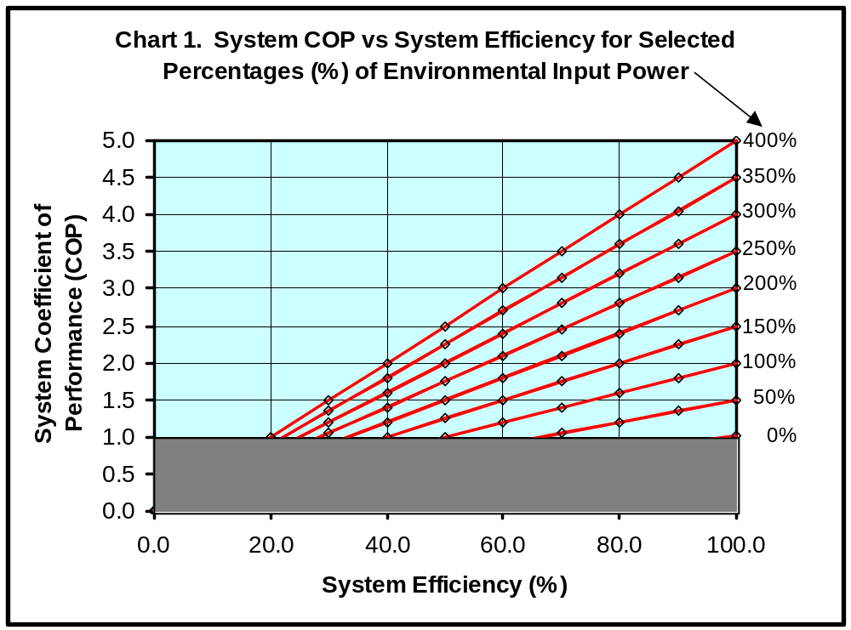

The selected ratios shown in Chart 1 have been expressed as a series of percentages that indicate the contribution of the environmental input power with respect to the operator input power. Thus, the curve labeled “400%” means the environment contributed four parts to one part from the operator, which is held constant at “100%”. For each selected EIP percentage, the system COP was computed (using equation (10)) for stepped values of system efficiency (every 10%) from 0% through 100%. The resulting plots show a family of linear curves, all of which originate at the origin.

Chart 1 above indicates that if the environmental input power is sufficiently large, say four times (400%) the operator input power (100%), and the system efficiency is 50%, then the COP would be 2.5, which indicates the achievement of an over-unity system. The breakpoint for a 50% efficient system would occur when the environmental and operator inputs were equal, producing a COP of 1.0.

The shaded area just above the system efficiency plot axis, which is bounded by System COP value 1.0 and System Efficiency values 0.0% and 100.0%, represents the region of system operation where the laws of Equilibrium Thermodynamics apply (Region 1, green), and the well-known first and second laws limit the COP and the efficiency to 1.0 or less {1}{2}. The area above Region 1 on Chart 1, where the System COP value is bounded between 1.0 and 5.0 and the System Efficiency is bounded by the values 0.0% and 100.0%, defines the region where the laws of Non-Equilibrium (or Disequilibrium) Thermodynamics apply (Region 2, light blue). In other words in Region 2, the system has been designed or modified to perform as an open system that is far from thermodynamic equilibrium with its environment {15(a) – 15(e)}.

Chart 2 below shows another plot for equation (10) where the EIP has been set to a very large value, and it follows that a linear relationship remains throughout Regions 1 and 2.

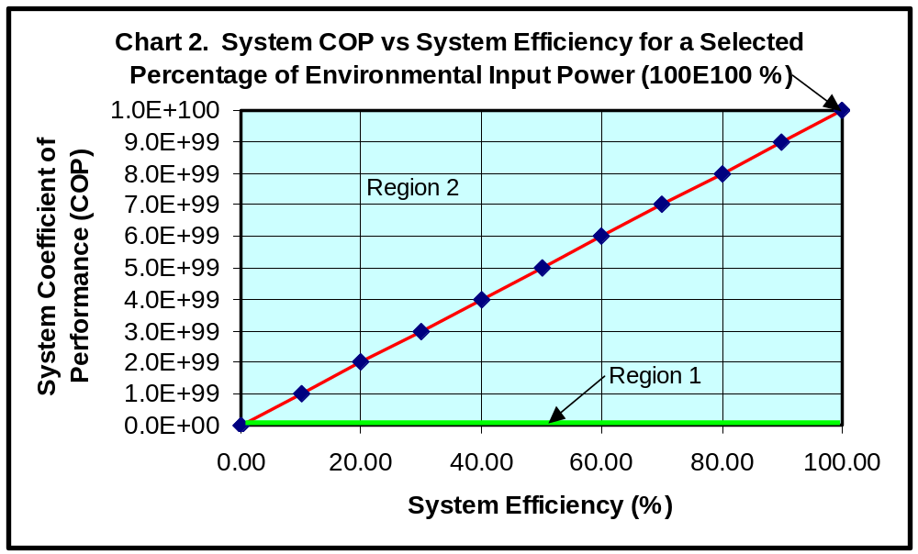
At this scale for Chart 2, Region 1 is a very thin rectangle along the System Efficiency axis, which is drawn to an exaggerated vertical scale to be able to see it.

The implicit assumption for these curves generated by equation (10) and displayed in Charts 1 and 2 is that the system is stable and linear in the production of its output. It is well recognized that many systems (especially electromagnetic systems) tend to be non-linear and may operate in an unstable or partially stable manner. Hence, actual results obtained may be attenuated due to the non-linear nature of the system being developed and tested. In this context, these curves may be regarded as the theoretical limits of actual results obtained.

As noted above the maximum value for the System COP can be infinity, which is consistent with equation (10) when the operator input energy is zero. Chart 3 below shows this relationship, which is drawn conceptually and not to scale.

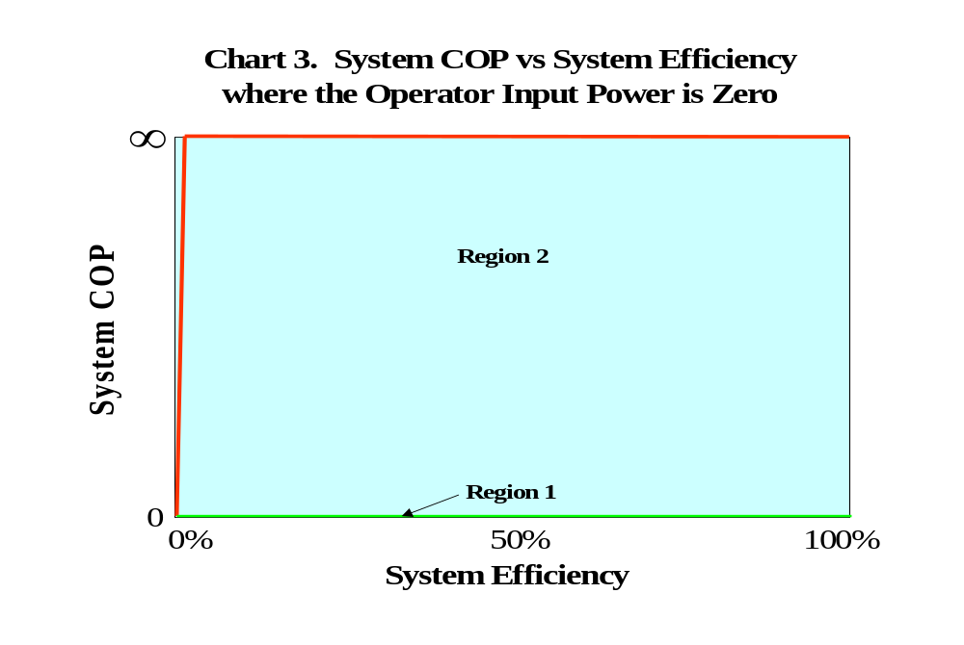

Chart 3 illustrates the windmill, waterwheel and sailboat type systems described previously, and as an example, it indicates the impact of using solar cells to power electronic circuits, e.g. satellite systems. Thus, it also shows the effects on a COP greater-than-unity system that has been closed-looped, so that all input energy is supplied by the environment, which in this example would be photon energy from the sun. Chart 3 also indicates the system efficiency must be large enough to overcome inherent system losses, which explains why the system COP does not reach infinity at 0.0% efficiency. In a real system, the operator must input enough energy to “prime the pump”, and once this is accomplished, the operator input is removed and the environment inputs the energy.

Clearly, the goal of the system designer is to maximize the system COP by achieving the highest possible system efficiency and environmental input, while minimizing the operator input needed to make the system function properly. Finally, the ultimate design goal is close-loop the system, and thereby achieve a COP of infinity.

5.0 Conclusions: System COP and system efficiency have different and distinct definitions. In the ideal limit, COP is a linear function of efficiency and the energy (or power) ratio between the environmental and the operator inputs.

a) The calculated efficiency value is bounded by 0.0 and 1.0 (0% to 100%). It is defined for the general form as:

ε ≡ E_{out (total useful)} / [E_{in (operator)} + E_{in (environment)}], where E is expressed in joules.

For electromagnetic systems:

ε ≡ P_{out (total useful)} / [P_{in (operator)} + P_{in} _{(environment)}], where P is expressed in watts.

b) The calculated COP value is bounded by 0.0 and infinity. It is defined for the general form as:

COP ≡ ε [1 + E_{in (environment)} / E_{in (operator)}] ≡ E_{out (total useful)} / E_{in (operator),} where E is expressed in joules.

For electromagnetic systems:

COP ≡ ε [1 + P_{in (environment)} / P_{in (operator)}] ≡ P_{out (total useful)} / P_{in (operator)}, where P is expressed in watts.

c) For a system with a COP in the range of zero to one, the calculated value of the COP and the efficiency will be equal. This situation is supported by the equations in paragraph b) above when the environmental input goes to zero.

d) For a system to maintain its performance above unity (i.e. COP greater than 1.0), it must be designed to function as an open system far from equilibrium with its environment, so that the system shall benefit from a continual input of environmental energy. This environmental input must be large enough to exceed the operator input, and it must overcome the effects of a system efficiency that is expected to be less than one.

e) The ultimate design goal is close-loop the system, so that all input energy is supplied by the environment and the resulting COP is infinite.

f) If the system efficiency and system COP are defined as shown in paragraphs a) and b) above, the resulting relationship between efficiency and COP (as illustrated in Charts 1-3) is very useful in furthering a better understanding of the relationships between under-unity and over-unity systems. In fact, this analysis strongly suggests that under-unity systems are a very small subset of an infinite set of over-unity systems, which can be developed through further research and engineering.

6.0 Acknowledgements: A sincere “thank you” to Dr. T. E. Bearden and to Mr. Alexander S. Labounsky for their very helpful advice, technical suggestions and edits. Their comments and viewpoints were extremely valuable in assembling the material, finding the references and maintaining a logical discourse throughout this paper.

7.0 References:

{1} Gyftopoulos, Elias P. and Gian Paolo Beretta, Thermodynamics: Foundations and Applications, MacMillan, 1991. This is an elaborate textbook developed over the years at MIT, providing a rigorous and authoritative exposition of thermodynamics.

{2} Kondepudi, Dilip and Ilya Prigogine, Modern Thermodynamics: From Heat Engines to Dissipative Structures, Wiley, New York, 1998.

{3} Radovic, Ljubisa R., Title - none, Chapter 4, p. 55 and 57, see website: http://www.ems.psu.edu/~radovic.

{4} Radovic, Ljubisa R., Title - none, Chapter 4, p. 69, see website: http://www.ems.psu.edu/~radovic.

{5} Bearden, T. E., Energy from the Vacuum: Concepts and Principles, Chapter 2, paragraph 2.1.6, 2002 (in press).

{6} Bearden, T.E., Energy from the Vacuum: Concepts and Principles, Appendix 1, Annotated Glossary of Selected Terms, “Coefficient of Performance”, 2002 (in press).

{7} Anastasovski, P. K., T. E. Bearden, C. Ciubotariu, W. T. Coffey, L. B. Crowell, G. J. Evans, Myron W. Evans, R. Flower, S. Jeffers, A. Labounsky, B. Lehnert, M. Meszaros, P. R. Molnar, J.-P. Vigier, and S. Roy, The New Maxwell Electrodynamic Equations: New Tools for New Technologies, Journal of New Energy, 4(3), Special Issue of AIAS papers, Winter 1999. Sixty papers by the Alpha Foundation’s Institute for Advanced Study, that advance electrodynamics to a non-Abelian, gauge theoretic higher topology theory in O(3) internal symmetry.

{8} Anastasovski, P. K. T. E. Bearden, C. Ciubotariu, W. T. Coffey, L. B. Crowell, G. J. Evans, M. W. Evans, R. Flower, S. Jeffers, A. Labounsky, B. Lehnert, M. Mészáros, P. R. Molnár, S. Roy, J.-P. Vigier, Development of the Sachs Theory of Electrodynamics, Foundations of Physics Letters, 14(6), Dec. 2001, p. 595-600.
{9} Anastasovski, P. K., T. E. Bearden, C. Ciubotariu, W. T. Coffey, L. B. Crowell, G. J. Evans, M. W. Evans, R. Flower, S. Jeffers, A. Labounsky, B. Lehnert, M. Mészáros, P. R. Molnár, J.-P. Vigier, S. Roy, Empirical Evidence for Non-Abelian Electrodynamics and Theoretical Development, Annales de la Fondation Louis de Broglie, 26 (1), 2001, p. 1-24. There is clear empirical evidence for the fact that classical electrodynamics is not fully described by the Maxwell-Heaviside equations. In this paper, the empirical evidence is used to construct a form of classical electrodynamics, which is more self-consistent and able to account for observations, where the received Maxwell-Heaviside view fails.
{10} Anastasovski, T. E. Bearden, M. W. Evans, et al., Derivation of O(3) Electrodynamics from the Einstein-Sachs Theory of General Relativity, Foundation of Physics Letters, 2002 (in review).
{11} Bearden, T. E. Extracting and Using Electromagnetic Energy from the Active Vacuum, in M. W. Evans (ed.), Modern Nonlinear Optics, Second Edition, 3 volumes, Wiley, 2001, Vol. 2, p. 639-698. The 3 volumes comprise a Special Topic issue as Volume 119, I. Prigogine and S. A. Rice (series eds.), Advances in Chemical Physics, Wiley, ongoing.

{12} Anastasovski, T. E. Bearden, M. W. Evans, et al., O(3) Electrodynamics from the Irreducible Representations of the Einstein Group, Foundations of Physics Letters, 15(2), Apr. 2002, p. 179-187.
{13} Anastasovski, T. E. Bearden, M. W. Evans, et al., The Aharonov-Bohm Effect as the Basis of Electromagnetic Energy Inherent in the Vacuum, Foundation of Physics Letters, 2002 (in review).
{14} Anastasovski, P. K., T. E. Bearden, et al, Explanation of the Motionless Electromagnetic Generator with O(3) Electrodynamics, Foundations of Physics Letters, 14(1), Feb. 2001, p. 87-94.

{15} Thermodynamics of dissipative systems far from thermodynamic equilibrium:
- Prigogine, Ilya, Nonequilibrium Statistical Mechanics, Wiley-Interscience, New York, 1962;
- Kondepudi, D., Thermodynamics: From Heat Engines to Dissipative Structures, Wiley, Chichester, 1998;
- Nicolis, G., Self-Organization in Non-Equilibrium Systems: From Dissipative Structures to Order through Fluctuations, Wiley, New York, 1977;
- Nicolis, G., Physics of far-from-equilibrium systems and self-organization, Chapter 11, Wiley, New York, 1977;
- Davies, Paul, The New Physics, Cambridge University Press, Cambridge, 1989, p. 316-347.
~End~

