Loo-Loo’s Alphabet Matching Game

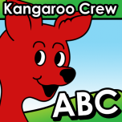

Search for “kangaroo crew alphabet” on iTunes or Google Play.