User Interface Design for Operational Risk AMA model

1. Technology

1.1 Developed with AngularJS, Bootstrap, HighCharts, HTML5, CSS3. The home page is index.html. Under scripts/ folder, contains all dependency libraries of Angular, Bootstrap, HighCharts and jQuery, and myApp.js. css/ folder is for style files, bootstrap.css and style.css.

1.2 Data is saved in JSON file under data/ folder. The default 7 sets of data is in clusterScores.json file, created 2 other sets of dummy data for testing "Add Data Set" function, set8.json, set9.json.

1.3 To run the page, it requires to run on a server, such as NodeJS.

1.4 For the browser version, open index.html in any browser to view the page.

2. UI Design and Functions:

2.1 Initial:

When open the index.html page in a browser, it display data table, which loads 7 sets of data from the json file. A "Chart / Table" toggle button, on top left corner, switchs displaying table or chart.

2.2 Table view

In table view, the scores display in table with 2 decimal digits. If 0, display as "-". Scores are displayed with different background color: Green for 1, Blue for 0.67, Orange for 0.33 and Red for 0. Considering customize change the score may not limited to the 4 number, set a range for each colour. The ranges are just for testing, and be able to change. The table is responsive when browser size changes.

The top row and left column used different colour to show Data Set Name: Not Clustered in grey, Clustered in light blue, with navy and dark red colour to separate different combined group.

There is a button of "Add Data Set" on top right cell of the table.

Legend displays under the table.

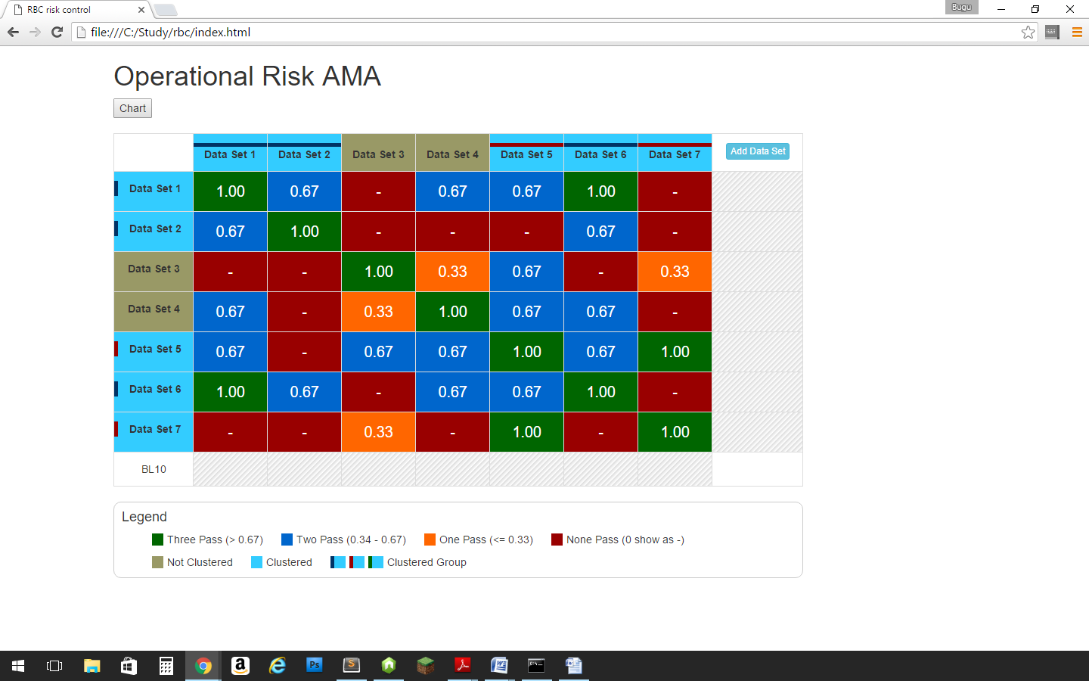

2.3 update score:

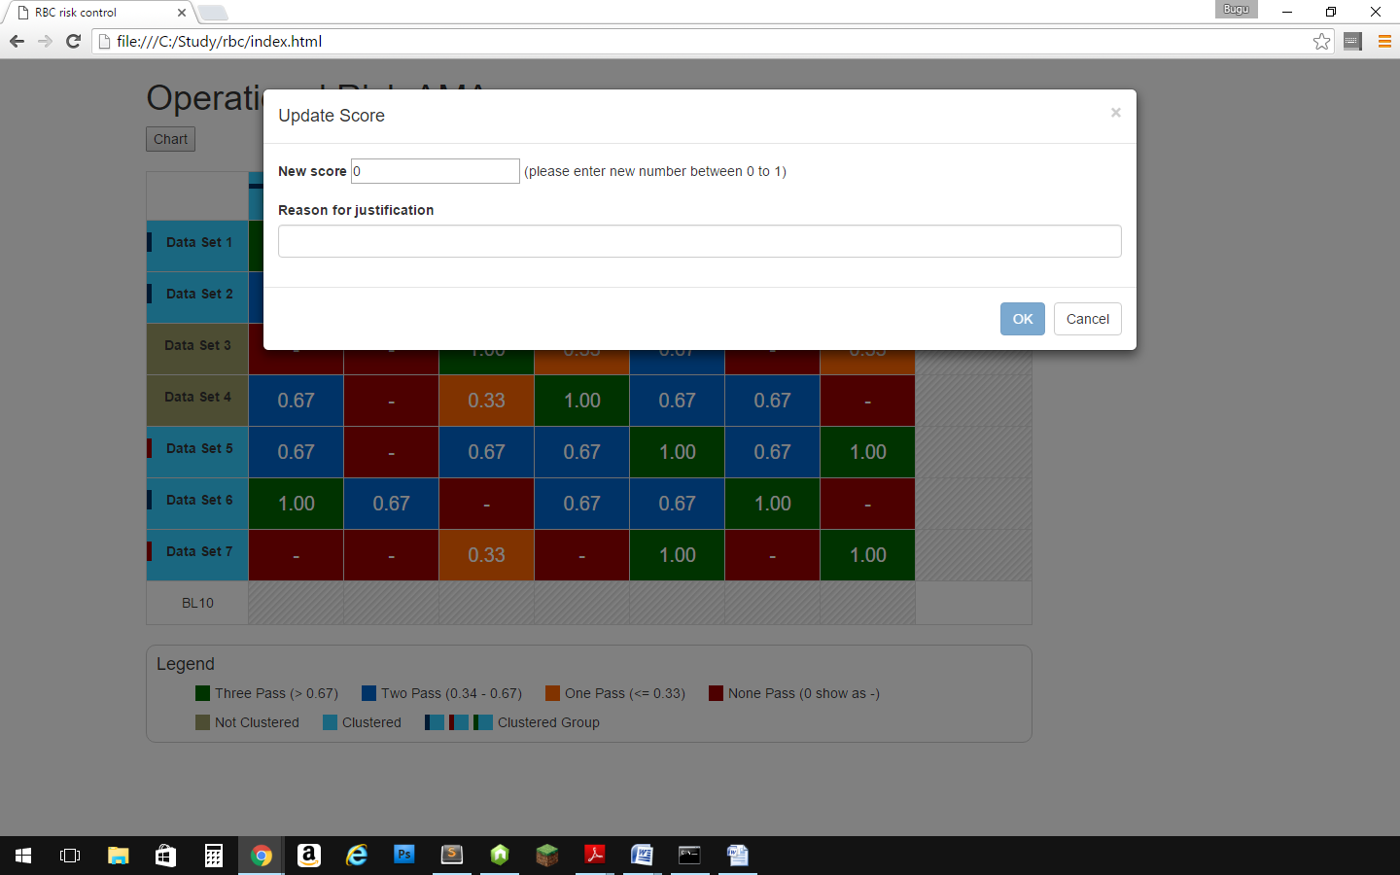

In table view, when click score in the table, a lightbox will popup with 2 fields and 2 buttons, new score field to enter number between 0 to 1, and the other field to collect the reason of updating the score. Click Cancel button will close the lightbox without doing anything. The OK button is disabled until valid number in the new score field and some reason entered. If the score on diagonal, cell1-1, 2-2,...,7-7, etc., which should be always 1, it will display an alert box when click OK button and close the lightbox without doing any change.

After a score updated, the score in the selected cell and its diagonal symmetry cell is changed (in the screenshot, cell5-2 and 2-5 changed to 0.40), and the Update Notes div shows beneath the Legend, and display the note like " Data Set5-2 is updated from 0 to 0.4 by the reason: test environment is changed". If more than one changes, all notes will listed below.

\* Note: the new score input field allows to enter any number between 0 to 1. If just need to change score among the 4 number 1, 0.67, 0.33 and 0, there is an option to use a dropdown list, which is in the code, tested, and comment out.

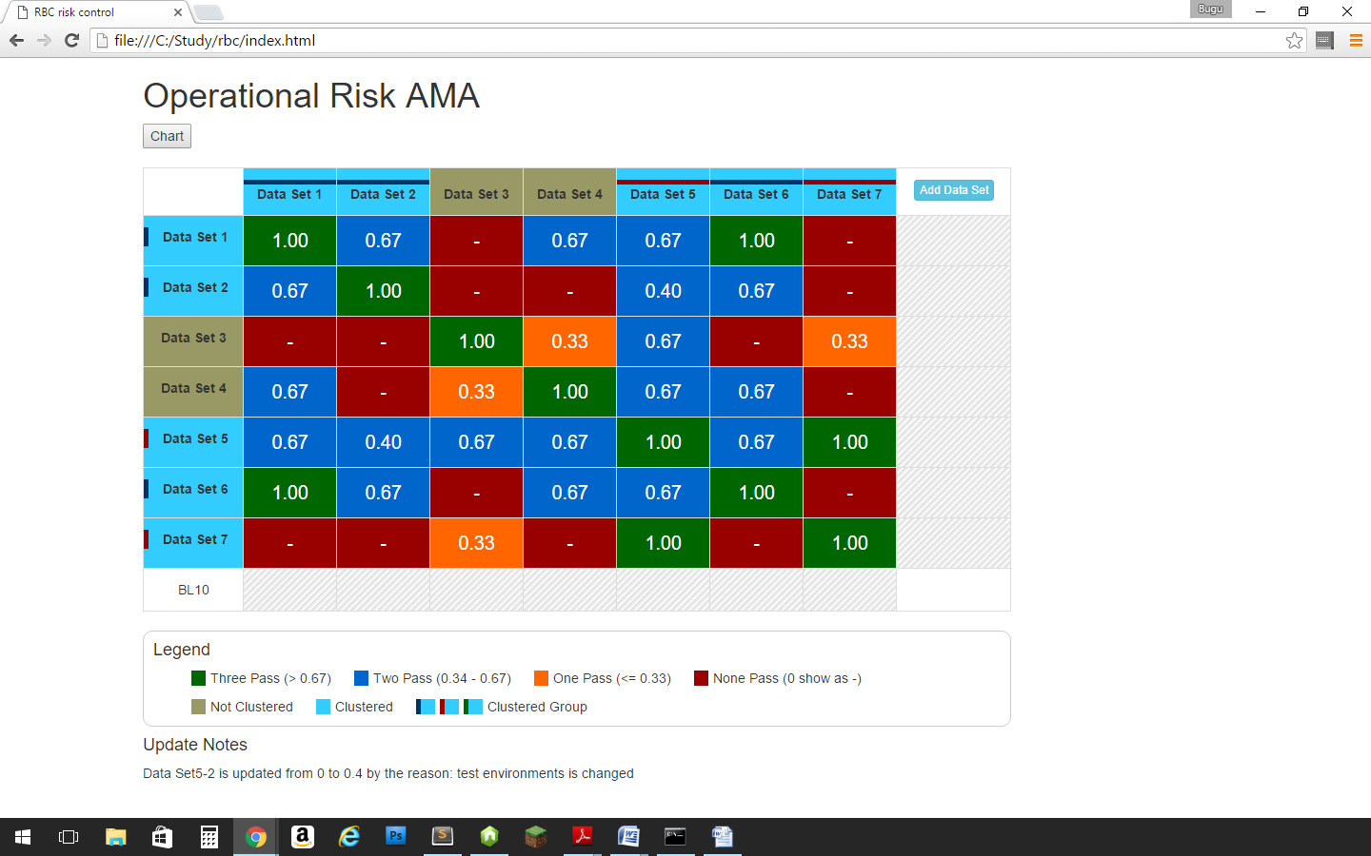

2.4 When click the "Add Data Set" button, it will display a new row at bottom and a new column at right. In the screenshot, Data Set 8 is added. The set8.json has 8 scores. The program automatic copy and add the symmetry score to each of other data sets.

\*Note: there are only 2 sets of json data for testing. If click more than 2 times, it will see 404 error on dev tools on server version but on web page will be no change, or a blank data set column and row in browser version.

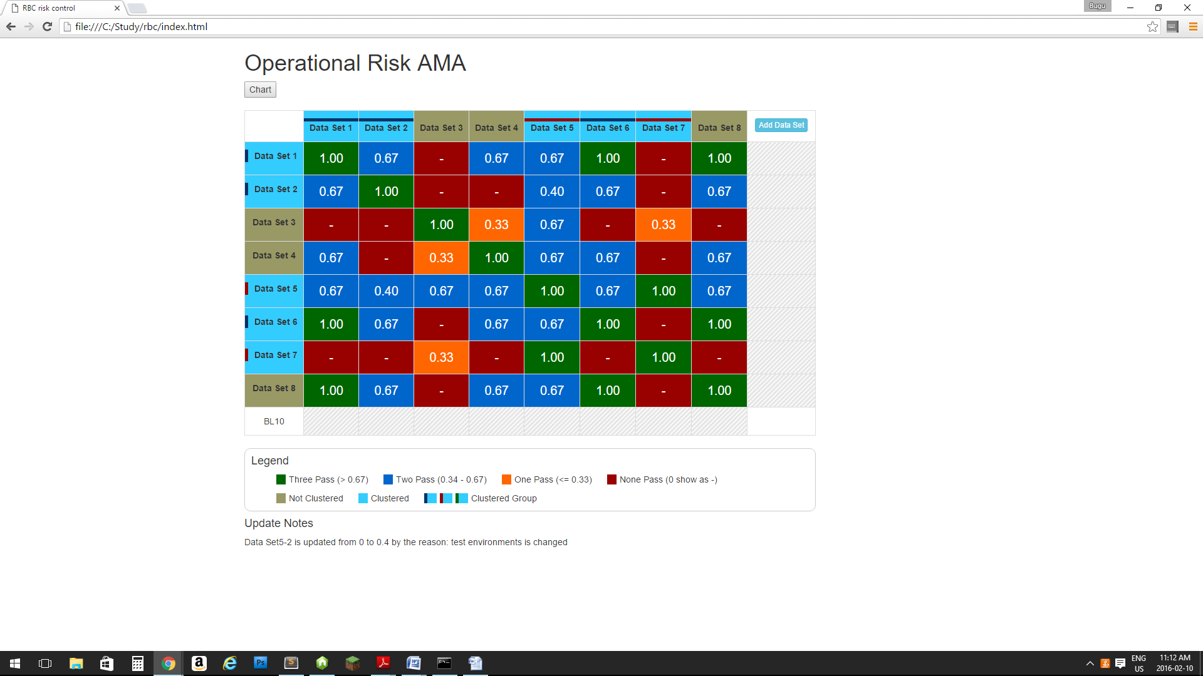

2.5 Chart view:

When click the "Chart" button, browser will display the column chart with updated data.

* xAxis is Set1, Set 2,....
* yAxis is 0-1.
* When mouse over the bar, display the group bars' numbers in a popup table. \*
* Theicon on top right is for several utility usage. When click it, a drop down list will show for Print Chart, Download png Image, Download jpg Image, Download pdf Image, and Download sng Vector Image.

\*Note: view bars' number info can be shown not in table, but display number on top of each bar when mouse over the bar.

