《英语》（牛津上海版）一年级第二学期1B Module3 Unit3 Clothes
一、单元教学内容(P34-37)
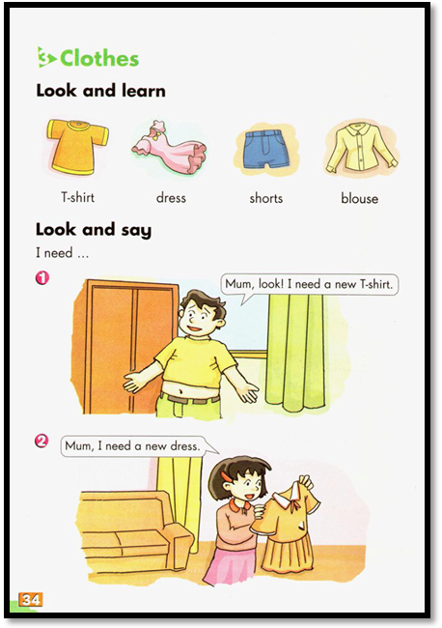
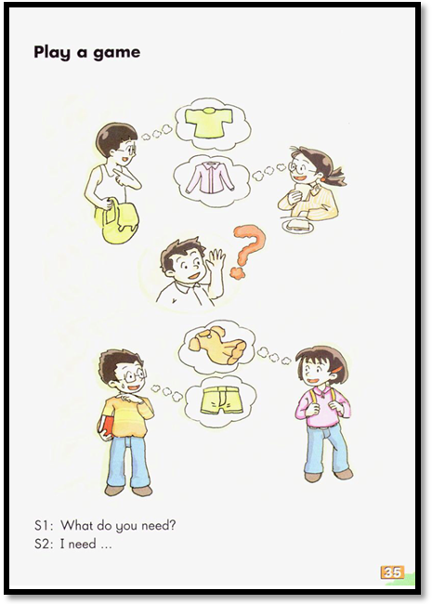
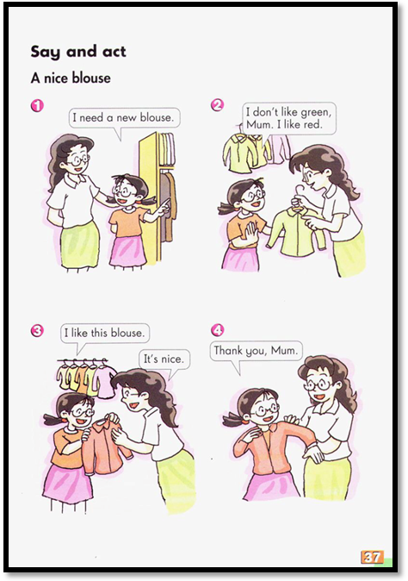
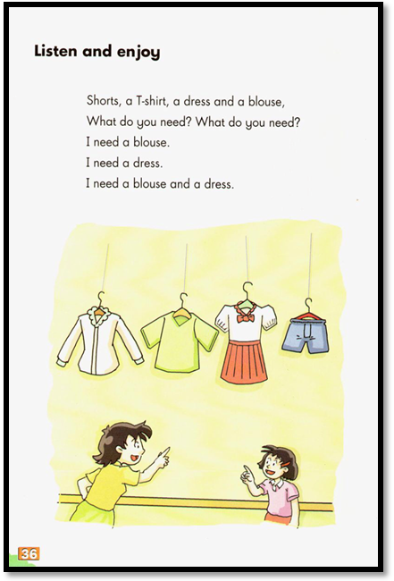

二、学习与评价的内容和要求
学习内容 |  |  | 学习水平 |  | 学习要求
 |  |  | 学段 | 年级 | 学习要求
字母 | 字母：Ii， Jj |  | A | A | 能认读、书写字母，初步知晓字母在单词中的发音
语音 | 1.1读音规则 | 1.1.1辅音字母的读音规则 | A | A | 背记辅音字母的读音规则
语音 | 1.2 朗读 | 1.2.1 基本句式的朗读语调 | A | A | 能用正确的声调和降调朗读句子
词汇 | 2.1 核心词汇：young, old, sister, brother |  | C | B | 背记、理解和运用核心词汇
句法 | 3.1 句子种类 | 3.1.1 一般疑问句： Is he/she…?  Yes, he/she is. /No, he/she isn’t. | C | B | 用一般疑问句提问，并作出回答
语篇 | 4.1 记叙文 | 4.1.1 基本信息 | A | A | 简单讲述对话、故事等记叙文中的时间、地点、人物、事件等基本信息

三、单元教学与评价目标
（一）语言运用目标
学生能在“My family” “Peter’s family”相关活动的语境中，借助图片、文字及多媒体，运用核心词汇young、old、brother、sister及核心句型Is he/she…? Yes，he/she is. No，he/she isn’t.，以口头询问方式，来获取他人家庭成员的的个人信息、外形样貌等信息。做到能正确拼读核心词汇、朗读核心句型，能模仿表达，运用恰当，语音语调正确优美。
（二）知识技能目标
（1）学生能在语境中知晓、背记字母Ii和Jj在单词中的读音规则，并正确朗读单词和儿歌。
（2）学生能在语境中背记、理解形容词young和old，能运用这些核心词汇进行询问，做到读音正确，并能正确书写。
（3）学生能在语境中理解并运用Is he/she…?Yes, he/she is./No, he/she isn’t.等核心句型进行提问并获取相关信息，做到语音语调正确，描述适切。
（4）学生能在语境中获得Look and say语篇和 Ask and answer对话中的基本信息，背记、理解并运用相关信息进行简单描述；能理解Play a game和Listen and enjoy中语篇的意义并能提取相关信息简单讲述自己家庭成员个人信息、外形样貌等，做到语音语调正确，表达适切。
（三）语言情感目标
（1）学生通过了解、介绍自己家庭成员的外貌特征，体会到家庭的重要和家庭成员之间的温情。
（2）在获取信息的过程中，促使学生了解别人的家庭，形成乐于交友的良好品格。

四、分课时教学与评价目标
话题与板块 | 知识与技能 | 语用与情感 | 评价内容与方法
Period 1  My family  Learn the letters  Listen and enjoy  Look and learn  Look and say | 1.能知晓、背记字母Ii和Jj在单词中的基本读音，并模仿跟读相关单词。  2.能识别、背记、理解形容词名词young和old并正确朗读；  3.能感知、理解核心句型Is he/she…?Yes, he/she is. /No, he/she isn’t.的意义和基本结构，并能正确朗读。  4.能听懂、读懂Look and say等语篇的意义并能尝试演一演。 | 1.能用一般疑问句进行人物关系的询问，并能获取有效的信息。  2.通过了解他人家庭成员的关系，进一步了解自己的同学和朋友。 | 1.借助照片、文字等方式获取准确的个人信息，要求语音语调正确，语意表达有逻辑。  2.课堂表现评价：学生互评，教师口头评价。  3.课后表现评价：学生互评。
Period 2:  Peter’s family  Learn the letters  Look and learn  Ask and answer  Listen and enjoy  Look and say | 1.能正确朗读含有字母Ii和Jj的单词及相应的句子；  2.能知晓、理解并正确朗读单词young和old，并能正确运用这些形容词尝试简单以口头方式询问他人的家庭成员。  3.能模仿运用核心句型Is he/she…?Yes, he/she is. No, he/she is.来询问相关家庭成员的外貌特征。 | 1.能用一般疑问句询问他人家庭成员之间的关系以及他人家庭成员的体形外貌特征等。  2.能体会到家庭成员之间的相互关爱之情，知晓家庭对每个人的重要性。。 | 1.借助照片、文字等方式获取准确的个人信息，外貌特征等，要求语音语调正确，语意表达有逻辑  2.课堂表现评价：学生互评，教师口头评价。  3.课后表现评价：教师面谈。

五、分课时教案
M2U2 Period 1 My family
I．Objectives：
1. Contents:
(1) Words: young old*mummy *daddy *kind *dear
(2) Sentence structures:
Is he/she…?
Yes, he/she is.
No, he/she isn’t.
2. Abilities:
(1) Be able to use the key patterns and adjectives to describe family
(2) Be able to use sentence pattern to describe the things one owns.
3. Culture: To be a good child to grandparents.
II. Language Focus:
(1) Understanding the key words in context
(2) Using formulaic expressions to talk about family members.
(3) Using modeled language structures to talk about family members.
III. Difficulty:
Using modeled language structures to talk about family members.
IV. Teaching aids: multi media

V. Teaching procedures:
学习目标  即评价指标 | 学习内容 | 活动序号 | 导学方法 |  | 说明与反思
学习目标  即评价指标 | 学习内容 | 活动序号 | 教师活动 | 学生活动 | 说明与反思
能快速进入学习英语的气氛。  能正确读出字母在单词中的发音。  能简单描述一下Sally和Jim。  能初步感知文本情景  能基本了解句子  内容。  能正确朗读句型  能学会并运用新  句型  能熟练在语段中运用句型  能初步感知文本  第一段内容  能正确朗读单词  能将单词进行结合句子初步运用  看初步感知文本情景  能正确朗读单词  能正确朗读儿歌  能够整体感知整个对话，并感受到讲话人的情感。  能正确运用单词句子进行综合运用。  能在课后巩固  ，综合运用所学  知识与技能。 | Pre-task preparation  Revision  While-task procedure  Is he/she…?  Yes, he/she is./  No, he/she isn’t.  Learn: Alice’s family member  (mummy, daddy)  （kind, dear )  Learn: Listen and enjoy  Post-task activities  Enjoy the whole dialogue  Ask your deskmate some questions about his family members.  Homework:  1. Listen P19.  2. Read the chant with emotion.  3. Introduce your family | 1  2  3  4  5  6  7.  8  8  9 | Try to say the rhyme.  Review the letter Ii and Ji  Talk about Sally and Jim  Alice is introducing her family to  Kitty.  What does Alice say? What does Kitty  say?  Let’s play a game.  Make a model with students.  Work in pairs.  This is Alice’s family.  Look! Guess. Who’s she/he?  He’s Alice’s daddy.  She’s Alice’s mummy  How is her father?  How is her mother?  Let’s listen to a rhyme.  How many people in her family?  Who are they?  How is mummy/daddy/sister/  brother?  Let’s to read the rhyme  Listen to the dialogue between Alice and Kitty.  Take out your family photo and talk about your family with your partner. | 1. Read the rhyme  2. Review the sound of Ii and Jj  3. Say something about Sally and Jim.  4.1Listen and watch the dialogue.  4.2Answer the questions.  4.3Listen and watch.  ---Is he/she …?(tall/thin/fat…)  ---Yes, he/she is.  (No, he/she isn’t.)  ---Is he/she XXX?  ---Yes/No.  4.4Play the game with friends.  5.1Understand the meaning of the new word.  5.2Read and spell the new words  5.3 Understand the meaning of the new word.  5.4 Read and spell the new words  5.5 Practice:  ---This is …  ---He/She…(young/old)  Is he/she …  (kind/dear/tall…)  ---Yes, he/she is.  No, he/she isn’t.  I like my …  6.1 Listen to the rhyme  6.2 Answer the questions  6.3 Read the rhyme.  7.1 Listen to the dialogue  7.2 Talk about your family with the partner.
Blackboard design:
M2U2 Period2 My family II
This is…(father/mother /grandfather …)
He/She is … Is he/she …?(tall/short/thin/fat) Yes, he/she is. /No, he/she isn’t.
He/She is …
I like my…

[本课时文本]
S1：This is …
S2:He/She is… （old/young）
Is he/she…?
S1: Yes, he/she is.
No, he/she isn’t.
I like my…

Module2 Unit2 Period2 Sub-topic: Peter’s famliy
School: Qingpu Xujing Primary School
Date: 2020-10-16
Teacher: Bill (徐青)
Topic: Peter’s family
Level: Grade Two
Type: New teaching

I. Objectives:
1. Contents:
(1) Word and expressions: sister， brother， insect， jar
(2) Sentence patterns: Is he/she …? Yes, he/she is. No, he/she isn’t.
(3) Passages: Dialogues
2. Abilities:
(1) Be able to read the words and the rhyme with /I/and /j/ sound correctly.
(2) Be able to use the key words in context.
(3) Be able to use adjectives to describe a person
(4) Be able to use modelled questions to find out particular information about a person
(5) Be able to use formulaic expressions to confirm or deny
3. Culture: Care for our family.
II. Language Focus:
(1) Understanding the key words in context
(2) Using formulaic expressions to talk about family members.
(3) Using modeled language structures to talk about family members.
III. Difficulty: Be able to use general questions to know about others fluently.
IV. Teaching aids: Multi-media, pictures, etc.
V. Teaching procedures:

学习目标  即评价目标 | 学习内容 | 活动序号 | 导学方法 |  | 说明与反思
学习目标  即评价目标 | 学习内容 | 活动序号 | 教师活动 | 学生活动 | 说明与反思
能在愉快的氛围中快速进入学习状态。  能初步感知文本情景  能基本了解句子内容。  能正确朗读句型  能学会并运用新句型  能熟练在语段中运用句型  能看图片初步感知单词  能正确朗读单词  能在词组中进一步掌握单词  能正确理解并运用单词。  能看图片初步感知单词  能正确朗读单词  能在词组中进一步掌握单词  能正确理解并运用单词。  能完全理解故  事。  能流利朗读故事  或有感情地表演  故事  能在课后巩固，  综合运用所学知  识与技能。 | Pre-task preparation  1. Letters: Ii, Jj  2. Review: My family  While-task procedure  1. Part I of the dialogue  2. Part II of the dialogue  Learn: sister  Learn:  ---Is she….?  ---Yes, she is./No, she isn’t.  3. Part III of the dialogue  Learn: brother  Learn:  ---Is he….?  ---Yes, he is./No, he isn’t.  Post-task activities  Enjoy the whole dialogue  Ask and answer  Homework:  1. Listen to the tape.  2. Read or act out the whole story  3. Try to introduce your family. | 1  2  1  2  3  1 | First, here’s a rhyme for you.  Let’s say the rhyme together.  In this rhyme, we can see Ii and Jj. Let’s write Ii and Jj  This is letter Ii and this is letter Jj. Ii/I/ insect Jj /dZ/  Look, this is Harry’s family. Let’s listen what Harry is saying.  Now, please introduce your family.  Who’s she?  How is sister?  Kitty and Peter are at Peter’s home. Peter is introducing his family to Kitty. What do they say? Let’s listen.  How’s Peter’s Mother?  How’s Peter’s father?  Let’s act out the dialogue.  Look! Who’s that girl? Let’s listen.  Show the picture of sisters  Let’s listen and read  Let’s say the chant  Let’s listen and learn.  Let’s read and act.  Let’s act out the 2nd part of the dialogue.  Peter has a sister. Does he have a brother? Let’s listen.  Let’s listen and read.  Let’s say the chant.  Who is the boy? Let’s listen and answer?  Let’s listen and learn.  Kitty says….(Is he…)  Let’s read and act.  Let’s act out 3rd part of the dialogue  Let’s review the whole dialogue and try to follow. | 1.1 Say a rhyme  1.2.Review the letters  1.3 Learn the sounds of Ii and Jj  2.1 Listen carefully  2.2 Introduce the family like Harry  3.4 Make a dialogue with friends  1.1 Listen  1.2 Watch and answer  1.3 Say and act  2.1 Listen  2.2 Learn the word: sister  2.3 Say the chant together  2.4 Listen and follow.  2.5 Read and act.  2.6 Say and act.  3.1 Watch and listen.  3.2 Listen and follow  3.3 Say the chant.  3.4 Watch the dialogue.  3.5 Read and act.  3.6 Listen, read and act.  1.1 Review and follow.
Blackboard design:
M2U2 Period1 My family I
Is he/she …? (young/old/tall/short/fat/thin)
Yes, he/she is. /No, he/she isn’t.

[本课时文本]
Kitty: Is she your sister?
Eddie: Yes, she’s my sister. She’s Sally. She is young.
Kitty: Is he your brother?
Eddie: No, he isn’t.
Kitty: Who’s he ?
Eddie: He’s Jim. He’s my friend.
Kitty: Who’s she?
Eddie: She’s my grandmother. She is old.

