《英语》（牛津上海版）一年级第二学期1B Module3 Unit3 Clothes
一、单元教学内容(P34-37)
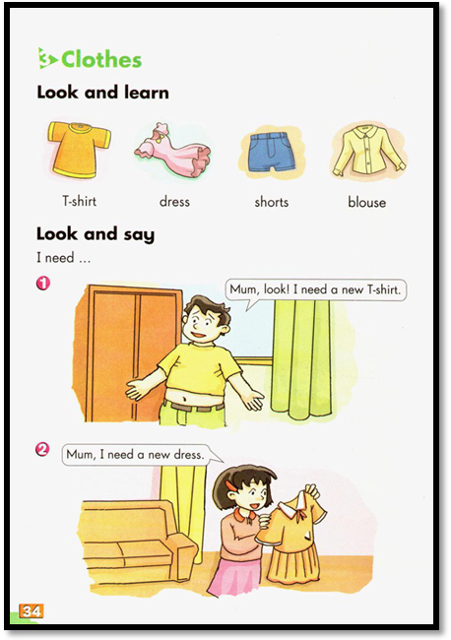
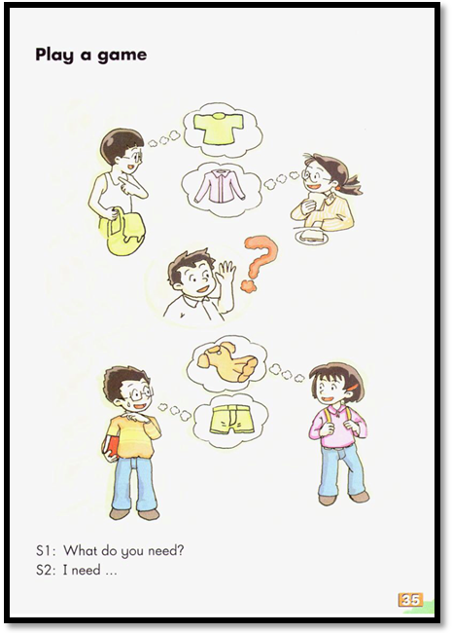
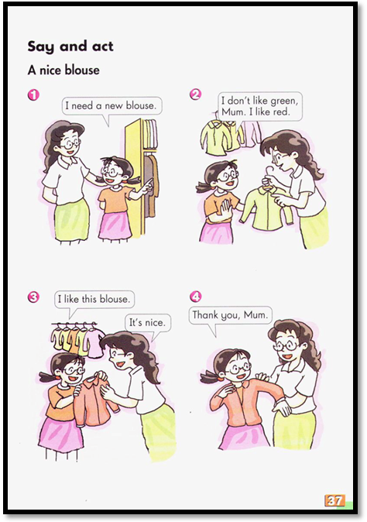
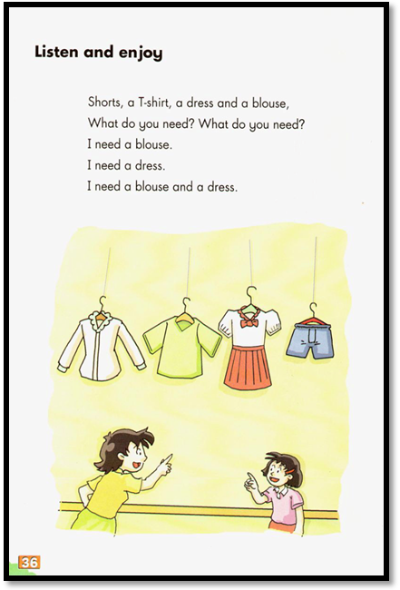

二、学习与评价的内容和要求
主题模块 |  | 学习内容 |  |  | 学习水平 |  | 学习与评价要求 | 评价方式
 |  |  |  |  | 学段 | 年级 | 学习与评价要求 | 评价方式
M3 U3 | 1 语音 | 1.3  朗读 | 1.3.2基本句式的朗读语调 |  | A | A | 用正确的升调和降调朗读基本句式 | 用降调正确朗读特殊疑问句What do you need?  用降调正确朗读陈述句I need…
M3 U3 | 2 词汇 | 2.1 核心词汇T-shirt, dress, shorts, blouse |  |  | C | A | 知晓、了解T-shirt, dress, shorts, blouse | 知晓单词的词义与发音
 |  |  |  |  |  |  |  | 认读单词，模仿运用
M3 U3 | 3 词法 | 3.1名词 | 3.1.1可数名词的数量表达 |  | A | A | 知晓可数名词的数量表达 | 知晓T-shirt, dress, blouse是可数名词
M3 U3 | 3 词法 | 3.1名词 | 3.1.2 不可数名词的数量表达 |  | A | A | 知晓不可数名词的数量表达 | 知晓shorts是不可数名词
M3 U3 | 4 句法 | 4.2  句子  种类 | 4.2.1  陈述句  I need… |  | C | A | 知晓I need…的表达与意义 | 知晓I need…的意义并能模仿运用
M3 U3 | 4 句法 | 4.2  句子  种类 | 4.2.2  疑问句 | 4.2.2.2 特殊疑问句  What do you need? | C | A | 用特殊疑问句What do you need?提问 | 知晓、了解特殊疑问句What do you need?在对话语篇中的意义，并作出应答。
M3 U3 | 5 语篇 | 5.1  记叙文 | 5.1.1  基本信息 | Look and say | A | A | 简单讲述对话、故事等记叙文中的时间、地点、人物、事件等基本信息 | 获取对话语篇中关于人物、衣服等基本信息
 |  |  |  | Say and act | A | A | 简单讲述对话、故事等记叙文中的时间、地点、人物、事件等基本信息 | 模仿表演对话

三、单元教学与评价目标
（一）语言运用目标
学生能在语境中，借助图片、文字与实物等，模仿运用核心词汇即表示衣物类的名词T-shirt, dress, shorts, blouse以及核心句型I need …正确表达自己喜欢的衣物。做到内容完整，语音语调正确优美，生动流利。
（二）知识技能目标
1．学生能在语境中，知晓、理解、模仿运用核心词汇T-shirt, dress, shorts, blouse来表达需要的衣物；
2．学生能在语境中理解句型What do you need? 的含义，模仿运用其询问他人需要的衣服，并用核心句型I need... 来问答需要的衣物。
3．学生能认读教材Look and say, Say and act中的对话，并尝试与同伴角色扮演。
（三）语言情感目标
通过一个单元的学习，学生能初步了解日常生活中的一些衣服，在交流中表达自己喜欢的衣物。

四、分课时教学与评价目标
话题与板块 | 知识与技能 | 语用与情感 | 评价内容与方法
Period 1:  Clothes we need  Look and learn  Look and say  Listen and enjoy | 1.能知晓、跟读核心词汇T-shirt, dress, blouse  2.能简单了解可数名词与不可数名词的数量表达。  3.能知晓、跟读，尝试模仿运用核心句型I need …  4.能模仿读演对话。 | 1.能在语境中，模仿运用核心词汇及核心句型读演对话  2.能了解在日常生活中出现的一些衣物。 | 1.借助图文内容，读演对话。  2.课堂表现评价：同学评价，教师评价。  3.课后评价：师生面谈。
Period 2:  Clothes we choose  Look and learn  Look and say  Play a game  Say and act  Listen and enjoy | 1.能认读核心词汇T-shirt, dress, shorts, blouse。  2.能模仿运用核心句型I need表达自己需要的衣物，并能尝试模仿运用What do you need?进行问答。  3.能认读对话语篇，并尝试与同伴角色扮演。 | 1.能在语境中，模仿运用核心词汇及核心句型，模仿表演对话。  2.能在交流中问答他人所需要的衣物 | 1.借助图文内容，模仿表演对话。  2.课堂表现评价：同学评价，教师评价。  3.课后评价：师生面谈。

五、分课时教案
Module3 Unit3 Period1 Sub-topic: Clothes we need
School: Qingpu Xujing Primary School
Date: Apr. 17th, 2019
Teacher: Zhang Sichun(张汜莼)
Topic: Clothes we need
Level: Grade One
Type: New teaching

I. Objectives：
1. Contents:
(1) Words: T-shirt, dress, blouse
(2) Sentence structure: I need...
2. Abilities:
(1) Be able to identify clothes
(2) Be able to use the key pattern to introduce oneself.
3. Culture: Help students to choose suitable clothes for themselves.
II. Language Focus:
(1) Using nouns to identify clothes
(2) Using the key pattern to introduce oneself
III. Difficulty: Be able to read the word “dress” correctly.
IV. Teaching aids: multimedia, etc.
V. Teaching procedures:
学习目标 | 学习内容 | 活动序号 | 导学方法 |  | 说明与反思
学习目标 | 学习内容 | 活动序号 | 教师活动 | 学生活动 | 说明与反思
能创设良好的学习氛围。  能快速导入情境。  能知晓、跟读核心词汇。  能知晓、跟读核心词汇。  能知晓、跟读核心句型，理解含义。  能知晓、跟读核心词汇。  能复习巩固核心内容。  能在课后继巩固运用新内容。 | Pre-task preparation  - A song:  Clothes  2. Introduction  While-task procedure  - Learn:  blouse  - Learn:  dress  - Learn:  I need …  new  - Learn:  T-shirt  Post-task activities  - Revision  Homework:  1. Listen and read P34  2.Read the story | 1  2  3  4  5  6  7 | Let’s enjoy a song.  Today, we have three new friends.  Let’s say hello to them.  What are they looking at?  They will have a clothes show.  Mum, look! A clothes show.  Cici goes to her room and look for the clothes.  How is the blouse?  Cici’s dress is too old. How about Kiki’s. Let’s have a look.  Her dress is too old.  Kiki, what do you need?  I need a new dress.  Guess. Which dress does she like?  Now practice in your group.  Listen, Tommy is calling. What happens?  He needs a t-shirt for the show.  What color?  Now practice in your group.  Cici has a blouse, but it’s too old.  Kiki has a dress, but it’s too short.  Tommy has a T-shirt, but it’s too small. So mum says … | 1-1. Listen and enjoy.  2-1.Greetings.  2-2. Look and listen.  3-1 Listen and answer.  3-2 Read and follow.  3-3 Chant  3-4 Answer and read.  3-5 Say like Cici.  4-1 Listen.  4-2 Read and follow.  4-3 Try to say: a ____ dress  4-4 Chant.  4-4 Imitate and act.  5-1 Listen and answer.  5-2 Imitate and read.  5-3 Say with the pictures.  5-4 Act like Kiki&Cici.  6-1Listen and answer.  6-2 Read and follow.  6-3 Chant  6-4 listen and read  6-4 Imitate and act.  7-1Listen and think  7-2 Read and follow.  7-3 Act out. | 通过视频和歌曲让学生了解什么是clothes show  通过问句带出单词教学  通过儿歌和图片，帮助学生理解单词。  通过试衣服让学生体会Kiki的不开心。  通过看一看，选一选，猜测Kiki喜欢的裙子，对I need …的句型进行练习。  先听后模仿，跟读句型。  通过儿歌的操练，巩固句型  通过妈妈记录shopping list回顾三个小朋友所需要的新衣服  通过模仿人物，表演对话，进一步巩固核心语言

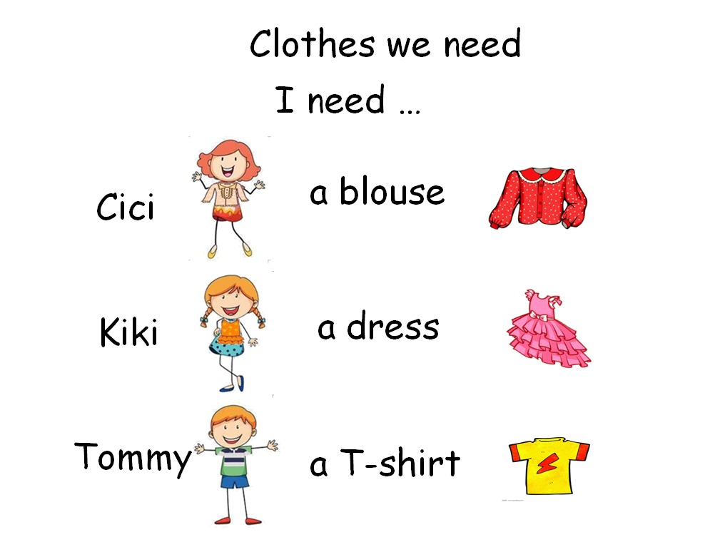
Blackboard design:
1BM3U3 Period 1

本课时主体文本：
Cici: I have a blouse for the show.
Uh-oh, too old.

Cici: Kiki, look. My blouse is too old. And you?
Kiki: Short. Too short! Oh, no! Too short. Wu, wu …
Cici: Mum, mum.
Mum: Yes?
Kiki: Mum, I need a new dress for the show.
Mum: OK.
Kiki: I like pink. I need a pink dress.
Mum: OK.
Cici: Mum, mum. I need a new blouse too.
Mum: All right.
(Tommy: Mum... Mum...)

Tommy: Mum, look. Too small. I need a new T-shirt for the show.
Mum: A yellow T-shirt?
Tommy: Yes! I like it.

Module3 Unit3 Period2 Sub-topic: Clothes we choose
School: Qingpu Xujing Primary School
Date: Apr.17th, 2019
Teacher: Alex Zhang (张佶一)
Topic: Clothes we choose
Level: Grade One
Type: New teaching

I. Objectives：
1. Contents:
(1) Words and expressions: T-shirt, dress, shorts, blouse, skirt
(2) Sentence structures: What do you need? I need...
I don’t like...
2. Abilities:
(1) Be able to use wh-questions to find out what clothes people need
(2) Be able to ask and answer about clothes with wh-questions
(3) Be able to make a dialogue about choosing clothes
3. Culture: Help students to choose nice clothes they like.
II. Language Focus:
(1) Asking wh-questions to find out what clothes people need.
(2) Telling others what you need with the sentence structure I need….
(3) Using adjectives to identify colours of some things you like.
III. Difficulty: Be able to use wh-questions to find out what clothes people need.
IV. Teaching aids: Multi-media, etc
V. Teaching procedures:
学习目标  ( 暨评价目标) | 学习内容 | 活动序号 | 导学方法 |  | 说明与反思
学习目标  ( 暨评价目标) | 学习内容 | 活动序号 | 教师活动 | 学生活动 | 说明与反思
复习旧知。  通过问答，激活旧知。  能创设良好的学习氛围。  能创设语境，引出故事主人公。  能初步感知文本，找出关键信息。  能知晓跟读核心句型。  能跟读核心词汇。  能把握人物心理，进行模仿表演。  能跟读拓展句型  能有感情地表演对话事。能复习巩固核心内容。  能跟读核心词汇  理解内容，进行表演。  能告诉妈妈他们需要什么衣服。  能进行表演，展示。学会搭配衣服。  课后进一步巩固内容。 | I. Pre-task preparation  1.Review  2.Ask and answer.  What do they need?  3.Introducing the beginning of the story.  II.While-task rocedure  1.Learn:  What do you need?  Review: T-shirt  2.Learn: shorts  3. Learn:  *I don’t like red.  4.Learn: skirt  III.Post-task activities  They go and tell theit mother.  Practice  - Show time  IV. Homework:  1.Listen and read the story from P34-37. (loud, right, nice)  2. Choose some clothes and show to your parents. | 1  2  3  4  5  6  7  8  9  10 | The school is going to hold a fashion show.  I need a …  They are so excited. They can’t fall asleep.  Kid is coming.  Kid:  What do you need, Tommy?  Tommy:  I need a T-shirt.  I need shorts,too.  What does Kiki need?  What colour? A red dress?  Kiki:  I don’t like red.  I need a pink dress.  Tommy and Kiki gets their new clothes. They are cool and nice.  Now it’s Cici’s turn. What does she need?  Cici:  I need a blouse. I need a skirt,too.  Now they have the new clothes.  They are happy to tell their mother.  Now please to ask and answer in your groups to know what do your members need?  Take out the clothes and show to our classmates | 1-1.Listen.  2-1.Look and say  3-1.Look and think  4-1 Listen and understand  4-2.Say a chant  4-2 Dialogue  5-1Listen and answer  5-2 Read and follow  5-3 Say a chant  5-4 Say like Tommy  5-5 Act out the part1  6-1 Listen and answer  6-2 Read and follow  6-3 Practice: I don’t like...  6-3 Act out the dialogue.  7-1 Listen and guess  7-2 Read and follow  7-3 Say a chant  7-4 Say like Cici  7-5 Listen and act  8-1 Listen and understand  8-2 Read the rhyme.  8-3 Make a new rhyme.  9-1 practice in groups  10-1 Show the clothes | 通过对上一课时的复习，引发孩子好奇，想要了解他们如何获得他们需要的衣服。  通过听对话，让孩子找关键信息。带出关键语句教学。  先跟读句型，通过儿歌练习句型。通过对话进行问答练习。  问题驱动，学习单词。  跟读句型，通过儿歌练习单词和句型。  模仿人物进行表述。最后表演对话。  问题驱动，在听的过程中寻找关键信息。带出语句教学。  通过替换练习熟练语句运用。  模仿人物进行对话表演。  听录音感受人物心理。进行单词教学。通过跟读和儿歌的形式练习单词。问题驱动方式，练习单词和句型表达。  模仿并表演。  通过show，让孩子学会挑选衣物和搭配，感受服饰装扮给孩子带来的美和酷。体会秀场的欢乐。

Blackboard design:
M3U3 P2 Clothes we choose
What do you need? 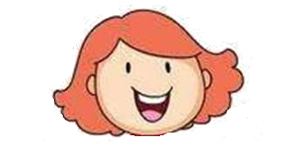 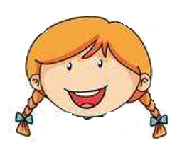 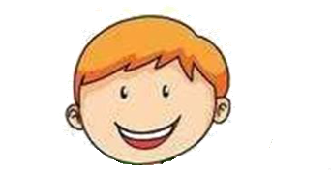
beautiful skirt pink dress yellow T-shirt
I need … red blouse I don’t like... cool shorts
How beautiful! How nice! How cool!

[本课时文本]
Kid: Look! What do you need?
Tommy: I need a T-shirt. Wow! Cool shorts. I need cool shorts, too.
Kid: OK. Here you are.
Cici & Kiki: Wow! How cool!

Kid: What do you need, Kiki?
Kiki: I need a dress.
Kid: A red dress?
Kiki: I don’t like red. I need a pink dress.
Kid: Here you are.
Tommy & Cici: Wow! How nice!

Kid: What do you need, Cici?
Cici: I need a blouse. I need a skirt,too.
Kid: OK. A blouse and a skirt. Here you are.
Tommy & Kiki: Wow! How beautiful!

