|  |  |
| --- | --- |
| **DOKUMENTASI EKSTERNAL**  External Documentation |  |
| **PROYEK**  **[*Assignment / Project*]** |
| **COMP6176 – Human and Computer Interaction**  ***Subject*** |
| SEMESTER [GENAP] 2019/2020 ***[Odd/Even/Compact] Semester Year 9999/9999*** |

## Judul Proyek

*[Assignment / Project]**Title*

* **BEAUDEI**

## Dokumentasi

*Report / Documentation*

1. **ALL PAGE**

* The Beaudi logo is clickable and will redirect the users back to the homepage

1. **For All Pages EXCEPT Register Page**

* Below the logo is the navbar, all is clickable except for the shop which when on mouse hover will display a dropdown choice of the shop type(clickable)
* Each navbar will redirect users to the selected page:
  + Promotions: Redirect to promotion page
  + Shops:
    - Makeup: Redirect to makeup page
    - Skin Care: Redirect to skin care page
* Register: Redirect to register page

1. **Homepage**

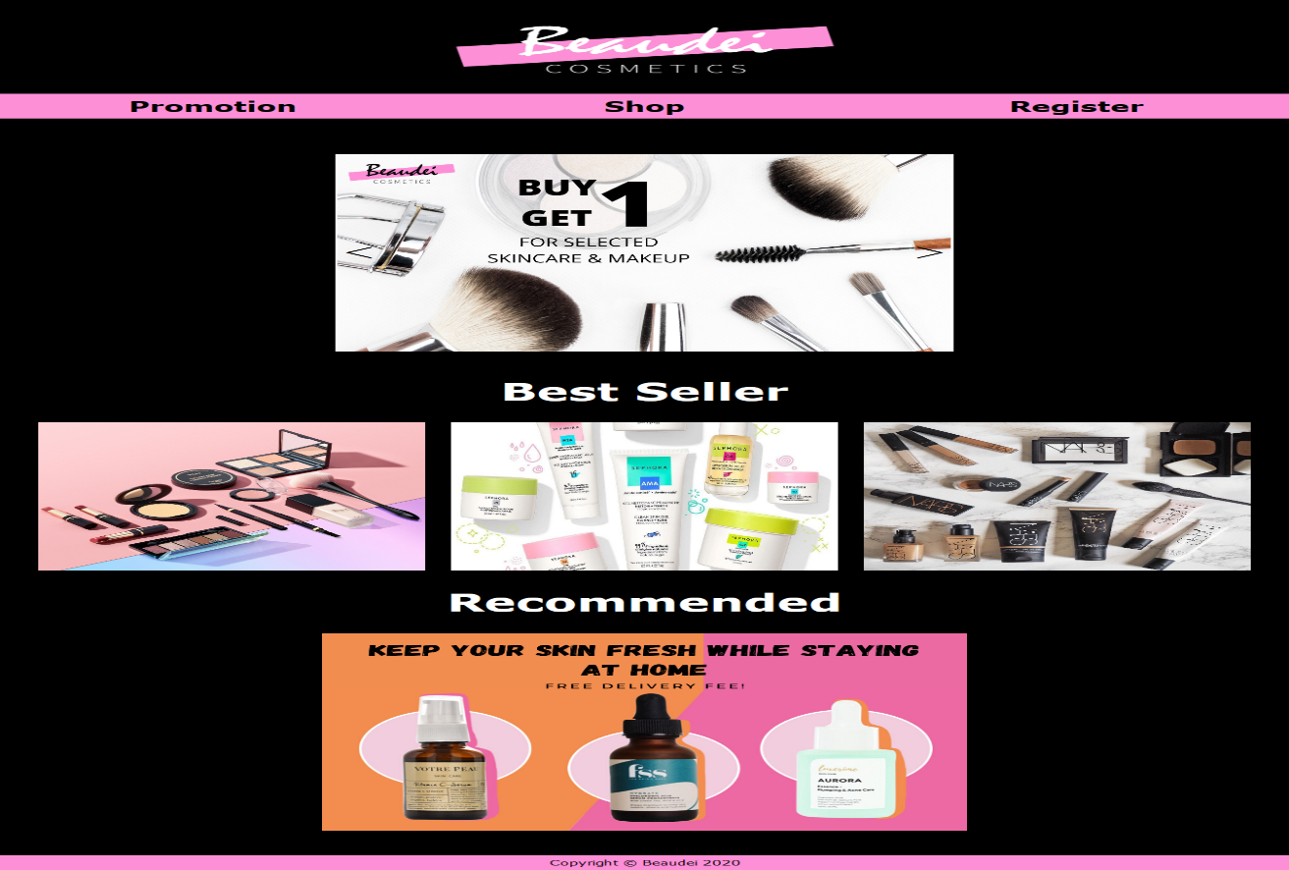

* A slider which will display the news, latest event, and promotions
* Hovering over the slide will display information and show the arrow button
* Clicking on the arrow button on the slide will change the slide previous or next
* The best seller display 3 images, hovering over the images will show the product name
* The Recommended displays a single image (with a free delivery fee message), when hover will display buy now button, clicking the button will redirect user to the skin care shop page

1. 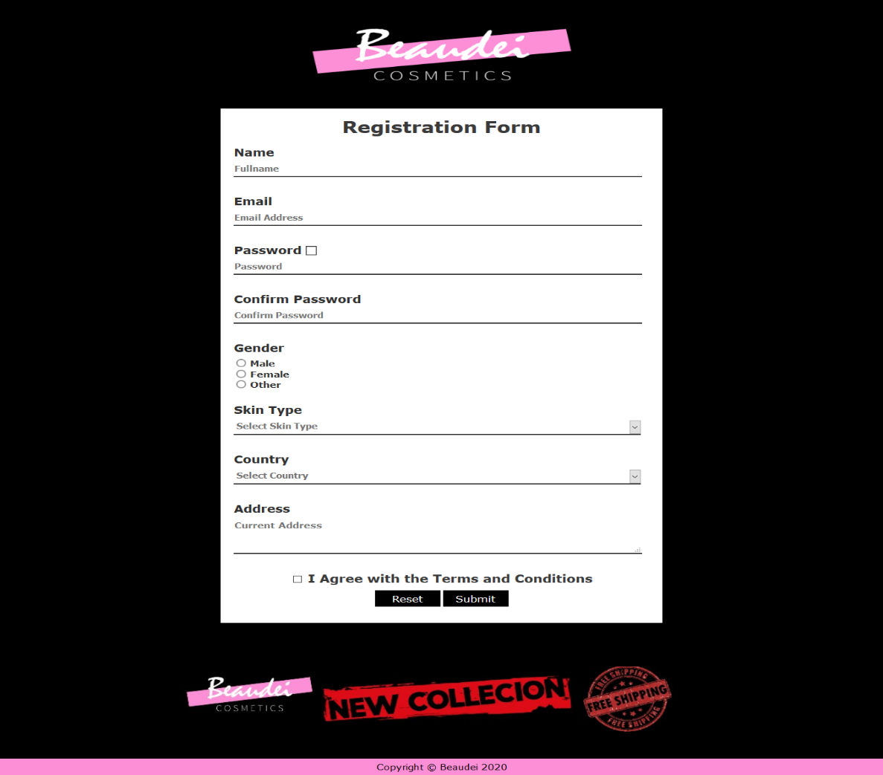**Register**

* A form must be filled by the user, if an invalid data is submitted, a red banner and a text will be displayed at the bottom
* Name: must not be less than 3 characters and not numeric
* Email: must follow the correct email address format (word@(email_type).com)
* Password must be filled (must contain one uppercase and a number)
* Clicking on the check-box beside the password will show the password (clicking on it again will hide it)
* Confirm Password must be the same with previous password
* A gender must be picked
* User must select a skin type
* User must select a country
* User must input their address (must be more than 5 words)
* User must also agree with terms and condition by clicking on the checkbox
* Clicking on the reset button will delete all the previous inputted data (clear all fields)
* Clicking submit will show an alert that will display all the users information (except for password) and the delete all the fields(reset)
* Below the form shows a banner with some important features of beaudei (new collection and free shipment)

1. **Promotion**

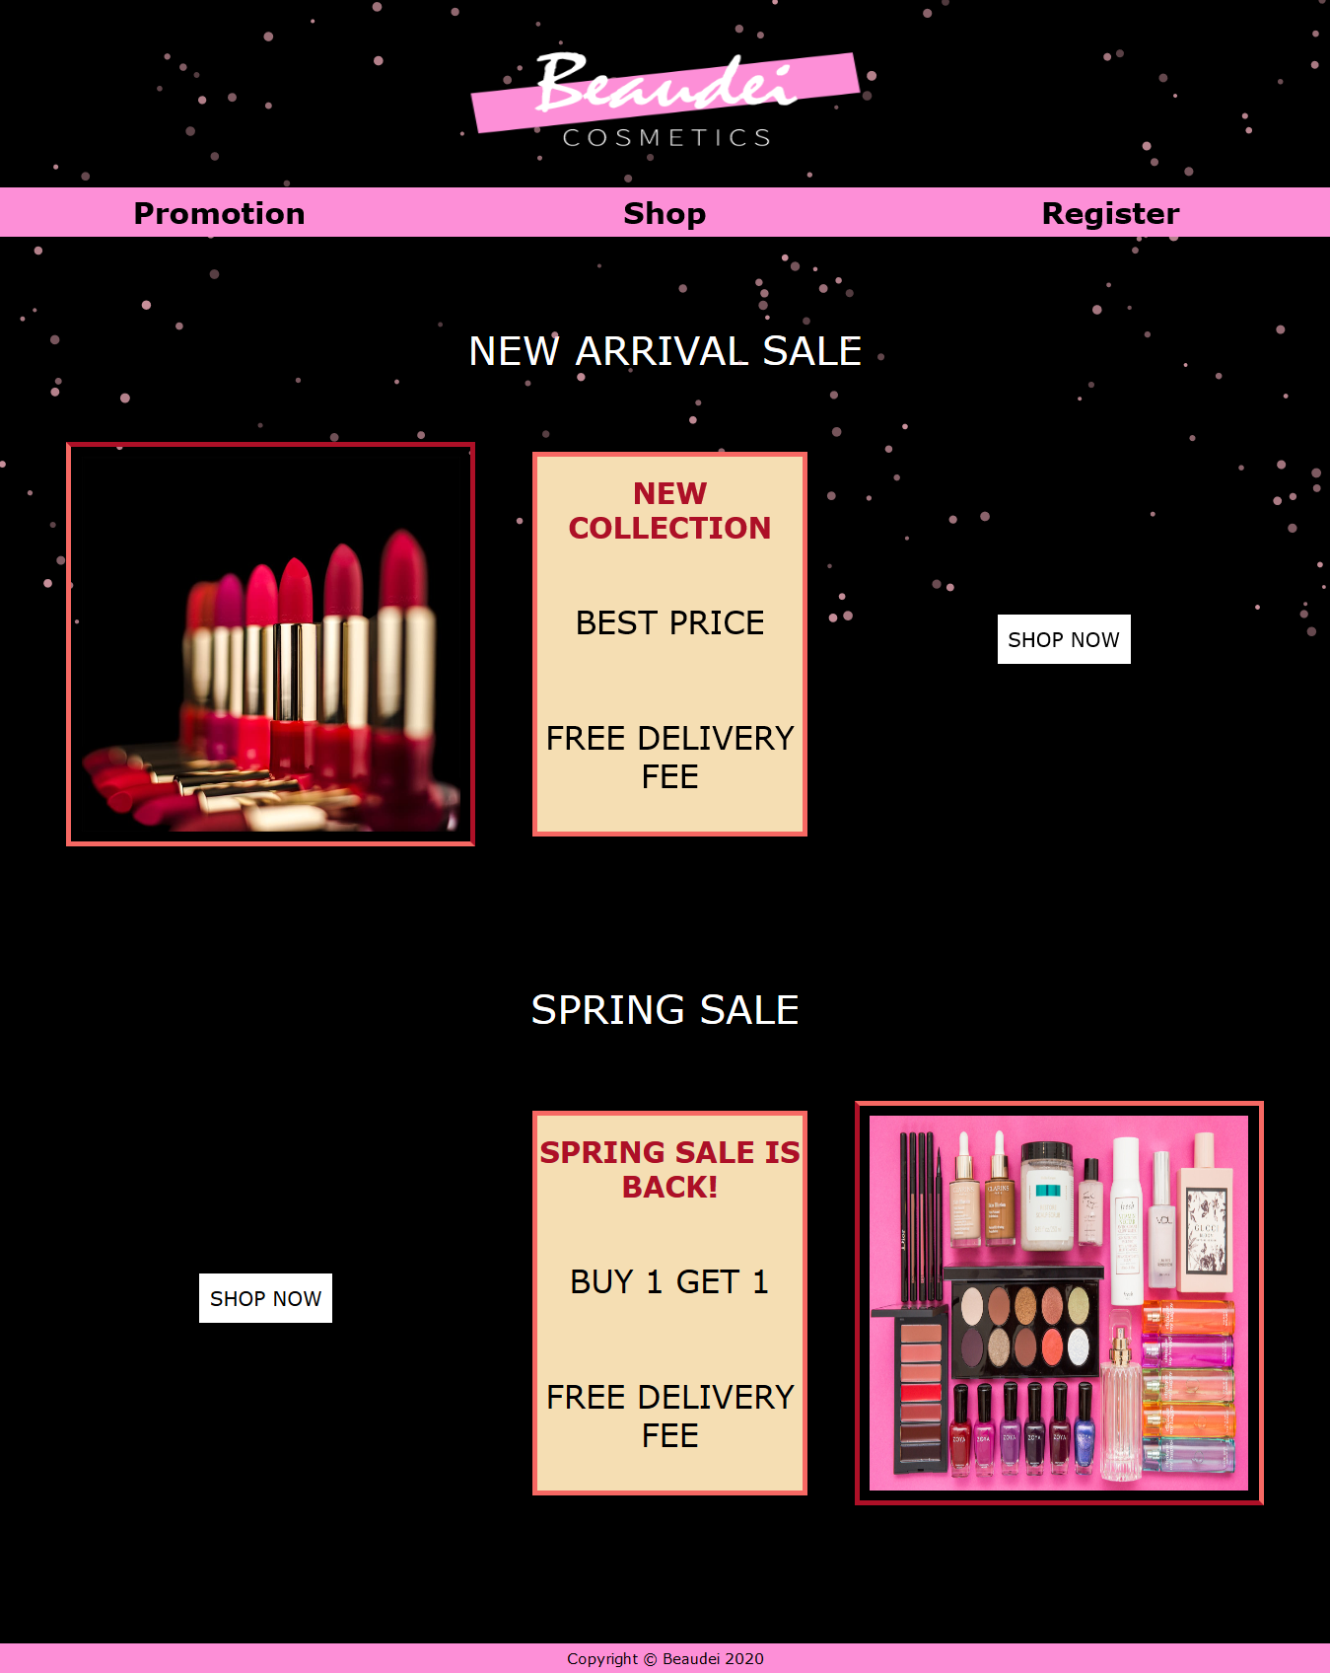

* The promotion features a snow effect (code on reference.txt), the snow will react to the users mouse
* The promotion page shows the title of the promotions (new collections and spring sale), the detail of the promotion and a buy now button
* Clicking on either buy now button will redirect user to the makeup shop page

1. 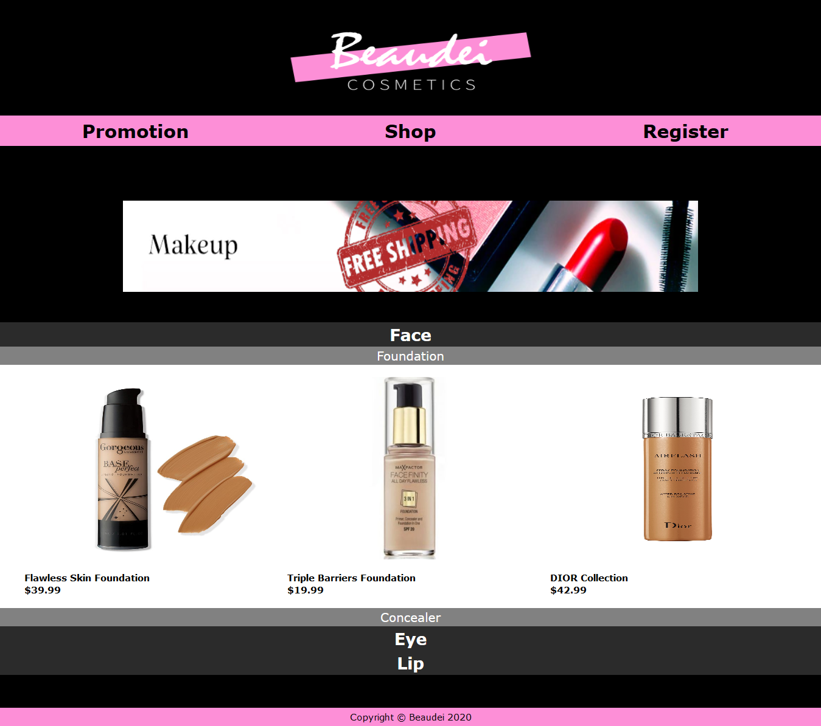**Makeup Shop**

* Makeup page will show a banner, and bellow the banner will be three options (Face, Eye, and Lip)
* Clicking on either one of the options will start a dropdown animation and display its sub-options
* Clicking on the sub-options will display its content

1. **Skin Care Shop**

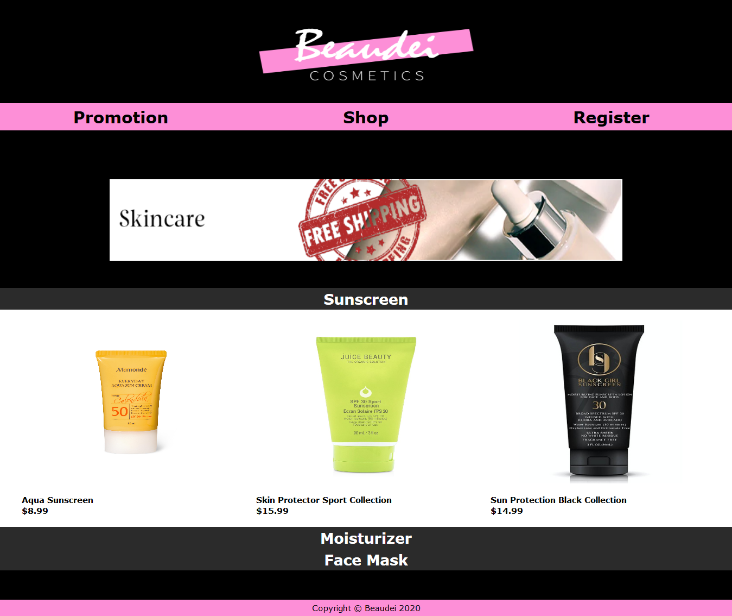

* Skin page will show a banner, and bellow the banner will be three options (Sunscreen, Moisturizer, and Face Mask)
* Clicking on either one of the options will start a dropdown animation and display its sub-options
* Clicking on the sub-options will display its content

## Referensi

*References*

**Homepage**

* SlideShowBanner: https://www.canva.com/
* bestseller1: https://images1-focus-opensocial.googleusercontent.com/gadgets/proxy?url=https://www.dewimagazine.com/img/images_image2/5c875ff32833512839_0.jpg&container=focus&resize_w=750
* bestseller2: https://imgix.bustle.com/uploads/image/2019/4/8/28a3bb15-4724-4aba-a4f1-1da9a473d9ed-54277558_280940052801488_8326423659618200387_n.jpg?w=970&h=546&fit=crop&crop=faces&auto=format%2Ccompress&cs=srgb&q=70
* bestseller3: https://www.lauralouisebeauty.co.uk/wp-content/uploads/2017/05/nars-foundation-ultimate-guide-1440x1694.gif
* recommended: https://www.cosmopolitan.co.id/newtest/vrgallery/teaser/Skincare-Lokal-OP_65_20190819185821bJmd1q.jpg

**Register**

* email validation: https://www.aspsnippets.com/Articles/Email-validation-without-using-Regular-Expression-in-JavaScript.aspx
* Free Shipping: https://www.hiclipart.com/free-transparent-background-png-clipart-idojn
* New Collection: https://www.psdstamps.com/wp-content/uploads/2019/12/grunge-new-collecion-label-png.png

**Promotion**

* Snowflake effect : https://stackoverflow.com/questions/13983764/creating-falling-snow-using-html-5-and-js
* Snowflake codes : http://jsfiddle.net/loktar/UdyN6/
* cosm1 : https://blog.shopping.life/wp-content/uploads/2019/04/idealna-pomadka-do-ust-1.jpg
* cosm2 : https://beautyhubbd.com/public/img/sliderContent/thumb/25e3b75f21f343.jpeg

**Makeup**

* Make Up Log: https://www.sephora.com/shop/makeup-cosmetics
* foundation1: https://cdn.shopify.com/s/files/1/1803/1135/products/BP_Best__sellers_second_image.jpg?v=1541706427
* foundation2 : https://asset-a.grid.id/crop/0x0:0x0/x/photo/2018/05/07/3760713531.jpg
* foundation3 : https://hips.hearstapps.com/vader-prod.s3.amazonaws.com/1570475312-foundation-dior-1570475286.jpg
* concealer1: https://tartecosmetics.com/on/demandware.static/-/Sites-master-catalog-tarte/default/dwf6cde8ce/836/7.12.19/MAIN/836_DDB%20shape%20tape%20concealer_22N_light%20neutral_DDB_misc-alt-1_ALT.jpg
* concealer2: https://images-na.ssl-images-amazon.com/images/I/71KO8caKi0L._SY355_.jpg
* concealer3: https://static-reg.lximg.com/images/product_images/closeup_1_Product_602004111548-Benefit-Boi-ing-Cakeless-Concealer-Shade-01_347bb627378f937226af348ce1ed4817a6d8ec2b_1566877048.png
* mascara1: https://media-asia-cdn.oriflame.com/-/media/images/externalImage.ashx?externalMediaId=product-management-media%2F33243%2F33243.png%3Fversion%3D1&q=70
* mascara2: https://www.maybelline.co.id/~/media/mny/id_id/eyes/mascara/hypercurl%20mascara/hypercurl-mascara-5.jpg
* mascara3: https://cdn.shopify.com/s/files/1/0098/9023/4434/products/GN1005_GrandeMASCARA_RichBlack_01.jpg?v=1587573915
* eyeliner1: https://m.maccosmetics.com/media/export/cms/products/640x600/mac_sku_M1G601_640x600_0.jpg
* eyeliner2: https://cdn.shopify.com/s/files/1/2405/1749/products/definition-eyeliner-02_1024x1024.jpg?v=1509779957
* eyeliner3: https://simplysiti.co.id/file/2019/03/SE-Defination-Liquid-Eye-Liner-01-scaled.jpg
* lg1: https://cdn.shopify.com/s/files/1/0846/7754/products/moisture-infusion-lipgloss_1000x1000_720x720_f2a147df-cffb-4b2f-808f-3f0b78815f8a_720x720.jpg?v=1535897577
* lg2: https://www.sephora.com/productimages/sku/s1493998-main-Lhero.jpg
* lg3: https://images.ulta.com/is/image/Ulta/2562810?op_sharpen=1&resMode=bilin&qlt=85&wid=800&hei=800&fmt=jpg
* ls1 : https://static2.kryolan.com/sites/default/files/products/05212_00/960/05212_00_prod_dance_960.jpg
* ls2: https://mocparis.vn/wp-content/uploads/Son-YSL-Tatouge-Couture-01-Rouge-Tatouge-Vibrant-Pink-Red.jpg
* ls3: https://localcdn.tinkerlust.com/media/catalog/product/cache/1/image/1440x1280/9df78eab33525d08d6e5fb8d27136e95/I/M/IMG_0008.JPG_677.jpg

**Skin Care**

* Skincare Logo: https://www.sephora.com/shop/skincare
* Sunscreen1: https://www.mamonde.com/int/en/product/__icsFiles/afieldfile/2019/04/18/Mamonde_everyday_aqua_suncream_20180808_DF.jpg
* Sunscreen2: https://cdn.shopify.com/s/files/1/2489/3542/products/0320-de-spf-30-tinted-mineral-moisturizer-web-photo-2000x2000_1024x1024.jpg?v=1587413444
* Sunscreen3: https://target.scene7.com/is/image/Target/GUEST_0879338a-6873-4ecf-bde3-619ab2da2fb6?wid=488&hei=488&fmt=pjpeg
* Mois1: https://n.nordstrommedia.com/ImageGallery/store/product/Zoom/9/_105986949.jpg?h=365&w=240&dpr=2
* Mois2: https://images.shopdutyfree.com/image/upload/v1531299508/040/003/001/27131799047/27131799047_1_default_default.jpg
* Mois3: https://images.squarespace-cdn.com/content/v1/5ae6f6954611a0353c508413/1565651644726-T9SU8HRK5ONP4D62ROOZ/ke17ZwdGBToddI8pDm48kPkAeG9VxKtehkWVZu7n3jx7gQa3H78H3Y0txjaiv_0fDoOvxcdMmMKkDsyUqMSsMWxHk725yiiHCCLfrh8O1z5QHyNOqBUUEtDDsRWrJLTmuD9UDKXxOJxXxCUgm7BwOiUqq9004LCCqcddK38v46NH5fNqLuuBzWTXYVZ6eAqt/Classic+Moisturizer+-+Front.png
* FM1: https://myer-media.com.au/wcsstore/MyerCatalogAssetStore/images/15/150/1456/12/17/204283670_161309890/204283670_161309890_1_720x928.jpg
* FM2: https://hips.hearstapps.com/vader-prod.s3.amazonaws.com/1533124376-s1901230-main-zoom.jpg?crop=1xw:1xh;center,top&resize=768:*
* FM3: https://hips.hearstapps.com/vader-prod.s3.amazonaws.com/1585936737-s1632868-main-hero-1500.jpg?crop=1xw:1.00xh;center,top&resize=768:*

Disiapkan Oleh,

*Prepared by,*

* **Billy winata - 2201771330**
* **Darryl Andrews - 2201767365**
* **Jason Pratama - 2201852542**
* **jonathan obert - 2201740426**