Пензенский государственный университет

Кафедра «Вычислительная техника»

ОТЧЕТ

по практике №2

на тему: «Базы данных»

Выполнил студент группы 22ВВВ1

Курушин Я.С.

Принял:

Синев М.П.

Пенза 2024

**Ход работы**

1) SELECT * FROM seats WHERE seat_no = '15F' ORDER BY aircraft_code DESC  
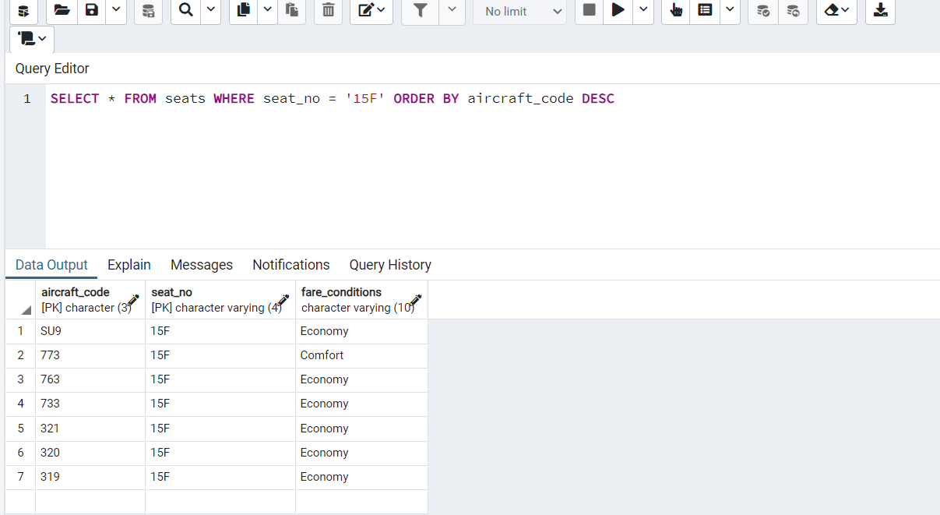

2) SELECT * FROM flights WHERE status NOT IN ('Arrived', 'Scheduled')  
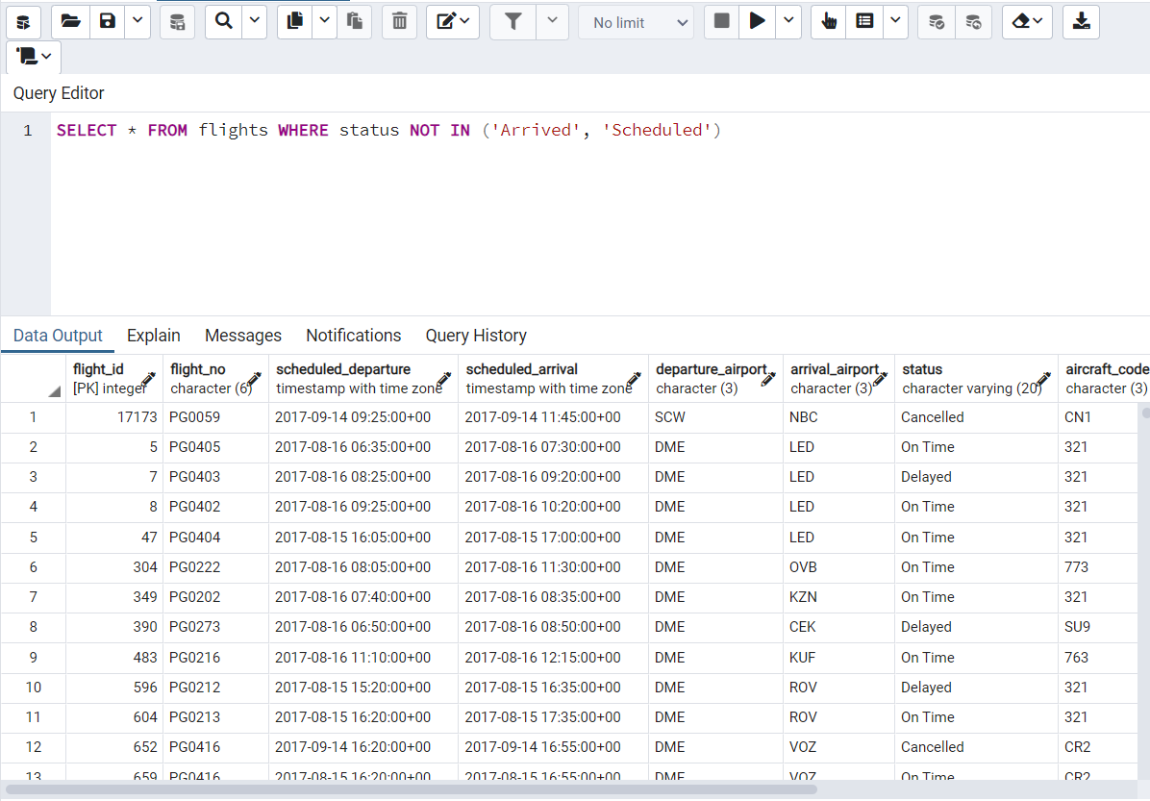

3) SELECT COUNT(*) FROM aircrafts_data WHERE "range" BETWEEN 3000 AND 5650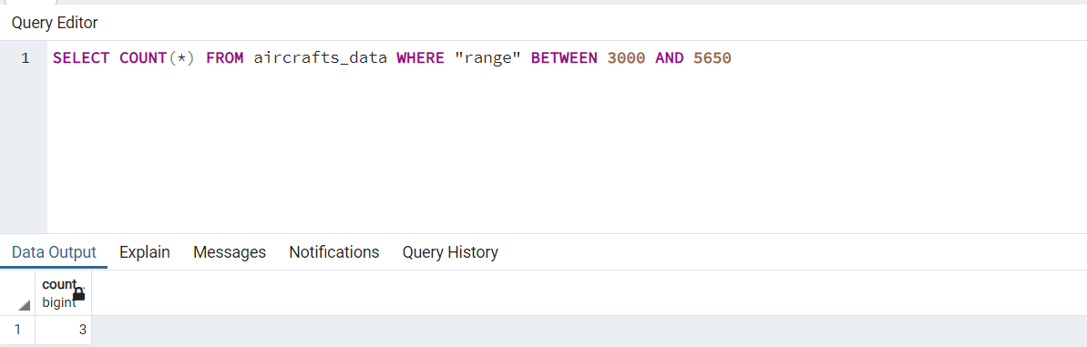

4) SELECT DISTINCT timezone FROM airports_data ORDER BY timezone LIMIT 5  
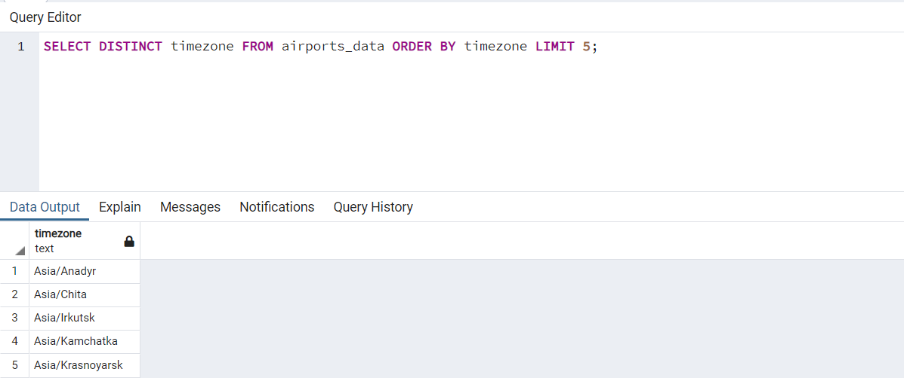

5) SELECT aircrafts_data.aircraft_code, seats.seat_no FROM aircrafts_data JOIN seats ON aircrafts_data.aircraft_code = seats.aircraft_codeWHERE aircrafts_data.aircraft_code = '320'  
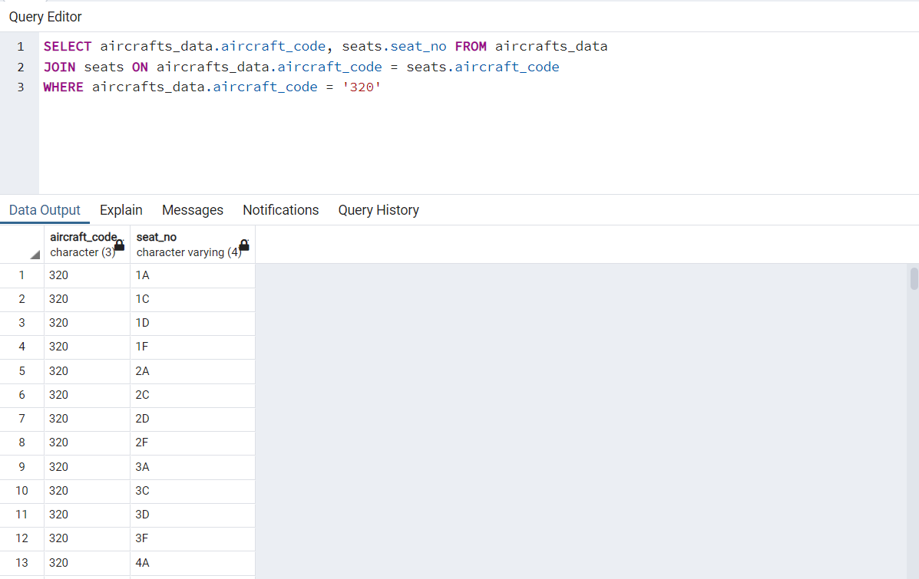

6) SELECT AVG(amount) FROM ticket_flights WHERE fare_conditions = 'Business'

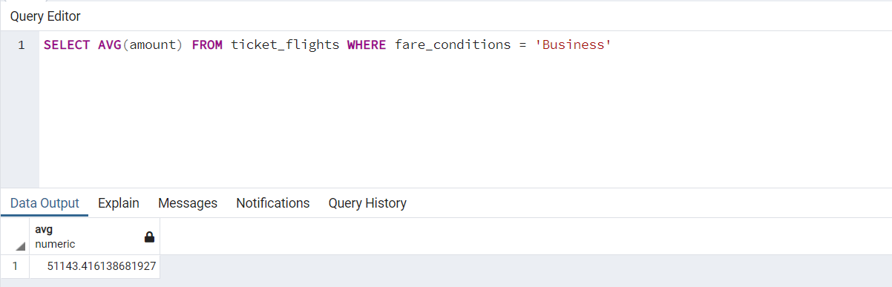

7) SELECT timezone, COUNT(*) FROM airports_data GROUP BY timezone HAVING COUNT(*) > 3

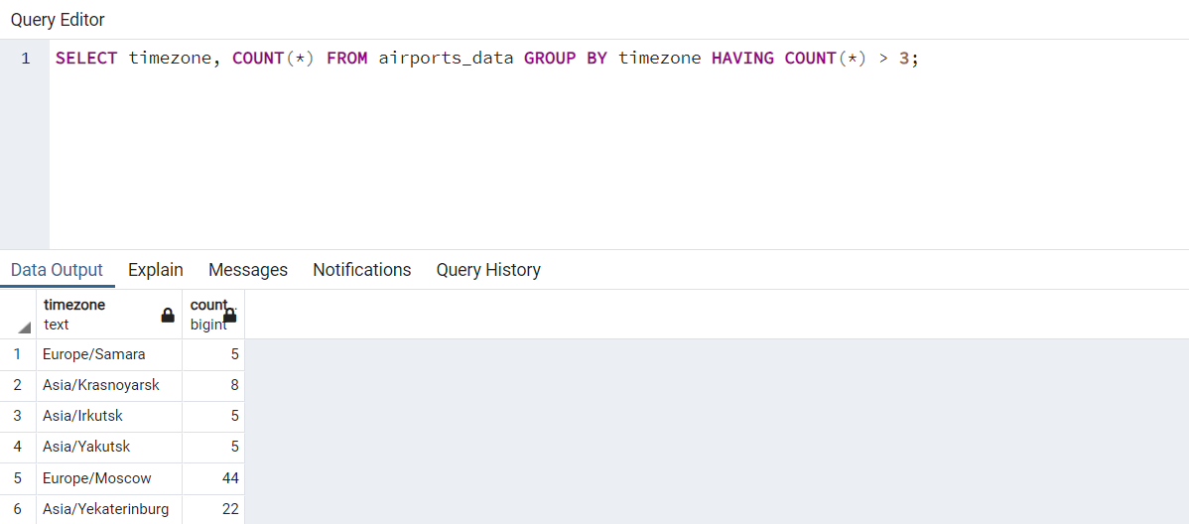

8) SELECT MIN(Amount) FROM ticket_flights WHERE fare_conditions = 'Business'  
  
