Community Health Clinic Management System
Design Report
Field | Details
Student name | [YOUR FULL NAME]
Student ID | [YOUR STUDENT ID]
Unit code and name | [UNIT CODE - UNIT NAME]
Lecturer / Tutor | [NAME]
Submission date | [DATE]
Word count (Sections A and B) | approximately 1,150

DRAFT - read before submitting. This document is a working draft, not a finished submission. Rewrite each section in your own words so that it reflects your own understanding, complete the cover details above, and replace every figure in Section B with a screenshot taken from your own run of the application. Delete this box once you have done so.

Section A - Design and Planning

1. System Overview
The Community Health Clinic Management System (CHCMS) is a Java Swing desktop application that replaces the clinic's manual paper process for patient records, appointment scheduling, doctor allocation and treatment history. An administrator signs in to a single main window and navigates six screens through a sidebar: Main Menu, Register Patient, Register Doctor, Appointment Booking, Treatment Entry and Reports. All records are held in memory in ArrayList collections during a session and written to plain-text files in a data folder, so information survives between runs without needing a database server. The system is built on the Model-View-Controller architecture and on a small set of deliberate object-oriented design decisions, both of which are explained below and demonstrated in the accompanying source code.

2. Functional Requirements
The application supports eight core functions. It registers patients with validated personal and Medicare details, and registers doctors with a specialisation, a consultation fee and a set of working days. It schedules thirty-minute appointments, rejecting any booking that falls outside a doctor's working days or that overlaps an existing booking for that doctor. It records treatments against a completed appointment, automatically calculating the total charge as the treatment cost plus the doctor's consultation fee. It searches patients, doctors, appointments and treatments by keyword, and sorts each list by several keys. It generates three reports: a clinic summary, a doctor's daily schedule and an individual patient history. Finally, it saves every collection to file and reloads it on start-up, rebuilding the links between appointments and the people they reference.

3. Object-Oriented Design Principles
Encapsulation is applied consistently: every field in every model class is private and reachable only through accessor methods, and Doctor returns a defensive copy of its availableDays set so external code cannot modify a doctor's roster by accident. Abstraction appears in the abstract Person class, which holds the identity data common to every human in the system and declares an abstract getRole method. Inheritance lets Patient, Doctor and Administrator extend Person and add only what makes them different: a Medicare number, a specialisation, or login credentials. Polymorphism follows from that abstraction, because any of the three subclasses can be treated as a Person and each returns its own role string. Composition is used where inheritance would be wrong: an Appointment holds a Patient and a Doctor rather than extending either of them.

4. High Cohesion and Low Coupling
Each class in the system has one clear reason to exist. Validator does nothing but check and parse raw text; SortUtil and SearchUtil contain only algorithms; CsvMapper only converts objects to and from a line of text; each controller coordinates one area of the system. This is high cohesion, and it makes the code easy to locate and to test. Coupling is kept low mainly through interfaces and through the direction of dependencies. The Clinic and the controllers depend on the Repository interface rather than on FileRepository, so the storage mechanism could be replaced by a database implementation without touching a single controller. The view classes hold references to controllers only, never to repositories or files. A useful illustration is Treatment.getTotalCharge, which reaches the consultation fee through its own appointment object; because Appointment stores real Patient and Doctor references rather than identifier strings, Treatment never needs to know that the Clinic or the persistence layer exists.

5. Relevant SOLID Principles
All five SOLID principles are visible in the design, as summarised below.
Principle | How it is applied in this system
Single Responsibility | Validator only validates, CsvMapper only converts records to and from text, and each controller handles one area. A change to the date format touches Validator alone.
Open/Closed | SortUtil accepts a Comparator instead of hard-coding a sort key, so a new sort order is added by passing a new comparator, never by editing the algorithm.
Liskov Substitution | Patient, Doctor and Administrator can each be used wherever a Person is expected; none of them weakens or contradicts the behaviour Person promises.
Interface Segregation | Identifiable declares only getId. The persistence layer needs nothing more, so it is not forced to depend on the wider Person or Appointment APIs.
Dependency Inversion | Clinic and the controllers depend on the Repository abstraction, not on FileRepository. Swapping to database storage means adding one class, not editing existing ones.

6. MVC Architecture
The Model layer contains the domain classes and the clinic's business rules, along with the persistence package that stores them. The View layer contains MainMenuFrame and the five JPanel screens; these classes collect text from the user, display tables and dialogs, and contain no business logic whatsoever. The Controller layer sits between the two: each controller takes raw strings from a screen, passes them through Validator, builds or retrieves model objects, asks the model to perform the operation, persists the result, and lets any ValidationException travel back to the screen that started the request. Because no controller imports a Swing class, the same controllers could drive a console or a web front end unchanged, which is the practical benefit MVC is intended to deliver.

7. UML Class Diagram
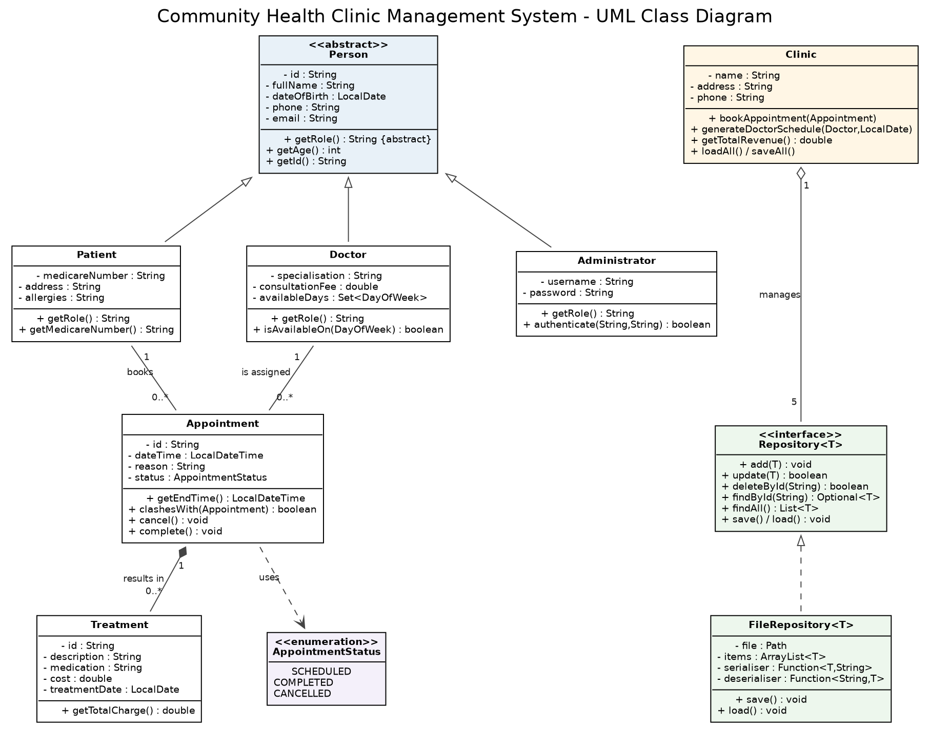
Figure 1 - UML class diagram of the domain and persistence layers

8. Explanation of Major Classes and Relationships
The diagram shows seven domain classes. Person is abstract and is generalised by Patient, Doctor and Administrator. Appointment is an association class joining exactly one Patient to exactly one Doctor, with a multiplicity of one to zero-or-many on each side, since a patient or a doctor may have any number of appointments but each appointment involves only one of each. Treatment is in a composition relationship with Appointment, drawn with a filled diamond, because a treatment record has no meaning once its appointment is gone; the multiplicity is one appointment to zero-or-many treatments. Clinic aggregates five Repository instances with a hollow diamond, since the repositories are containers the clinic manages rather than parts of its identity. FileRepository realises the Repository interface, and Appointment depends on the AppointmentStatus enumeration.

9. Testing Strategy
Testing uses JUnit 5 and focuses on the three classes where a defect would be most damaging. Validator is tested because it is the only barrier between user typing and stored data; Appointment is tested because its clash detection protects the clinic's core rule; and SortUtil together with SearchUtil is tested because hand-written algorithms are easy to get subtly wrong at their boundaries. A fourth integration class exercises the controllers, the Clinic and FileRepository together. Test cases deliberately include boundary conditions rather than only happy paths: two appointments that touch exactly at the thirty-minute mark must not be reported as clashing, an empty list must sort without throwing, a binary search for a missing key must return minus one, and a deliberately corrupted line in a data file must be skipped with a console warning instead of crashing the load. Expected results are asserted with assertEquals, assertTrue and assertThrows.
Class under test | Test objective | Test case | Expected result
Validator | Reject every malformed input | requirePhone("04123") | ValidationException naming the Phone field
Validator | Accept valid input and trim it | requirePhone(" 0412 345 678 ") | Returns "0412345678"
Appointment | Detect an overlapping booking | Two 30-minute slots 15 minutes apart, same doctor | clashesWith returns true
Appointment | Allow back-to-back slots (boundary) | Slots at 09:00 and 09:30, same doctor | clashesWith returns false
Appointment | Free the slot when cancelled | Cancel the first, then re-book the time | clashesWith returns false
SortUtil | Bubble and Quick Sort agree | Same list, same comparator, both algorithms | Identical resulting order
SortUtil | Survive degenerate input | Empty list and single-item list | No exception; list unchanged
SearchUtil | Report a missing key correctly | binarySearch for an absent ID | Returns -1
Integration | Persist and restore object links | Save an appointment, reload the clinic | Patient and Doctor references rebuilt
Integration | Tolerate a corrupt data file | Append a malformed line, reload | Line skipped, warning logged, other records intact

Section B - Implementation Evidence
Every figure below must be replaced with a screenshot captured on your own machine, showing your own data. Figures 9 and 10 have no image yet - run the JUnit suite in your IDE and paste the results.

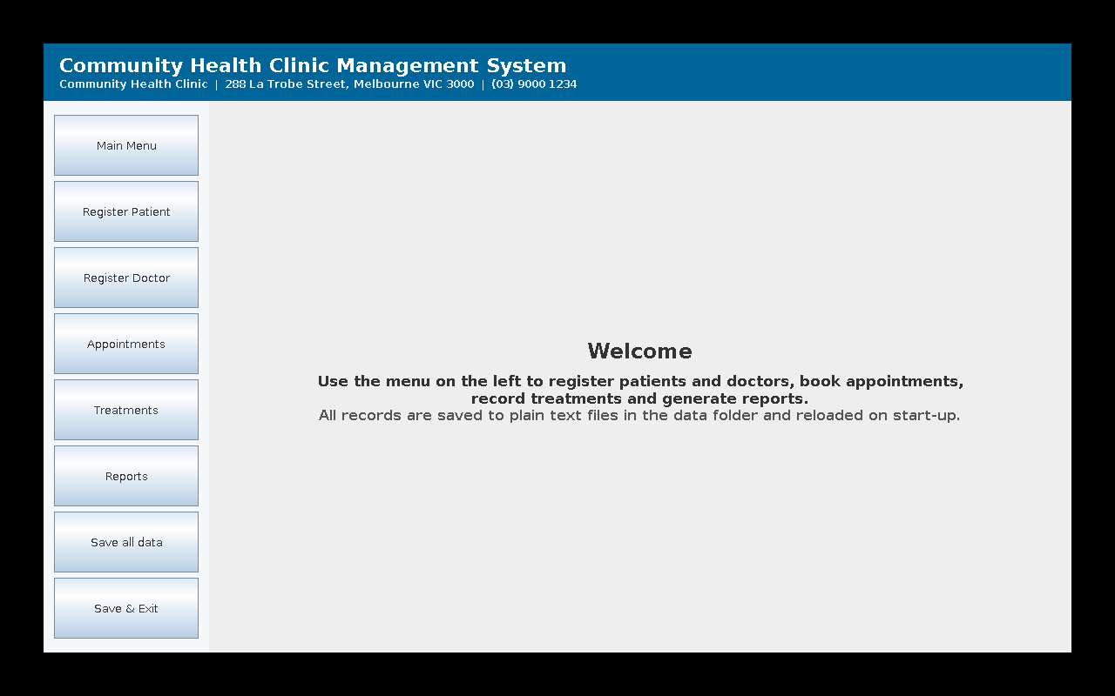
Figure 2 - Main application interface with sidebar navigation
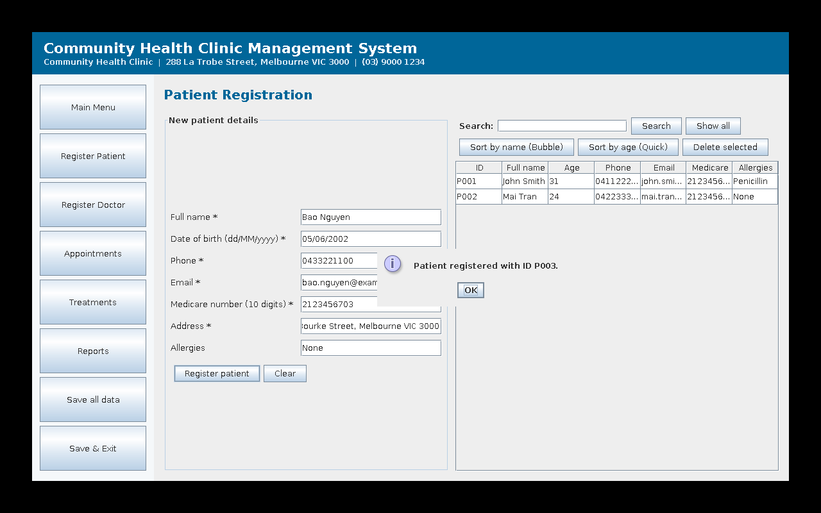
Figure 3 - Patient registration with confirmation of the generated ID
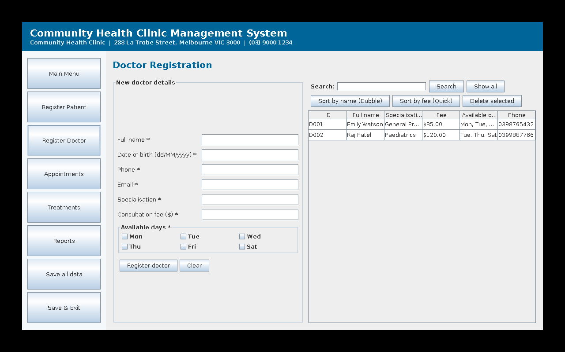
Figure 4 - Doctor registration, including working-day selection
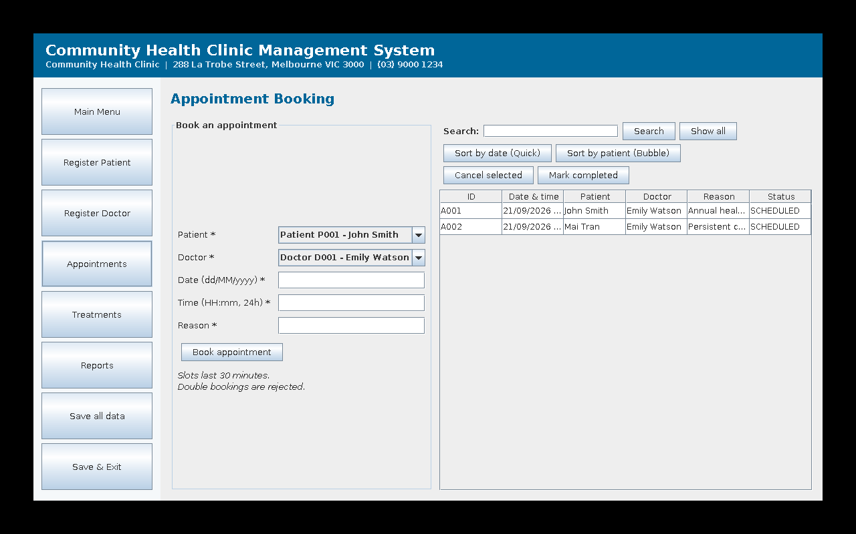
Figure 5 - Appointment management with sorting and status controls
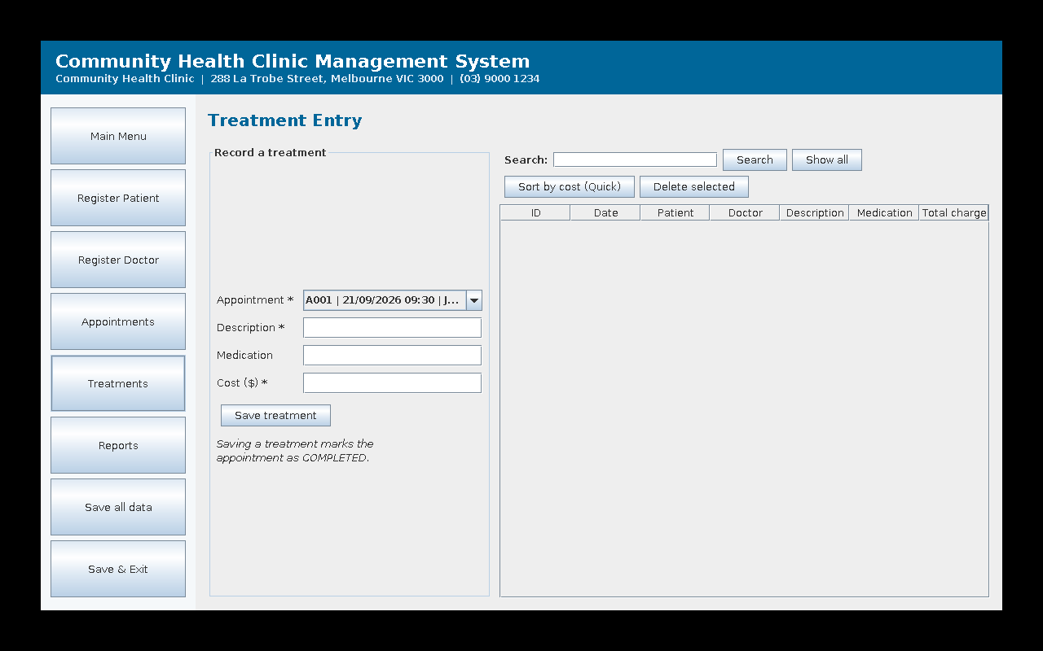
Figure 6 - Treatment management linked to a selected appointment
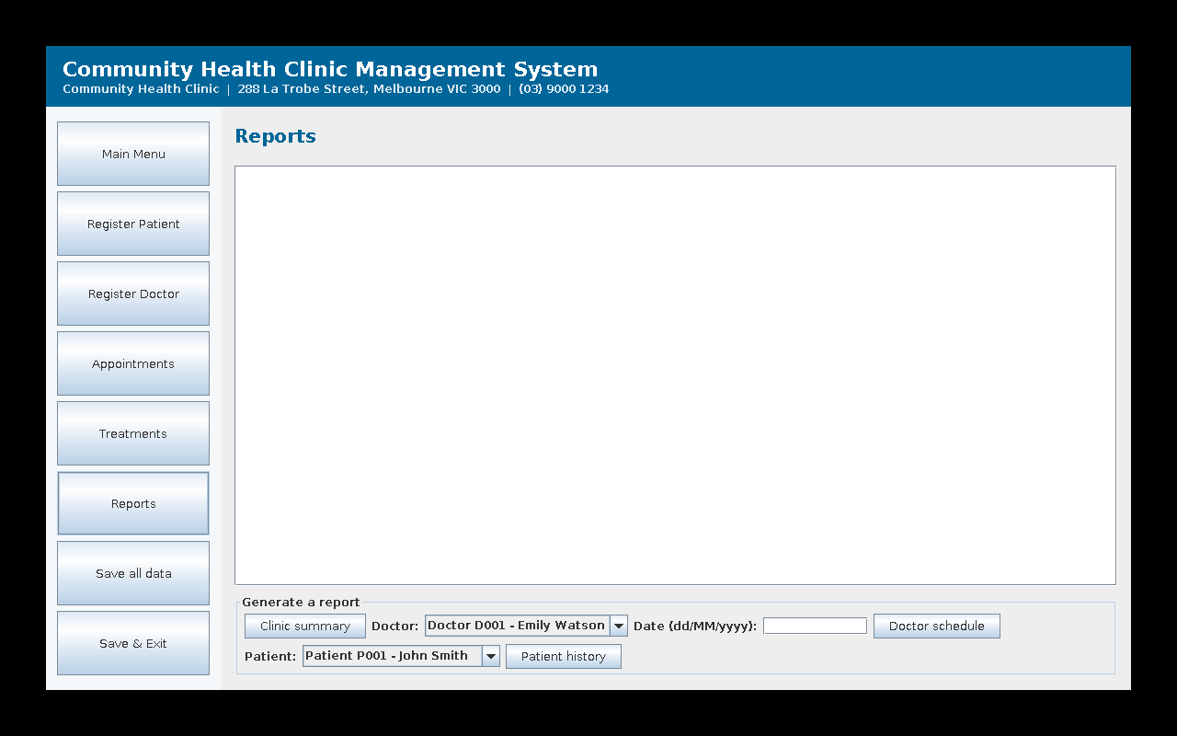
Figure 7 - Reports screen: summary, doctor schedule and patient history
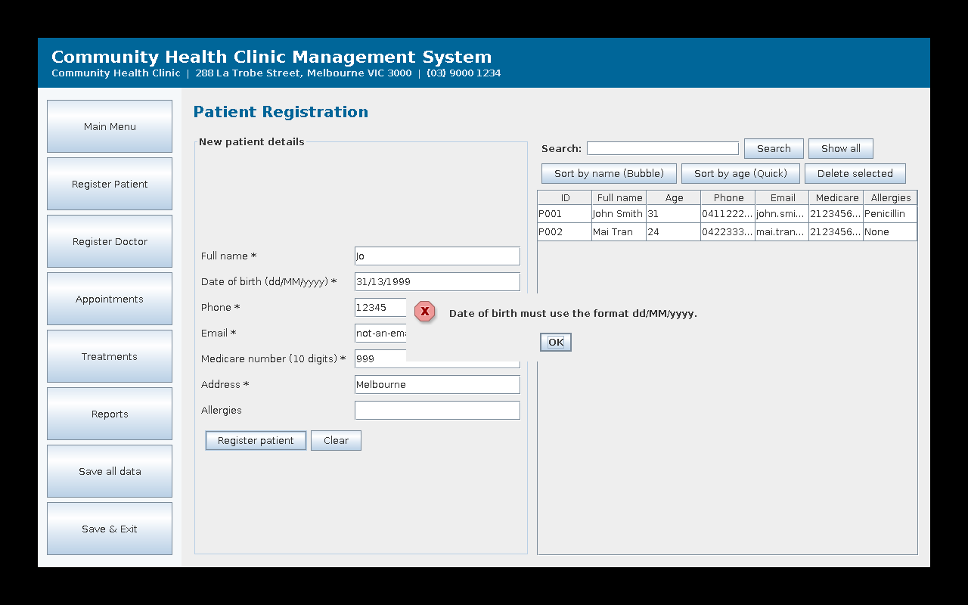
Figure 8 - Input validation and exception handling on the registration form
INSERT YOUR OWN SCREENSHOT HERE
Figure 9 - Searching and sorting in use (capture from your own run)
INSERT YOUR OWN SCREENSHOT HERE
Figure 10 - JUnit test execution showing all tests passing

References
Gamma, E., Helm, R., Johnson, R. and Vlissides, J. (1994) Design Patterns: Elements of Reusable Object-Oriented Software. Reading, MA: Addison-Wesley.
Martin, R. C. (2018) Clean Architecture: A Craftsman’s Guide to Software Structure and Design. Boston: Prentice Hall.
Oracle (2024) The Java Tutorials: Creating a GUI With Swing. Available at: https://docs.oracle.com/javase/tutorial/uiswing/ (Accessed: [DATE]).
The JUnit Team (2024) JUnit 5 User Guide. Available at: https://junit.org/junit5/docs/current/user-guide/ (Accessed: [DATE]).

Appendix A - Source Code Structure
src/model - Person, Patient, Doctor, Administrator, Appointment, Treatment, Clinic, AppointmentStatus, Identifiable
src/view - MainMenuFrame, PatientPanel, DoctorPanel, AppointmentPanel, TreatmentPanel, ReportsPanel, UIHelper
src/controller - PatientController, DoctorController, AppointmentController, TreatmentController, ReportController
src/persistence - Repository, FileRepository, CsvMapper
src/util - Validator, SearchUtil, SortUtil, IdGenerator
src/exception - ValidationException
test - ValidatorTest, AppointmentTest, SearchSortUtilTest, ClinicIntegrationTest (32 test cases)

