1. **Group members**

Group members: Ziqi Liu 9364-4917

Enyang Wang 6494-1124

1. **How to run**

Steps: 1. Enter root folder (proj4_2).

2.type commend as: mix phx.server

1. **What is working**

The goal of our project is to implement a Twitter-like engine and use actor model to simulate several clients and a single-engine process.

In 4.2 we add the web interface for all the functionalities we have in 4.1.

1. **Functionalities**

All the functionalities in proj4.1:

1. Register
2. Login
3. Delete
4. logout (new add)
5. send_tweet
6. subscribe
7. re_tweet
8. query

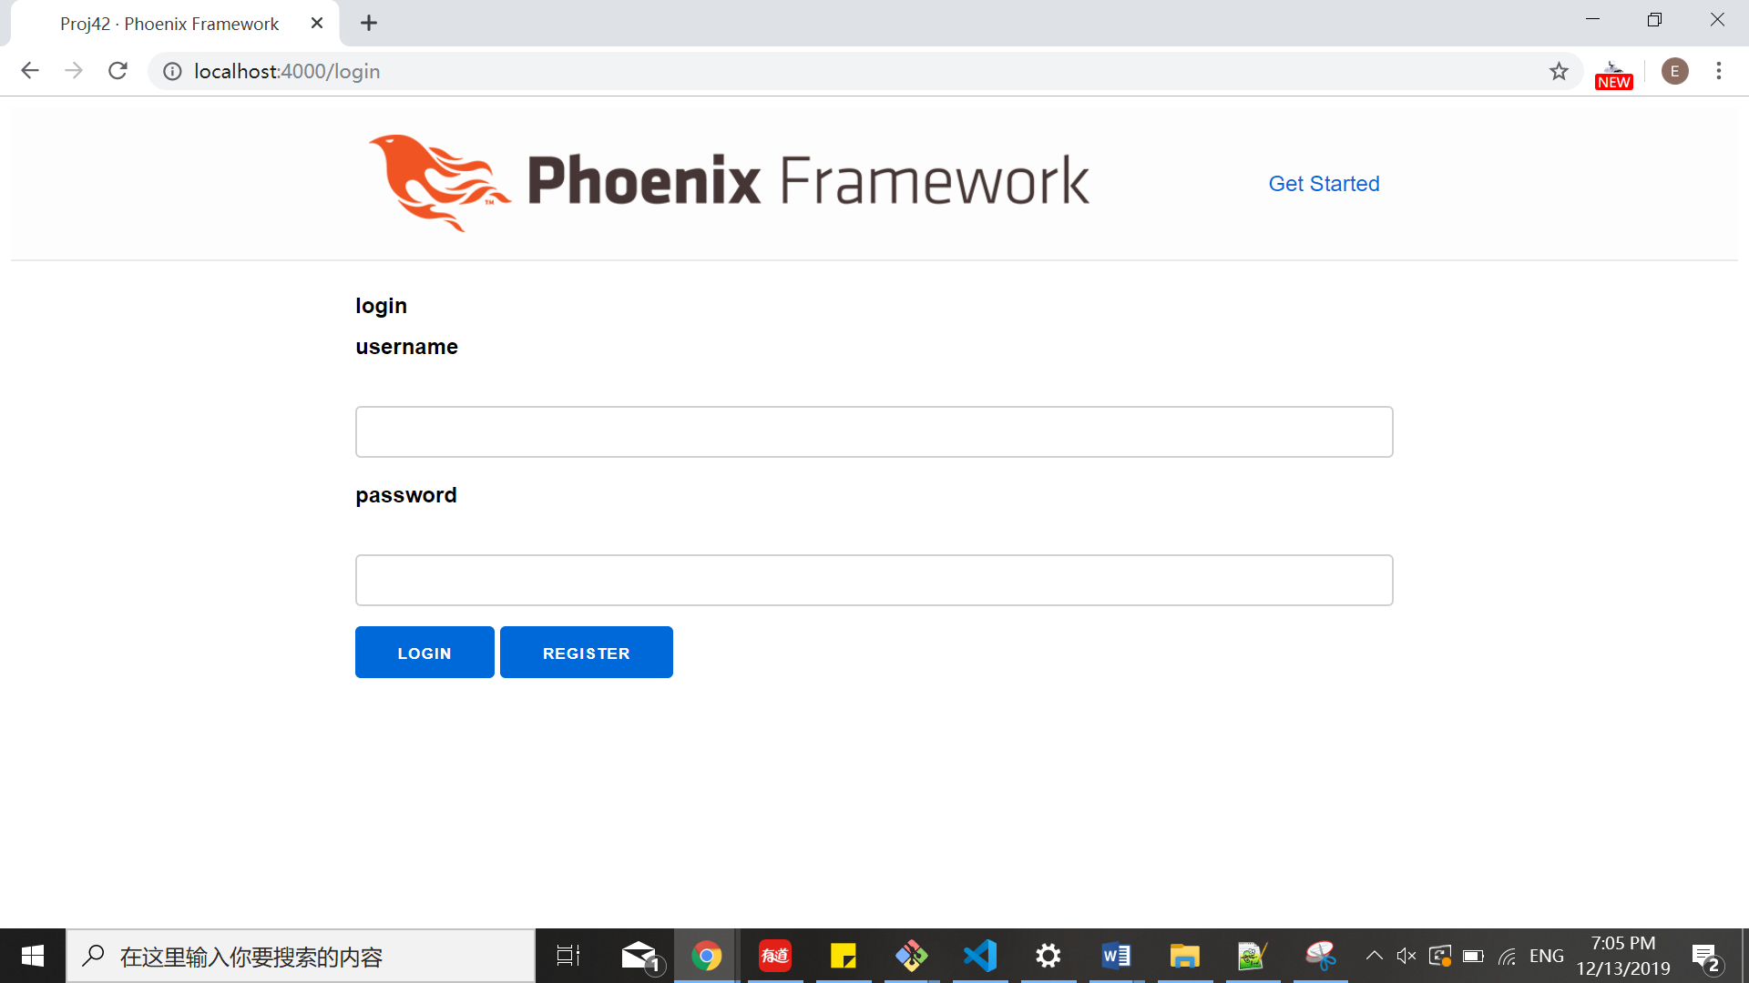

Login page

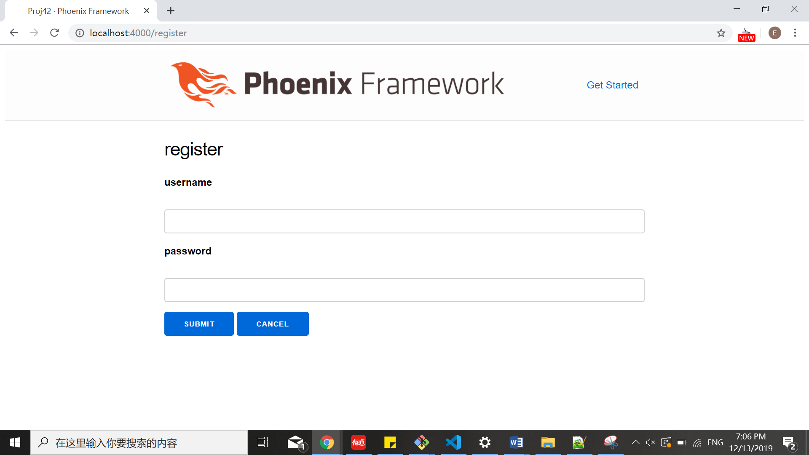

Register page

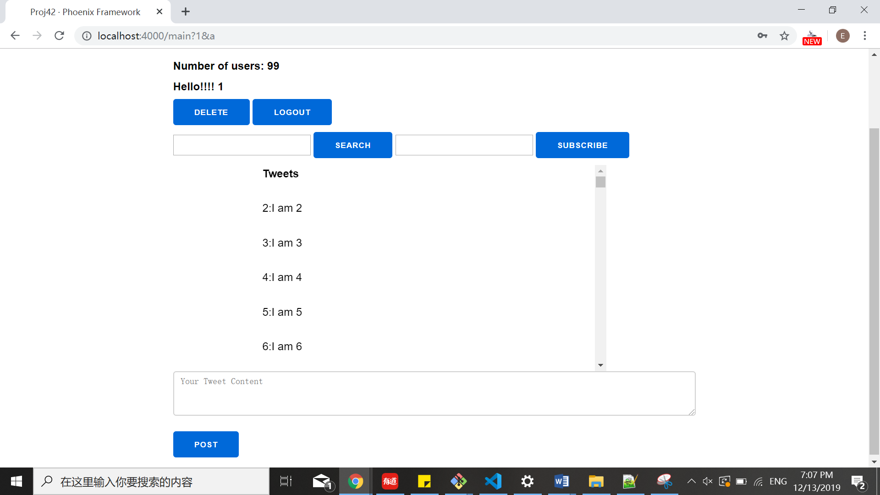

Main page

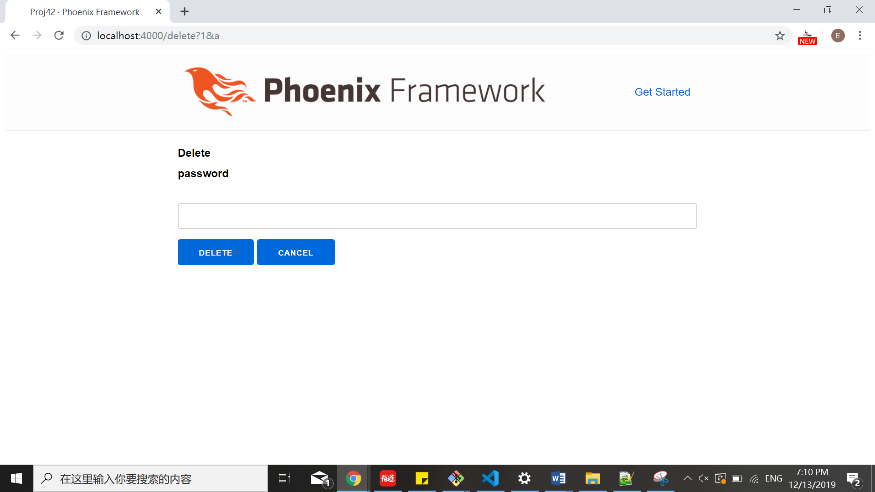

Delete page

1. **Video link**

[https://youtu.be/esLqaXN4wiA](https://youtu.be/esLqaXN4wiA?fbclid=IwAR3Eoylr3q8mGT-CYjO9T3jgy-lQ5usUeLpHZwD9M3sCYwMEgh0nPDhgqdc)