## Principal Component Analysis and Dictionary Learning

1. For PCA, I select top 64 eigen vectors.

For KSVD, I set iteration as 50, and the original dictionary is a 256*256 identity matrix concatenate with the top 94 256*256 Fourier matrix.

As a result, the error of PCA is about 0.09488, and the error of KSVD is about 0.012049.

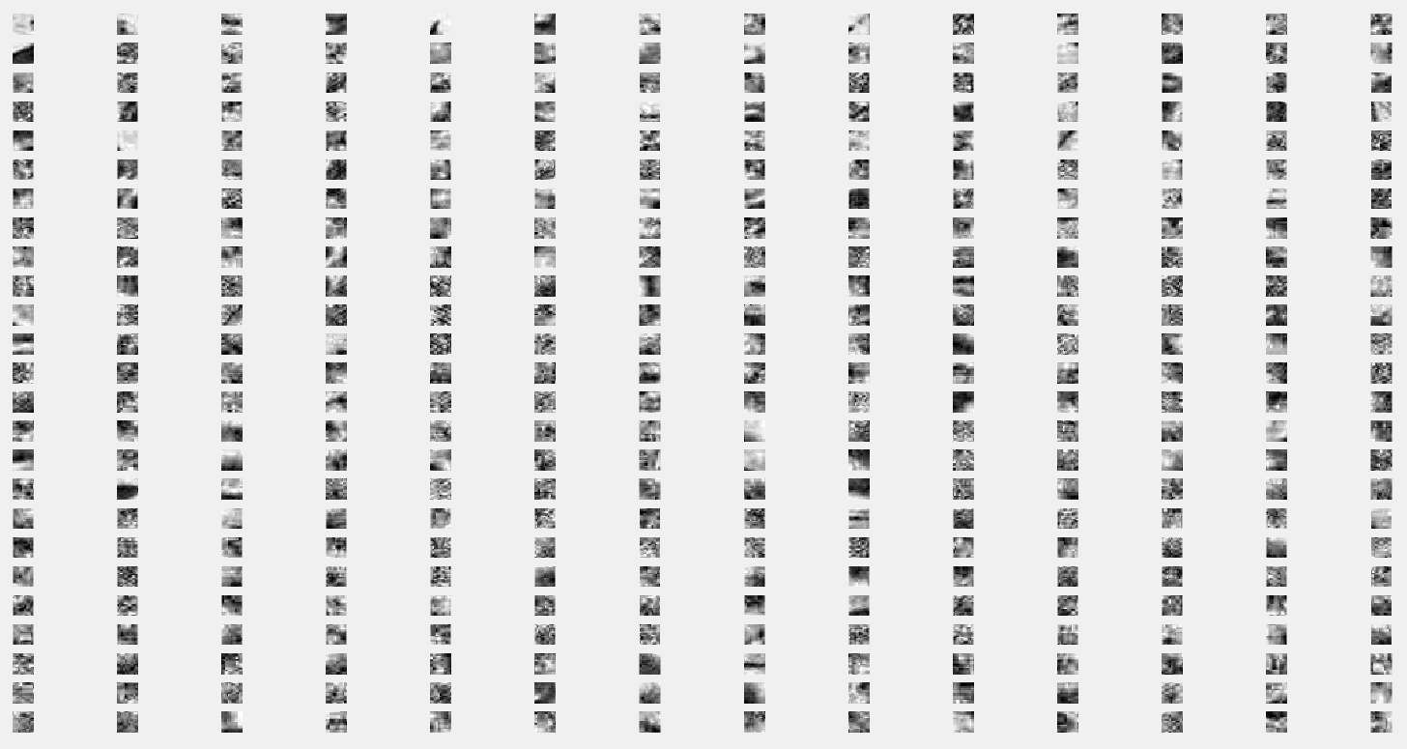

Visualize final dictionary (350-d)

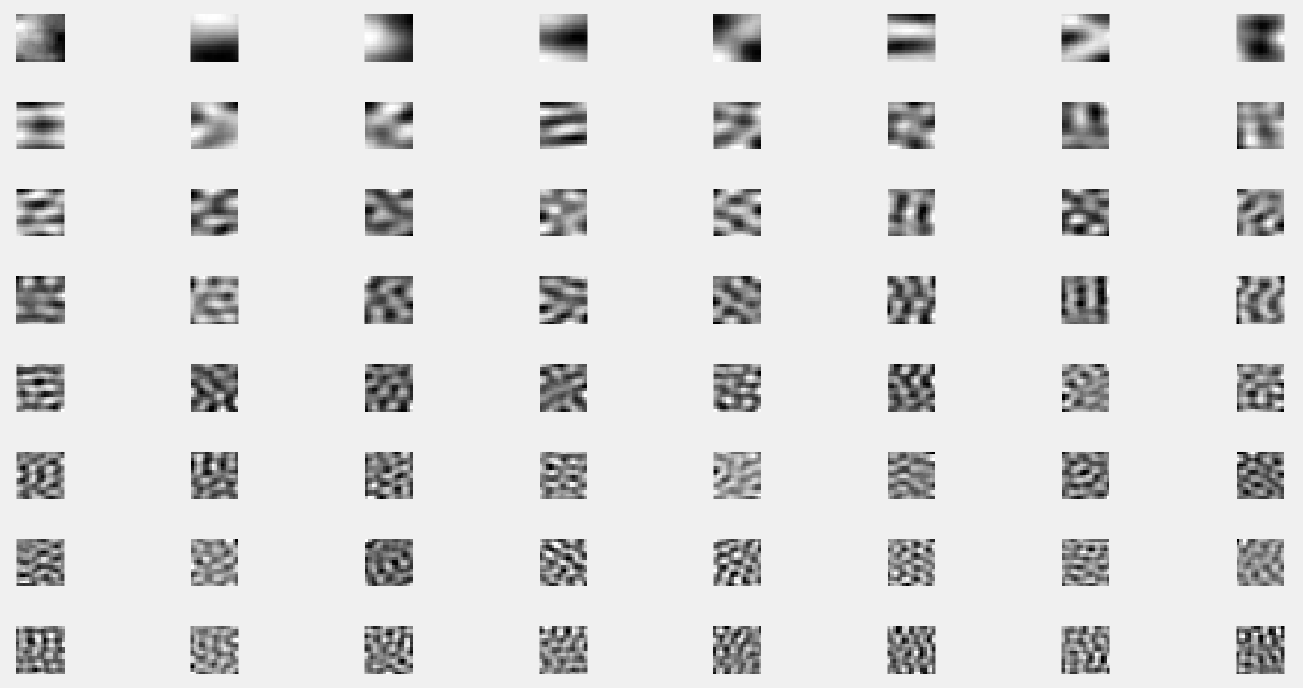

Top 64 eigen vectors