Cooking Fuel Data Tool — User Guide
This guide walks through every screen and control in the Cooking Fuel Data Tool. It is intended for analysts and modellers who will use the tool.
The tool always opens to Outputs with the default selections applied. The two top-level views (Outputs / Inputs) sit as folder tabs at the top of the body; the sidebar on the left holds the filters and applies to both views.
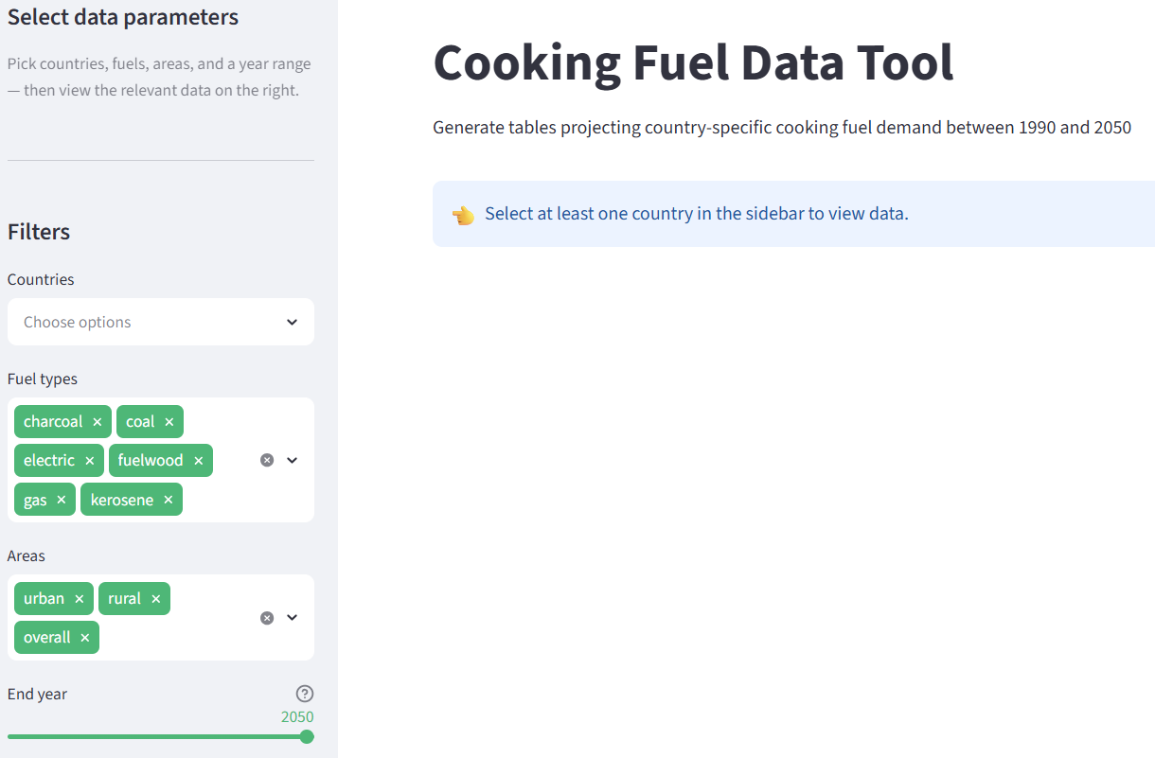

Default View: first select at least one country to see data.

Section 1 — Default Output: Total Fuel Consumption
On launch you see the Total fuel consumption sub-tab inside the Outputs view. The big table is the headline output of the tool: estimated fuel users and total consumption for every selected (country, area, fuel, year) combination.
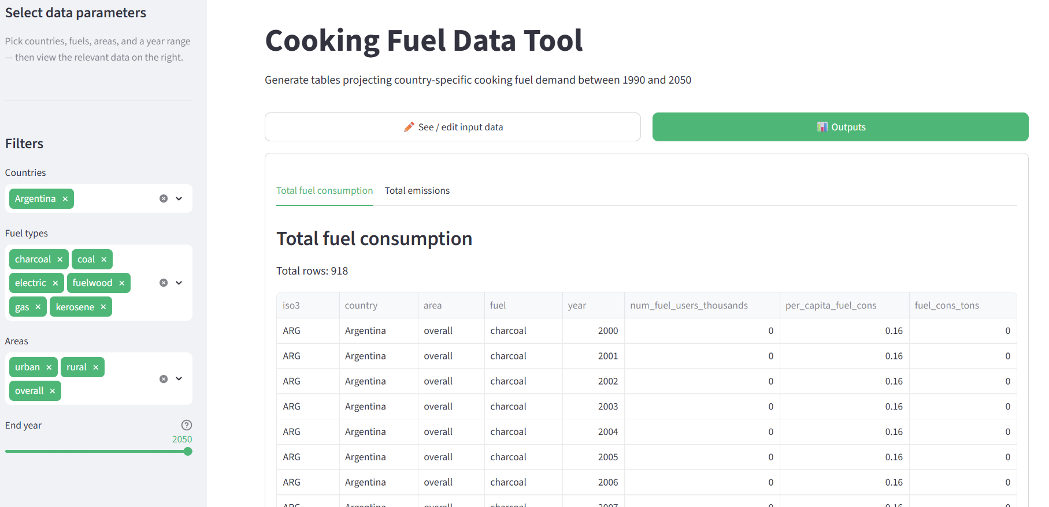

Same page: scrolled down

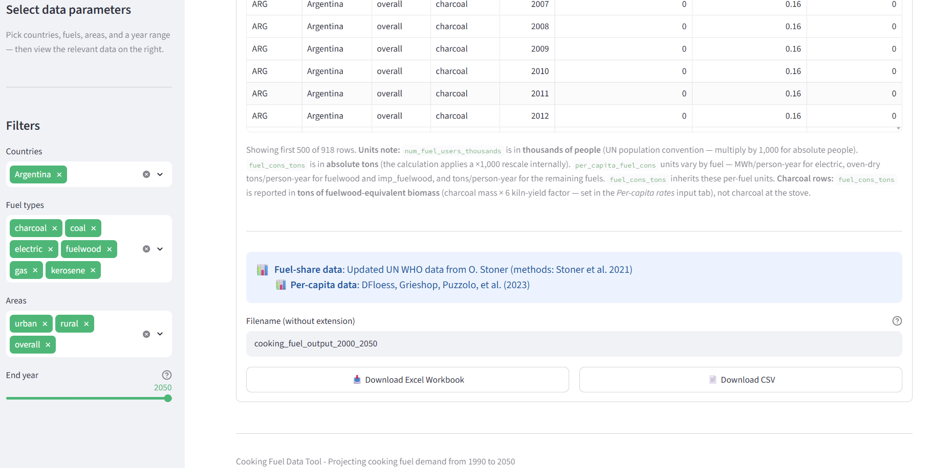

Default view once a country is or countries are selected.

1.1 Sidebar filters
The left-side panel controls what data the rest of the app shows. Changes apply immediately on rerun — no "apply" button needed.
Control | What it does | Notes
Countries | Multi-select of all countries present in the fuel-share dataset | Required — the body shows a prompt to pick at least one country before any data is rendered.
Fuel types | Multi-select of fuel categories: fuelwood, charcoal, imp_fuelwood, imp_charcoal, gas, kerosene, coal, electric, ethanol, pellets, biogas | Defaults to all available. Only fuels present in the fuel-share dataset can appear in output; the rest are silently dropped from the merge.
Areas | Multi-select: urban, rural, overall | overall is derived as urban + rural (see § 1.3). Default is all three.
End year | Slider snapping to one of 2020 / 2030 / 2035 / 2040 / 2050 | Start year is fixed at 2000. Default end year is 2050.

1.2 The output table
The table is a single row per (iso3, country, area, fuel, year) combination. Columns:
Column | Meaning | Units
iso3, country, area, fuel, year | Identifiers — area is one of urban/rural/overall; fuel is lowercase | —
num_fuel_users_thousands | Number of people using this fuel in the given (country, area, year) | Thousands of people (UN WPP convention)
per_capita_fuel_cons | Per-capita consumption rate from the per-capita dataset | Varies by fuel: MWh/person-year for electric; oven-dry tons/person-year for fuelwood/imp_fuelwood; tons/person-year for others
fuel_cons_tons | Total consumption: num_fuel_users_thousands × per_capita_fuel_cons × 1,000 | Absolute tons (rounded to whole numbers in the display and exports)

The region column exists in the backend (used to join per-capita rates) but is hidden from the display so the table stays readable.

Units quick-reference
num_fuel_users_thousands is in thousands of people, but fuel_cons_tons is in absolute tons. The calculation applies a ×1,000 rescale internally so the consumption value lands in absolute tons (more useful for emissions and policy). Because of that, the identity users × per_capita = fuel_cons_tons does NOT hold without the additional ×1,000 — see the inline caption beneath the table and the metadata sheet of the Excel export for the explicit note.

1.3 How overall is computed
The overall row for each (country, fuel, year) is computed as the sum of the urban and rural rows for that combination — not taken from the source's "Overall" series. This guarantees overall.num_fuel_users_thousands = urban.num_fuel_users_thousands + rural.num_fuel_users_thousands and the same for fuel_cons_tons. The source's Overall rows from the WHO/Stoner dataset are intentionally discarded; the modelled "Overall" share doesn't always equal the population-weighted average of the urban and rural shares, and the tool prefers the arithmetic identity for consistency.

1.4 Downloading the data
Below the table are two download buttons side-by-side:
Button | Format | Contents
Download Excel Workbook | .xlsx | Two sheets: Metadata & Sources (run parameters, citations, units notes) and Fuel Consumption Data (the table).
Download CSV | .csv | Single file. The first two rows are a parameter preamble — end_year,efchratio then the values (e.g. 2050,6). Row 3 onward is the data table (header + rows). Designed for ingestion by downstream tools that expect a small named-parameter header above the data.

The text input above the buttons sets the filename stem — both downloads use it (with .xlsx and .csv extensions respectively). Illegal filename characters are stripped automatically.

About the kiln yield in the CSV preamble
The efchratio value in the CSV preamble is the wood-to-charcoal kiln yield set in the Per-capita rates input tab (§ 3). It applies to charcoal rows of fuel_cons_tons: those rows are multiplied by the kiln yield so they represent the upstream wood biomass burned to produce the charcoal — the right unit for forest-impact / biomass-supply analyses, not stove-side charcoal mass.

Section 2 — Inputs: Fuel Shares
Click "See / edit input data" at the top to switch from outputs to the inputs view. The Inputs view has two sub-tabs; Fuel shares is the first.

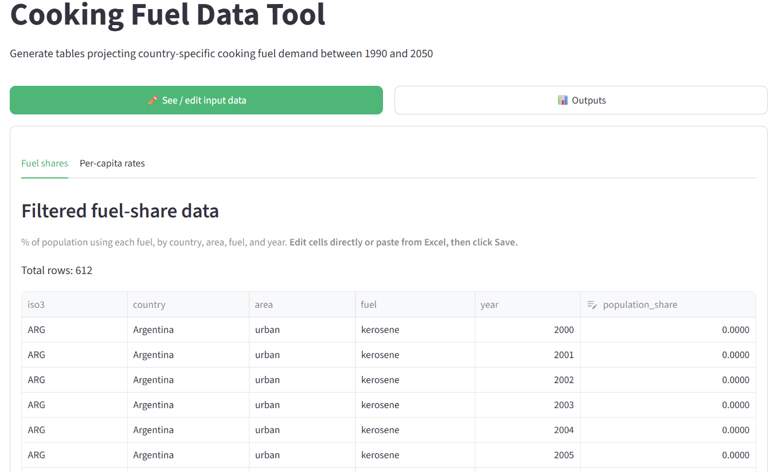
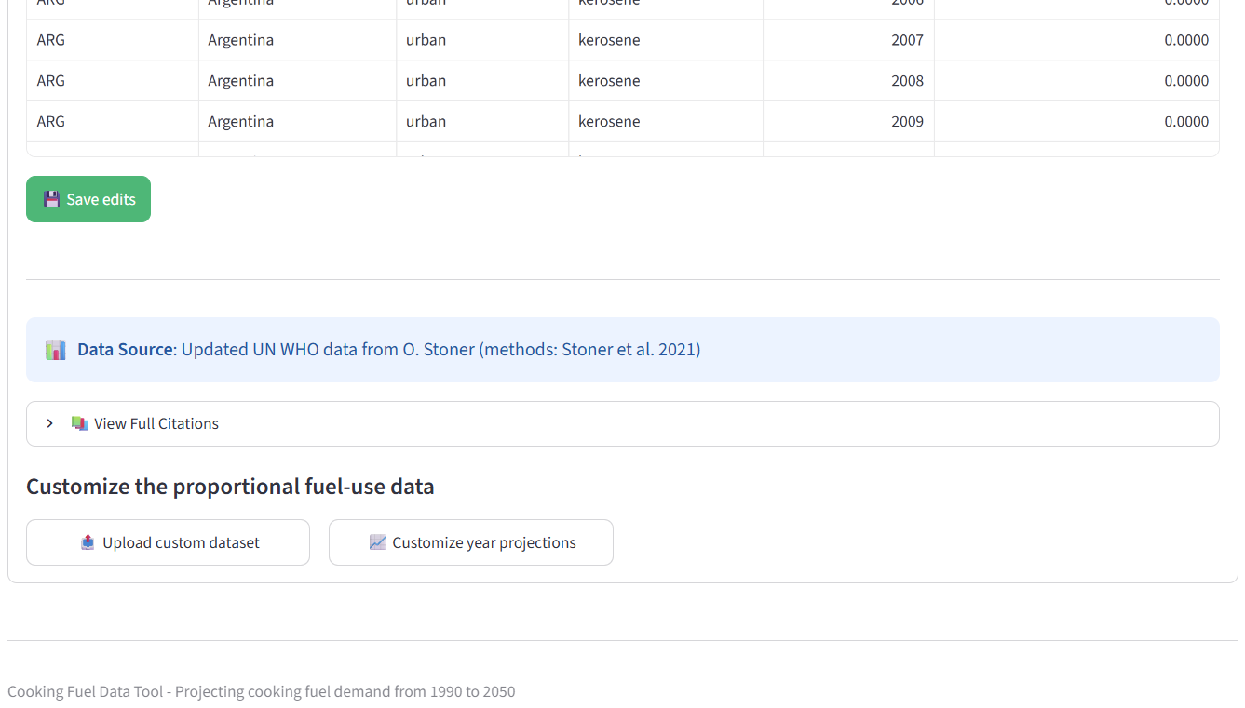

Select/see input data tab Fuel shares

2.1 The editable share table
The table shows the fraction of population using each fuel for every (iso3, country, area, fuel, year) in the current filter selection. The editable column is population_share (values 0–1); all identifier columns are locked.
To edit:
- Click a cell in the population_share column and type a new value, OR paste a column from Excel.
- Click Save edits to commit. The status banner confirms the row count applied.
Edits are persistent for the rest of the session: they flow into the consumption calculation the moment you save, and the metadata sheet of any subsequent Excel export records that in-app edits were made.
Note: the editor switches to a read-only preview if the current selection produces more than 8,000 rows. Narrow your sidebar filters (fewer countries or a shorter year range) to drop below that threshold and re-enable editing.

2.2 Data source ribbon and citations
Below the table is a coloured ribbon showing the current active data source — blue for the default Stoner et al. (2021) data, yellow when a custom dataset has been loaded or in-app edits have been applied. Expand "View Full Citations" to see the bibliographic entries for whatever is currently in use, including any custom-projection citation you provided.

2.3 The four action buttons
Below the citations are four buttons; the last two only appear when the corresponding state is active.
Button | What it does
Upload custom dataset | Opens a modal to upload your own fuel-share CSV/XLSX (replaces the default Stoner et al. data wholesale). The required columns are iso3, country, region, area, fuel, year, population_share. Region is re-derived from iso3 on upload so user-supplied region values are normalised.
Customize year projections | Opens a modal to set custom values for a specific year (e.g. 2030); the rest of the timeseries is linearly interpolated between the 1990 baseline and the custom year, then to 2050. Provide either the values inline in a data editor or by uploading a CSV. Either way, a data-source citation is required.
Revert to default WHO data | Only visible after a custom dataset has been loaded. Restores the bundled Stoner et al. data.
Clear custom projections | Only visible after custom-year projections are active. Removes them and returns to the baseline projections.

Custom upload — minimum requirements
- File must be .csv or .xlsx with the header row matching iso3, country, region, area, fuel, year, population_share (case-insensitive; the loader lowercases column names).
- population_share values must be between 0 and 1.
- A free-text data-source description is required at upload time (it shows up in the citations expander and the Metadata sheet of every subsequent Excel export).
- Any Overall rows in the upload are dropped; overall is always derived as urban + rural downstream. Use lowercase urban/rural (case is normalised automatically).

Section 3 — Inputs: Per-Capita Rates
The second Inputs sub-tab.
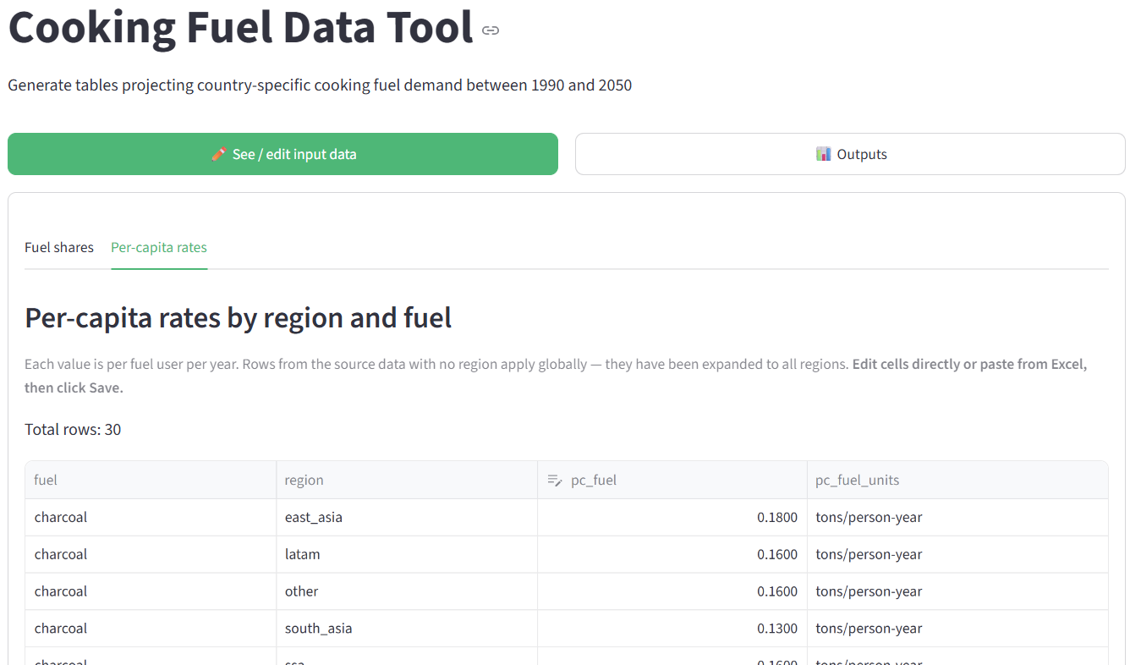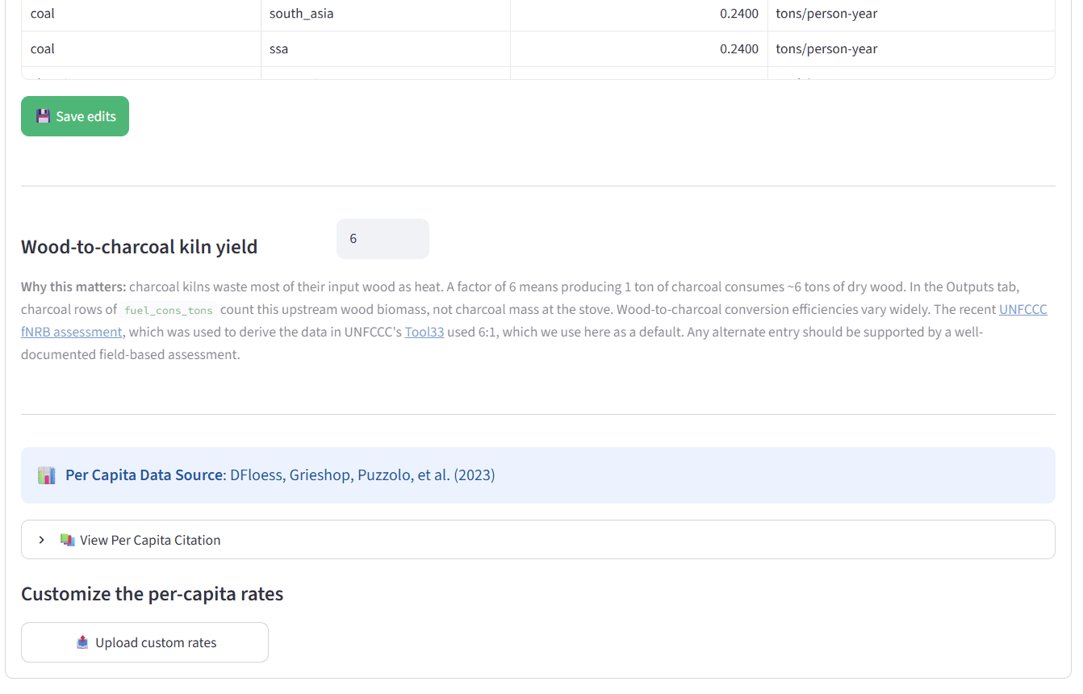
Select/see input data tab Per-capita rates

3.1 The editable rate table
Each row gives the per-capita annual fuel consumption for one (region, fuel) pair. The editable column is pc_fuel; fuel, region, and pc_fuel_units are locked. The table is filtered to the fuels selected in the sidebar so you only see the rows relevant to your current run.
Per-capita rates are keyed on (region, fuel) — not on area or year — so a single edit applies to every (country, area, year) row in that region/fuel combo. This is by design: per-capita rates are intended as regional structural assumptions, not country-level observations.
The pc_fuel_units column shows the unit each rate is expressed in (varies by fuel — MWh/person-year for electric, oven-dry tons/person-year for fuelwood/imp_fuelwood, tons/person-year for the rest).
Click Save edits to apply your changes. As with the share editor, edits are persisted for the rest of the session and noted in the Excel metadata sheet.

3.2 Wood-to-charcoal kiln yield (efchratio)
Below the per-capita table is the Wood-to-charcoal kiln yield input — a single numeric field. This is the value exported as efchratio in the CSV preamble (§ 1.4).
Detail | Value
What it represents | Kilograms of dry wood needed to produce 1 kg of charcoal in a kiln.
Where it's applied | The fuel_cons_tons column for charcoal rows only. After computing the stove-side charcoal mass, the value is multiplied by the kiln yield to give the upstream wood biomass.
Default | 6 (typical traditional earthen-kiln yield in sub-Saharan Africa — FAO regional reference).
Typical range | 3–5 for more efficient kilns; 1 if you want to keep charcoal rows as stove-side mass.

Why this matters: charcoal kilns waste most of their input wood as heat. A factor of 6 means that producing 1 ton of charcoal consumes ~6 tons of dry wood — the right number for forest-impact / fNRB analyses. The caption block under the input links to the UNFCCC fNRB assessment that informed the default.

3.3 Custom per-capita upload
If the default per-capita data is missing or you want to replace it, the Upload custom rates button (visible at the top of the tab when no default is loaded, and via a modal action when it is) accepts a .csv or .xlsx with columns fuel, region, pc_fuel, pc_fuel_units. Rows with an empty region value are treated as global and expanded into every region at load time. As with the share upload, a data-source citation is required and recorded in the metadata sheet.

Section 4 — Emissions Output
Back in the Outputs view, the second sub-tab is Total emissions. The emissions calculation uses the consumption results from Section 1 as input: total_GHG = fuel_cons_tons × em_intens_GHG for each of CO2, CH4, and N2O.
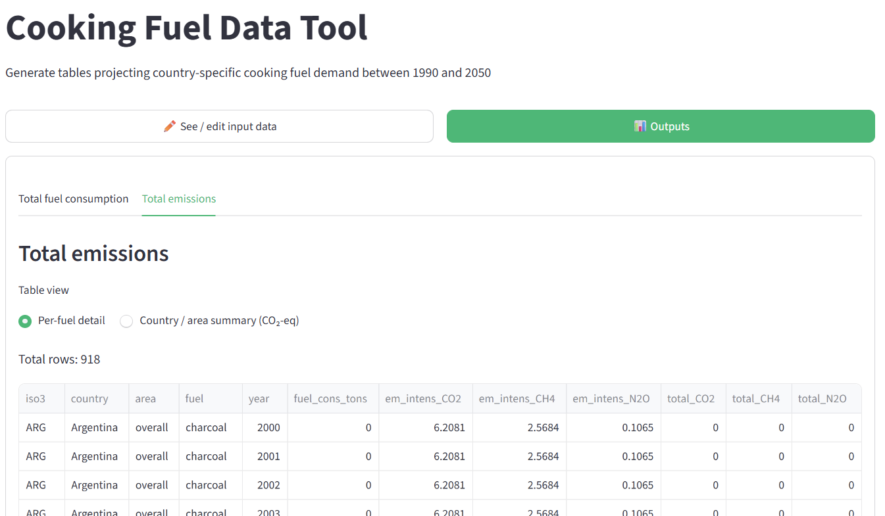
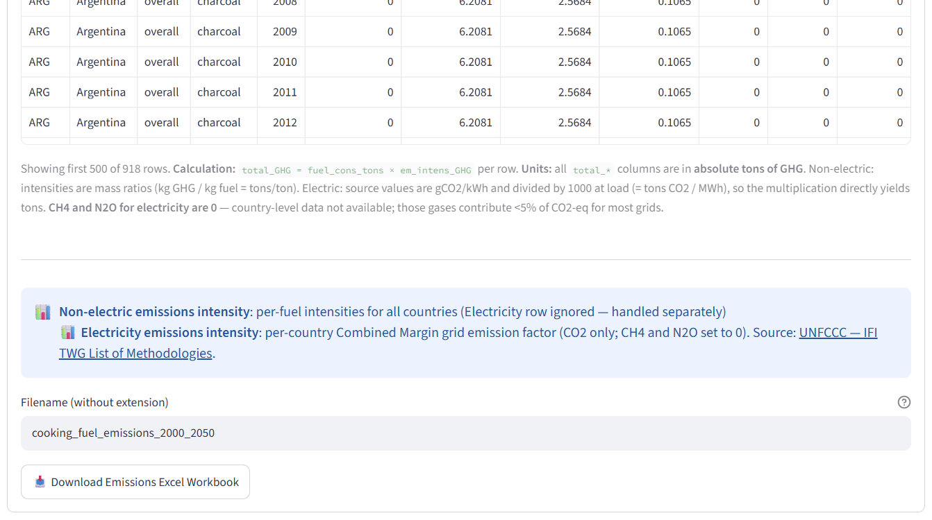
Output data tab Emissions from fuel use

4.1 Two views — toggle at the top
A radio control at the top of the tab switches between two views of the same emissions calculation:
View | Row granularity | Columns
Per-fuel detail | (iso3, country, area, fuel, year) | fuel_cons_tons, em_intens_CO2/CH4/N2O, total_CO2/CH4/N2O
Country / area summary (CO2-eq) | (iso3, country, area, year) — summed across all fuels | total_CO2, total_CH4, total_N2O, total_CO2eq

The summary view computes:
total_CO2eq = total_CO2 + 28 × total_CH4 + 265 × total_N2O
using IPCC AR5 GWP-100 factors — the UNFCCC Enhanced Transparency Framework default for reporting after 2024.

4.2 Units and electricity treatment
- All total_* columns are in absolute tons of GHG.
- For non-electric fuels, intensities are mass ratios (kg GHG / kg fuel = tons/ton) sourced from the per-fuel intensity file.
- For electricity, per-country Combined Margin grid emission factors (from the UNFCCC IFI TWG methodology list) are used; the loader divides the source gCO2/kWh by 1,000 so the in-memory value lines up dimensionally with fuel_cons_tons for electric rows (which is in MWh).
- CH4 and N2O for electricity are set to 0 because country-level data isn't available; for most grids these gases contribute less than 5% of CO2-equivalent, so the omission has limited impact on the summary view but is an important caveat to keep in mind for grids where biomass cofiring is significant.
The on-screen caption below each table restates these units and the calculation explicitly.

4.3 Missing-intensity diagnostic
If any rows in the per-fuel detail have no matching emissions intensity (likely cause: a fuel name in your share/per-capita data doesn't match anything in the intensity files), a yellow "N rows have no matching emissions intensity" expander appears under the table. Open it to see the count grouped by fuel and identify which fuel name needs reconciling.

4.4 Downloading the emissions data
The Download Excel Workbook button at the bottom of the emissions tab produces a three-sheet workbook:
Sheet | Content
Metadata & Sources | Run parameters, intensity sources, GWP factors, units note.
Total Emissions | The per-fuel detail table (regardless of which view is on screen).
Summary by Country-Area | The aggregated CO2-eq summary.

The filename stem is independent from the consumption export — it starts as cooking_fuel_emissions_<start_year>_<end_year> but is editable in the text input above the button.
There is no CSV bundle for the emissions tab at present; the Excel workbook is the only download option here.

Appendix — Quick reference

Where each parameter lives
Parameter | Where to set it | Where it shows up in exports
selected_countries, selected_fuels, selected_areas | Sidebar | Metadata sheet, CSV preamble (in CSV bundles), filter applied to data rows
start_year | Fixed at 2000 — not user-editable | Metadata sheet "Year Range"
end_year | Sidebar slider | Metadata sheet "Year Range", end_year in CSV preamble
efchratio (kiln yield) | Per-capita rates tab → Wood-to-charcoal kiln yield | Metadata sheet, efchratio in CSV preamble, applied to charcoal rows of fuel_cons_tons
Custom share dataset / projections | Fuel shares tab → action buttons | Metadata sheet records the source description and citation
Per-capita inline edits | Per-capita rates tab → data editor + Save | Metadata sheet flag "Per Capita — In-App Edits: Yes"
Share inline edits | Fuel shares tab → data editor + Save | Metadata sheet flag "Population Share — In-App Edits: Yes"

Conventional units cheat sheet
Quantity | Unit
num_fuel_users_thousands | thousands of people
per_capita_fuel_cons | varies by fuel (see column pc_fuel_units on the per-capita tab)
fuel_cons_tons | absolute tons
total_CO2, total_CH4, total_N2O, total_CO2eq | absolute tons of GHG
efchratio | kg wood / kg charcoal (dimensionless)
population_share | fraction in [0, 1]

