Software Requirements Specification
<The Jungle Game>

LI Hang Chun 23081548D
Chung Man Fai 23082538D
Huang Lok Shu 23079879D

Preface
This Software Requirements Specification (SRS) document is planned for several stakeholder of The Jungle Game application. The expected readership includes the following groups:
Developer Team: Team members assigned to design and implement The Jungle Game application according to specified requirements.
Tester: Team members assigned to test whether The Jungle Game application meets all specifications.
End User: User can check whether their needs are correctly understood and documented by reading this document.

Introduction
The purpose of this document is to present a detailed description of The Jungle Game application by defining functional requirements and non-functional requirements. It will explain objective and rules of this game application, what the application will do, and how interaction with users will be performed. This document aims to provide a clear guide for application development and testing.

This software will implement The Jungle Game, a turn-based strategy game between two players, inspired by the traditional Chinese board game Dou Shou Qi. In this application, players can start a new game, make moves according to movement rules of each piece, capture opponents’ pieces according to rank, and win by either capturing all opponents’ pieces or reaching the opponents’ den.

Glossary
Term | Definition
CLI | Command line interface (CLI) which is a text-based interface allowing players to interact with the application.
Pieces | Each player controls eight animal pieces to move on game board. Some animal pieces have unique rules.
Rank | Animal pieces are ranked from highest to lowest as follows: Elephant (8), Lion (7), Tiger (6), Leopard (5), Wolf (4), Dog (3), Cat (2), and Rat (1).
Capture | When a piece enters a square occupied by an opponent’s piece, if it has an equal or higher rank (except in the special case where rat pieces can capture elephant pieces.), the opponent’s piece is removed.
Den | A special square on game board where player will win when player occupies opponents’ one.
Trap | A special square on the game board where any piece that enters will have its rank temporarily reduced to 0.
River | A special square on game board that only rat pieces can enter, and lion and tiger pieces can jump over.
Software Requirements Specification | A document that completely describes all the functions of a proposed system and the constraints under which it must operate. For example, this document.
Save File | A file storing current game board, piece position and player turn for player pausing and continuing game later.
Record File | A file recording previous game moves for player replay.

User requirements definition
Requirement | Description
Start a new game | Users can start a new game with two players. The system will initiate the game board and the position of pieces.
CLI interact | Users can interact with the application through inputting command via CLI.
View game board | Users can view the current game board and all piece positions displayed by the application through the CLI.
Name players | Users can input a name or generate a random name to be their players’ name.
Move pieces | Users can move their pieces by interacting with the application through the CLI, according to the game rules.
Capture pieces | Users can capture opponent’s piece according to the game rules.
Take back movements | Users can undo up to the three most recent moves in the current game. Each player can undo almost 3 times in whole game.
Exit game | Users can terminate and exit an ongoing game.
Save game | Users can save current game status in file with an extension name “.jungle”.
Continue a saved game | Users can load a game from a file with an extension name “.jungle”.
Record game | Users can record all game movements and player information in a file with the extension “.record”.
Replay game | Users can replay the game from a file with an extension name “.record”.
Win the game | Users can win by either capturing all opponents’ pieces or reaching the opponents’ den and this application will end.

System architecture
In project, MVC (Model-View-Controller) pattern is expected to be applied in development. The Model component manages the system data and associated operations on that data. The View component defines and manages how the data is presented to the user. The Controller handles user input, interpret commands, and update both the Model and the View.
In this application, the Model opponent will maintain data related to game elements such as piece attribute, movement rules, and the game board. The View opponent will control the user interface, including displaying the game board and the positions of the pieces. The Controller opponent will interpret player inputs, execute corresponding commands, and update both the Model opponent and the View opponent accordingly. Each opponent should contain several classes for handling different functions.
The architecture of this project can be referenced by following diagram:
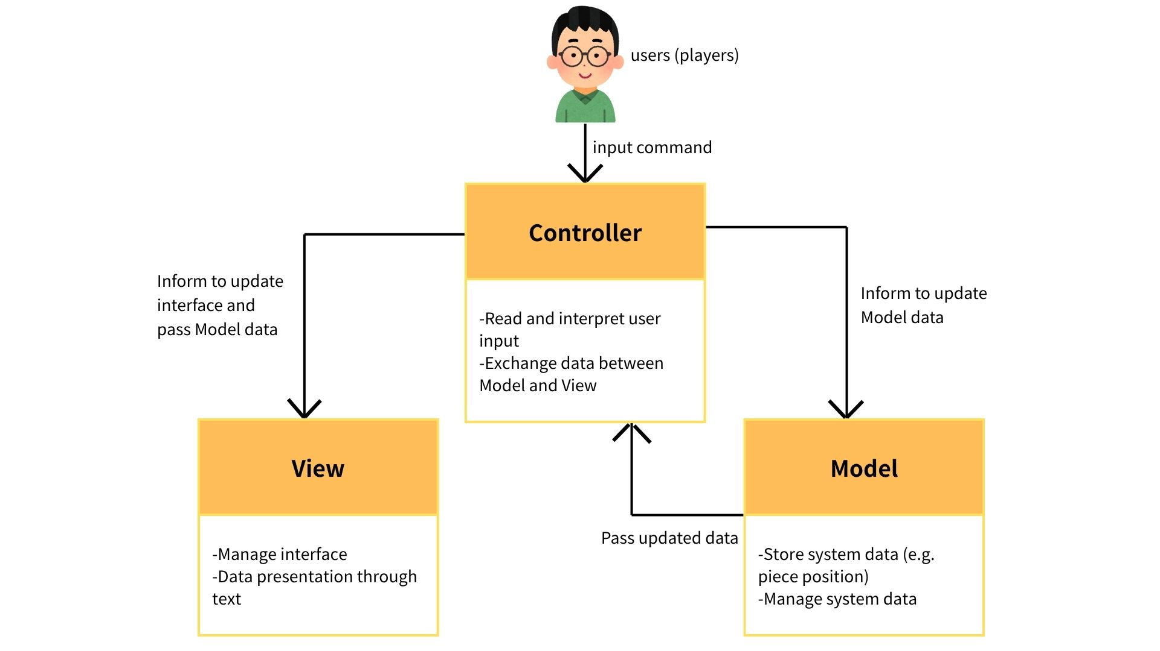

Software requirements specification
Functional Requirements
Game Initialization:
ID | Requirement
FR1 | The system shall allow 2 players to start a new Jungle Game.
FR2 | The system shall generate a game board consisting of seven columns and nine rows (a total of 63 squares).
FR3 | The system shall generate special areas on the board, including trap squares, den squares, and river squares, positioned according to the official The Jungle Game layout.
FR4 | The system shall generate animal pieces with Chinese letters(names) on the board according to their initial positions.

Player Name:
ID | Requirement
FR5 | The system shall read the strings inputting from players in CLI to be their players’ name at the start of the game.
FR6 | The system shall generate a random player name for a player who does not input a name.
FR7 | Each player’s name shall be unique, whether entered manually or randomly generated.

Gameplay and Movement:
ID | Requirement
FR8 | The system shall manage and enforce a strict turn order between players.
FR9 | The system shall restrict each player from moving only their own game pieces.
FR10 | The system shall restrict movement of pieces to one square horizontally or vertically.
FR11 | The system shall ban any illegal moves such as diagonal moves or movement into invalid squares.
FR12 | The system shall allow following special movement rules:  - Rat pieces can enter river squares.  - Lion and tiger pieces can jump over a river by moving horizontally or vertically from one edge of the river to the next land square on the opposite side, provided that no rat occupies any square within the river along the jump path.  - Pieces cannot move to their respective den square.

Capturing Pieces:
ID | Requirement
FR13 | A piece shall capture an opponent’s piece when it moves to the square occupied by that opponent’s piece and the opponent’s piece is of equal or lower rank.
FR14 | The system shall apply following exceptions about capturing pieces:  - The elephant piece cannot capture the rat piece.  - A rat piece can capture an elephant piece, but not while the rat is in the river squares.  - A rat piece can capture opponents’ rat piece, if both pieces are in the river squares or on the land squares.  - Any piece may capture an opponent’s piece located in one of the player’s trap squares.

Undoing Movements:
ID | Requirement
FR15 | The system shall maintain a history of the previous three moves for each player.
FR16 | The system shall allow a player to undo up to the three most recent moves in the current game, but the total number of undo actions by that player across the entire game shall not exceed three.

Game End:
ID | Requirement
FR17 | The player shall win either by moving a piece into the opponent’s den or capturing all the opponent’s pieces. The system shall end when a player wins.
FR18 | The system shall end when a player input “exit” command in CLI.

User Interaction:
ID | Requirement
FR19 | The system shall read players’ input for interacting via a CLI.
FR20 | The system shall provide textual guidance to players via the CLI.
FR21 | The system shall display the current status of the game board via a CLI.
 | The system shall recognize and reject invalid user commands, providing appropriate error messages.

Saving and Loading:
ID | Requirement
FR22 | The system shall allow players to save the current game state and players’ name to a file with a “.jungle” extension.
FR23 | The system shall allow players to load a saved game from a file with a “.jungle” extension.
FR24 | The system shall allow saving game moves and related information in a “.record” file.
FR25 | The system shall allow players to replay a saved game record on board from a file with a “.record” extension.

Non-Functional Requirements
Usability:
ID | Requirement
NFR1 | The system interface shall be easy to use and beginner friendly.

Performance:
ID | Requirement
NFR2 | The system shall respond to players’ command within 0.5 second.
NFR3 | The system shall load saved games and records within 1 seconds.

Portability:
ID | Requirement
NFR4 | The application shall run on major operating systems that support a command-line interface (e.g., Windows, Linux).

Reliability:
ID | Requirement
NFR5 | The system shall correctly interpret and respond to at least 99% of valid user commands under normal operating conditions.
NFR6 | The system shall save and record the game with at least 99% accuracy.

Robustness:
ID | Requirement
NFR7 | The system shall not occupy failure due to putting invalid command.

Size:
ID | Requirement
NFR8 | The size of the application shall not exceed 20MB.

