Part A Report

Name: Billy Lin (replace with your own name and delete this instruction!)

Assignment 6: Perceptron Classification and Training

CSE 415 Introduction to Artificial Intelligence, Winter 2021, University of Washington

Please answer each question using text in Blue, so your answers stand out from the questions.

QA1. How many epochs were required to train your perceptron on the 2-class Iris data having 2 features?

4

QA2. Include a graphic produced using matplotlib that shows both the training data points (in separate colors) and the “separating” lines implied by the weights at the end of each training epoch.” (Reduce the graphic as necessary to make it fit here without taking up more than half the page.)

Was there any thrashing (oscillation in the separator, such as flipping slope back and forth between positive and negative values, or having its y intercept jumping up and down as epochs proceed? How would you describe the progress of the learning, on the basis of the plot?

No, the slope and the y-intercept adjust gradually to correctly identify the separator. The y-intercept and the slope of the separator increased overtime to distinguish the two types of data.

QA3. What was the performance of your perceptron on the test data?

There are 80 examples and 78 of them are correctly classified. 0.975% of examples are correctly classified. There are 2 examples that were misclassified, with a 0.025% rate of misclassification.

QA4. After plotting the ring data, describe its distribution in words.

The data points distributed over a ring-shaped path and the separators were unable to find a linear path to separate the data points.

QA5. Describe the sequence of separators obtained when training your perceptron for 5 epochs using the ring data. To what extent is there convergence? Thrashing? Hope for convergence?

The separators thrashed. They have fluctuating slopes, but they have similar y-intercepts. The second and fourth epochs have estimated the separator close to the true separator, so it should converge to the true separator after a few more epochs.

QA6. After you have re-mapped the ring data with the provided non-linear mapping function, plot the data and describe the distribution.

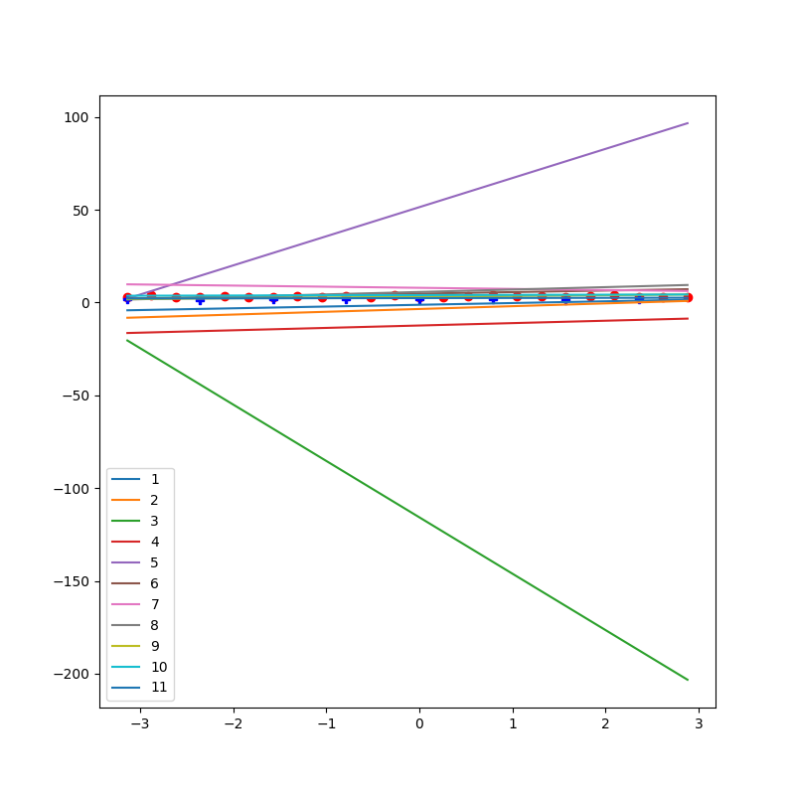The data were distributed linearly over the x-axis rather than distributed over a circular path. This is because we transformed our data from a linear plane to a polar plane where circular in linear plane becomes linear in polar plane.

QA7. After training your perceptron on the re-mapped ring data, did it achieve convergence, and if so, how many epochs were used?

It converged after 11 epochs

QA8. What does these results suggest about the power of perceptrons to classify data that may consist of clusters that cannot be separated by a linear manifold (such as a line or plane)?

By transforming the data, we can manipulate the distribution of the datapoints and eventually train our classifier to distinguish the datapoints that cannot be separated by a linear manifold.

QA9. Did you run into any difficulties either setting up for Part A or running the programs and answering the questions? If so, please describe them.

I was unable to read the files using csv reader when I tried to run using the button Run without Debug on VSCode. I experimented adding the working directory in my PYTHONPATH in the environment variable and clicking the run button on the upper right corner and it worked.

QA10. What portion(s) of Part A did you find most worthwhile and why?

I liked how we can actually implement and experience using perceptrons. These helped me understand how it works better.