Part B Report

Name: Billy Lin (replace with your own name and delete this instruction!)

Assignment 6: Perceptron Classification and Training

CSE 415 Introduction to Artificial Intelligence, Winter 2021, University of Washington

Please answer each question using text in Blue, so your answers stand out from the questions.

QB1. How many epochs were required to train your perceptron on the 3-class Iris data having 4 features (the given training file, with 30 examples) ?

85 epochs

QB2. How many of the test data examples (out of 120) were mis-classified? Determine the percentage error rate and write that here.

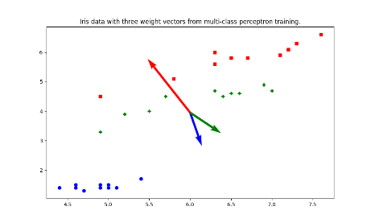14 in the test data were misclassified, and the error rate is 11.6%.

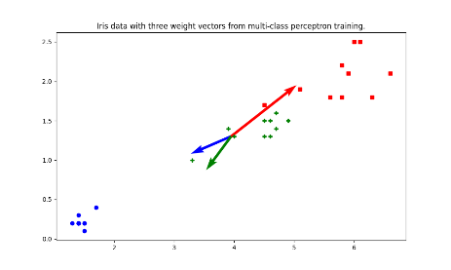QB3. Capture the plot that is produced by the program showing the training data and the weight vectors when projected onto the 2-D subspace spanned by sepal length and petal length (which is the starter-code default in run_3_class_4_feature_iris_data.py. Paste it here, reduced to fit in the remaining space on this page.

Fig. 1. Sepal length, Petal length

QB4. In the file run_3_class_4_feature_iris_data.py, adjust the commenting near lines 23-25 so you can see the data in the plot projects to features 2 and 3 (petal length and petal width). Describe the how the data seems to be distributed in this view. Describe how the weight vectors seem to be pointing. Finally, describe the relationship between the weight vectors and the distribution of the data.

Fig. 2. Petal length, Petal width

The datapoints were distributed in three clusters on the graph. The weight vectors were pointing to where the clusters are in the graph. The weight vectors represent the trends of the data in the clusters. The weights vectors were the average of all the data distribution of the clusters.