miniLLM Learning Notes
These notes show my full learning path for miniLLM, an autoregressive language-model training workflow written in C11.

1. What Configuration Values Does miniLLM Use?
There are a few different core structs.

MiniLLMConfig
include/minillm.h
typedef struct {
int vocab_size; /* The byte tokenizer is fixed at 256 tokens. */
int context_length; /* Maximum tokens visible at once. */
int d_model; /* Vector dimension of each token representation. */
int n_heads; /* Attention heads; d_model must be divisible by n_heads. */
int n_layers; /* Number of Transformer blocks. */
int hidden_dim; /* MLP intermediate width, usually 2–4 times d_model. */
uint64_t seed; /* Seed for initialization and sampling. */
} MiniLLMConfig;
- vocab_size: The number of distinct token IDs. Because one byte is used as one token, there are 2^8 = 256 possible byte values.
- context_length: The maximum number of token positions processed in one sequence during a forward/backward pass—the context window.
- For each training sample, we select context_length + 1 tokens. The first context_length tokens are the inputs, and the same sequence shifted one token to the right provides the targets.
- d_model: The number of dimensions in each token representation. For example, a token can be embedded as a one-dimensional array of 32 numbers. After each Transformer block, the hidden state is still D-dimensional but also contains contextual information.
- n_heads: The number of attention heads. d_model must be divisible by n_heads, so each head normally uses d_model / n_heads dimensions.
- n_layers: The number of Transformer blocks.
- hidden_dim: The width of the MLP's intermediate layer, usually 2–4 times d_model.
- seed: The random seed used for parameter initialization and sampling.

MiniLLMOptimizer
typedef struct {
float learning_rate;
float beta1;
float beta2;
float epsilon;
float weight_decay;
float grad_clip; /* Gradient-norm limit; <= 0 disables clipping. */
} MiniLLMOptimizer;
These are the optimizer hyperparameters.

Tensor
src/internal/minillm_internal.h
typedef struct {
size_t count;
float *value; /* Parameter values, w */
float *grad; /* Gradients, dw */
float *m; /* Adam first-moment estimates */
float *v; /* Adam second-moment estimates */
} Tensor;
- count: The total number of scalar values in the tensor.
- value, grad, m, and v each point to a separate contiguous one-dimensional array containing count floats. A matrix or higher-dimensional shape is imposed by the code that uses the tensor; these are not pointers to two-dimensional arrays.

Transformer Block Parameters
typedef struct {
Tensor rms1_gain; /* [D] */
Tensor wq; /* [D, D] */
Tensor wk; /* [D, D] */
Tensor wv; /* [D, D] */
Tensor wo; /* [D, D] */
Tensor rms2_gain; /* [D] */
Tensor w1; /* [D, F] */
Tensor b1; /* [F] */
Tensor w2; /* [F, D] */
Tensor b2; /* [D] */
} Block;
- D: The model's hidden dimension, for example 128.
- F: The MLP's intermediate dimension, for example 512.
- T: The context length.
Roles of the block parameters
- rms1_gain: Normalization gain before attention.
- wq / wk / wv: Produce the Query, Key, and Value projections.
- wo: Mixes and projects the attention result.
- rms2_gain: Normalization gain before the MLP.
- w1 / b1: Expands from D to the MLP intermediate dimension F.
- w2 / b2: Projects from F back to the model dimension D.

2. Linear Layers and the MLP
In this project, the MLP is built from two linear layers with a nonlinear activation between them.

Forward Pass
void minillm_linear_forward(const float *x, const Tensor *weight,
const Tensor *bias, float *y,
int rows, int input_dim, int output_dim) {
int row;
for (row = 0; row < rows; ++row) {
int out;
for (out = 0; out < output_dim; ++out) {
int in;
float sum = bias != NULL ? bias->value[out] : 0.0f;
for (in = 0; in < input_dim; ++in) {
sum += x[row * input_dim + in] *
weight->value[in * output_dim + out];
}
y[row * output_dim + out] = sum;
}
}
}

Shape Convention
In this project, the linear layer uses the following shapes:
- Input x: [rows, input_dim]
- Weight W: [input_dim, output_dim]
- Bias b: [output_dim] (optional)
- Output y: [rows, output_dim]
In other words:
y[row][out] = x[row][0] * W[0][out]
+ x[row][1] * W[1][out]
+ ...
+ bias[out]
(m × n)(n × p) → (m × p)
A way I remember it
The two inner dimensions must match, and the two outer dimensions determine the output shape.

Example: One Row (One Token)
Suppose the input is:
x = [2, 3]
We want an output of length 2:
y = [?, ?]
The weight matrix and bias are:
W = [[1, 4],
[2, 5]]
b = [10, 20]
The linear forward pass computes y[0] and y[1] separately.
First output
y[0] = x[0] * W[0][0] + x[1] * W[1][0] + b[0]
= 2 * 1 + 3 * 2 + 10
= 18
Second output
y[1] = x[0] * W[0][1] + x[1] * W[1][1] + b[1]
= 2 * 4 + 3 * 5 + 20
= 43
Therefore:
y = [18, 43]

Why Is There an Outer row Loop?
Why does the code have an outer row loop?
Because it normally processes multiple token rows at once. Every token row uses the same linear-layer weights.

Projection to the Vocabulary
For the final projection to the vocabulary:
final_norm : [T, D]
output_weight : [D, 256]
output_bias : [256]
logits : [T, 256]
Here, 256 is the vocabulary size. Each row is one token's D-dimensional feature vector. A [1, D] row multiplied by [D, 256] produces [1, 256], and processing T rows produces [T, 256].
These 256 values are logits—unnormalized scores. Applying softmax converts them into a probability distribution over the 256 byte tokens.

Backward Pass
void minillm_linear_backward(const float *x, Tensor *weight, Tensor *bias,
const float *dy, float *dx,
int rows, int input_dim, int output_dim) {
int row;
for (row = 0; row < rows; ++row) {
int out;
for (out = 0; out < output_dim; ++out) {
int in;
const float gradient = dy[row * output_dim + out];
if (bias != NULL) {
bias->grad[out] += gradient;
}
for (in = 0; in < input_dim; ++in) {
weight->grad[in * output_dim + out] +=
x[row * input_dim + in] * gradient;
dx[row * input_dim + in] +=
weight->value[in * output_dim + out] * gradient;
}
}
}
}
dy has exactly the same shape as the forward output y.
After the forward pass, the backward pass uses the upstream gradient dy to compute three things:
- dx: The gradient with respect to the input x. It is passed to the preceding layer as that layer's upstream gradient.
- weight->grad: The gradient with respect to the weight matrix W.
- bias->grad: The gradient with respect to the bias b.
The forward equation is:
y = xW + b
For one token row and one output position:
y[row][out] = Σ x[row][in] * W[in][out] + b[out]
The backward equations are:
dW[in][out] += x[row][in] * dy[row][out]
db[out] += dy[row][out]
dx[row][in] += W[in][out] * dy[row][out]
The += operators matter because gradients accumulate across token rows and output dimensions.

What Does gradient Mean?
const float gradient = dy[row * output_dim + out];
dy is the gradient passed back from the later part of the network:
dy[row][out] = ∂loss / ∂y[row][out]
In other words, it measures how a small change in the current output y[row][out] would change the final loss.
Next: use the optimizer to update the weights and biases.

3,RMSNorm
Force the signal to stay in a healthy scale rh is -1 ～1

void minillm_rms_forward(const float *x, const float *gain, float *y,
float *inverse_rms, int rows, int columns) {
int row;
for (row = 0; row < rows; ++row) {
int col;
float square_sum = 0.0f;
for (col = 0; col < columns; ++col) {
const float value = x[row * columns + col];
square_sum += value * value;
}
inverse_rms[row] = 1.0f /
sqrtf(square_sum / (float)columns + MINILLM_RMS_EPSILON);
for (col = 0; col < columns; ++col) {
y[row * columns + col] = x[row * columns + col] *
inverse_rms[row] * gain[col];
}
}
}
X：input with shape [t,d]
Rows：amount of tokens t
Colums：hidden dimensions d
So the shape of the input is [t,d]

Gain: a 1d array with length d-> will be shared for all the tokens
The only learnable factor in norm layer
它的作用：归一化会把向量强行拉到均方根为 1。但这可能破坏了模型表达能力，所以模型需要一个参数来把数值再“缩放”到它觉得合适的范围内。
逐元素乘法 token每一个维度对应一个

float *inverse_rms：
To save a middle result for calculation in backward pass

Only 3 steps：
For every row（token), square each of them and sum them up
And then squareroot that value and do 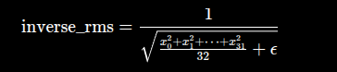

And then we save this
And then 每一个token 里面的每一个维度*这个token的inverserm再*gain里面的对应的那一个数值

void minillm_rms_backward(const float *x, Tensor *gain,
const float *inverse_rms, const float *dy,
float *dx, int rows, int columns) {
int row;
for (row = 0; row < rows; ++row) {
int col;
float dot = 0.0f;
const float r = inverse_rms[row];
for (col = 0; col < columns; ++col) {
const int index = row * columns + col;
dot += dy[index] * gain->value[col] * x[index];
gain->grad[col] += dy[index] * x[index] * r;
}
for (col = 0; col < columns; ++col) {
const int index = row * columns + col;
const float u = dy[index] * gain->value[col];
dx[index] += r * u - x[index] * r * r * r * dot / (float)columns;
}
}
}

2 things we want to calculate
The gradient of gain to update gain
And also the dx to give to the last layer

Gain:

dx: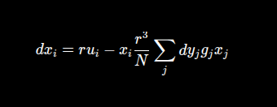

dx 和 x 同形状​ gain.grad 和 gain.value 同形状​

32个样本并行 forward → 32个 loss → 平均成 1 个 loss → 一次 backward → 得到相当于 32 个样本梯度平均后的 gradient → 更新一次参数

4. Attention

First understand the structure

For attention layer the input is still [t,d]

And the output is also [t,d]

Q v k each has a size of[d,d]

So obv wq wv wk is also [t,d]

And then we do some operation to put wq wv wk tgt and we get the final matrix [t,d]

First we can focus on one layer for example q

So basically q means query: what im looking for?
When we do the operation wq, the result we get means: what im looking for
How to understand:
Q is a matrix which is trained to input a token and output what its looking for
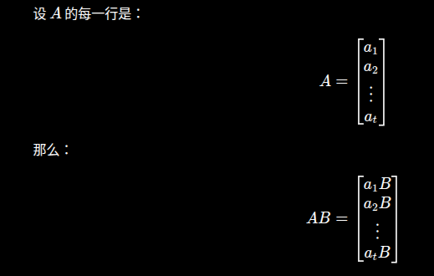

So for each token(the hidden layer(vector)) becomes another vector which represents what its looking for

This works for all the q v k

So basically each vector means sth else

And then
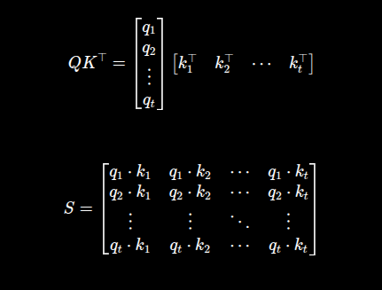

Realize how we retake K so we can compare every token in Q with every token in k and get the attention score for every token to every token
Also for everytoken we only show the previous token and it cannot c the future tokens so the matrix would look like this
devide by d so we wont make the attention score too big
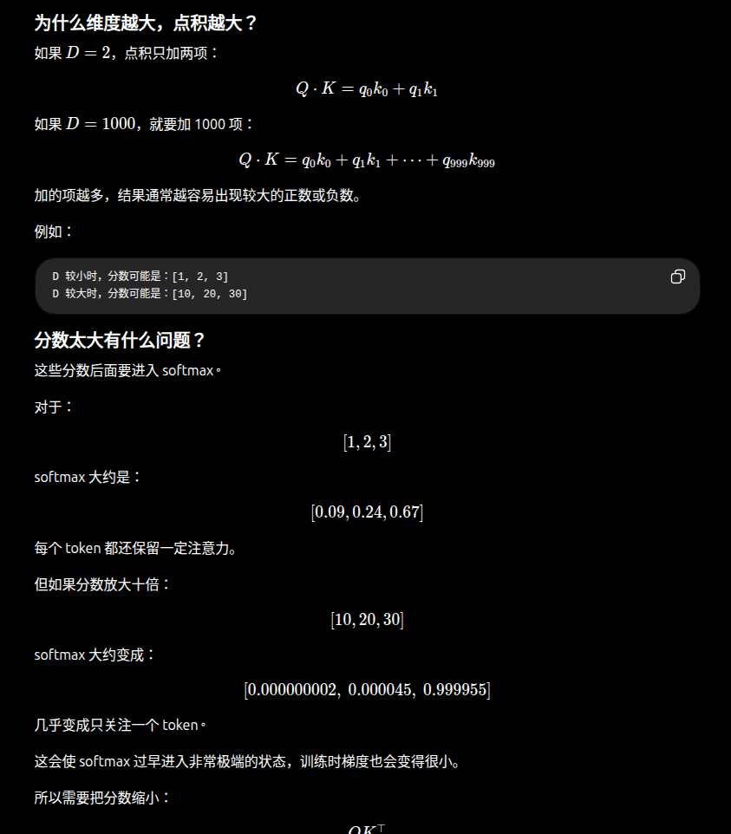

Ok now we have an attention matrix which looks like this 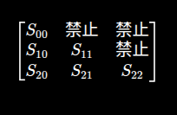

We softmax() each row and get this sth like this: 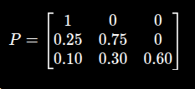

Again this is the attention score for token to every token
And then we do P*V

We also use this intuition
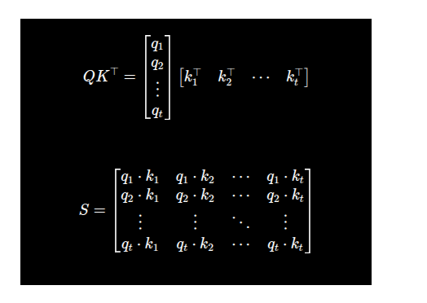
So Oi,c​ 表示：token i 从所有可见 token 的 Value 第 c个特征中，加权收集到的结果。
Ths shape of o:[t d]

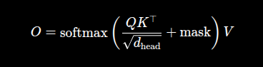
输出就是o

int minillm_attention_backward(const float *q, const float *k, const float *v,
const float *probability, const float *d_output,
float *d_q, float *d_k, float *d_v,
int token_count, int d_model, int heads) {
const int head_dim = d_model / heads;
const float scale = 1.0f / sqrtf((float)head_dim);
float *d_probability = minillm_calloc((size_t)token_count, sizeof(float));
int i;
if (d_probability == NULL) return 0;

for (i = 0; i < token_count; ++i) {
int head;
for (head = 0; head < heads; ++head) {
int j;
float probability_dot = 0.0f;
const size_t row_base = ((size_t)head * (size_t)token_count +
(size_t)i) * (size_t)token_count;

/* output=P@V，所以 dP=d_output@V，dV=P^T@d_output。 */
for (j = 0; j <= i; ++j) {
int c;
float dp = 0.0f;
const float p = probability[row_base + (size_t)j];
for (c = 0; c < head_dim; ++c) {
const int channel = head * head_dim + c;
dp += d_output[i * d_model + channel] *
v[j * d_model + channel];
d_v[j * d_model + channel] +=
p * d_output[i * d_model + channel];
}
d_probability[j] = dp;
probability_dot += p * dp;
}

/* softmax 导数：dscore[j]=P[j]*(dP[j]-sum(P*dP))。 */
for (j = 0; j <= i; ++j) {
int c;
const float p = probability[row_base + (size_t)j];
const float d_score = p * (d_probability[j] - probability_dot) * scale;
/* score=Q·K/sqrt(Dh)，所以梯度分别乘另一个向量。 */
for (c = 0; c < head_dim; ++c) {
const int channel = head * head_dim + c;
d_q[i * d_model + channel] +=
d_score * k[j * d_model + channel];
d_k[j * d_model + channel] +=
d_score * q[i * d_model + channel];
}
}
}
}
free(d_probability);
return 1;
}

反向传播

从 O=PVO=PV 求 dPdP 和 dV

通过 softmax 求 dS

3. 从 S=QK⊤/dhS=QK^\top/\sqrt{d_h} 求 dQ,dK

