CPE301 – SPRING 2019

Design Assignment 2AT1

Student Name: Billy Maddex

Student #: 2000928390

Student Email: [maddex@unlv.nevada.edu](mailto:maddex@unlv.nevada.edu)

Primary Github address: <https://github.com/billymaddex/fluffy-chainsaw>

Directory: DA2A/T1

Submit the following for all Labs:

1. In the document, for each task submit the modified or included code (only) with highlights and justifications of the modifications. Also, include the comments.
2. Use the previously create a Github repository with a random name (no CPE/301, Lastname, Firstname). Place all labs under the root folder ESD301/DA, sub-folder named LABXX, with one document and one video link file for each lab, place modified asm/c files named as LabXX-TYY.asm/c.
3. If multiple asm/c files or other libraries are used, create a folder LabXX-TYY and place these files inside the folder.
4. The folder should have a) Word document (see template), b) source code file(s) and other include files, c) text file with youtube video links (see template).

1. **COMPONENTS LIST AND CONNECTION BLOCK DIAGRAM w/ PINS**

Atmega328PB-XMINI

Multi-Function Arduino Module

1. **INITIAL/MODIFIED/DEVELOPED CODE OF TASK 1/A**

;

; DA2AT1.asm

;

; Created: 9/29/2019 3:15:15 PM

; Author : Billy

;

;; Set GPIO ports

;; Set DDR B,C,D to known initial value

LDI R25, 0x00

OUT DDRB, R25

OUT DDRC, R25

OUT DDRD, R25

;; set PORT B,C,D to know initial value

LDI R25, 0xFF

OUT PORTB, R25

OUT PORTC, R25

OUT PORTD, R25

;; set PORTB 2 and 3 to output

SBI DDRB, 3

SBI DDRB, 2

;; set PINC 3 to input

CBI DDRC, 3

MAIN_LOOP:

;; LED pulse

;; turn the light on

CBI PORTB, 3

;; call delay at 250ms

LDI R17, HIGH(250)

LDI R16, LOW(250)

CALL DELAY

;; turn the light off

SBI PORTB, 3

;; call delay at 375ms

LDI R17, HIGH(375)

LDI R16, LOW(375)

CALL DELAY

;; if switch is not pressed, repeat the loop

SBIC PINC, 3

RJMP MAIN_LOOP

;; otherwise, flash the other light

;; turn the light on

CBI PORTB, 2

;; call delay at 1333ms

LDI R17, HIGH(1333)

LDI R16, LOW(1333)

CALL DELAY

;; turn the light off

SBI PORTB, 2

;; repeat the loop

RJMP MAIN_LOOP

;; simple delay function

;; takes input as 16-bit int in R17:R16

;; delay is supposed to be in ms

DELAY:

LDI R20, 0

MOV R22, R17

MOV R21, R16

L3:

LDI R23, 0X2F

L2:

LDI R24, 0X70

NOP

L1:

DEC R24

BRNE L1

DEC R23

BRNE L2

SUBI R21, 1

SBCI R22, 0

BRNE L3

CP R21, R20

BRNE L3

RET

1. **DEVELOPED MODIFIED CODE OF TASK 2/A from TASK 1/A**
2. **SCHEMATICS**

Use fritzing.org

1. **SCREENSHOTS OF EACH TASK OUTPUT (ATMEL STUDIO OUTPUT)**

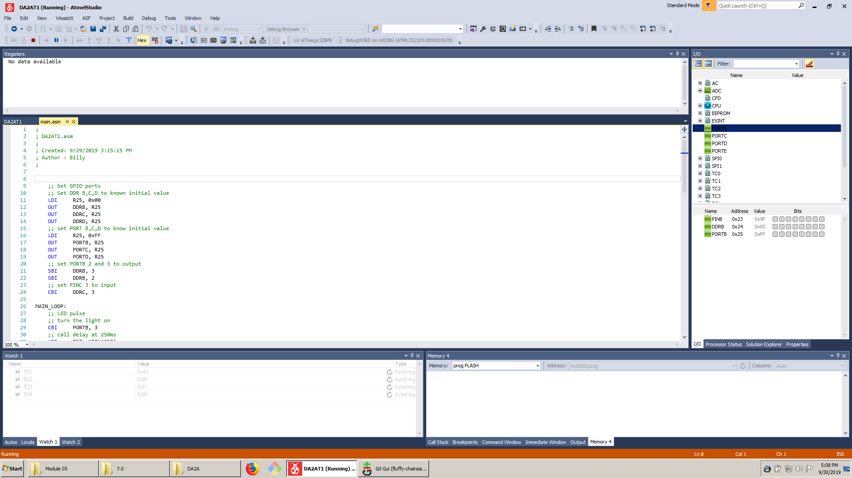

1. **SCREENSHOT OF EACH DEMO (BOARD SETUP)**

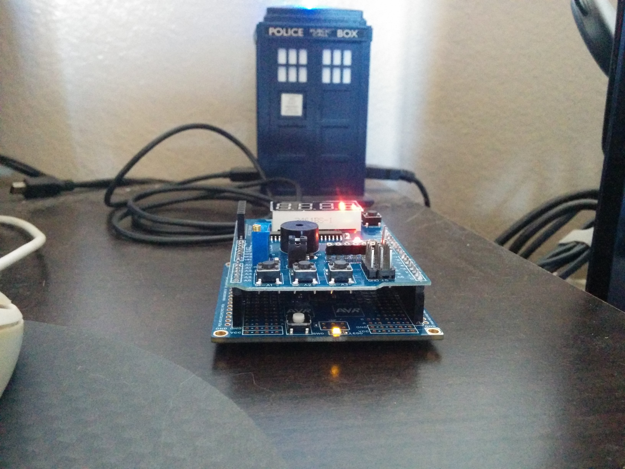

1. **VIDEO LINKS OF EACH DEMO**

<https://youtu.be/jWZDmGci-QE>

1. **GITHUB LINK OF THIS DA**

<https://github.com/billymaddex/fluffy-chainsaw/tree/master/DesignAssignments/DA2A/T1>

**Student Academic Misconduct Policy**

<http://studentconduct.unlv.edu/misconduct/policy.html>

“This assignment submission is my own, original work”.

Billy Maddex