CPE301 – SPRING 2019

Design Assignment 2AT2

Student Name: Billy Maddex

Student #: 2000928390

Student Email: [maddex@unlv.nevada.edu](mailto:maddex@unlv.nevada.edu)

Primary Github address: <https://github.com/billymaddex/fluffy-chainsaw>

Directory: DA2A/T2

Submit the following for all Labs:

1. In the document, for each task submit the modified or included code (only) with highlights and justifications of the modifications. Also, include the comments.
2. Use the previously create a Github repository with a random name (no CPE/301, Lastname, Firstname). Place all labs under the root folder ESD301/DA, sub-folder named LABXX, with one document and one video link file for each lab, place modified asm/c files named as LabXX-TYY.asm/c.
3. If multiple asm/c files or other libraries are used, create a folder LabXX-TYY and place these files inside the folder.
4. The folder should have a) Word document (see template), b) source code file(s) and other include files, c) text file with youtube video links (see template).

1. **COMPONENTS LIST AND CONNECTION BLOCK DIAGRAM w/ PINS**

Atmega328PB-XMINI

Multi-Function Arduino Module

1. **INITIAL/MODIFIED/DEVELOPED CODE OF TASK 1/A**

/*

* DA2AT2.c

*

* Created: 9/29/2019 7:42:05 PM

* Author : Billy

*/

#define F_CPU 1600000UL

#include <avr/io.h>

#include <util/delay.h>

int main(void)

{

// Set DDR B,C,D to known initial value

DDRB = 0x00;

DDRC = 0x00;

DDRD = 0x00;

// set PORT B,C,D to know initial value

PORTB = 0xFF;

PORTC = 0xFF;

PORTD = 0xFF;

// set PORTB 2 and 3 to output

DDRB |= (1 << 3);

DDRB |= (1 << 2);

// set PINC 3 to input

DDRC &= ~(1 << 3);

// LED pulse

while (1)

{

// turn the light on

PORTB &= ~(1 << 3);

// call delay

_delay_ms(2500);

// turn the light off

PORTB |= (1 << 3);

// call delay

_delay_ms(3750);

// if switch is pressed, flash the other light

if (~PINC & (1 << 3))

{

// turn the light on

PORTB &= ~(1 << 2);

// call delay

_delay_ms(13330);

// turn the light off

PORTB |= (1 << 2);

}

}

}

1. **DEVELOPED MODIFIED CODE OF TASK 2/A from TASK 1/A**
2. **SCHEMATICS**

Use fritzing.org

1. **SCREENSHOTS OF EACH TASK OUTPUT (ATMEL STUDIO OUTPUT)**

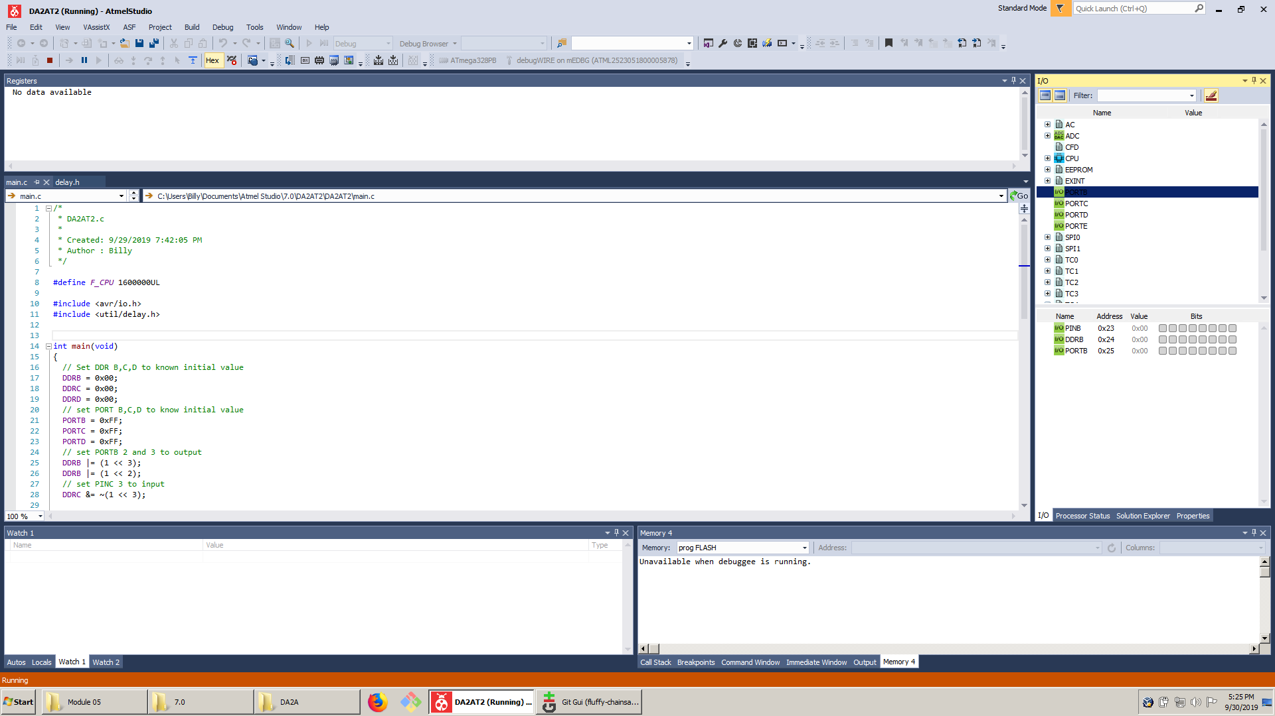

1. **SCREENSHOT OF EACH DEMO (BOARD SETUP)**

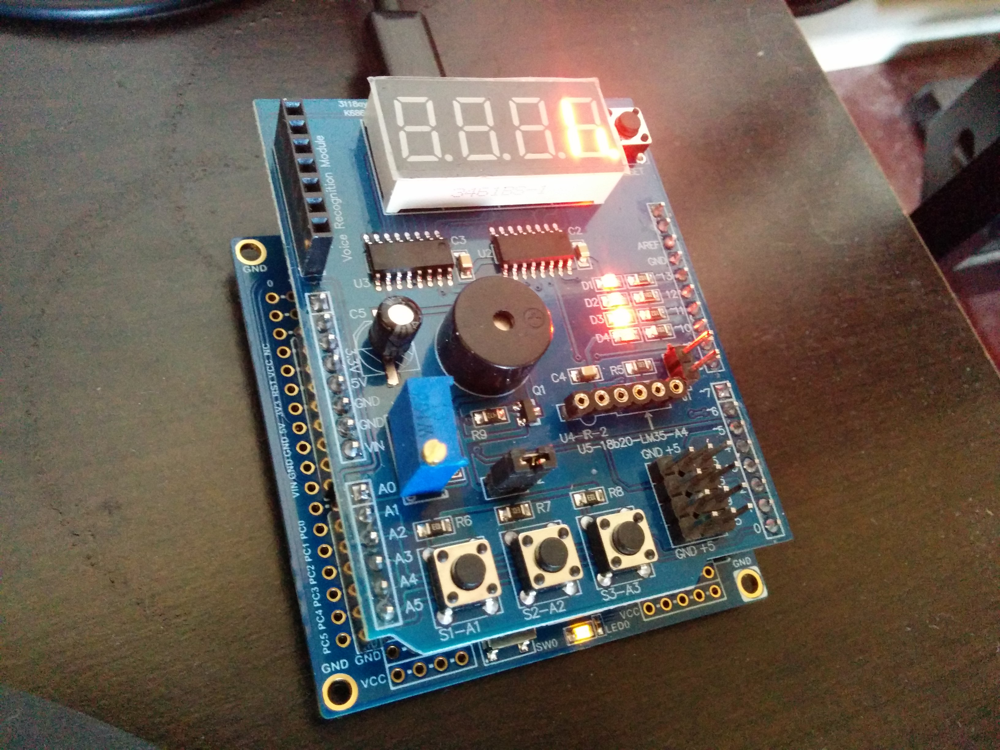

1. **VIDEO LINKS OF EACH DEMO**

<https://youtu.be/xyT9z0zNjb0>

1. **GITHUB LINK OF THIS DA**

<https://github.com/billymaddex/fluffy-chainsaw/tree/master/DesignAssignments/DA2A/T2>

**Student Academic Misconduct Policy**

<http://studentconduct.unlv.edu/misconduct/policy.html>

“This assignment submission is my own, original work”.

Billy Maddex